Supplementary Figures

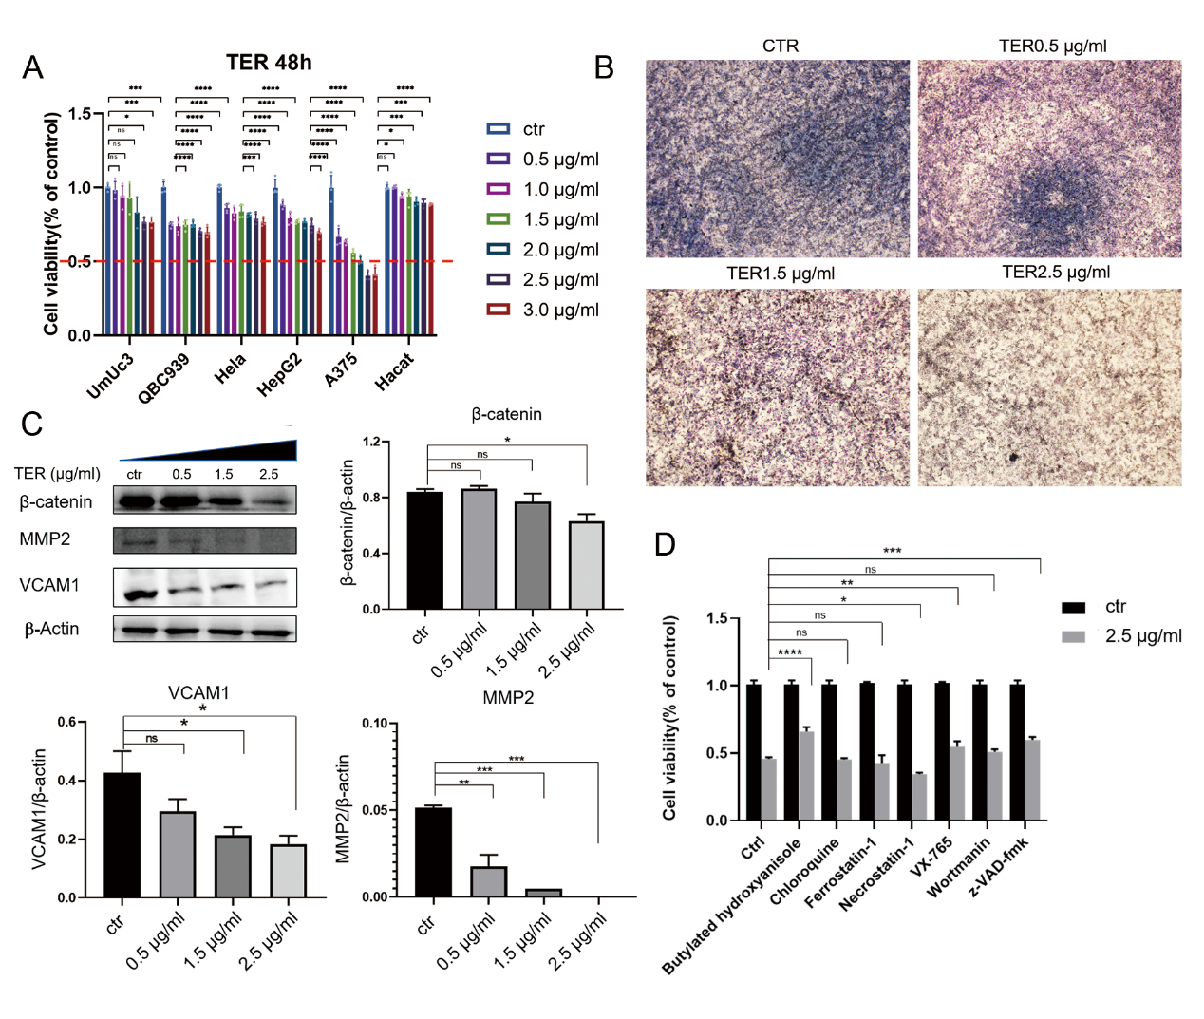
Figure S1: TER inhibits cell viability, migration and invasion of A375 cells. (A) UmUc3, QBC939, Hela, HepG2, A375 and Hacat cells were treated with different doses (0.5, 1.0, 1.5, 2.0, 2.5 and 3.0 μg/ml) of TER for 48 h, after which cell viability was determined via the MTT assay (n = 4). The red line shows the percentage of cell viability of A375 cells after 2.0 μg/ml TER treatment for 48h. (B) The migration and invasion ability of the cells were detected by Transwell assay after 48h treatment with different doses (0.5, 1.5 and 2.5 μg/ml) of TER. (C) Cells were treated with different doses (0, 0.5, 1.5 and 2.5 μg/ml) of TER, and the expression of β-catenin, MMP2 and VCAM1 was detected via SDS‒PAGE and protein blotting (n = 3). (D) A375 cells were pretreated with seven cell death inhibitors, respectively, and then the cell viability of the A375 cells at TER 2.5 μg/ml was detected by MTT assay (n = 4). Data in A, B, D and E are shown as mean + SEM. Ns: not significant, p > 0.05, *p < 0.05, **p < 0.01, ***p < 0.001, ****p < 0.0001.

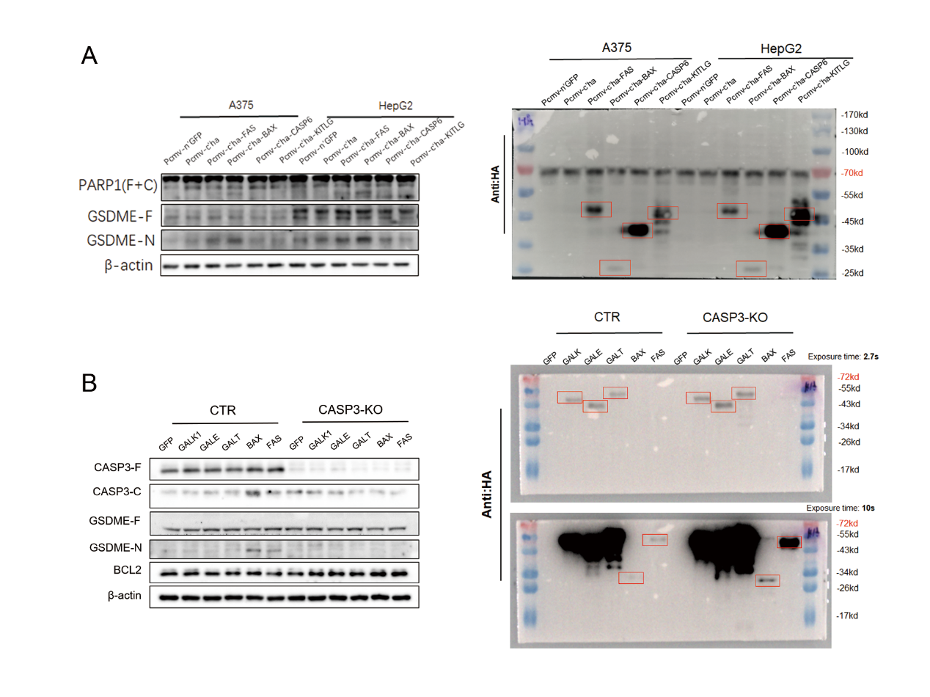
Figure S2: Protein expression in the gene overexpression group. (A) Overexpression of signaling pathway-related genes (FAS, BAX CASP6 and KITLG) in A375 cells, and cleavage of PARP1 and GSDME proteins was detected by SDS‒PAGE and protein blotting. (B) Overexpression of GALK1/GALE/GALT/BAX/FAS proteins in A375 and CASP3-KO cells, and cleavage of CASP3 and GSDME proteins was detected by SDS‒PAGE and protein blotting (n = 3).

