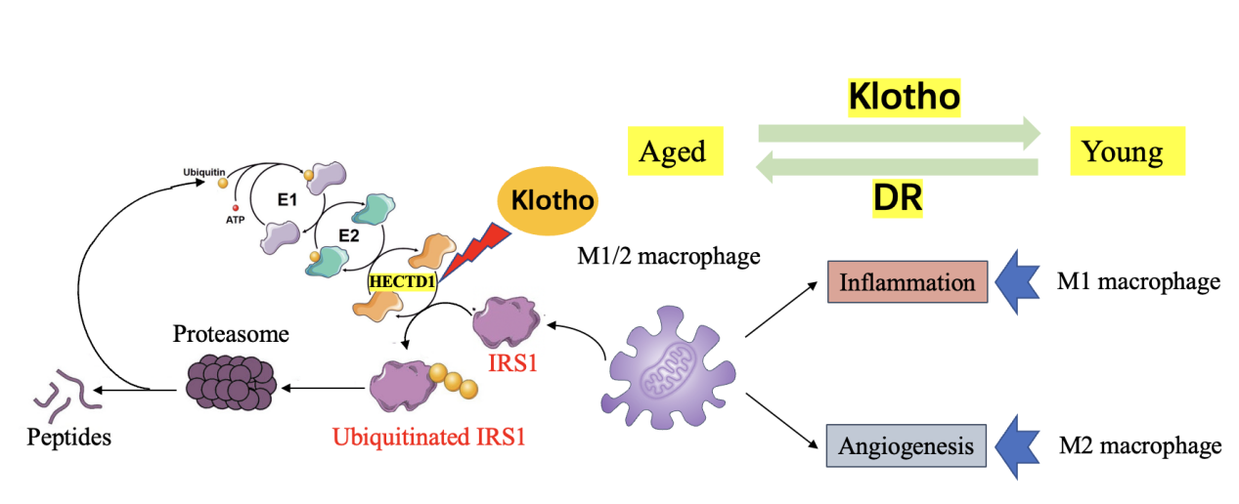
Supplementary Figure. S1: KL can ameliorate diabetes-induced retinal macrophage senescence via the HECTD1/IRS1 pathway. It can inhibit E3 ubiquitin ligase HECTD1 expression, downregulating IRS1 ubiquitination and degradation.

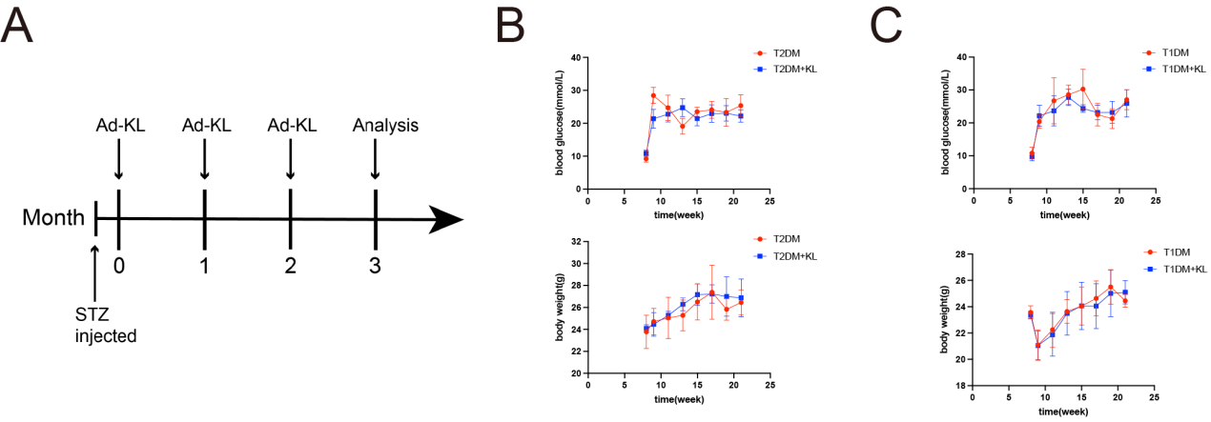
Supplementary Figure. S2: Ad-KL treatment did not cause a significant difference in body weight or blood glucose of diabetic mice. (A) Illustration of the time points of STZ injection and Ad-KL treatment. There was no statistically significant difference in body weight (B) or blood glucose (C) of mice between the DM group and the DM+KL group.

 |  | Control | PDR | P value
serum group | Age (years) | 62.13±4.49 | 62.25±3.91 | 0.9336
serum group | Sex, males (%) | 46.67 | 43.75 | 1
serum group | SBP (mmHg) | 137.00±13.61 | 148.38±16.72 | 0.1149
serum group | DBP (mmHg) | 77.13±10.37 | 81.63±10.33 | 0.3258
serum group | FPG (mmol/L) | 4.60±0.68 | 10.40±4.50 | <0.0001
serum group | Duration (years) | 0 | 14.19±7.11 | <0.0001
serum group | HbA1c (%) | 5.60±0.40 | 8.00±2.20 | 0.0008
serum group | BUN (mmol/L) | 4.44±0.96 | 4.24±0.98 | 0.5657
serum group | SCr (μmol/L) | 58.92±11.97 | 66.79±14.12 | 0.1061
serum group | SUA (μmol/L) | 321.00±78.09 | 334.69±104.52 | 0.6842
aqueous humor group | Age (years) | 61.86±5.26 | 62.14±8.24 | 0.9138
aqueous humor group | Sex, males (%) | 42.86 | 64.29 | 0.256
aqueous humor group | SBP (mmHg) | 148.36±23.09 | 162.57±32.99 | 0.198
aqueous humor group | DBP (mmHg) | 86.29±10.67 | 88.71±10.76 | 0.5453
aqueous humor group | FPG (mmol/L) | 5.50±0.80 | 9.50±4.00 | <0.0001
aqueous humor group | Duration (years) | 0 | 17.47±9.85 | <0.0001
aqueous humor group | HbA1c (%) | 5.80±0.40 | 7.60±1.20 | <0.0001
aqueous humor group | BUN (mmol/L) | 5.41±1.58 | 7.81±6.81 | 0.2100
aqueous humor group | SCr (μmol/L) | 80.61±16.15 | 75.42±21.29 | 0.4743
aqueous humor group | SUA (μmol/L) | 301.93±66.71 | 305.14±93.66 | 0.9175
vitreous humor group | Age (years) | 58.73±4.58 | 57.00±9.01 | 0.2841
vitreous humor group | Sex, males (%) | 46.15 | 46.67 | 0.978
vitreous humor group | SBP (mmHg) | 133.01±12.24 | 151±27.48 | 0.0618
vitreous humor group | DBP (mmHg) | 80.09±10.20 | 86.43±10.90 | 0.2051
vitreous humor group | FPG (mmol/L) | 4.62±0.43 | 10.45±4.07 | <0.0001
vitreous humor group | Duration (years) | 0 | 14.60±7.66 | <0.0001
vitreous humor group | HbA1c (%) | 5.31±0.22 | 7.98±1.31 | <0.0001
vitreous humor group | BUN (mmol/L) | 4.80±1.23 | 5.08±1.88 | 0.6457
vitreous humor group | SCr (μmol/L) | 63.03±16.08 | 75.24±18.31 | 0.0742
vitreous humor group | SUA (μmol/L) | 315.77±77.07 | 278.00±72.10 | 0.1921
Supplementary Table S1: Comparison of clinical and biochemical data of subjects. Data are presented as the mean ± standard deviation. Unpaired t‐test were used for comparisons of normally distributed continuous variables between two groups, respectively. SBP, systolic blood pressure; DBP, diastolic blood pressure; FPG, fasting plasma glucose; BUN, blood urea nitrogen; SCr, serum creatinine; SUA, serum uric acid.

antibody | Source | Catalog No. | Type of antibody | Dilution
P53 | Santa Cruz Biotechnology | sc-126 | mouse | IF: 1:250  WB: 1:1000
P21 | Santa Cruz Biotechnology | sc-6246 | mouse | WB: 1:1000
P16 | Santa Cruz Biotechnology | sc-1661 | mouse | WB: 1:1000
Klotho | Sigma | SAB3500604 | rabbit | IF: 1:100  WB: 1:1000
HECTD1 | proteintech | 20605-1-AP | rabbit | WB: 1:1000
IRS1 | abcam | ab131487 | rabbit | WB: 1:1000
β-actin | Cell Signaling Technology | 4970 | rabbit | WB: 1:1000
HSP90 | Cell Signaling Technology | 4877 | rabbit | WB: 1:1000
Ki67 | abcam | ab15580 | rabbit | IF: 1:500
F4/80 | Santa Cruz Biotechnology | sc-377009 | mouse | IF: 1:250
IB4 | Vector Laboratories | DL-1207 | rabbit | IF: 1:100
CD34 | abcam | ab81289 | rabbit | IF: 1:100
PI3K | proteintech | 20584-1-AP | rabbit | WB: 1:1000
p-AKT | proteintech | 66444-1-Ig | mouse | WB: 1:1000
AKT | Cell Signaling Technology | 9272 | rabbit | WB: 1:1000
Supplementary Table S2: Antibodies used in the study

CSF2 | Forward | 5'-CCTTGAACATGACAGCCAGCTA-3'
CSF2 | Reverse | 5'-CACAGTCCGTTTCCGGAGTT-3'
CSF3 | Forward | 5'-CCTGCAGGCTCTATCGGGTAT-3'
CSF3 | Reverse | 5'-ATCCAGCTGAAGCAAGTCCAA-3'
VEGFA | Forward | 5'-GTACCTCCACCATGCCAAGTG-3'
VEGFA | Reverse | 5'-TGGGACTTCTGCTCTCCTTCTG-3'
TNF-α | Forward | 5'-GACCCTCACACTCAGATCA-3'
TNF-α | Reverse | 5'-ACTTGGTGGTTTGCTACG-3'
IL-1a | Forward | 5'-AAGAGACCATCCAACCCAGATC-3'
IL-1a | Reverse | 5'-CCTGACGAGCTTCATCAGTTTG-3'
MMP2 | Forward | 5'-GACACCTGCACCACCTTA-3'
MMP2 | Reverse | 5'-AAGGTTGAAGGAAACGAGC-3'
CXCL10 | Forward | 5'-TAAGCTATGTGGAGGTGCGA-3'
CXCL10 | Reverse | 5'-TAGAACTGACGAGCCTGAG-3'
KL | Forward | 5'-TTGGGTCACTGGGTCAATCTC-3'
KL | Reverse | 5'-CCGGCACGATAGGTCATGTT-3'
IL-10 | Forward | 5'-CAAGGAGCATTTGAATTCCC-3'
IL-10 | Reverse | 5'-GGCCTTGTAGACACCTTGGTC-3'
TGF-β | Forward | 5'-TGATACGCCTGAGTGGCTGTCT-3'
TGF-β | Reverse | 5'-CACAAGAGCAGTGAGCGCTGAA-3'
β-actin | Forward | 5'-TAAGGCCAACCGTGAAAAG-3'
β-actin | Reverse | 5'-ACCAGAGGCATACAGGGACA-3'
Supplementary Table S3: The primer sequences for qRT-PCR.

