Nesfatin-1 enhances vascular smooth muscle calcification through facilitating BMP-2 osteogenic signaling
Xue-Xue Zhu^{1,2#}, Xin-Yu Meng^{1#}, Guo Chen^{1#}, Jia-Bao Su^{3#}, Xiao Fu¹, An-Jing Xu¹, Yao Liu⁴, Xiao-Hui Hou⁴, Hong-Bo Qiu¹, Qing-Yi Sun¹, Jin-Yi Hu¹, Zhuo-Lin Lv¹, Hai-Jian Sun^{1,5}, Hai-Bin Jiang^{6*}, Zhi-Jun Han^{7*}, Jian Zhu^{8*}, Qing-Bo Lu^{8*}
¹MOE Medical Basic Research Innovation Center for Gut Microbiota and Chronic Diseases, School of Medicine, Jiangnan University, Wuxi, 214122, China.
²Department of Physiology, Eberhard-Karls-University of Tübingen, Tübingen University, Tübingen 72076, Germany.
³Department of Anesthesiology, Affiliated Hospital of Jiangnan University, Jiangnan University, Wuxi 214122, China.
⁴Department of Ultrasound, The Fourth Affiliated Hospital of Nanjing Medical University, Nanjing 210000, China.
⁵State Key Laboratory of Natural Medicines, China Pharmaceutical University, No. 24 Tongjia Lane, Nanjing 210009, China.
⁶Department of Cardiology, Wuxi No.2 People's Hospital (Jiangnan University Medical Center), Wuxi School of Medicine, Jiangnan University, Wuxi 214001, China.
⁷Department of Clinical Research Center, Jiangnan University Medical Center (Wuxi No.2 People’s Hospital), Wuxi School of Medicine, Jiangnan University, Wuxi 214001, China.
⁸Department of Endocrinology, Affiliated Hospital of Jiangnan University, Jiangnan University, Wuxi 214122, China.
# Contributed equally
Running title: Nesfatin-1 in vascular calcification
Category of the manuscript: Submission of original research article
Figures and tables: 9 Figures, 14 supplementary figures and 4 tables

*Address for correspondence:
Hai-Bin Jiang, Department of Cardiology, Wuxi No.2 People's Hospital (Jiangnan University Medical Center), Wuxi, China, Email: jambo777@163.com
Zhi-Jun Han, Department of Clinical Research Center, Jiangnan University Medical Center (Wuxi No.2 People’s Hospital), Wuxi School of Medicine, Wuxi 214001, China, Email: zjhan1125@163.com
Jian Zhu, Department of Endocrinology, Affiliated Hospital of Jiangnan University, Jiangnan University, Wuxi 214122, China, Email: drzhujian@hotmail.com
Qing-Bo Lu, Department of Endocrinology, Affiliated Hospital of Jiangnan University, Jiangnan University, Wuxi 214122, China, Email: bonnielqb@yeah.net

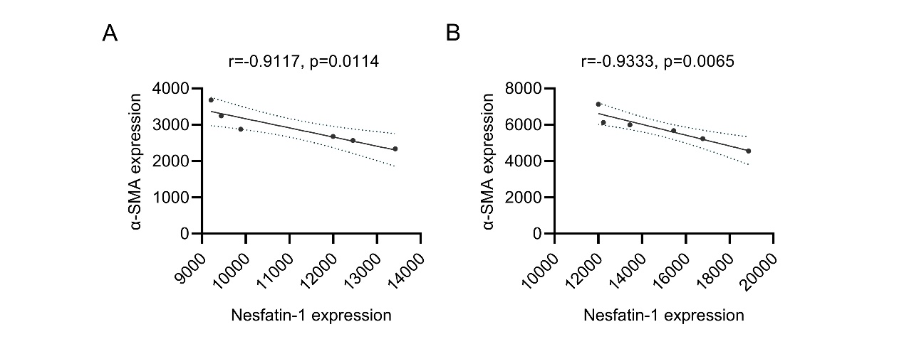
Figure S1. The correlation between α-SMA and nesfatin-1 expression. (A) The negative association of α-SMA and nesfatin-1 by a linear regression analysis in isolated aortas from VD3-induced mice. (B) The negative association of α-SMA and nesfatin-1 by a linear regression analysis in isolated aortas from VD3-induced mice.
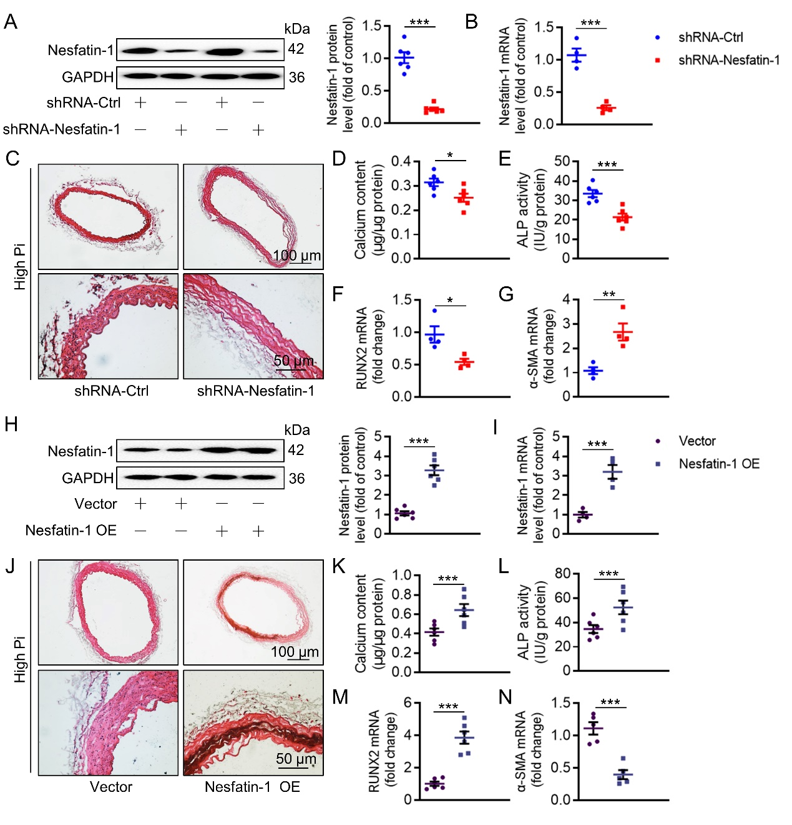
Figure S2. Effects of nesfatin-1 on the VC in ex vivo aortas. (A) Western blot analysis of nesfatin-1 protein levels in aortas. (B) RT-PCR analysis of nesfatin-1 mRNA levels in aortas. (C) Representative Alizarin red S staining of aortas. Scale bar, 100 μm or 50 μm. (D) Calcium content. (E) ALP activity. (F) Relative mRNA level of RUNX2. (G) Relative mRNA level of α-SMA. (H) Western blot analysis of nesfatin-1 protein levels in aortas. (I) RT-PCR analysis of nesfatin-1 mRNA levels in aortas. (J) Representative Alizarin red S staining of aortas. Scale bar, 100 μm or 50 μm. (K) Calcium content. (L) ALP activity. (M) Relative mRNA level of RUNX2. (N) Relative mRNA level of α-SMA. The P-value was calculated by unpaired two-tailed Student’s t-test. *P<0.05, **P<0.01, ***P<0.001 versus the indicated group. n = 4-6.

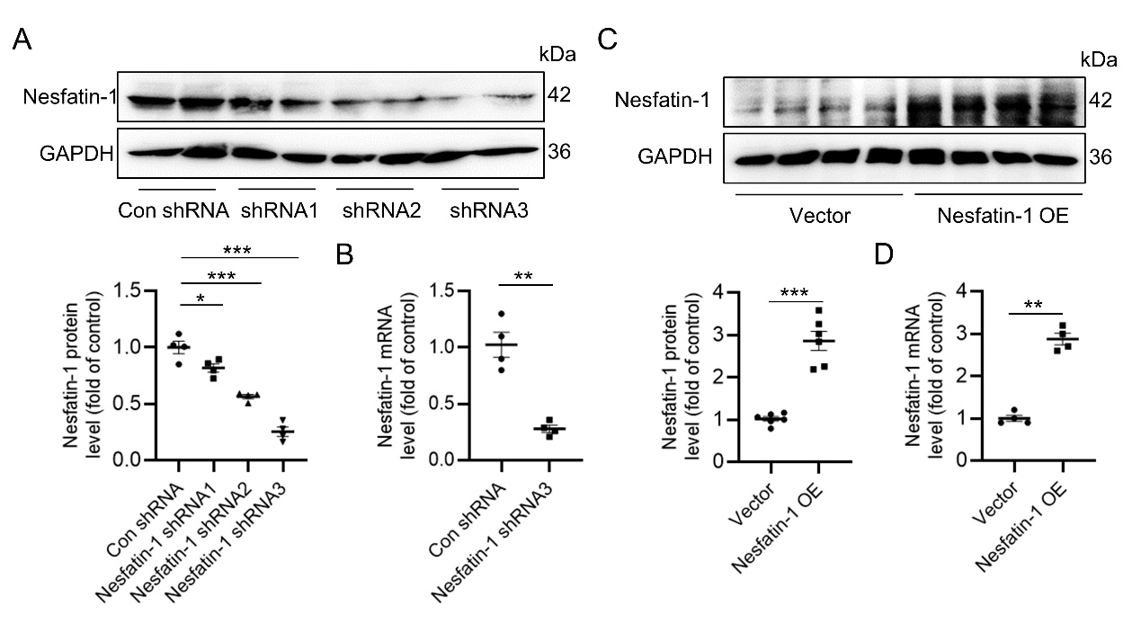
Figure S3. Detection of knockdown and overexpression efficiency of nesfatin-1. (A,C) Western blot analysis of nesfatin-1 protein levels in VSMCs. (B,D) RT-PCR analysis of nesfatin-1 mRNA levels in VSMCs. Differences between groups were assessed with ANOVA followed by Bonferroni post-hoc test (A). The P-value was calculated by unpaired two-tailed Student’s t-test (B-D). P<0.05, **P<0.01, ***P<0.001 versus the indicated group. n = 4-6.

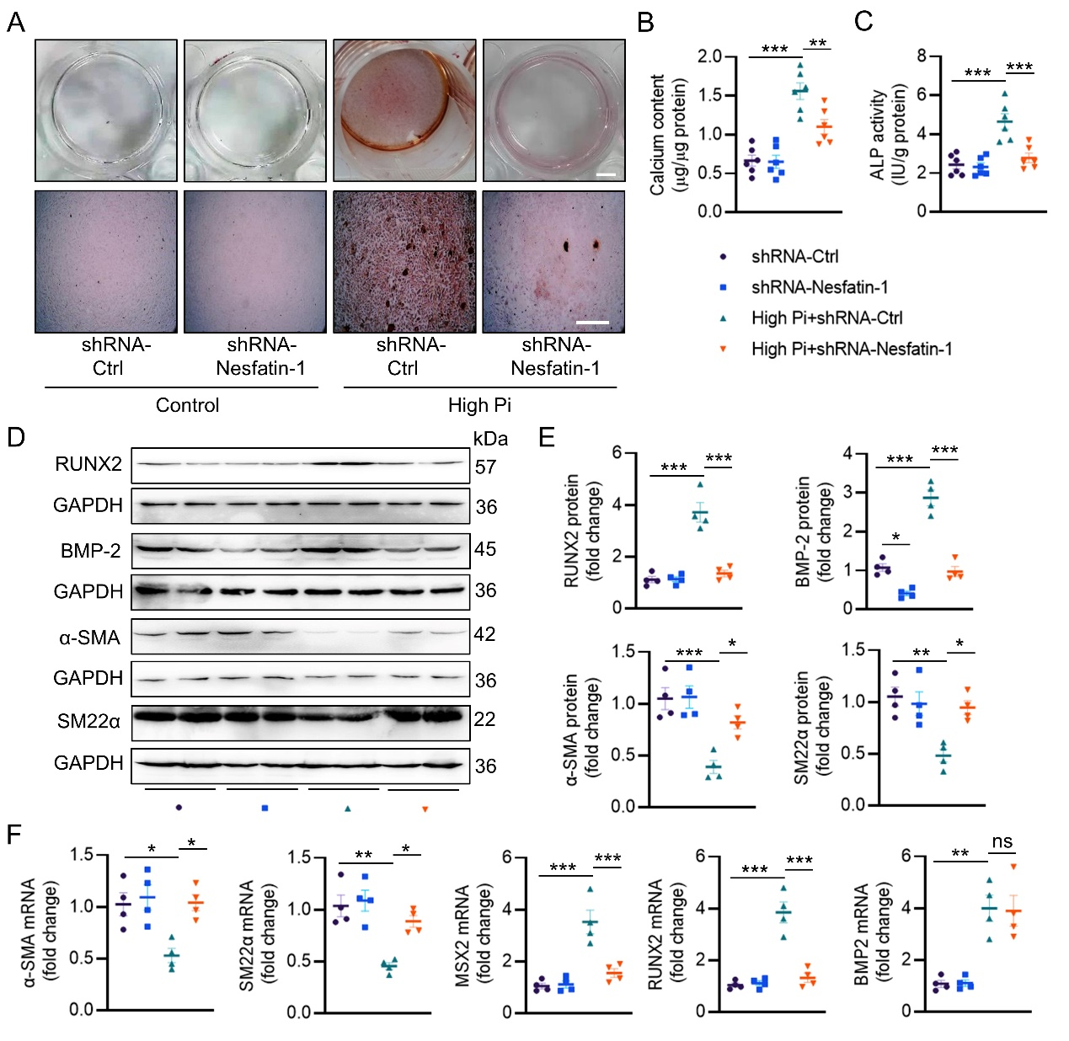
Figure S4. Effects of nesfatin-1 knockdown on the progression of VC in VSMCs. (A) Alizarin red S staining including whole well (Scale bar, 5 mm) and microscopic images (Scale bar, 250 μm) in VSMCs. (B) Quantification of calcium deposition. (C) ALP activity. (D,E) Western blot analysis of RUNX2, BMP-2, α-SMA, and SM22α. (F) RT-PCR analysis of α-SMA, SM22α, MSX2, RUNX2 and BMP-2. Differences between groups were assessed with ANOVA followed by Bonferroni post-hoc test. *P<0.05, **P<0.01, ***P<0.001 versus the indicated group. n = 4-6.

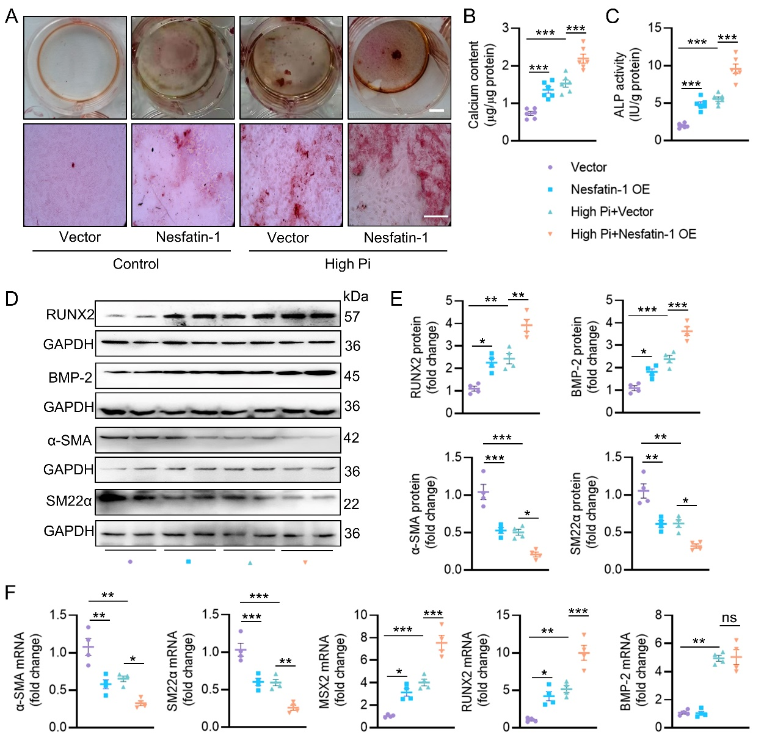
Figure S5. Effects of nesfatin-1 overexpression on the progression of VC in VSMCs. (A) Alizarin red S staining including whole well (Scale bar, 5 mm) and microscopic images (Scale bar, 250 μm) in VSMCs. (B) Quantification of calcium deposition. (C) ALP activity. (D,E) Western blot analysis of RUNX2, BMP-2, α-SMA, and SM22α. (F) RT-PCR analysis of α-SMA, SM22α, MSX2, RUNX2 and BMP-2. Differences between groups were assessed with ANOVA followed by Bonferroni post-hoc test. *P<0.05, **P<0.01, ***P<0.001 versus the indicated group. n = 4-6.


Figure S6. Effects of different concentration of BMP-2 on the expression of nesfatin-1 in VSMCs. (A) RT-PCR analysis of nesfatin-1. The P-value was calculated by unpaired two-tailed Student’s t-test. ***P<0.001 versus the indicated group. n = 6.

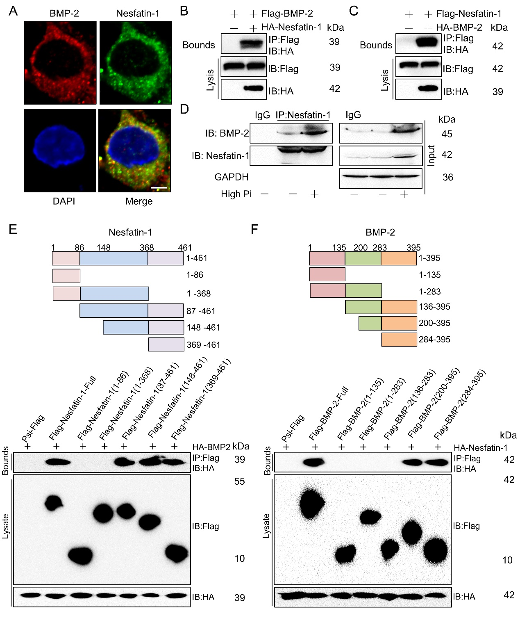
Figure S7. Interaction of nesfatin-1 with BMP-2. (A) Immunofluorescence double staining of nesfatin-1 and BMP-2 by laser confocal assay. Scale bar, 10 μm. (B) HEK293 cells were transfected with Flag-tagged BMP-2 and HA-tagged Nesfatin-1. Anti-Flag and anti-HA antibodies were used as western blot probes. (C) HEK293 cells were transfected with Flag-tagged nesfatin-1 and HA-tagged BMP-2. Anti-Flag and anti-HA antibodies were used as western blot probes. (D) Interaction of BMP-2 and nesfatin-1 in high Pi-incubated VSMCs. (E,F) Results from co-IP assays showing the binding regions between nesfatin-1 and BMP-2. n = 6.

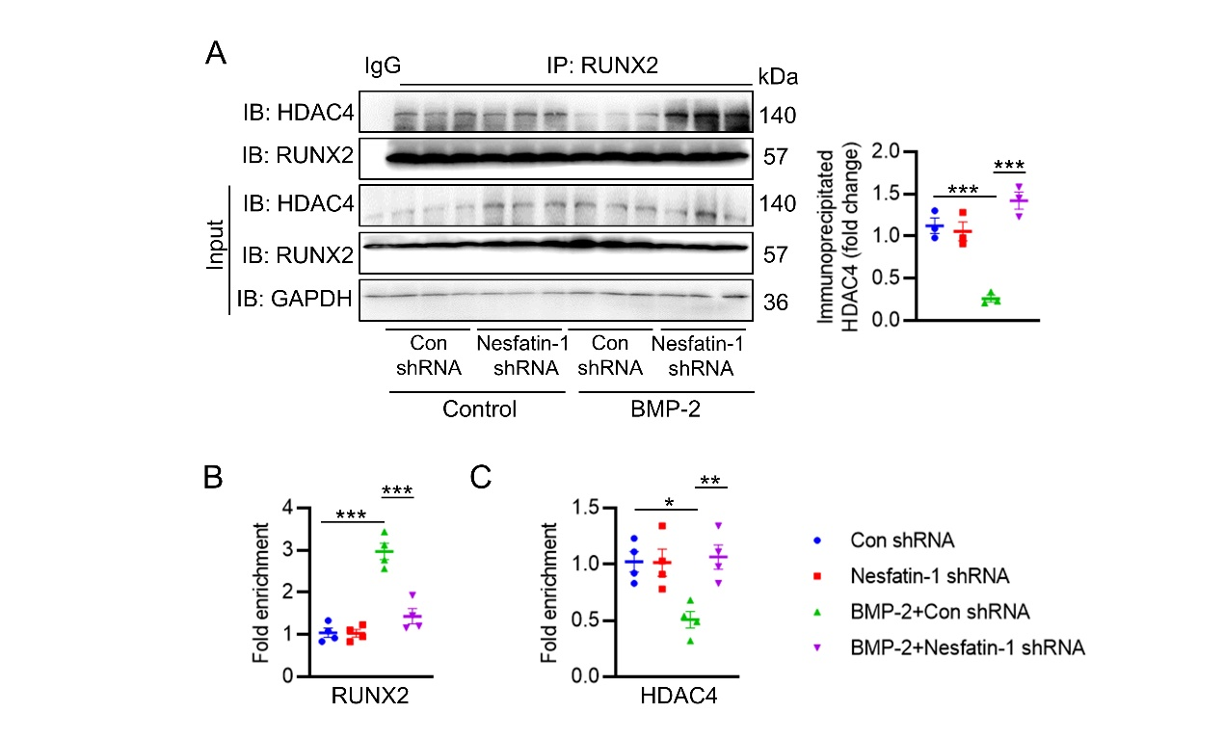
Figure S8. Deficiency of nesfatin-1 restored the binding of HDAC4 to RUNX2 in VSMCs induced by BMP-2. (A) Representative blots showing the interaction of RUNX2 with HDAC4. (B) Fold enrichment of RUNX2 within the promoters of OPN. (C) Fold enrichment of HDAC4 within the promoters of OPN. Differences between groups were assessed with ANOVA followed by Bonferroni post-hoc test. *P<0.05, **P<0.01, ***P<0.001 versus the indicated group. n = 6.

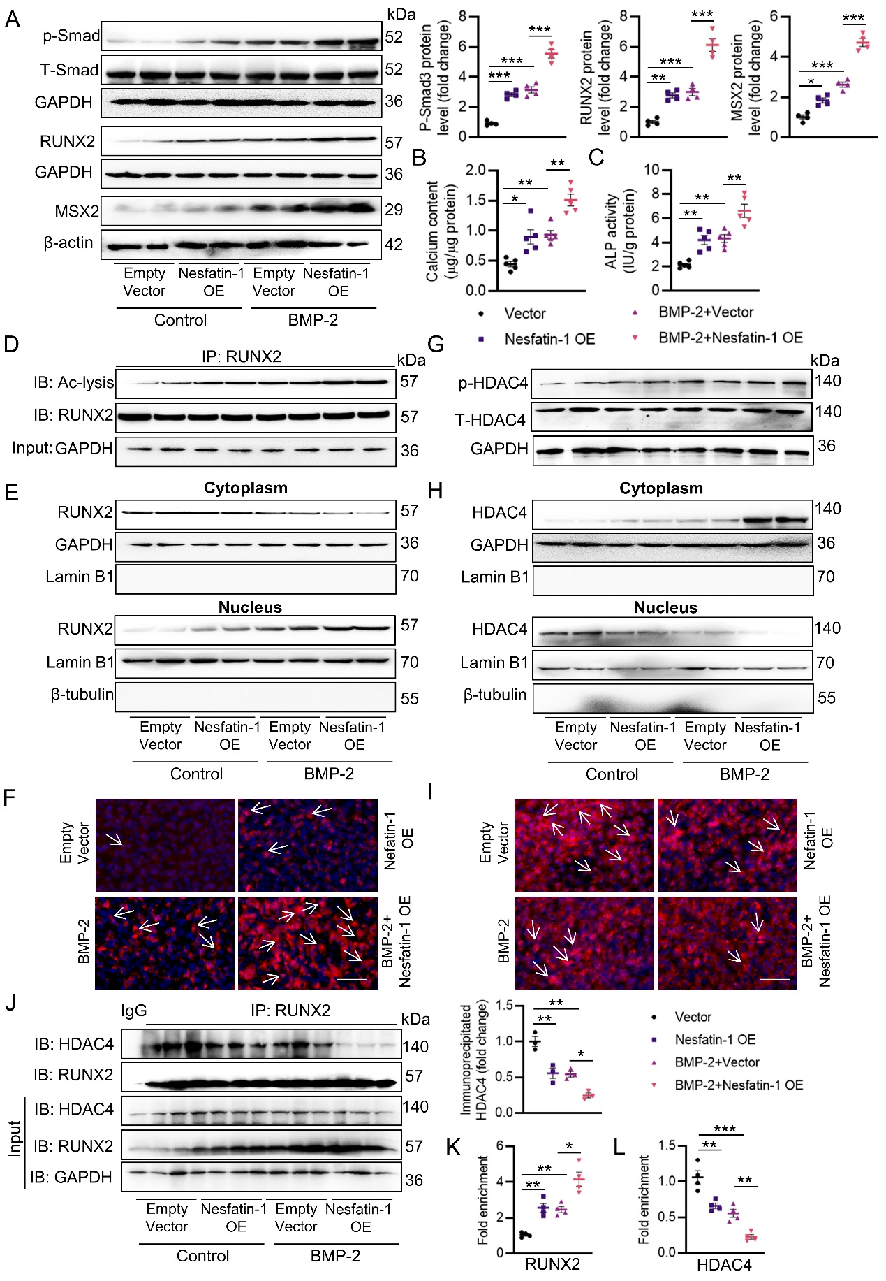
Figure S9. Overexpression of nesfatin-1 potentiates BMP-2 osteogenic signaling. (A) Western blot analysis of Smad, RUNX2 and MSX2. (B) Quantification of calcium deposition. (C) ALP activity. (D) Acetylation level of RUNX2. (E) RUNX2 protein expression in the nucleus and cytoplasm. (F) Immunofluorescence staining of RUNX2. Scale bar, 25 μm. (G) The phosphorylation level of HDAC4. (H) HDAC4 protein expression in the nucleus and cytoplasm. (I) Immunofluorescence staining of HDAC4. Scale bar, 25 μm. (J) Representative blots showing the interaction of RUNX2 with HDAC4. (K) Fold enrichment of RUNX2 within the promoters of OPN promoters. (L) Fold enrichment of HDAC4 within the promoters of OPN promoters. Differences between groups were assessed with ANOVA followed by Bonferroni post-hoc test. *P<0.05, **P<0.01, ***P<0.001 versus the indicated group. n = 6.

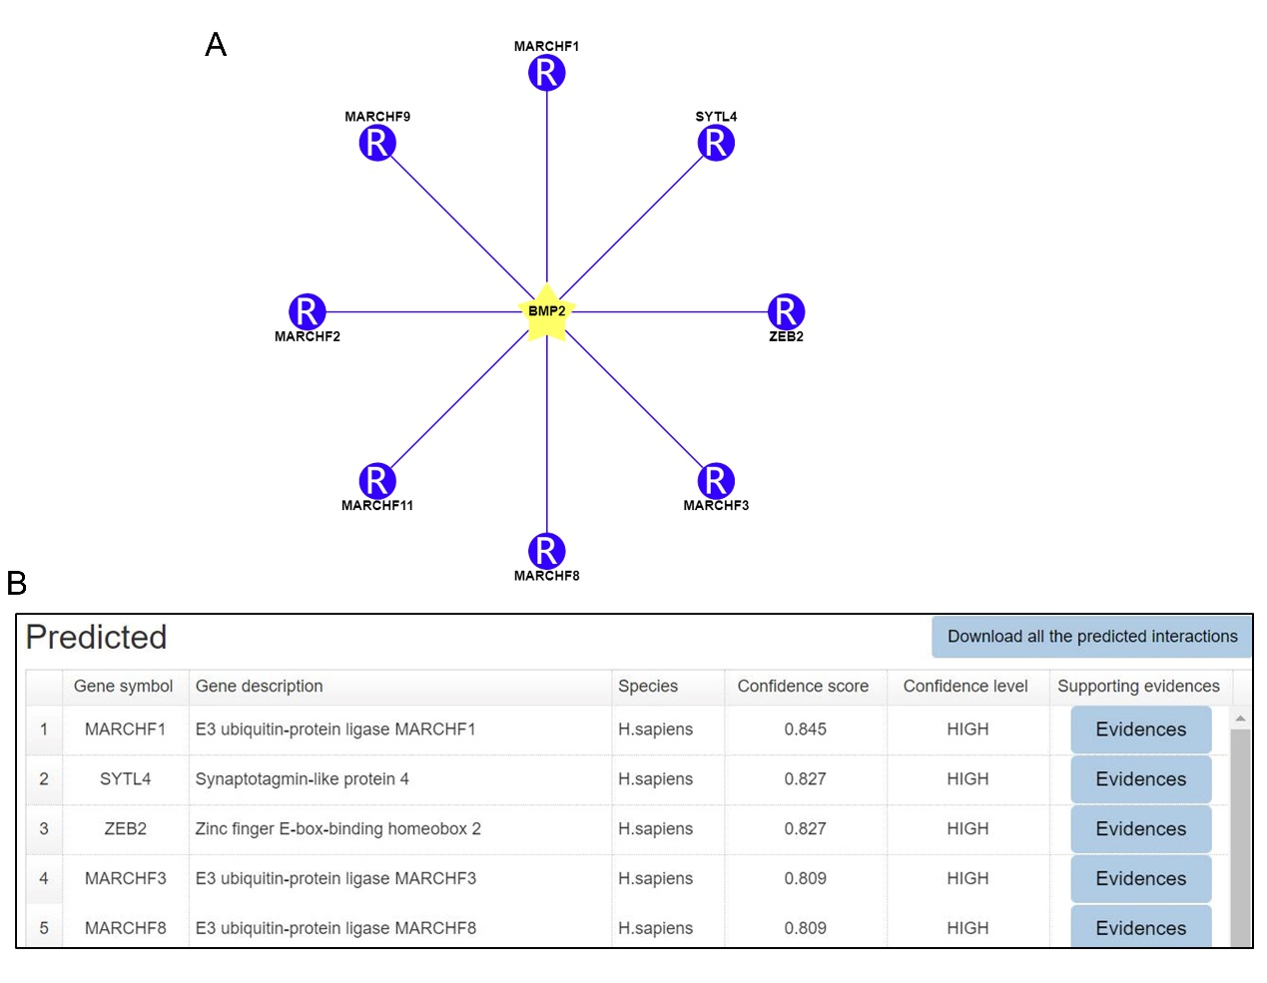
Figure S10. The potential E3 ubiquitin ligases that promote the ubiquitination of BMP-2. (A) The predicted E3 ubiquitin ligases that promote the ubiquitination of BMP-2. (B) The top 5 predicted E3 ubiquitin ligases that promote the ubiquitination of BMP-2.

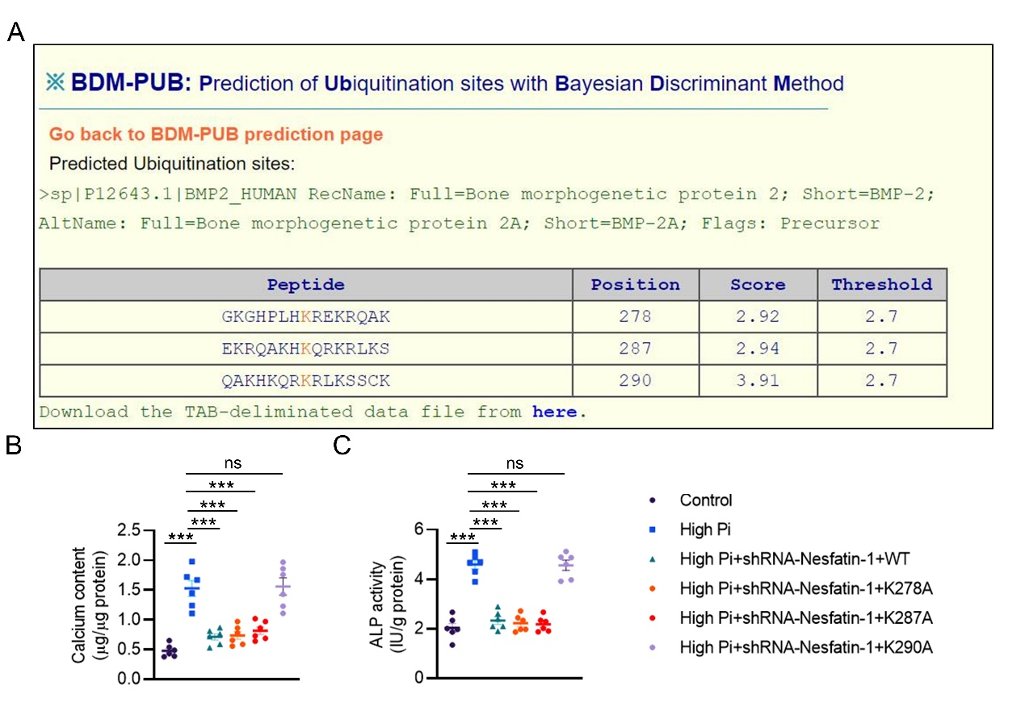
Figure S11. Identification of the ubiquitination sites of BMP-2. (A) Prediction of the ubiquitination sites of BMP-2 using BDM-PUB database. (B) Effects of K278, K287 and K290 mutations on the calcium contents in high Pi-induced VSMCs. (C) Effects of K278, K287 and K290 mutations on ALP activity in high Pi-induced VSMCs. Differences between groups were assessed with ANOVA followed by Bonferroni post-hoc test. *P<0.05, **P<0.01, ***P<0.001 versus the indicated group. n = 6.

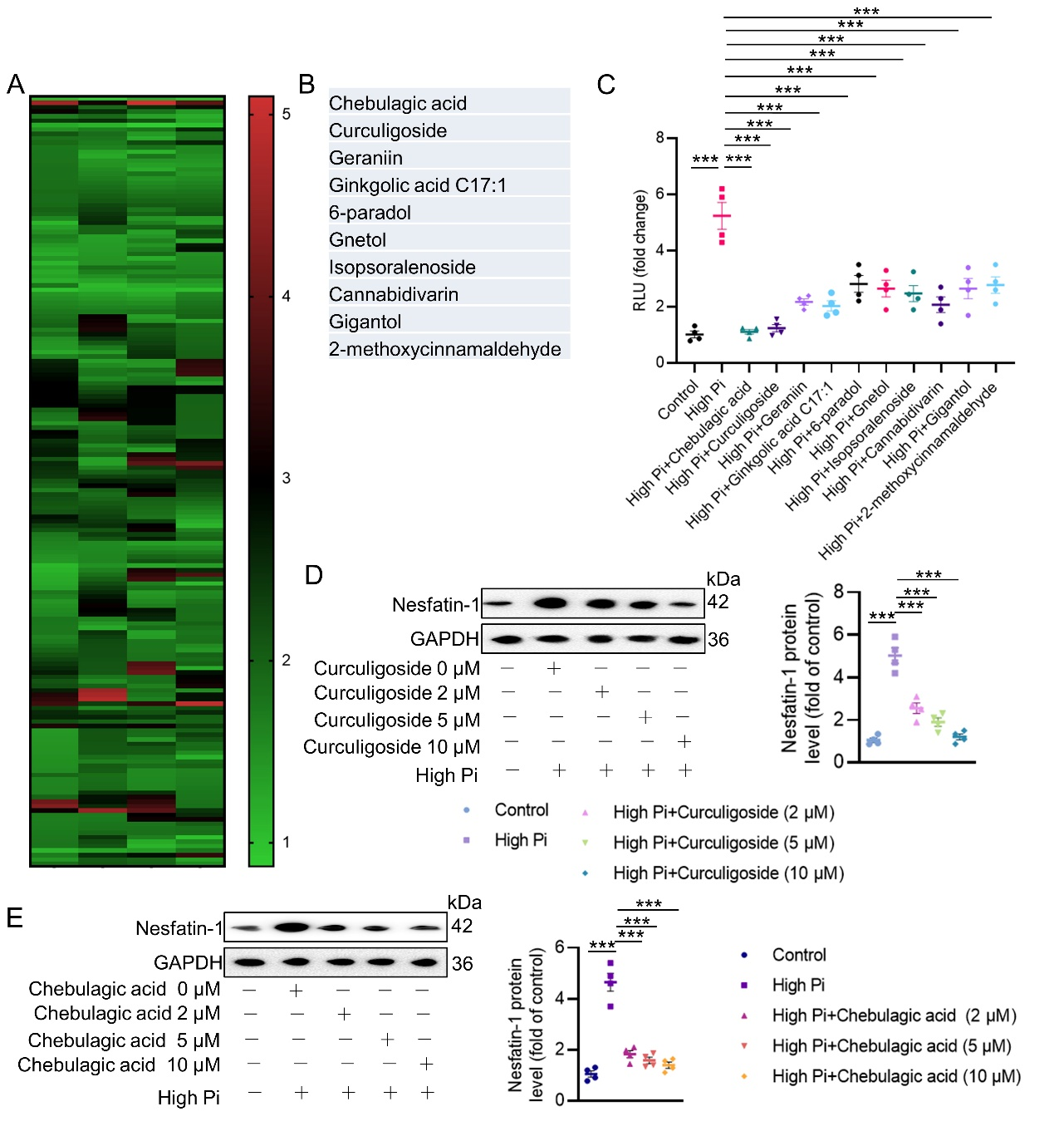
Figure S12. Identification of potential nesfatin-1 inhibitors in VC. (A) Heatmap showing the effects of different compounds on the luciferase reporter gene activity of nesfatin-1 in high Pi-incubated VSMCs. (B,C) Top 10 compounds that inhibited the luciferase reporter gene activity of nesfatin-1. (D) Effects of Curculigoside on the protein expression of nesfatin-1. (E) Effects of Chebulagic acid on the protein expression of nesfatin-1. Differences between groups were assessed with ANOVA followed by Bonferroni post-hoc test. *P<0.05, **P<0.01, ***P<0.001 versus the indicated group. n = 6.

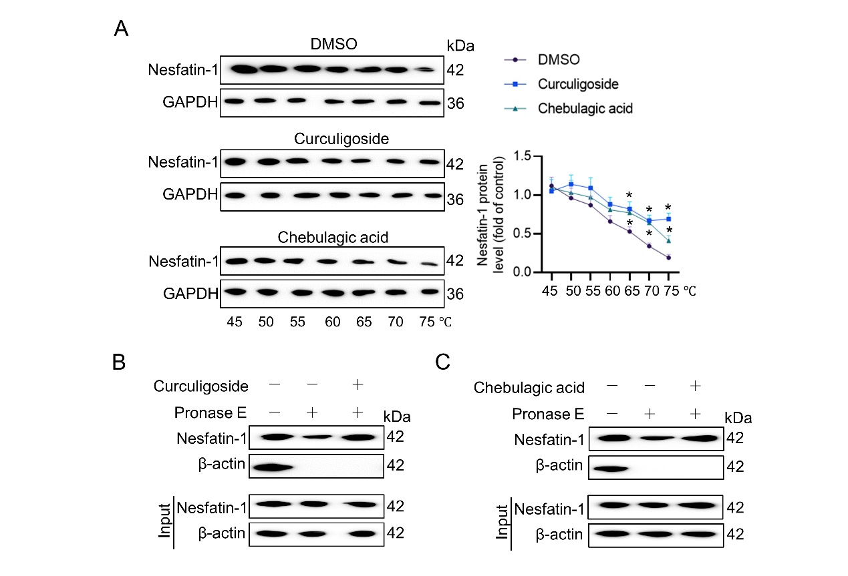
Figure S13. Interaction of nesfatin-1 with Curculigoside or Chebulagic acid. (A) CETSA showing the interaction of nesfatin-1 with Curculigoside or Chebulagic acid. (B) DARTS showing the interaction of nesfatin-1 with Curculigoside. (C) DARTS showing the interaction of nesfatin-1 with Chebulagic acid. The P-value was calculated by unpaired two-tailed Student’s t-test. *P<0.05 versus the indicated group. n = 6.

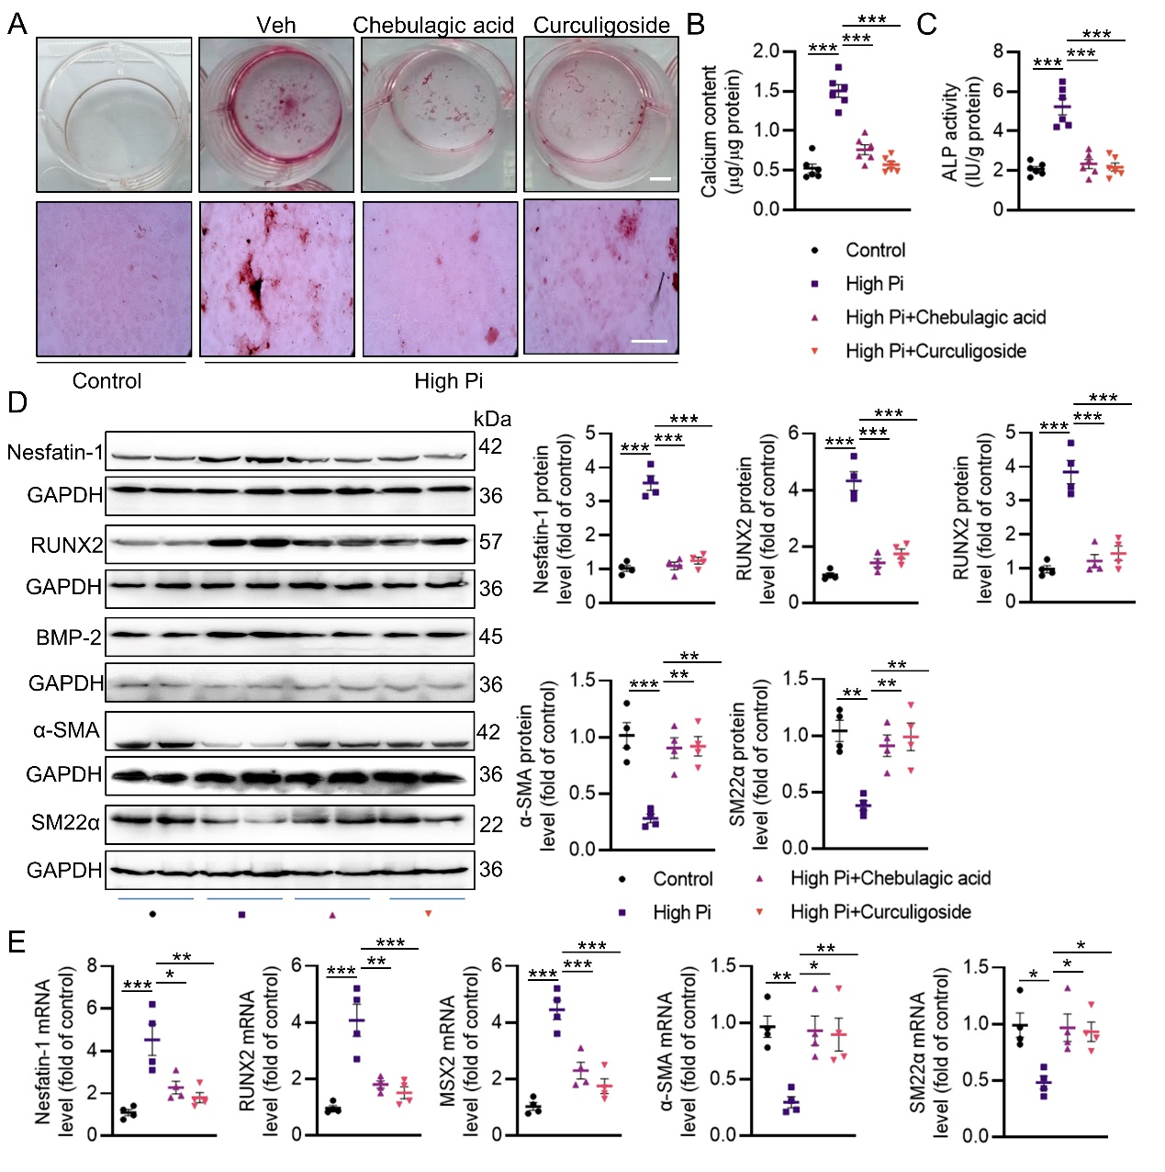
Figure S14. Effects of Curculigoside and Chebulagic acid on the progression of VC in VSMCs. (A) Alizarin red S staining including whole well (Scale bar, 5 mm) and microscopic images (Scale bar, 250 μm) in VSMCs. (B) Quantification of calcium deposition. (C) ALP activity. (D) Western blot analysis of nesfatin-1, RUNX2, BMP-2, α-SMA and SM22α. (E) RT-PCR analysis of nesfatin-1, RUNX2, MSX2, α-SMA and SM22α. Differences between groups were assessed with ANOVA followed by Bonferroni post-hoc test. *P<0.05, **P<0.01, ***P<0.001 versus the indicated group. n = 6.

Table S1. Baseline characteristics of 109 subjects.
Variables | No  calcification | Mild  calcification | Moderate calcification | Severe  calcification | P value
Age (year) | 52.61±7.79 | 60.11±9.61 | 62.41±9.32 | 63.11±10.31 | 0.012*
BMI (kg/m²) | 25.01±3.11 | 26.41±3.27 | 24.73±3.12 | 26.03±3.57 | 0.633
Sex, male (%) | 15 (48.3) | 14 (51.9) | 11 (45.8) | 11(55.0) | 0.932
Smoking | 9 | 7 | 8 | 6 | 0.867
Hypertension | 3 | 10 | 13 | 12 | 0.00093*
Diabetes | 3 | 11 | 12 | 9 | 0.00592*
Hyperlipidaemia | 8 | 9 | 9 | 10 | 0.360
TC (mM) | 4.39±1.02 | 4.44±0.89 | 4.59±1.09 | 4.61±1.04 | 0.612
HDL-C (mM) | 1.11±0.33 | 1.05±0.27 | 1.09±0.32 | 1.02±0.35 | 0.122
TG (mM) | 1.76±1.11 | 1.72±0.98 | 1.81±1.23 | 1.84±1.21 | 0.877
LDL-C (mM) | 2.76±0.91 | 2.89±0.98 | 3.02±1.34 | 3.08±1.22 | 0.134
Creatinine (mM) | 68.11±13.2 | 70.6±12.7 | 72.6±13.6 | 72.8±14.1 | 0.755
Notes: Values are mean±SD or %; * p values were calculated by Kruskal-Wallis test for continuous characteristics; † p values were calculated by Chi-square test for binary characteristics. TG = triglyceride; TC = total cholesterol; HDL-C = high-density lipoprotein cholesterol; LDL-C = low-density lipoprotein cholesterol; BUN = blood urea nitrogen.
Table S2. Primers for Real-time quantitative PCR analysis in mice.
Gene name | Sequences
Mouse Nesfatin-1 | 5′-TGGCATGAATCACCACCTTCT-3′  5′-CCGAGTCCGGTCATATTGCT-3′
Mouse Osterix | 5′-ACCCCAAGATGTCTATAAGCCC-3′  5′-CGCTCTAGCTCCTGACAGTTG-3′
Mouse OPN | 5'-AGAGCGGTGAGTCTAAGGAGT-3'  5'-TGCCCTTTCCGTTGTTGTCC-3'
Mouse OCN | 5′-CTCTGGCCACTTACCCAAGG-3′  5′- GACTGGGTGTCCCCACTTTT-3′
Mouse BMP-2 | 5′-GGGACCCGCTGTCTTCTAGT-3′  5′-TCAACTCAAATTCGCTGAGGAC-3′
Mouse RUNX2 | 5′-GACTGTGGTTACCGTCATGGC-3′  5′-ACTTGGTTTTTCATAACAGCGGA-3′
Mouse α-SMA | 5′-CCCAGACATCAGGGAGTAATGG-3′  5′-TCTATCGGATACTTCAGCGTCA-3′
Mouse SM22α | 5′-AACAGGGGTCCGAGCTATG-3′  5′-GCGGGTGCTCTATATCCTCAG-3′
Mouse β-actin | 5′-CCGTGAAAAGATGACCCAGA-3′  5′-TACGACCAGAGGCATACAG-3′

Table S3. Primers for Real-time quantitative PCR analysis in cells.
Gene name | Sequences
Rat Nesfatin-1 | 5′-CTTCTCTCTGACCAGCA-3′  5′-ACATGGGTTCCTGAGTC-3′
Rat cbfa-1 | 5′-AGTGATTTAGGGCGCATTCC-3′  5′-GGTGGGGAGGATTGTGTCTG-3′
Rat Osterix | 5′-TTGGTTAGGTGGTGGGCAGG-3′  5′-GAGGTGGGGTGCTGGATAGG-3′
Rat OPN | 5'-AGACTGGCAGTGGTTTGCTT-3'  5'-ATGGCTTTCATTGGAGTTGC-3'
Rat OCN | 5′-GGTGCAAAGCCCAGCGACTCT-3′  5′-GGAAGCCAATGTGGTCCGCTA-3′
Rat BMP-2 | 5′-TCAAGCCAAACACAAACAGC-3′  5′-GGTTTCCAGGTCATCCATTC-3′
Rat α-SMA | 5′-CCACGAAACCACCTATAACAGC-3′  5′-GGAAGGTAGACAGCGAAGCC-3′
Rat SM22α | 5′-AGGTGTGGCTGAAGAATG-3′  5′-CCTGTTCCATCTGCTTGA-3′
Rat β-actin | 5′-CACCCGCGAGTACAACCTTC-3′  5′-CCCATACCCACCATCACACC-3′

Table S4. Compound information used for screening experiments.
No. | Compounds | Inhibition rate (%)
1 | Cannabidiol | 0.5463
2 | Hexahydrocurcumin | 0.6334
3 | Dimethylcurcumin | 0.8472
4 | Chebulinic acid | 0.6730
5 | Chebulagic acid | 0.9921
6 | 2',3'-Dihydroxy-4'-methoxyacetophenone | 0.7332
7 | Homovanillyl alcohol | 0.7641
8 | Homogentisic acid | 0.8084
9 | Eugenin | 0.6635
10 | Atranorin | 0.7910
11 | Isopsoralenoside | 0.8726
12 | Psoralenoside | 0.8322
13 | Pyromeconic acid | 0.8449
14 | Gigantol | 0.8562
15 | Chicoric Acid | 0.8452
16 | Nordihydroguaiaretic acid | 0.8027
17 | Deoxyrhapontin | 0.8143
18 | 2-5-dihydroxyacetophenone | 0.7934
19 | Glucosyringic acid | 0.7725
20 | Phenylacetaldehyde | 0.7484
21 | 2'-Hydroxyacetophenone | 0.7307
22 | BENZYLACETONE | 0.7098
23 | trans-Benzylideneacetone | 0.6815
24 | Atraric acid | 0.6864
25 | 4-Methoxybenzoic acid | 0.6612
26 | Forsythoside I | 0.7857
27 | Raspberry ketone glucoside | 0.8017
28 | 2-HYDROXY-3,4-DIMETHOXYBENZOIC ACID | 0.7553
29 | androsin | 0.7688
30 | Hydroxytyrosol Acetate | 0.8005
31 | Cannabidivarin | 0.8659
32 | Gallic aldehyde | 0.7793
33 | Anisic aldehyde | 0.7633
34 | 2-methoxycinnamaldehyde | 0.8508
35 | 3,5-Dimethoxyphenol | 0.8835
36 | 6-paradol | 0.8765
37 | Gnetol | 0.8019
38 | Ginkgolic acid C15:1 | 0.8498
39 | Ginkgolic acid C13:0 | 0.8303
40 | Ginkgolic acid C17:1 | 0.8960
41 | Geraniin | 0.9010
42 | Curculigoside | 0.9935
43 | 6-Shogaol | 0.8822
44 | 8-Gingerol | 0.8521
45 | Paeonolide | 0.8220
46 | Mulberroside A | 0.7919
47 | Vanillin | 0.7618
48 | Gossypol | 0.6811
49 | Acetovanillone | 0.7176
50 | D-DELTA-TOCOPHEROL | 0.5933
51 | Orcinol gentiobioside | 0.6247
52 | Apiopaeonoside | 0.6412
53 | Desmethoxy yangonin | 0.6878
54 | Rhaponiticin | 0.7154
55 | 4-Ethylphenol | 0.7367
56 | Isovanillic acid | 0.7731
57 | 4'-Methoxyresveratrol | 0.6935
58 | Methylnissolin-3-O-glucoside | 0.6365
59 | Acetyl-trans-resveratrol | 0.6073
60 | 3,4-Dimethoxybenzaldehyde | 0.5447
61 | Zearalenone | 0.5500
62 | 4-Hydroxymandelic acid | 0.7135
63 | DL -3,4-Dihydroxymandelic acid | 0.6894
64 | Agrimol B | 0.4672
65 | Dryocrassin ABBA | 0.4537
66 | Alnustone | 0.5110
67 | DL-Normetanephrine hydrochloride | 0.4972
68 | alpha-Arbutin | 0.4835
69 | 3,4-Dihydroxyphenylacetic acid | 0.5461
70 | 3-Hydroxyphenylacetic acid | 0.5487
71 | 4-Methylcatechol | 0.5359
72 | 3-Methoxytyramine hydrochloride | 0.6987
73 | L-KAWAIN | 0.7138
74 | Kakuol | 0.6244
75 | Dendrophenol | 0.6177
76 | Oxyresveratrol | 0.5670
77 | yangonin | 0.6434
78 | Thymol | 0.6542
79 | Homovanillic acid | 0.4939
80 | Punicalagin | 0.5668
81 | 10-Gingerol | 0.3785
82 | Erianin | 0.5203
83 | 7,2'-Dihydroxy-3',4'-dimethoxyisoflavan | 0.6090
84 | Pinosylvin | 0.5695
85 | Dihydroresveratrol | 0.5663
86 | Isorhapontigenin | 0.5374
87 | Corilagin | 0.6245
88 | 1,2,3,4,6-O-Pentagalloylglucose | 0.5856
89 | Rhapontigenin | 0.6905
90 | 2'-Hydroxy-5'-methoxyacetophenone | 0.7027
91 | 2,6-Dimethoxybenzoic acid | 0.7150
92 | Pinostilbene | 0.7177
93 | 4-Hydroxybenzyl alcohol | 0.6740
94 | Veratric acid | 0.6450
95 | Olivetol | 0.6238
96 | Tetrahydro Curcumin | 0.6149
97 | Methyl gallate | 0.6735
98 | Ethyl gallate | 0.6617
99 | Methylparaben | 0.8660
100 | Methyl syringate | 0.8377
101 | β-thujaplicin | 0.8093
102 | Sesamol | 0.7810
103 | Helicid | 0.7527
104 | 3,4-Dihydroxyphenylethanol | 0.9196
105 | 6-Gingerol | 0.6496
106 | Bakuchiol | 0.5223
107 | Protocatechualdehyde | 0.6200
108 | Honokiol | 0.8386
109 | p-Hydroxybenzaldehyde | 0.7401
110 | 5-Hydroxy-1,7-diphenyl-6-hepten-3-one | 0.7540
111 | Isoeugenol | 0.7398
112 | Chrysophanic Acid | 0.7206
113 | Cardamonin | 0.6869
114 | 4-Hydroxybenzoic acid | 0.6073
115 | (-)-Epigallocatechin Gallate | 0.6214
116 | Epigallocatechin | 0.7108
117 | Xanthoxyline | 0.7878
118 | Sodium Danshensu | 0.8013
119 | 3,4,5-Trimethoxyphenol | 0.7542
120 | Ethyl Vanillate | 0.7652
121 | Paeonol | 0.7333
122 | Pterostilbene | 0.7454
123 | Phloretic acid | 0.7448
124 | Tyrosol | 0.6919
125 | Gentisic acid | 0.6889
126 | Phloracetophenone | 0.5192
127 | Orsellinic acid | 0.5586
128 | Morin | 0.4143
129 | Ethyl ferulate | 0.6251
130 | Caffeic Acid | 0.6477
131 | 7-Methoxy-4-methylcoumarin | 0.6140
132 | Orsellinic acid ethyl ester | 0.4873
133 | (+)-Catechin Hydrate | 0.3349
134 | Orcinol glucoside | 0.3222
135 | Rosmarinic acid | 0.1940
136 | Gossypol acetic acid | 0.6886
137 | Salvianolic acid B | 0.5748
138 | Methylarbutin | 0.5702
139 | Hematoxylin | 0.6983
140 | Vitamin E | 0.4192
141 | Resveratrol | 0.7435
142 | Methyl protocatechuate | 0.7170
143 | Terphenyllin | 0.7673
144 | Guaiacol | 0.7155
145 | Eugenol | 0.7352
146 | Vitamin E Acetate | 0.7617
147 | 3-Hydroxy-4-methoxyacetophenone | 0.8316
148 | Gallic acid | 0.7938
149 | Ethylparaben | 0.7422
150 | Benzoic acid | 0.7941
151 | Cianidanol | 0.7756
152 | Tannic acid | 0.7970
153 | 3,4-Dimethoxybenzyl alcohol | 0.7913
154 | Gallic acid trimethyl ether | 0.7855
155 | Methyl EudesMate | 0.6695
156 | Protocatechuic acid | 0.5596
157 | Ellagic acid | 0.3709
158 | Phenylephrine hydrochloride | 0.3528
159 | Methyl salicylate | 0.2251
160 | Salicylamide | 0.6236
161 | Methylsyringol | 0.5643
162 | 4-Hydroxyphenylacetonitrile | 0.7547
163 | 2'-Hydroxy-4'-methylacetophenone | 0.7638
164 | Ethyl 4-hydroxyphenylacetate | 0.7504
165 | 4-(4-Methoxyphenyl)-2-butanone | 0.7891
166 | Methyl 4-hydroxycinnamate | 0.7935
167 | Rubrofusarin-6-O-beta-D-gentiobioside | 0.8289
168 | Ethyl salicylate | 0.8876
169 | kaempferide | 0.4988
170 | Cimifugin beta-D-glucopyranoside | 0.7970
171 | 5-O-Methylvisammioside | 0.7411

