Supplementary Information for
Immunomodulatory effects of trastuzumab deruxtecan through the cGAS-STING pathway in gastric cancer cells
Kyoung-Seok Oh₁, Ah-Rong Nam₁, Ju-Hee Bang₁, Yoojin Jeong₁, Sea Young Choo₁, Hyo Jung Kim₁, Su In Lee₁, Jae-Min Kim₁, ₂, Jeesun Yoon₃, Tae-Yong Kim₁, ₃, and Do-Youn Oh₁, ₂, ₃*
₁Cancer Research Institute, Seoul National University College of Medicine, Seoul 03080, Korea
₂Integrated Major in Innovative Medical Science, Seoul National University Graduate School, Seoul 03080, Korea
₃Department of Internal Medicine, Seoul National University Hospital, Seoul 03080, Korea
Do-Youn Oh, MD, Ph.D.
Professor,
Department of Internal Medicine, Seoul National University Hospital, Seoul, Korea
Cancer Research Institute, Seoul National University College of Medicine, Seoul, Korea
101 Daehak-ro, Jongno-gu, Seoul 03080, Korea;
Tel: +82-2-2072-0701; Fax: +82-2-762-9662;
Email: ohdoyoun@snu.ac.kr

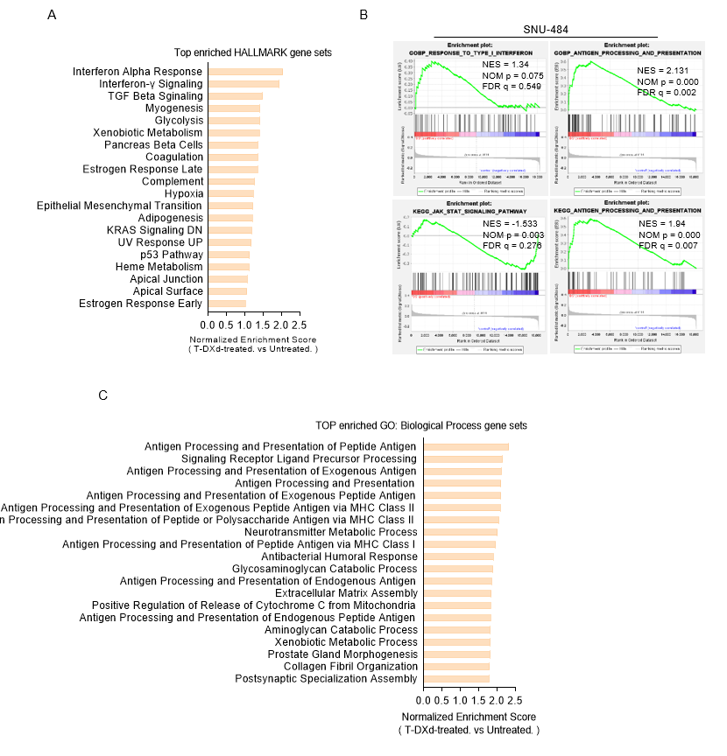Supplementary Figure 1. RNA-Seq identifies T-DXd treatment-induced gene sets associated with antitumor immunity in HER2-moderate expressing GC cell line, SNU-484. RNA-Seq analysis was performed using SNU-484 cells treated with vehicle or T-DXd (1 µg/ml) for 72 h. (A) Top 20 enriched Hallmark gene sets ranked by normalized enrichment score from GSEA in response to T-DXd. (B) Representative images from GSEA showing enrichment of gene signatures associated with antitumor immune response. (C) Top 20 enriched GO: Biological Process gene sets ranked by NES from GSEA in response to T-DXd.
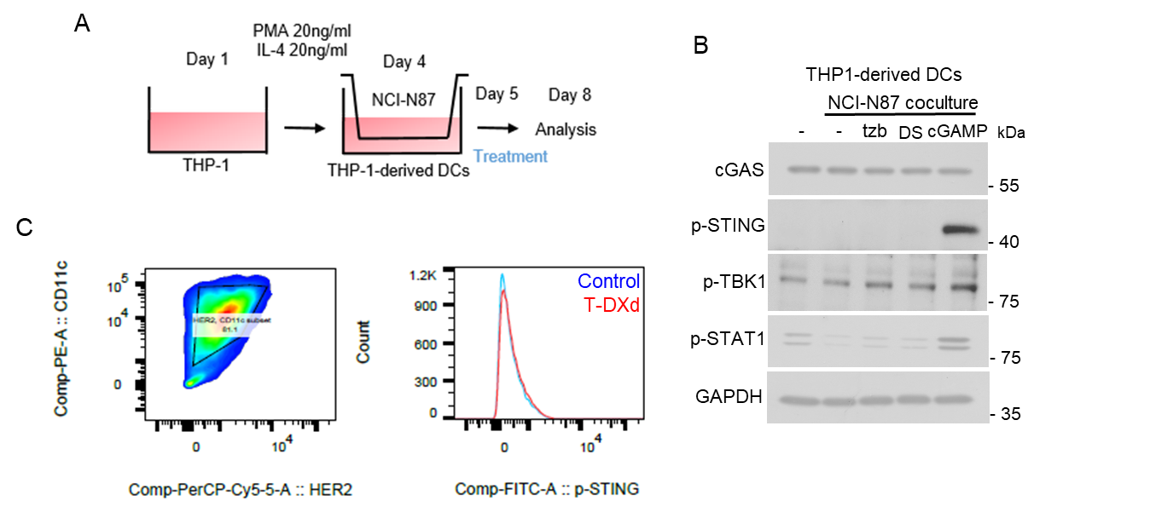
Supplementary Figure 2. T-DXd fails to induce cGAS-STING pathway activation in TDDCs during indirect coculture in a transwell system. (A) Schematic diagram illustrating the experimental setup for the indirect coculture of NCI-N87 cells and TDDCs in a transwell system, where direct contact between cancer cells and DCs is prevented. (B) Immunoblot analysis of key components of the cGAS-STING pathway in TDDCs harvested from the lower chamber after 72 h of indirect coculture. (C) Flow cytometry analysis of phosphorylated STING (Ser366) in TDDCs.
Supplementary Figure 3. T-DXd promotes the release of exosomal dsDNA. Quantification of exosomal dsDNA isolated from the conditioned medium of NCI-N87 cells treated with 1 µg/ml of trastuzumab or T-DXd for 48 h. Exosomal dsDNA levels were measured using the SpectraMax Quant AccuBlue Pico dsDNA Assay Kit. The sum of two technical replicates is shown as mean ± SEM.

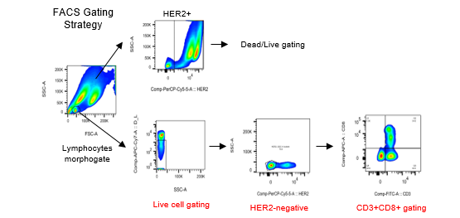
Supplementary Figure 4. Gating strategy for flow cytometry analysis using human PBMCs. Cancer cells were selected based on size and HER2⁺ expression. Live lymphocytes were selected based on size, Zombie NIR™ Fixable Viability Kit⁻, and HER2⁻ expression. Cytotoxic T cells were selected based on CD3⁺ and CD8⁺ expression.
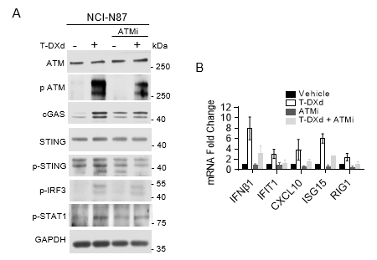
Supplementary Figure 5. ATM inhibition prevents T-DXd-induced cGAS-STING activation in NCI-N87 cells. (A) Immunoblotting of cGAS-STING pathway in NCI-N87 cells treated with T-DXd (1 µg/ml) with or without AZD0156 (ATMi, 0.1 µM) for 72 h. GAPDH was used as a loading control. (B) RT-qPCR analysis of ISGs in RNA isolated from NCI-N87 cells treated with T-DXd (1 µg/ml) with or without AZD0156 (0.1 µM) for 72 h. Data represent the sum of at least three independent experiments.
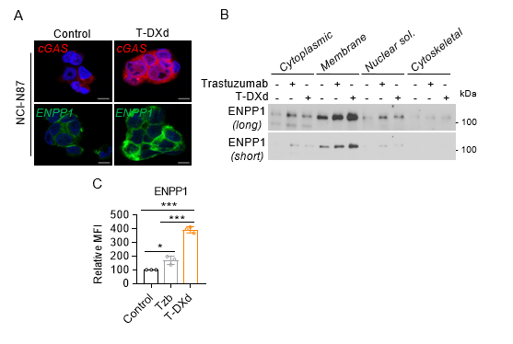
Supplementary Figure 6. T-DXd upregulates ENPP1 expression in HER2-positive GC cells. (A) Immunofluorescence analysis of cGAS (Red) and ENPP1 (Green) levels in SNU-216 cells treated with T-DXd (1 µg/ml) for 72 h. Representative images from biological duplicates are shown. (B) Immunoblotting of ENPP1 expression in specific cell organelles using lysates isolated from NCI-N87 cells treated with trastuzumab or T-DXd (1 µg/ml). GAPDH was used as a loading control. (C) Flow cytometry analysis of surface ENPP1 expression in NCI-N87 cells treated with trastuzumab or T-DXd (1 µg/ml) for 72 h. Data from biological triplicates are presented as mean ± SEM, *, p < 0.05; ***, p < 0.001.

