Supplementary information: Additional File: Supplementary Figure 1. Uncropped blots of Figure 2F (A), 2H (B) and 3C (C). Additional File: Supplementary Figure 2. Uncropped blots of Figure 6B. Additional File: Supplementary Figure 3. Uncropped blots of Figure 7B. Additional File: Supplementary Figure 4. Uncropped blots of Supplementary figure 9. Additional File: Supplementary Figure 5. Proteomic comparison of upregulated and downregulated proteins identified in MCF-7 YS vs P. Additional File: Supplementary Figure 6. Proteomic comparison of deregulated proteins identified in CAFs vs NFs. Additional File: Supplementary Figure 7. Proteomic analysis of NFs, NFs treated with MCF-7 P and YS-CM and CAFs. Additional File: Supplementary Figure 8. Proteomic analysis of downregulated proteins shared between NF treated with YS-CM treated and CAFs. Additional File: Supplementary Figure 9. Effects of IGF-1 in serum-free medium on YAP expression in NFs. Additional File: Supplementary Figure 10. Clinical significance of the co-expression of IGF-1, IGF-1R, and YAP canonical target gene CCN2 in breast cancer patients. Additional File: Supplementary Figure 11. Immunohistochemical analysis of xenograft tumors. Additional File: Supplementary Figure 12. ki-67 immunohistochemical analysis of xenograft tumors. Additional File: Supplementary Table S1. Oligonucleotide primers used in this study. Additional File: Supplementary Table S2. Gene Ontology “Pathways Maps” defined by MCF-7YS Mutant-expressing cells.

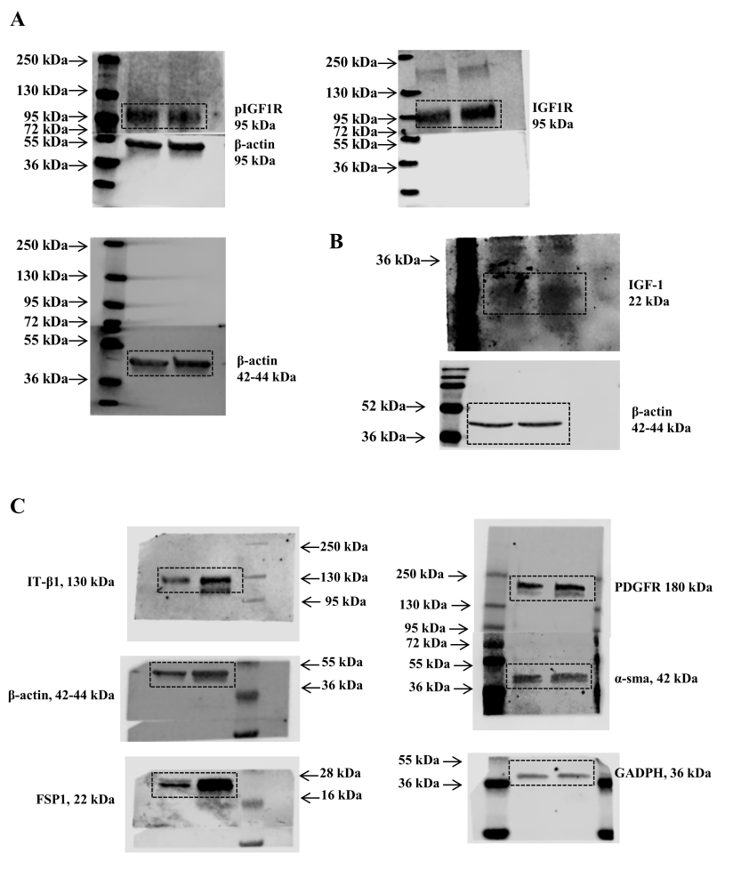
Supplementary Figure 1. Uncropped blots of Figure 2F (A), 2H (B) and 3C (C).
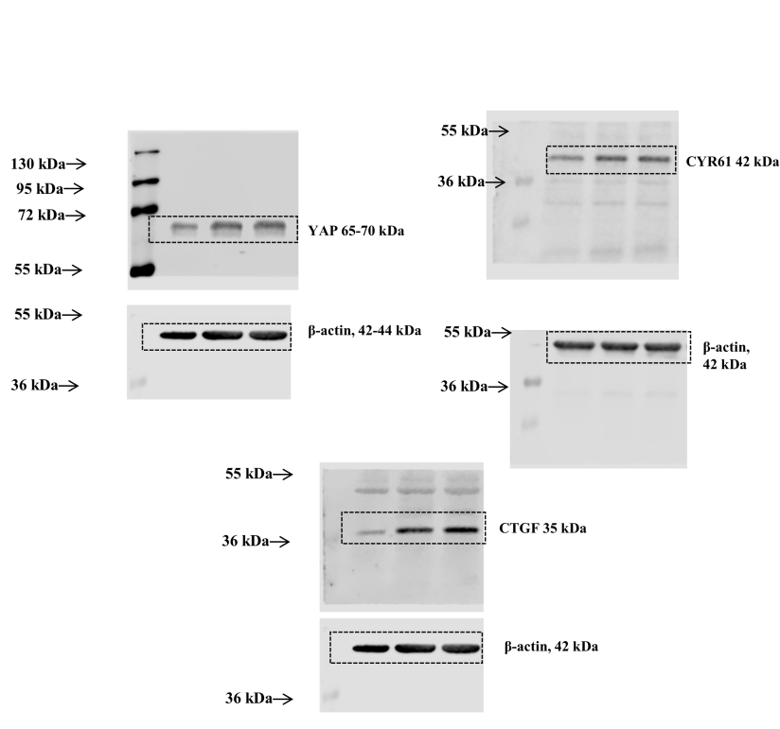
Supplementary Figure 2. Uncropped blots of Figure 6B.
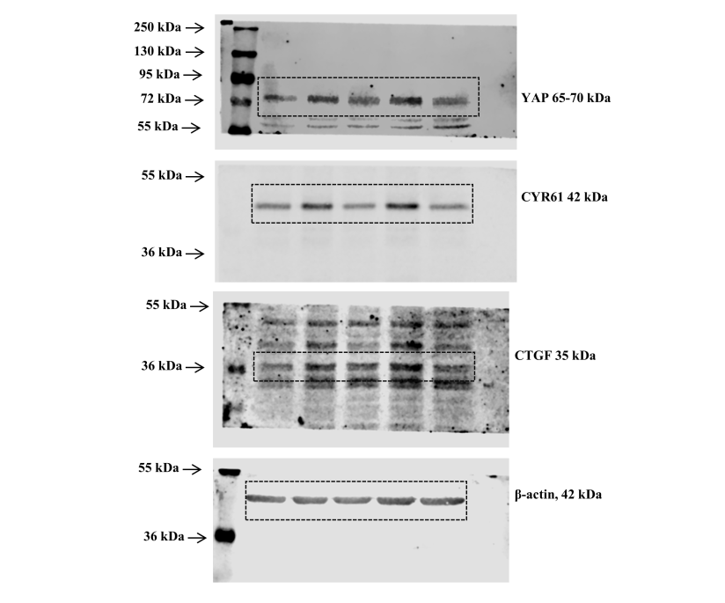
Supplementary Figure 3. Uncropped blots of Figure 7B.
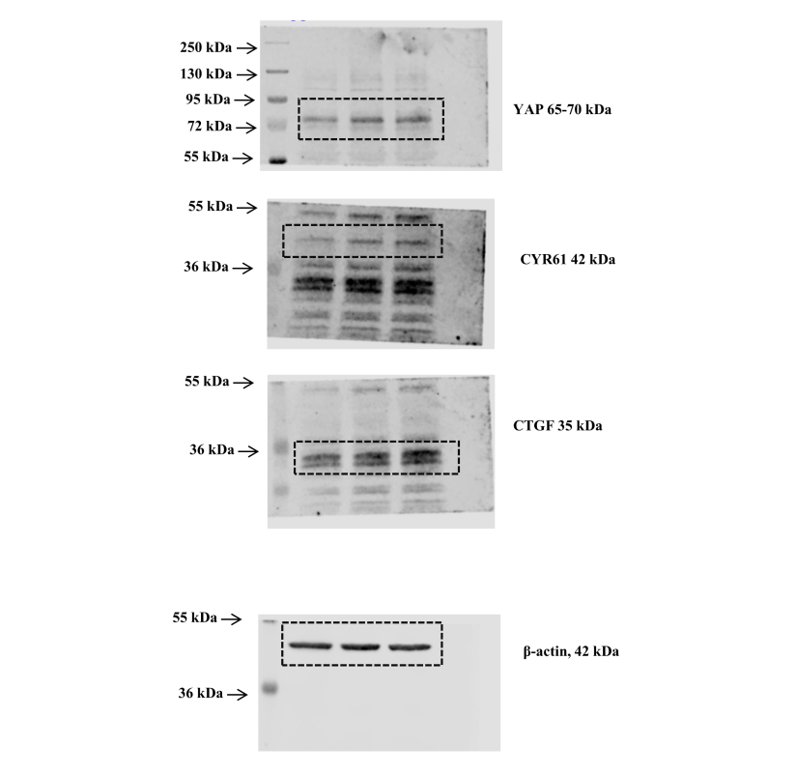
Supplementary Figure 4. Uncropped blots of Supplementary figure 9.

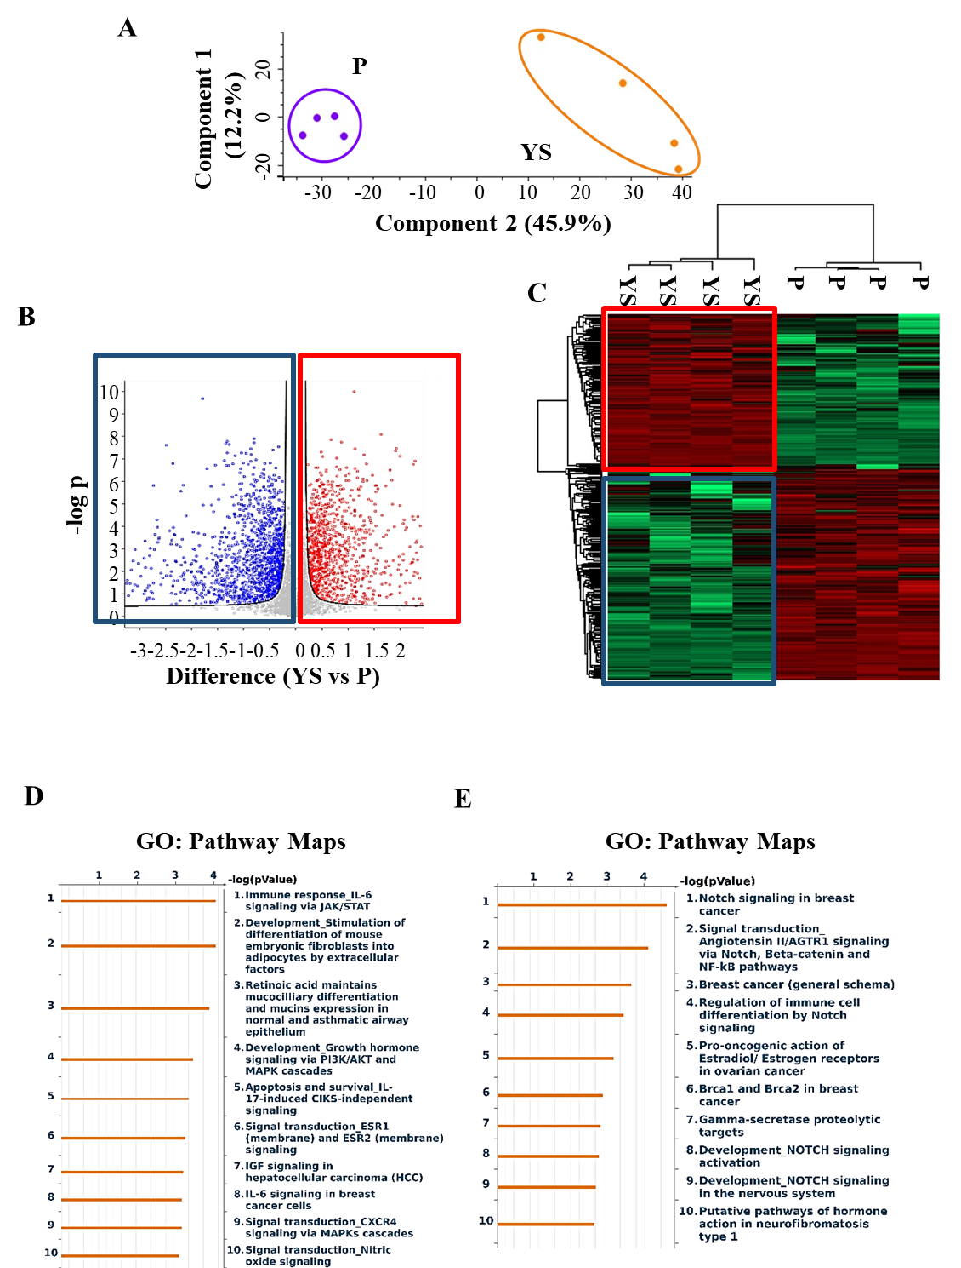
Supplementary Figure 5. Proteomic comparison of upregulated and downregulated proteins identified in MCF-7 YS vs P. (A) Principal Component Analysis (PCA) was applied to the MCF-7 P and YS cells. Principal components 1 and 2 are shown on the X and Y axes, and the percent variation explained by each component is indicated in parentheses. (B) Volcano plot representing all detected proteins in MCF-7 P vs YS cells. The significant proteins are shown on the right (red dots and box, upregulated proteins) and on the left (blue dots and box, downregulated proteins). The gray dots correspond to proteins whose expression did not significantly change according to the selected parameters. (C) Heatmap representing supervised hierarchical clustering of the differentially expressed proteins between MCF-7 P and YS cells identified by LC-MS/MS analysis. The heatmap is shown in red color for the upregulated proteins (red box) and in green for the degree of downregulated proteins (blue box). Gene Ontology (GO) enrichment analysis of upregulated (Fold cut off ≥2.5, D) and downregulated (Fold cut off ≤2.5, E) proteins related to Pathway Maps according to Metacore.
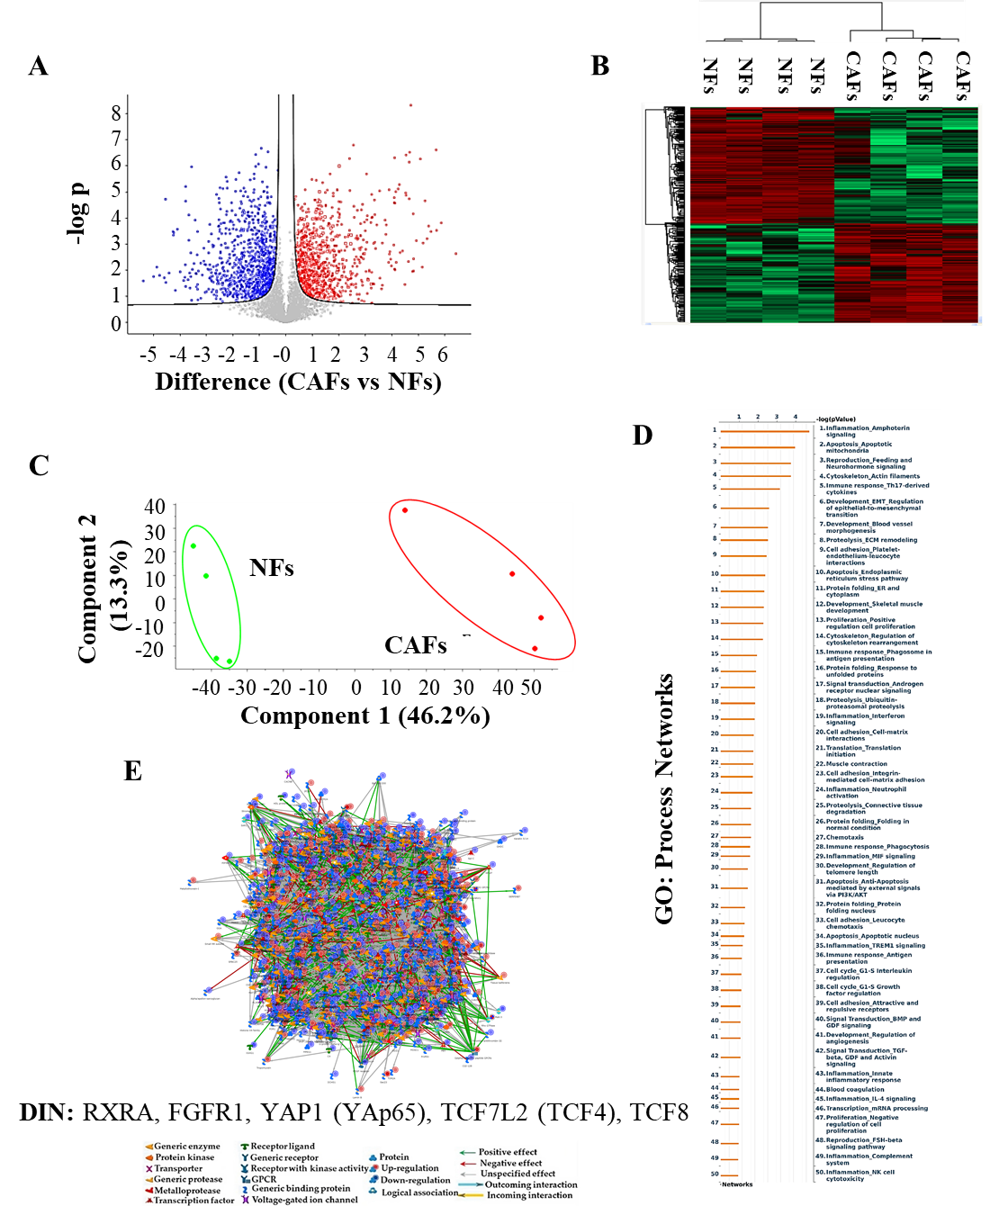
Supplementary Figure 6. Proteomic comparison of deregulated proteins identified in CAFs vs NFs. (A) Volcano plot representing all detected proteins in CAF vs NFs cells. The significant proteins are shown on the right (red dots and box, upregulated proteins) and on the left (blue dots, downregulated proteins). The gray dots correspond to proteins whose expression did not significantly change according to the selected parameters. (B) Heatmap representing supervised hierarchical clustering of the differentially expressed proteins between CAFs and NFs cells identified by LC-MS/MS analysis. The heatmap is shown in red color for the upregulated proteins (red box) and in green for the degree of downregulated proteins. (C) PCA was applied to NFs and CAFs. Principal components 1 and 2 are shown on the X and Y axes, and the percent variation explained by each component is indicated in parentheses. (D) Gene Ontology (GO) enrichment analysis of proteins related to Process Networks according to Metacore. (E) Direct interaction network (DIN) constructed by processing the deregulated proteins identified in the comparison between NFs and CAFs. The colors of the arrows indicate positive (green), negative (red) or unknown (gray) effects of the different network items represented with different symbols (reported in the legend). DIN: RXRA, FGFR1, YAP1 (YAp65), TCF7L2 (TCF4), TCF8.
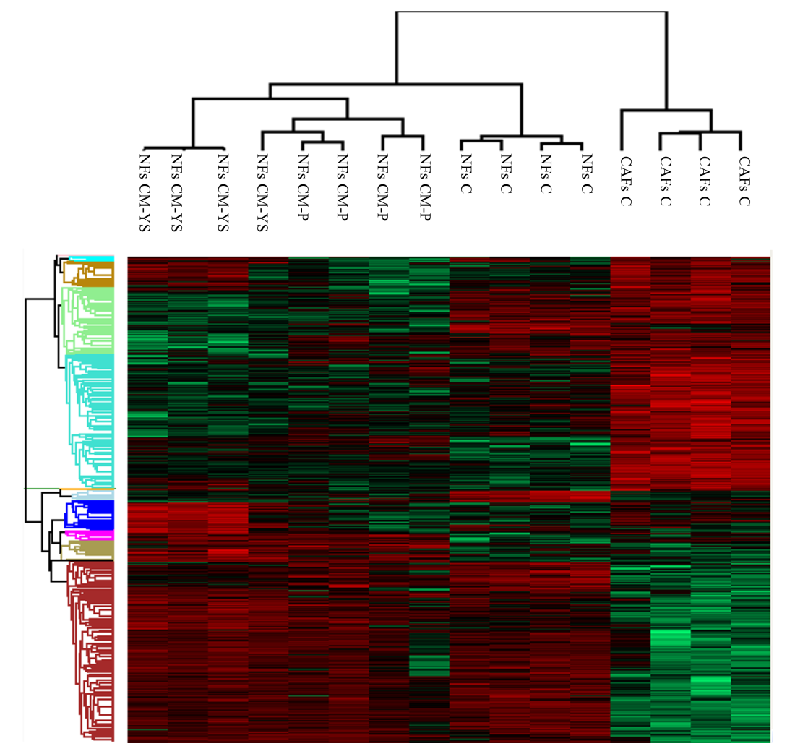
Supplementary Figure 7. Proteomic analysis of NFs, NFs treated with MCF-7 P and YS-CM and CAFs. Heatmap representing supervised hierarchical clustering of the differentially expressed proteins between NFs, NFs treated without (-) or with CM derived from MCF-7 P and YS for 5 days and CAFs identified by LC-MS/MS analysis. The heatmap is shown in red for the degree of upregulated proteins and in green for the degree of downregulated proteins.

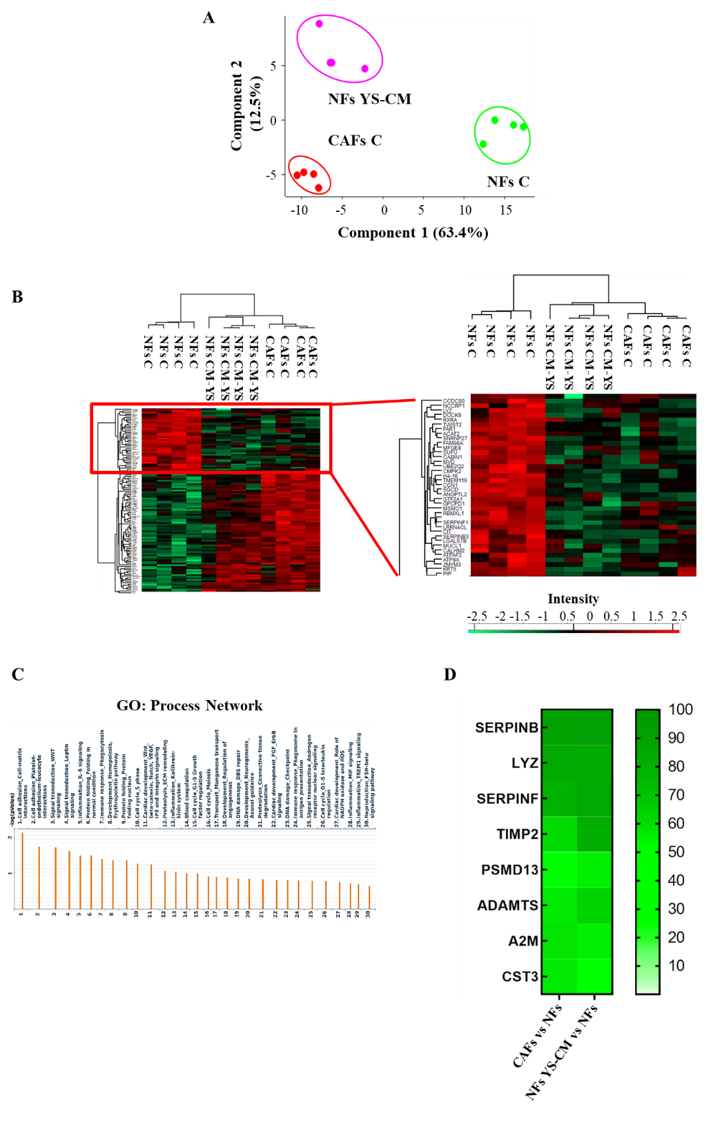
Supplementary Figure 8. Proteomic analysis of downregulated proteins shared between NF treated with YS-CM treated and CAFs. (A) PCA was applied to NFs and CAFs. Principal components 1 and 2 are shown on the X and Y axes, and the percent variation explained by each component is indicated in parentheses. (B) Heatmap representing supervised hierarchical clustering of the differentially expressed proteins (Fold cut off ±2.5) between NFs treated without (-) or with CM derived from P and YS for 5 days and CAFs identified by LC-MS/MS analysis. Heatmap shows red color for degree of upregulated proteins, while green for the degree of downregulated proteins. Metacore functional analysis of the down-regulated proteins (80, Fold cut off ≤2.5) in CAFs vs NFs. (C) Gene ontology (GO) enriched in Process network is shown. (D) Heatmap of the most representative proteins of the different functional categories reported in the GO “process network”.
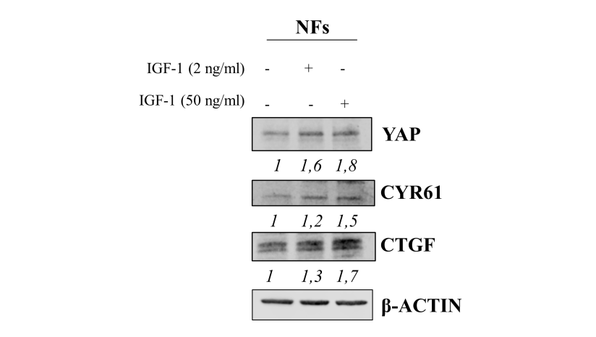
Supplementary Figure 9. Effects of IGF-1 in serum-free medium on YAP expression in NFs. Immunoblotting showing YAP1, CYR61 and CTGF in NFs treated with IGF-1 for 5 days. β-actin was used as a control for equal loading and transfer. Numbers below the blots represent the mean of the band optical density expressed as fold over control, normalized for β-actin.

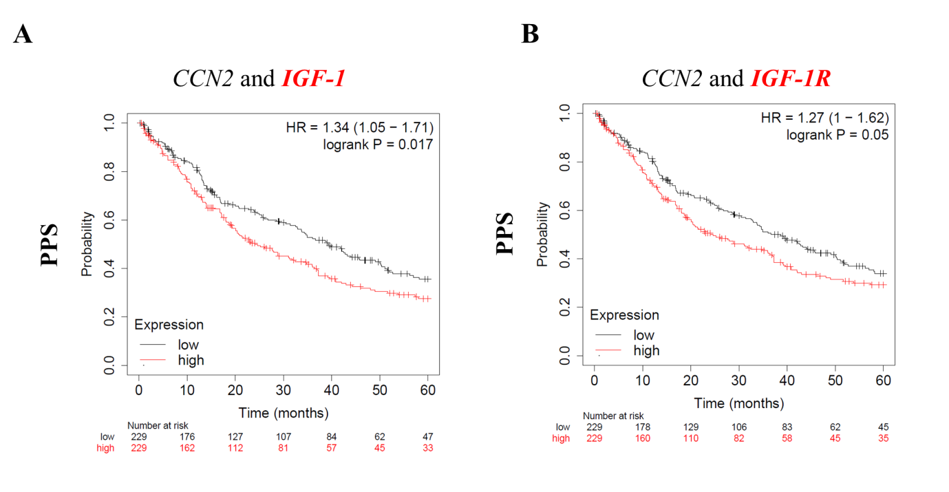
Supplementary Figure 10. Clinical significance of the co-expression of IGF-1, IGF-1R, and YAP canonical target gene CCN2 in breast cancer patients. Kaplan-Meier survival analysis of post-progression survival (PPS) rate of breast cancer patients (n = 229) according to high co-expression levels of IGF-1/CCN2 and IGF-1R/CCN2. HR: hazard ratio.
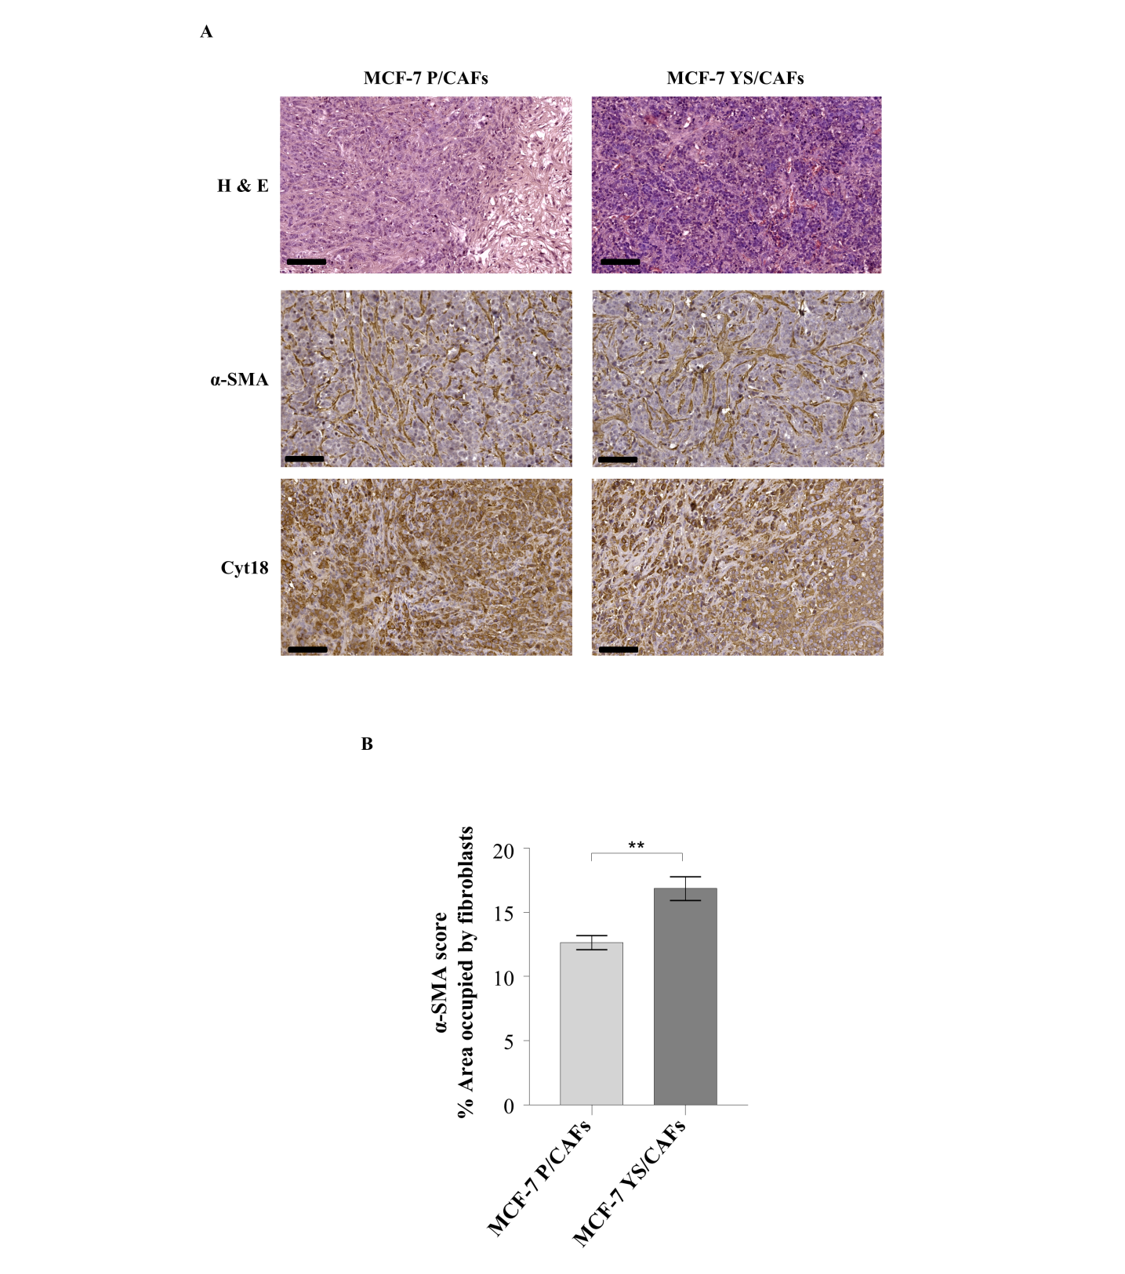
Supplementary Figure 11. Immunohistochemical analysis of xenograft tumors. (A) Representative hematoxylin and eosin (H&E) stained histologic images of MCF-7/CAF xenograft tumors (40X). (B) Immunohistochemical staining for human α-SMA and cytokeratin 18 in MCF-7/CAF xenograft tumor sections. Scale bars = 100 μm. α-SMA score reported as area occupied by fibroblasts, calculated as described in Material and Methods of MCF-7P and MCF-7 YS breast cancer cells c-implanted with CAFs in xenograft models. **p<0.01

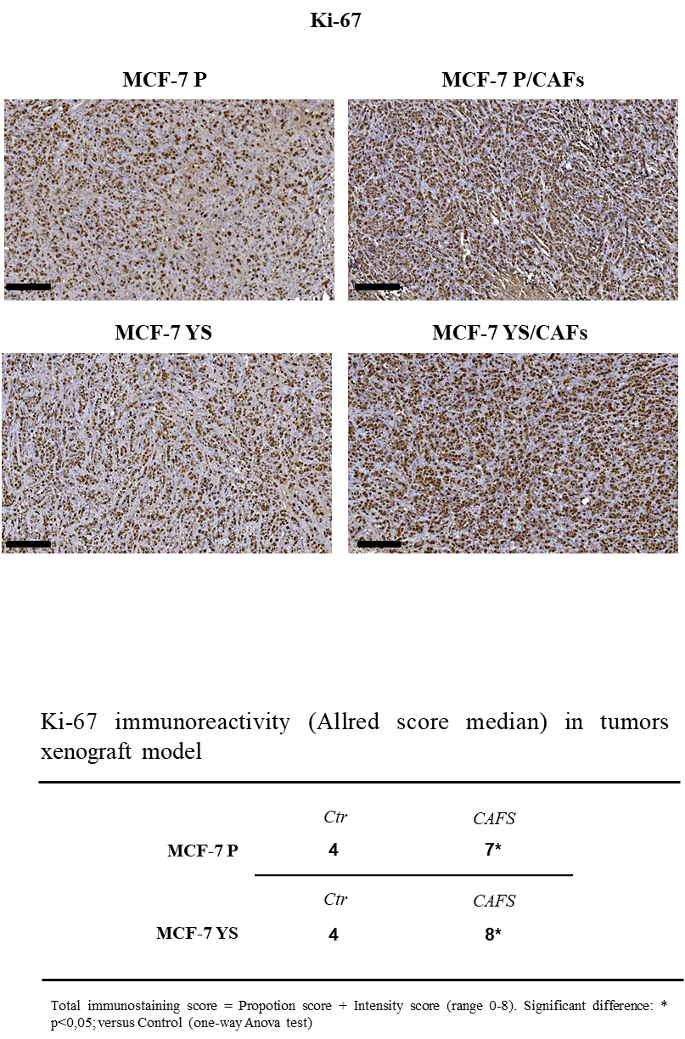

Supplementary Figure 12. Immunohistochemical analysis of xenograft tumors. (A) Immunohistochemical staining for human ki-67 in MCF-7 and MCF-7/CAF xenograft tumor sections. Scale bars = 100 μm. Allred score was calculated as described in Material and Methods. *p<0.05.

Supplementary Table S1. Oligonucleotide primers used in this study
Gene symbol | Gene name | Primer Sequences
IGF-1 | Insulin Like Growth Factor 1 | For 5’-GGCCCCCATGACTCCTTACCT-3’  Rev 5’ -CCCATCAGCACACGCATCTC-3’
IGF-1R | Insulin Like Growth Factor 1 Receptor | For 5’-TGTCCAGGCCAAAACAGGAT-3’ Rev 5’-CATTCCCCAGCCTGCTGTTA-3’
18S | 18s rRNA | For 5’-CCCACTCCTCCACCTTTGAC-3’  Rev 5’-TGTTGCTGTAGCCAAATTCGTT-3’

Supplementary Table S2. Gene Ontology “Pathways Maps” Defined by MCF-7YS mutant-expressing cells.
# | Maps | Total | p-value | In Data
1 | Chemotaxis_Lysophosphatidic acid signaling via GPCRs | 129 | 3,767E-13 | 42
2 | Signal transduction_IGF-1 receptor signaling | 106 | 2,206E-11 | 35
3 | Signal transduction_AKT signaling | 43 | 4,628E-11 | 21
4 | IGF signaling in lung cancer | 44 | 8,059E-11 | 21
5 | IL-6 signaling in breast cancer cells | 53 | 1,140E-10 | 23
6 | Oxidative stress_ROS signaling | 108 | 1,849E-10 | 34
7 | Signal transduction_mTORC2 downstream signaling | 68 | 2,126E-10 | 26
8 | Apoptosis and survival_BAD phosphorylation | 42 | 2,403E-10 | 20
9 | Immune response_IFN-alpha/beta signaling via PI3K and NF-kB pathways | 94 | 3,176E-10 | 31
10 | Role of Tissue factor-induced Thrombin signaling in cancer | 65 | 4,082E-10 | 25
11 | Development_Estrogen-independent activation of ESR1 and ESR2 | 44 | 6,826E-10 | 20
12 | Translation_Regulation of EIF4F activity | 53 | 8,199E-10 | 22
13 | Signal transduction_FGFR4 signaling | 82 | 9,240E-10 | 28
14 | Immune response_TNF-R2 signaling | 45 | 1,119E-09 | 20
15 | Immune response_IL-4 signaling | 94 | 1,498E-09 | 30
16 | HBV-dependent NF-kB and PI3K/AKT pathways leading to hepatocellular carcinoma (HCC) | 50 | 1,534E-09 | 21
17 | Apoptosis and survival_Regulation of apoptosis by mitochondrial proteins | 106 | 2,063E-09 | 32
18 | Immune response_IL-22 signaling | 51 | 2,374E-09 | 21
19 | Development_PIP3 signaling in cardiac myocytes | 47 | 2,856E-09 | 20
20 | Development_The role of GDNF ligand family/ RET receptor in cell survival, growth and proliferation | 92 | 3,871E-09 | 29
21 | Cytoskeleton remodeling_FAK signaling | 57 | 4,246E-09 | 22

