Supplementary materials

Supplementary Table 1. Antibodies and inhibitions information in this study.
Antibodies | Isotype | Use | Product no. | Source
Anti-β-tubulin monoclonal antibody | Mouse | WB:(1:5000) | M20005S | Abmart
Anti-FLAG antibody | Rabbit | WB:(1:5000) | M20008 | Abmart
Anti-LC3 antibody | Rabbit | WB:(1:2000)  IF:(1:1000) | EPR18709 | Abcam
Anti-AKT antibody | Rabbit | WB:(1:1000) | IPB0950 | Baijia
AKT-phospho-S473 Monoclonal antibody | Mouse | WB:(1:1000) | 66444-1-Ig | Proteintech
JNK monoclonal antibody | Rabbit | WB:(1:1000) | 66,210-1-Ig | Proteintech
Phospho-JNK (Tyr183/Tyr185) antibody | Rabbit | WB:(1:500) | AF5860 | Beyotime
Anti-p62 antibody | Rabbit | WB:(1:1000) | P113161 | KleanAB
Anti-Histone H3 antibody | Rabbit | WB:(1:5000) | 17168-1-ap | Proteintech
Phospho-MAPKβ (S181) antibody | Rabbit | WB:(1:1000) | APG01841G | Leading Biology
ERK1/2 rabbit monoclonal antibody | Rabbit | WB:(1:3000) | AF1051 | Beyotime
Phospho-ERK1(Thr202/Tyr204/185/Tyr187) monoclonal antibody | Rabbit | WB:(1:3000) | AF1891 | Beyotime
Phospho-p38 (Thr180/Tyr182) polyclonal antibody | Rabbit | WB:(1:1000) | 28796-1 | Proteintech
Anti-AjFoxO antibody | Rabbit | WB:(1:1000)  IF:(1:500) |  | Genscript
Anti-AjFoxO antibody | Mouse | WB:(1:1000)  IF:(1:500) |  | Genscript
p38 polyclonal antibody | Mouse | WB:(1:200) |  | Antiserum
Anti-MAPKβ antibody | Mouse | WB:(1:500) |  | Antiserum
HRP-conjugated goat anti-rabbit IgG | Rabbit | WB:(1:5000) | D110058 | BBI
HRP-conjugated goat anti-mouse IgG | Mouse | WB:(1:5000) | D110087 | BBI
AP-conjugated goat anti-mouse IgG | Mouse | ELISA(1:1000) | ZY2044 | Ziyunbao
Cy3-Goat anti-Rabbit IgG | Rabbit | IF:(1:1000) | A10520 | Invitrogen
Alexa Fluor™488-Goat anti-Mouse IgG | Mouse | IF:(1:1000) | A11001 | Invitrogen
Cy3-Goat anti-Mouse IgG | Mouse | IF:(1:1000) | M30010 | Invitrogen
Alexa Fluor™488-Goat anti-Rabbit IgG | Rabbit | IF:(1:1000) | A11008 | Invitrogen
Apocynin (APO) |  |  | HY-N0088 | MCE
3-Methyladenine (3-MA) |  |  | HY-19312 | MCE
Bafilomycin A1 |  |  | HY-100558 | MCE
MK-2206 |  |  | SF2712 | Beyotime

Supplementary Table 2. List of primers, probes and siRNA sequences used in this study.
Primer | Sequence（5'-3'）
pET-28a-AjFoxO | F: AGCAAATGGGTCGCGGATCCATGGATGAAATAGATCCTGATT
pET-28a-AjFoxO | R: GGTGGTGGTGGTGCTCGAGTTTAGTGCACCCAATTGGTTC
pcDNA3.1-FLAG-AjFoxO | F: CTCCGGACTCTAGAAAGCTTATGGATGAAATAGATCCTGATT
pcDNA3.1-FLAG-AjFoxO | R: TGGTCTTTGTAGTCCTCGAGGTGCACCCAATTGGTTC
PGL3-basic-LC3 (WT)-Luc | F: CTTACGCGTGCTAGCCCGGGCCACAAGTTCTCAGATTAACA
PGL3-basic-LC3 (WT)-Luc | R: ACCAACAGTACCGGAATGCCACCACAACATCAGCCGTCTT
PGL3-basic-LC3 (Mut)-Luc | F: ACACCATTCGGAAAGACGGCTGATGTTGTGGTA
PGL3-basic-LC3 (Mut)-Luc | R: CGTCTTTCCGAATGGTGTACAAAAGGATATGCACAGATCA
PGL3-basic-ATG4 (WT)-promoter | F: CTTACGCGTGCTAGCCCGGGACTCTATGCCACTGACCAATT
PGL3-basic-ATG4 (WT)-promoter | R: ACCAACAGTACCGGAATGCCACATAATGTTTATGCCATCA
PGL3-basic-ATG4 (Mut)-promoter | F: CGCCTCATTACGTCATCAACCGATCAGCTGTCG
PGL3-basic-ATG4 (Mut)-promoter | R: GTTGATGACGTAATGAGGCGCCGTAAAAATTG
siAjFoxO-1 | GCUUCACCUCCGAUUCCUATT
siAjFoxO-1 | UAGGAAUCGGAGGUGAAGCTT
siAjFoxO-2 | CCAACAACGGUGACAUCAATT
siAjFoxO-2 | TTGGUUGUUGCCACUGUAGUU
siRNA-NC | UUCUCCGAACGUGUCACGUTT
siRNA-NC | ACGUGACACGUUCGGAGAATT
AjLC3 Mut probe | ATATCCTTTTGTCTGTTTTTCGGAAAG-Biotin
AjLC3 Mut probe | CTTTCCGAAAAACAGACAAAAGGATAT
AjLC3 WT probe | ATATCCTTTTGTGACACCTTCGGAAAG-Biotin
AjLC3 WT probe | CTTTCCGAAGGTGTCACAAAAGGATAT
AjATG4 WT probe | TTTACGGCGCCTGTTTACGTCATCAACC-Biotin
AjATG4 WT probe | GGTTGATGACGTAAACAGGCGCCGTAAA
AjATG4 Mut probe | TTTACGGCGCGACAAAACGTCATCAACC-Biotin
AjATG4 Mut probe | GGTTGATGACGTTTTGTCGCGCCGTAAA
qAjLC3 | F: AGACACAGTTGCCTTTGTTGGAC
qAjLC3 | R: CCATCCTCATCTTTCTCTTCCCG
qAjATG4 | F: GATGTATGCTAAGATGTGGT
qAjATG4 | R: ACTTGTGCTACTGTGTTTGG
qAjFoxO | F: ATTCCACCTTCAGGGTTAATCAGT
qAjFoxO | R: AGCTAGTGAGGACGTGGTGTTAG
qAjβ-Tubulin | F: GCACATCAAGCCGTCAAACTCAC
qAjβ-Tubulin | R：TATGCCCGCATAGCAAACATACC
qAjβ-actin | F: CCATTCAACCCTAAAGCCGGCA
qAjβ-actin | R: ACACACCGTCTCCTGAGTCCAT
qRPS9 | F: GTCAACATCCCATCCTTT
qRPS9 | R: TTCCTCTTCTTCTCCTCC
qGAPDH | F: GCTGCGAAGGCTGTTGGA
qGAPDH | R: ACTGCTGGCTGCTTTTTT
qNADH | F: GTCCTACGACCCAATCTGGA
qNADH | R: ATGAGCCTTGGTTACGTTGG
qEF1α | F: GTTCGAAACCAAAAAGTA
qEF1α | R: GTGTAAGCCAATAAGCAT
qRPS18 | F: GACGGCAAGTTCAACCAGAT
qRPS18 | R: GTGCTGACCTCTGACACGAA
qRPL18A | F: CAGAGGGAACTTCAGCTTGC
qRPL18A | R: TACCCAGTGCTACCGTGACA

Figure S1. The amplification efficiency and specificity of AjLC3, AjATG4 and AjFoxO RT-qPCR primer was detected by Stand Curve, Amplification Plot and Melt Curve.
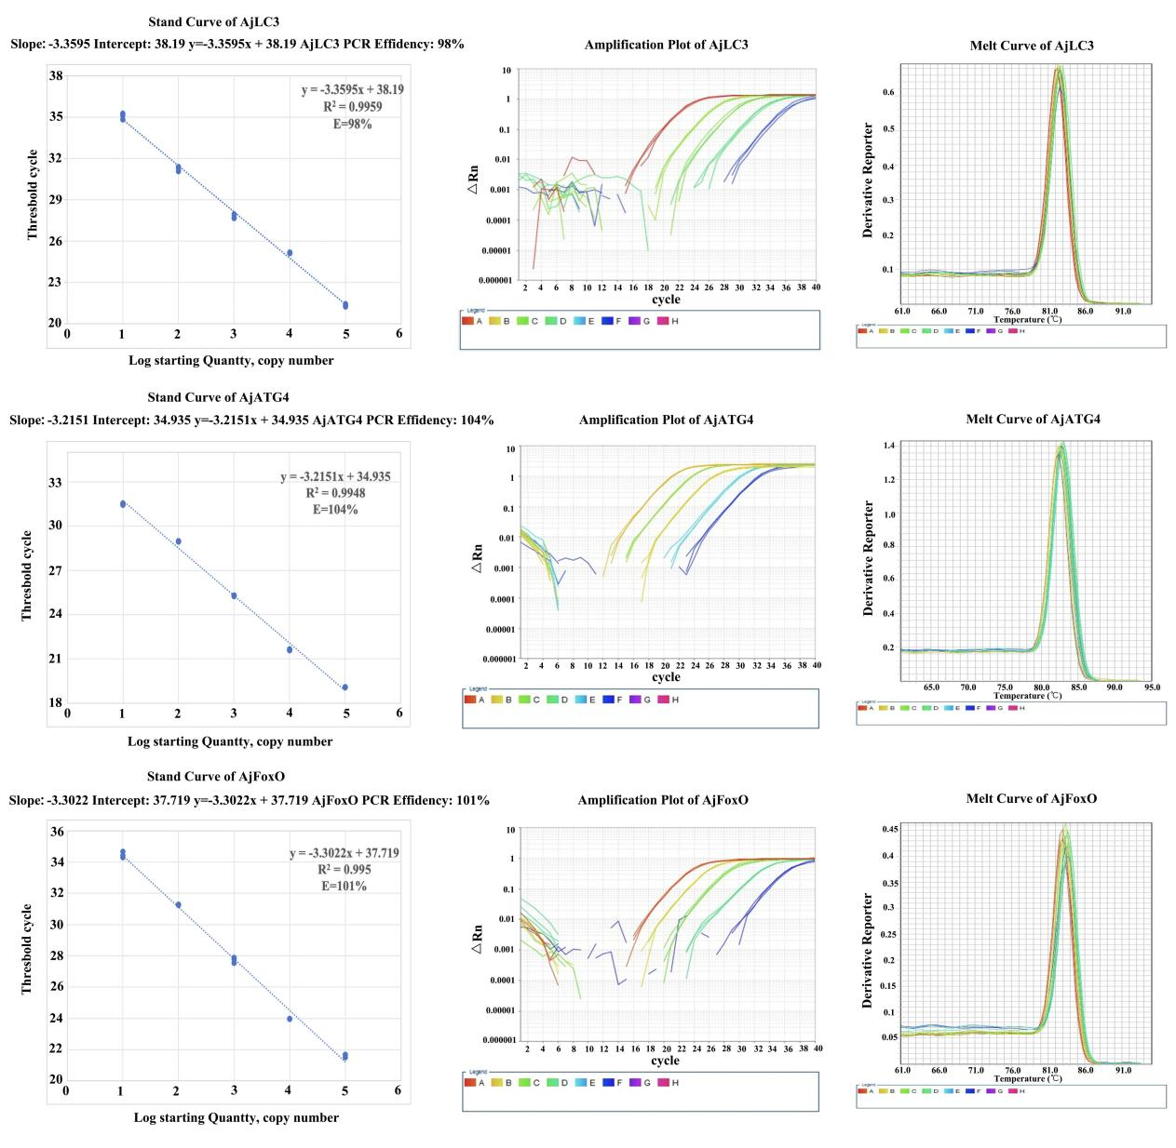
Figure S2. The gene expression stability of 8 candidate housekeeping genes (β-actin, β-Tubulin, Elongation factor-1 (EF1α), 40 S ribosomal protein S9 (RPS9), RPS18, Glyceraldehyde 3-phosphate dehydrogenase (GAPDH), NADH dehydrogenase (NADH) and 60 S ribosomal protein L18a (RPL18A)) was evaluated by four algorithms including geNorm, NormFinder, BestKeeper and RefFinder. A: Expression stability of the 8 candidate reference genes in samples at different stages of intestine regeneration by geNorm. B: Expression stability of the candidate reference genes in samples at different stages of intestine regeneration by NormFinder. C: Expression stability values of the candidate reference genes calculated by BestKeeper. D: Expression stability of the candidate reference genes in samples at different stages of intestine regeneration by RefFinder.
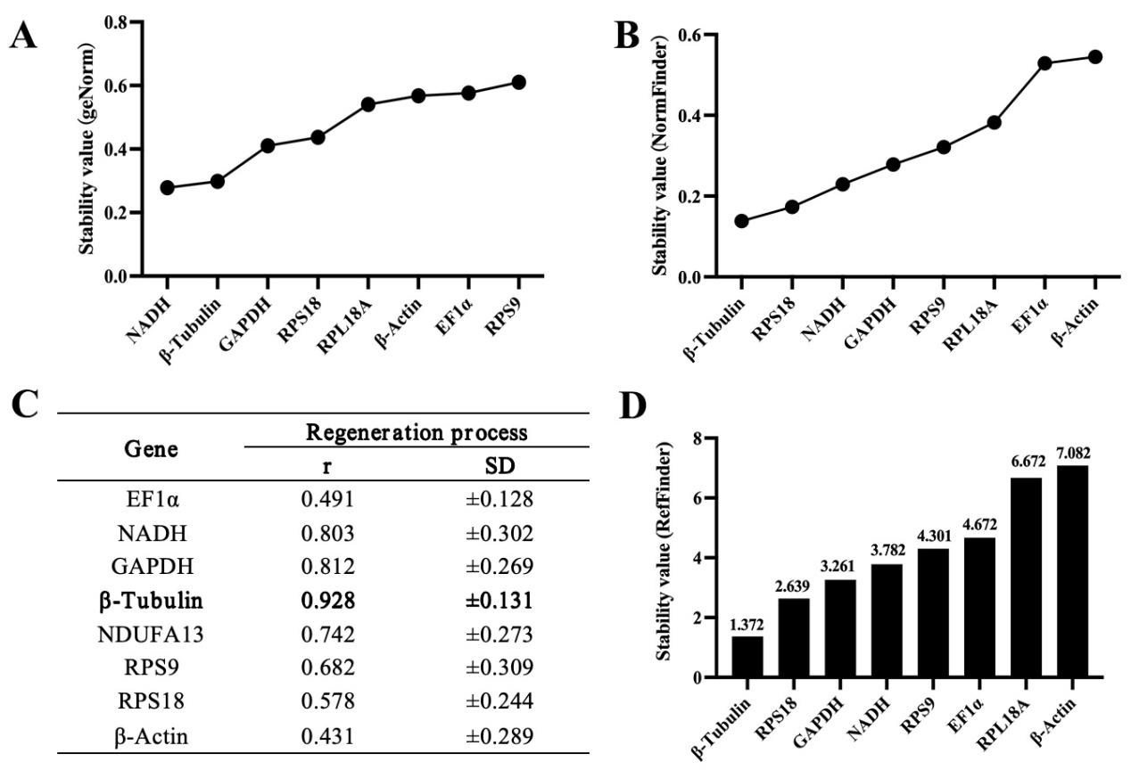
Figure S3. Statistics of regeneration area of A. japonicus intestine at different stages (control (normal mesentery), 2-dpe, 7-dpe, 12-dpe, 20-dpe, 28-dpe) of regeneration of Figure 1F. The data was presented as mean ± SD, n = 3 repeats. Different letters above each bar indicate the significant differences (p < 0.05).
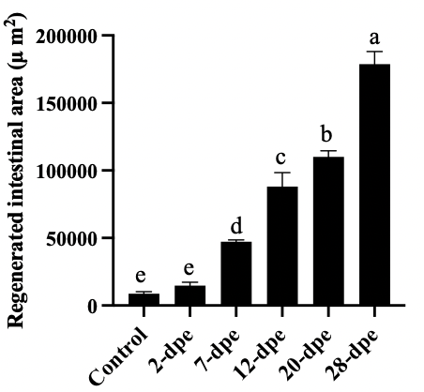
Figure S4. Mean fluorescence value of AjLC3 in the regeneration intestine of A. japonicus at different stages (control (normal mesentery), 2-dpe, 7-dpe, 12-dpe, 20-dpe, 28-dpe) of Figure 1F. The data was presented as mean ± SD, n = 3 repeats. Different letters above each bar indicate the significant differences (p < 0.05).
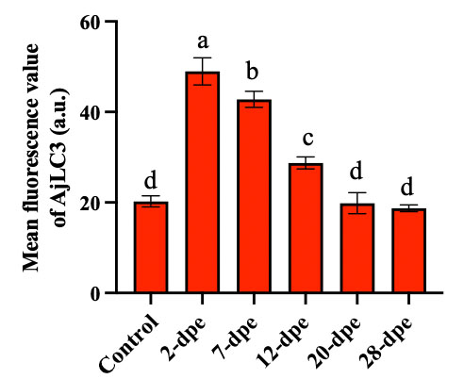
Figure S5. Statistical analysis on the number of autophagosomes in intestinal cells of normal (control) group and 2-dpe group of Figure 1G. For each experiment, select 3 representative images for depth observation. Randomly select 3 cells from each image as samples and accurately count the number of autophagosomes. The data was presented as mean ± SD, n = 9 repeats. ****p < 0.0001.
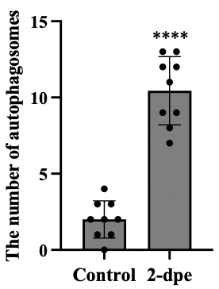
Figure S6. The band density of AjLC3-II/I and Ajp62 proteins in Figure 2B and C was quantified using the ImageJ program. A: Relative band intensity of AjLC3-II/I of Figure 2B; B: Relative band intensity of Ajp62 of Figure 2B; C: Relative band intensity of AjLC3-II/I of Figure 2C; Relative band intensity of Ajp62 of Figure 2C. The data was presented as mean ± SD, n = 3 repeats. “ns” indicates no significant difference versus the control; *p < 0.05; **p < 0.01; ****p < 0.0001.
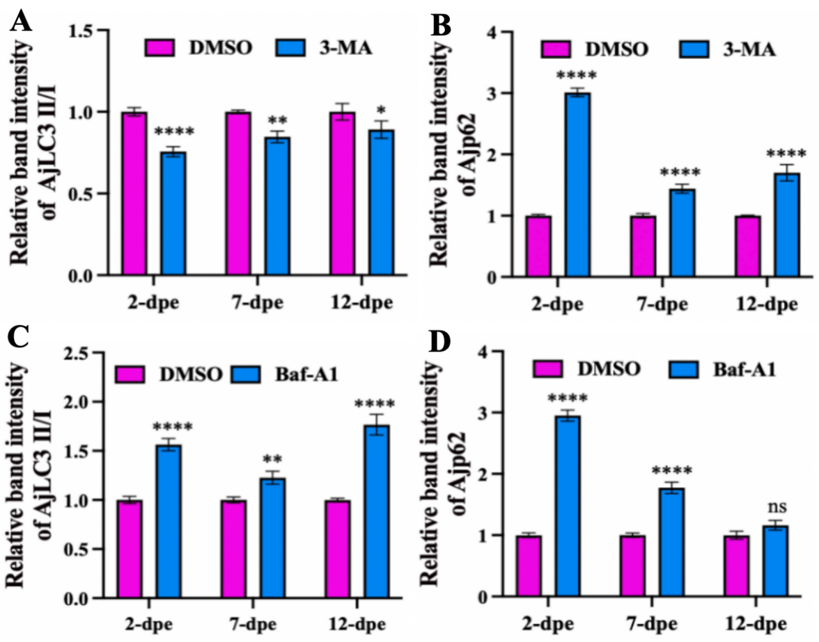
Figure S7. Mean fluorescence value of AjLC3 in the regeneration intestine of A. japonicus at different stages (control (normal mesentery), 2-dpe, 7-dpe) in different treatment groups (DMSO, 3-MA, Baf-a1) of Figure 2D. The data was presented as mean ± SD, n = 3 repeats. **p < 0.01; ****p < 0.0001.
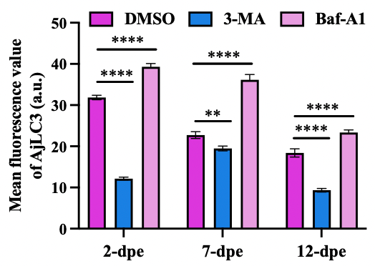

Figure S8. The expression patterns of 13 differentially expressed specific genes in the FoxO pathway during intestinal regeneration after APO treatment.
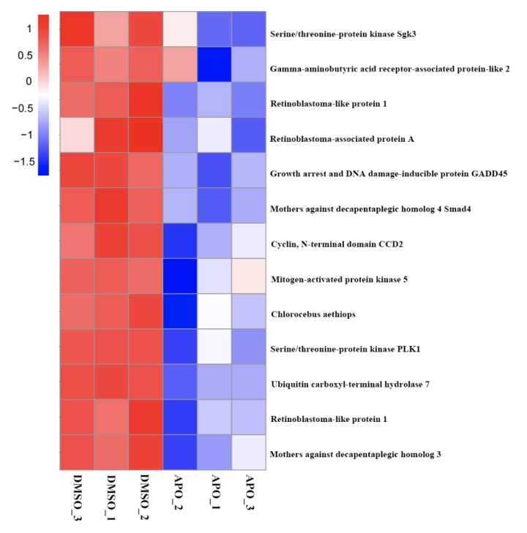
Figure S9. Recombinant protein expression and antibody specificity verification (A) SDS-PAGE analysis of the expression of pET28a (+)-AjFoxO in Escherichia coli Rosetta (DE3). M1: protein marker, Lane 1: uninduced Escherichia coli Rosetta (DE3) harboring pET-28a-AjFoxO, Lane 2: induced Escherichia coli Rosetta (DE3) harboring pET-28a-AjFoxO, Lane 3: purified rAjFoxO; (C) AjFoxO antibody specificity detection. M2: protein marker; Lane 4, western blot of recombinant FoxO protein using AjFoxO polyclonal antibody; Lane 5, western blot of regenerated intestinal tissue lysate using AjFoxO polyclonal antibody; Lane 6, western blot of control protein (recombinant AjTubulin protein) using AjFoxO polyclonal antibody. (C) AjFoxO polyclonal antibody titer determination.
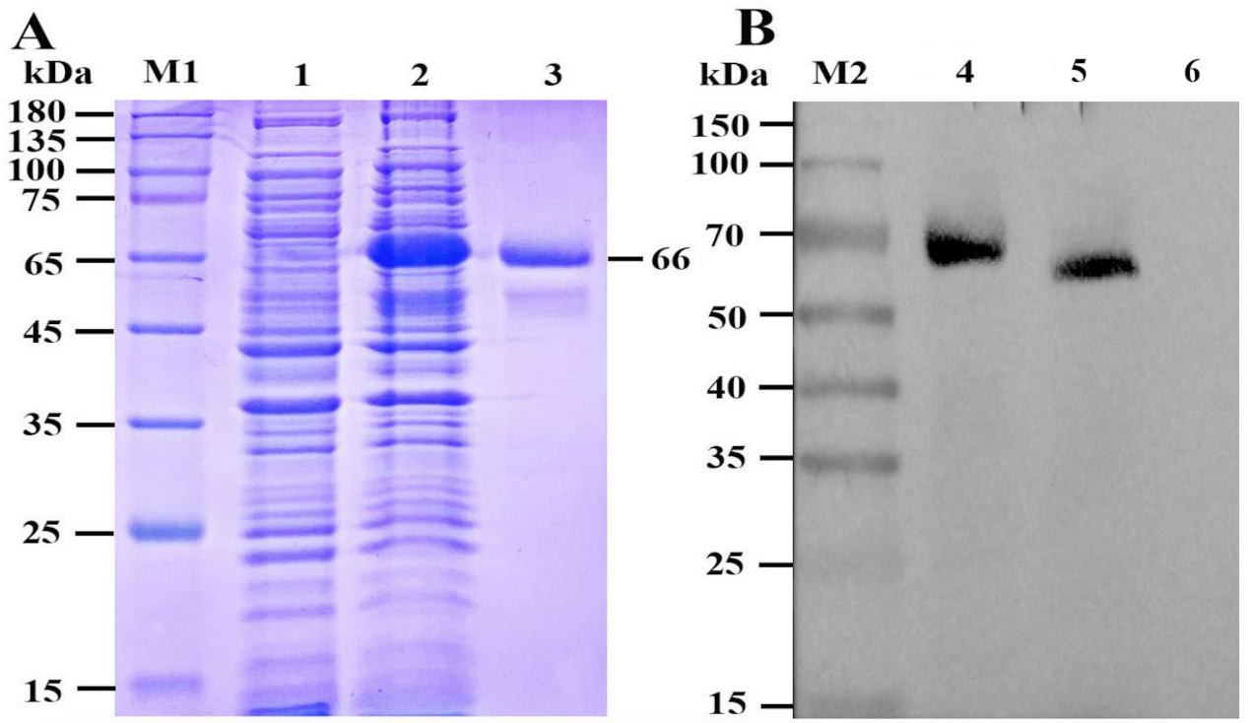
Figure S10. ELISA was used to detected the dilution factor of AjFoxO polyclonal antibody
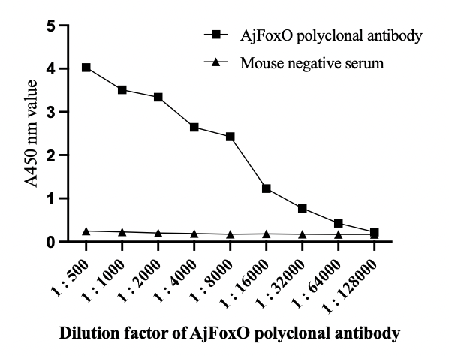
Figure S11. The band density of AjAKT, Ajp-AKT, AjERK, Ajp-ERK, Ajp38, Ajp-p38, AjJNK, Ajp-JNK, AjAMPKβ, Ajp-AMPKβ proteins in Figure 4E was quantified using the ImageJ program. The data was presented as mean ± SD, n = 3 repeats. “ns” indicates no significant difference versus the control; ****p < 0.0001.
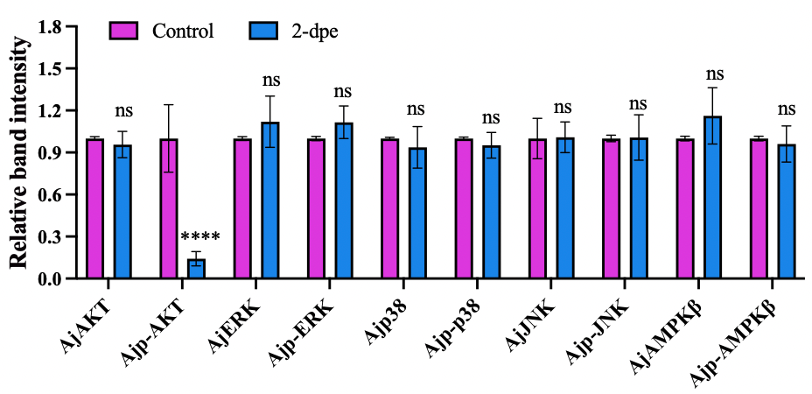
Figure S12. The band density of AjAKT, Ajp-AKT, phos-tag AjFoxO, unphos AjFoxO, AjLC3-II/I, Ajp62 proteins in Figure 4F was quantified using the ImageJ program. The data was presented as mean ± SD, n = 3 repeats. Different letters above each bar indicate the significant differences (p < 0.05).
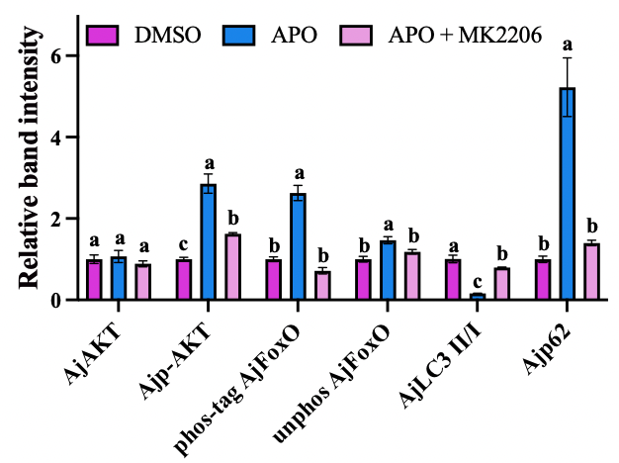
Figure S13. Mean fluorescence value of ROS and AjLC3 in the regeneration intestine of A. japonicus at different stages (2-dpe, 7-dpe, 12-dpe) in DMSO, APO, APO + MK2206 groups of Figure 4G. A: Mean fluorescence value of ROS; B: Mean fluorescence value of AjLC3. The data was presented as mean ± SD, n = 3 repeats. Different letters above each bar indicate the significant differences (p < 0.05).
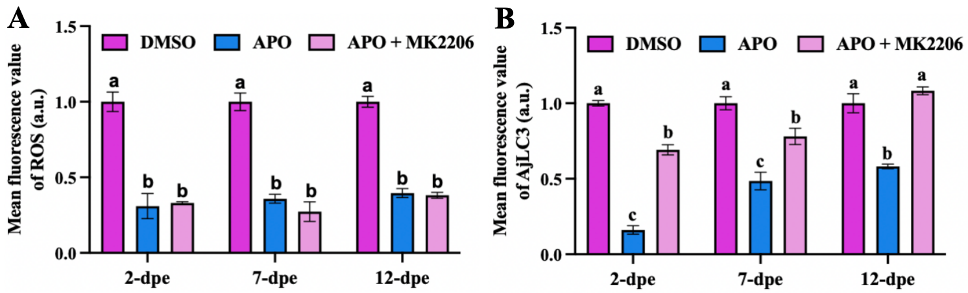
Figure S14. Statistics of regeneration area of A. japonicus intestine at different stages (2-dpe, 7-dpe, 12-dpe, 20-dpe, 28-dpe) of regeneration in DMSO, APO and APO + MK2206 groups of Figure 4G. The data was presented as mean ± SD, n = 3 repeats. Different letters above each bar indicate the significant differences (p < 0.05).
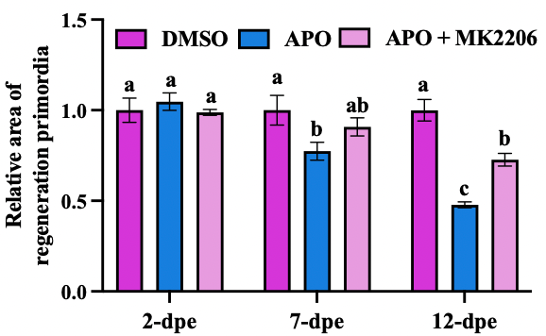
Figure S15. AjFoxO expression in intestine of A. japonicus at 2-dpe post treatment with different concentrations of siAjFoxO (siAjFoxO-1 or siAjFoxO-2) was measured by qRT-PCR. A: Relative mRNA expression of AjFoxO after trarted by siAjFoxO-1; B: Relative mRNA expression of AjFoxO after trarted by siAjFoxO-2. The data was presented as mean ± SD, n = 3 repeats. “ns” indicates no significant difference versus the control; *p < 0.05, ***p < 0.001, ****p < 0.0001.

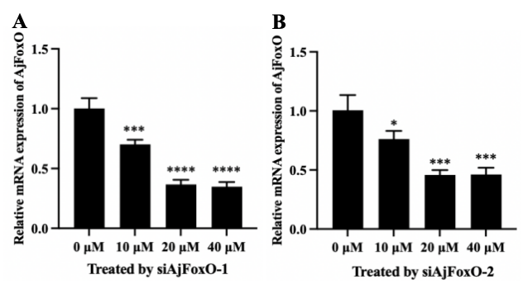
Figure S16. The band density of AjFoxO, AjLC3-II/I, Ajp62 proteins in Figure 5C was quantified using the ImageJ program. The data was presented as mean ± SD, n = 3 repeats. **p < 0.01; ***p < 0.001; ****p < 0.0001.
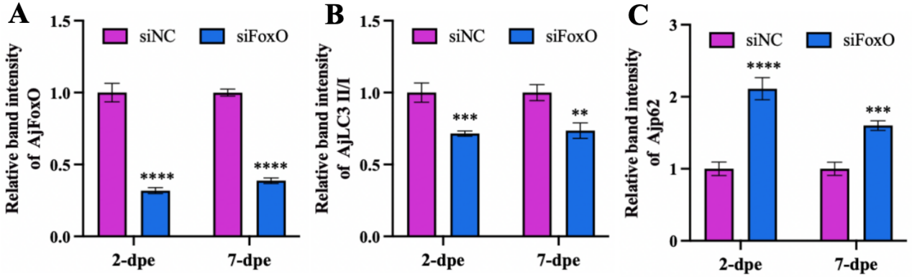
Figure S17. Western blot was performed to detect the expression changes of AjFoxO, AjLC3-II/I and Ajp62 protein in siRNA-NC and siAjFoxO-2 group.
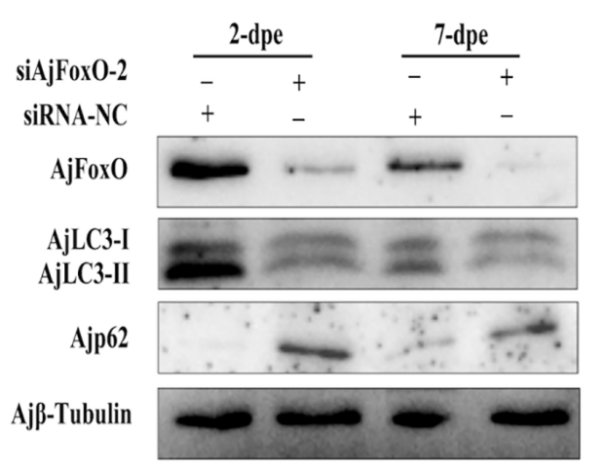
Figure S18. Mean fluorescence value of AjLC3 and AjFoxO in the regeneration intestine of A. japonicus at different stages (2-dpe, 7-dpe) in siNC, siFoxO groups of Figure 5D. A: Mean fluorescence value of AjLC3; B: Mean fluorescence value of AjFoxO. The data was presented as mean ± SD, n = 3 repeats. ****p < 0.0001.
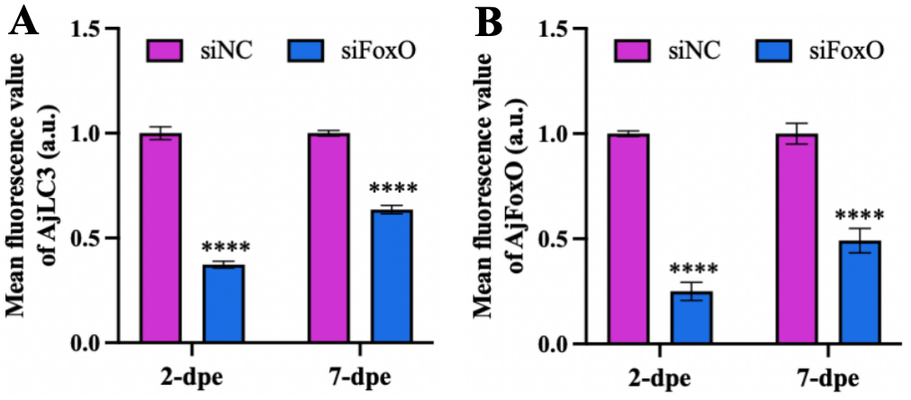

Figure S19. Statistics of regeneration area of A. japonicus intestine at different stages (2-dpe, 7-dpe) of regeneration in siRNA-NC and siFoxO groups of Figure 5D. The data was presented as mean ± SD, n = 3 repeats. “ns” indicates no significant difference versus the control; ****p < 0.0001.
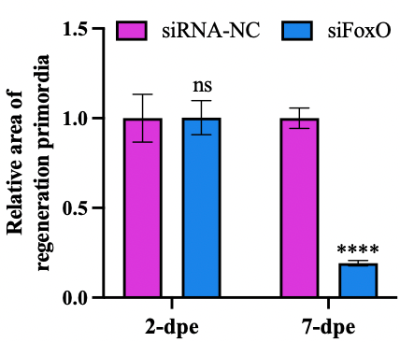

Figure S20. Top 10 motifs with highest scores in AjFoxO chip results.
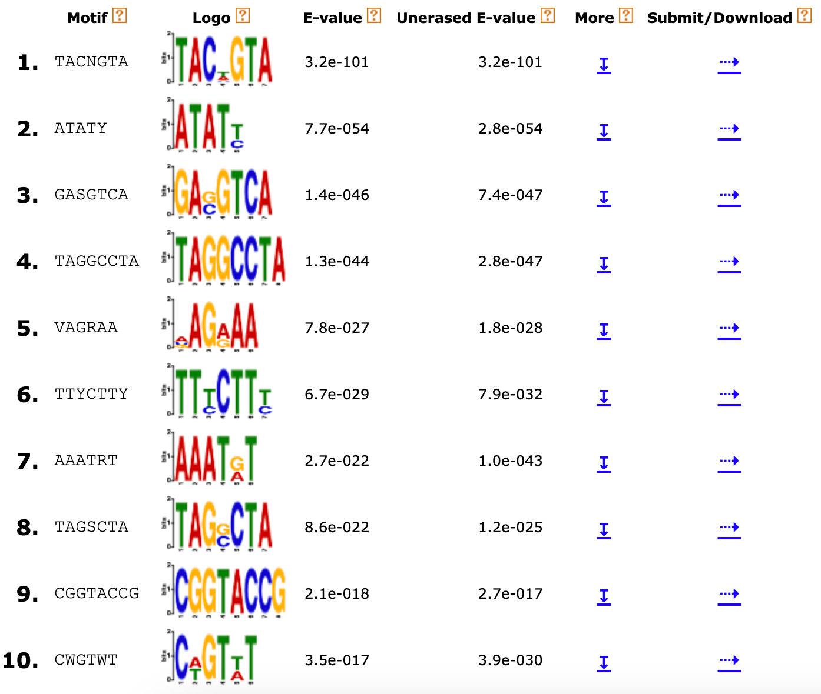
Figure S21. Sequence information of upstream promoters for AjLC3 and AjATG4.
Promoter of AjLC3
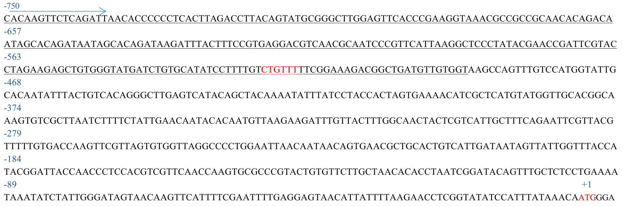
Promoter of AjATG4
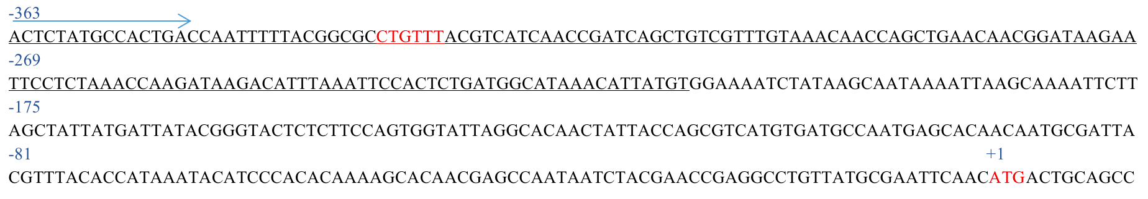
Full length uncropped original western blots used in the manuscript.
