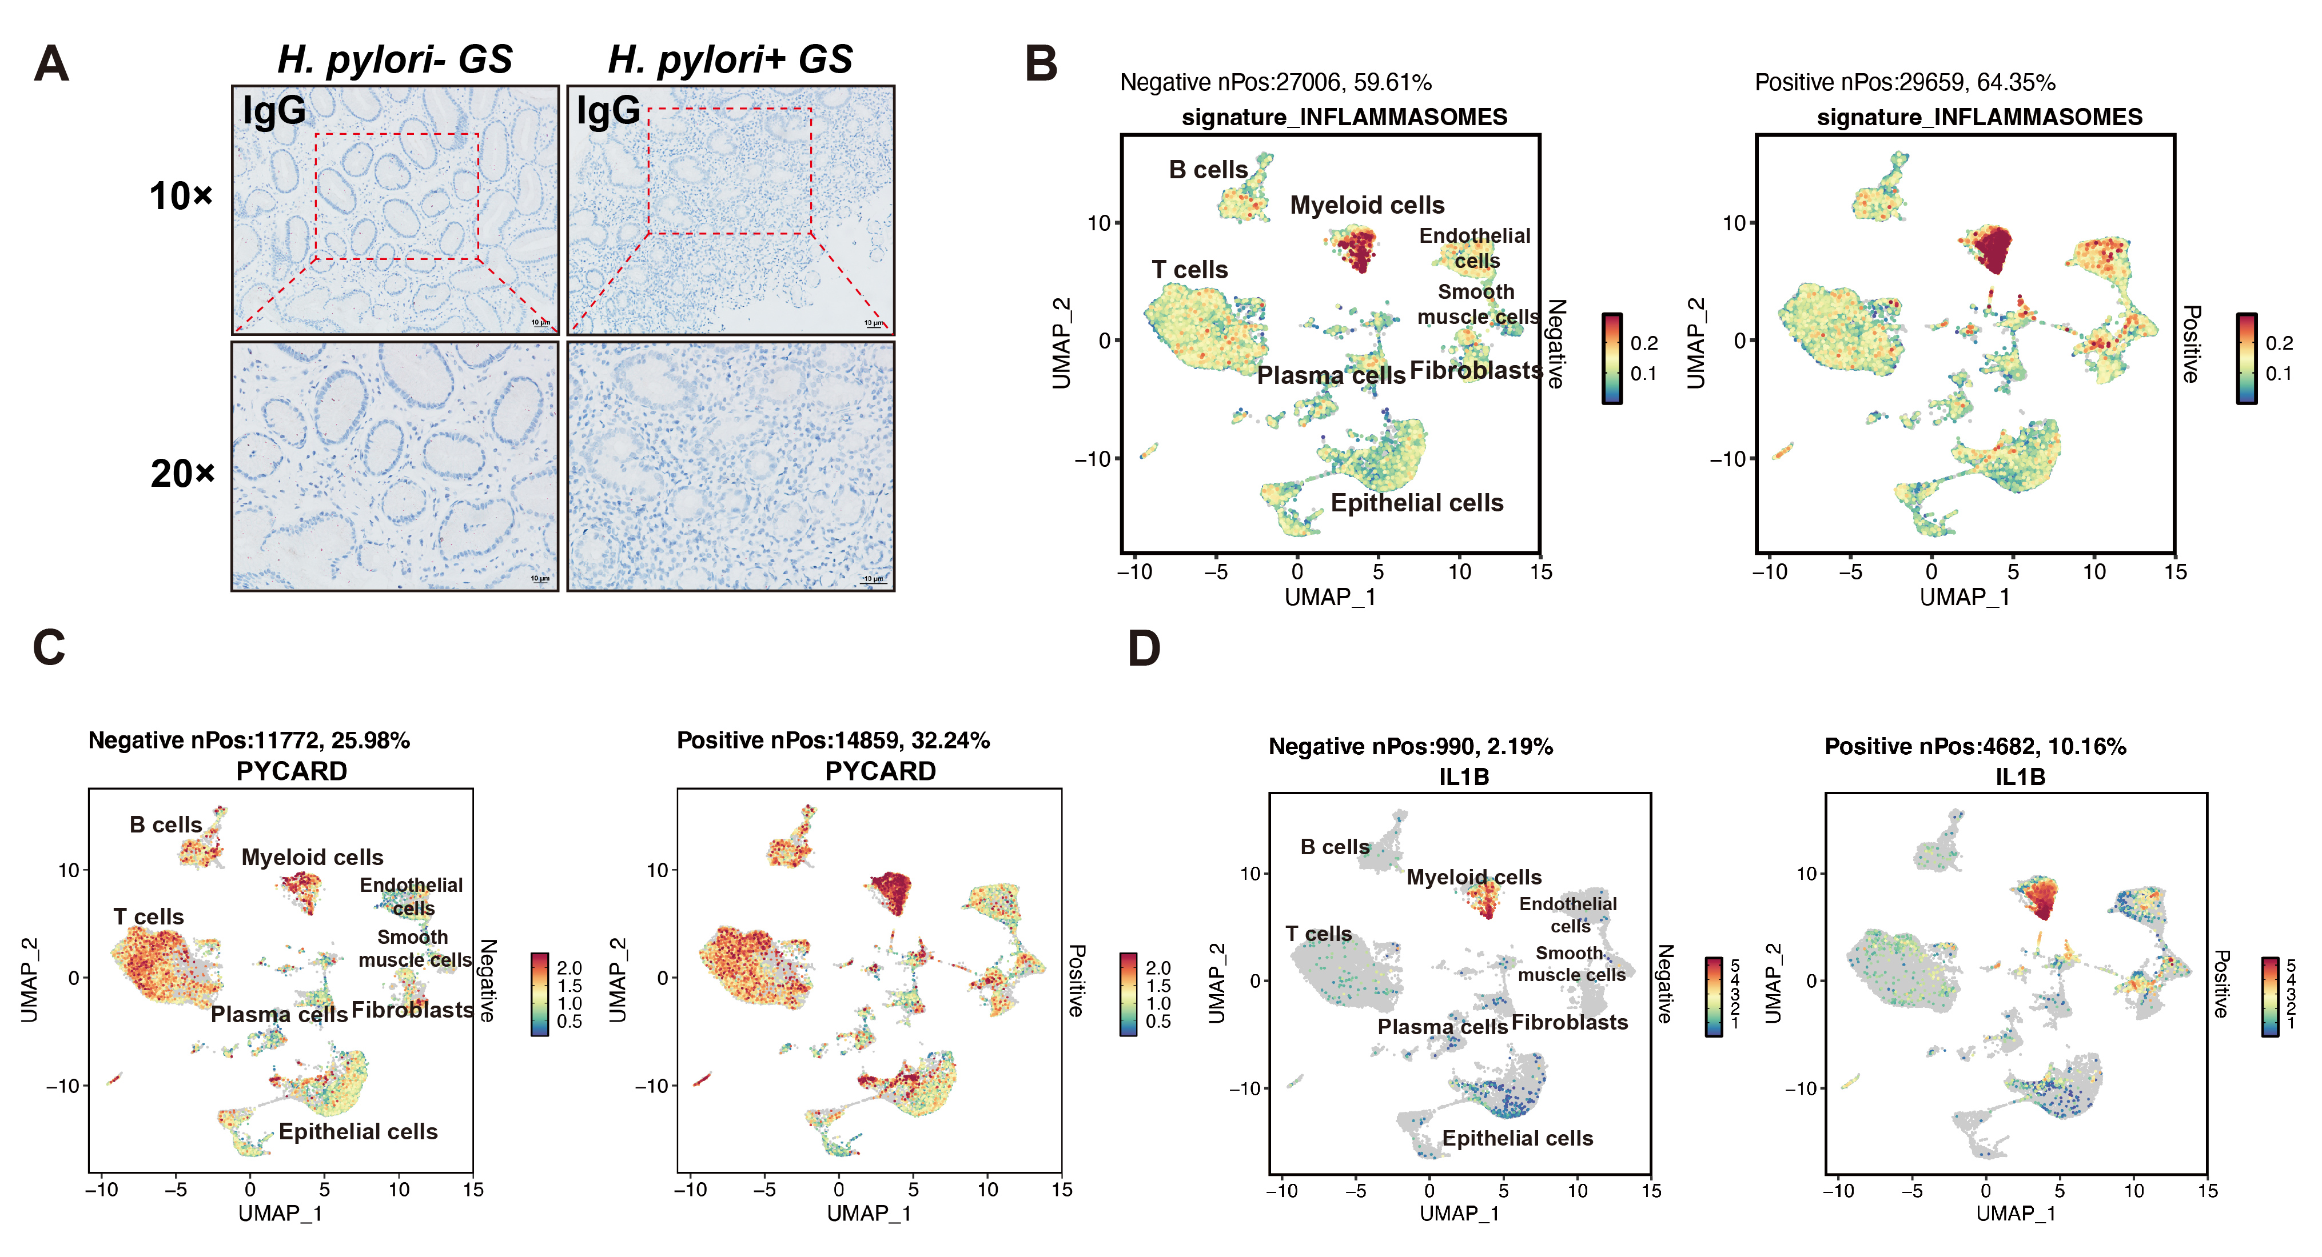
Figure S1. The analysis of the activity of the inflammasome pathway based on our previous scRNA-seq data from human gastric tissues. (A) Immunohistochemistry staining for IgG in human gastritis tissues with or without H. pylori infection. (B-D) The UMAP plots display the expression activity of (B) the inflammasome pathway, (C) PYCARD (also known as ASC), and (D) IL1B gene in H. pylori-positive and negative tissues respectively. The annotated percentage values in the figure represent the proportion of cells expressing this specific gene out of all cells.
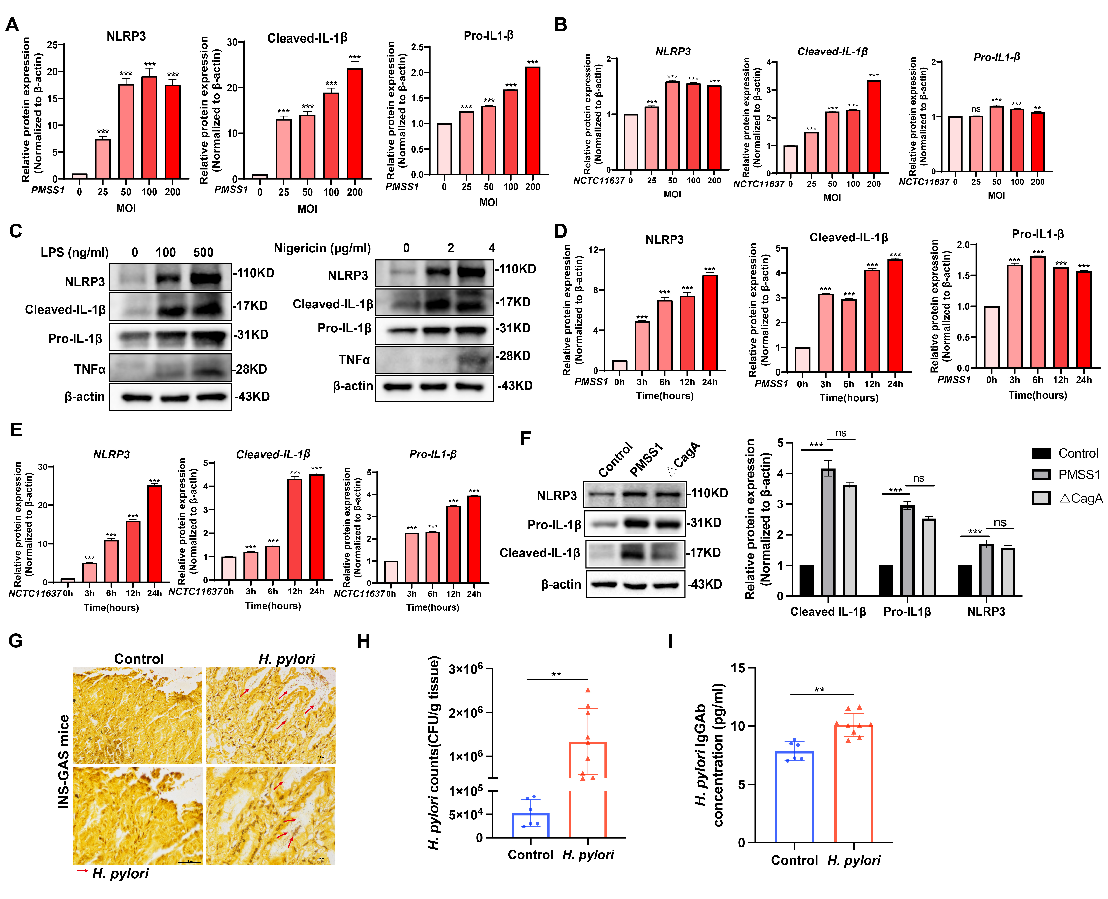
Figure S2. The impact of H. pylori infection on NLRP3 inflammasome in THP1 cells. (A-B) The quantification of NLRP3, Cleaved-IL-1β and Pro-IL-1β as described in Figure 2D-E. (C) Western blots for the protein levels of the NLRP3 inflammasome pathway, including NLRP3, Cleaved-IL-1β, Pro-IL-1β and TNFα, in THP1 cells after treatment with LPS (left panel) or Nigericin (right panel). (D-E) Quantitative densitometric analysis for the western blot data from Figure 2F. (F) Western blots for expression of NLRP3 inflammasome-related proteins in THP1 cells infected with PMSS1 or its isogenic CagA⁻ mutant strain (MOI=100). (G-H) Silver staining (G) and CFU assay (H) showing H. pylori colonization in gastric tissues of INS-GAS mice following H. pylori infection. Scale bar, 10 μm. (I) ELISA assay for the concentration of H. pylori specific IgG antibody in mouse serum from control or H. pylori-infected INS-GAS mice.
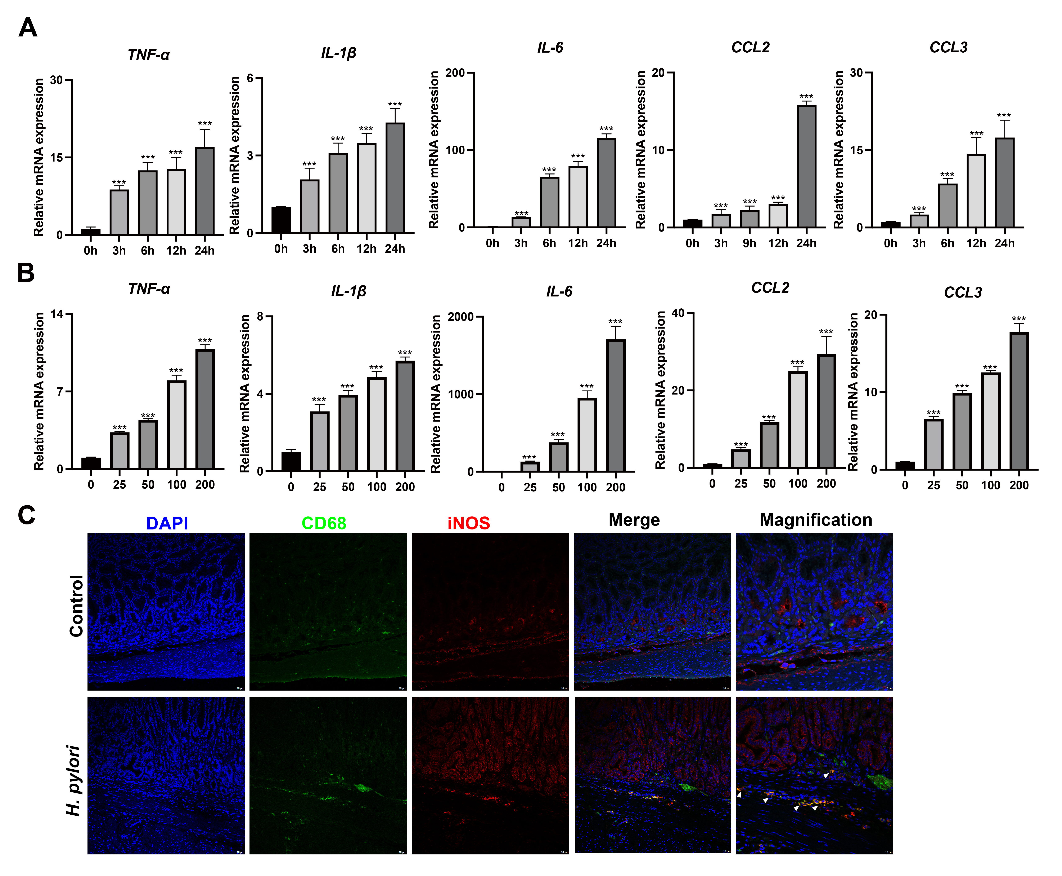
Figure S3. H. pylori infection induces M1 macrophage polarization. (A, B) The qRT-PCR analysis was performed for signature genes of M1 macrophages, including TNF-α, IL-1β, IL-6, CCL2 and CCL3 in THP1 cells co-cultured with PMSS1 strain at different time points (A) and with different MOI (B). (C) Immunofluorescence staining was performed to detect the localization of CD68 and iNOS in the gastric tissues of H. pylori-infected INS-GAS mice at 4 months post-infection. Scale bar, 10 μm.
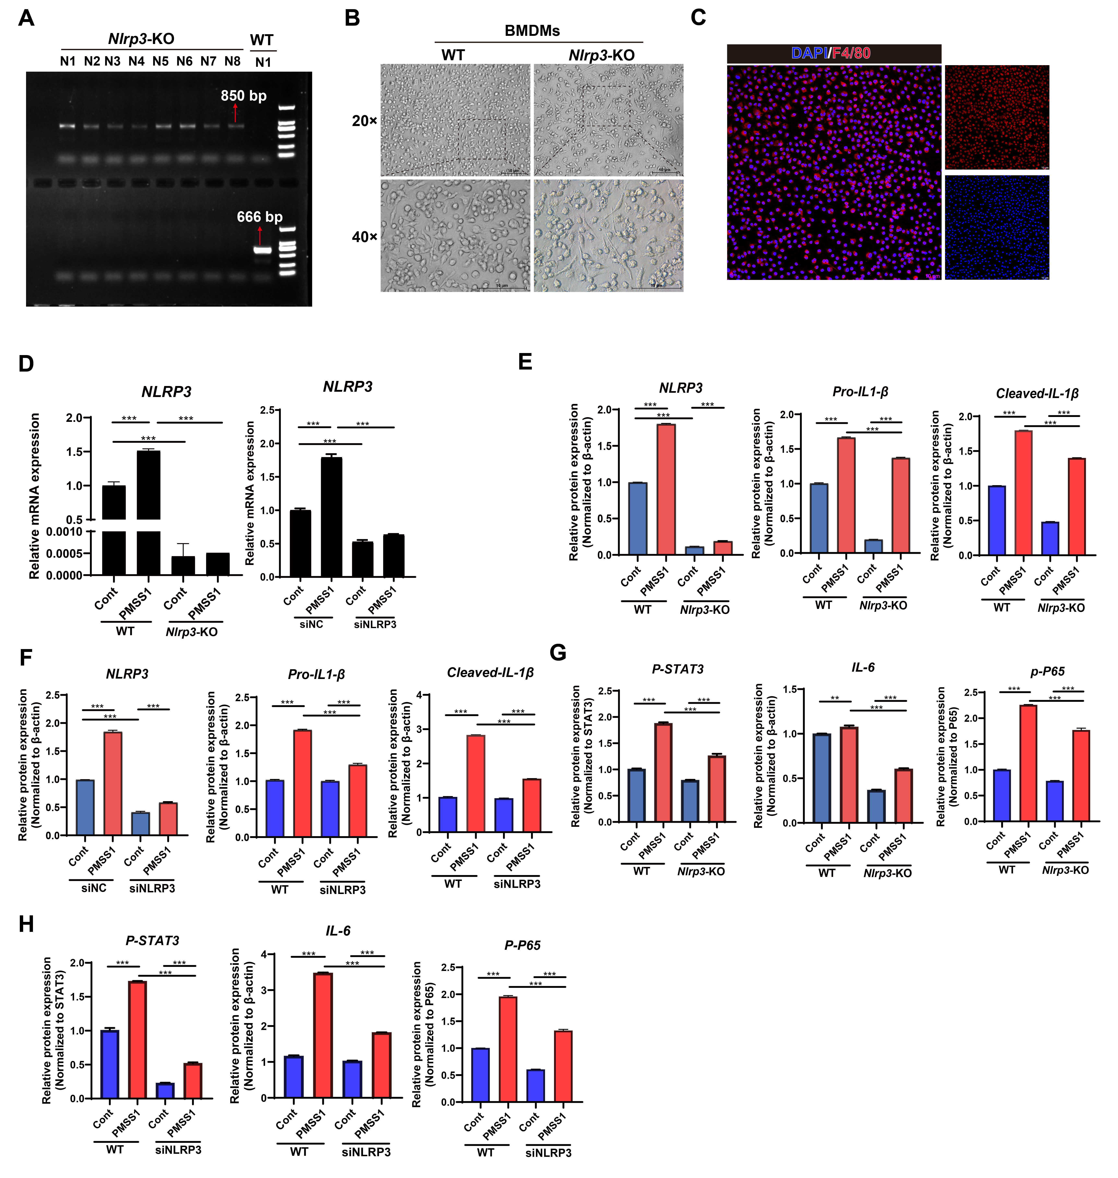
Figure S4. NLRP3 deficiency significantly inhibits the STAT3 and NF-κB pathways in macrophages upon H. pylori infection. (A) PCR genotyping for the validation of NLRP3 knockout efficiency in mice. (B) The morphology of BMDMs from WT and Nlrp3-KO mice. (C) Immunofluorescence staining for F4/80 in BMDMs. (D) The qRT-PCR analysis for NLRP3 mRNA levels in BMDMs from WT and Nlrp3-KO mice (left panel), or in THP1 cells transfected with NLRP3 siRNA (right panel). (E-F) The quantification of NLRP3, pro-IL-1β, and Cleaved-IL-1β expression, as described in Figure 4A and 4D, respectively. (G) The quantification of p-STAT3 normalized to total STAT3, IL-6, and p-p65 normalized to total p65, as described in Figure 4G and 4H. (H) The quantification of p-STAT3 normalized to total STAT3, IL-6, and p-p65 normalized to total p65, as described in Figure 4I and 4J.
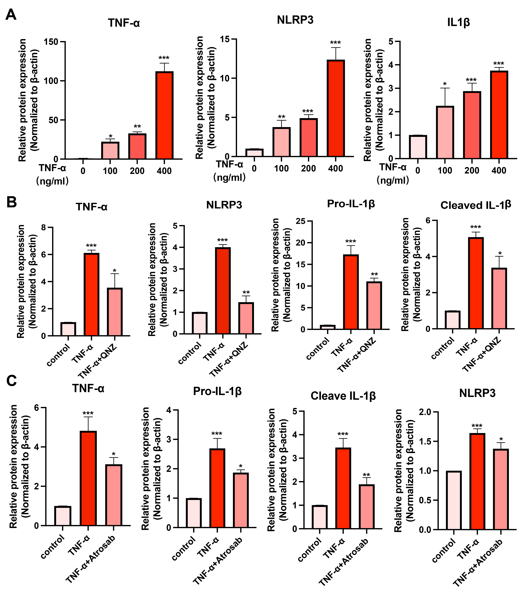
Figure S5. Quantitative densitometric statistical analysis of the bands from the western blot data in Figure 5.

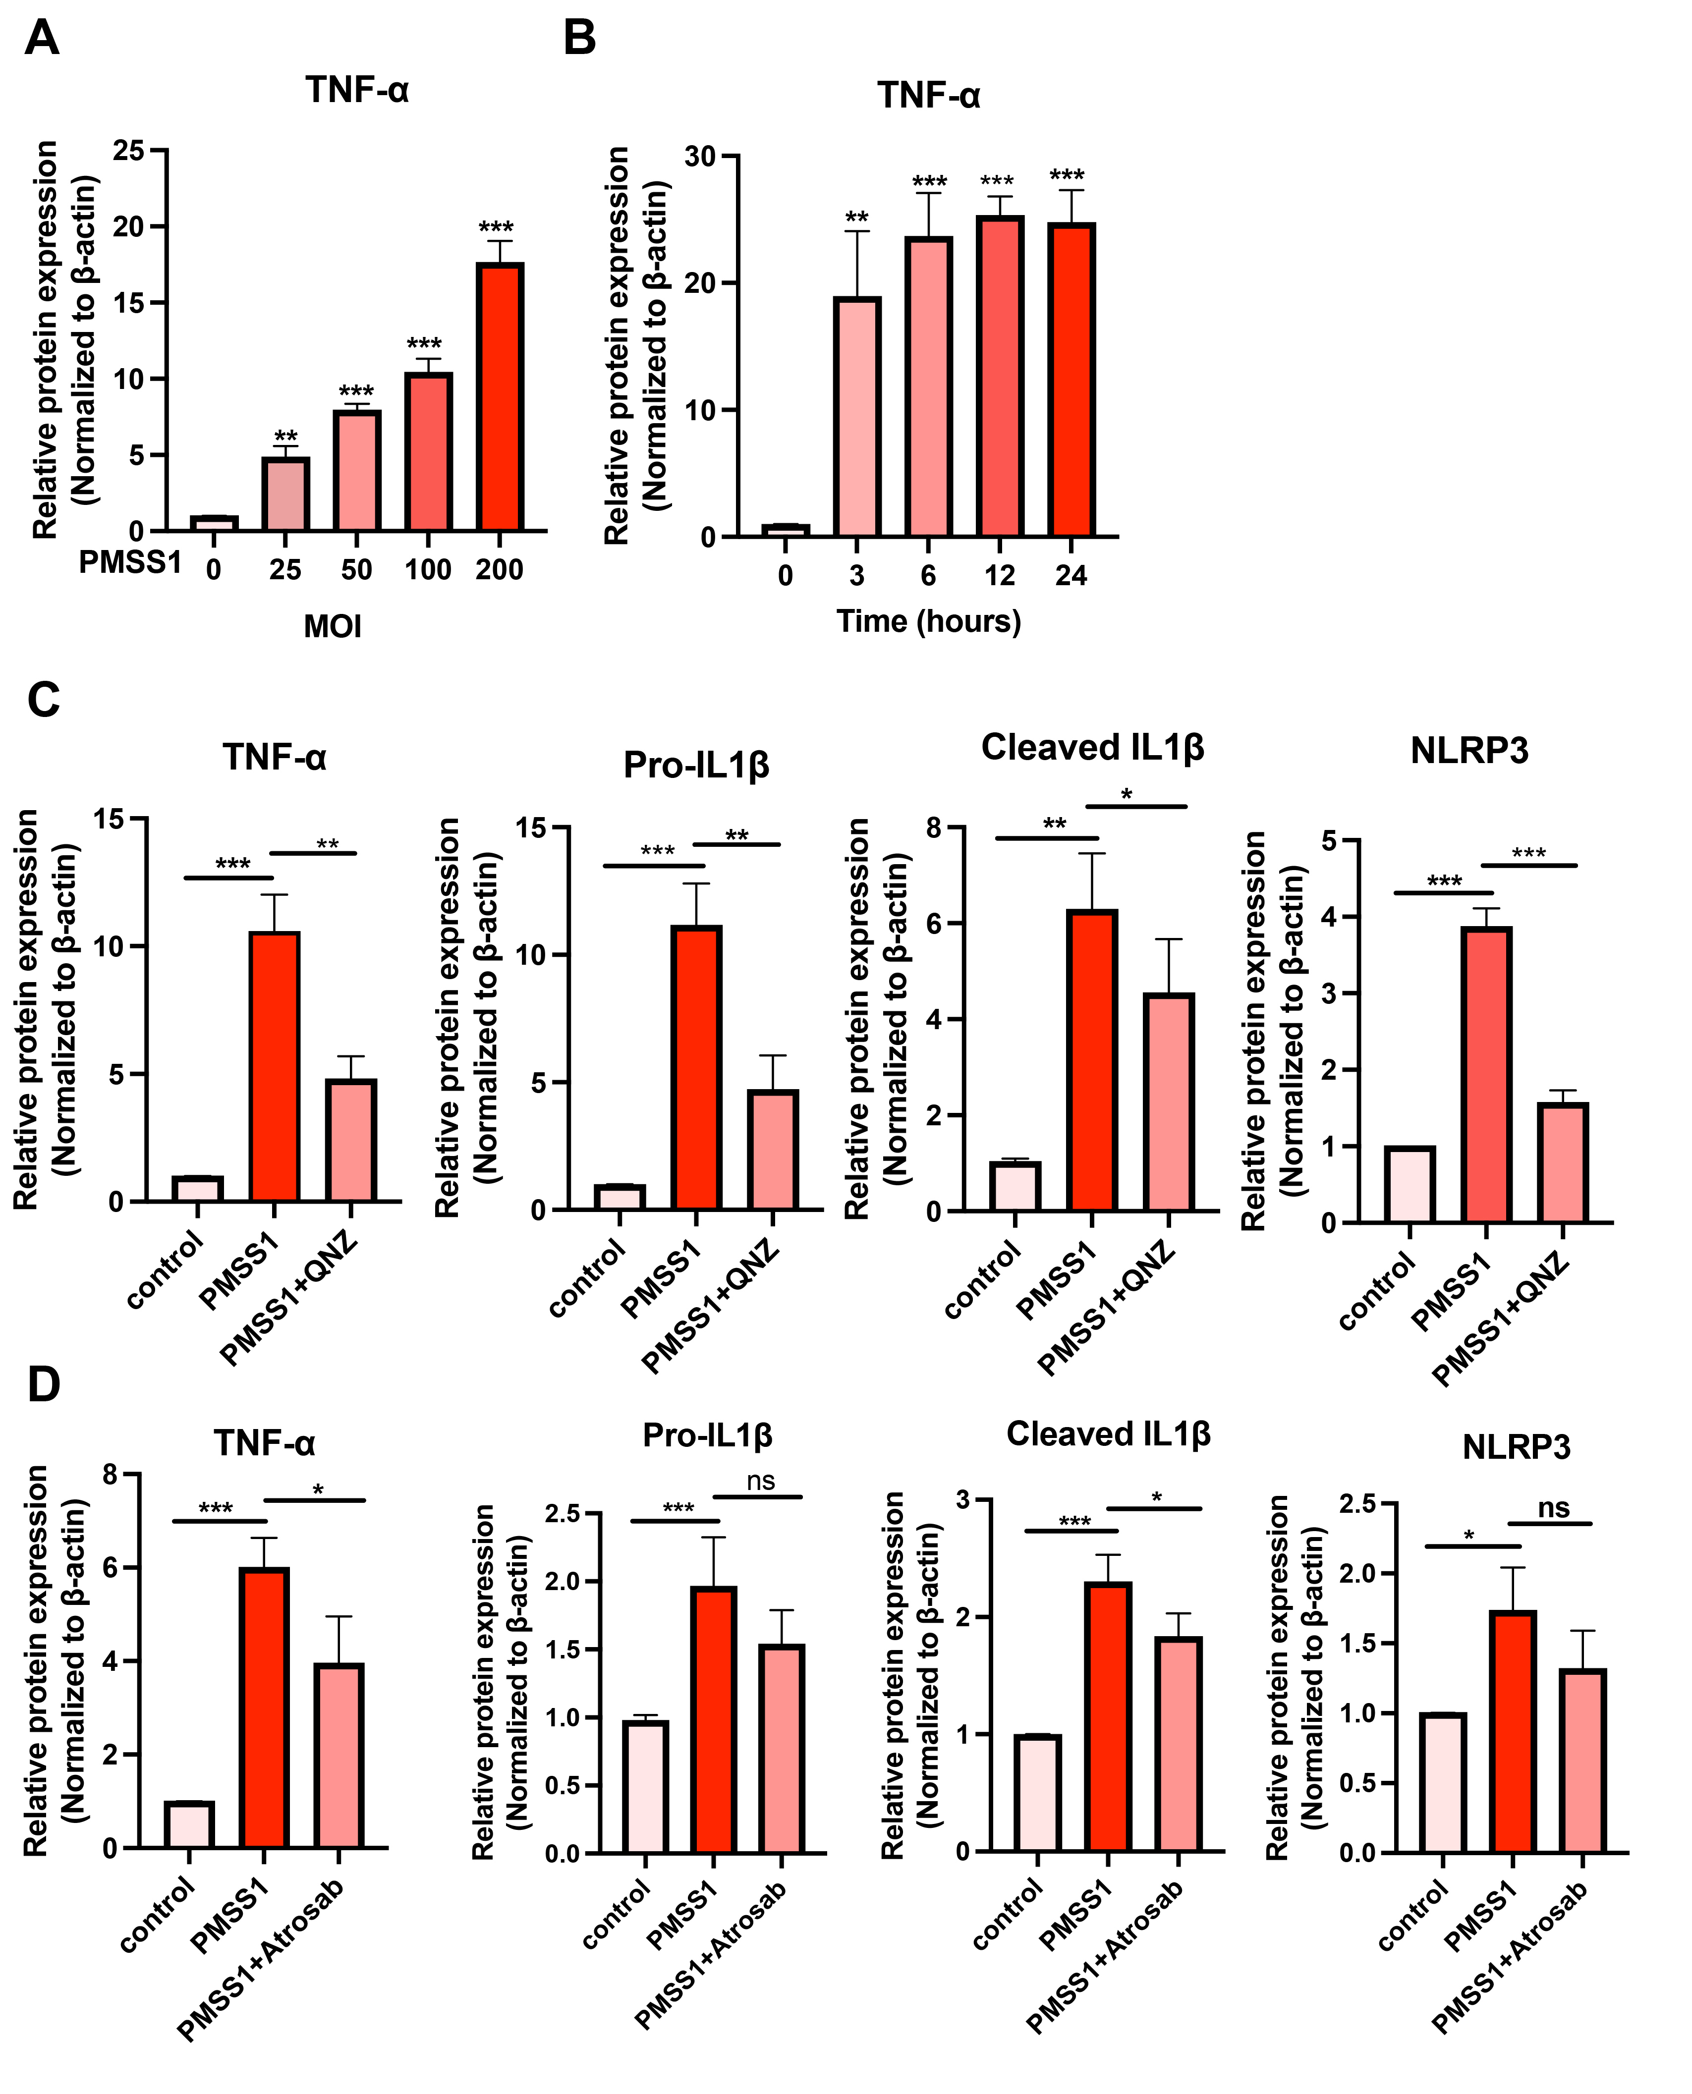
Figure S6. Quantitative densitometric statistical analysis of the bands from the western blot data in Figure 6.

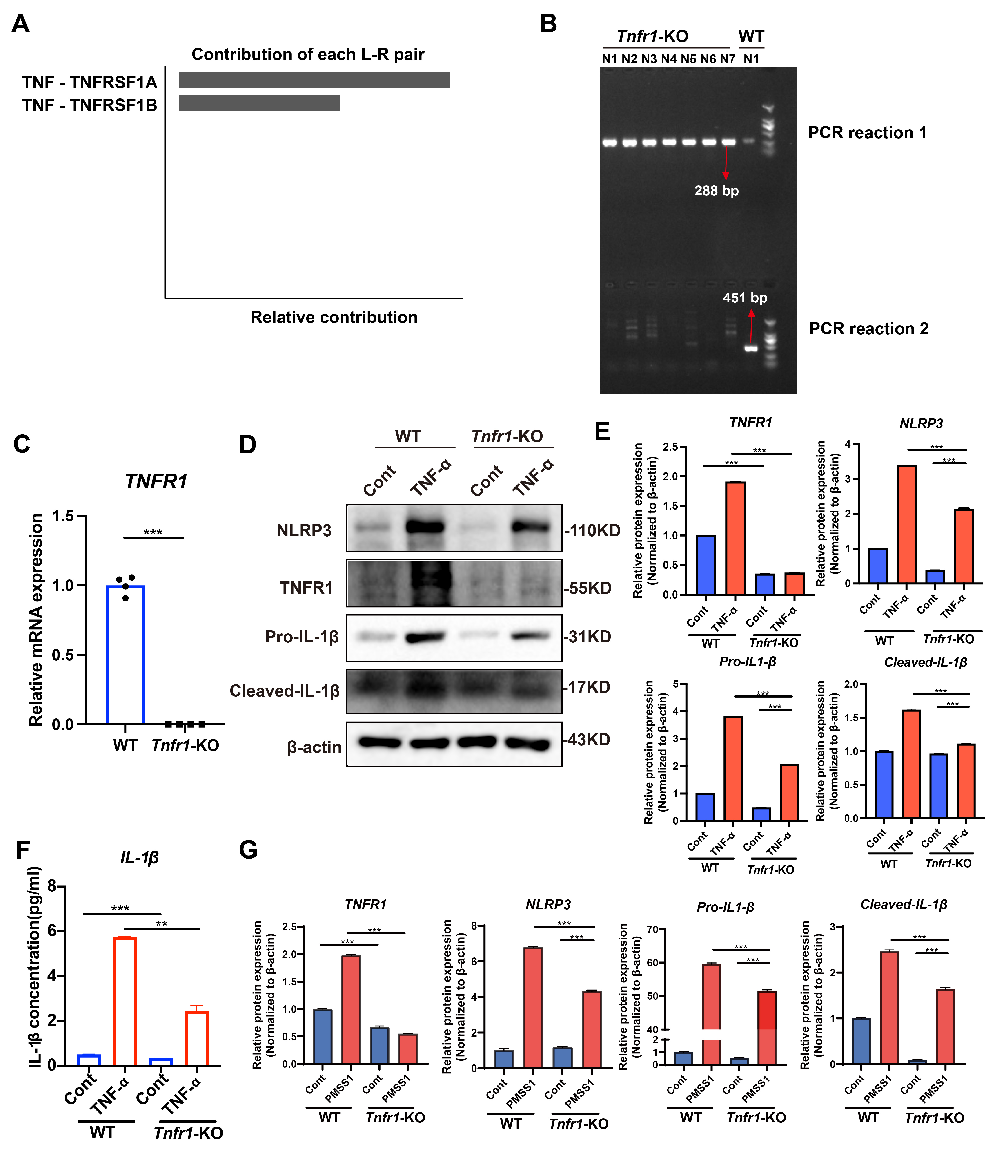
Figure S7. TNFR1 deficiency inhibits H. pylori-induced NLRP3 inflammasome activation. (A) CellChat analysis computed the contribution of each ligand-receptor pair within TNF signaling pathway network. The histogram plot showing the contribution of TNF-TNFR1 (TNFRSF1A) and TNF-TNFR2 (TNFRSF1B) ligand-receptor pairs in the TNF signaling network. (B) PCR genotyping for validation of the TNFR1 knockout efficiency in mice. (C) The qRT-PCR analysis of TNFR1 mRNA levels to validate the Tnfr1 knockout efficiency in mice. (D and E) WT and Tnfr1-KO BMDMs were treated with 200 ng/ml TNFα. Western blots for the protein expression of molecules of NLRP3 inflammasome (D) and their densitometric statistical analysis (E). (F) ELISA for IL-1β concentration in cell supernatant. (G) Quantitative densitometric analysis of the western blot data in Figure 7E.

