Supplementary figures
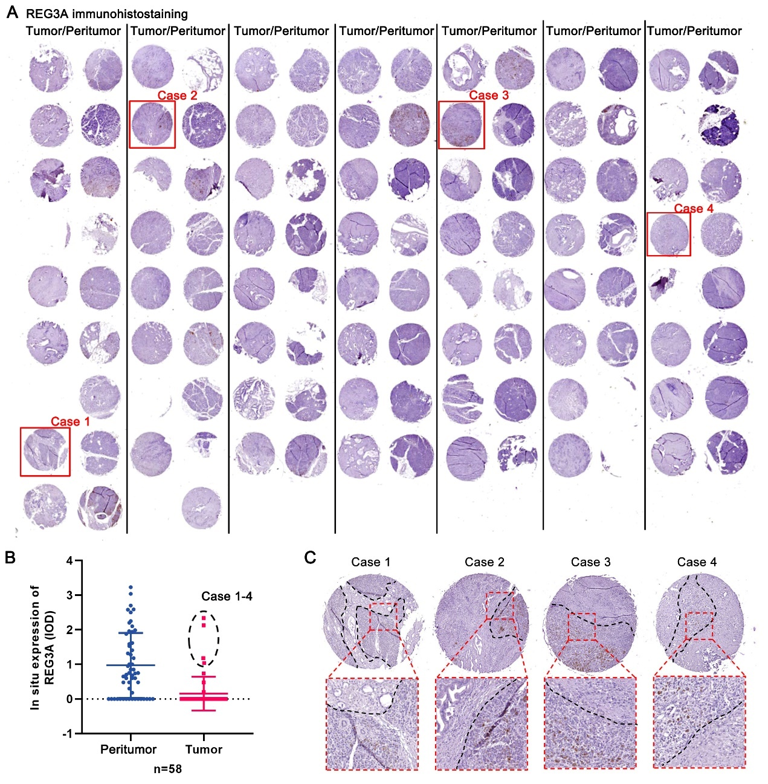
Figure S1, related to figure 1. Immunostaining of REG3A in a tissue microarray (TMA) cohort of PDAC. (A) The immunostaining of REG3A in a paired tumor and peritumor TMA cohort of PDAC. (B) The integral optical density (IOD) analysis of in situ REG3A expression from the TMA PDAC specimens. (C) The reevaluation of specimens initially showing higher expression of REG3A in tumor tissues than in peritumoral tissues from four patients with PDAC (indicated in Figure S1B and Figure 1D).

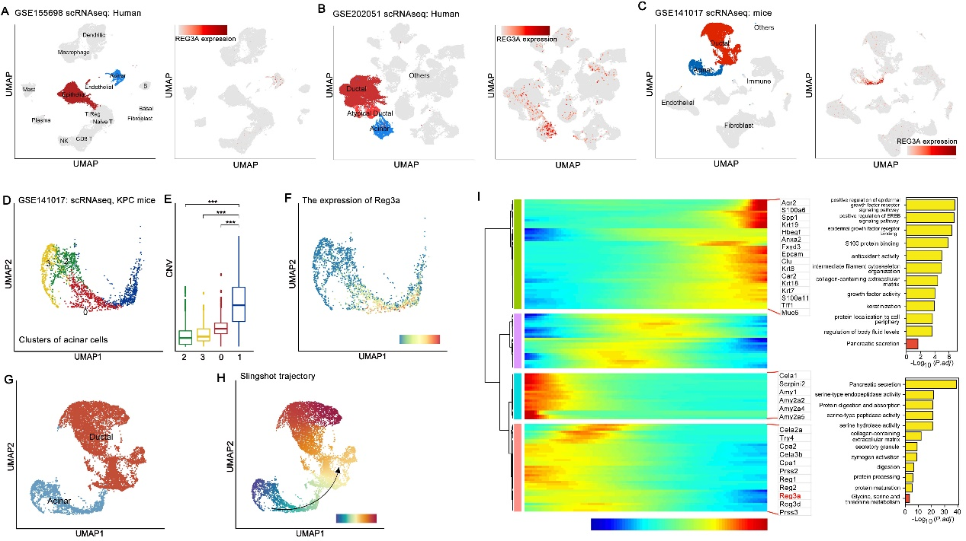
Figure S2, related to figure 1. Bioinformatic analysis of a public scRNA-seq data, GSE155698, GSE202051 from human PDAC tissue, GSE141017 from KPC (LSL-Kras^{G12D/+}; Trp53^{fl/+}; Pdx1-Cre) mice. (A) UMAP representation of different subgroups generated from the GSE155698 dataset; the expression levels of REG3A in each subgroup were plotted onto the UMAP. (B) UMAP representation of different subgroups generated from the GSE202051 dataset; the expression levels of REG3A in each subgroup were plotted onto the UMAP. (C) The UMAP representation of different subgroups of acinar cells in GSE141017; the expression levels of REG3A in each subgroup were plotted onto the UMAP. (D) The different clusters of acinar cells in GSE141017. (E) The CNV scores in the different clusters of acinar cells in (D). (F) The expression levels of Reg3a in each subgroup were plotted onto the UMAP. (G) UMAP representation of ductal and acinar cells in GSE141017. (H) Pseudo-time of acinar and ductal cells from GSE141017 with abnormal gene expression profiles and malignant ductal cells inferred by slingshot trajectory. (I) Pseudo-time of acinar and ductal cells from GSE141017 inferred by monocle2.

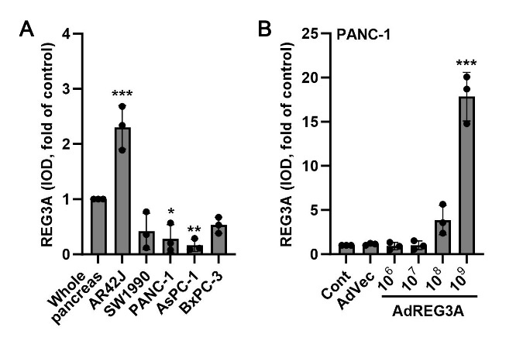
Figure S3, related to figure 2. Integrated optical density (IOD) analysis of western blot in figure 2. (A) The IOD of each band in the independent blot was analyzed in figure 2A, (B) figure 2B. All blots were repeated for at least 3 times, tubulin was used as internal reference; *p<0.05, **p<0.01, ***p<0.001, compared to control group, n=3.

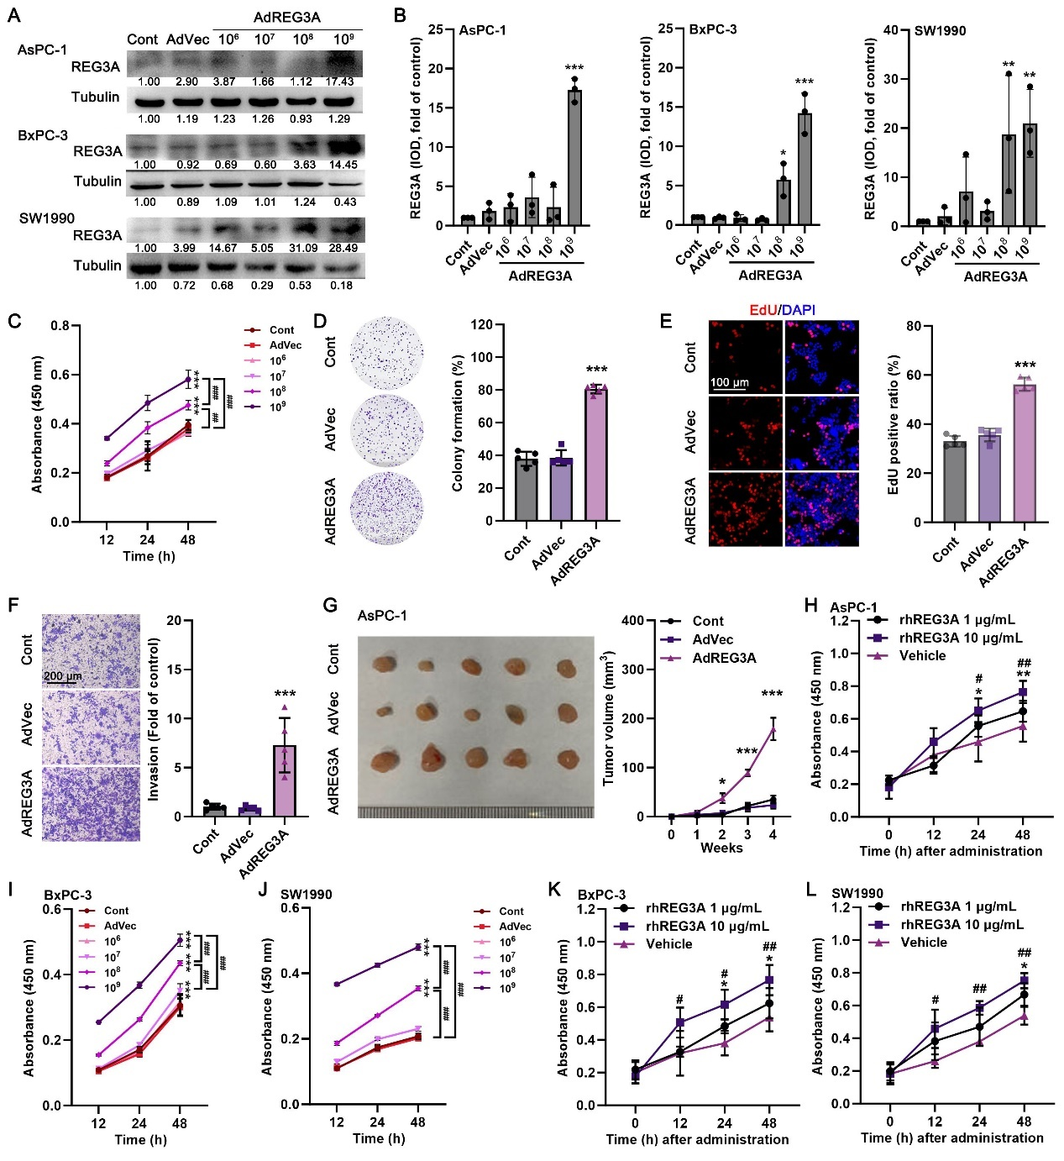
Figure S4, related to figure 2. REG3A promotes PDAC tumor growth in vitro and in vivo. (A) The AsPC-1, BxPC-3, or SW1990 cells were infected with adenovirus overexpressed REG3A (AdREG3A) or vector (AdVec), then the expression of REG3A was detected by western blot. (B) All blots were repeated for at least 3 times, tubulin was used as internal reference; the integrated optical density (IOD) of each band in the independent blot was analyzed (*p<0.05, **p<0.01, ***p<0.001, compared to control group, n=3). (C) At different times after infection, the cell viability of AsPC-1 cells was measured. (D) After infection with AdREG3A or AdVec for 1 week, AsPC-1 cell colonies were stained with crystal violet, and the colony numbers were counted. (E) After infection with AdREG3A or AdVec for 48 h, EdU staining was performed in AsPC-1 cells to assess the proliferative ratio in the different groups. (F) After infection with AdREG3A or AdVec for 48 h, transwell assay was performed to measure cell invasion. ***p<0.001 compared to the Control group, n=5. (G) Photograph of AsPC-1 xenograft tumors at 4 weeks after cell injection. The in vivo tumor volume after AsPC-1 cell injection was recorded. *p<0.05, ***p<0.001, n=5. (H) AsPC-1 cells were treated with different concentration of recombinant human REG3A (rhREG3A) for different times, the cell viability was detected. (I-J) Different times after infection with AdREG3A or AdVec, the cell viability of BxPC-3 or SW1990 cells was measured. (K-L) BxPC-3 or SW1990 cells were treated with different concentration of recombinant human REG3A (rhREG3A) for different times, the cell viability was detected. **p<0.01, ***p<0.001 in 1 μg/mL group; #p<0.05, ##p<0.01, in 10 μg/mL group; compared to vehicle-treated group, n=6.

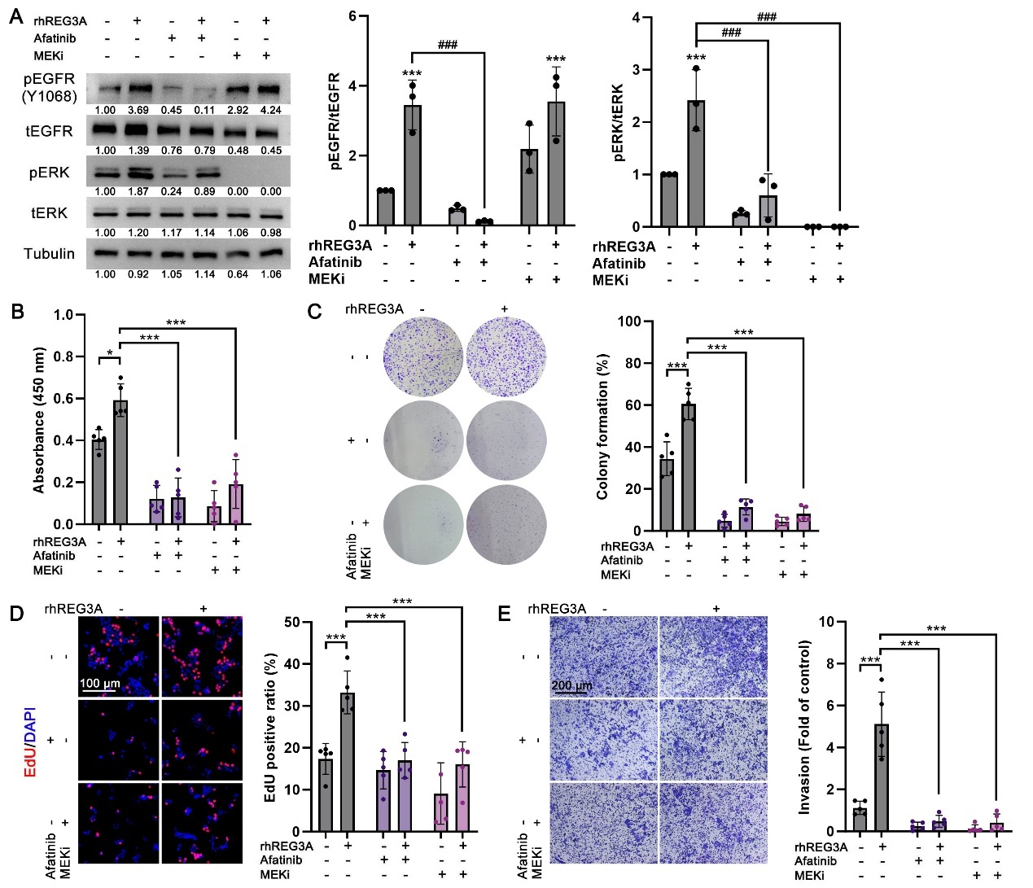
Figure S5. related to figure 4. Inhibition of EGFR-MAPK signal reduces rhREG3A-stimulated EGFR-MAPK signaling pathway. (A) Phosphorylation of EGFR and ERK detected by western blotting of PANC-1 cells serum starved for 24 h, followed by 10 μg/mL rhREG3A with/without afatinib or MEK inhibitor (MEKi, PD98059) treatment for 5 min. All blots were repeated at least 3 times; tubulin was used as an internal reference; the integrated optical density (IOD) of each band in the independent blot was analyzed, and the pEGFR/tEGFR or pERK/tERK ratio was calculated. ***p<0.001, compared to vehicle-treated group; ###p<0.001 as indicated; n=3. (B-E) PANC-1 cells were treated with 10 μg/mL rhREG3A with/without afatinib or MEKi for different times, the cell viability, colony formation, EdU staining, and cell invasion assays were performed, *p<0.05, **p<0.01, ***p<0.001, as indicated, n=5.

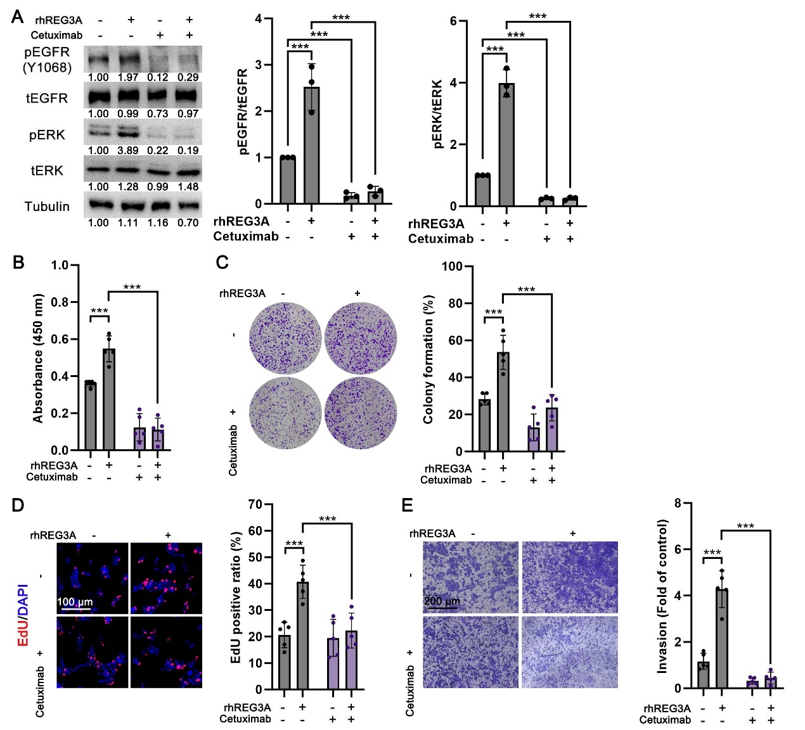
Figure S6. related to figure 4. Cetuximab inhibits rhREG3A-stimulated EGFR-MAPK signaling pathway. (A) Phosphorylation of EGFR and ERK detected by western blotting of PANC-1 cells serum starved for 24 h, followed by 10 μg/mL rhREG3A with/without 10 μg/mL cetuximab treatment for 5 min. All blots were repeated at least 3 times; tubulin was used as an internal reference; the integrated optical density (IOD) of each band in the independent blot was analyzed, and the pEGFR/tEGFR or pERK/tERK ratio was calculated. ***p<0.001, compared to vehicle-treated group; ###p<0.001 as indicated; n=3. (B-E) PANC-1 cells were treated with 10 μg/mL rhREG3A with/without 10 μg/mL cetuximab for different times, the cell viability, colony formation, EdU staining, and cell invasion assays were performed, *p<0.05, **p<0.01, ***p<0.001, as indicated, n=5.

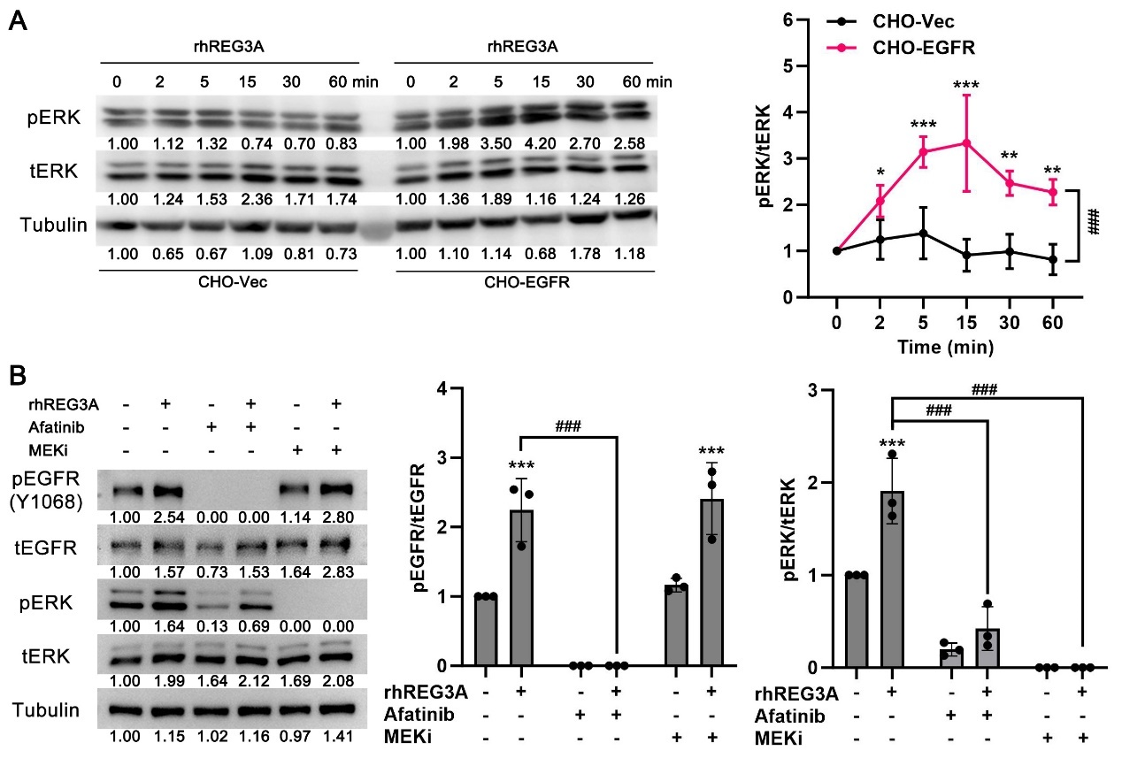
Figure S7. related to figure 5. The effect of rhREG3A on EGFR-MAPK activation in CHO-EGFR cells. (A) CHO cells transfected with vector plasmid (CHO-Vec) or EGFR-overexpression plasmid (CHO-EGFR) were starved for 24 h, and stimulated with 10 μg/mL rhREG3A for different times and evaluated for phosphorylation of ERK by western blotting. All blots were repeated at least 3 times; tubulin was used as an internal reference; the integrated optical density (IOD) of each band in the independent blot was analyzed (*p<0.05, **p<0.01, ***p<0.001, compared to 0-time; ###p<0.001 between two groups (Two-way ANOVA); n=3). (B) Effects of afatinib or MEKi for 5 min on phosphorylation of EGFR and ERK detected by western blotting in CHO-EGFR cells serum starved for 24 h, followed by 10 μg/mL rhREG3A treatment. ***p<0.001, compared to vehicle-treated group; ###p<0.001, as indicated; n=3.

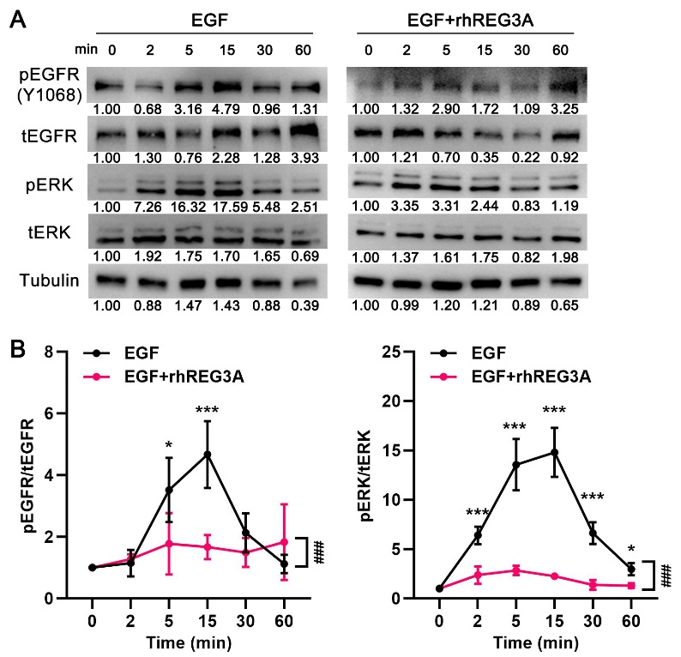
Figure S8. related to figure 6. Time-dependent phosphorylation of EGFR-ERK signal. (A) PANC-1 cells were starved for 24 h, and stimulated with 10 ng/mL EGF in the present/absent of 10 μg/mL rhREG3A for different times and evaluated for phosphorylation of EGFR-ERK by western blotting. (B) All blots were repeated at least 3 times; tubulin was used as an internal reference; the integrated optical density (IOD) of each band in the independent blot was analyzed, and the pEGFR/tEGFR or pERK/tERK ratio was calculated. *p<0.05, **p<0.01, ***p<0.001, compared to 0-time; ###p<0.001 between two groups (Two-way ANOVA); n=3.

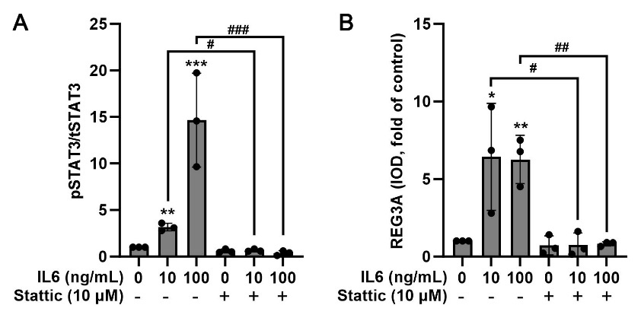
Figure S9. related to figure 7. Integrated optical density (IOD) analysis of western blot in figure 7Q. (A) The IOD of each band in the independent blot was analyzed, and the ratio of pSTAT3/tSTAT3 was calculated and corrected by the internal reference tubulin expression. (B) The IOD of each band (REG3A) in the independent blot was analyzed. All blots were repeated for at least 3 times, tubulin was used as internal reference; *p<0.05, **p<0.01, ***p<0.001, compared to control group; #p<0.05, ##p<0.01, ###p<0.001 as indicated; n=3.

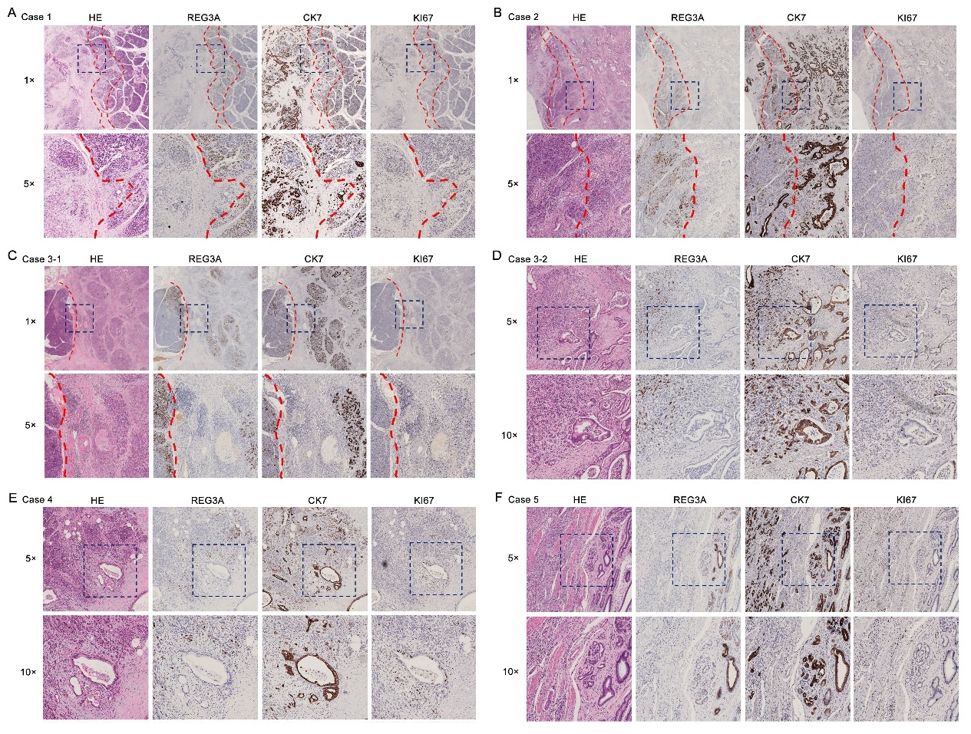
Figure S10, related to figure 8. The HE staining and immunohistochemical staining using REG3A, CK7, and KI67 antibodies in different PDAC tissues.

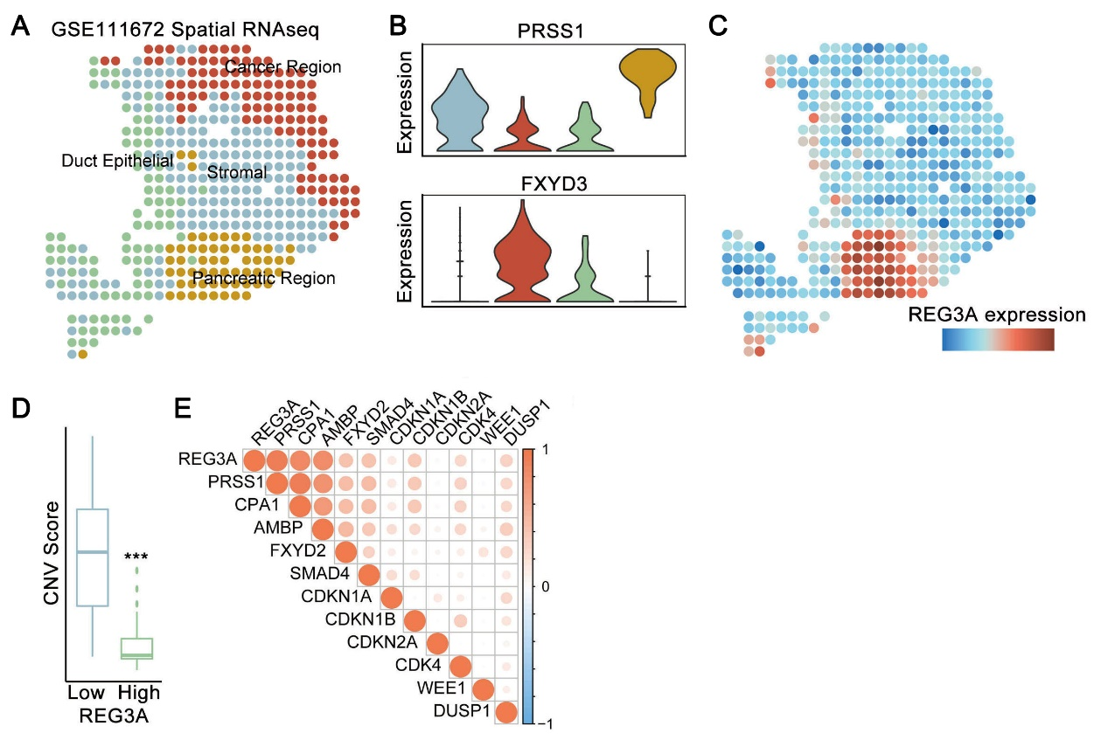
Figure S11, related to figure 8. REG3A is specifically expressed in peritumoral acinar cells that were spatially close to the malignant PDAC cells. (A) The ST mapping of different cell types from the GSE111672 data set. (B) The expression of PRSS1 and FXYD3 in different clusters corresponding to (A). (C) Standardized expression levels of REG3A in (A). (D) The CNV scores in the epithelial cells with different REG3A expression levels. ***p<0.001, as indicated. (E) The correlation between REG3A and some malignant gene expression in epithelial cells.

Supplementary Table 1. The characteristics of patients in serum REG3A measurement
Patient number | Gender | Age | Pathological stage | Clinical stage | Serum REG3A expression (ng/mL) | Survival State  (0=survival, 1=death) | Survival (month) | Metastasis
1 | female | 77 | Healthy | Healthy | 3.14 | \ | \ | \
2 | female | 68 | Healthy | Healthy | 3.50 | \ | \ | \
3 | male | 70 | Healthy | Healthy | 11.29 | \ | \ | \
4 | male | 72 | Healthy | Healthy | 3.50 | \ | \ | \
5 | male | 78 | Healthy | Healthy | 18.82 | \ | \ | \
6 | female | 72 | Healthy | Healthy | 9.31 | \ | \ | \
7 | female | 71 | Healthy | Healthy | 4.82 | \ | \ | \
8 | female | 46 | Healthy | Healthy | 16.87 | \ | \ | \
9 | male | 54 | Healthy | Healthy | 5.18 | \ | \ | \
10 | male | 70 | Healthy | Healthy | 15.12 | \ | \ | \
11 | male | 60 | Healthy | Healthy | 10.88 | \ | \ | \
12 | female | 68 | Healthy | Healthy | 13.81 | \ | \ | \
13 | female | 69 | Healthy | Healthy | 13.23 | \ | \ | \
14 | male | 68 | Healthy | Healthy | 16.49 | \ | \ | \
15 | male | 71 | Healthy | Healthy | 14.18 | \ | \ | \
16 | male | 48 | PanIN 1 | PanIN | 26.41 | 0 | 36 | none
17 | male | 73 | PanIN 1 | PanIN | 38.95 | 0 | 57 | none
18 | male | 58 | PanIN 2 | PanIN | 11.86 | 0 | 45 | none
19 | female | 51 | PanIN 2 | PanIN | 37.02 | 0 | 28 | none
20 | male | 57 | PanIN 2 | PanIN | 30.32 | 1 | 12 | none
21 | female | 67 | PanIN 2 | PanIN | 5.83 | 0 | 13 | none
22 | male | 83 | PanIN 3 | PanIN | 16.02 | 1 | 26 | none
23 | male | 55 | 1 | 1B | 21.23 | 0 | 27 | none
24 | female | 81 | 1 | 1B | 2.77 | 1 | 30 | none
25 | female | 65 | 1 | 1B | 40.79 | 1 | 15 | none
26 | male | 56 | 1 | 2A | 37.06 | 0 | 58 | none
27 | male | 69 | 1 | 2A | 20.66 | 0 | 30 | none
28 | female | 76 | 1 | 2A | 21.30 | 1 | 7 | none
29 | female | 70 | 1 | 2A | 28.79 | 1 | 28 | none
30 | female | 69 | 1 | 2B | 40.27 | 0 | 7 | none
31 | female | 66 | 1 | 2B | 18.14 | 1 | 5 | none
32 | male | 63 | 1 | 2B | 16.85 | 1 | 1 | none
33 | male | 69 | 1 | 2B | 46.55 | 1 | 8 | none
34 | female | 58 | 2 | 1B | 2.58 | 1 | 8 | none
35 | male | 52 | 2 | 1B | 16.66 | 1 | 12 | none
36 | male | 75 | 2 | 1B | 17.76 | 1 | 21 | none
37 | male | 74 | 2 | 1B | 75.60 | 1 | 24 | none
38 | male | 73 | 2 | 1B | 73.05 | 0 | 56 | none
39 | male | 69 | 2 | 1B | 7.56 | 1 | 8 | none
40 | male | 64 | 2 | 2A | 4.67 | 1 | 3 | none
41 | male | 81 | 2 | 2A | 18.44 | 1 | 4 | none
42 | male | 66 | 2 | 2A | 32.02 | 0 | 31 | none
43 | male | 65 | 2 | 2A | 77.12 | 1 | 9 | none
44 | female | 50 | 2 | 2A | 53.68 | 0 | 64 | none
45 | male | 50 | 2 | 2A | 25.42 | 1 | 4 | none
46 | male | 45 | 2 | 2B | 35.54 | 0 | 24 | none
47 | male | 70 | 2 | 2B | 31.53 | 0 | 35 | none
48 | female | 84 | 2 | 2B | 40.69 | 1 | 7 | none
49 | male | 57 | 2 | 2B | 29.33 | 0 | 42 | none
50 | female | 58 | 2 | 2B | 11.64 | 1 | 3 | none
51 | male | 63 | 2 | 2B | 28.44 | 1 | 16 | none
52 | male | 52 | 2 | 2B | 70.55 | 1 | 4 | none
53 | male | 75 | 2 | 2B | 54.98 | 1 | 6 | none
54 | male | 58 | 2 | 2B | 25.72 | 1 | 16 | none
55 | male | 74 | 2 | 2B | 54.27 | 1 | 14 | none
56 | male | 74 | 2 | 2B | 78.41 | 1 | 8 | none
57 | male | 76 | 2 | 2B | 40.18 | 1 | 4 | none
58 | male | 61 | 2 | 2B | 38.12 | 1 | 7 | none
59 | female | 61 | 2 | 2B | 13.03 | 1 | 9 | none
60 | male | 73 | 2 | 2B | 72.19 | 1 | 5 | none
61 | female | 68 | 2 | 2B | 25.28 | 0 | 34 | none
62 | male | 65 | 2 | 3 | 59.93 | 1 | 12 | none
63 | female | 63 | 2 | 3 | 0.76 | 0 | 33 | none
64 | female | 67 | 2 | 3 | 18.30 | 1 | 4 | none
65 | female | 80 | 2 | 3 | 61.23 | 1 | 14 | none
66 | male | 83 | 2 | 3 | 9.69 | 1 | 0 | none
67 | male | 76 | 2 | 3 | 44.57 | 1 | 10 | none
68 | female | 70 | 3 | 1B | 7.76 | 0 | 36 | none
69 | male | 76 | 3 | 1B | 48.58 | 1 | 1 | none
70 | male | 44 | 3 | 2B | 14.81 | 1 | 6 | none
71 | male | 59 | 3 | 2B | 44.63 | 1 | 4 | none
72 | female | 50 | 3 | 3 | 14.49 | 1 | 4 | none
73 | male | 70 | 3 | 3 | 2.33 | 0 | 40 | none
74 | female | 77 | 3 | 3 | 26.75 | 1 | 15 | none
75 | female | 82 | 3 | 3 | 65.74 | 1 | 6 | none
76 | male | 69 | 3 | 3 | 74.92 | 1 | 1 | none
77 | female | 65 | 3 | 4 | 28.19 | 1 | 6 | lung
78 | female | 67 | 3 | 4 | 63.09 | 1 | 30 | liver
79 | female | 66 | 3 | 4 | 70.14 | 1 | 16 | liver
80 | male | 78 | 3 | 4 | 33.75 | 1 | 5 | liver
81 | male | 71 | 3 | 4 | 75.54 | 1 | 7 | liver
82 | male | 67 | 3 | 4 | 19.82 | 1 | 9 | mesenterium

Supplementary Table 2. The characteristics of patients in tissue microarrays
Patient  number | Survival  (month) | Tumoral REG3A expression (IOD) | Peritumoral REG3A expression (IOD) | Neucleic  pSTAT3 ratio (%) | Gender | Age | Metastasis | Pathological stage | Clinical stage
1 | 6 | 5.50 | 91.00 | 14 | female | 78 | none | 2 | 2A
2 | 65 | 0.00 | 7.00 | 32 | male | 72 | none | 3 | 1B
3 | 15 | 0.00 | 76.00 | 21 | male | 71 | none | 2 | 1B
4 | 8 | 0.00 | 15.00 | 7 | male | 65 | none | 3 | 2B
5 | 9 | 0.00 | 379.00 | 22 | female | 73 | none | 1 | 2B
6 | 4 | 1.60 | 1.50 | 12 | male | 60 | none | 1 | 2A
7 | 57 | 0.00 | 3.00 | 9 | female | 68 | none | 2 | 1B
8 | 57 | 0.00 | 0.00 | 34 | male | 50 | none | 2 | 2A
9 | 9 | 218.00 | 10.00 | 65 | male | 58 | none | 2 | \
10 | 5 | 0.00 | 0.00 | 90 | male | 68 | none | 3 | 2A
11 | 4 | 0.00 | 1697.00 | 81 | female | 68 | liver | 3 | 4
12 | 6 | 134.00 | 4.80 | 38 | female | 69 | none | 2 | \
13 | 6 | 0.00 | 97.00 | 35 | female | 78 | none | 2 | 2B
14 | 32 | \ | 0.00 | 18 | female | 60 | none | 2 | 2B
15 | 16 | 0.00 | 386.00 | 52 | male | 68 | none | 1 | 2B
16 | 17 | 0.00 | 317.00 | 52 | male | 54 | none | 3 | 2B
17 | 12 | 0.00 | 5.60 | 63 | male | 57 | none | 3 | 2B
18 | 8 | 0.00 | 5.60 | 39 | female | 71 | none | 3 | \
19 | 3 | 0.00 | 39.00 | 62 | male | 66 | none | 3 | 2B
20 | 16 | 0.00 | 88.00 | 41 | male | 59 | none | 3 | 2B
21 | 44 | 0.00 | 4.50 | 45 | male | 77 | none | 1 | 2A
22 | 8 | \ | 0.00 | 9 | female | 76 | none | 2 | 2A
23 | 3 | 0.00 | 0.00 | 93 | male | 56 | none | 3 | 2B
24 | 5 | 0.00 | 19.00 | 93 | female | 79 | none | 2 | 2B
25 | 28 | 0.00 | 0.00 | 21 | male | 65 | none | 1 | 1B
26 | 4 | 0.00 | 4.00 | 46 | male | 41 | liver | 3 | 4
27 | 2 | 0.00 | 0.00 | 29 | male | 70 | none | 1 | 2A
28 | 8 | 15.00 | 42.00 | 66 | male | 72 | none | 2 | 2A
29 | 8 | 0.00 | 178.00 | 95 | female | 72 | none | 3 | 2B
30 | 6 | 0.00 | 10.00 | 85 | male | 57 | none | 3 | \
31 | 35 | 0.00 | 3.00 | 72 | male | 67 | none | 2 | 2A
32 | 34 | 0.00 | 0.00 | 49 | female | 59 | none | 3 | 2A
33 | 2 | 0.00 | 2.00 | 39 | female | 85 | none | 3 | 2A
34 | 21 | 0.00 | 1.00 | 26 | female | 56 | none | 3 | 2B
35 | 9 | \ | 7.00 | 29 | male | 54 | mesenterium | 3 | 4
36 | 32 | 0.00 | 159.00 | 81 | female | 79 | none | 1 | 2A
37 | 1 | 0.00 | 505.00 | 96 | male | 76 | none | 3 | 2A
38 | 8 | 0.00 | 0.00 | 18 | male | 63 | none | 3 | 2B
39 | 31 | 0.00 | 5.00 | 34 | female | 69 | none | 2 | 2A
40 | 30 | 0.00 | 1.00 | 40 | female | 58 | none | 2 | 2B
41 | 13 | 0.00 | 4.00 | 37 | male | 77 | none | 2 | \
42 | 30 | 0.00 | 0.00 | 17 | male | 62 | none | 2 | 2B
43 | 23 | \ | 5.50 | 99 | female | 59 | none | 2 | 1A
44 | 5 | \ | 3.00 | 86 | male | 59 | liver | 3 | 4
45 | 13 | 0.00 | 21.00 | 38 | female | 56 | none | 1 | 2B
46 | 28 | 0.00 | 34.00 | 66 | male | 43 | none | 2 | 2B
47 | 2 | 0.00 | 9.00 | 23 | male | 68 | none | 3 | 2A
48 | 10 | 0.00 | \ | \ | male | 73 | none | 1 | 2B
49 | 9 | 0.00 | 26.00 | 13 | male | 53 | none | 2 | \
50 | 14 | 11.00 | 0.00 | 84 | female | 60 | none | 3 | 2B
51 | 10 | 3.00 | 0.00 | 49 | male | 55 | none | 3 | 2
52 | 23 | 0.00 | 127.00 | 99 | male | 54 | none | 2 | 2A
53 | 7 | 0.00 | 4.00 | 17 | male | 81 | none | 2 | \
54 | 4 | 0.00 | \ | \ | male | 59 | none | 3 | \
55 | 17 | 0.00 | \ | \ | female | 76 | none | 3 | 2A
56 | 12 | 0.00 | 1.00 | 4 | male | 71 | none | 2 | \
57 | 3 | 0.00 | 1103.00 | 34 | female | 77 | none | 2 | 2A
58 | 31 | \ | \ | \ | female | 63 | none | 1 | 2A

Supplementary Table 3. GEO datasets
GEO accession | Samples | Platforms | References
GSE71989 | 14 pancreatic ductal adenocarcinoma tumors and 8 normal pancreatic tissue samples | GPL570 [HG-U133_Plus_2] Affymetrix Human Genome U133 Plus 2.0 Array | (1)
GSE32676 | 42 human pancreatic ductal adenocarcinoma tumors and 7 non-malignant pancreas samples | GPL570 [HG-U133_Plus_2] Affymetrix Human Genome U133 Plus 2.0 Array | (2,3)
GSE101448 | 24 human pancreatic ductal adenocarcinoma tumors and 19 non-malignant pancreas samples | GPL10558 Illumina HumanHT-12 V4.0 expression beadchip | (4)
GSE43795 | 6 pancreatic adenocarcinomas and 5 non-neoplastic pancreatic tissues | GPL10558 Illumina HumanHT-12 V4.0 expression beadchip | (5)
GSE62165 | 118 human pancreatic ductal adenocarcinoma tumors and 13 non-malignant pancreas samples | GPL13667 [HG-U219] Affymetrix Human Genome U219 Array | (6)
GSE28735 | 45 pancreatic ductal adenocarcinoma tumors and matching normal pancreatic tissue samples | [HuGene-1_0-st] Affymetrix Human Gene 1.0 ST Array [transcript (gene) version] | (7,8)
GSE62452 | 69 pancreatic ductal adenocarcinoma tumors, including 61 matching normal pancreatic tissue samples | [HuGene-1_0-st] Affymetrix Human Gene 1.0 ST Array [transcript (gene) version] | (9)
References of supplementary table 3
1. Jiang J, Azevedo-Pouly AC, Redis RSS, Lee EJ, Gusev Y, Allard D, et al. Globally increased ultraconserved noncoding RNA expression in pancreatic adenocarcinoma. Oncotarget 2016;7:53165-77
2. Donahue TR, Tran LM, Hill R, Li Y, Kovochich A, Calvopina JH, et al. Integrative survival-based molecular profiling of human pancreatic cancer. Clinical cancer research : an official journal of the American Association for Cancer Research 2012;18:1352-63
3. Toste PA, Li L, Kadera BE, Nguyen AH, Tran LM, Wu N, et al. p85alpha is a microRNA target and affects chemosensitivity in pancreatic cancer. J Surg Res 2015;196:285-93
4. Klett H, Fuellgraf H, Levit-Zerdoun E, Hussung S, Kowar S, Kusters S, et al. Identification and Validation of a Diagnostic and Prognostic Multi-Gene Biomarker Panel for Pancreatic Ductal Adenocarcinoma. Front Genet 2018;9:108
5. Park M, Kim M, Hwang D, Park M, Kim WK, Kim SK, et al. Characterization of gene expression and activated signaling pathways in solid-pseudopapillary neoplasm of pancreas. Mod Pathol 2014;27:580-93
6. Janky R, Binda MM, Allemeersch J, Van den Broeck A, Govaere O, Swinnen JV, et al. Prognostic relevance of molecular subtypes and master regulators in pancreatic ductal adenocarcinoma. BMC Cancer 2016;16:632
7. Zhang G, Schetter A, He P, Funamizu N, Gaedcke J, Ghadimi BM, et al. DPEP1 inhibits tumor cell invasiveness, enhances chemosensitivity and predicts clinical outcome in pancreatic ductal adenocarcinoma. PLoS One 2012;7:e31507
8. Zhang G, He P, Tan H, Budhu A, Gaedcke J, Ghadimi BM, et al. Integration of metabolomics and transcriptomics revealed a fatty acid network exerting growth inhibitory effects in human pancreatic cancer. Clinical cancer research : an official journal of the American Association for Cancer Research 2013;19:4983-93
9. Yang S, He P, Wang J, Schetter A, Tang W, Funamizu N, et al. A Novel MIF Signaling Pathway Drives the Malignant Character of Pancreatic Cancer by Targeting NR3C2. Cancer Res 2016;76:3838-50

