Supporting Information for:
Probiotics promote cellular wound healing responses by modulating the PI3K and TGF-β/Smad signaling pathways
Sixuan Zhang¹, Yvonne Elbs-Glatz¹, Siyuan Tao¹, Steven Schmitt², Zhihao Li^{1*}, Markus Rottmar^{1, *}, Katharina Maniura-Weber^{1, *}, Qun Ren^{1,} *
¹ Empa, Swiss Federal Laboratories for Materials Science and Technology, Biointerfaces Lab, 9014 St. Gallen, Switzerland
² ETH Zurich, D-BSSE (Department of Biosystems Science and Engineering), 4056 Basel, Switzerland
* Corresponding authors

Corresponding Authors
*Email:
qun.ren@empa.ch
katharina.maniura@empa.ch
markus.rottmar@empa.ch
zhihaoli91@gmail.com

EXPERIMENTAL SECTION
- Cytocompatibility of PI3K inhibitor to HDFs and BioK
Cytocompatibility of PI3K inhibitor to HDFs: HDFs were tested for the inhibitor cytotoxicity with DMEM medium containing 10% FCS. Cells at a density of 10,000 per well were seeded in a 96-well plate, and inhibitor LY294002 at final concentrations 0, 0.125, 0.25, 0.5, 1, 2, 4, 6, 8, 10, 20 µM were added. A concentration of 0.1% Triton was used as negative control. The cells were incubated for 1, 3 and 5 days respectively; the medium was changed every day. Cell viability was determined using PrestoBlue Kit and the Mithras plate reader, with fluorescence excitation wavelength at 547nm and emission wavelength at 582nm.
Effect of PI3K inhibitor on the growth kinetics of probiotics: Probiotic growth kinetics were studied in MRS and DMEM media using PI3K inhibitor. The starting concentration of probiotics was O.D 0.1, the concentrations of PI3K inhibitor were 0, 0.125, 0.25, 0.5, 1, 2, 4 µM, respectively. 200 µL media containing BioK and inhibitors were added in a 96-well plate and incubated in a Synergy™ H1 Microplate reader at 37°C for 24 h, during which the absorbance at 600 nm was recorded every 30 min.
- Promoting effect of lactate on fibrosis of HDFs
Preparation of calibration curves for lactate: Standard curves of lactate were prepared using (S)-2-Hydroxypropionic acid (L(+)-Lactic acid) (Fluka, Switzerland) and differentiation medium where the gradients of lactate were 0, 1, 2.5, 5, 10, 25, 50 and 100 mM. The correlation of lactate concentration and the lactate peak area was followed.
Screening of lactate concentration for myofibroblast differentiation experiments: HDFs were used for the lactate cytotoxicity test in DMEM medium containing 10% FCS. Cells at a density of 10,000 per well were seeded in a 96-well plate, and lactate at final concentrations 1, 5, 10, 20, 30 and 40 mM was added. A concentration of 0.1% Triton was used as negative control. The cells were incubated for 1, 2 and 3 days respectively; the medium was changed every day. Cell viability was determined using the PrestoBlue Kit as above. Based on the results, Lactate at a concentration of 1, 5 and 10 mM were selected for subsequent experiments.
Myofibroblast differentiation experiment with lactate and BioK: In the differentiation experiment, RPMI-1640 containing 1% HS and 1% glutamine was used to prepare the conditioned medium. Ten experimental groups were investigated, including the control group (HS), a positive control group (TGF), two groups with MOI 1 probiotic (BioK and BioK+TGF), six lactate groups including lactate 1, 5, 10 mM and Lactate+TGF 1, 5, 10 mM. HDFs were seeded in a 96-well plate with 20,000 cells for staining, and 30,000 cells in a 48-well plate for gene expression test, and after overnight culture, the prepared medium replaced the old medium. After a 3-day coculture period, the medium was collected for HPLC and pH measurements, the cells were collected for gene expression analysis and immunohistological staining.
Supplementary figures
- Effects of PI3K inhibitor and MEK on the growth of fibroblasts and probiotics
Figure S1A show the effects of PI3K inhibitor on the cellular activity of fibroblasts. The results of the data indicate that the lower the concentration, the smaller the effect. Based on this result, we narrowed down the concentration range (0-4 µM) to examine the effect of the inhibitor on the growth of probiotics in both MRS (Figure S1B) and DMEM (Figure S1C) media. It was found that the selected concentrations of inhibitor did not negatively affect the growth of probiotics.
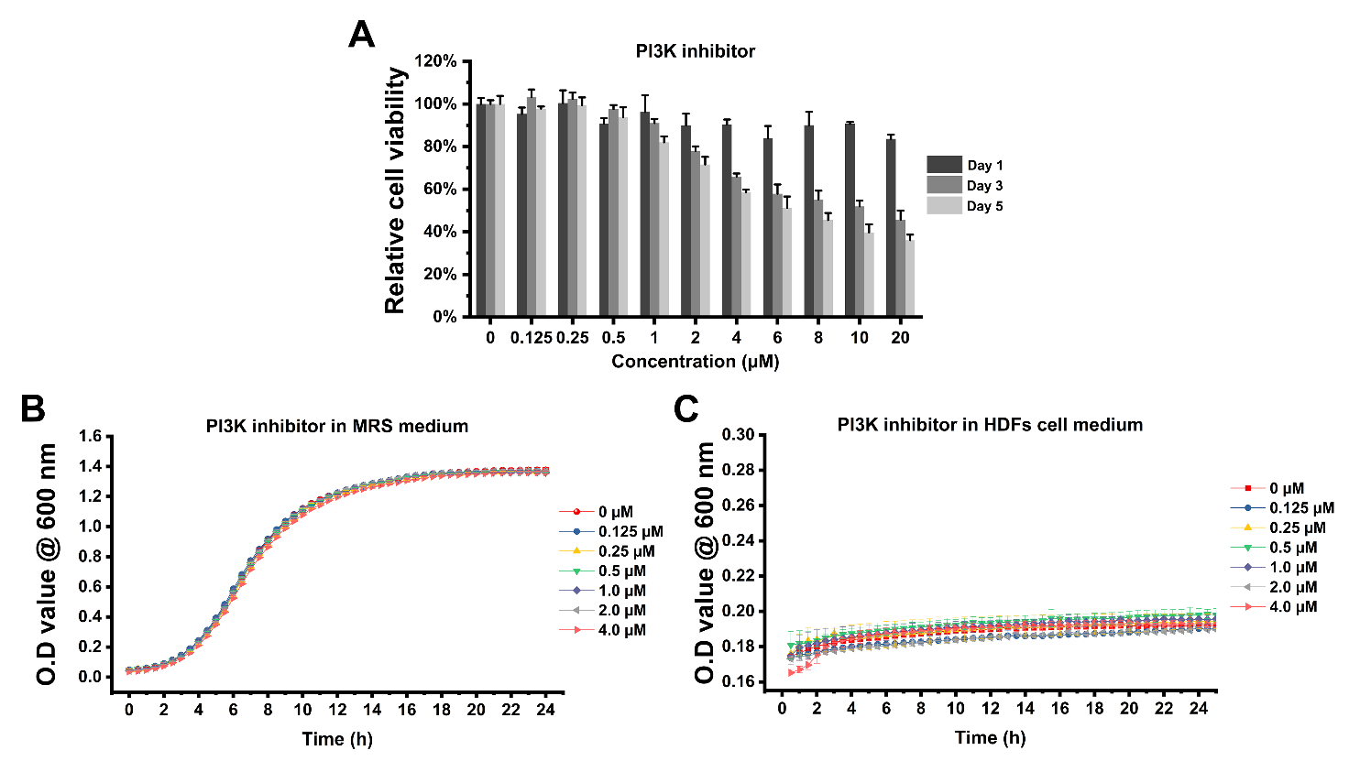
Figure S1. Effects of PI3K inhibitor on the viability of HDFs (A) and growth of probiotics in MRS medium (B) and DMEM medium (C). Data are the mean ± SD (n=3).

- Effects of different concentrations of PI3K inhibitor and MEK on the expression of genes related to PI3K signaling pathway
With the assurance that the inhibitor concentration screened will not affect the cell viability, it is necessary to ensure that the PI3K inhibitor does reduce the expression of genes involved in PI3K-related signaling pathway. Based on the results of Figure S1, we selected three concentrations of 0.25, 0.5, and 1.0 µM for PI3K inhibitor for the screening of final conditions. The results of PCR showed that 1 µM of PI3K inhibitor reduced the expression of PI3K-related genes such as Paxillin (Figure S2A), PI3K (Figure S2B), PKC (Figure S2C), and ITG-β1 (Figure S2D). A concentration of 1µM LY294002 was chosen for the next validation experiments as the negative control.
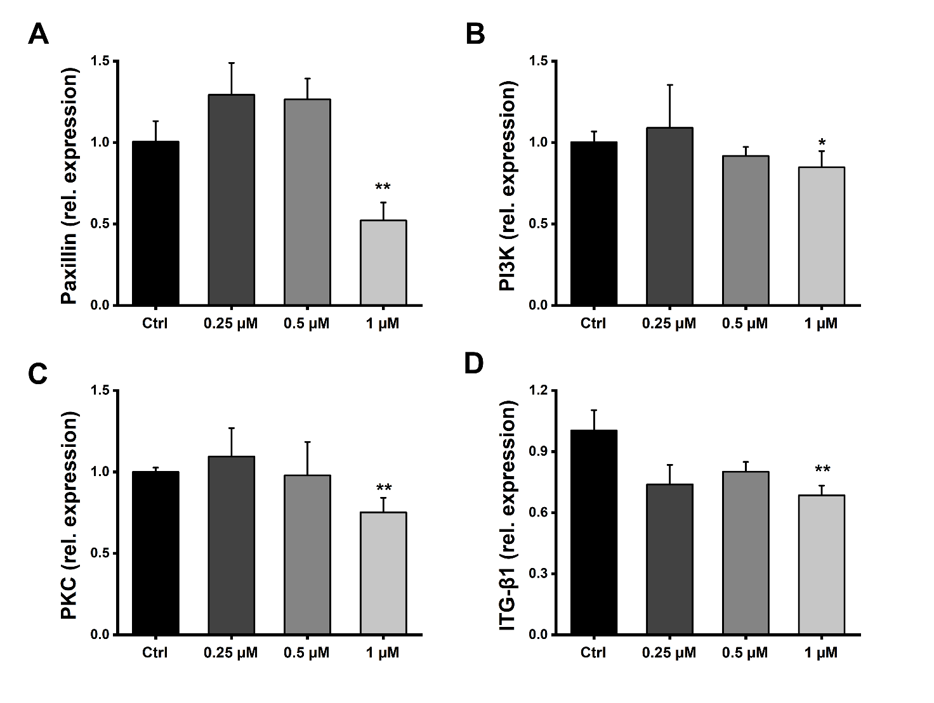
Figure S2. Effects of different concentrations of PI3K inhibitor on the expression of genes related to PI3K signaling pathway. (A) Paxillin, (B) PI3K, (C) PKC and (D) ITG-β1. Control is the group without treatment of PI3K inhibitor. Error bars represent the standard deviation of the mean (n=3, *P< 0.05, **P<0.01 by t-test).

- Effect of BioK of MOI 1 on the TGF-β signalling pathway

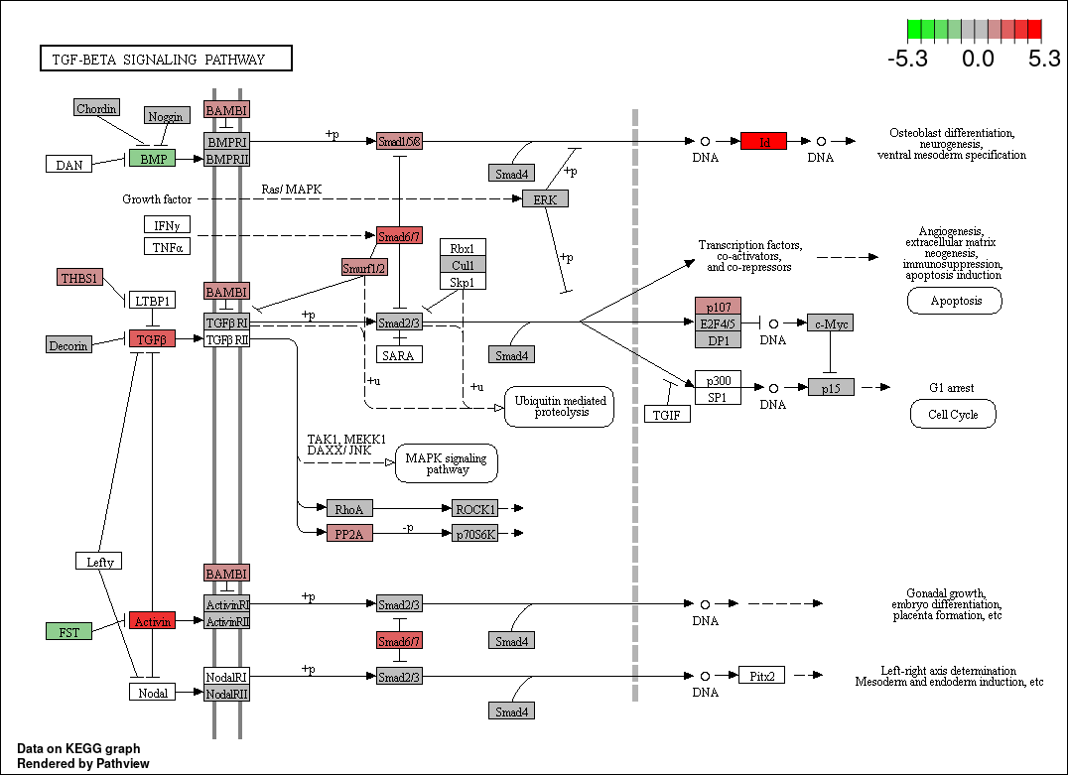
Figure S3: The up- and down-regulated expression of genes involved in the TGF signalling pathway via KEGG analysis in MOI 1 BioK treated group. Red colour indicates up-regulation of gene expression, while green colour indicates a decrease in gene expression. Colour saturation is proportional to the absolute value.

- Quantitative analysis of extracellular collagen
Figure S4 shows a polynomial fit to the collagen concentration vs absorbance data. The fitted equation is:
Y=0.0031•x+0.04348, (R²=0.9983)
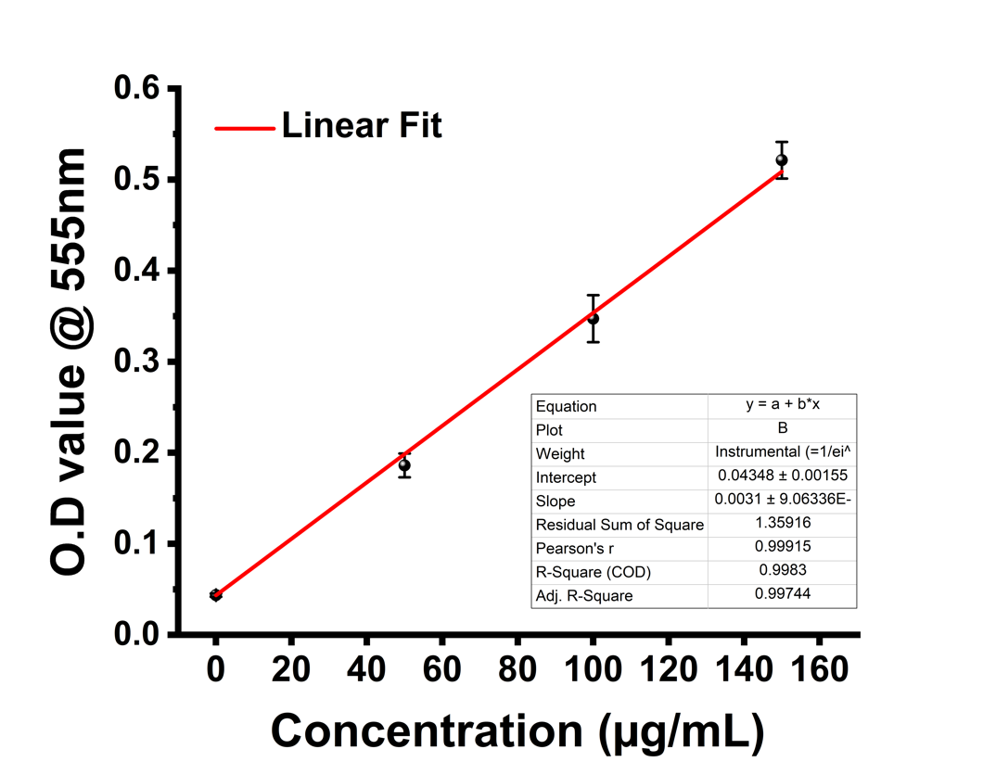
Figure S4. The calibration curve of type Ⅰ collage measured using a Sirol kit.

- Biochemical properties of media containing different concentrations of sodium bicarbonate
Figure S5A illustrates the pH stability of media containing different concentrations of buffer after 24 h of incubation. Figure S5B shows the starting pH of the differentiation media containing different concentrations of buffer, which was 7.47 for the complete medium and 7.15, 7.03, 6.88 and 6.64 for the medium containing 50%, 40%, 30% and 20% buffer, respectively. The cytotoxicity test results of showed that after incubating the cells with 50%, 40%, 30% and 20% buffered medium for 3 days, the corresponding cellular activities were 97%, 85%, 75% and 48%, respectively (Figure S5C). As a consequence, a differentiation medium containing 40% buffer was used as reference groups for the next validation experiments.
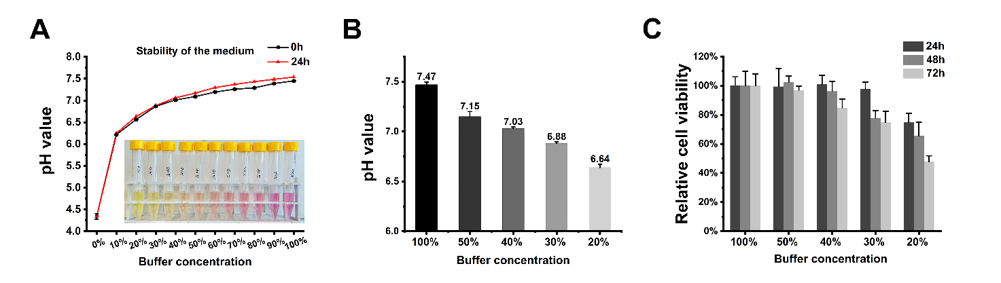
Figure S5. Biochemical properties of media containing different concentrations of sodium bicarbonate buffer. (A) Changes in color and pH corresponding to media with different buffer concentrations over 24 hours; (B) Initial pH of differentiation media with different concentrations of buffer; (C) Effect of differentiation media containing different concentrations of buffer on cell vitality. Data are the mean ± SD (n=3).

- Quantitative analysis of lactate
Figure S6 shows a polynomial fit to the lactate concentration vs response data (lactate peak area). The fitted equation is:
Y=2.57×10⁴•x-9.0×10³, (R²=0.99985)
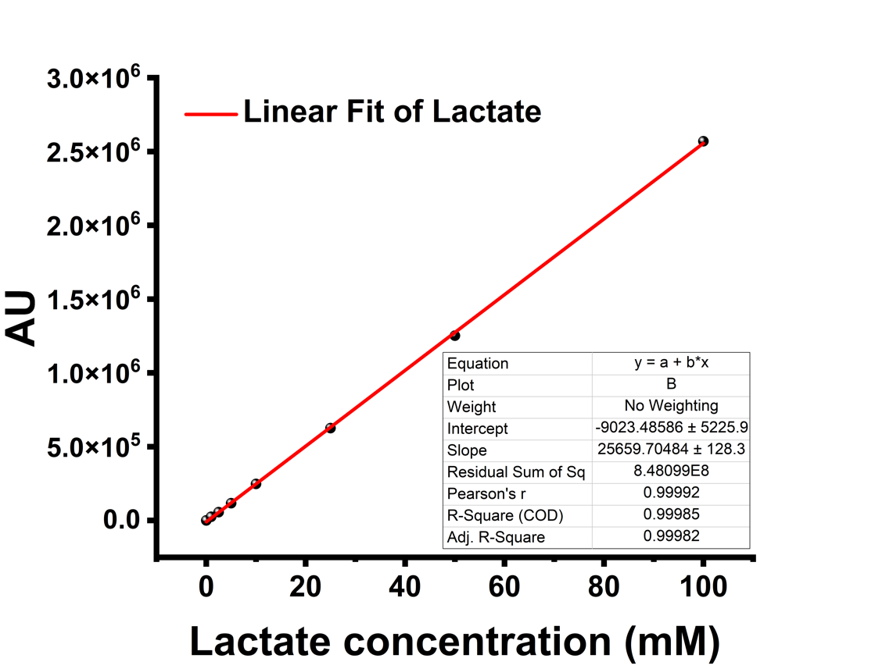
Figure S6. The polynomial fit curve of lactate concentration in the HPLC test.

- Screening of lactate concentration for the differentiation of fibroblasts to myofibroblasts
Figure S7 demonstrates the effect of different concentrations of lactate on cell activity analysed by CCK assay. The relative cell viability decreases with increasing concentration. CCK test results show that the viability of the cells incubated with 10 mM lactate was at 89% after 3 days, but was reduced to 73% with 20 mM lactate. Therefore, 10 mM concentration of lactate was chosen for the next differentiation experiments.
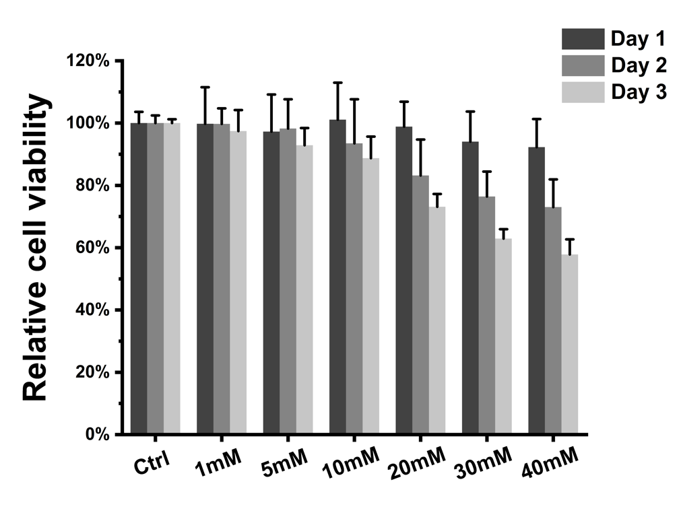
Figure S7. Cytocompatibility of different concentrations of lactate for fibroblasts. 'Ctrl' is the group without treatment of lactate. Data are the mean ± SD (n=3).

