Supplementary Tables and Figures
Experimental  System | Condition | Proteomics  replicates | Phosphoproteomics  replicates | Average Pearson Correlation in proteomics replicates | Average Pearson Correlation in phosphoproteomics replicates
K562 | Ctrl | 4 | 4 | 0.97 | 0.8
K562 | Ima | 4 | 4 | 0.97 | 0.85
LAMA84 | Ctrl | 4 | 3 | 0.98 | 0.82
LAMA84 | Ima | 4 | 4 | 0.99 | 0.82
K562-R | Ctrl | 3 | 4 | 0.95 | 0.87

Table A. Table reporting the number of replicates and the average Pearson correlation for K562, LAMA84 and K562-R cells in control condition and upon imatinib exposure in proteomics and phosphoproteomics experiments.
Inhibitor | Vendor | Catalog number
Azacytidine | Selleck Chemicals | S1782
Copanlisib | Selleck Chemicals | S2802
Ibrutinib | Selleck Chemicals | S2680
Imatinib | Selleck Chemicals | S2475
Midostaurin | Selleck Chemicals | S8064
MK-2206 | Selleck Chemicals | S1078
Quizartinib | Selleck Chemicals | S1526
Ruxolitinib | Selleck Chemicals | S1378
Venetoclax | Selleck Chemicals | S8048

Table B. Table reporting the inhibitor used for treatment of CML cell models.
Antibody | Vendor | Catalog number
α-phospho-c.ABL (Y412) | Cell Signaling Technology | 2865
α-c-ABL | Santa Cruz | sc-23
α-phospho-STAT5 (Y694) | Cell Signaling Technology | BK9351
α-STAT5 | Cell Signaling Technology | 94205
α-phospho-ERK1/2 (T202/Y204) | Cell Signaling Technology | 9101
α-ERK1/2 | Cell Signaling Technology | 4695
α-phospho-mTOR (S2448) | Cell Signaling Technology | 5536
α-mTOR | Cell Signaling Technology | 4517
α-phospho-P70 S6 Kinase (T389) | Cell Signaling Technology | 9234
α-P70 S6 Kinase | Cell Signaling Technology | 9202
α-phospho-AKT (S473) | Cell Signaling Technology | 4060
α-AKT | Cell Signaling Technology | 9272
α-GAPDH | Cell Signaling Technology | 2118
α-p62 | Santa Cruz | sc-28359
α-LC3B | Cell Signaling Technology | 3868
α-PI3 Kinase p85α | Cell Signaling Technology | 4275
α-phospho-JAK1 (Y1035/1035) | Cell Signaling Technology | 3331
α-JAK1 | Cell Signaling Technology | 50996
α-phospho-FLT3 (Y589/591) | Cell Signaling Technology | 3464
α-FLT3 | Cell Signaling Technology | 3462
α-MYC | Cell Signaling Technology | 9402
α-γH2AX | Cell Signaling Technology | 9718
α-NFKB p65 (RELA) | Santa Cruz | sc-8008
α-ACTIN | Sigma | A2066
α-VINCULIN | Cell Signaling Technology | 13901
α-Cyclin B1 | Cell Signaling Technology | 4138
α-Cyclin H | Cell Signaling Technology | 2927
α-CDK1/2 | Santa Cruz | sc-53219
α-CDK2 | Santa Cruz | sc-6248
α-p21 | Santa Cruz | sc-6246

Table C. Table reporting antibodies used for Western blotting and Immunofluorescence analysis.

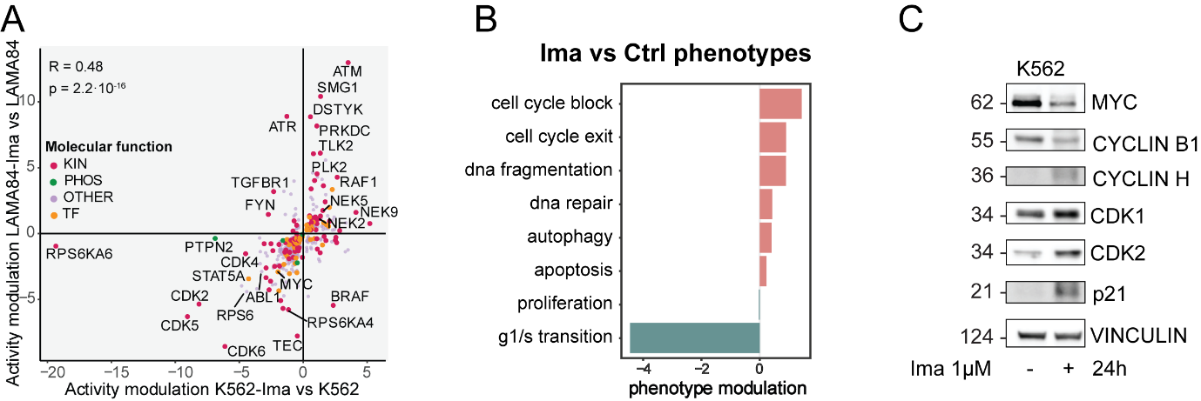
Figure S1. Functional analysis of imatinib-treated sensitive cell models and patients
A. Scatterplot showing the comparison between imatinib-mediated changes of inferred protein activity in K562 (x-axis) and LAMA84 (y-axis) cells. Each dot represents a protein, and the color indicates the molecular function: kinases (red), phosphatases (green), others (violet), and transcription factors (orange). R indicates Pearson correlation.
B. Bar plot of the phenotypic modulation upon imatinib treatment in sensitive cells inferred by SignalingProfiler 2.0. Blue and red bars represent inactive and active phenotypes, respectively.
C. Representative western blot of how proteins involved in cell cycle regulation are modulated by 24h imatinib treatment.
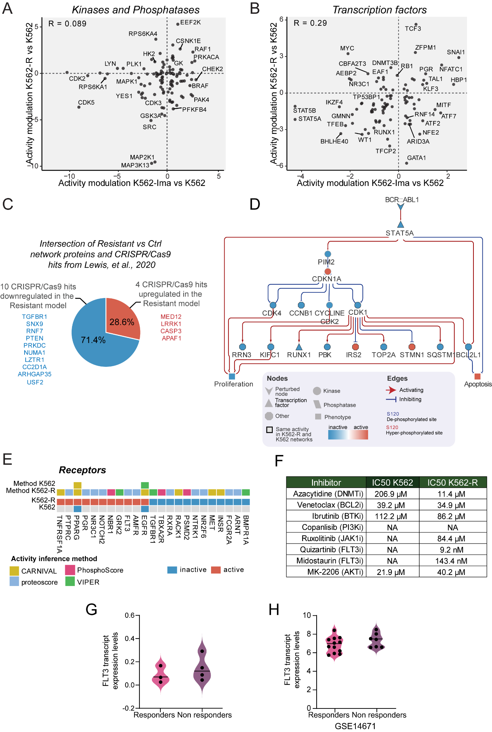
Figure S2. Construction and validation of K562-R resistance model
A-B. Scatterplots showing the comparison between kinases/phosphatases (A) and transcription factors (B) activity predicted in K562 and K562-R cells vs control cells datasets for kinases and phosphatases. R indicates Pearson correlation.
C. Pie chart of the intersection of K562-R cells signaling network proteins with CRISPR/Cas9 hits from Lewis, et al., 2020 work.
D. BCR::ABL1-dependent mechanisms in K562-R cells signaling network. Functional submodel extracted from SignalingProfiler 2.0 output linking BCR::ABL1 to proteins with the same modulation in K562-R and K562 upon imatinib treatment (highlighted in black).
E. Heatmap reporting for control and K562-R cells the activity of receptors in SignalingProfiler 2.0 generated networks.
F.Table showing IC50 calculations derived from MTT viability assays of FDA-approved inhibitors on K562 and K562-R for 24 hours.
G. Quantification of FLT3 transcript levels in RNAseq analysis of responder and non responder patients derived primary blasts (GSE280476).
H. Quantification of FLT3 transcript levels in responders and non responders CML patients from RNAseq analysis obtained from GEO dataset (GSE14671).

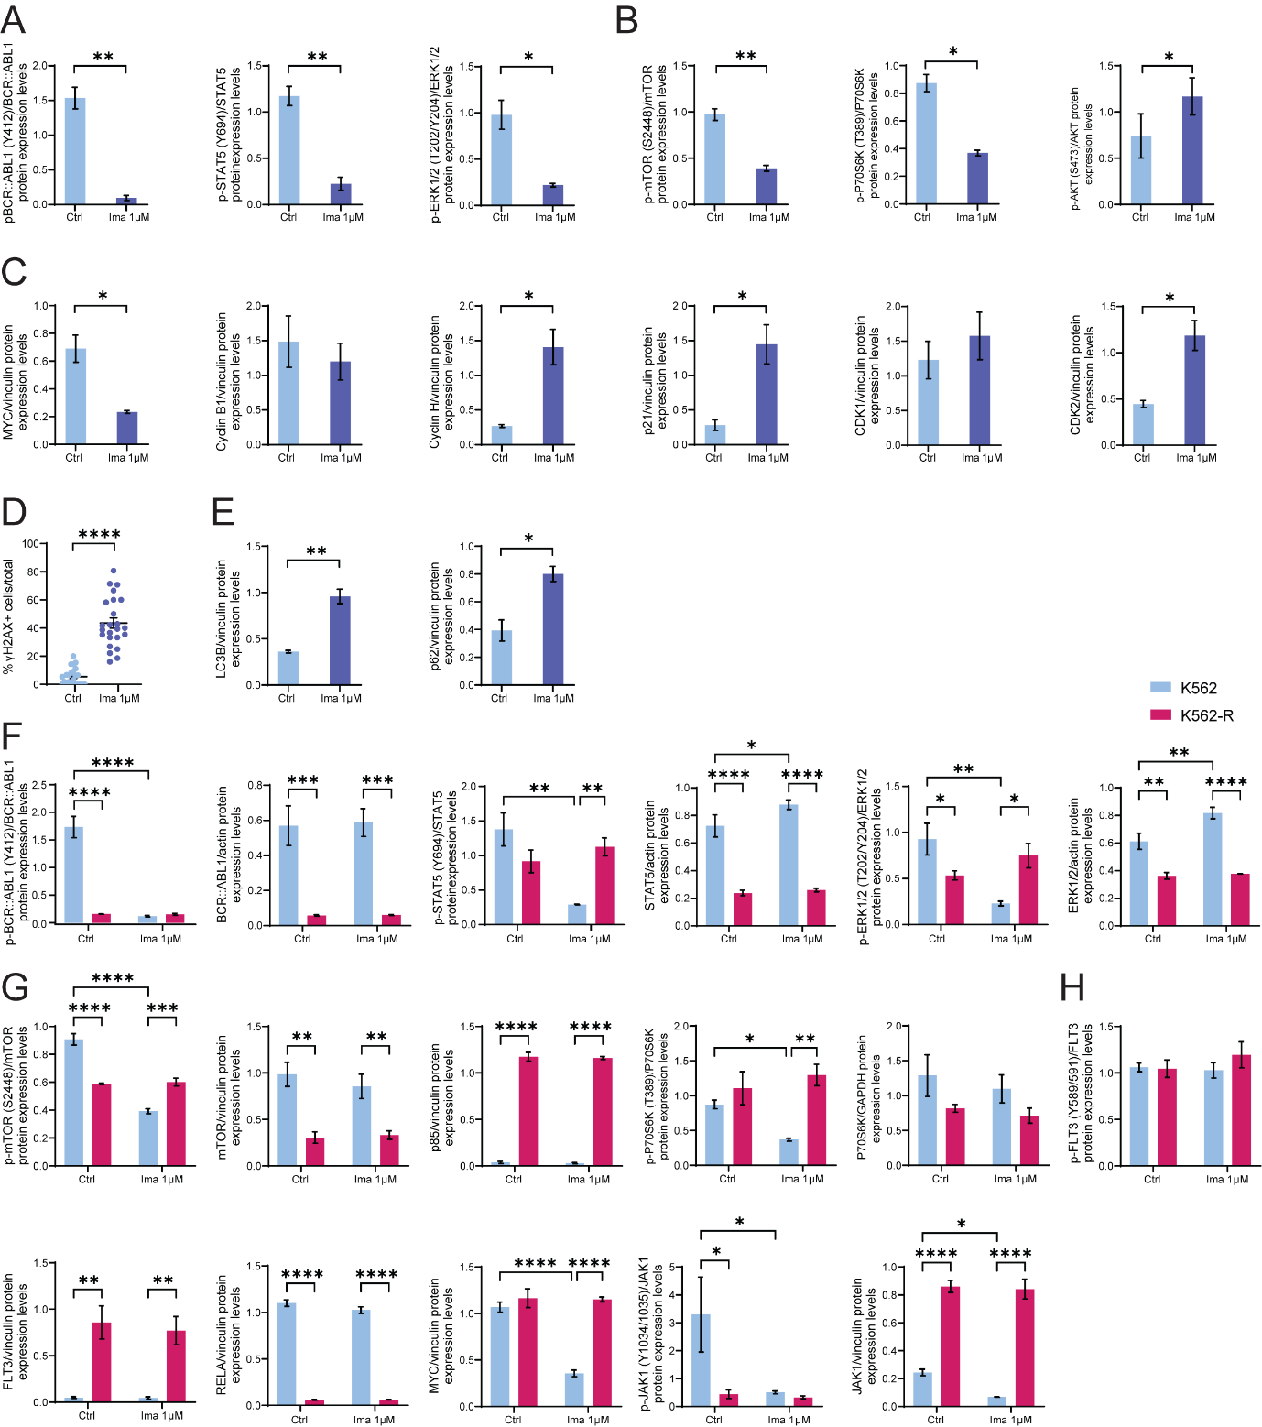
Figure S3. Quantification of proteins phosphorylation status and expression levels
A. Quantification of phosphorylation status of p-BCR::ABL1 (Y412), p-STAT5 (Y694), p-ERK1/2 (T202/Y204) upon 24h of 1µM imatinib treatment in K562 cells.
B. Quantification of phosphorylation status of p-mTOR (S2448), p-P70S6K (T389) and p-AKT (S473) upon 24h of 1µM imatinib treatment in K562 cells.
C. Quantification of protein abundance of MYC, Cyclin B1, Cyclin H, p21, CDK1 and CDK2 upon 24h of 1µM imatinib treatment in K562 cells.
D. Quantification of the percentage of γH2AX+ K562 cells upon 24h exposure to imatinib. Cells were considered positive if they show ≥ 5 foci. The number of γH2AX positive cells were normalized on the total number of cells.
E. Quantification of protein abundance of key autophagy regulators LC3B and p62 in K562 cells upon 90 minutes imatinib treatment.
F. Quantification of phosphorylation status and protein abundance of p-BCR::ABL1 (Y412), p-STAT5 (Y694), p-ERK1/2 (T202/Y204) upon 24h of 1µM imatinib treatment in K562 and K562-R cells.
G. Quantification of phosphorylation status and protein abundance of p-mTOR (S2448), p85α and p-P70S6K (T389) upon 24h of 1µM imatinib treatment in K562 and K562-R cells.
H. Quantification of phosphorylation status and protein abundance of p-FLT3 (Y589/591), RELA, MYC and p-JAK1 (Y1034/1035) upon 24h of 1µM imatinib treatment in K562 and K562-R cells.

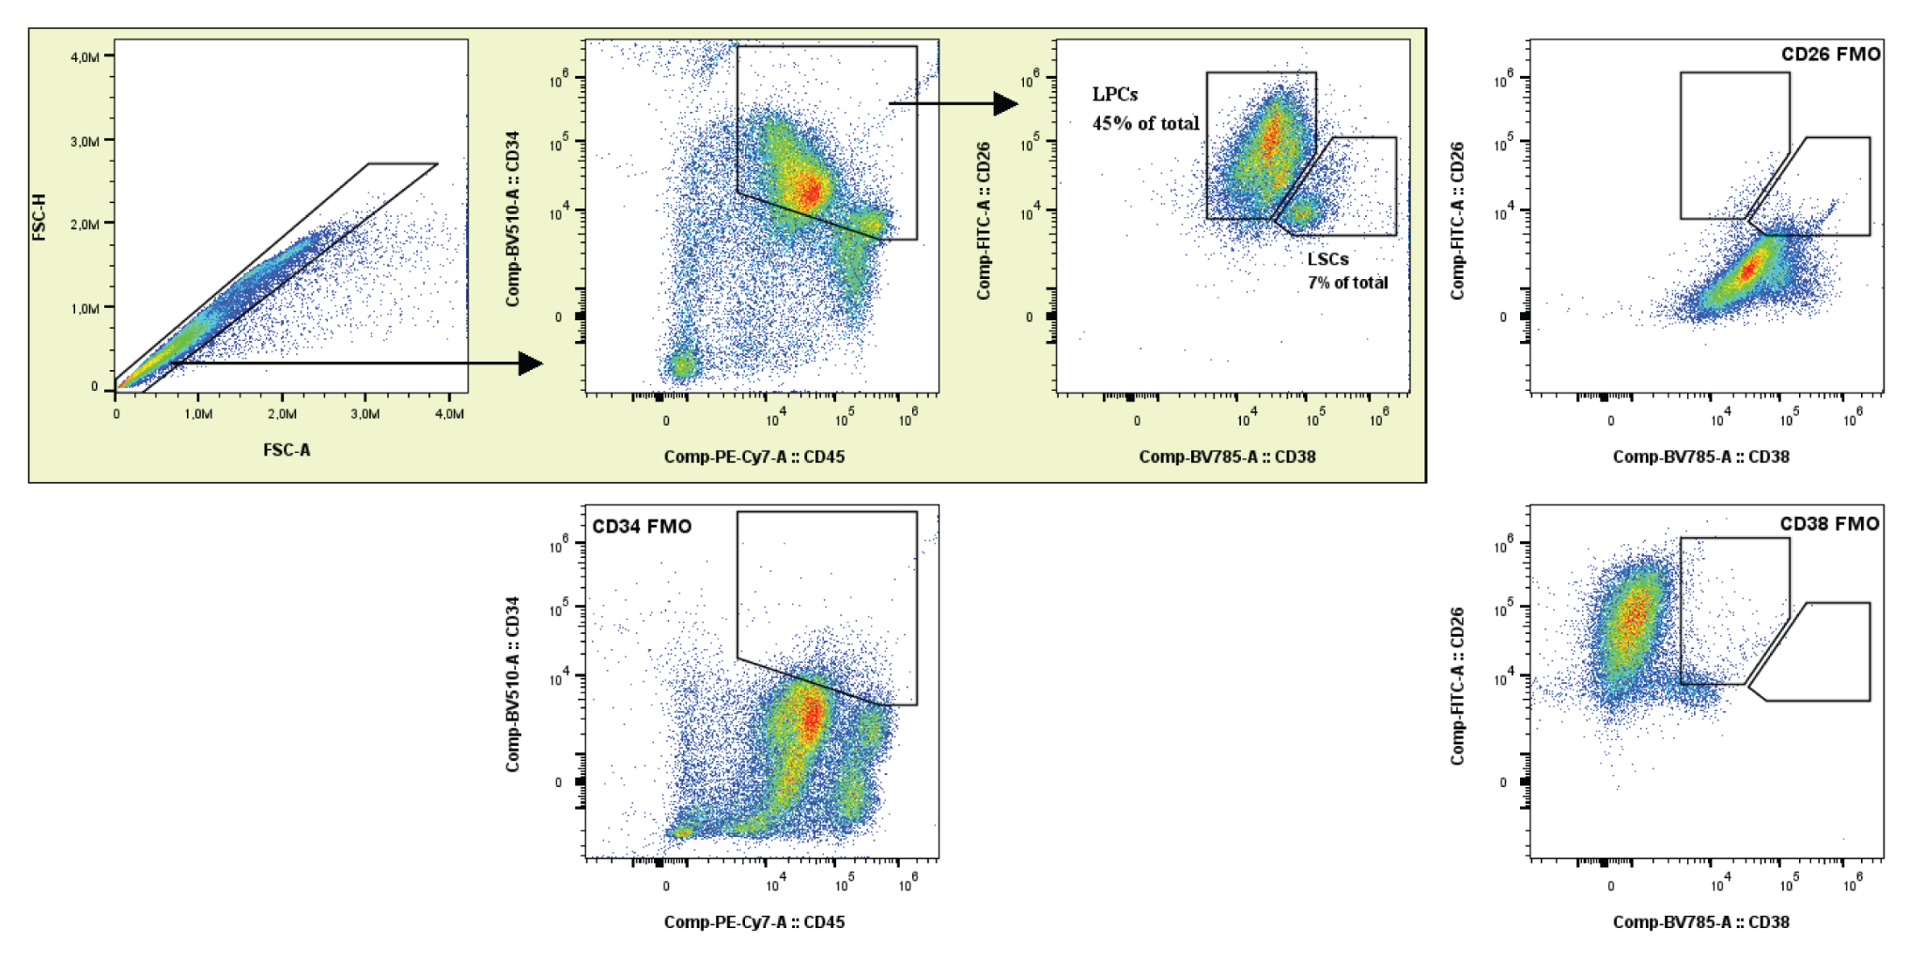
Figure S4. Gating strategy for sorting CD38+ cells (LPCs) and CD26+ cells (LSCs) from patients derived samples.

