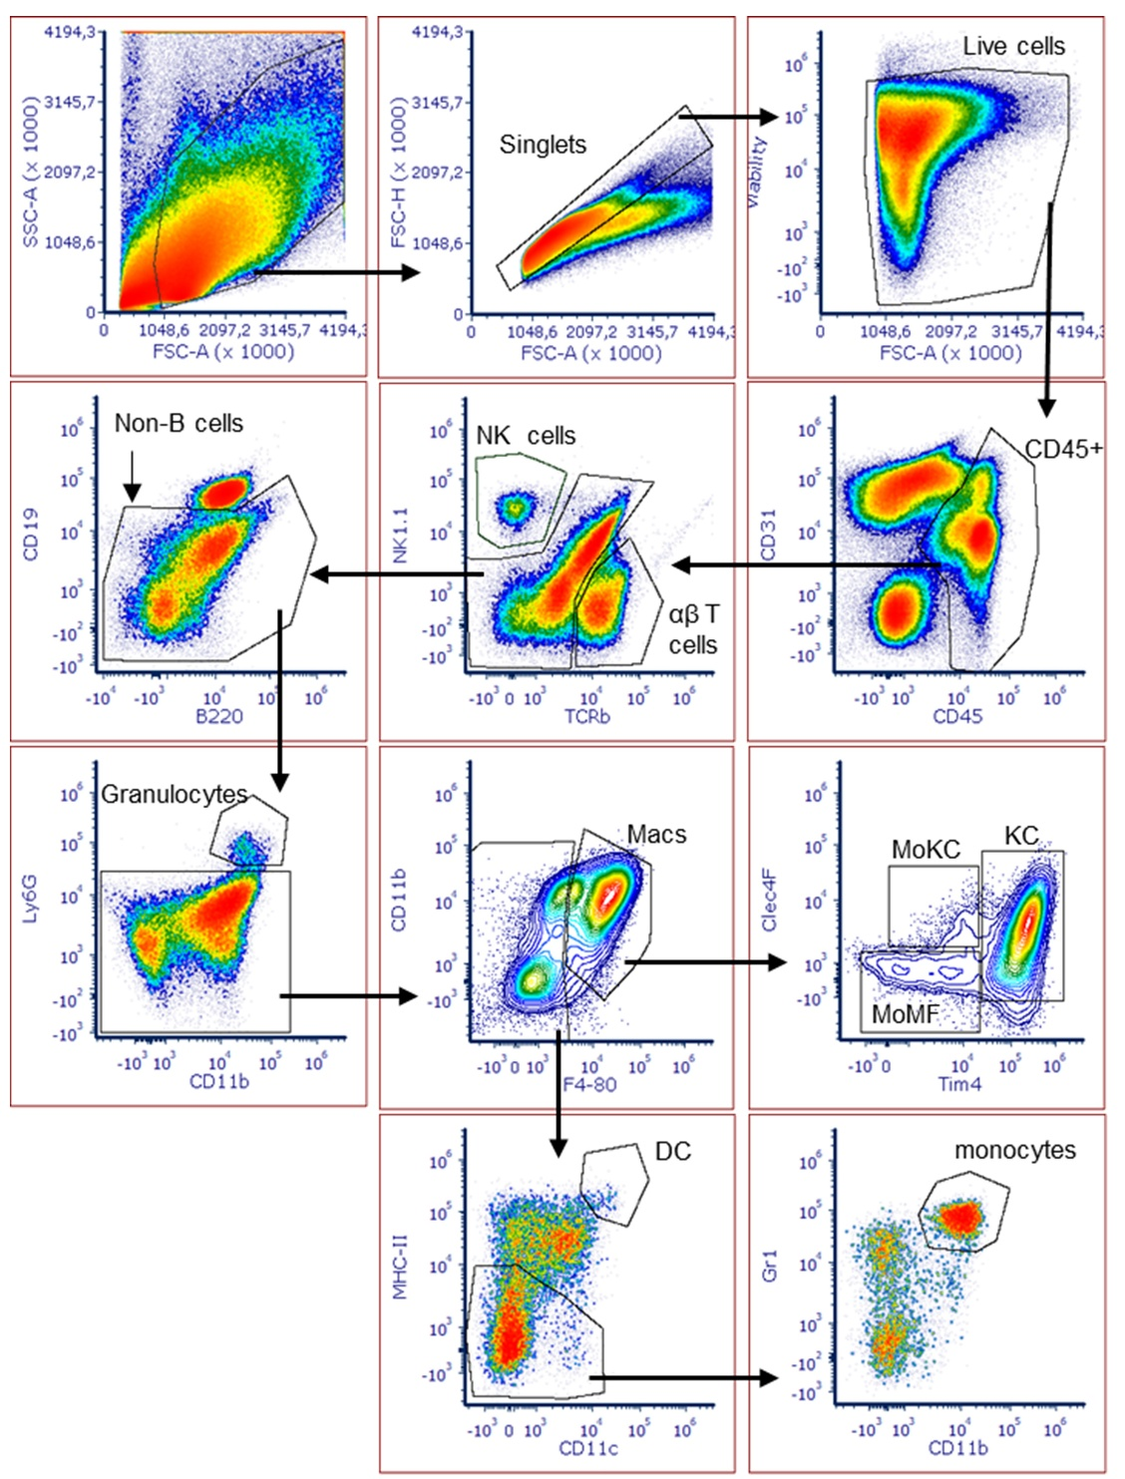
Figure S1. Gating strategy for liver myeloid cell subsets. Representative Flow plots showing the gating strategy used for identification of hepatic myeloid cell populations in mice with diet-induced MASH. Abbreviations: Macs: macrophages; KC: Kupffer cells; MoKC: monocyte-derived Kupffer cells; MoMF: monocyte-derived macrophages; DC: Dentritic cells.

