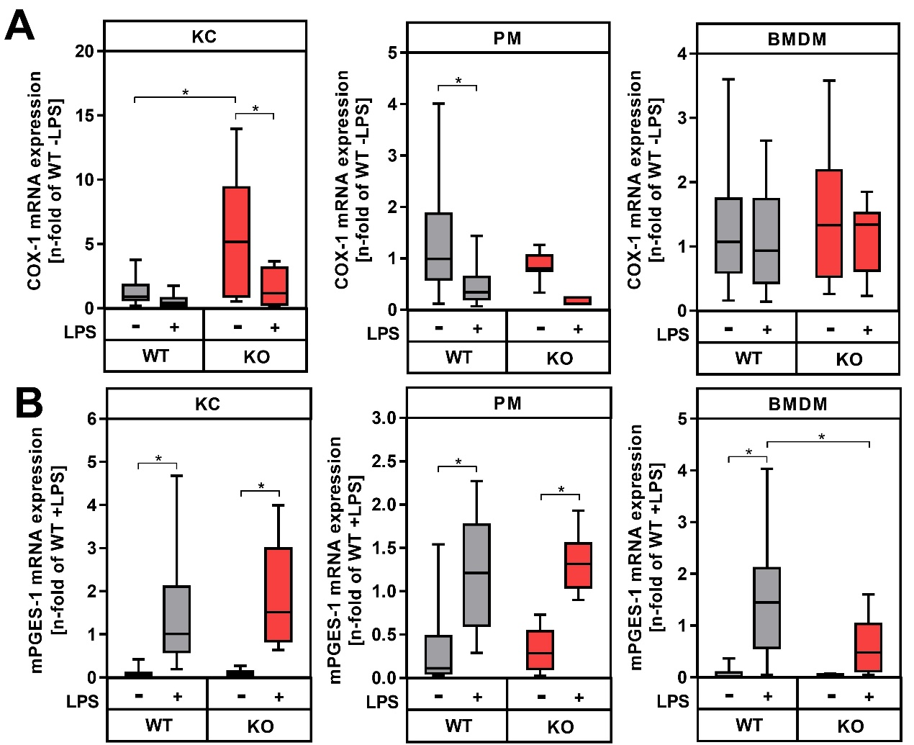
Figure S4. COX-1 and mPGES-1 mRNA expression in macrophages from wildtype controls (WT) and COX2-deficient mice (KO). Primary Kupffer cells (KC), peritoneal macrophages (PM) and bone marrow-derived macrophages (BMDM) were stimulated with for 24 h with LPS. Relative mRNA expression of COX-1 (gene name Ptges1; A) and mPGES-1 (gene name Ptges; B) were determined by RT-qPCR with Hprt as the reference gene. Values are median (line), upper- and lower quartile (box) and extremes (whiskers) of n=26-32 (WT) or n=5-10 (KO) independent experiments. Statistics: Two-way-ANOVA with Tukey´s post hoc test for multiple comparison. *p<0.05.

