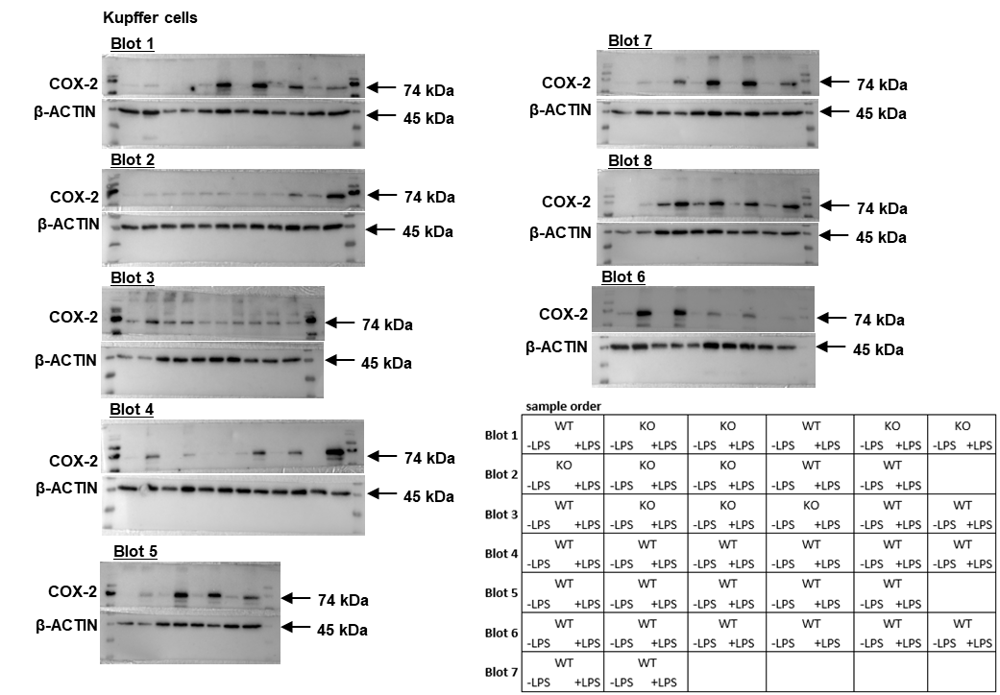
Figure S5. Detection of COX-2 and β-Actin in Kupffer cells. Primary Kupffer cells (KC) were stimulated with for 24 h with LPS. Protein lysates were analyzed by immunoblotting for COX-2 protein expression, with β-Actin serving as the loading control.

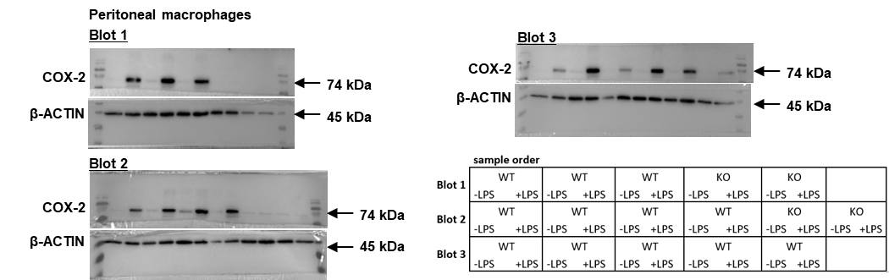
Figure S6. Detection of COX-2 and β-Actin in peritoneal macrophages. Primary peritoneal macrophages (PM) were stimulated for 24 h with LPS. Protein lysates were analyzed by immunoblotting for COX-2 protein expression, with β-Actin serving as the loading control.
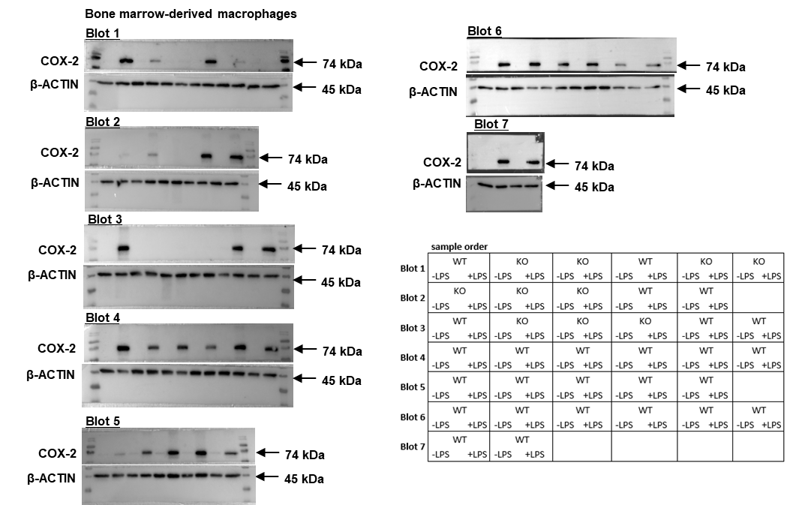
Figure S7. Detection of COX-2 and β-Actin in bone marrow-derived macrophages. Primary bone marrow-derived macrophages (BMDM) were stimulated for 24 h with LPS. Protein lysates were analyzed by immunoblotting for COX-2 protein expression, with β-Actin serving as the loading control.

