Supplementary Information

Rapid and high-yield recovery of plasma-derived extracellular vesicles using modified chromatography with soluble protein depletion for biomarker discovery

Yang You^{1#}*, Zhengrong Zhang^{1#}, Samuel Cortes^{1, 2}, SonNgoc Nguyen³, Prakruthi Vadakattu¹, Bridgette C. Melvin¹, Sean D. Mann Jr¹, Nibedita Basu Ray¹, Maria Bregendahl¹, Pam J. McLean¹, Maria Paz Gonzalez-Perez³, Seiko Ikezu¹, Tsuneya Ikezu^{1,4}*

Supplementary Tables
Supplementary Table 1 Quantitative protein expression of identified proteins from plasma-derived EVs isolated from different methods by data-independent-acquisition mass spectrometry.
Supplementary Table 2 List of neurodegenerative diseases-related risk genes from online GWAS datasets.
Supplementary Table 3 Gene ontology (GO) and KEGG pathway analysis of 565 unique proteins from EVs isolated via the qEV+CCS method.
Supplementary Table 4 Unique EV protein clusters in the qEV+CCS group by STRING network analysis.

Supplementary Figures
Supplementary Figure 1 Plasma-derived EV isolation and fractionation by SEC using qEVoriginal column.
Supplementary Figure 2 The phenotyping of positive plasma-EVs from different isolation methods were analyzed using nano-flow cytometry (NanoFCM).
Supplementary Figure 3 The volcano plots showing the comparisons of common proteins identified in at least two out of three replicates between the qEV+CCS group and neat plasma, as well other tested methods.

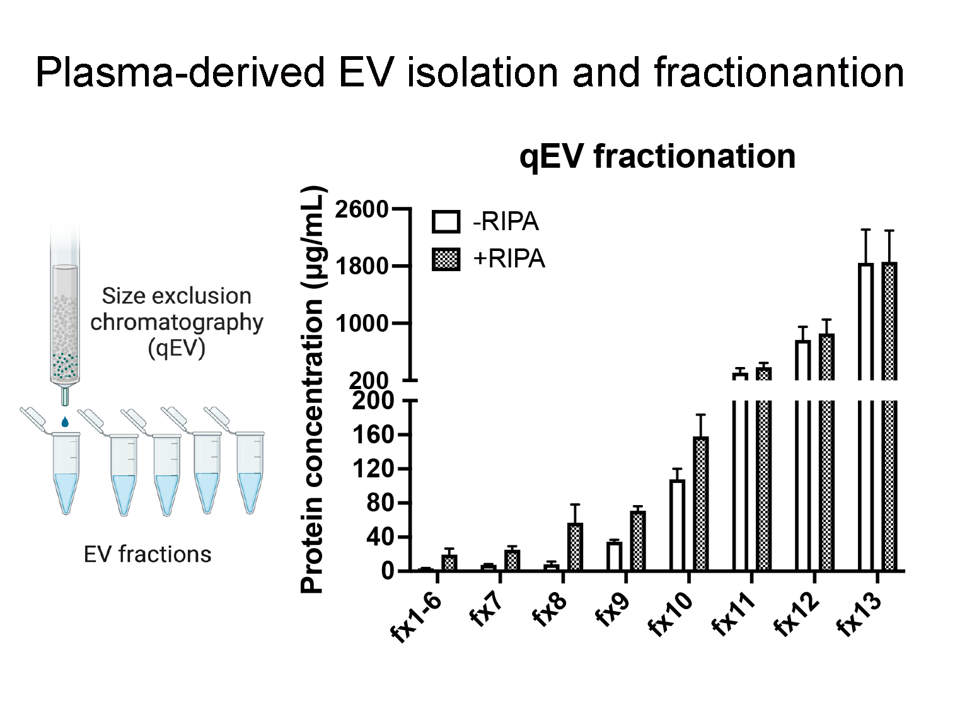
Supplementary Figure 1. Plasma-derived EV isolation and fractionation by SEC using qEVoriginal column. Fraction 1 to 13 was collected and EV protein concentration in each fraction was detected by microBCA assay before and after RIPA buffer lysis. Proteins detected before RIPA addition represent primarily soluble, non-vesicular plasma proteins, whereas proteins released after RIPA reflect membrane-enclosed EV-associated proteins. Data are shown as the mean ± SEM. Three independent experiments were conducted.

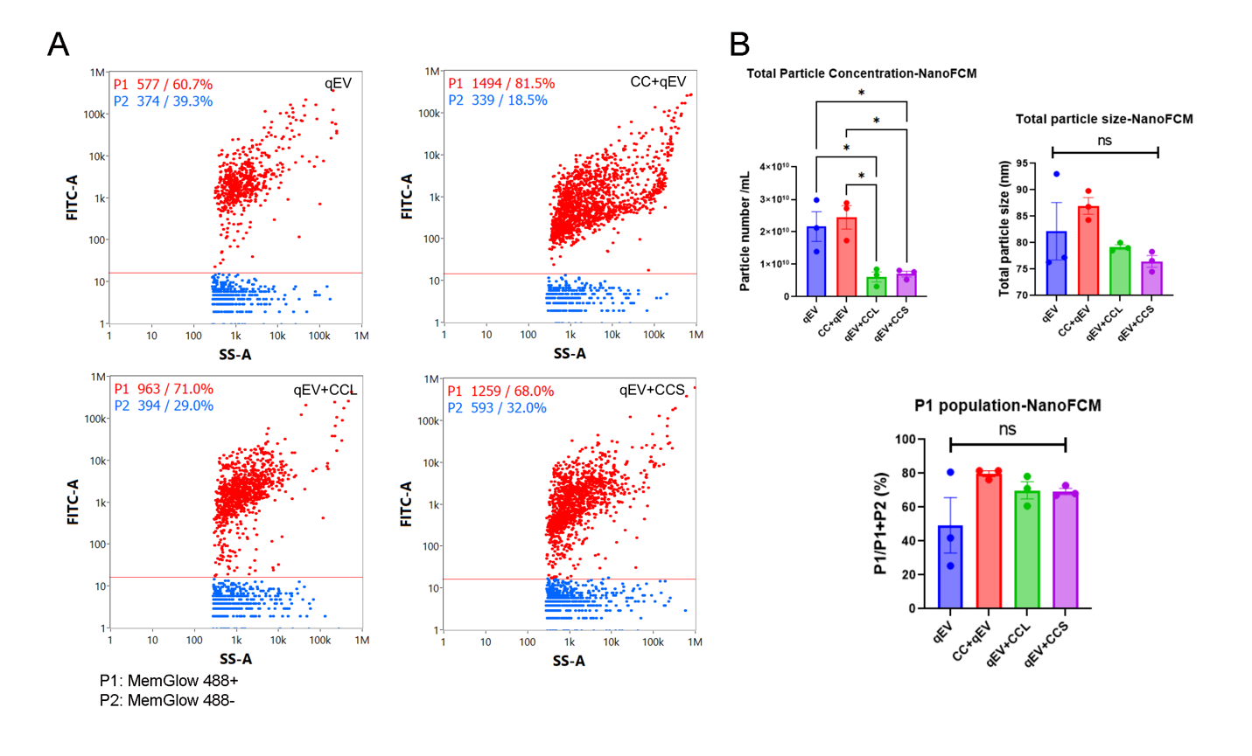
Supplementary Figure 2. The phenotyping of positive plasma-EVs from different isolation methods were analyzed using nano-flow cytometry (NanoFCM). A, The different EV samples were fluorescently labelled with Alexa 488 conjugated MemGlow for flow cytometry analysis. Bivariate dot-plots of FITC Alexa 488 fluorescence versus regular scatter for plasma-EV preparations from qEV, CC+qEV, qEV+CCL and qEV+CCS, respectively. P1, MemGlow_488 positive particles; P2, MemGlow_488 negative particles. B, Quantitative analysis of total particle concentration and size, and percentage of P1 population measured by NanoFCM among different isolation methods. Data are shown as the mean ± SEM. One-way ANOVA with Tukey's multiple comparisons test was applied. ns, no significance. *p < 0.05. Three biological replicates were used.

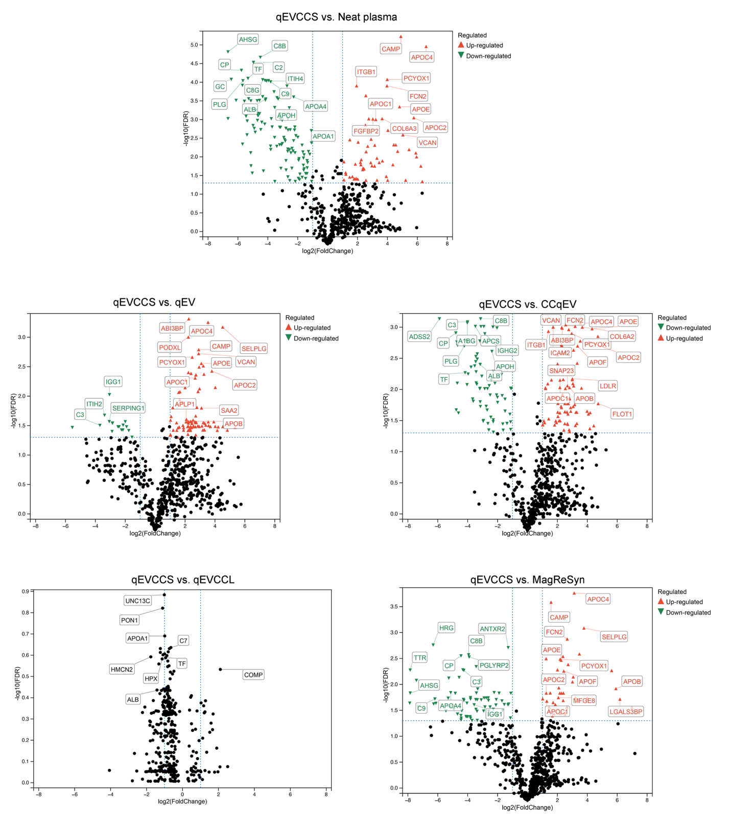
Supplementary Figure 3. The volcano plots showing the comparisons of common proteins identified in at least two out of three replicates between the qEV+CCS group and neat plasma, as well other tested methods. The significantly upregulated and downregulated proteins were selected with FDR corrected p value < 0.05 and |fold change| > 2 as shown in the figure. Red color indicates significantly upregulated proteins, and green color indicates significantly downregulated proteins.

