Supplementary File
miR-125b-5p and miR-145a-5p Modulation Drives Functional Enhancement of Wharton’s Jelly-MSCs derived small Extracellular Vesicles in Response to Hypoxia Preconditioning
Yashvi Sharma¹, Seema Kashyap², Aastha Singh³, Ritu Kulshreshtha³, Sefali Bhakuni¹, Sujata Mohanty^{1*}
¹Stem Cell Facility- DBT-Centre of Excellence for Stem Cell Research, All India Institute of Medical Sciences, New Delhi 110029, India; yashvi2707@gmail.com (Y.S.); shefa.bhakuni21@gmail.com (S.B.) drmohantysujata@gmail.com (S.M.)

²Department of Ocular Pathology, Dr. R. P. Centre for Ophthalmic Sciences, All India Institute of Medical Sciences, New Delhi, India; dr_skashyap@hotmail.com (S.K.)

³Department of Biochemical Engineering and Biotechnology, Indian Institute of Technology, New Delhi, 110016, India; 5aastha199@gmail.com (A.S); ritu@dbeb.iitd.ac.in (R.K)

*Correspondence: drmohantysujata@gmail.com

Supplementary Figures
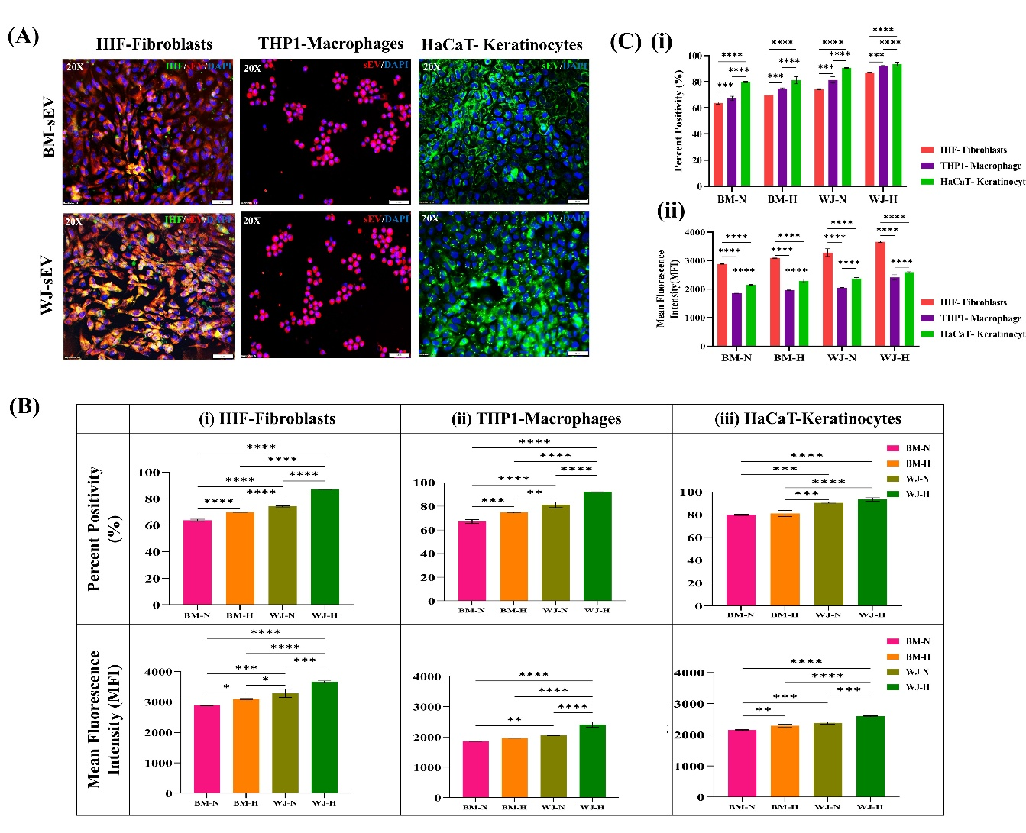
Figure S1 Uptake Analysis of sEV in Fibroblasts, Keratinocytes and Macrophages. (A) Representative images of BM- and WJ- sEV uptake in Fibroblasts (IHF), Macrophages (THP-1) and Keratinocytes (HaCaT) (Scale bar: 50µM). (B) Quantitative analysis for sEV uptake (BM; WJ; Normoxia; Hypoxia) expressed as percentage positivity and mean fluorescence intensity in (i)IHF, (ii) THP-1 Macrophages, and (iii) HaCaT via flow cytometry. (C) Quantitative analysis for relative uptake of sEV (BM; WJ; Normoxia; Hypoxia) in the 3 cell types expressed as (i) percent positivity and (ii) mean fluorescence intensity. n=3, *p value <0.05; ** <0.01; ***<0.001; ****<0.0001

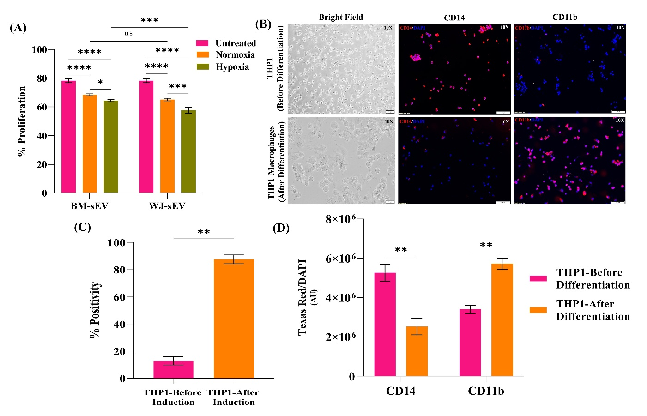
Figure S2 Evaluation of immunosuppressive potential of sEV in PBMC and Macrophage Induction (A) Flow cytometry-based analysis for mixed lymphocyte reaction of sEV treated human Peripheral Blood Mononuclear Cells (PBMCs). (B) Immunofluorescence assay depicting the expression of CD14 (monocyte marker) and CD11b (macrophage marker) in THP-1 monocytes (before differentiation) and THP-1 macrophages (after differentiation) (10X). (C) Flow cytometry-based analysis for the expression of CD11b before and after THP-1 induction into macrophages (D) Integrated density analysis for expression of CD14 and CD11b in THP-1 monocytes and THP-1 macrophages. n=3, *p value <0.05; ** <0.01; ***<0.001; ****<0.0001
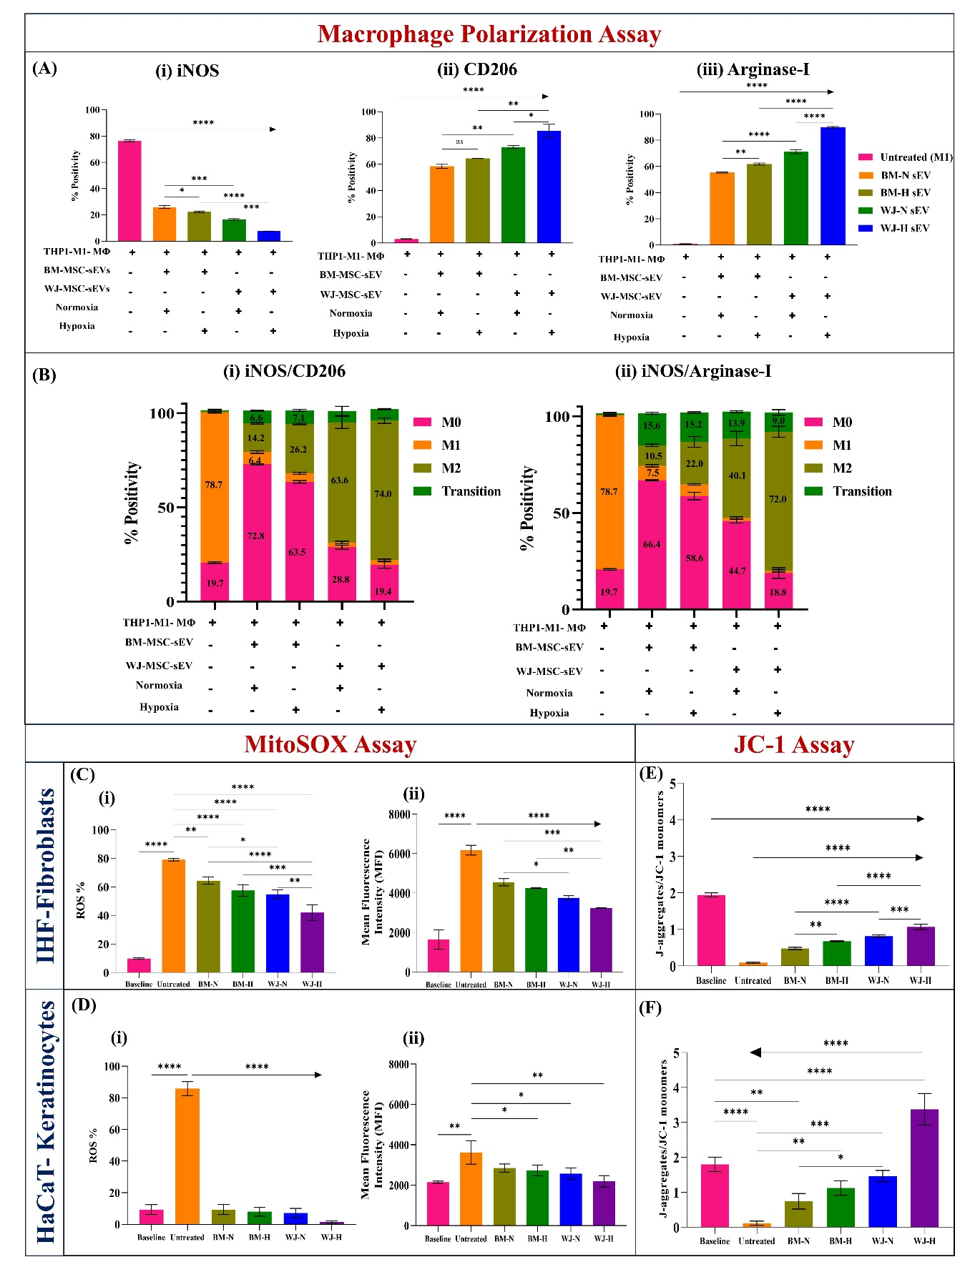
Figure S3 Macrophage Polarization and ROS reduction assessment of sEV. (A) Flow cytometry-based quantitative analysis for (i) iNOS expression (M1) (ii) CD206 expression (M2) and (iii) Arginase-1 expression (M2). (B) Dual marker analysis of macrophage phenotypes for (i) iNOS and CD206 and (ii) iNOS and Arginase-1 via flow cytometry. (C) MitoSOX assay for quantification of superoxide ions in IHF cells expressed as (i) ROS % and (ii) Mean fluorescence intensity. (D) MitoSOX assay for quantification of superoxide ions in HaCaT cells expressed as (i) ROS % and (ii) Mean fluorescence intensity. JC-1 assay for quantification of mitochondrial membrane permeability expressed as J-aggregates/JC-1 monomer ratio in (E) IHF cells and (F) HaCaT cells . n=3, *p value <0.05; ** <0.01; ***<0.001; ****<0.0001

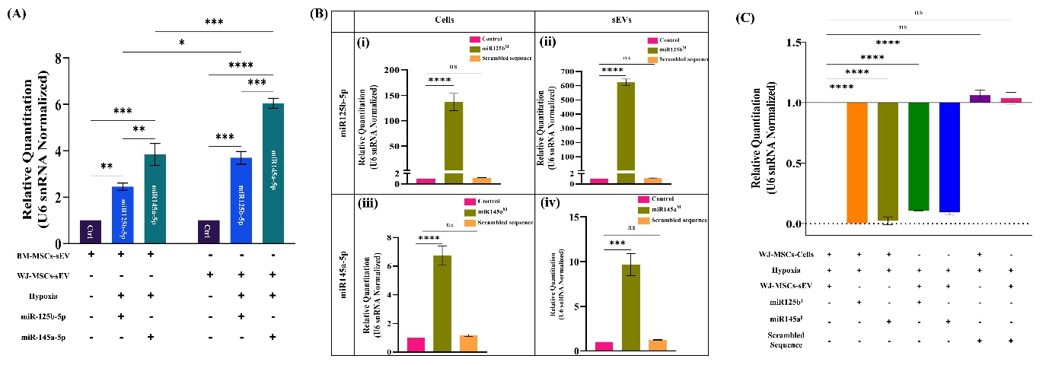
Figure S4 Analysis of miRNA enrichment in sEV upon hypoxia exposure, and post lipofection. (A) qRT-PCR based analysis for the expression of miR-125b-5p and miR-145a-5p upon hypoxia exposure in BM & WJ-sEV. (B) Expression of miR-125b-5p and miR-145a-5p post miRNA mimics transfection in normoxia cultured WJ-MSCs- (i & iii respectively) and their sEV (ii and iv respectively). (C) Expression of miR-125b-5p and miR-145a-5p post miRNA inhibitors transfection in hypoxia cultured WJ-MSCs and their sEV. n=3, *p value <0.05; ** <0.01; ***<0.001; ****<0.0001. Ctrl: Untreated Control; miR125b^{M}: miR-125b-5p mimics; miR145a^{M}: miR-145a-5p mimics; miR125b^{I}: miR-125b-5p inhibitors; miR145a^{I}: miR-145a-5p inhibitors
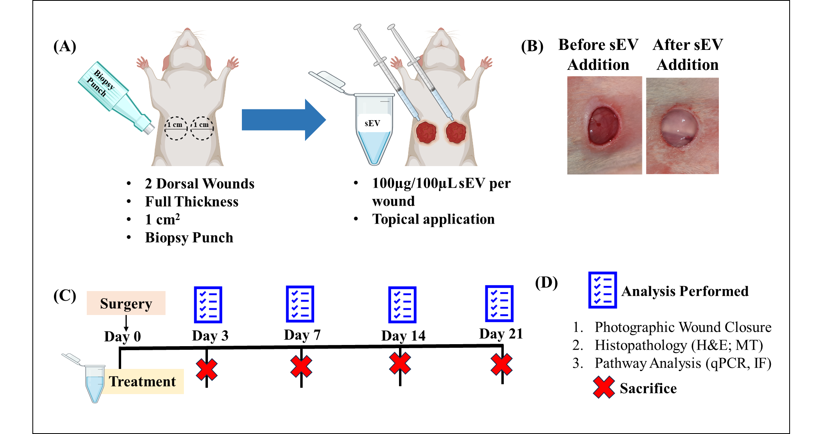
Figure S5 Schematic representation of in vivo study design. (A) Pictorial representation of wound creation surgery and treatment strategy (B) Photographic representative images of wound before and after sEV application (C) Timeline of in vivo study (D) Glossary of symbols and list of analysis performed.
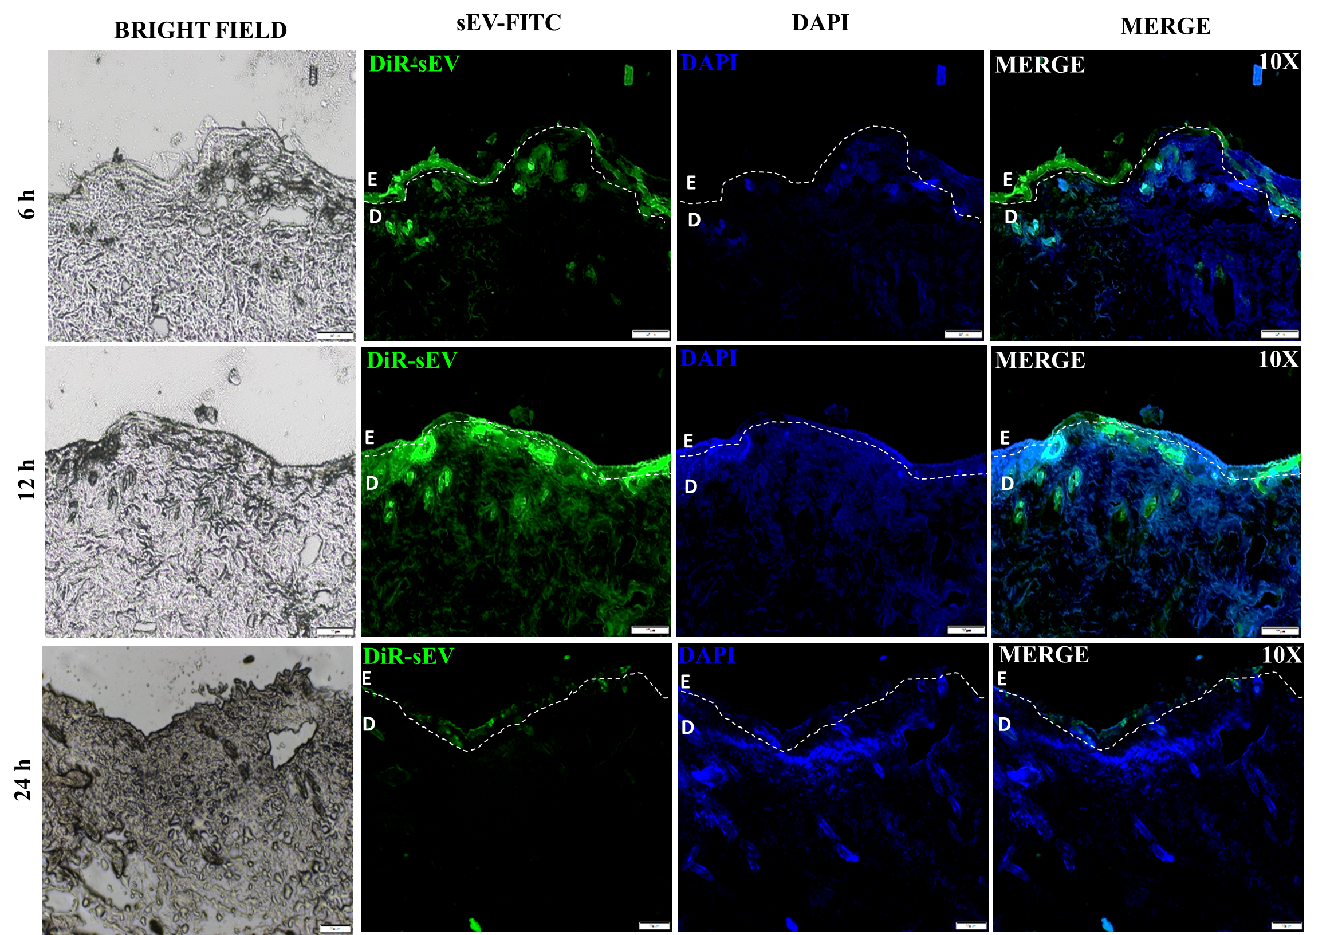
Figure S6 sEV Localization in Skin Wound Edge Tissue. Internationalization of DiR labelled sEV was evaluated in the wound edge tissues 6 hours, 12 hours, and 24 hours post topical application (10X). E: Epidermis; D: Dermis. Dotted line segregates epidermis and dermis.
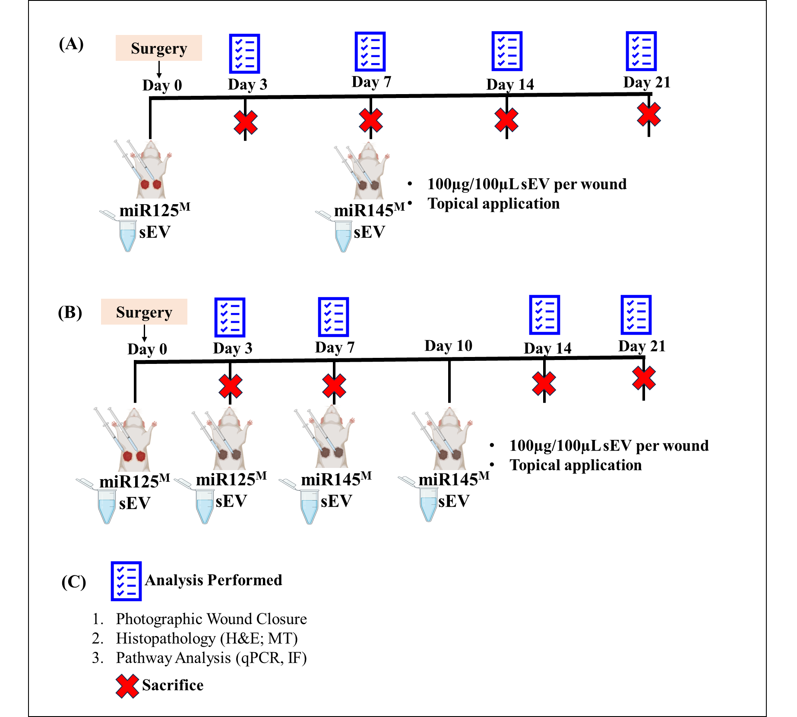
Figure S7 Schematic representation of in vivo study design for R1 and R2 strategy. (A) Pictorial representation of R1 strategy of sequential dosing (B) Pictorial representation of R2 strategy of multiple sequential dosing (C) Glossary of symbols and list of analysis performed.

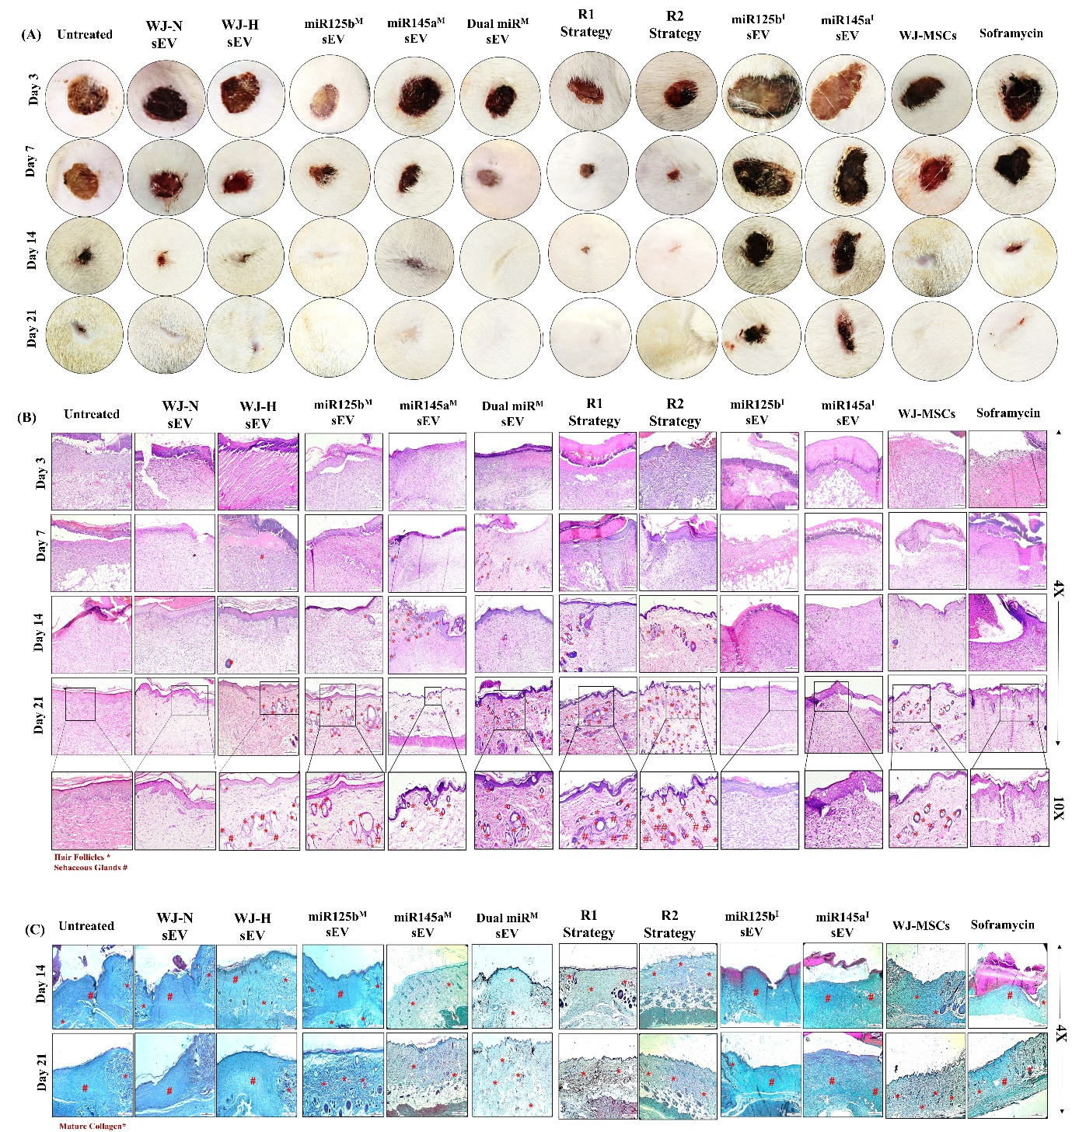
Figure S8 In vivo studies at a glance. (A) Photographic wound closure analysis for all study groups. (B) H&E staining on wound tissues for all study groups (C) MT staining on wound tissues for all study groups.
Supplementary Tables
Table S1. List of primary antibodies used in the study
S.No. | Antibody | Company | Catalogue Number
 | CD105 | eBiosciences, USA | 17-1057
 | CD73 | Becton Dickinson, USA | 550257
 | CD29 | eBiosciences, USA | 14-0299
 | CD90 | Becton Dickinson, USA | 561558
 | HLA-ABC | Becton Dickinson, USA | 555555
 | HLA-DR | Becton Dickinson, USA | 555560
 | CD34/45 | Becton Dickinson, USA | 341071
 | CD63 | Abcam, USA | ab59479
 | ALIX | Genetex, USA | GTX135282
 | Calnexin | Genetex, USA | GTX13504
 | GAPDH | Genetex, USA | GTX100118
 | iNOS | eBiosciences, USA | 53-5920-82
 | CD206 | eBiosciences, USA | 25-2069-42
 | Arginase 1 | eBiosciences, USA | 17-3697-82
 | CD14 | Abcam, UK | ab63319
 | CD11b | eBiosciences, USA | 25-0118-42
 | IL-6 | Affinity Biosciences, USA | DF6087
 | IL-6R | Affinity Biosciences, USA | DF6466
 | Rel-A p65 | Affinity Biosciences, USA | AF5006
 | NFκB-1 p105/p50 | Affinity Biosciences, USA | AF6217
 | TGFB2 | Affinity Biosciences, USA | AF0260
 | SMAD4 | Affinity Biosciences, USA | AF5247

Table S2 List of miRNA primers
S.No. | miRNA primer | Company and Catalogue Number | GeneGlobe ID
1 | hsa-miR125b-5p | Qiagen, 339306 | YP00205713
2 | hsa-miR145a-5p | Qiagen, 339306 | YP00204483
3 | hsa-miR34a-5p | Qiagen, 339306 | YP00204486
4 | hsa-miR21-5p | Qiagen, 339306 | YP00204230
5 | U6 snRNA | Qiagen 339306 | YP02119464

Table S3 Scoring criteria for epidermal regeneration
Epidermis
None | 0
Mild epithelialisation | 1
Epithelialisation of more than half of wound | 2
Complete epithelialisation | 3
Note: More the score indicates better wound healing
Table S4 Scoring Criteria for Dermal Regeneration
Dermis
Collagen fibre orientation | Normal basket weave pattern | 0
Collagen fibre orientation | <25% abnormal | 1
Collagen fibre orientation | 26–50% abnormal | 2
Collagen fibre orientation | 51–75% abnormal | 3
Collagen fibre orientation | 76–100% abnormal | 4
Collagen fibre orientation | Keloid-like fiber orientation | 5
Collagen fiber  density | Normal fiber bundle density | 0
Collagen fiber  density | <25% abnormal | 1
Collagen fiber  density | 26–50% abnormal | 2
Collagen fiber  density | 51–75% abnormal | 3
Collagen fiber  density | 76–100% abnormal | 4
Collagen fiber  density | Keloid-like fibers | 5
Collagen fiber  maturity | Normal fiber maturity | 0
Collagen fiber  maturity | <25% abnormal | 1
Collagen fiber  maturity | 26–50% abnormal | 2
Collagen fiber  maturity | 51–75% abnormal | 3
Collagen fiber  maturity | 76–100% abnormal | 4
Collagen fiber  maturity | Keloid-like fibers | 5
Note: Lesser the score indicates better wound healing
Table S5 List of primer sequences for cloning the 3' UTR in the pMIR-REPORT Luciferase vector
Gene | Forward primer (5’-3’) | Reverse primer (5’-3’)
IL-6R 3’UTR cloning primers | AGGAAGGCAAGACAAGCATG | GCTTCTCACCTGAGGTCCTG
TGFB2 3’UTR cloning primers 1 | ATAAGAGAGCCTTGGTTCATCAG | AAGAGTAAGAATGGGAAGGGTG
TGFB2 3’UTR cloning primers 2 | AGAAGAGGTATCCTCATGCTG | AGTGCATTCATGAGGAAAGAC

