Supplemental figure legends
Figure S1. Microtubule-targeting agents induce concentration-dependent pyroptosis in ovarian cancer cell lines.
A-B. Dose-response analysis of pyroptotic cell death in OVCAR8 cells. Quantitative analysis of OVCAR8 cells following 24-hour treatment with paclitaxel (0-40 nM) (A) or nocodazole (0-1000 nM) (B).
C-D. Dose-response analysis of pyroptotic cell death in OVCAR3 cells. Quantitative analysis of OVCAR3 cells following 24-hour treatment with paclitaxel (0-40 nM) (C) or nocodazole (0-1000 nM) (D).
E-F. Flow cytometry analysis for OVCAR8 cells stained by Annexin V-FITC and PI, with paclitaxel treatment for 24 hours. The percentage of double-positive cells, presumably pyroptotic cells.
G-H. Flow cytometry analysis for OVCAR8 cells stained by Annexin V-FITC and PI, with nocodazole treatment for 24 hours. The percentage of double-positive cells, presumably pyroptotic cells.
I-J. Cell viability assay of OVCAR8 cells treated with paclitaxel (I) or nocodazole (J) at concentration gradients.
The data in (A, B, C, D, F, H) are representative of three independent experiments and presented as the mean ± SEM. *P < 0.05, **P < 0.01, ***P < 0.001, ****P < 0.0001.
Figure S2. Caspase-8/Caspase-3/GSDME mediated pyroptosis of ovarian cancer cells during mitotic arrest.
- LDH release from OVCAR8 cells treated with nocodazole (250 nM) or DMSO for 24 hours after knocking down GSDME for 48 hours.
- After knocking out GSDME via CRISPR-Cas9, the protein levels of GSDME，cleaved GSDME and pH3s10 in OVCAR8 cells treated with paclitaxel (20 nM) or DMSO for 24 hours were determined by Western blot assay.
- LDH release from OVCAR8 cells with pre-treatment of caspase inhibitors (Z-VAD-FMK or 10 μM and Z-DEVD-FMK at 10 μM) for 30 minutes and then nocodazole (250 nM) treatment for 24 hours.
- OVCAR8 cells were observed under a phase-contrast microscope with pre-treatment of caspase inhibitors (Z-VAD-FMK at 10 μM or Z-DEVD-FMK at 10 μM) for 30 minutes and then nocodazole (250 nM) treatment for 24 hours. The red arrows indicate the large bubbles emerging from the plasma membrane.Scale bar=50 μm.
- After knocking down caspase-9 for 48 hours, LDH release from OVCAR8 cells treated with paclitaxel (20 nM) or DMSO for 24 hours was detected.
The data in (A, C, E) are representative of three independent experiments and presented as the mean ± SEM. *P < 0.05, **P < 0.01, ***P < 0.001, ****P < 0.0001.

Figure S3. The cGAS-STING-TBK1-IRF3 pathway mediates paclitaxel-induced pyroptosis in ovarian cancer cells.
- A schematic diagram of protein-protein interaction analysis of Caspase-8. The data is from BioGRID.
- The protein levels of pyroptosis pathway and phosphorylation of IRF3 in OVCAR8 cells treated with paclitaxel (20 nM) or DMSO for 24 hours were determined by western blot.
- After knocking down cGAS for 48 hours, OVCAR8 cells were observed under a phase-contrast microscope with paclitaxel (20 nM) or DMSO for 24 hours. Scale bar =100 μm.
- After knocking down cGAS for 48 hours, LDH release from OVCAR8 cells treated with paclitaxel (20 nM) or DMSO for 24 hours was detected.
- After knocking out TBK1, OVCAR8 cells were observed under a phase-contrast microscope with paclitaxel (20 nM) and DMSO treatment for 24 hours. The red arrows indicated the large bubbles emerging from the plasma membrane. Scale bar =100 μm.
- After knocking out TBK1, the protein levels of pyroptosis pathway components in OVCAR8 cells treated with paclitaxel (20 nM ) or DMSO for 24 hours were determined by Western blot assay.
- After knocking out STING, OVCAR8 cells were observed under a phase-contrast microscope with paclitaxel (20 nM) and DMSO treatment for 24 hours. The red arrows indicated the large bubbles emerging from the plasma membrane. Scale bar =100 μm.
- After knocking out STING, the protein levels of pyroptosis pathway components in OVCAR8 cells treated with paclitaxel (20 nM) or DMSO for 24 hours were determined by Western blot assay.
- The protein levels of pyroptosis pathway components in OVCAR8 cells treated with paclitaxel (20 nM) and DMSO for 24 hours were determined by Western blot assay after knocking down IRF3, followed by rescue with IRF3-WT, IRF3-AA, IRF3-386A or IRF3-396A mutants.
The data in (D) are representative of three independent experiments and presented as the mean ± SEM. *P < 0.05, **P < 0.01, ***P < 0.001, ****P < 0.0001.

Figure S4. IRF3 recruits the Ripoptosome (RIPK1/FADD/Caspase-8) complex triggering pyroptosis in ovarian cancer cells during mitotic arrest.
- Endogenous CO-IP assay to assess the interactions among IRF3 and Caspase-8, RIPK1 and FADD in OVCAR3 cells treated with paclitaxel (20 nM) for 24 hours after knocking out cGAS.
- Endogenous CO-IP assay to assess the interactions among Caspase-8 and RIPK1, FADD as well as total IRF3 in OVCAR8 cells treated with paclitaxel (20 nM) or DMSO for 24 hours after knocking out cGAS.
- After knocking down FADD for 48 hours, OVCAR8 cells were observed under a phase-contrast microscope with paclitaxel (20 nM) and DMSO treatment for 24 hours. The red arrows indicated the large bubbles emerging from the plasma membrane. Scale bar =100 μm.
- After knocking down FADD for 48 hours, LDH release from OVCAR8 cells treated with paclitaxel (20 nM) or DMSO for 24 hours was detected.
- Endogenous CO-IP assay to assess the interactions between Caspase-8 and total IRF3 in OVCAR8 cells treated with paclitaxel (20 nM) for 24 hours after knocking down FADD with siRNA for 48 hours.
- After knocking down RIPK1 for 48 hours, OVCAR8 cells were observed under a phase-contrast microscope with paclitaxel (20 nM) and DMSO treatment for 24 hours. The red arrows indicated the large bubbles emerging from the plasma membrane. Scale bar=100 μm.
- After knocking down RIPK1 for 48 hours, LDH release from OVCAR8 cells treated with paclitaxel (20 nM) or DMSO for 24 hours was detected.
- Endogenous CO-IP assay to assess the interactions between Caspase-8 and total IRF3 in OVCAR8 cells treated with paclitaxel (20 nM) for 24 hours after knocking down RIPK1 with siRNA for 48 hours.
The data in (D, G) are representative of three independent experiments and presented as the mean ± SEM. *P < 0.05, **P < 0.01, ***P < 0.001, ****P < 0.0001.

Figure S5. Alternative antimitotic agents volasertib and colchicine induce pyroptosis in OVCAR8 cells.
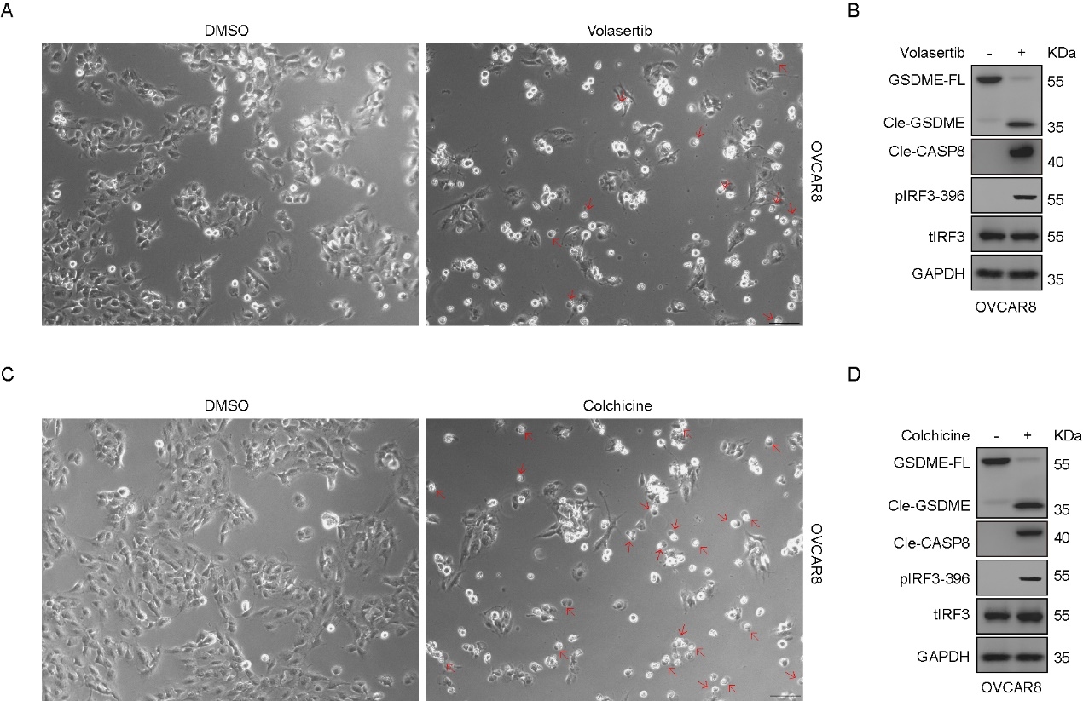
- OVCAR8 cells were observed under a phase-contrast microscope with Volasertib (500 nM) and DMSO treatment for 24 hours. The red arrows indicated the large bubbles emerging from the plasma membrane. Scale bar =100 μm.
- The protein levels of pyroptosis pathway components in OVCAR8 cells treated with Volasertib (500 nM) or DMSO for 24 hours were determined by Western blot assay.
- OVCAR8 cells were observed under a phase-contrast microscope with Colchicine (250 nM) and DMSO treatment for 24 hours. The red arrows indicated the large bubbles emerging from the plasma membrane. Scale bar =100 μm.
- The protein levels of pyroptosis pathway components in OVCAR8 cells treated with Colchicine (250 nM) or DMSO for 24 hours were determined by Western blot assay.

Figure S6. Anti-mitotic agents inhibited tumor growth by inducing pyroptosis in the nude mice model.
- Representative images of subcutaneous tumors in BALB/c-Nude mice, showing the subcutaneous tumor volume in these animals injected with OVCAR8 sg-control. The animals received treatment through tail vein injections of either vehicle (n=5) or paclitaxel at a dosage of 10 mg/kg every two days (n=5). Line chart showing tumor volume over time treated with Paclitaxel (n = 5) or Vehicle (n=5) in OVCAR8 sg-control group.
- Bar plot showing the tumor weight of Vehicle (n = 5) and Paclitaxel (n = 5) mice in OVCAR8 sg-control group.
- Representative images of subcutaneous tumors in BALB/c-Nude mice, showing the subcutaneous tumor volume in these animals injected with OVCAR8 sg-cGAS, with or without paclitaxel.
- Line chart showing tumor volume over time treated with Paclitaxel (n = 5) or Vehicle (n=5) in OVCAR8 sg-cGAS group.
- Bar plot showing the tumor weight of Vehicle (n = 5) and Paclitaxel (n = 5) mice in OVCAR8 sg-cGAS group.
G-H. Bar plot showing the body weight changes of Vehicle (n = 5) and Paclitaxel (n = 5) mice in OVCAR8 sg-control group (G) and OVCAR8 sg-cGAS group (H).
I. The knockout efficiency of cGAS in CRISPR-edited OVCAR8 cells detected by Western blot .

Figure S7. Anti-mitotic agents inhibited tumor growth by inducing pyroptosis in the subcutaneous model.
A-B. Line chart showing the tumor weight of Vehicle (n = 5) and Paclitaxel (n = 5) mice in the ID8 sg-control group (A) and the ID8 sg-cGAS group (B).
C. The knockout efficiency of cGAS in CRISPR-edited ID8 cells detected by Western blot.
D. The protein levels of cleaved GSDME, cleaved caspase-8, and cleaved caspase-3, as well as p-IRF3, derived from the five ID8 subcutaneous tumors were determined by Western blot assay after treatment.

Figure S8. Flow cytometry analysis and GSDME knockout validation in the ID8 subcutaneous model.
- Gating strategy for flow cytometry used throughout the study.
- Bar plot showing the percentage of CD3⁺, CD4⁺ or CD8⁺ cells in C57BL/6 mice from four groups.

Figure S9. GSDME and Caspase-3 expression correlate with immune cell markers in paclitaxel-treated ovarian cancer patients.
A-B. The expression levels of immune cell markers including CD4, CD8A, CD8B, CD3D, CD3E, CD3G, MST1R, CD163, CSF1R, ITGAM, CD2, KLRB1, CD1C, CCR7, and IL3RA in ovarian cancer patients were stratified according to their GSDME (A) and Caspase-3 (B) expression levels following paclitaxel treatment. This analysis was conducted using data from the TCGA database with a median-based cutoff.

