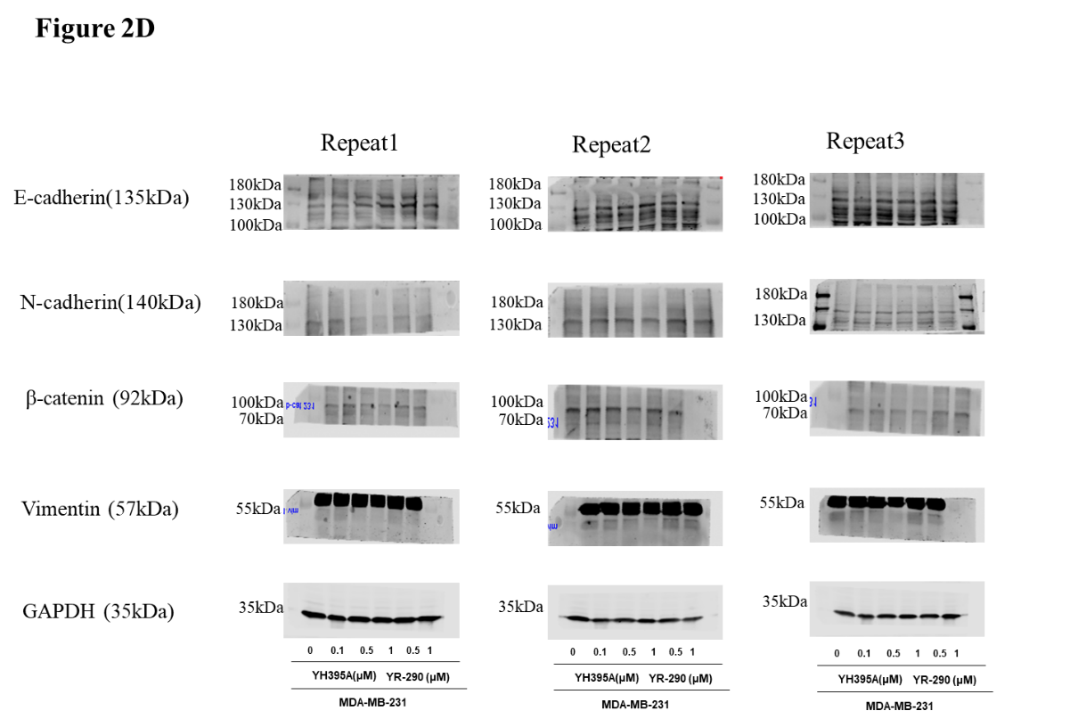
Figure 2D shows the whole blot after cutting membrane at molecular weight 130 kDa,100 kDa,70 kDa, 55 kDa and 35 kDa for E-cadherin(135kDa), N-cadherin(140kDa),β-catenin (92kDa), Vimentin (57kDa) and GAPDH (35kDa)
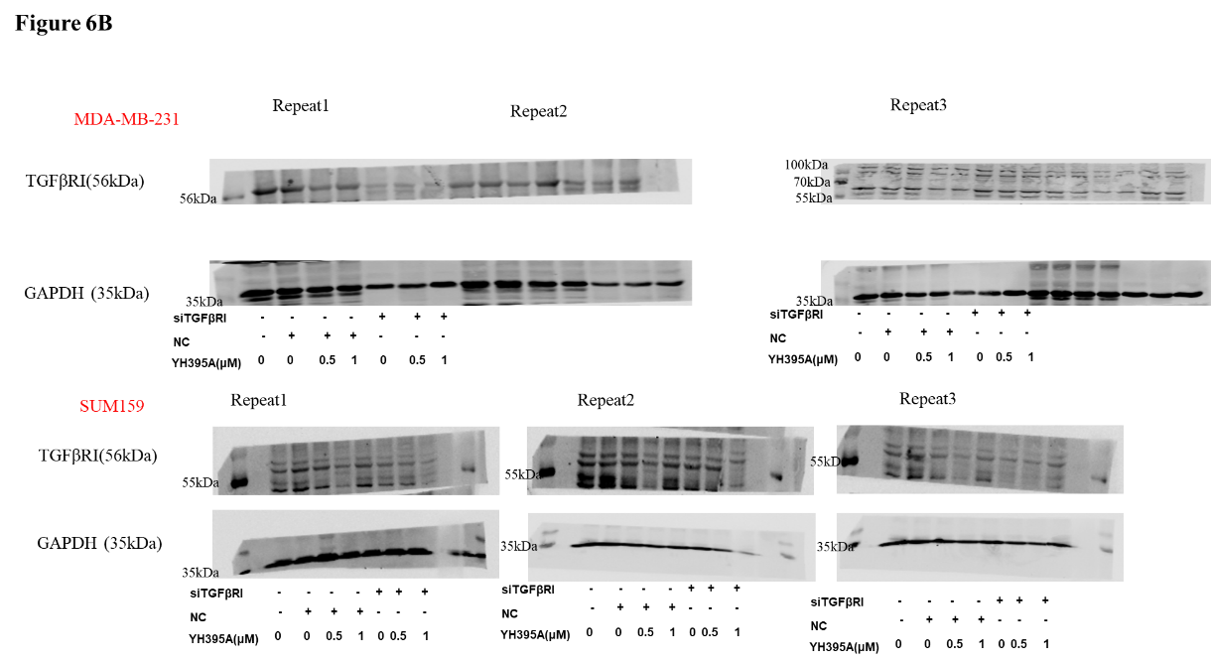
Figure 6B shows the whole blot after cutting membrane at molecular weight 55 kDa and 35 kDa for TGFβRI(56kDa) and GAPDH (35kDa)

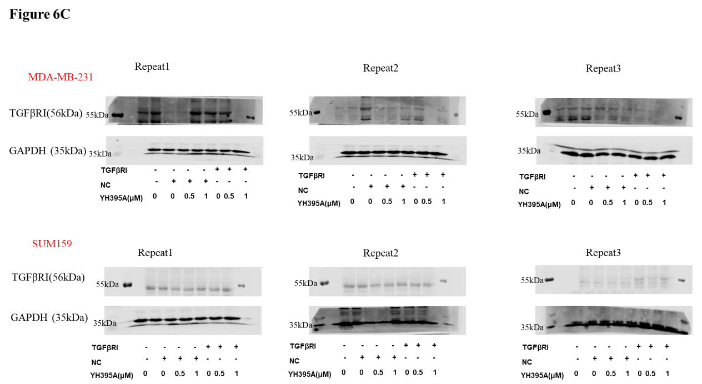
Figure 6C shows the whole blot after cutting membrane at molecular weight 55 kDa and 35 kDa for TGFβRI(56kDa) and GAPDH (35kDa)

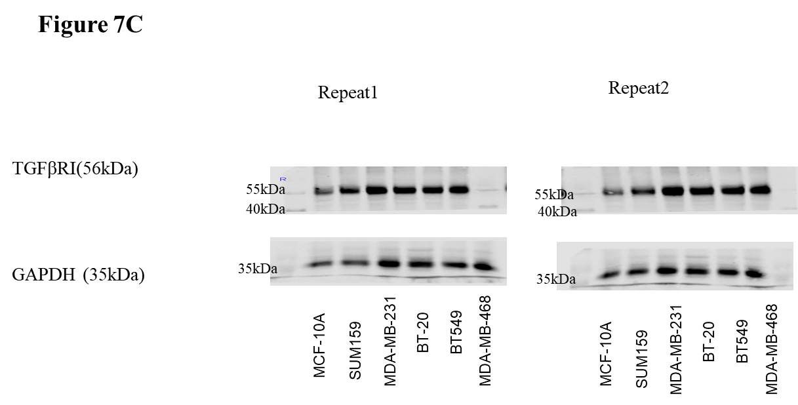
Figure 7C shows the whole blot after cutting membrane at molecular weight 55 kDa and 35 kDa for TGFβRI(56kDa) and GAPDH (35kDa)

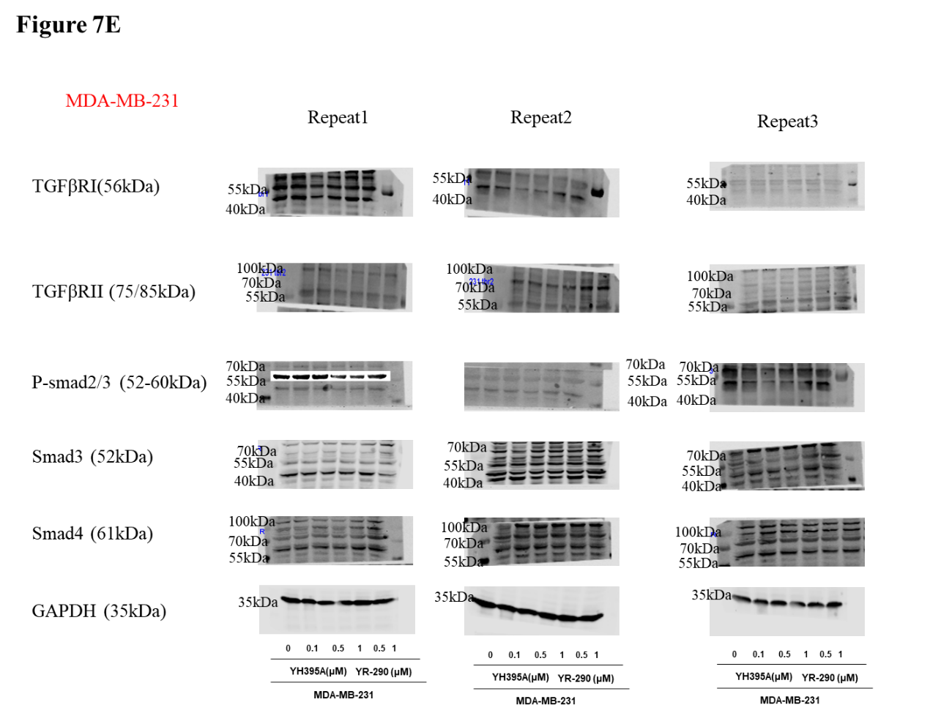
Figure 7E shows the whole blot after cutting membrane at molecular weight 100 kDa,70 kDa, 55 kDa and 35 kDa for TGFβRI(56kDa), TGFβRII (75/85kDa), P-smad2/3 (52-60kDa), Smad3 (52kDa), Smad4 (61kDa)and GAPDH (35kDa)
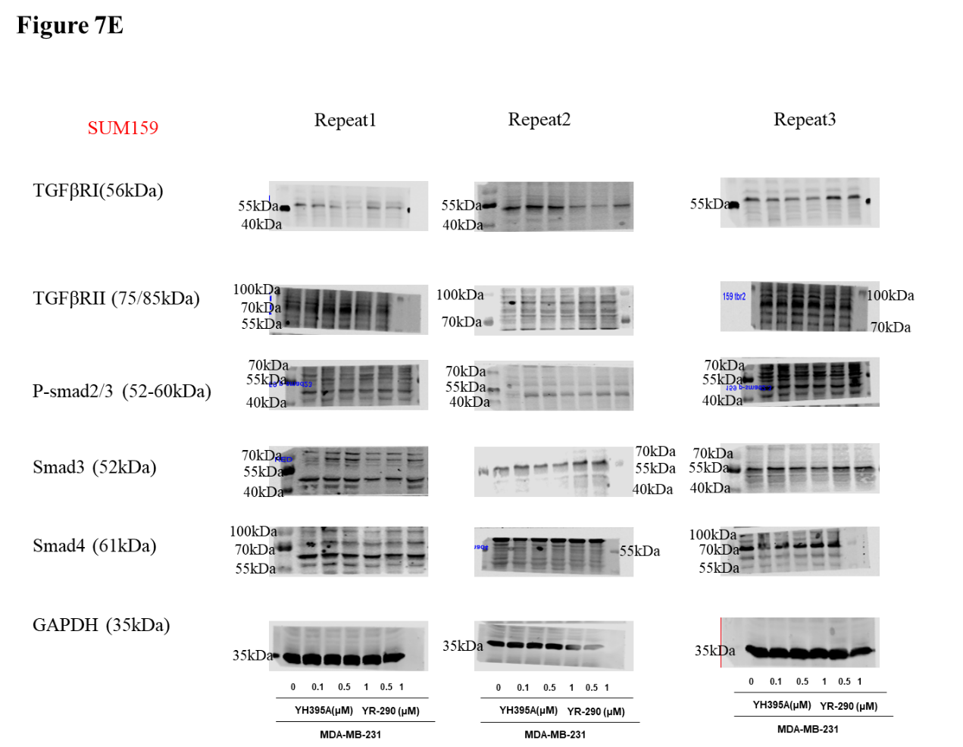
Figure 7E shows the whole blot after cutting membrane at molecular weight 100 kDa,70 kDa, 55 kDa and 35 kDa for TGFβRI(56kDa), TGFβRII (75/85kDa), P-smad2/3 (52-60kDa), Smad3 (52kDa), Smad4 (61kDa) and GAPDH (35kDa)

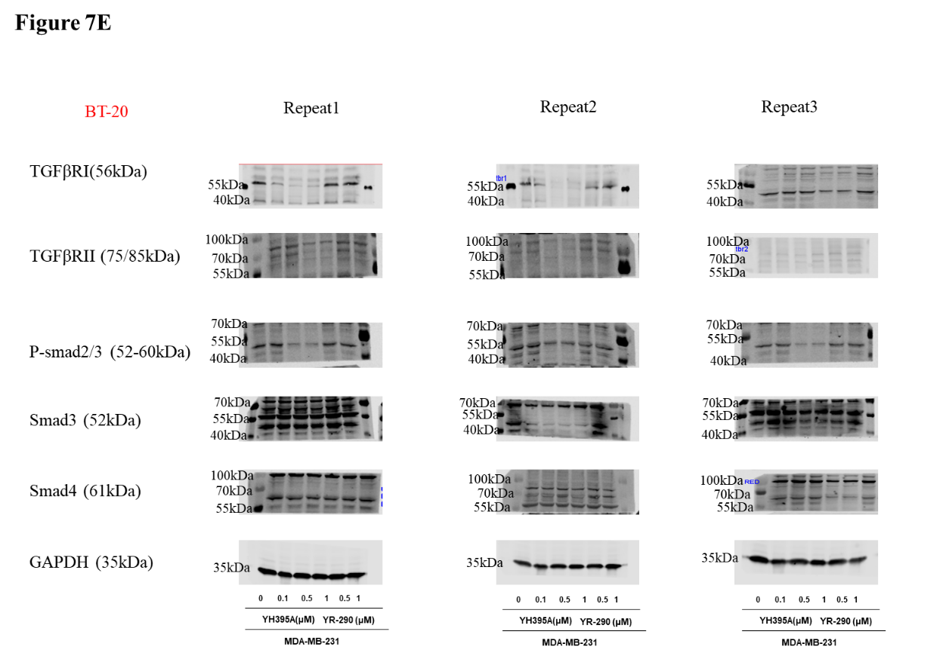
Figure 7E shows the whole blot after cutting membrane at molecular weight 100 kDa,70 kDa, 55 kDa and 35 kDa for TGFβRI(56kDa), TGFβRII (75/85kDa), P-smad2/3 (52-60kDa), Smad3 (52kDa), Smad4 (61kDa) and GAPDH (35kDa)

