Supporting information

Artificial Intelligence-Driven Discovery of YH395A: A Novel TGFβR1 Inhibitor with Potent Anti-Tumor Activity Against Triple-Negative Breast Cancer
Jun Ling^{a,b#}, Jie Zhang^{c#}, Baozhen Wang^{a,d}, Tao Li^{d,}*, Jing Chen^{a,}*
ªSchool of Basic Medical Sciences, Ningxia Medical University, Ningxia, 750004, China; Key Laboratory of Fertility Maintenance Ministry of Education, Ningxia Medical University, Ningxia, 750004, China.
^{b}The Laboratory Medicine Department of Shanxi Provincial People Hospital, Taiyuan, 030001, China.
^{c}Shanghai Frontiers Science Center of Genome Editing and Cell Therapy, Shanghai Key Laboratory of Regulatory Biology, The Institute of Biomedical Sciences, School of Life Sciences, East China Normal University, Shanghai 200241, China.
^{d}Department of Oncology, General Hospital of the Ningxia Medical University, Yinchuan 750004, China.

Table of contents
1. Supplementary biological data. Table S1-9, Figure S1-8.
2.Synthetic routine

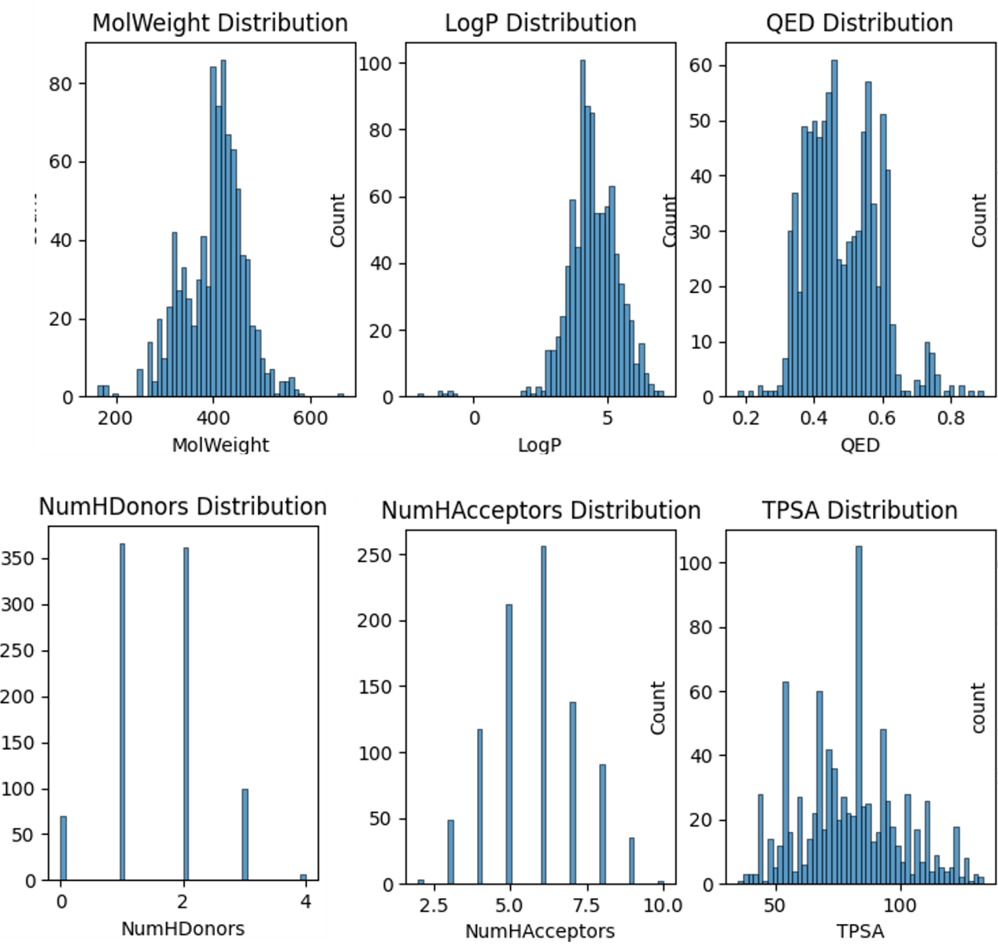
Supplementary Fig.S1. Molecular property distribution for 902 potent TGFβ‐R1 inhibitors extracted from the ChEMBL database (IC₅₀ < 100 nM). The figure presents the range and distribution of key physicochemical parameters—such as molecular weight, calculated lipophilicity (cLogP), hydrogen bond donor and acceptor counts, and topological polar surface area—thereby delineating the chemical space occupied by these inhibitors and providing insights into their drug‐likeness and potential for further optimization.

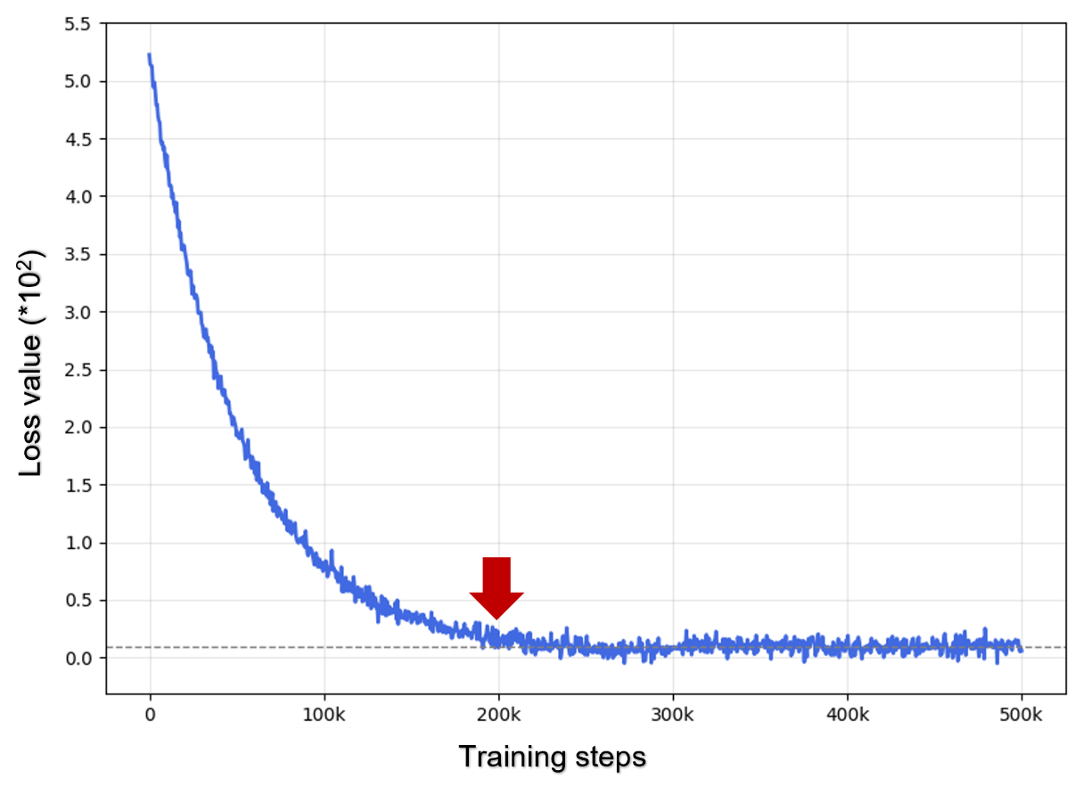
Supplementary Fig.S2. Convergence profile of the training loss for the Graph Deep Learning (GDL) model. The plot displays the loss metric—computed over the training dataset—as a function of the number of training epochs, illustrating an initial rapid decrease followed by stabilization, which attests to the model's effective optimization and convergence during training.

Supplementary Fig.S3. Comparative reconstruction performance of different generative models for molecular library design.

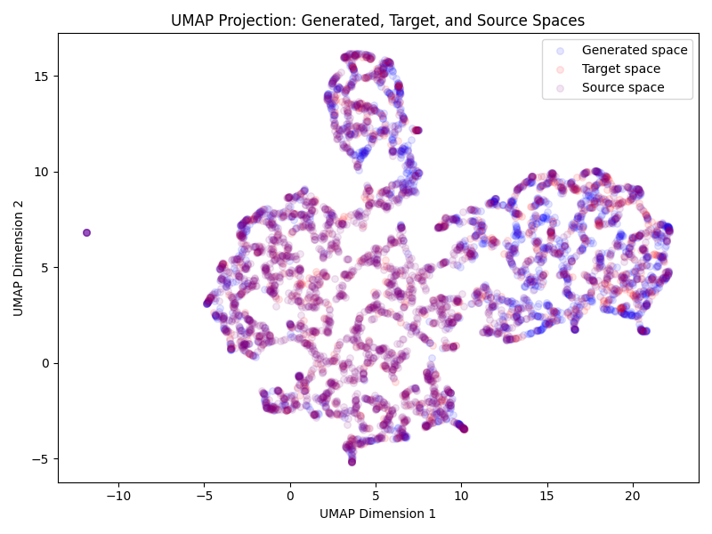
Supplementary Fig.S4. Chemical space navigation by transfer learning. UMAP plots of molecule distributions of randomly selected 3000 molecules from the source data, 1000 molecules from the target data and 2000 molecules from the generated data.

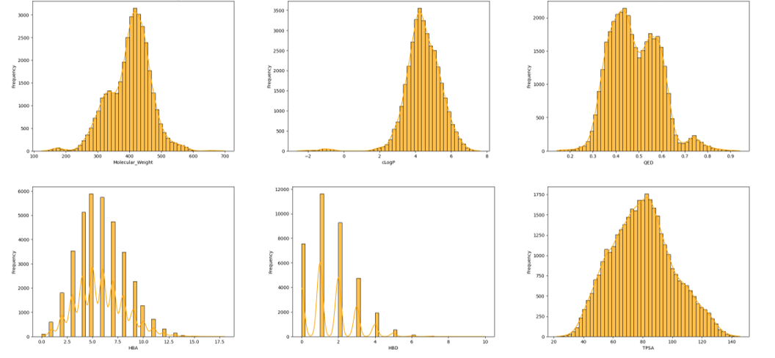
Supplementary Fig.S5. Molecular property distribution for 35,894 potential TGFβ‐R1 inhibitors extracted from the generative molecular library. The figure presents the range and distribution of key physicochemical parameters—such as molecular weight, calculated lipophilicity (cLogP), hydrogen bond donor and acceptor counts, and topological polar surface area—thereby delineating the chemical space occupied by these inhibitors and providing insights into their drug‐likeness and potential for further optimization.

Supplementary Table S1. Descriptors used for chemical feature screening
Descriptor/Descriptor Family | Notes
Gasteiger/Marsili Partial Charges | Tetrahedron 36:3219-28 (1980)
BalabanJ | Chem. Phys. Lett. 89:399-404 (1982)
BertzCT | J. Am. Chem. Soc. 103:3599-601 (1981)
Ipc | J. Chem. Phys. 67:4517-33 (1977)
HallKierAlpha | Rev. Comput. Chem. 2:367-422 (1991)
Kappa1 - Kappa3 | Rev. Comput. Chem. 2:367-422 (1991)
Phi | New in 2021.03 release Quant. Struct.-Act. Rel. 8:221-224 (1989)
Chi0, Chi1 | Rev. Comput. Chem. 2:367-422 (1991)
TPSA | J. Med. Chem. 43:3714-7, (2000) See the section in the RDKit book describing differences to the original publication.
Supplementary Table S2.
Successful synthesis of TGFβ‐R1 inhibitors with YR290 molecular scaffold.
Compd. | Structure | Compd. | Structure
YH395A | 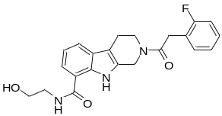 | YH481 | 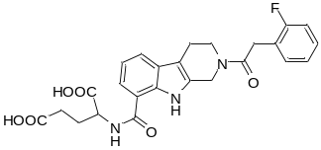
YH391 | 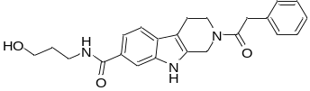 | YH439A | 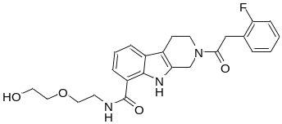
YH407A | 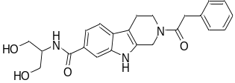 | YH459 | 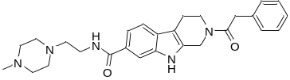
YH409D | 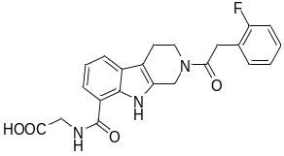 | YH467 | 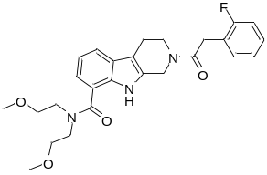
YH421B | 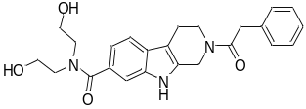 | WG358 | 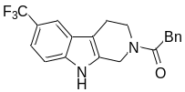
YH423 | 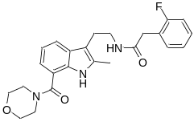 | WG402 | 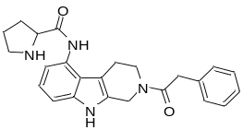
YH449 | 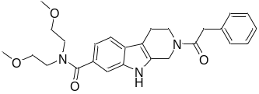 | WG502 | 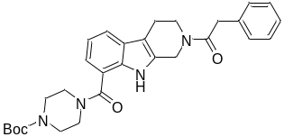
YH477 | 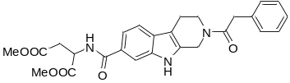 | WG446B | 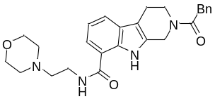
YH445 | 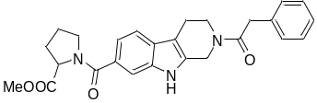 | WG481 | 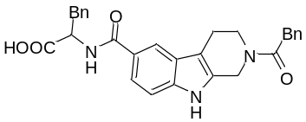
 |  | WG494 | 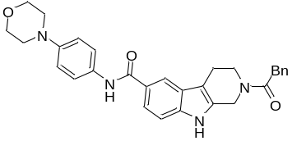
YH437A | 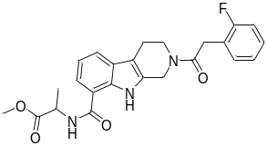 | WG445 | 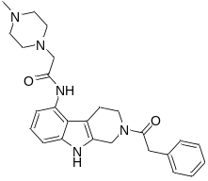

Supplementary Fig.S6. In vitro screening of the antimetastatic activity of a transforming growth factor beta receptor 1 (TGFβR1) inhibitor. YR-290 structural formula. The candidate compound (5 μM) inhibited MDA-MB-231 migration in triple-negative breast cancer cells.

Table S3. Solubility of YR290 and YH395A
Concentration-peak area standard curve of YR-290

Concentration-peak area standard curve of YH395A

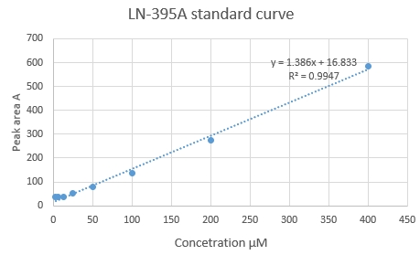
YH395A standard curve

Table S4. Kinetic Solubility of YR290
Compd. | Media | Visual Appearance | Kinetic Solubility |  | Kinetic Solubility
Compd. |  |  |  | (μg/mL) |  | (μM)
 | Buffer pH2.0 | transparent |  | 0.50 |  | 1.72
YR-290 | Buffer pH7.4 | transparent |  | 1.86 |  | 6.42
 | Buffer pH9.0 | transparent |  | 6.30 |  | 21.7

Table S5. Thermodynamic Solubility of YR290
Compd. | Media | Visual Appearance | Thermodynamic Solubility |  | Thermodynamic Solubility
Compd. |  |  |  | (μg/mL) |  | (μM)
 | Buffer pH2.0 | many particles |  | 0.65 |  | 2.23
YR-290 | Buffer pH7.4 | many particles |  | 2.10 |  | 7.24
 | Buffer pH9.0 | many particles |  | 3.10 |  | 10.7

Table S6. Kinetic Solubility of YH395A
Compd. | Media | Visual Appearance | Kinetic Solubility |  | Kinetic Solubility
Compd. |  |  |  | (μg/mL) |  | (μM)
 | Buffer pH2.0 | transparent |  | 34.3 |  | 86.9
YH395A | Buffer pH7.4 | transparent |  | 47.9 |  | 121
 | Buffer pH9.0 | transparent |  | 51.4 |  | 130

Table S7. Thermodynamic Solubility of YH395A
Compd. | Media | Visual Appearance | Thermodynamic Solubility |  | Thermodynamic Solubility
Compd. |  |  |  | (μg/mL) |  | (μM)
 | Buffer pH2.0 | many particles |  | 12.5 |  | 31.6
YH395A | Buffer pH7.4 | many particles |  | 13.3 |  | 33.7
 | Buffer pH9.0 | many particles |  | 22.6 |  | 57.2

Table S8. Predicted Pharmacokinetic parameters of YH395A (using pkCSM)
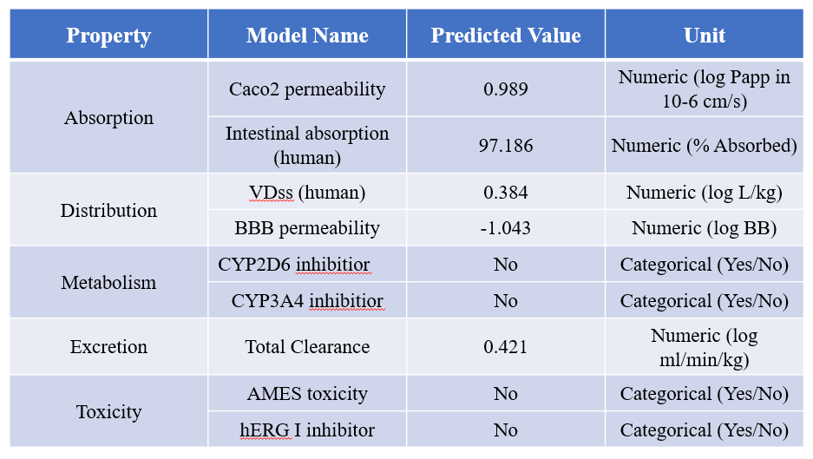

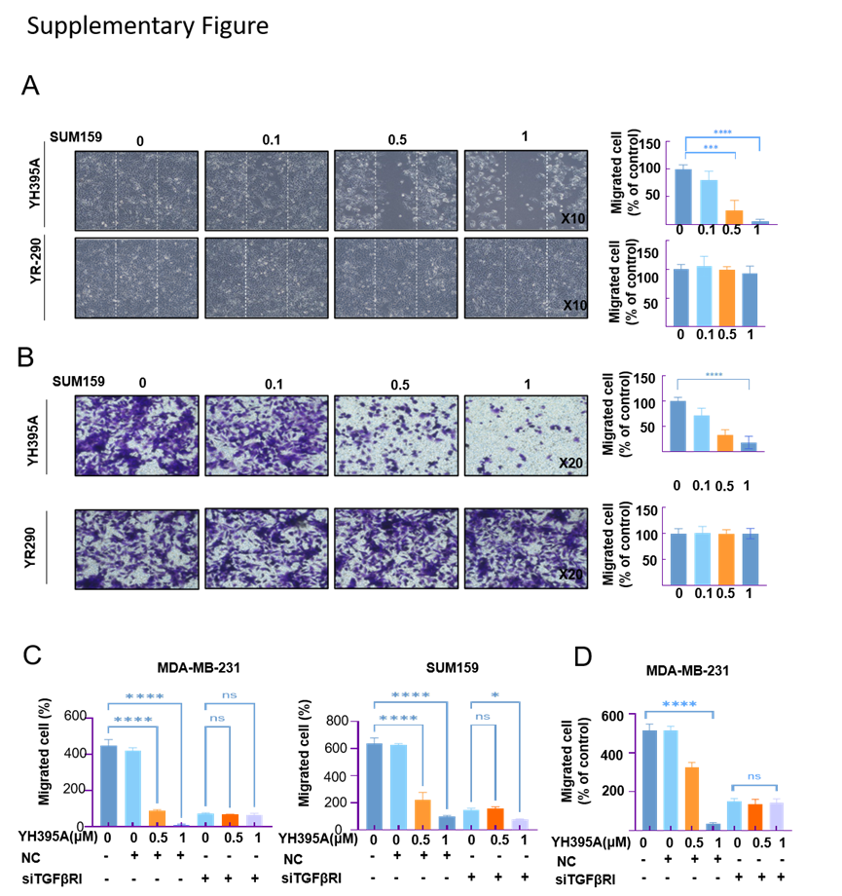
Supplementary Fig.S7. YH395A anti-migration and anti-invasion bioactivities in the SUM159 cell line. (A)YH395A inhibited cell migration in the SUM159 breast cancer cell line as shown in a wound healing assay. Data are presented as the mean ± s.d., and the significance between different groups was analyzed by one-way ANOVA. **P < 0.01, *** P < 0.001. (B) YH395A inhibited cell invasion in the SUM159 breast cancer cell line. The bars indicate the mean ± SD. Statistically significant differences, **P <0.01, ***P < 0.001. (C) Statistical analysis of the chamber invasion experiment. **P < 0.01, ***P < 0.001.
Supplementary Fig.S8. MST Analysis Reveals Moderate-Specific Binding Between TGFβR1 and YH395A at 25°C The interaction between TGFβR1 and the ligand YH395A was analyzed using MST technology at 25.0°C. The experimental setup included a target TGFβR1 concentration of 50 nM, a ligand YH395A concentration range of 200 µM to 0.0061 µM, a repetition number of n=4, an excitation power of 100%, and an MST power of 40%. The results showed that the dissociation constant (Kd) between the two was 3.56×10⁻⁵ M (confidence interval ±9.52×10⁻⁶ M), with a response amplitude of 12.99, a signal-to-noise ratio of 18.15, and a regression standard error of 0.77, indicating high reliability of the experimental data. The raw data of the dose-response curve showed that the response value remained stable (average value ~896.87) at a ligand concentration as low as 6.10×10⁻⁹ M, and the standard deviation at most concentration points was less than 2. Only a few high-concentration points (such as 0.0002 M) showed slightly higher fluctuations (standard deviation 1.44), but the overall concentration-dependent response trend was clear, confirming the existence of a moderate-intensity specific binding interaction between TGFβR1 and YH395A.

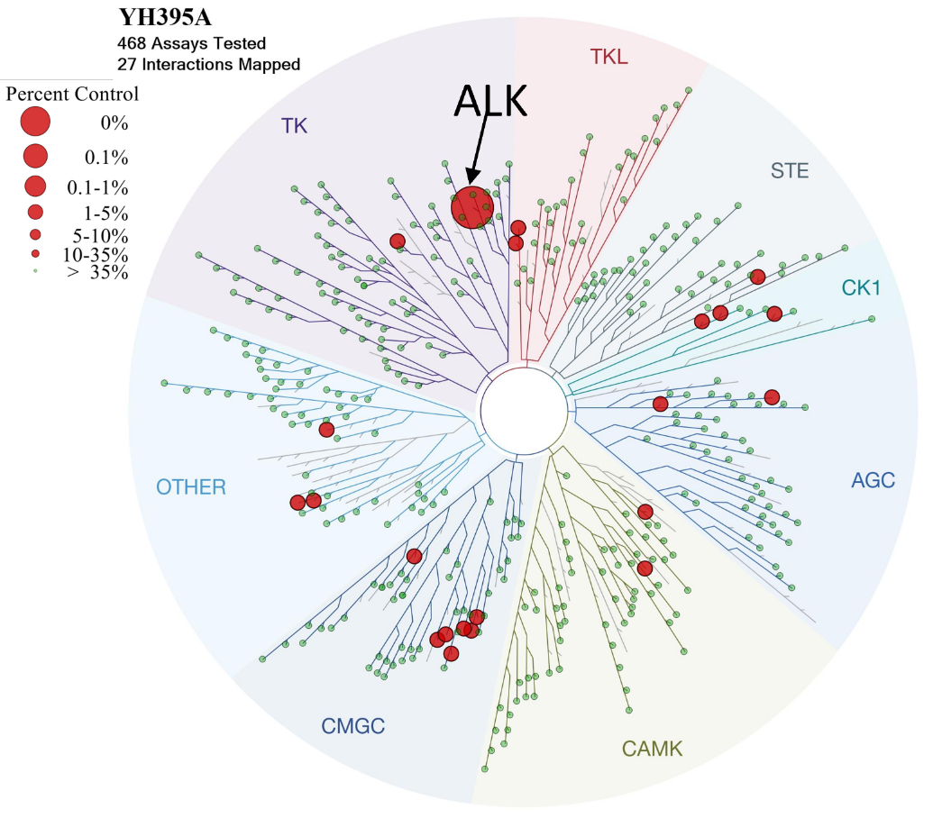
Supplementary Fig.S9. Kinome-wide selectivity profile of YH395A against 468 kinase. A phylogenetic tree of 468 human kinases grouped by major families (shaded sectors: TK, TKL, STE, CK1, AGC, CAMK, CMGC, OTHER). Red circles mark the 27 kinases exhibiting >50% binding displacement at 10 µM YH395A, with circle area scaled to the percent displacement. YH395A shows strongest activity against the TK family (actually ALK kinase, labeled by black row), moderate engagement of CMGC and OTHER kinases, and minimal off-target interactions across the remaining branches.

Table S10. Parameter name Candidate values Default value
Batch size | 512
Batch size for transfer learning | 50
Feature extractor hidden unit number | 128
Feature extractor RNN layer number | 4
Generative RNN hidden unit number | 512
Generative RNN layer number | 2
Embedding size | 32
Gaussian distribution of noise (𝜇, 𝜎) | (1, 0)
Sampling number | 50
Optimizer type | Adam
Learning rate | 0.0001

Synthetic routine
All chemicals and reagents were purchased from Bidepharm, Adamas-beta, Energy Chemical, Sigma-Aldrich or J&K Scientific, and solvents were used as acquired from Tansoole. All the reagents and solvents were used as received unless otherwise mentioned. All non-aqueous reactions were carried out under an inert atmosphere (N2 or Ar). The reaction progresses were monitored by TLC. Products were purified by column chromatography on silica gel (Qingdao, 200e300 mesh). 1H and 13C NMR spectra were generated on Bruker 500 or 600 MHz instruments using CDCl3 or DMSO-d6. High-resolution mass spectra were generated on an Agilent 6550 iFunnel Q-TOF LC/MS System. Purity detection with HPLC was generated by an Agilent Technologies 1200 series, the method is: Eclipse XDB C18 column, 5 mm, 4.6 mm 150 mm; column temperature 40 C; flow rate ¼ 1.5 mL/min; solvent A, water; solvent B, MeOH; gradient of 40e90% B (0e10 min), 90% B (10e15 min), 90- 40% B (15e20 min). Biological activities of compounds were tested with the permission of purity over 95%
All chemicals and reagents were purchased from Bidepharm, Adamas-beta, Energy Chemical, Sigma-Aldrich or J&K Scientific, and solvents were used as acquired from Tansoole. All the reagents and solvents were used as received unless otherwise mentioned. All non-aqueous reactions were carried out under an inert atmosphere (N2 or Ar). The reaction progresses were monitored by TLC. Products were purified by column chromatography on silica gel (Qingdao, 200e300 mesh). 1H and 13C NMR spectra were generated on Bruker 500 or 600 MHz instruments using CDCl3 or DMSO-d6. High-resolution mass spectra were generated on an Agilent 6550 iFunnel Q-TOF LC/MS System. Purity detection with HPLC was generated by an Agilent Technologies 1200 series, the method is: Eclipse XDB C18 column, 5 mm, 4.6 mm 150 mm; column temperature 40 C; flow rate ¼ 1.5 mL/min; solvent A, water; solvent B, MeOH; gradient of 40e90% B (0e10 min), 90% B (10e15 min), 90- 40% B (15e20 min). Biological activities of compounds were tested with the permission of purity over 95%
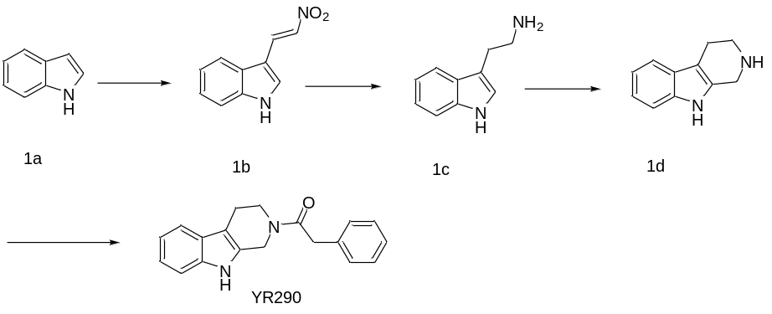
(E)-3-(2-nitrovinyl)-1H-indole (1b).
To a solution of indole (1a, 3 g, 25.61 mmol) in TFA was added (E)-N, N-dimethyl-2-nitroethen-1-amine (3.27 g,28.17 mmol) at 0℃, the reaction was stirred overnight. Then solvent was evaporated under vacuum, NaOH aqueous solution was used to adjust pH>9. The solution precipitated a large number of yellow solid, extraction, wash with deionized water for three times, the solid was dried by vacuum drying oven to obtain yellow powder 1b (3.1 g, 64.3% yield).
2-(1H-indol-3-yl)ethan-1-amine (1c)
To a solution of 1b (3.1 g, 16.47mmol) in MeOH was added NaBH₄ slowly under ice bath condition. and the reaction was stirred for 5 hours until the solution became clear. Under nitrogen condition, Pd/C powder was added to the solution, then replaced the nitrogen with freshly prepared hydrogen, kept stir overnight. The colorless filtrate was obtained by filtration, the filtrate was concentrated to a minimum amount, extracted with ethyl acetate/water, evaporated under vacuum, purified by chromatography to obtain a colorless oil 1c (1.2 g, 45.5% yield).
2,3,4,9-tetrahydro-1H-pyrido[3,4-b]indole(1d)
Intermediate 1c (1.2 g, 7.49 mmol) was dissolved in acetic acid (15 mL), formaldehyde solution (2 mL) was added dropwise under nitrogen protection, the reaction was stirred at room temperature overnight, then acetic acid was evaporated under vacuum, sodium hydroxide solution was used to adjust pH>12, the residue extracted with EtOAc (3x20 mL).The combined organic layer washed with brine, dried over anhydrous Na₂SO₄ and concentrated. The residue was purified by column chromatography to obtain 1d (945 mg, 73.3% yield)
2-phenyl-1-(1,3,4,9-tetrahydro-2H-pyrido[3,4-b]indol-2-yl)ethan-1-one(YR290)
The mixture of intermediate 1d (945 mg, 5.49 mmol), phenylacetic acid (821 mg, 6.04 mmol), HATU (4.17g, 10.98 mmol), in DMF (15 mL) was stirred at room temperature for 5 hours. The solvent was poured into water (30 mL) and extracted with EtOAc (3x40 mL). The combined organic layer was washed with brine and dried over anhydrous Na₂SO₄, then concentrated and purified by column chromatography to give YR290 (912 mg, 57.3% yield)
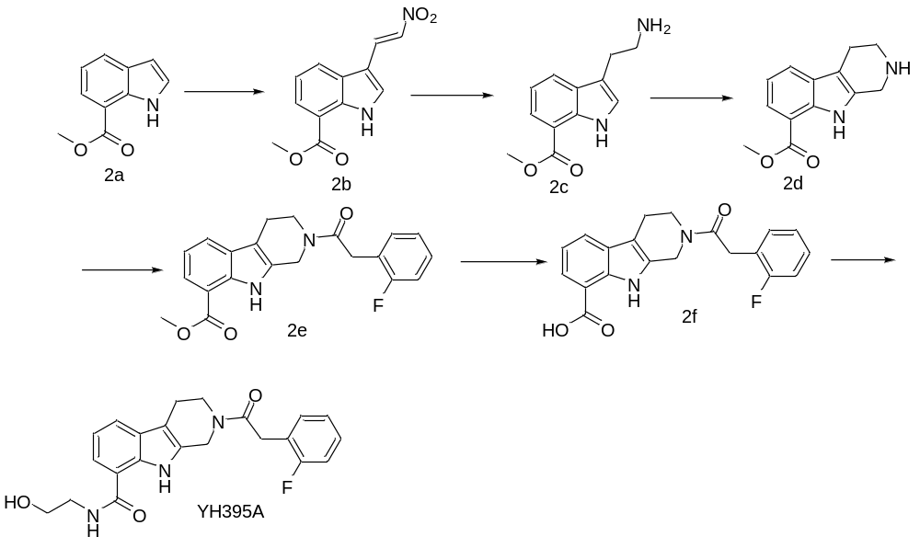
Intermediate 2e was dissolved in THF/H₂O, then LiOHH₂O was added into the solution, the system stirred at room temperature overnight. Then 2N HCl was used to adjust pH to approximately 5, quenched by EA/H₂O, the combined organic layer washed with beine, dried over anhydrous Na₂SO₄ and concentrated to get white powder 2f.
2-(2-(2-fluorophenyl)acetyl)-N-(2-hydroxyethyl)-2,3,4,9-tetrahydro-1H-pyrido[3,4-b]indole-8-carboxamide(YH395A)
The mixture of intermediate 2f, 2-aminoethan-1-ol, HATU (4.17g, 10.98 mmol), in DMF was stirred at room temperature overnight. The solvent was poured into water (30 mL) and extracted with EtOAc (3x40 mL). The combined organic layer was washed with brine and dried over anhydrous Na₂SO₄, then concentrated and purified by column chromatography to give YH395A.

