Supplementary Materials

Figure S1
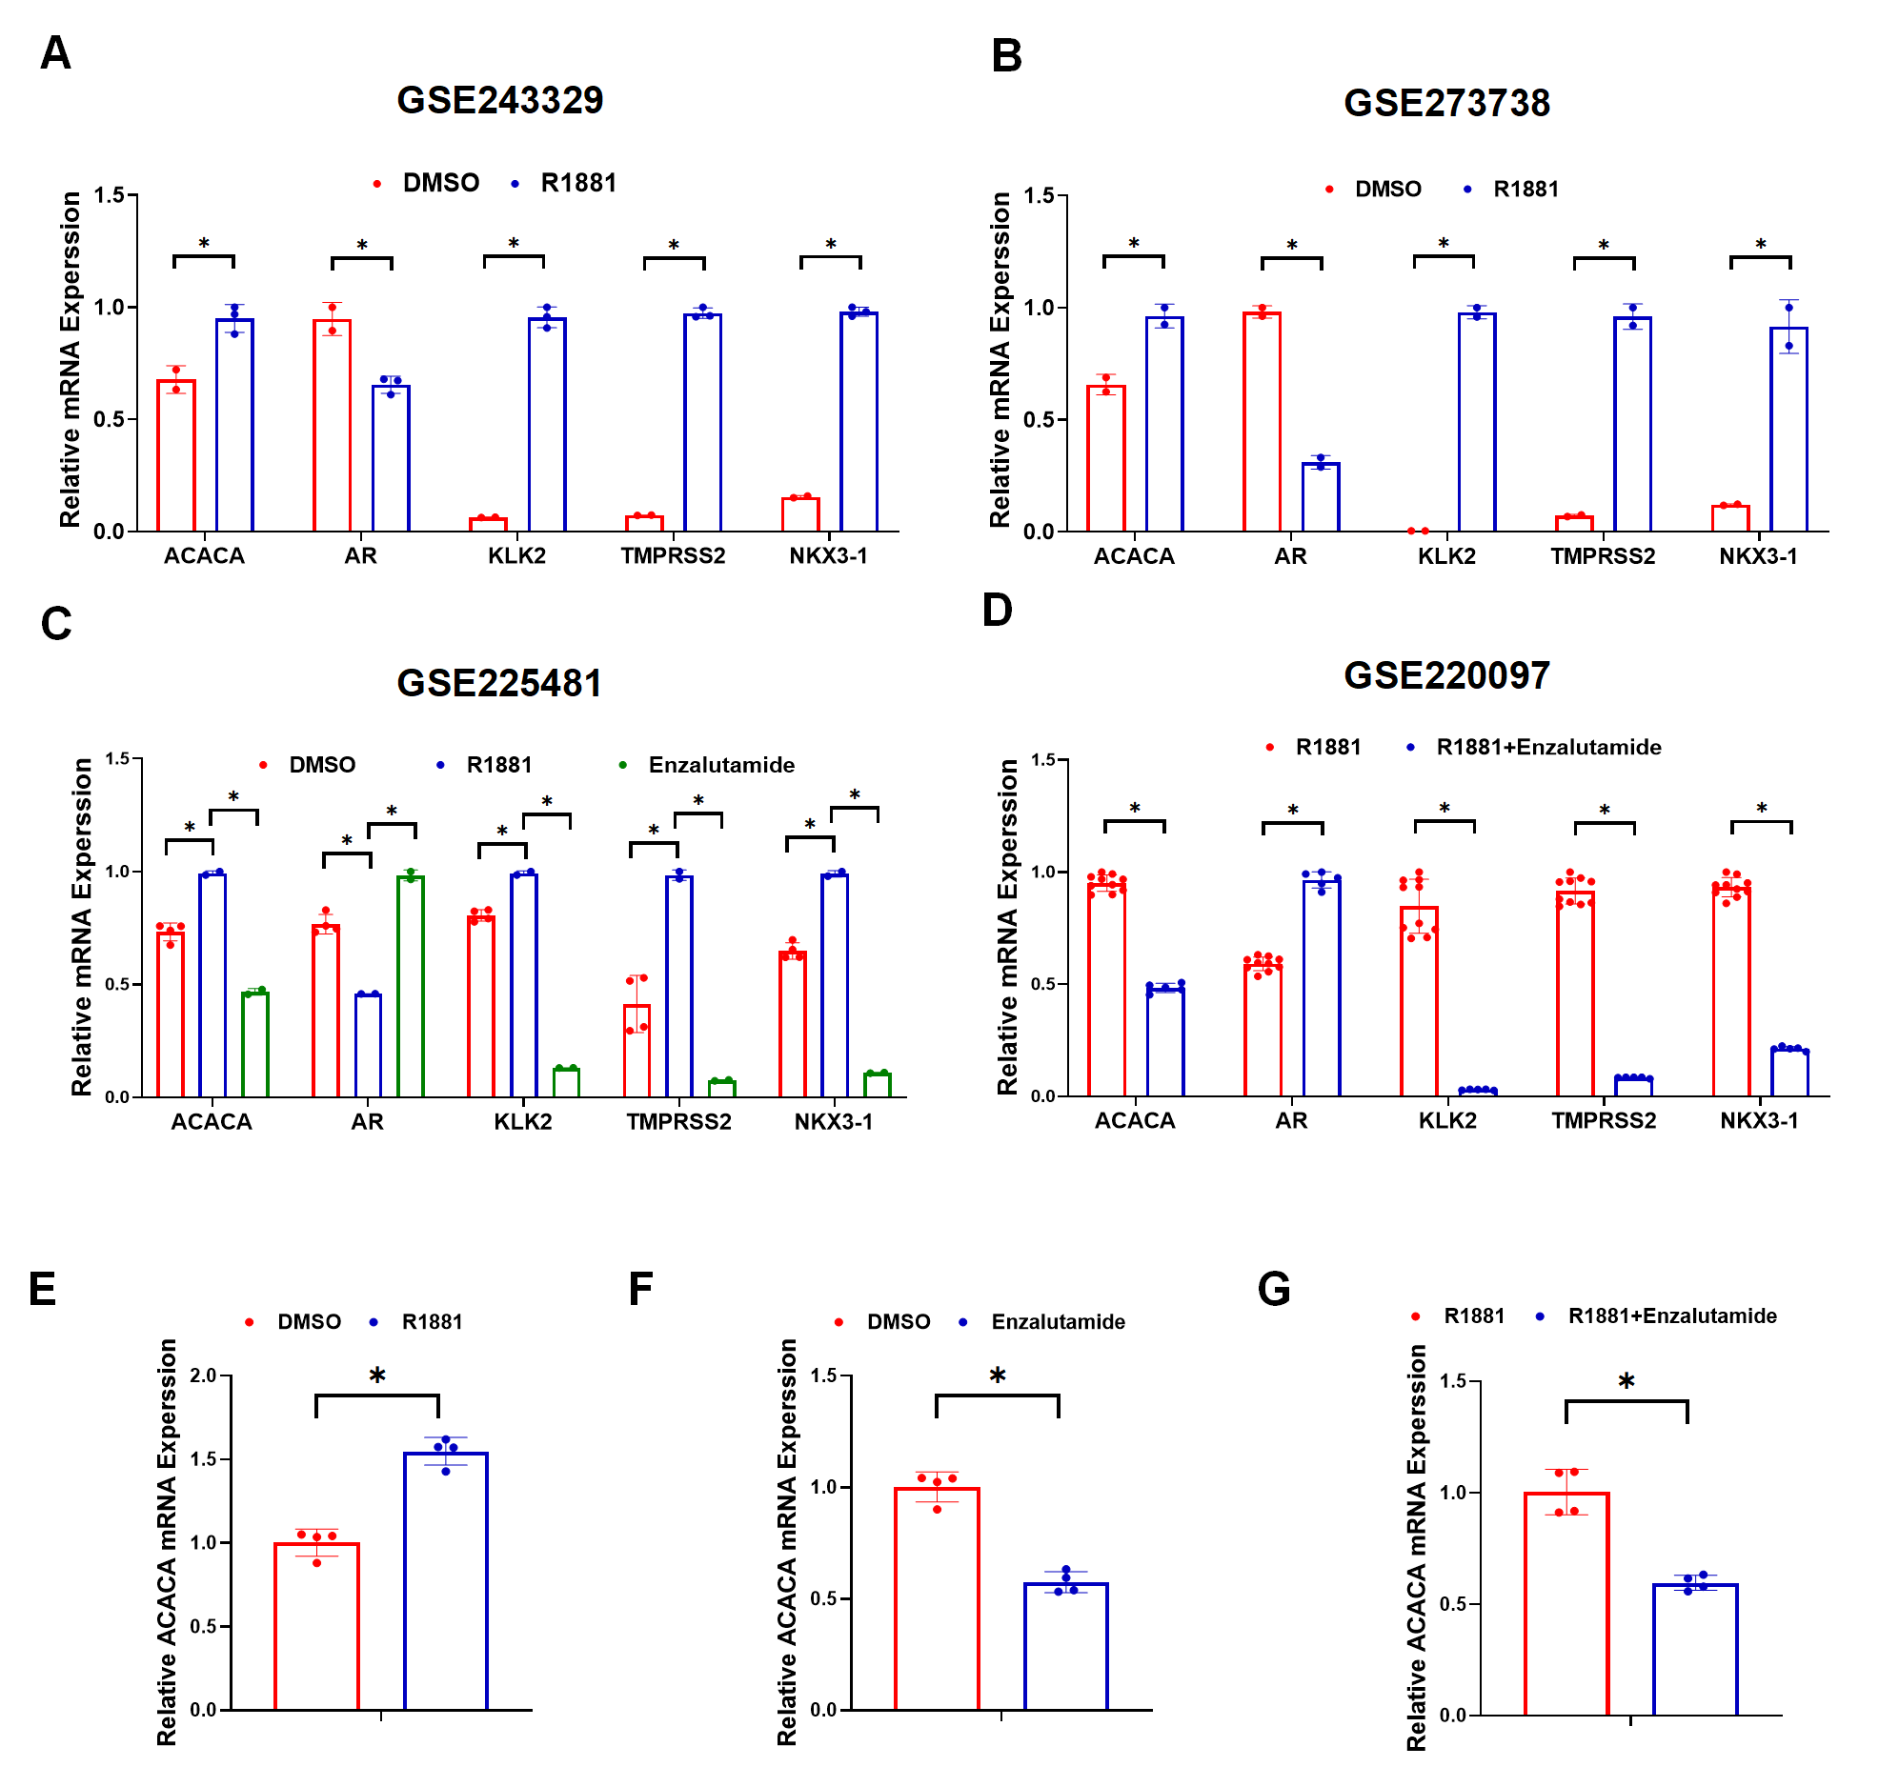
Fig. S1. (A-D)Relative mRNA expression of ACACA, AR, KLK2, TMPRSS2, NKX3-1 in LNCaP cells treated with DMSO, 1 nM R1881, 2 uM Enzalutamide, or their combination, as determined by RNA-seq in indicated datasets.
- G) qPCR analysis of ACACA mRNA expression in LNCaP cells treated with DMSO, 1nM R1881,2 uM Enzalutamide, or their combination.

Figure S2 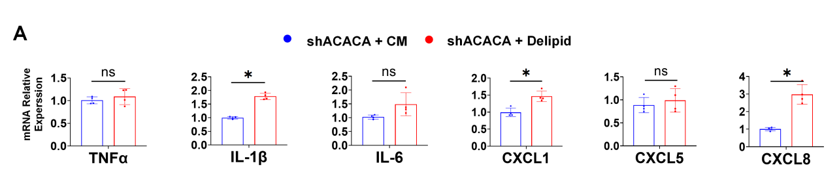
Fig. S2. Delipid treatment of DU145 cells.(A) qPCR analysis of inflammation biomarker-related gene expression in ACACA-depleted DU145 cells cultured in complete medium (CM, 10% FBS) or delipidated medium (Delipid, 10% Delipid-FBS).

Table S1
shRNA | Target
shACACA#1 | TACAAGGGATACAGGTATTTA
shACACA#2 | CCAGCACTCTCGATTCATAAT
1.1 shRNA

1.2 siRNA
siRNA | Orientation | Sequence
siACACA | sense (5'-3') | UACAAGGGAUACAGGUAUUUATT
siACACA | antisense (5'-3') | UAAAUACCUGUAUCCCUUGUATT
sicPLA2 | sense (5'-3') | GUCCAUACGAAAUUGGCAUdTdT
sicPLA2 | antisense (5'-3') | AUGCCAAUUUCGUAUGGACdTdT

Table S2: Antibodies
Antibodies | Source | Identifier | Dilution
ACACA | Cell Signaling Technology | 3676S | WB : 1:1000
ACACA | Proteintech | 21923-1-AP | IHC : 1:500
α-TUBLIN | Abcam | ab176560 | WB : 1:2000
ACTIN | Affinity Bioscience | AF7018 | WB : 1:2000
IL-1β | Immunoway | YT5201 | IHC : 1:200
IL-6 | Affinity Biosciences | DF6087 | IHC : 1:200
TNFα | Affinity Biosciences | AF7014 | IHC : 1:200
CD68 | Abcam | ab201340 | IHC : 1.0 µg/mL
F4/80 | Abcam | ab111101 | IHC : 1:2000
P65 | Cell Signaling Technology | 8242 | WB : 1:2000
pP65 | Cell Signaling Technology | 3033 | WB : 1:2000
IKKα | Cell Signaling Technology | 11930 | WB : 1:1000
IKKB | Cell Signaling Technology | 8943 | WB : 1:1000
IKBα | Cell Signaling Technology | 4814 | WB : 1:1000
pIKBα | Cell Signaling Technology | 2859 | WB : 1:1000
pIKKα/β | Cell Signaling Technology | 2697 | WB : 1:1000
cPLA2 | Proteintech | 68133-1-Ig | WB : 1:1000

Table S3: Primers
Primer | Sequence
IL-1β-F | CACGATGCACCTGTACGATCA
IL-1β-R | GTTGCTCCATATCCTGTCCCT
IL‐6-F | GGAGAGGAGACTTCACAGAGGA
IL‐6-R | ATTTCCACGATTTCCCAGAGA
TNFα-F | CCTCTCTCTAATCAGCCCTCTG
TNFα-R | GAGGACCTGGGAGTAGATGAG
CXCL1-F | GCGCCCAAACCGAAGTCATA
CXCL1-R | ATGGGGGATGCAGGATTGAG
CXCL5-F | CAGACCACGCAAGGAGTTCATC
CXCL5-R | TTCCTTCCCGTTCTTCAGGGAG
CXCL6-F | GTTTACGCGTTACGCTGAGAGTAA
CXCL6-R | CGTTCTTCAGGGAGGCTACCA
CXCL8-F | GAGAGTGATTGAGAGTGGACCAC
CXCL8-R | CACAACCCTCTGCACCCAGTTT
P65-F | TGAACCGAAACTCTGGCAGCTG
P65-R | CATCAGCTTGCGAAAAGGAGCC
cPLA2 F | TACCAGCACATTATAGTGGAGCA
cPLA2 R | GCTGTCAGGGGTTGTAGAGAT
Snail1 F | TCGGAAGCCTAACTACAGCGA
Snail1 R | AGATGAGCATTGGCAGCGAG
Slug-F | CGAACTGGACACACATACAGTG
Slug R | CTGAGGATCTCTGGTTGTGGT

Table S4: Marker genes used for the AR score
Genes | Genes
KLK3 | PART1
KLK2 | ALDH1A3
TMPRSS2 | STEAP4
FKBP5 | AR
NKX3-1 | FOXA1
PLPP1 | GATA2
PMEPA1 | SLC45A3

