Supplementary Figures

LIMCH1 inhibits antitumor immunity by upregulating PDL1 in triple-negative breast cancer
Minghan Qiu^{1, 2, 4, 5, #}, Zhanhua Gao^{1, 5, #}, Mengran Tian^{1, 5, #}, Yuya Liu^{5, #}, Jinpu Liu⁵, Qiaonan Zhang⁵, Ruxue Liu⁶, Yayun Wang⁵, Xiangqian Zheng⁷, Jie Hao^{1, 3,} *, Zhen Yang^{3, *}, Ming Gao^{1, 3,} *
- Department of Thyroid and Breast Surgery, Tianjin Union Medical Center, The First Affiliated Hospital of Nankai University, Tianjin 300121, China.
- Department of Oncology, Tianjin Union Medical Center, The First Affiliated Hospital of Nankai University, Tianjin 300121, China.
- Tianjin Cancer Institute of Integrative Traditional Chinese and Western Medicine, Tianjin Union Medical Center, The First Affiliated Hospital of Nankai University, Tianjin 300121, China.
- The Institute of Translational Medicine, Tianjin Union Medical Center, The First Affiliated Hospital of Nankai University, Tianjin 300121, China.
- School of Medicine, Nankai University, Tianjin, 300071, China.
- College of Integrative Medicine, Tianjin University of Traditional Chinese Medicine, Tianjin 300121, China.
- Department of Thyroid and Neck Tumor, Tianjin Medical University Cancer Institute and Hospital, National Clinical Research Center for Cancer, Key Laboratory of Cancer Prevention and Therapy, Tianjin's Clinical Research Center for Cancer, Tianjin, 300060, China.

#These authors have contributed equally to this work.
*Correspondence:
Ming Gao, headandneck2008@126.com; Zhen Yang, yangz_tumc@126.com; Jie Hao, haojie1215@126.com

Supplement Table 1. Summary of antibodies
Antibodys | Product code | Company | Experiments | Address
Limch1 | ab96178 | Abcam | western blotting, IF, IHC | MA, USA
β-ACTIN | 81115-1-RR | Proteintech | western blotting | Wuhan, China
PDL1 | ab213480 | Abcam | western blotting, IHC | MA, USA
p-PI3K | 4228 | Cell Signaling Technology | western blotting | CA, USA
p-AKT | 4060 | Cell Signaling Technology | western blotting | CA, USA
ERK1/2 | 4695 | Cell Signaling Technology | western blotting | CA, USA
p-ERK1/2 | 4370 | Cell Signaling Technology | western blotting, IHC | CA, USA
MEK1/2 | 8727 | Cell Signaling Technology | western blotting | CA, USA
p-MEK1/2 | 9154 | Cell Signaling Technology | western blotting | CA, USA
p38 | 8690 | Cell Signaling Technology | western blotting | CA, USA
p-p38 | 4511 | Cell Signaling Technology | western blotting | CA, USA
JNK | 9252 | Cell Signaling Technology | western blotting | CA, USA
p-JNK | 4668 | Cell Signaling Technology | western blotting | CA, USA
p65 | 10745-1-AP | Proteintech | western blotting | Wuhan, China
p-p65 | 82335-1-RR | Proteintech | western blotting | Wuhan, China
GAPDH | 5174 | Cell Signaling Technology | western blotting | CA, USA
CD3-FITC | 100203 | Biolegend | flow cytometry | CA, USA
CD8-BV650 | 116016 | Biolegend | flow cytometry | CA, USA
CD4-PE/cy7 | 116016 | Biolegend | flow cytometry | CA, USA
PDL1-APC | 329708 | Biolegend | flow cytometry | CA, USA
CD16/32 | 101319 | Biolegend | flow cytometry | CA, USA

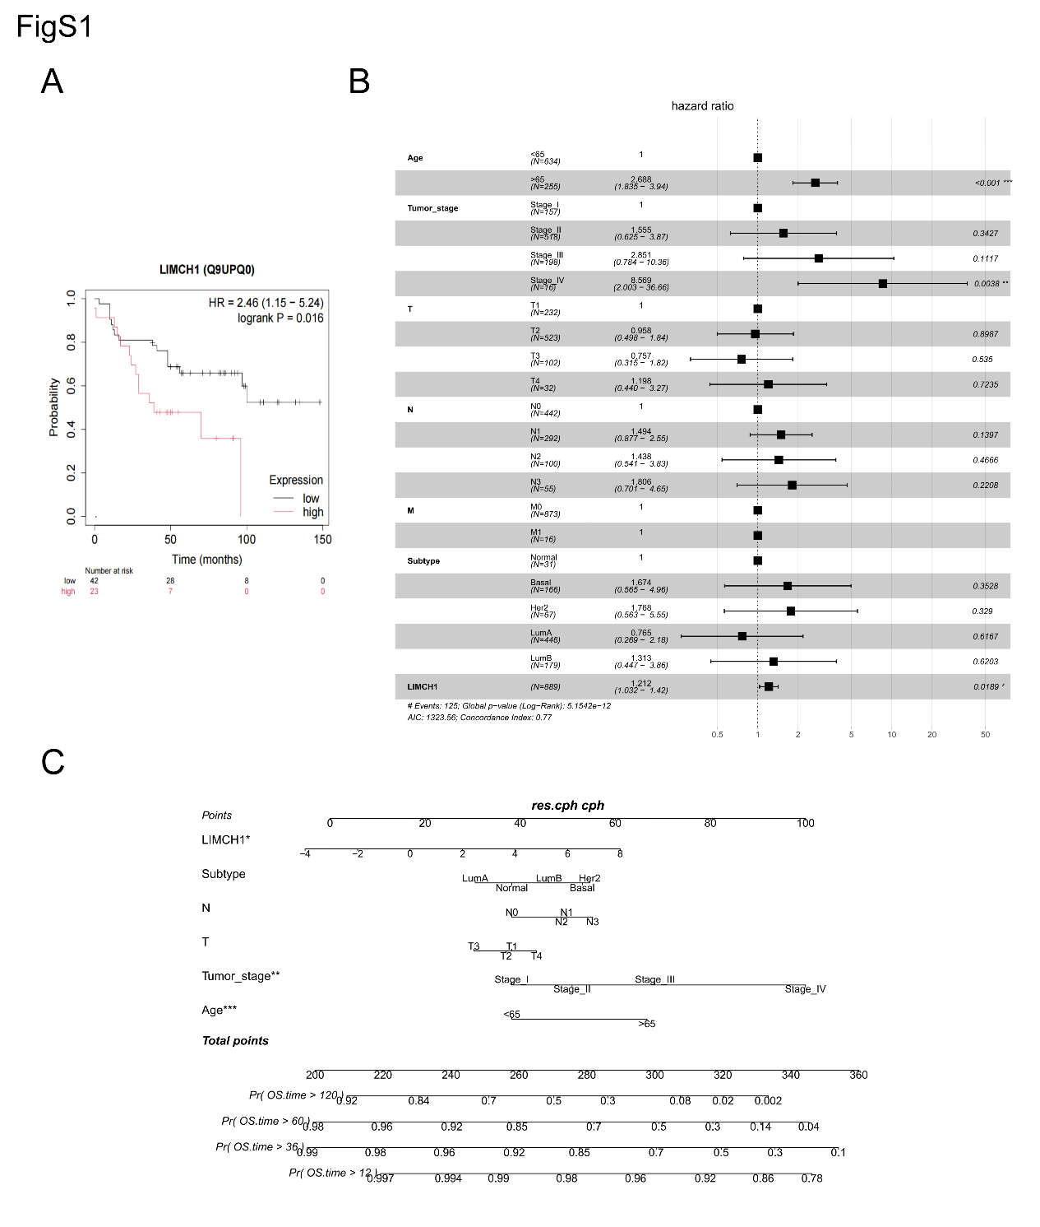
Figure S1. LIMCH1 is highly expressed in breast cancer tissues and associated with prognosis. A. The relationship between LIMCH1 protein expression levels and overall survival in breast cancer patients was analyzed using the KM-plot. B. Multivariate Cox proportional hazards regression analysis showed that LIMCH1 is an independent factor influencing overall survival in breast cancer patients. C. Nomogram based on LIMCH1 and other clinical characteristics.

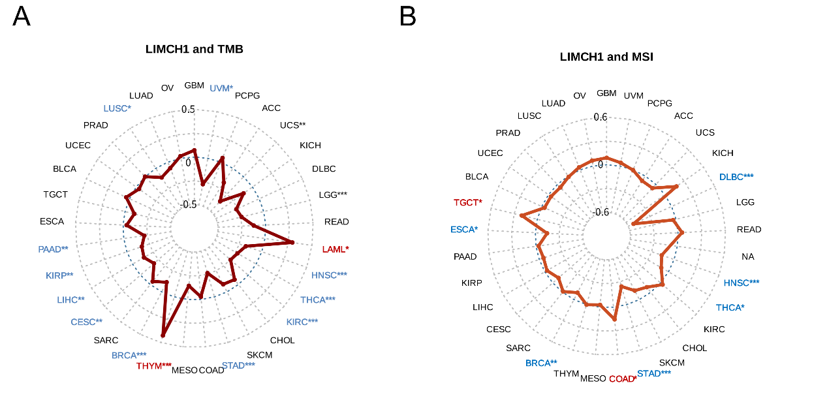
Figure S2. Spearman correlation analysis of LIMCH1 with tumor mutational burden (TMB) and microsatellite instability (MSI). A. Spearman correlation analysis results between LIMCH1 and TMB. B. Spearman correlation analysis results between LIMCH1 and MSI. Red indicates positive correlation, while blue indicates negative correlation. *P < 0.05, **P < 0.01, ***P < 0.001.

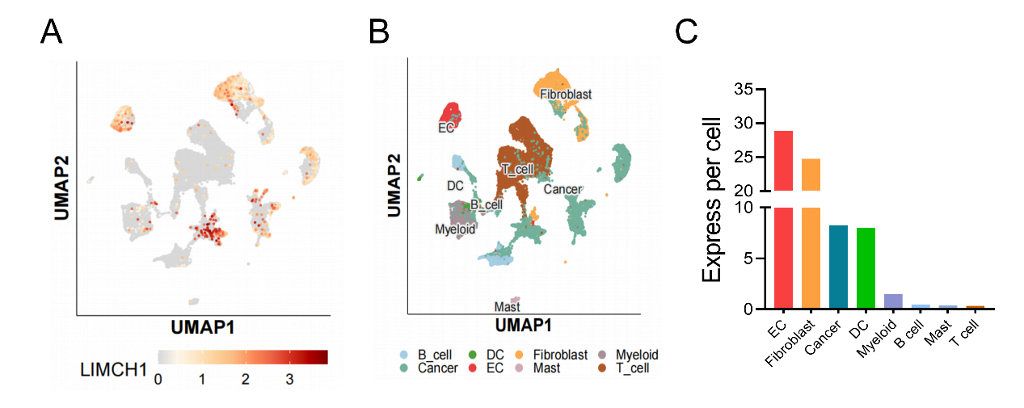
Figure S3. Single-cell transcriptome analysis using SCAR database. A-B. Breast cancer’s single-cell data was analyzed using SCAR database to compare differences of LIMCH1 expression in breast cancer tumor cell populations. C. Histogram shows LIMCH1 expression in each cell population.

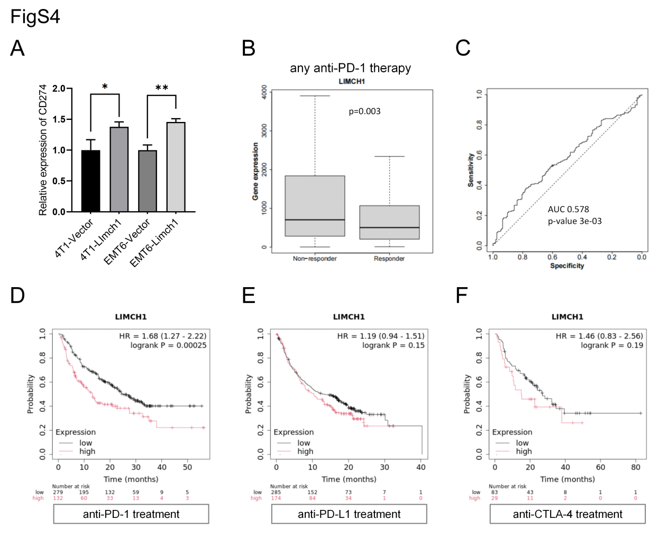
Figure S4. Expression and prognostic analysis of LIMCH1 in different immunotherapies. A. LIMCH1 overexpression increases CD274 mRNA levels in 4T1 and EMT6 cells. B. LIMCH1 expression levels in responders versus non-responders to anti-PD-1 therapy, analyzed via the ROC-plotter database. C. ROC-plotter database ROC curve assessing the predictive capacity of LIMCH1 for anti-PD-1 therapy response. D. KM-plotter database analysis of LIMCH1 expression and survival rates in patients treated with anti-PD-1, anti-PD-L1, and anti-CTLA-4 therapies.

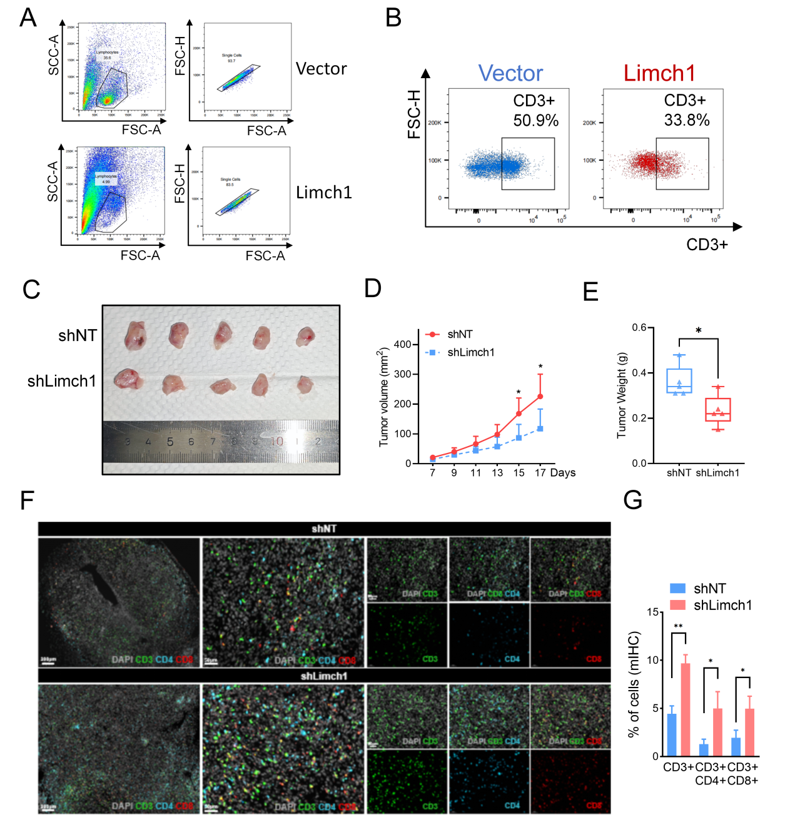
Figure S5. LIMCH1 promotes proliferation and metastasis of TNBC tumors and suppresses T-cell infiltration in the TIME. A-B. Gating strategy and representative flow cytometry plots for CD3⁺ T cells shown in Figure 8C. C. Images of tumors from shNT and shLIMCH1 groups in the 4T1 orthotopic mouse model. D. Tumor growth curves over time. E. Tumor weights at endpoint. F. Multiplex immunofluorescence staining of CD3⁺, CD3⁺CD4⁺, and CD3⁺CD8⁺ cells in tumor tissues. G. Quantification of CD3⁺, CD3⁺CD4⁺, and CD3⁺CD8⁺ T cell populations. Statistical analyses were performed using unpaired t-tests. * P<0.05, * *P<0.01.

