Supplementary Figures and Figure legends
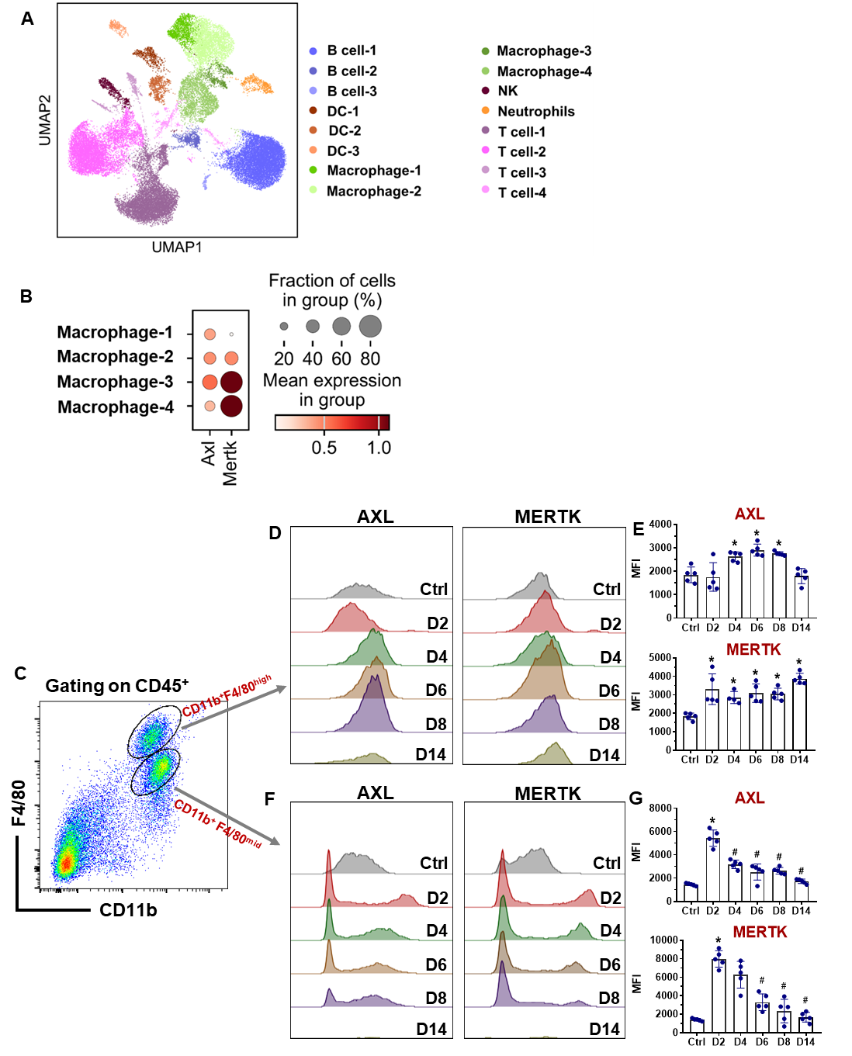
Supplementary Figure 1. The expression pattern of AXL and MERTK in pancreatic macrophages during severe acute pancreatitis. Pancreatic CD45⁺ leukocytes from the mice of control and day 4 post pancreatitis were subjected to single-cell RNA sequencing analysis (n = 1 sample in control group and n = 3 samples in day 4 group; each sample from 3-4 mice). (A) UMAP plot shows clusters of all immune cells analyzed by 10 × Genomics scRNA-seq. (B) Bubble plots show the percentage of Axl and Mertk positive cells in each cluster of macrophages. (C) Representative histograms show CD11b⁺F4/80^{high} and CD11b⁺F4/80^{mid} macrophages. (D) Representative histograms show AXL and MERTK expression and (E) Quantification (mean fluorescent intensity, MFI) on F4/80^{high} macrophages (n = 5 per group). (F) Representative histograms show AXL and MERTK expression and (G) Quantification (mean fluorescent intensity, MFI) on F4/80^{mid} macrophages (n = 5 per group). Data were the mean ± SD. The P values were calculated using a one-way ANOVA. *P < 0.05 versus control, #P < 0.05 versus the group labelled*. Ctrl, control; D2, day 2; D4, day 4; D6, day 6; D8, day 8; D14, day 14.

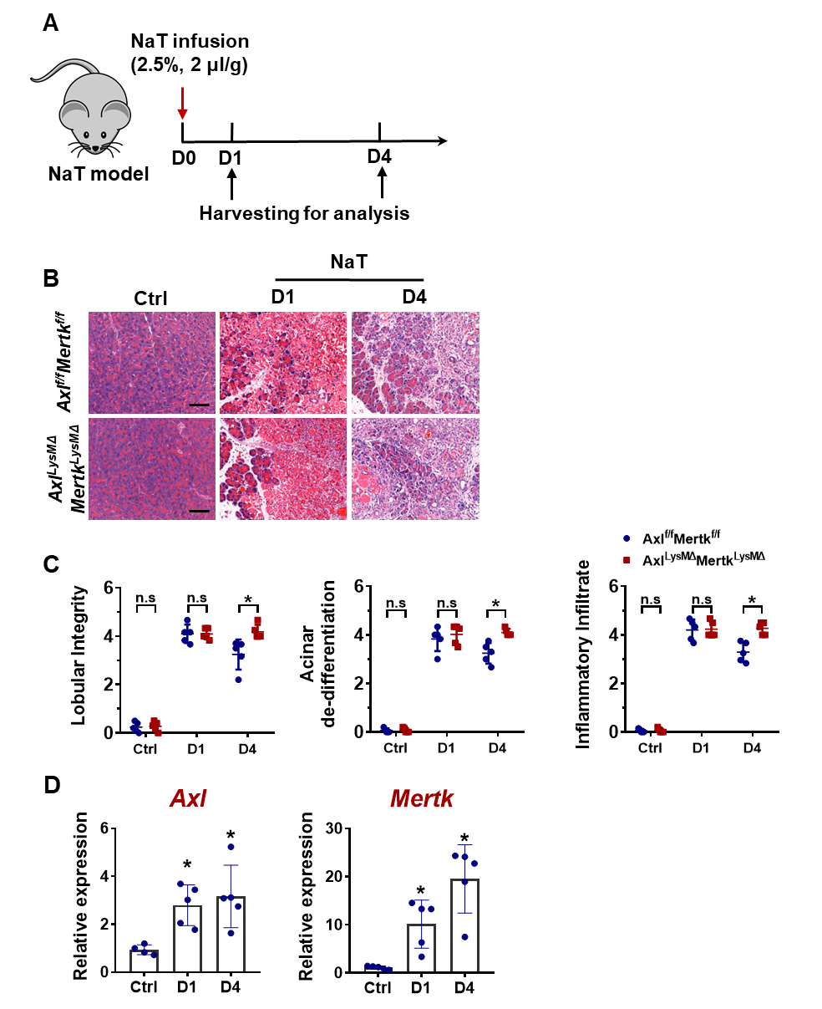
Supplementary Figure 2. Myeloid cell-specific deletion of Axl and Mertk impairs pancreatic tissue repair after sodium taurocholate-induced severe acute pancreatitis. (A) Schematic diagram of the experimental procedures for sodium taurocholate-induced severe acute pancreatitis and harvesting the tissues. (B) Representative haematoxylin and eosin-stained pancreatic sections from Axl^{f/f}Mertk^{f/f} and Axl^{LysMΔ}Mertk^{LysMΔ} mice (n = 5 per group). Scale bars, 100 μm. (C) Histological scoring of pancreatic tissues (n = 5 per group). (D) Pancreatic tissues were analyzed for expression of Axl and Mertk using RT–qPCR (n = 5 per group). Data were expressed as the mean ± SD. The P values were calculated using 2-tailed unpaired Student’s t test. For C, *P < 0.05 and ns, not significant. For D, *P < 0.05 versus control. NaT, sodium taurocholate; Ctrl, control (D0, day 0); D1, day 1; D4, day 4.
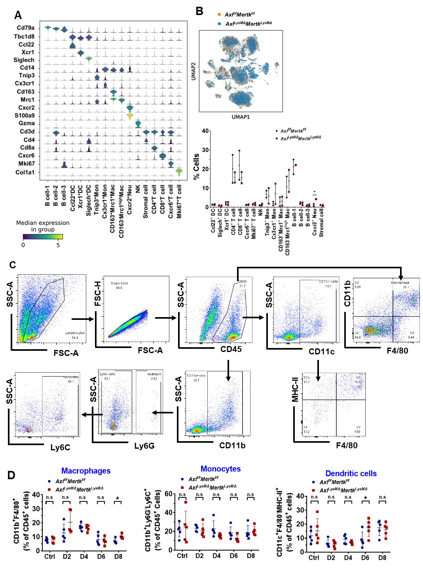
Supplementary Figure 3. Single-cell RNA sequencing analysis of pancreatic CD45⁺ immune cells at Day 4 following severe acute pancreatitis and time-course flow cytometry analysis of pancreatic macrophages, monocytes and dendritic cells. (A) Violin plots show the expression levels of selected marker genes in each cluster. (B) Combined UMAP plots colored by groups (up) and relative proportions of cell types in each group (down). (C) The gating strategies and (D) quantifications of macrophage (CD45⁺CD11b⁺F4/80⁺), monocyte (CD45⁺CD11b⁺Ly6G⁺Ly6C⁺) and dendritic cell (CD45⁺CD11c⁺F4/80⁻MHCII⁺). Data are the mean ± SD. The P values were calculated using 2-tailed unpaired Student’s t test. *P < 0.05 and ns, not significant. Ctrl, control; D2, day 2; D4, day 4; D6, day 6; D8, day 8.
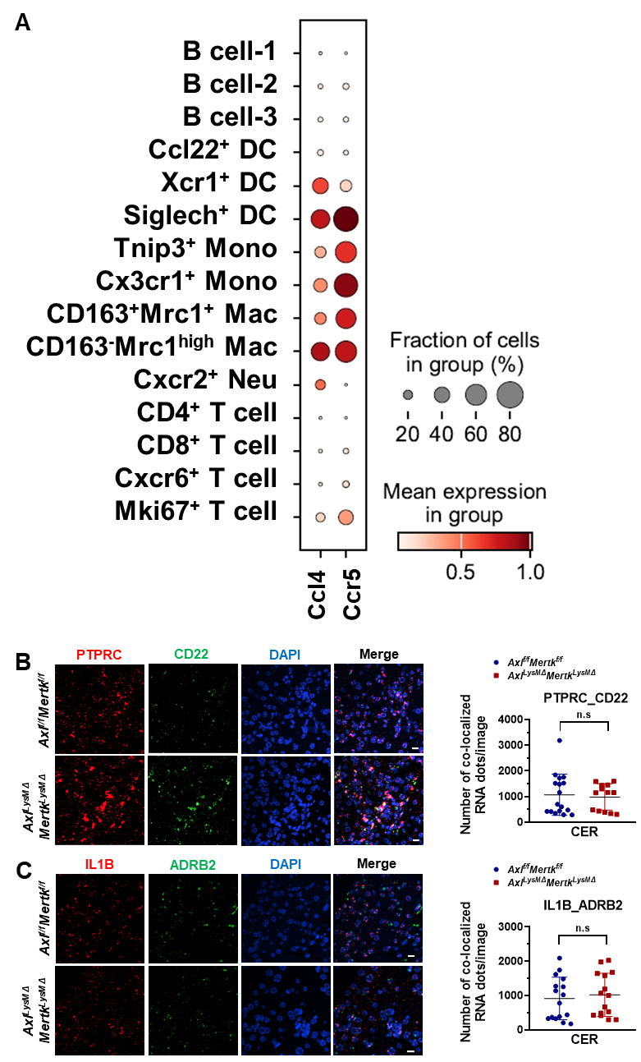
Supplementary Figure 4. The expression pattern of Ccl4 and Ccr5 in pancreatic CD45⁺ immune cells and quantification of PTPRC_CD22 and IL1B_ADRB2 ligand-receptor pairs. (A) Bubble plots show the percentage of Ccl4 and Ccr5 positive cells in each cluster of total cells. Representative images of (B) PTPRC_CD22 and (C) IL1B_ADRB2 ligand-receptor pair (left), with quantifications of co-localized RNA dots in the right panels. Scale bars, 20 μm. Data are the mean ± SD. The P values were calculated using 2-tailed unpaired Student’s t test. ns, not significant; CER, Caerulein.

Supplementary Table 1. Pancreatic histological scoring system for tissue repair.
Score | Lobular integrity | Acinar de-differentiation (AD) | Immune infiltrate
0 | No abnormality  Mild space between lobules | No abnormality | No significant infiltration  Minimal interlobular infiltration
1 | Mild interlobular space  Mild intralobular space  No peri-parenchyma space | ≤ 10% AD | Mild interlobular infiltration  Mild intralobular peri-ductal infiltration
2 | Mild interlobular space  Mild intralobular space  ≤25% peri-parenchymaspace | 10-30% AD | Severe interlobular infiltration  Severe intralobular peri-ductal infiltration  ≤ 10% intralobular infiltrate
3 | Moderate interlobular space  Moderate intralobular space  25-50% peri-parenchyma space | 30-60% AD | 10-30% intralobular infiltrate  ±interlobular infiltration
4 | Severe interlobular space  Severe intralobular space  50-75% peri-parenchyma space | 60-90% AD | 30-60% intralobular infiltrate  ±interlobular infiltration
5 | Severe interlobular space  Severe intralobular space  75-100% peri-parenchyma space | 90-100%AD | 60-100% intralobular infiltrate  ±interlobular infiltration

Supplementary Table 2. Sequences of mouse genes primers for RT-qPCR.
Gene | Forward primer (5′–3′) | Reverse primer (5′–3′)
Axl | CGGTGCAGTATTTCCCTCCA | CCCTCATCCATGTTGACATAGA
Mertk | CCCTCATCCATGTTGACATAGA | GTTGTCCAACTTCATGGTCTTC
Amy2a | TGCAGGTCTCTCCACCCAATGAAA | TGCACCTTGTCACCATGTCTCTGA
Krt19 | TCCCAGCTCAGCATGAAAGCT | AAAACCGCTGATCACGCTCTG
Il1b | GTACTCCAGAAGACCAGAGG | TGATGTGCTGCTGCGAGATT
Il6 | GAGAGGAGACTTCACAGAGG | GTACTCCAGAAGACCAGAGG
Tnf | CCCACGTCGTAGCAAACCA | ACAAGGTACAACCCATCGGC
Mrc1 | CTCTGTTCAGCTATTGGACGC | CGGAATTTCTGGGATTCAGCTTC
Arg1 | GTACATTGGCTTGCGAGACG | ATCGGCCTTTTCTTCCTTCCC
Retnla | CAGCTGATGGTCCCAGTGAAT | CAGTGGAGGGATAGTTAGCTGG
Adam8 | TGGTATTGCAGGGCACCAAG | GAGGCTCGTAGACGCTGCTT
Mmp9 | TCACCATGAGTCCCTGGCA | AGCGGTACAAGTATGCCTCTGC
Rplp0 | TTATAACCCTGAAGTGCTCGAC | CGCTTGTACCCATTGATGATG

