Extracellular matrix protein signaling promotes multi-step cancer vasculogenic mimicry formation.
Gabriel Mingo¹, Andrés Valdivia¹, Gema Nicolle Santander^{1,14}, Nicole Babbitt^{1,14}, Varina Aldana¹, Javiera Pradenas¹, Pamela González^{1,14}, Cristóbal Canales^{1,14}, Jorge Toledo^{6,7}, Carolina Ibáñez^{2,8,9}, Francisco Nualart¹⁰, Manuel Varas-Godoy^{5,11}, Roger Gejman³, Juan Carlos Roa^{3,9,14}, Andrea Ravasio⁴, Cristina Bertocchi^{1,12}, Gareth I. Owen^{1,2,9,13,14*}.
¹Department of Physiology, Faculty of Biological Sciences, Pontificia Universidad Católica de Chile, Santiago, Chile.
²Department of Hematology and Oncology, Faculty of Medicine, Pontificia Universidad Católica de Chile, Santiago, Chile.
³Department of Pathology, Faculty of Medicine, Pontificia Universidad Católica de Chile, Santiago, Chile.
⁴Institute for Biological and Medical Engineering, Schools of Engineering, Medicine and Biological Sciences, Pontificia Universidad Católica de Chile, Santiago, Chile
⁵Centro de Biología Celular y Biomedicina (CEBICEM), Facultad de Medicina y Ciencia, Universidad San Sebastián, Santiago Chile.
⁶ Center for Advanced Clinical Research (CICA), Department of Neurology & Neurosurgery, Faculty of Medicine, Universidad de Chile, Santiago, Chile.
⁷Advanced Scientific Equipment Network (REDECA), Faculty of Medicine, Universidad de Chile, Santiago, Chile

⁸Fundación Oncomujer, Santiago, Chile
⁹Center for Cancer prevention and Control (FONDAP-CECAN), Santiago, Chile. Pontificia Universidad Católica de Chile.
¹⁰Faculty of Biological Sciences, NeuroCellT and CMA BIO BIO, University of Concepcion.
¹¹Centro Ciencia & Vida, Fundación Ciencia & Vida, Santiago, Chile
¹²Graduate School of Engineering Science, Osaka University, Japan.
¹³Advanced Center for Chronic Diseases (FONDAP-ACCDiS), Santiago, Chile. Pontificia Universidad Católica de Chile.
¹⁴Millennium Institute on Immunology and Immunotherapy, Santiago 8331150, Chile.
* Correspondence:
Gareth I. Owen gowen@bio.puc.cl
Journal: Cell Communication and Signaling
Supplementary video 1. Time lapse formation of VM in HEY-A8 cell line
HEY-A8 cells (15,000) were seeded onto Matrigel and placed in a temperature-controlled microenvironment for observation by time-lapse light microscopy. Video recorded from 0 to 60 hours using the Cell observer Z1 (Zeiss) with a 20X objective.

Supplementary video 2. Contraction and blebbing are present in the formation of VM in HEY-A8 cell line
HEY-A8 cells (15,000) were seeded onto Matrigel and placed in a temperature-controlled microenvironment for observation by MuviCyte Live Imaging System time-lapse (Perkin Elmer) microscopy. Video recorded formation from 0 to 72 hours.

Supplementary figure 1. Confocal microscopy demonstrating the appearance of a bridge structure during the second phase of VM
HEY-A8 cells were transfected with GFP and seeded on top of Matrigel. After 72 hours, the sample was fixed and analyzed by using confocal microscopy, with nuclei stained with DAPI (blue). Representative figure of a minimum of three experiments.

Supplementary figure 2. Differential cortactin distribution between the upper and lower region of the tubular structure. (A) Representative images of four independent experiments (based on either reconstruction or orthogonal views) demonstrating a higher Cortactin to nuclei (DAPI) ratio in the upper region of the tubular structure at 96 hours in the HEY-A cancer cell line. (B) Quantification of cortactin to nuclei (DAPI) ratio in the upper and lower layers of the tubular structures. All the images used were z-stack, with pixel values ​taken for each image in the z-stack in lower layer (>10 μm from Matrigel) or the upper layer (between 30-40μm). Statistical significance* determined by student t-test p<0.03. N=6 independent experiments.

Supplementary figure 3. Pathway inhibitors do not cause toxicity in the HEY-A8 ovarian cancer cell line.
(A) MTS assay in the HEY-A8 cells line evaluating cellular viability after 48 hours of vehicle, LY-294002 hydrochloride (20µM, iPI3K), PF-573228 (400nM, iFAK) or AKT inhibitor IV (625nM, iAKT) treatment, N=3. (B) HEY-A8 cells were seeded on Matrigel for 96 hours. 1 hour after seeding cells were treated with Vehicle, PF-573228 (400nM, iFAK) or AKT inhibitor IV (625nM, iAKT). Photographs were taken 96 hours. Inhibition of FAK or AKT allow initial alignment and connections before 24 hours, however no further progression was observed. Cells grown on denaturated Matrigel proliferated to form a cell monolayer in all conditions demonstrating that cellular toxicity was not present despite an inhibition of the VM structures. N=1.
Supplementary figure 4. Vasculogenic mimicry structures only for on natured Matrigel.
(A) Tubular structures only form on Matrigel (normal conditions, natured) as shown at 96 hours after seeding. The right-hand panel demonstrates that heated denatured Matrigel permits ovarian cancer cells (HEY-A8) to grow to a complete monolayer at 96 hours, but not form tubular structures. (B) Representative images of the four independent cell culture experiments before the cells were harvested at the stated timepoints for RNAseq analysis. Scale bar = 400µm.
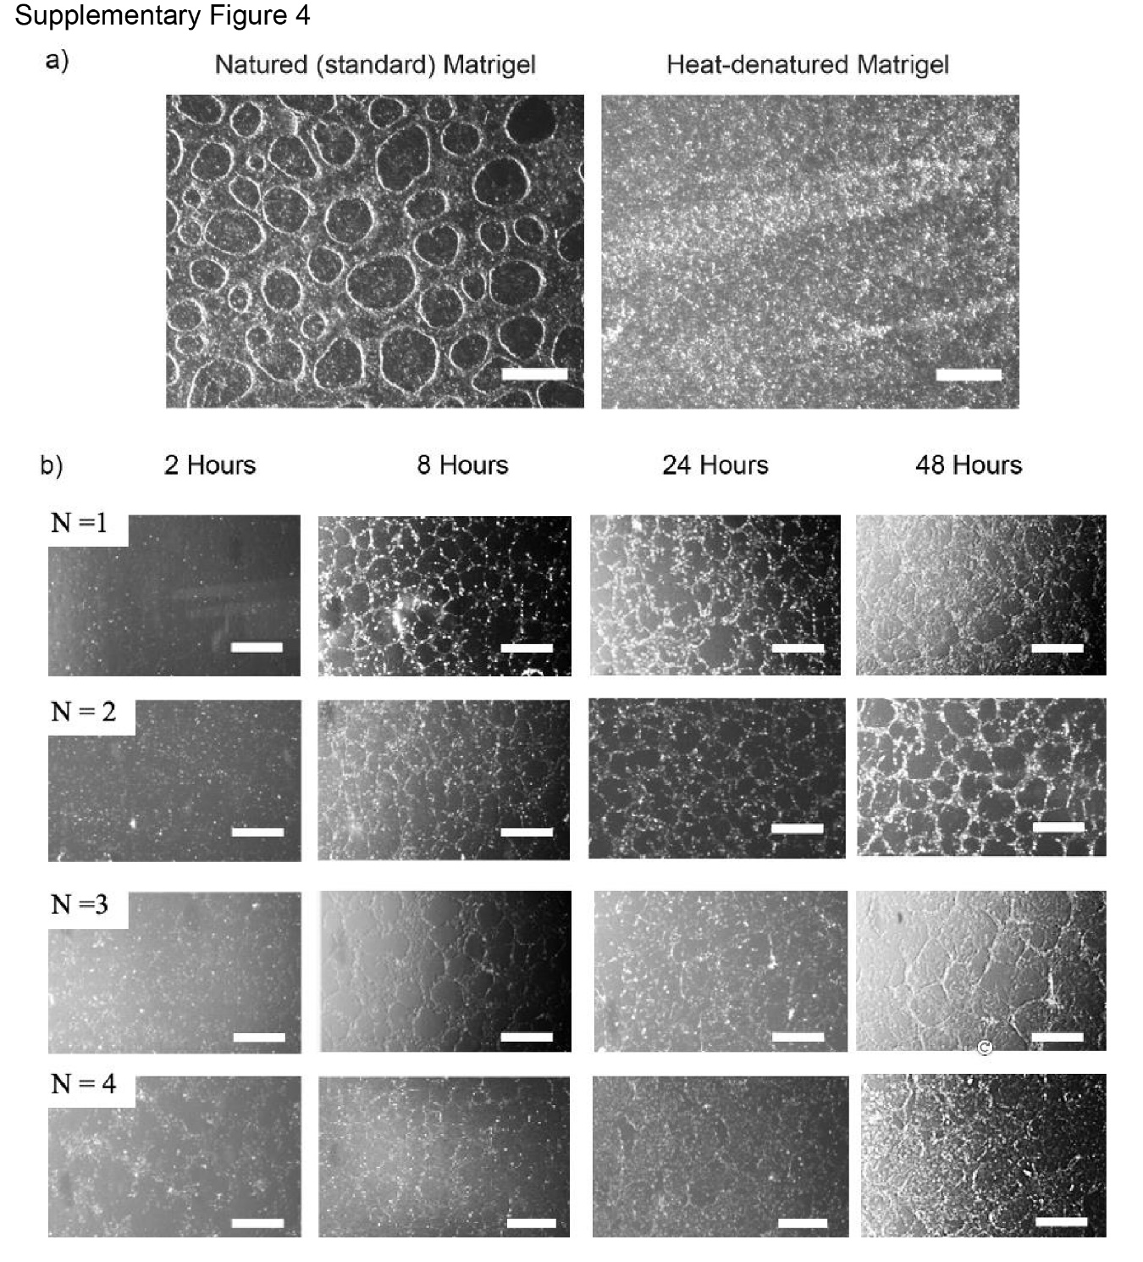
Supplementary figure 5. Differential gene expression (DEG) in cells that form VM structures or those that form a monolayer.
Volcano plots of the third replicate that was analyzed by RNASeq, showing the DEGs that were up and downregulated at the different timepoints of VM formation as compared the monolayer formed on denatured Matrigel.

Supplementary figure 6. Gene ontology obtained from RNASeq analysis
Representative gene ontology of the third replicate obtained from the RNASeq analysis, at the 4 different timepoints taken during VM formation of the HEY-A8 ovarian cell line.

Supplementary table 1. RNAseq transcripts regulated during Vasculogenic Mimicry
Differential gene expressions (DEGs) that had a significant change in their levels in at least two of the replicates, when comparing cells forming VM against cells forming a monolayer. It is shown the four timepoints, but in green it is highlighted at what time it was seen the statistical difference.

