Western blot images uncropped
Fig 3b BKCa

Fig 3b GAPDH

Fig 4c BK
Fig 4c B-Actin

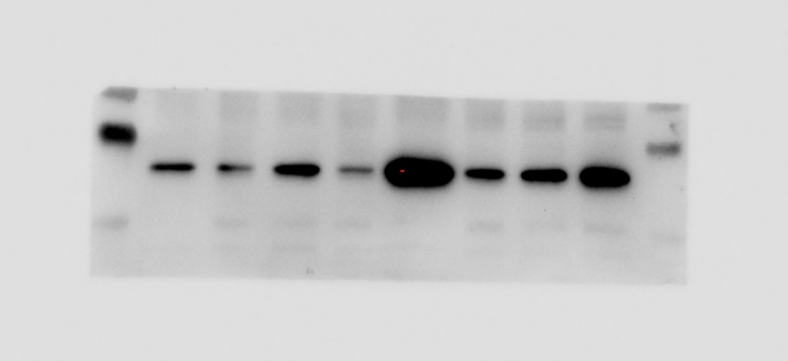
Supplementary Fig 5b Caveolin-1

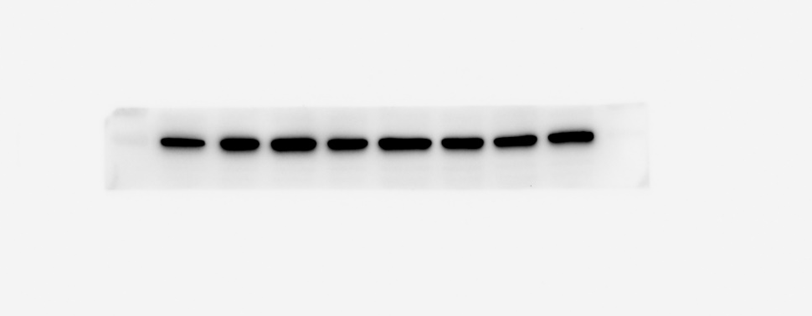
Supplementary Fig 5b
α-tubulin

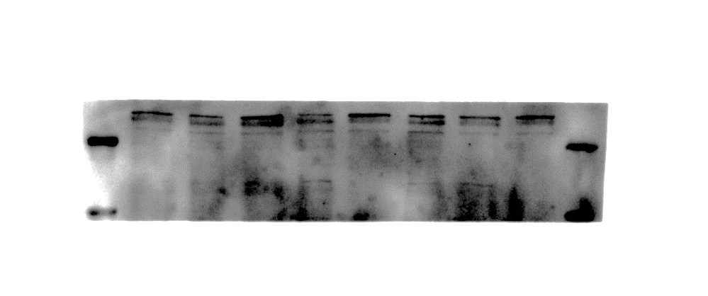
Supplementary Fig 8c Piezo-1
Supplementary Fig 8c
α-tubulin
Supplementary Fig 8c α-tubulin
