Supplementary Figure 1. CCL signaling pathway network in non-responder (NR) and responder (R) groups
- Circle plot illustrating cellular communication among macrophages, CD8+ T cells, CD4+ T cells, B cells, proliferating T cells, plasma cells, and NK cells in responder (R) and non-responder (NR) groups. Circle sizes correspond to the number of cells in each group, and flow thickness represents interaction weight.
- The heatmap compares the cellular communication probabilities via the CCL signaling pathway in immune cells between NR (top) and R (bottom) melanoma patients. The communication probability is represented by the color intensity, with darker shades indicating higher interaction weights.

Supplementary Figure 2. CCR1 mRNA expression (log2(TPM+1)) in tumor (n=461) and normal (n=558) tissues from TCGA-SKCM and GTEx Data in GEPIA website. The box plot visualizes the differential expression of CCR1 mRNA between tumor (T) and normal (N) tissues in the TCGA-SKCM and GTEx datasets.
Data with error bars are shown as mean ± SEM. ns, not significant; *, P <0.05 as determined by unpaired Student t test

Supplementary Figure 3. UMAP plots showing CCR1 expression primarily in macrophages across different melanoma scRNA-Seq datasets in TISCH website. UMAP visualization of CCR1 expression in macrophages across four melanoma single-cell datasets: A) GSE72056, B) GSE115978, C) GSE134388, and D) GSE123139.
Supplementary Figure 4. Colocalization of CCR1 with the macrophage marker F4/80 in mouse melanoma tissue. Representative mIHC image demonstrating the expression of CCR1 and F4/80 in mouse melanoma tissue. CCR1 is indicated in green, F4/80 in white, and DAPI in blue. Scale bars, 20 μm.

Supplementary Figure 5. UMAP plots showing CCR1 mRNA expression in macrophages compared between NR and R groups (GSE120575).

Supplementary Figure 6. Representative immunohistochemistry staining of CCR1+ cells in human melanoma tissue. Scale bars, 50 μm.

Supplementary Figure 7. Correlation between CCR1 expression and T Cell exhaustion-related genes from TCGA-SKCM in TIMER2.0 website.
- Correlation between CCR1 and PDCD1 expression.
- Correlation between CCR1 and HAVCR2 expression.
- Correlation between CCR1 and CTLA4 expression.
- Correlation between CCR1 and LAG3 expression.

Supplementary Figure 8. CCR1⁺ macrophage score showed a significant positive correlation with the Exhausted T cell Score in tumor tissues from TCGA-SKCM.

Supplementary Figure 9. Tumors of B16F10 melanoma medels treated with either BX471, PD-1 blockade (ICB), a combination of both, or placebo.

Supplementary Figure 10. Flow cytometry analysis of CD44⁺ CD8⁺ T cells populations in tumors treated with either BX471, PD-1 blockade (ICB), a combination of both, or placebo.
Data with error bars are shown as mean ± SEM. ns, not significant as determined by unpaired Student t test.

Supplementary Figure 11. Spatial relationship of CCR1⁺ macrophages and CD8⁺ Tex cells in human melanoma tissue
- Spatial scatter pie plots showing the proportions of seven cell type for spots with co-localization of CCR1⁺ macrophage and CD8⁺ Tex cells.
- Heatmap displaying the correlation between the proportions of eight distinct cell types.

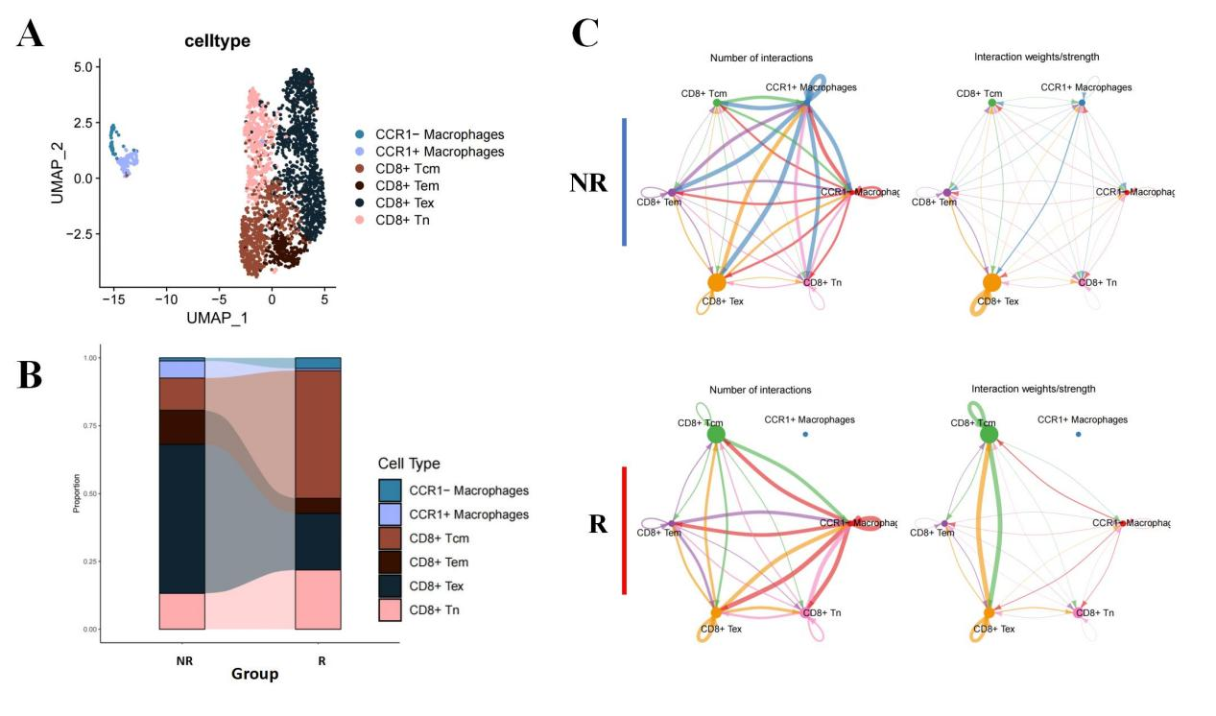
Supplementary Figure 12. Crosstalk between macrophages and CD8⁺ T Cell subtypes
- UMAP plot illustrating the subtypes of macrophages and CD8⁺ T cells derived from melanoma scRNA-seq data (GSE120575).
- Proportional differences of macrophage and CD8⁺ T cell subtypes between Non-responder (NR) and Responder (R) groups in melanoma scRNA-seq data (GSE120575).
- Circle plot visualizing the cellular communication between macrophage and CD8⁺ T cell subtypes in NR and R groups. Circle sizes correspond to the number of cells in each group, and flow thickness represents interaction weight.

Supplementary Figure 13. Pseudotime Trajectory of CD8⁺ T Cells in Melanoma

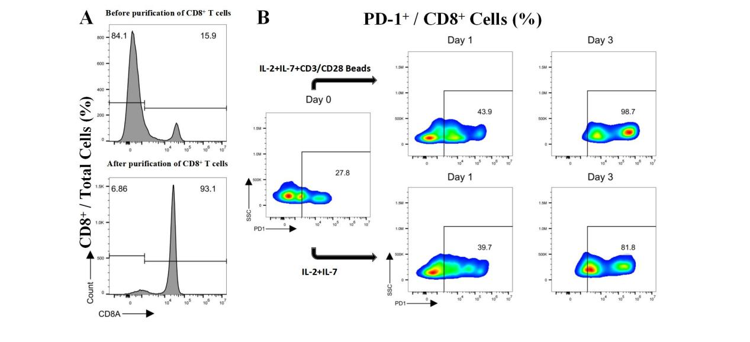
Supplementary Figure 14. Isolation and Activation of CD8+ T Cells
- Flow cytometric analysis showing the isolation of CD8+ T cells.
- Flow cytometry plots demonstrating the exhaustion of CD8+ T cells following activation with CD3/CD28 beads.

