Supplementary information
Hydrogen sulfide induces regulatory B cells via glycolysis and mitochondrial ROS, attenuating LPS-induced lung injury
Supplementary figures
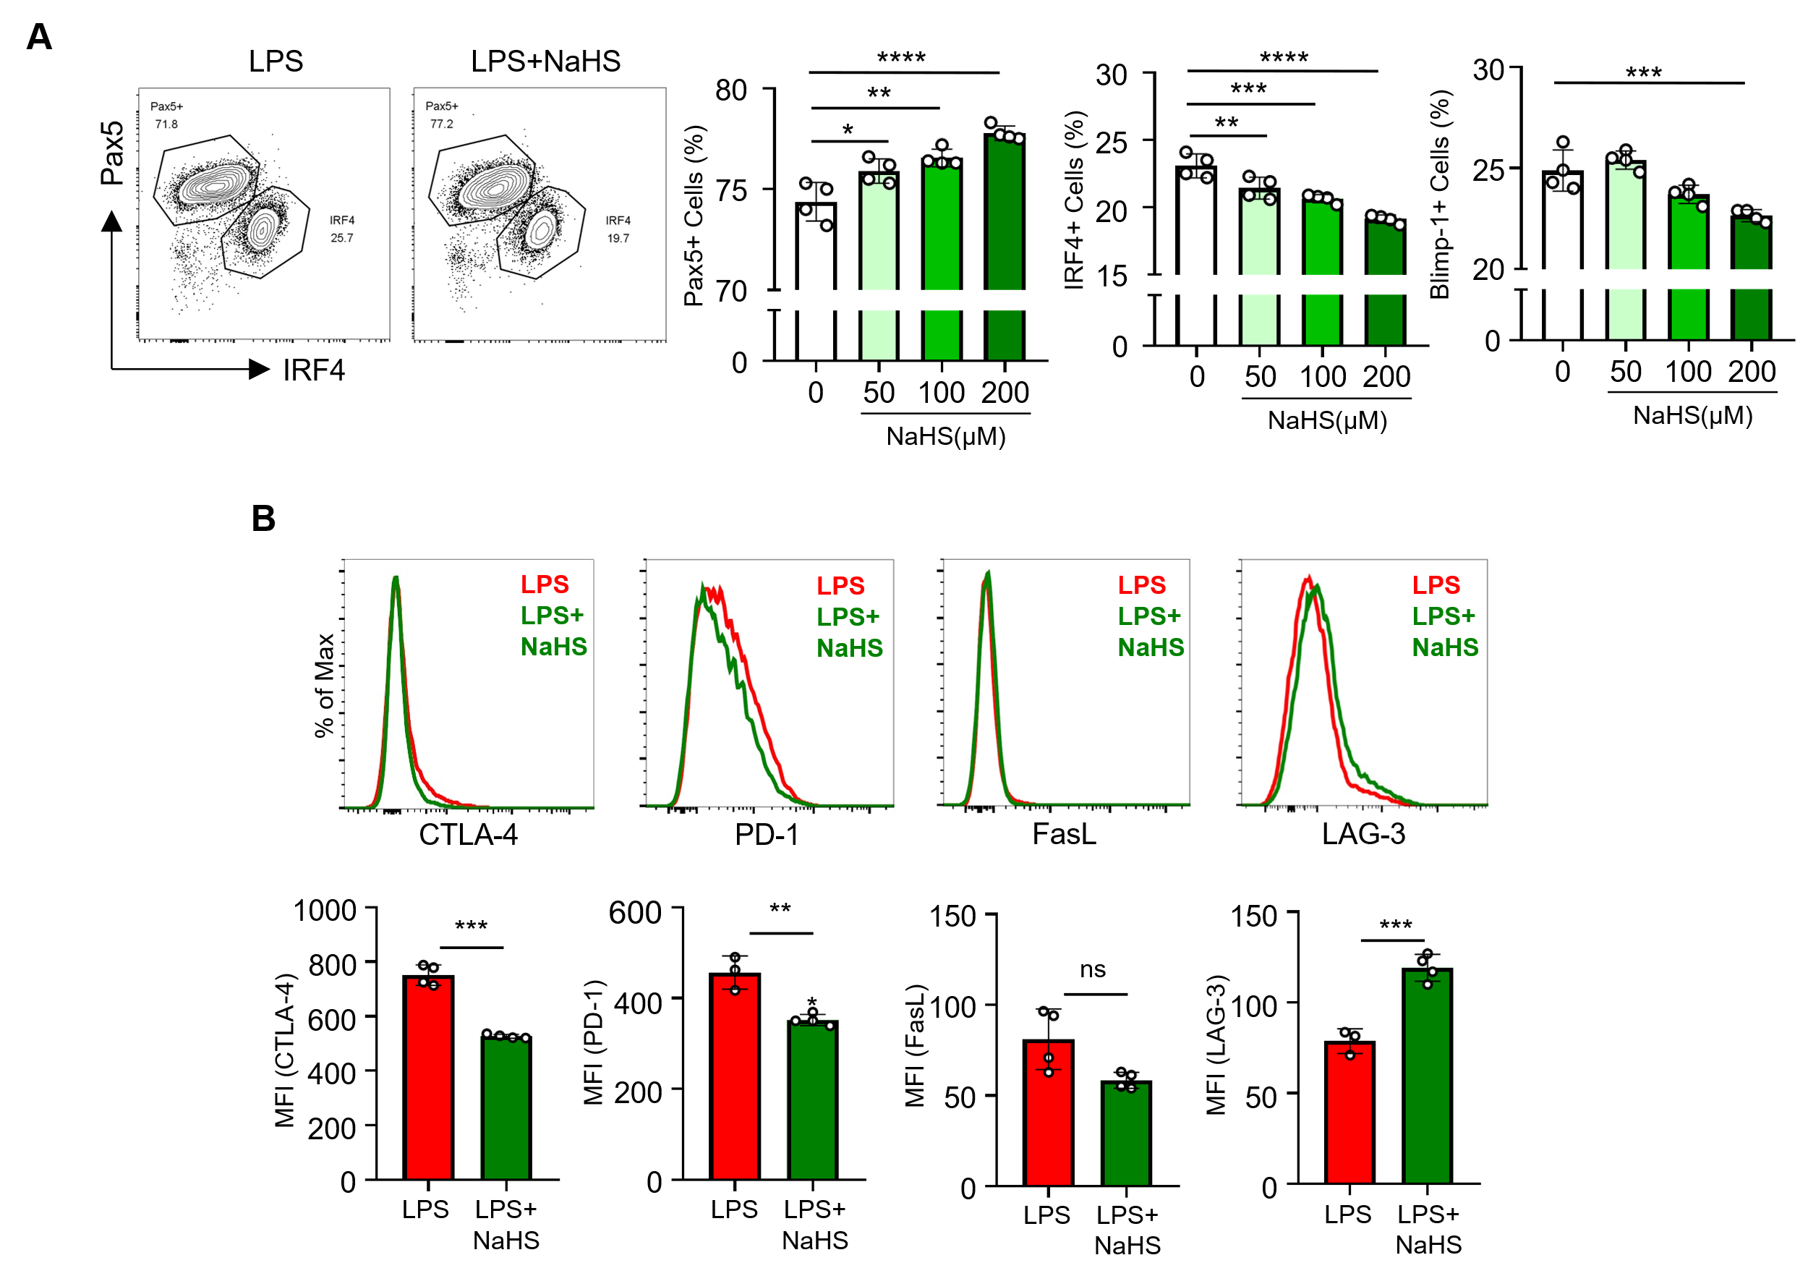
Supplementary figure 1. H₂S decreased plasma cell differentiation-related transcription factors and modulated the expression of immune checkpoints.
(A-B) B cells stimulated with LPS (10 μg/ml) or LPS + NaHS (200 μM) on day 3 were used for analysis. (A)Representative plot of IRF4 and Pax5 and quantified graphs of each transcription factor positive population (n = 4). (B) Representative histograms of surface expressions of CTLA-4, PD-1, FasL, and RAG3 and quantification of the MFI (n = 3-4). Data are expressed as the mean ± SD. Statistical significance was determined using Students’ t-test (B), one-way ANOVA with Sidak’s multiple comparisons test (A). *P < 0.05; **P < 0.01; ***P < 0.001; ****P < 0.0001.

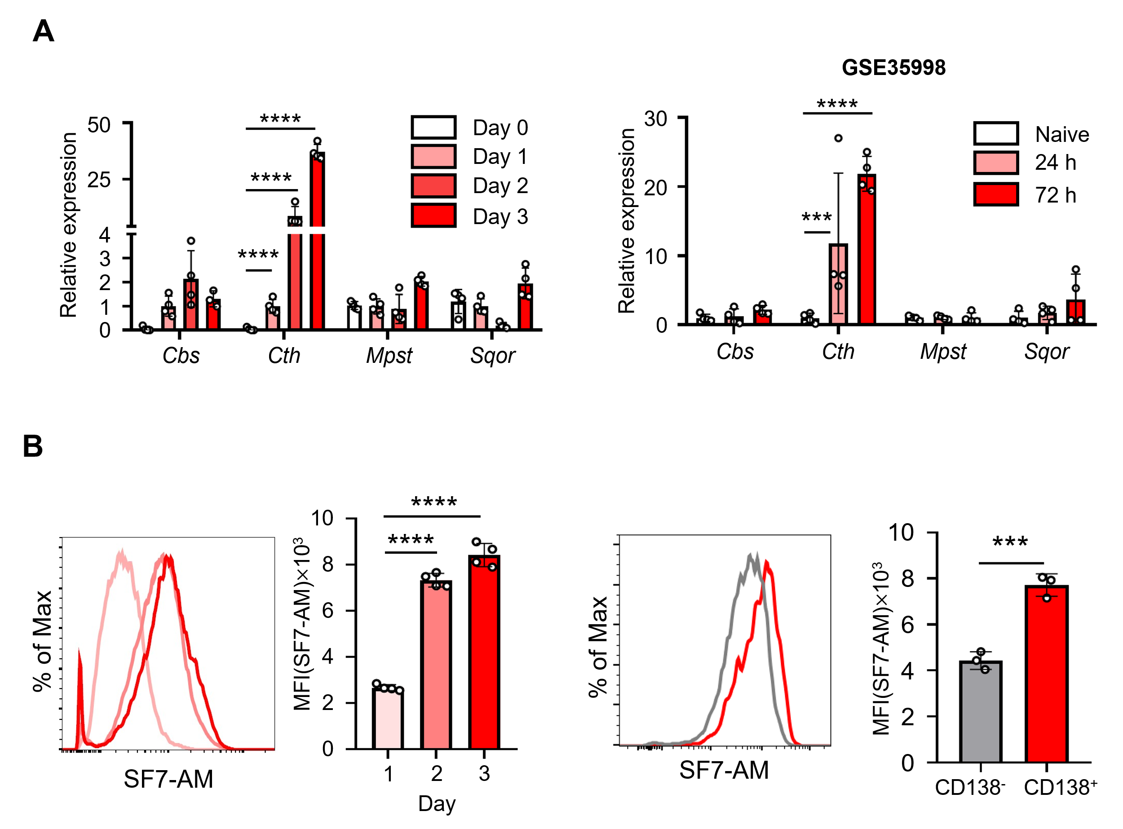
Supplementary figure 2. Endogenous H₂S is increased during LPS-induced B cell activation.
(A) (Left) mRNA expression levels of cystathionine beta-synthase (Cbs), cystathionine gamma-lyase (Cth), 3-mercaptopyruvate sulfurtransferase (Mpst), and sulfide quinone oxidoreductase (Sqor), measured every day for 3 days under LPS (10 μg/ml) stimulation (n=4). (Right) mRNA expression levels of Cbs, Cth, Mpst, and Sqor were analyzed in the publicly available GSE35998 dataset (n=4). (B) Intracellular H₂S levels in B cells during the time course (n=4) were measured and compared between CD138- and CD138+ cells (n=3) using SF7-AM probe. Data are expressed as the mean ± SD. Statistical significance was determined using Student’s t-test (B), one-way ANOVA with Sidak’s multiple comparisons test (B), and two-way ANOVA with Sidak’s multiple comparisons test (A). ***P < 0.001; ****P < 0.0001.

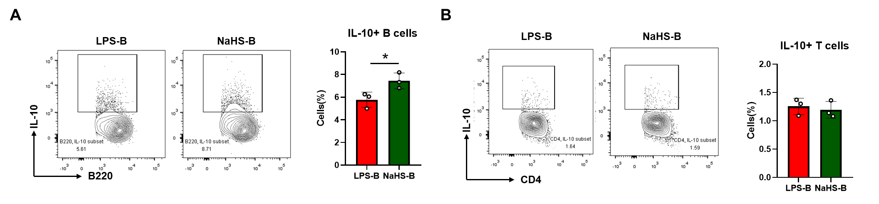
Supplementary figure 3. B cells are major population producing IL-10 in B-T co-culture condition shown in Figure 2D.
Splenic CD4 T cells and LPS-activated B cells were co-cultured at the ratio of 1 : 1 for 72 h. CD4 T cells were stimulated with anti-CD3 and anti-CD28. (A) Representative plots for B220 and IL-10. IL-10 positive cells were quantified (n = 4). (B) Representative plots for CD4 and IL-10. IL-10 positive cells were quantified (n = 4). Statistical significance was determined using Student’s t-test (A). *P < 0.05.

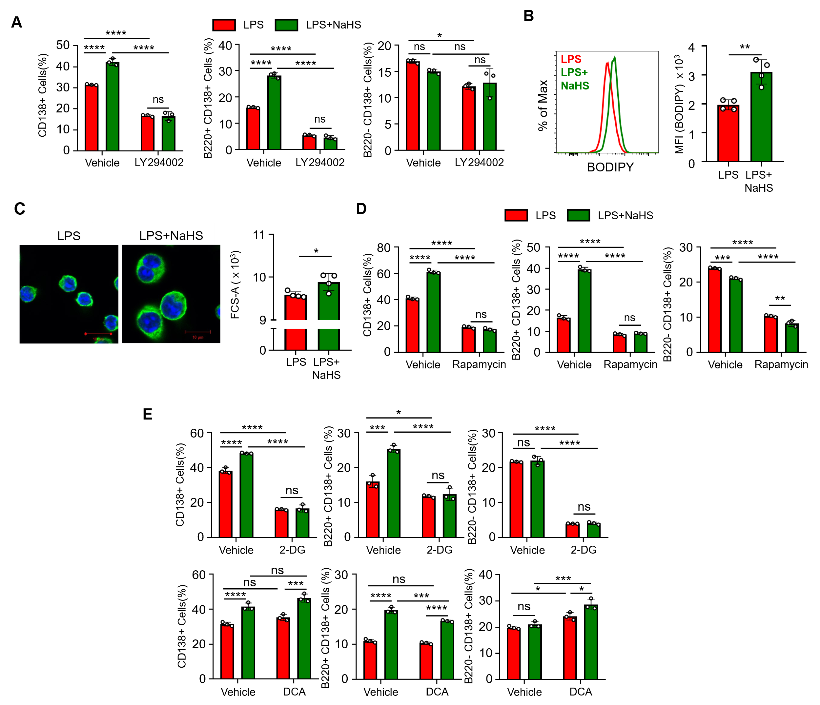
Supplementary figure 4. H₂S enhanced PI3K/Akt/mTORC1 signaling pathway and glycolysis during LPS-induced B cell activation.
(A) The frequency of total CD138⁺ cells, B220⁺CD138⁺ cells, and B220⁻CD138⁺ cells were quantified (n=3). B cells were treated with LPS (10 μg/ml) or LPS + NaHS (200 μM) in the presence or absence of LY294002 (n=3). Cells were analyzed at day 3. (B) Representative histogram and quantification of intracellular lipid level were measured by BODIPY staining (n=4). (C) Cell size was observed by confocal microscopy and flow cytometry. Cells were immune-stained with β-actin (green) and DNA was stained with Hoechst (blue). Scale bar: 10 μm. (D) The frequency of total CD138⁺ cells, B220⁺CD138⁺ cells, and B220⁻CD138⁺ cells were quantified (n=3). B cells were treated with LPS or LPS + NaHS in the presence or absence of rapamycin (n=3). Data are expressed as the mean ± SD. Statistical significance was determined using Student’s t-test (B, C), and two-way ANOVA with Tukey’s multiple comparisons test (A, D, E). *P < 0.05; **P < 0.01; ***P < 0.001; ****P < 0.0001; ns not significant.

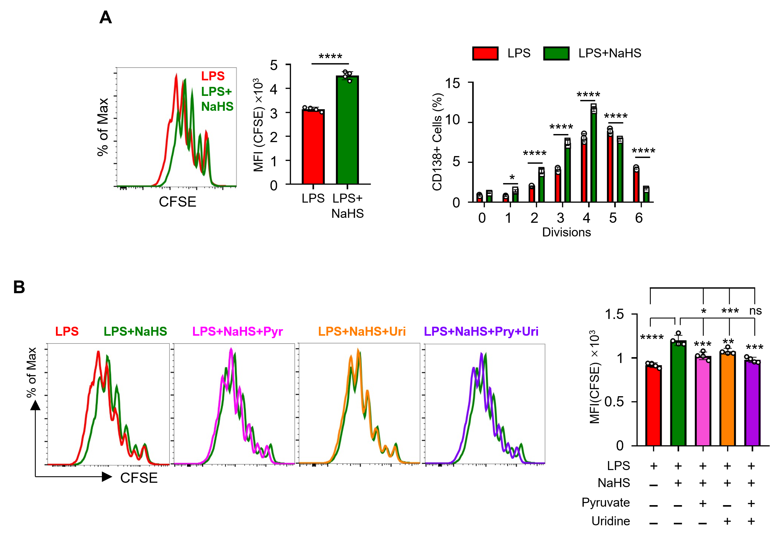
Supplementary figure 5. H₂S decreased cellular proliferation and adding pyruvate and uridine rescues the decreased proliferation.
Flow cytometric analysis of B cell proliferation on day 3 of LPS stimulation monitored by CFSE staining. (A) Representative histogram and MFI of CFSE in B cells treated with LPS (10 μg/ml) or LPS + NaHS (200 μM) and frequency of CD138⁺ cells at each cell division in B cells treated with LPS or LPS + NaHS (n=4). (B) B cells were treated with pyruvate (1 mM), uridine (1 mM) simultaneously with LPS (10 μg/ml) or LPS + NaHS (200 μM) for 3 days. Representative histogram of CFSE and the MFI of CFSE was quantified. Data are expressed as the mean ± SD. Statistical significance was determined using Student’s t-test (A), or one-way ANOVQ with Sidak’s multiple comparisons test (A) and two-way ANOVA with Tukey’s multiple comparisons test (B). *P < 0.05; **P < 0.01; ***P < 0.001; ****P < 0.0001; ns not significant.

