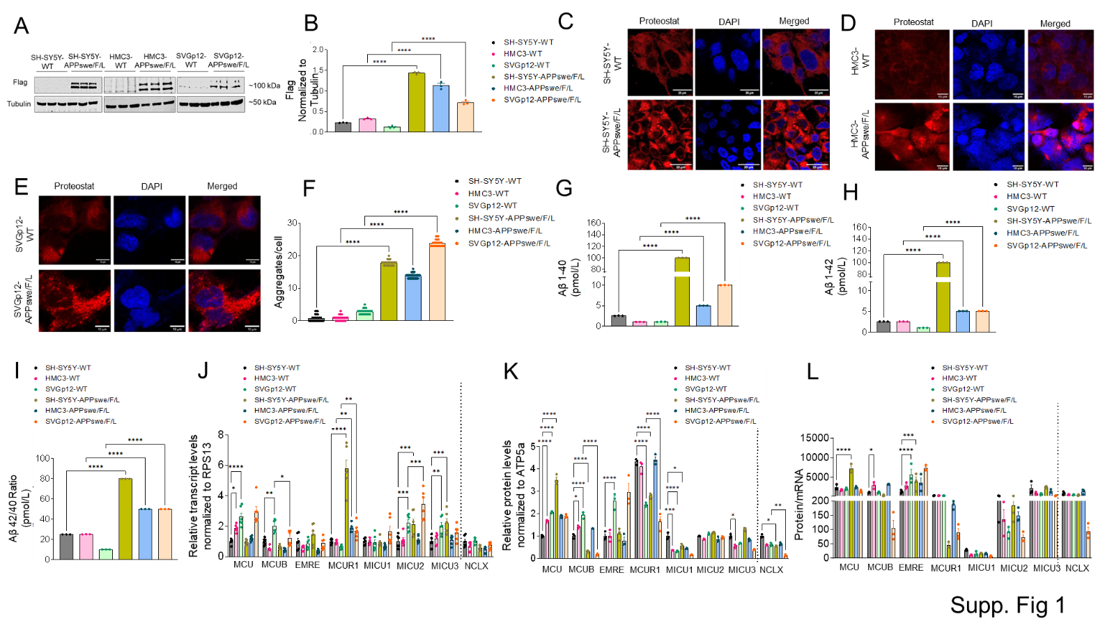
SUPPLEMENTARY FIGURES
Supplementary Figure 1. Brain cells exhibit APPswe/F/L expression and aggregate formation. (A–B) Western blot validation of APPswe/F/L expression in SH-SY5Y, HMC3, and SVGp12 cells, normalized to tubulin as an internal control. (C–E) Confocal imaging of protein aggregates using Proteostat dye in SH-SY5Y, HMC3, and SVGp12 cells under WT and APPswe/F/L-expressing conditions. (F) Quantification represents average puncta count per cell. (G–I) Sandwich ELISA quantification of Aβ 1–40, Aβ 1–42, and Aβ 42/40 ratio. (J) qRT-PCR analysis of mtCU component and NCLX exchanger mRNA expression in WT vs. APPswe/F/L-expressing cells using RPS13 as an endogenous control. (K) Densitometry of mtCU and NCLX protein levels normalized to ATP5A. (L) Protein-to-mRNA ratio for mtCU components and NCLX in all groups. Data are presented as mean ± SEM from n = 3 independent experiments. Statistical significance was determined by two-way ANOVA with Tukey’s multiple comparisons test. *p < 0.05, **p < 0.01, ***p < 0.001, ****p < 0.0001.
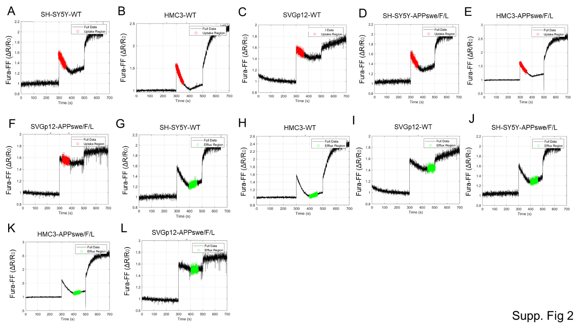
Supplementary Figure 2. Cell-type-specific differences in _{m}Ca²⁺ uptake and efflux at physiological Ca²⁺ levels. (A–F) Traces show _{m}Ca²⁺ uptake in WT and APPswe/F/L-expressing SH-SY5Y, HMC3, and SVGp12 cells. (G–L) Traces show corresponding _{m}Ca²⁺ efflux. All traces were extracted using a custom MATLAB script (MathWorks, R2024a).
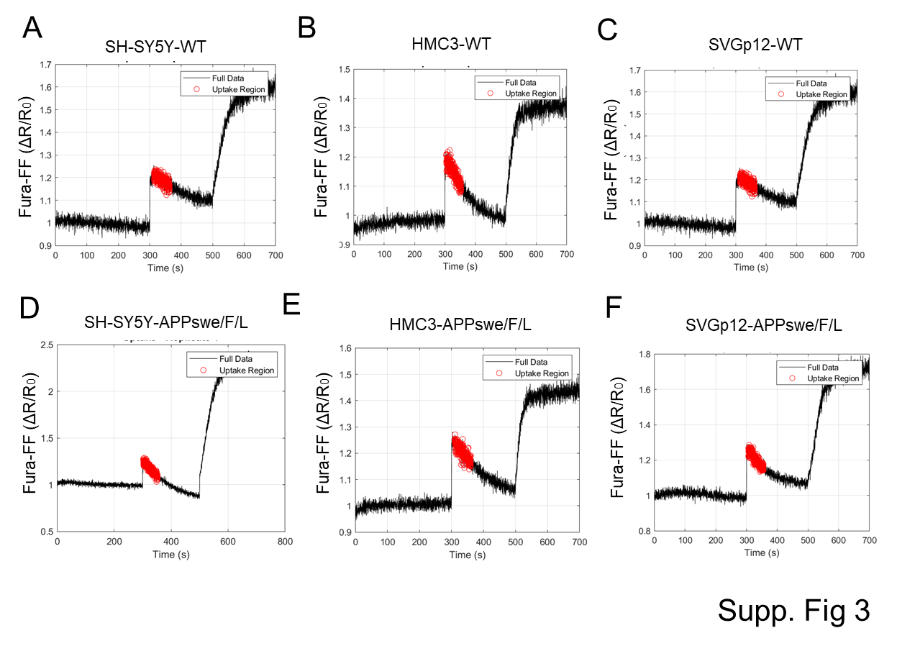
Supplementary Figure 3. _{m}Ca²⁺ uptake dynamics at low cytosolic Ca²⁺ concentrations across brain cell types. (A–F) Traces represent uptake phases in WT vs. APPswe/F/L-expressing SH-SY5Y, HMC3, and SVGp12 cells following 3 μM Ca²⁺ bolus, extracted via MATLAB (MathWorks, R2024a).
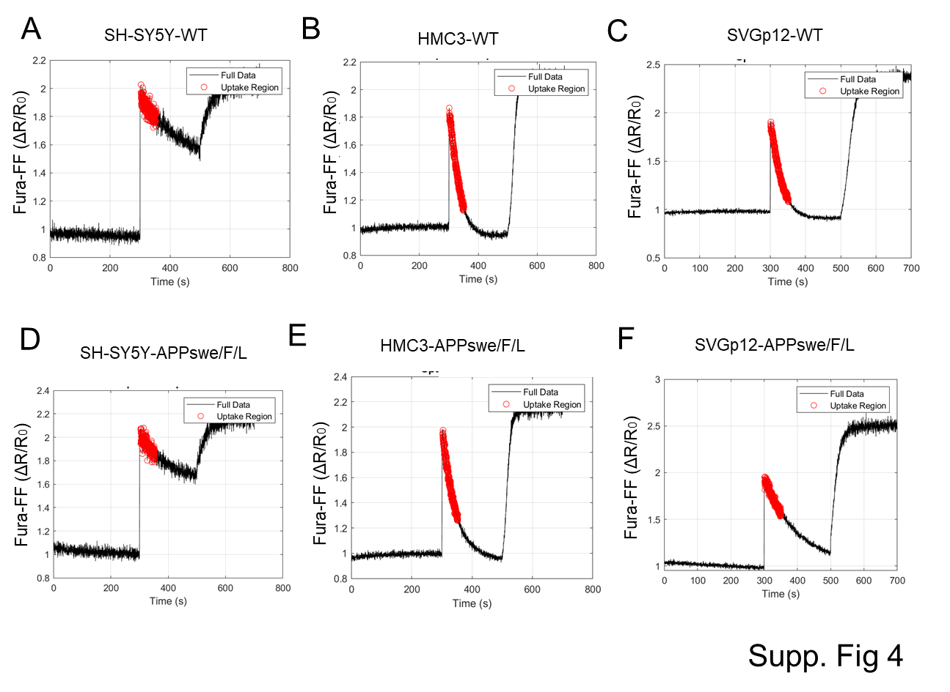
Supplementary Figure 4. _{m}Ca²⁺ uptake dynamics at high cytosolic Ca²⁺ concentrations across brain cell types. (A–F) Traces represent uptake regions in WT and APPswe/F/L-expressing SH-SY5Y, HMC3, and SVGp12 cells following 20 μM Ca²⁺ stimulation, extracted using MATLAB (MathWorks, R2024a).
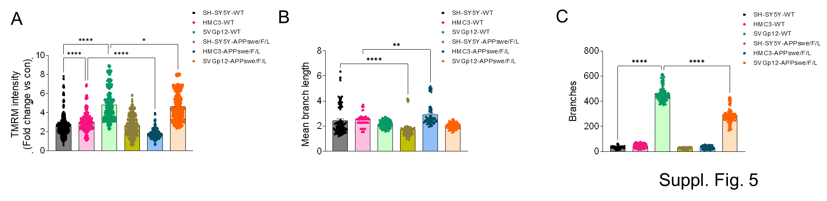
Supplementary Figure 5. APP mutations impair mitochondrial membrane potential and morphology. (A) Quantification of TMRM fluorescence intensity in WT vs. APP-expressing SH-SY5Y, HMC3, and SVGp12 cells using ImageJ. (B–C) Quantitative morphological analysis showing: (B) Mean branch length and (C) Number of mitochondrial branches. Data are presented as mean ± SEM from n = 3 independent experiments. Statistical significance was determined by two-way ANOVA with Tukey’s multiple comparisons test. *p < 0.05, **p < 0.01, ****p < 0.0001.
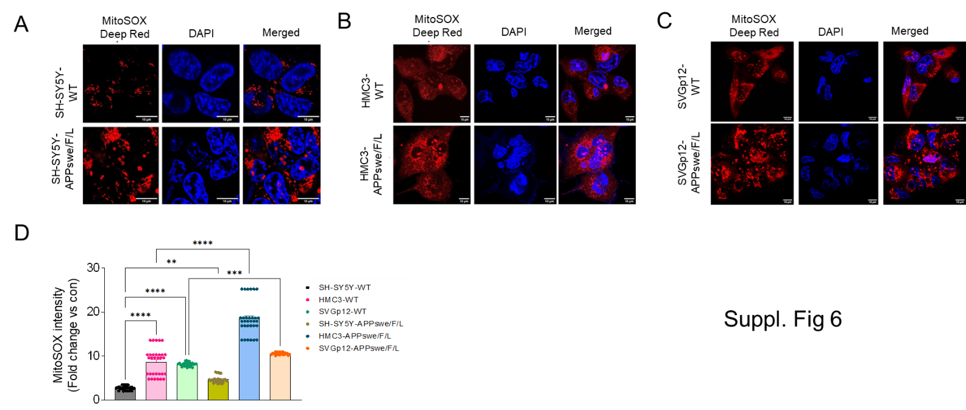
Supplementary Figure 6. AD-associated increase in mitochondrial ROS across brain cell types. (A–C) Confocal images of MitoSOX Red (mitochondrial ROS; red) and Hoechst (nuclei; blue) in SH-SY5Y, HMC3, and SVGp12 cells under WT and APPswe/F/L conditions. Scale bar = 10 μm. (D) Quantification of MitoSOX intensity (fold change vs. SH-SY5Y-WT). Data are presented as mean ± SEM from n = 3 independent experiments. Statistical significance was determined by two-way ANOVA with Tukey’s multiple comparisons test. **p < 0.01, ***p < 0.001, ****p < 0.0001.
Supplementary Figure 7. Aβ1–42 pre-formed fibrils treatment decreased mito-CRC in SH-SY5Y cells. A Sandwich ELISA based quantification of Aβ 1–42 preformed fibrils (5μM) in SH-SY5Y-WT cells. B Representative traces of mito-CRC analyzed using a using Fura-FF ratiometric fluorescence in SH-SY5Y-WT and SH-SY5Y-WT-pCMV6 cells. Repeated Ca²⁺ pulses (5 μM) were applied (black arrows) until mitochondrial membrane potential collapsed. C Quantification of mito-CRC %. Tg: thapsigargin; Suc: succinate; Dg: digitonin. Data are presented as mean ± SEM from n = 3 independent experiments. Statistical significance was determined by two-way ANOVA with Tukey’s multiple comparisons test. **p < 0.01, ***p < 0.001, ****p < 0.0001.
Supplementary Figure 8. Full-length Western blots for all proteins analyzed in this study. Representative full-length Western blot images for MCU, MCUB, EMRE, MCUR1, MICU1, MICU2, MICU3, and NCLX, as well as APP and internal controls (ATP5A and Tubulin), are shown for SH-SY5Y, HMC3, and SVGp12 cells under WT and APPswe/F/L-expressing conditions. Blots correspond to the cropped images presented in main Figures 1B. Each target protein was detected using a separate membrane with its corresponding loading control, shown here in uncropped format. All full-length blots are provided to ensure transparency and confirm band specificity.
SUPPLEMENTARY TABLE 1. List of primer sequences used in the study.
Gene (Human) | Forward primer | Reverse primer
RPS13 | CCTTCACAGATCGGTGTAATCC | TCAGGAGCAAGTCCCTTAGA
MCU | GGGGTACCCCACCAAAACAGCTATTC | CCCAAGCTTGGGTTCCGATCTGTCGG
MCUB | GTGTGAAGCTGTGTGGAAATG | CAAGGGAAGGCCATGTCTATAA
EMRE | CTGAGATGTGCTGTCCACTAAG | GAGACAACTGCACCAACTAGAA
MCUR1 | TGAGGTTGCTGGCCTCAAAA | TCCCAGAGCTACTGTTAGGCA
MICU1 | AACATTCCTTGACTTCCCTCC | TCTGAATCTTGCTGTGTTCCC
MICU2 | TGGAAGGATAAAACAATACATATGGG | GGAACATGAAGATGTCTGGAATTG
MICU3 |  | CTTTCCAAACTGGTGGTGTTTC
  ACAACAGATGAGCCCAAAGT
NCLX (SLC8B1) | CAGAAAGGGAAGTGGAGAGTAAG | GCCATTAGCAGCACACAAAG

