Figure 3E
PIGF (16 kD)
VEGFA (30 kD)
WNT3A (37 kD)
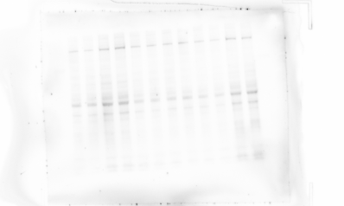
CTNNB1 (100 kD)
VEGFR1 (55 kD)
VEGFR2 (147 kD)
p-VEGFR1 (147 kD)
p-VEGFR2 (147 kD)
β-actin (43 kD)
Figure S3A
PIGF (16 kD)
VEGFA (30 kD)
WNT3A (37 kD)
CTNNB1 (100 kD)
VEGFR1 (55 kD)
VEGFR2 (147 kD)
p-VEGFR1 (147 kD)
p-VEGFR2 (147 kD)
β-actin (43 kD)

Figure 5A
PIGF (16 kD)
VEGFA (30 kD)
CTNNB1 (100 kD)
VEGFR1 (55 kD)
VEGFR2 (147 kD)
p-VEGFR1 (147 kD)
p-VEGFR2 (147 kD)
β-actin (43 kD)
Figure 5I
PIGF (16 kD)
VEGFA (30 kD)
CTNNB1 (100 kD)
VEGFR1 (55 kD)
VEGFR2 (147 kD)
p-VEGFR1 (147 kD)
p-VEGFR2 (147 kD)
β-actin (43 kD)

