SUPPLEMENTARY INFORMATION

AlphaFold3-based structural prediction of the TULP3–ACE2 interaction
Sequence-Based Biophysical Profiling Identifies a Membrane-Proximal Helical Segment as a Candidate TULP3 Cargo Motif – To identify potential TULP3-binding motifs on ACE2, we performed full-length sequence profiling of ACE2 (UniProt: Q9BYF1) and TULP3 (UniProt: O75386) using smoothed Kyte–Doolittle hydropathy (5-residue window) and α-helix propensity scores (Levitt scale). This analysis highlighted a 25-residue stretch, ACE2 (749–773), with consistently high hydropathy and strong helical propensity—features characteristic of membrane-adjacent helices recognized by the TULP3 tubby domain. The segment bridges the C-terminal end of the transmembrane helix and its cytoplasmic extension, maintaining both juxtamembrane continuity and surface accessibility. By contrast, the upstream region (720–748) displays lower hydropathy and multiple proline/glycine disruptions, impairing helix formation and membrane affinity. The downstream region (774–805) becomes highly polar and disordered, consistent with a cytosolic, unstructured tail. Together, these features support ACE2 (749–773) as a structurally and biophysically favorable candidate for TULP3 recognition. Schematic diagram shows the domain organization of ACE2 and TULP3, with the identified binding region highlighted (Supplementary Fig. S1).
Fragment Selection and Systematic Testing – We focused on the C-terminal transmembrane region of ACE2 (741–783), which is topologically analogous to validated TULP3 cargoes. Secondary structure and hydropathy analysis identified ACE2 (749–773) as a membrane-proximal hydrophobic stretch likely to adopt a helical conformation. In parallel, we selected a TULP3 fragment spanning residues 271–430, encompassing the full tubby domain (β1–β12) and its canonical cargo-binding surface (β8–β12). To assess specificity and robustness, we systematically tested alternative ACE2 fragments (741–805, 700–805, 748–773) and TULP3 truncations (250–442, 270–430, 300–442). Most combinations produced low inter-protein TM-scores (iPTM < 0.3), suggesting incompatible interfaces. In contrast, the ACE2 (749–773)–TULP3 (271–430) pairing consistently produced the strongest results, achieving a maximum iPTM of 0.58 and pTM of 0.78 across 15 AlphaFold3 prediction runs (Supplementary Fig. S1). Although these values indicate moderate confidence, they are notable given the challenges AlphaFold3 faces in modeling membrane-proximal interactions.
Model Selection and Detailed Interaction Analysis – From the 75 models generated across 15 prediction runs, we selected the top eight structures with iPTM > 0.5 for detailed analysis. These models exhibited convergent interaction patterns. Notably, ACE2 residue I761 consistently engaged the TULP3 cargo-binding surface (β8–β10), with recurring contacts such as N390–I761 and F391–I761 appearing in seven out of eight models. Consensus mapping confirmed the spatial clustering of I761 along the β8–β10 strands, matching the geometry of known tubby domain cargo interfaces. The interaction profile included both hydrophobic contacts (F391–I761, L377–I761) and polar interactions (N390–I761), reflecting the amphipathic character typical of recognized cargo motifs. While AlphaFold3 does not explicitly model membrane topology and may underestimate weak or membrane-mediated interactions, the reproducibility and convergence across independent predictions support the plausibility of this TULP3–ACE2 interface.

Mutational Analysis of I761 Confirms the Hydrophobic Dependence of the TULP3–ACE2 Interface – To examine how mutations at residue I761 influence the TULP3–ACE2 interface, we performed extensive mutational AlphaFold3 analysis using the same fragment pairing as in the main modeling (TULP3 271–430; ACE2 749–773). Residue I761 was individually replaced with all 19 other amino acids. For each variant, six random seeds were used, and AlphaFold3 generated five structures per seed, yielding 30 models per mutation. For consistency, only the six highest-confidence predictions—those ranked first by AlphaFold3 for each mutation—were used for subsequent distance and scoring analyses. For each selected model, we quantified the distances between the mutant site and two key TULP3 interface residues, N390 and F391, using three complementary metrics: (1) Cβ–Cβ distance, (2) minimum heavy-atom distance, and (3) center-of-mass (COM) distance of all heavy atoms. N390–I761 and F391–I761 values were averaged across the top-ranked models for each amino-acid substitution. As shown in Supplementary Fig. S2, hydrophobic substitutions (e.g., M, W, L, V) consistently maintained short N390–I761 and F391–I761 distances across all metrics, indicating stable hydrophobic interface packing. In contrast, polar or charged replacements (e.g., R, Q, K, E) produced substantially larger separations, suggesting weakened interactions at the cargo-binding surface. The native isoleucine showed the smallest mean distances, reflecting optimal hydrophobic complementarity and steric fit. Across all 600 predictions, smaller inter-residue distances were generally associated with higher inter-protein TM-scores (iPTM), supporting overall consistency between structural compactness and model confidence (Supplementary Fig. S2). Together, these results reinforce that I761 functions as a hydrophobic anchor stabilizing the TULP3–ACE2 interface. Hydrophobic substitutions partly preserve this interaction, whereas non-hydrophobic mutations disrupt it, confirming that hydrophobic complementarity at I761 underlies the stability of the predicted cargo-binding interface.

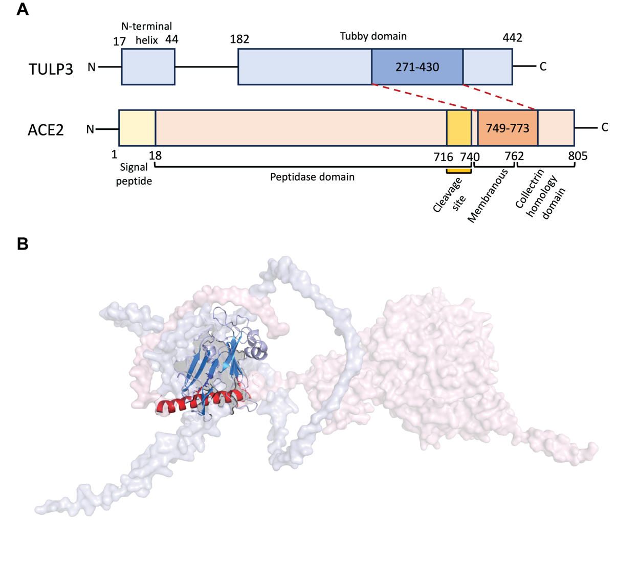
Supplementary figure 1. Sequence-Based Biophysical Profiling Identifies a Membrane-Proximal Helical Segment as a Candidate TULP3 Cargo Motif
A. Schematic diagram shows the domain organization of ACE2 and TULP3, with the identified binding region highlighted. Secondary structure and hydropathy analysis identified ACE2 (749–773) as a membrane-proximal hydrophobic stretch likely to adopt a helical conformation. In parallel, we selected a TULP3 fragment spanning residues 271–430, encompassing the full tubby domain (β1–β12) and its canonical cargo-binding surface (β8–β12).
B. Illustrative model of the ACE2–TULP3 interaction. Full-length ACE2 (reddish) and TULP3 (blueish) structures predicted by AlphaFold3 and aligned based on the AlphaFold3-predicted ACE2 (749–773)–TULP3 (271–430) binding complex. Binding regions are displayed as ribbon cartoons with solid color; non-binding regions as surfaces with muted color. This model provides architectural context for the spatial arrangement of the ACE2 membrane-proximal helix engaging the TULP3 tubby domain but has not been subjected to molecular dynamics refinement or membrane simulations.
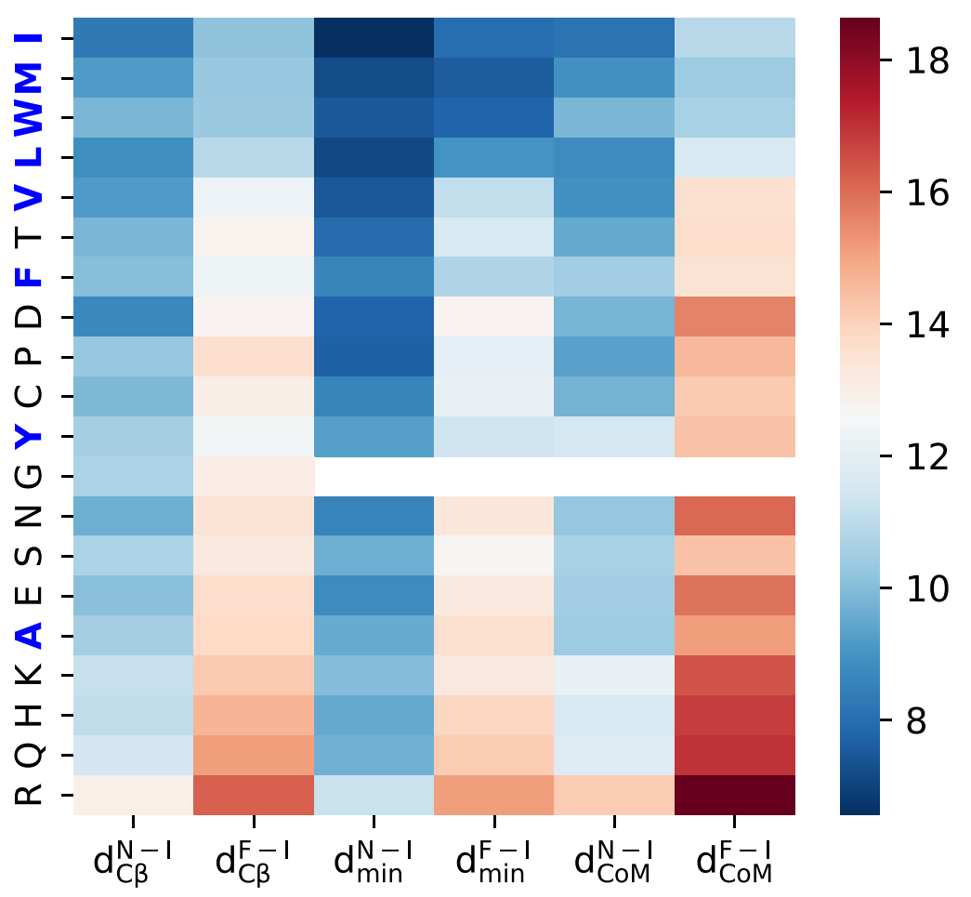
Supplementary Figure 2. Effects of I761 mutations on the TULP3–ACE2 interface. Heatmap showing inter-residue distances between TULP3 and ACE2 upon mutation of ACE2 residue I761. The x-axis represents six distance definitions, combining two residue pairs (N390–I761 and F391–I761) with three distance metrics (Cβ–Cβ, minimum heavy-atom, and center-of-mass). The y-axis lists the 20 amino-acid substitutions at position 761. Each cell shows the average distance from the six top-ranked AlphaFold3 predictions for that mutation. Cooler colors indicate shorter distances (tighter packing), whereas warmer colors indicate longer distances (looser packing).
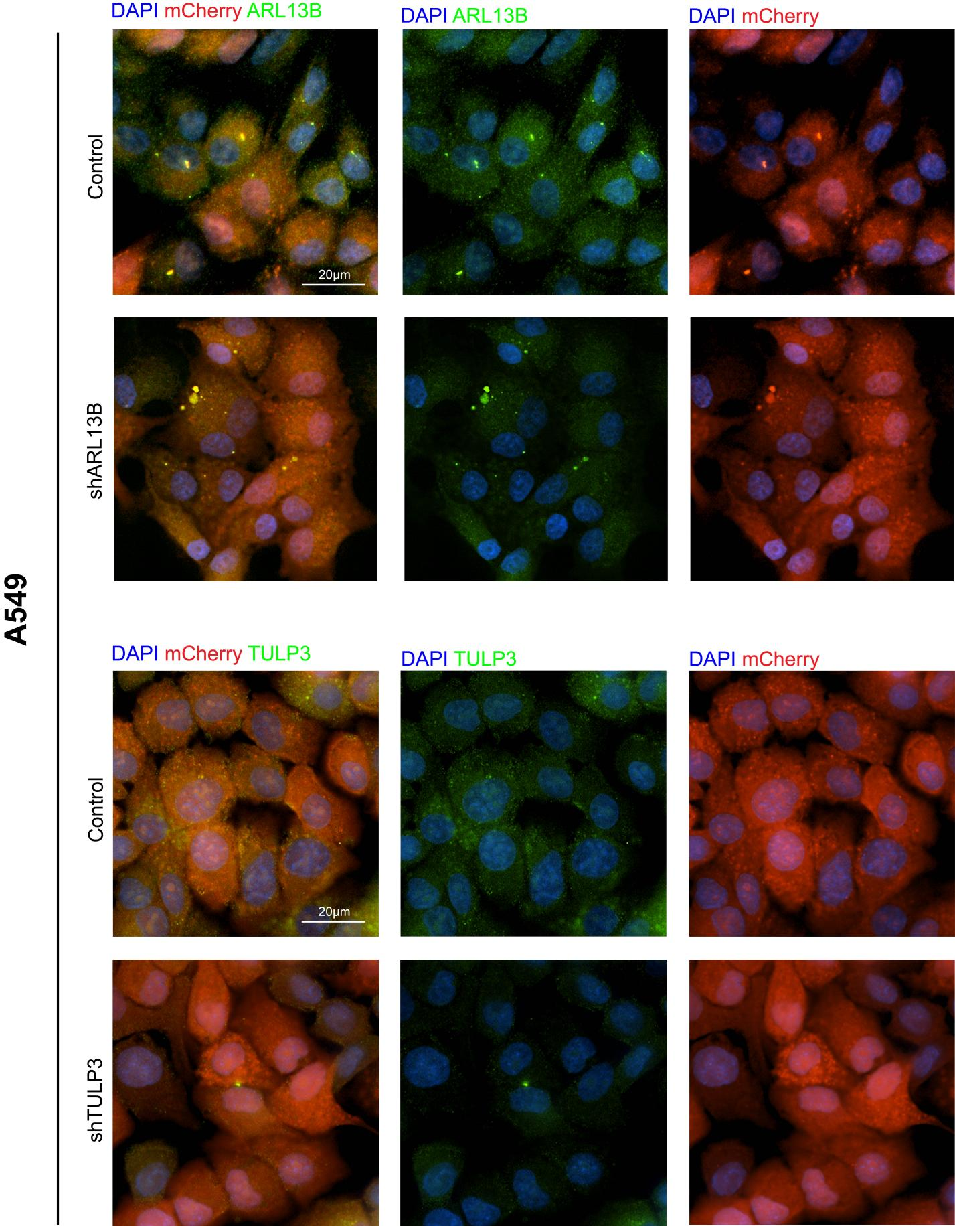
Supplementary Figure 3. Immunofluorescence staining of ARL13B and TULP3 in the A549 cells Representative immunofluorescence images show a reduced fluorescent intensity on the KD proteins in the ARL13B and TULP3KD groups in A549 cells.

