Menin-Driven mTOR Signaling Sustains Taxane Resistance in CRPC and Reveals a Targetable Vulnerability for Combination Therapy

İpek Bulut¹, Buse Cevatemre^{1,2}, Neslihan Yuksel-Catal³, Hamzah Syed^{1,2}, Tamer Onder^{1,2}, Ceyda Acilan^{1,2}
¹Koc University Research Center for Translational Medicine, Istanbul, Turkey
²Koc University Graduate School of Health Sciences, Istanbul, Turkey
³Koc University School of Medicine, Istanbul, Turkey
*corresponding author: cayhan@ku.edu.tr

Figure 2D:
(Left Panel Menin Blotting / Right Panel Beta-Actin Blotting)
Sample 1-3: Sample 4-7:
Du145-P Du145-DtxR
NT-MEN1^{KO1}-MEN1^{KO2} (Main figure) NT-MEN1^{KO1}-MEN1^{KO2}-MEN1^{KO3} (Biologic Replicate)

(Left Panel Menin Blotting / Right Panel Beta-Actin Blotting)
Sample 1-3: Sample 1-3:
Du145-DtxR Du145-DtxR
NT-MEN1^{KO1}-MEN1^{KO2} (Main figure) NT-MEN1^{KO1}-MEN1^{KO2} (Main figure)

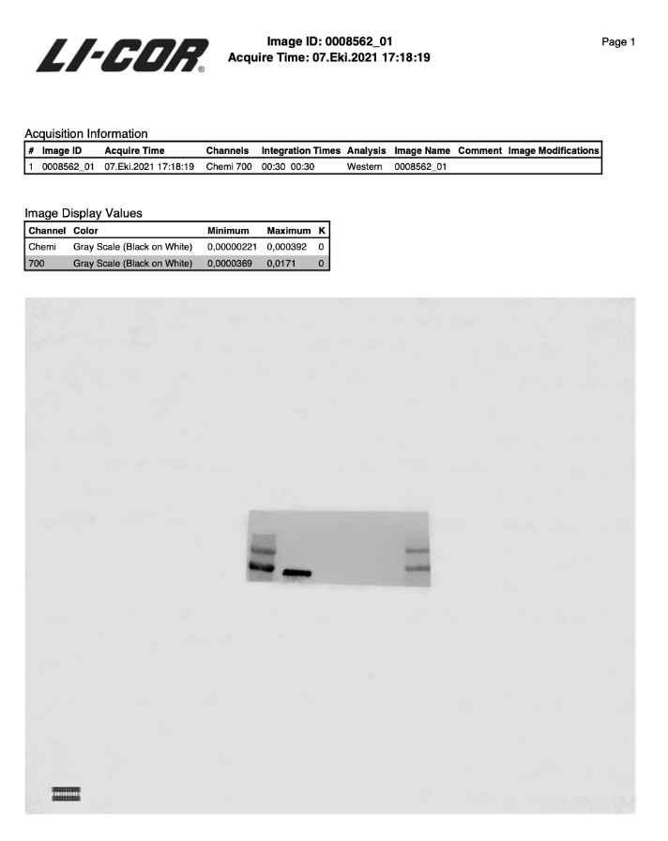
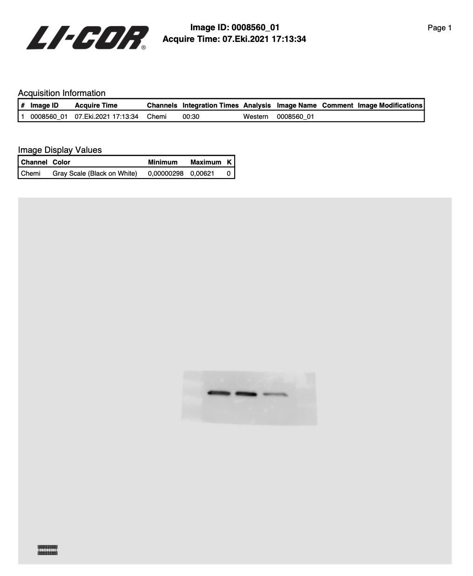

Left Panel Menin Blotting / Right Panel Beta-Actin Blotting
Sample 1-4: Sample 1-4:
Du145-DtxR Du145-DtxR
NT-MEN1^{KO1}-MEN1^{KO2}-MEN1^{KO3} (Bio. Rep.) NT-MEN1^{KO1}-MEN1^{KO2}-MEN1^{KO3} (Bio. Rep.)

Left Panel Menin Blotting / Right Panel Beta-Actin Blotting
Sample 1-4: Sample 1-4:
Du145-P Du145-P
NT-MEN1^{KO1}-NT-MEN1^{KO2} (Bio.Rep.) NT-MEN1^{KO1}-NT-MEN1^{KO2} (Bio.Rep.)

Figure 2G:

Left Panel Menin Blotting / Right Panel GAPDH Blotting
Sample 1-7: Sample 1-7:

NT-gMEN1-(gMEN1+MEN1WT) (Main figure) NT-gMEN1-(gMEN1+MEN1WT) (Main figure)

Left Panel Menin Blotting / Right Panel GAPDH Blotting
Sample 1-7: Sample 1-7:

NT-gMEN1-(gMEN1+MEN1WT) (Bio Rep) NT-gMEN1-(gMEN1+MEN1WT) (Bio.Rep)

Left Panel Menin Blotting / Right Panel GAPDH Blotting
Sample 1-7: Sample 1-7:

NT-gMEN1-(gMEN1+MEN1WT) (Bio Rep) NT-gMEN1-(gMEN1+MEN1WT) (Bio.Rep)

Left Panel Menin Blotting / Right Panel GAPDH Blotting
Sample 1-7: Sample 1-7:

NT-gMEN1-(gMEN1+MEN1WT) (Bio Rep) NT-gMEN1-(gMEN1+MEN1WT) (Bio.Rep)

Left Panel Menin Blotting / Right Panel GAPDH Blotting
Sample 1-7: Sample 1-7:

NT-gMEN1-(gMEN1+MEN1WT) (Bio Rep) NT-gMEN1-(gMEN1+MEN1WT) (Bio.Rep)

Figure 2K:
Left Panel MEN1 Blotting / Right Panel GAPDH Blotting

1-2 Samples 1-2 Samples
Ladder/P-shFF/P-shMEN1 Ladder/P-shFF/P-shMEN1

Left Panel MEN1 Blotting / Right Panel GAPDH Blotting

1-4 Samples 1-4 Samples
P-shFF/P-shMEN1/DtxR-shFF/DtxRshMEN1 P-shFF/P-shMEN1/DtxR-shFF/DtxRshMEN1

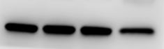


Figure 5F:
Cyclin D1 Blotting
Samples: DuDtxR-NT/ DuDtxR-MEN1KO/ DuDtxR-MEN1KO+MEN1WT (Main figure)

MEN1 Blotting
Samples: DuDtxR-NT/ DuDtxR-MEN1KO/ DuDtxR-MEN1KO+MEN1WT (Main Figure)

GAPDH Blotting
Samples: DuDtxR-NT/ DuDtxR-MEN1KO/ DuDtxR-MEN1KO+MEN1WT (Main figure)

MEN1 Blotting
Samples: DuDtxR-NT/ DuDtxR-MEN1KO/ DuDtxR-MEN1KO+MEN1WT (Biologic Replicate)

Cyclin D1
Samples: DuDtxR-NT/ DuDtxR-MEN1KO/ DuDtxR-MEN1KO+MEN1WT (Biologic Replicate)

GAPDH
Samples: DuDtxR-NT/ DuDtxR-MEN1KO/ DuDtxR-MEN1KO+MEN1WT (Biologic Replicate)

Cyclin D1
Samples: DuDtxR-NT/ DuDtxR-MEN1KO/ DuDtxR-MEN1KO+MEN1WT/ (Biologic Replicate)

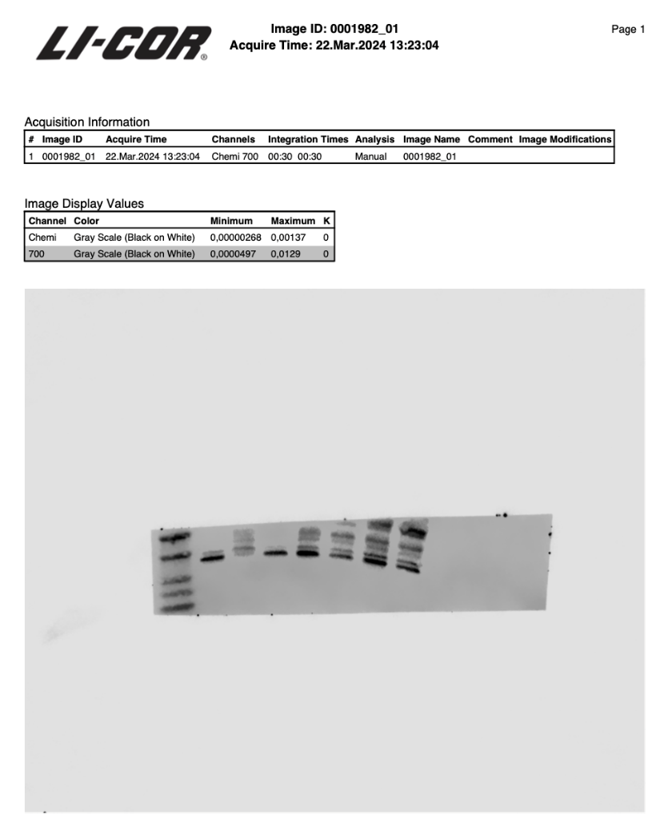

MEN1
Samples: DuDtxR-NT/ DuDtxR-MEN1KO/ DuDtxR-MEN1KO+MEN1WT (Biological Replicate)

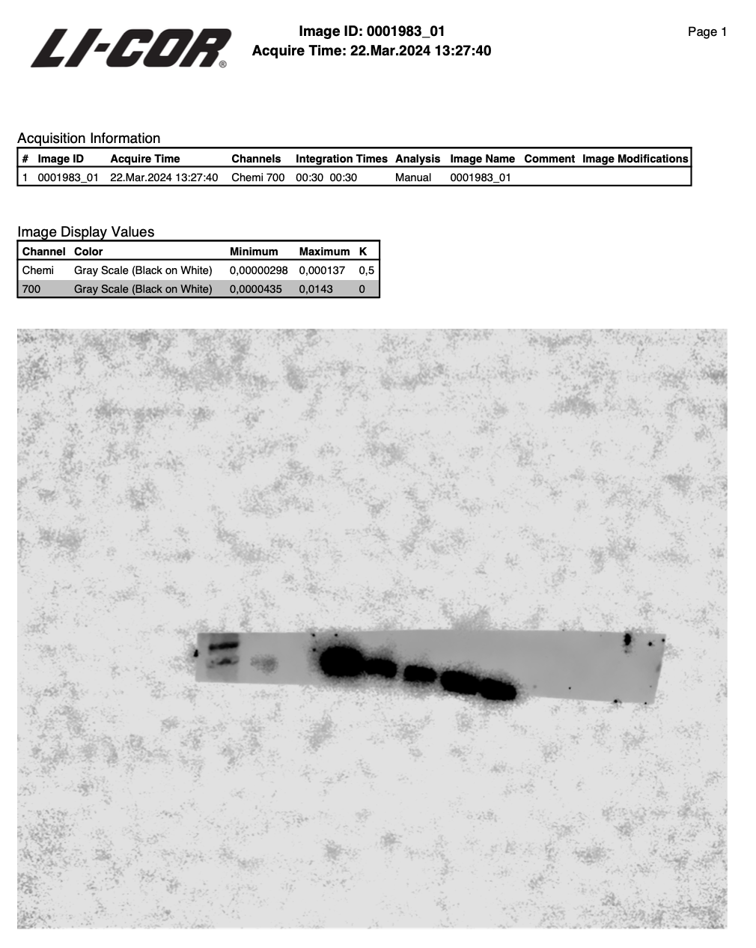

GAPDH
Samples: DuDtxR-NT/ DuDtxR-MEN1KO/ DuDtxR-MEN1KO+MEN1WT
(Biological Replicate)

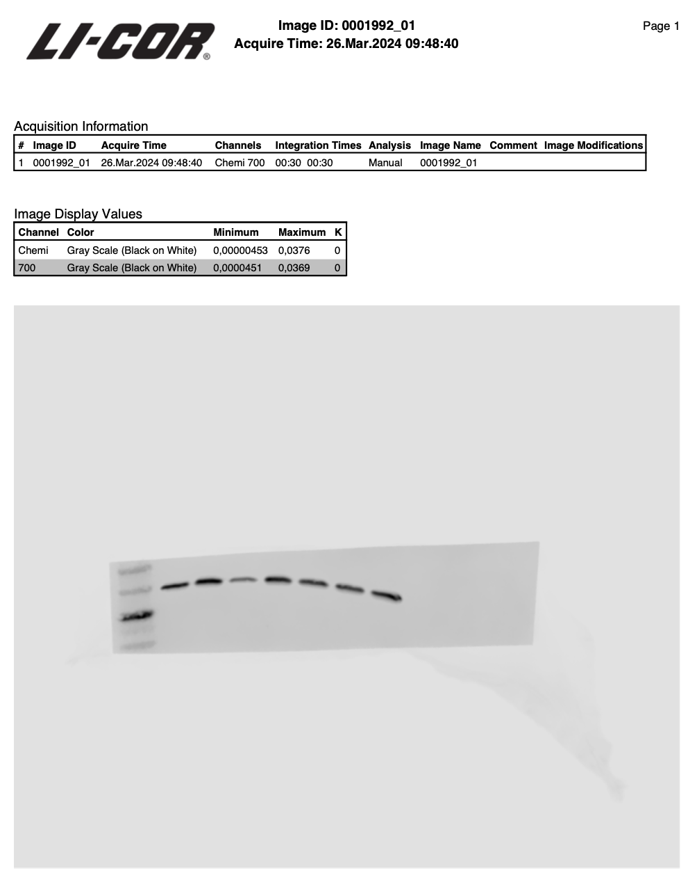

Supplementary Figures:

Figure S3A:
AR Blotting:
Samples: LNCaP-NT / LNCaP-MEN1^{KO}

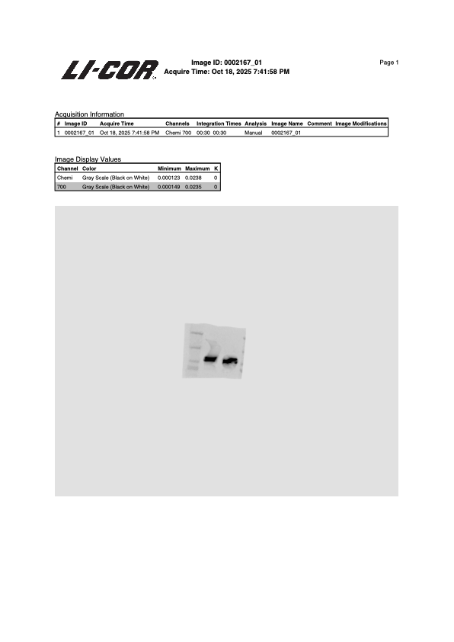
MEN1 Blotting:
Samples: LNCaP-NT / LNCaP-MEN1^{KO}

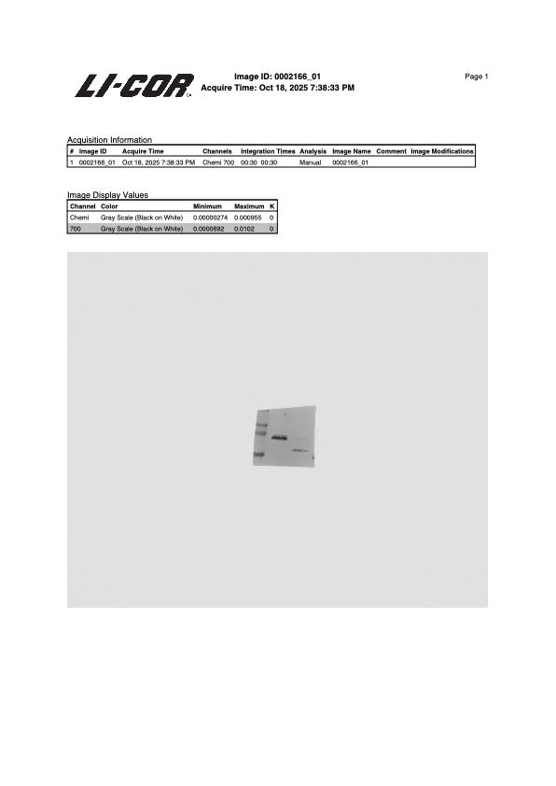

GAPDH Blotting:
Samples: LNCaP-NT / LNCaP-MEN1^{KO}

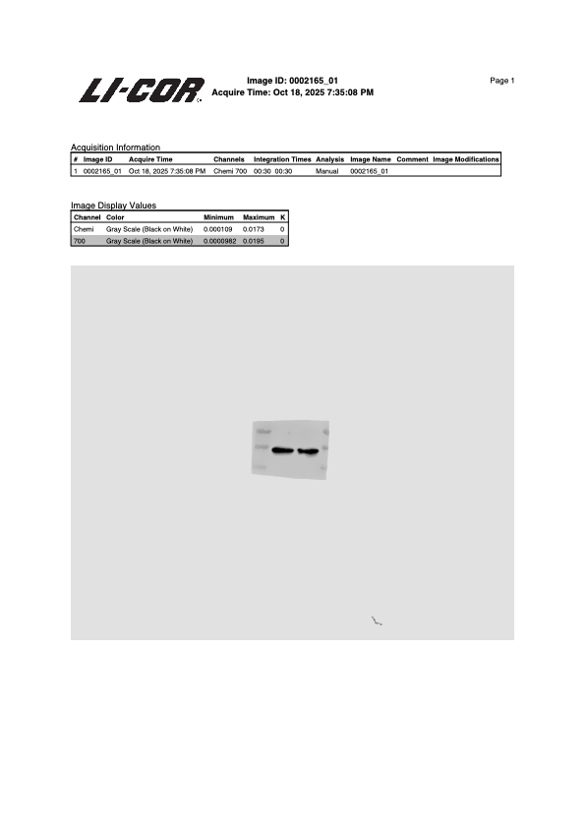
Figure S3C:
MEN1 Blotting
Samples: 22Rv1
P-NT / P-MENKO / DtxR-NT / DtxR-MENKO
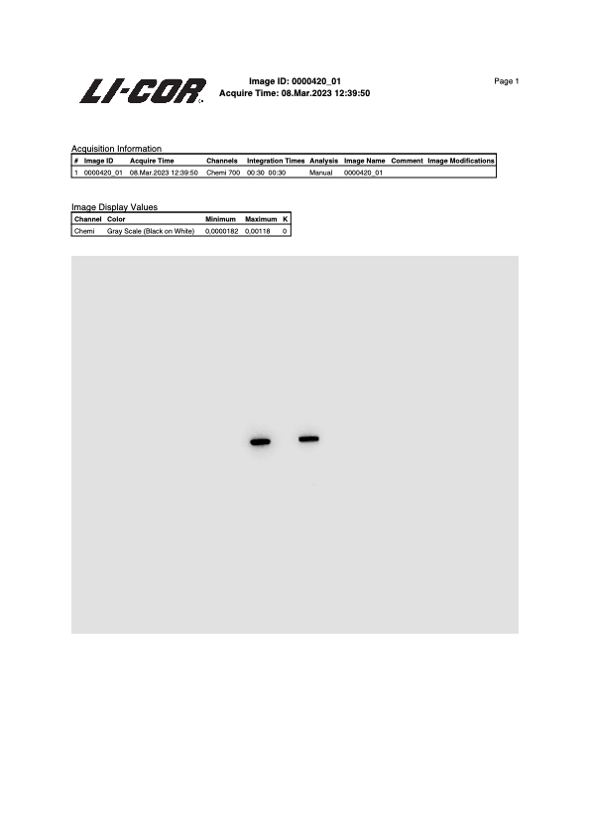
GAPDH Blotting
Samples: 22Rv1
P-NT / P-MENKO / DtxR-NT / DtxR-MENKO

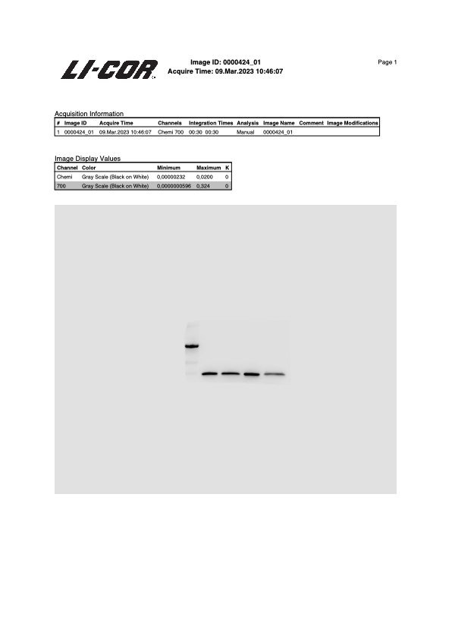
Figure S4B:
ABCB1 Blotting,
Samples: P-DtxR

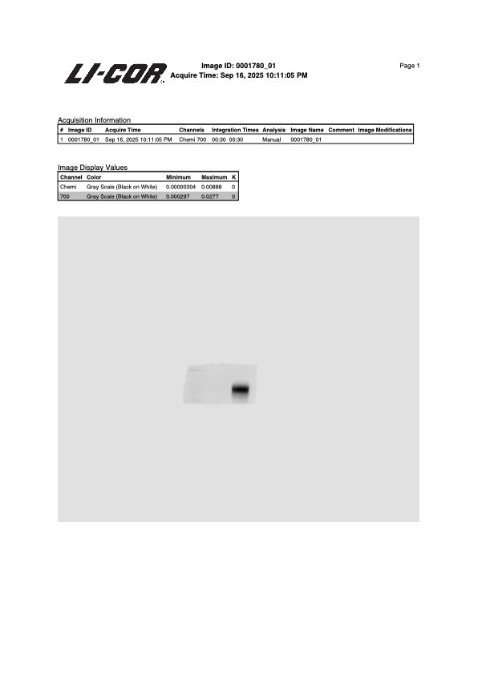

MEN1 Blotting,
Samples: P-DtxR

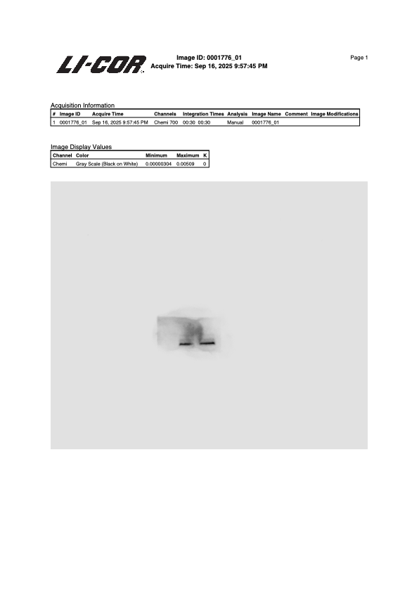
GAPDH Blotting
Samples: P-DtxR

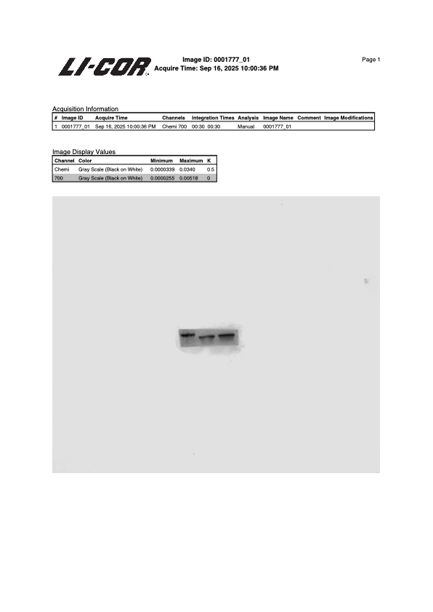

ABCB1 Blotting,
Samples: DtxR (NT-MI2)

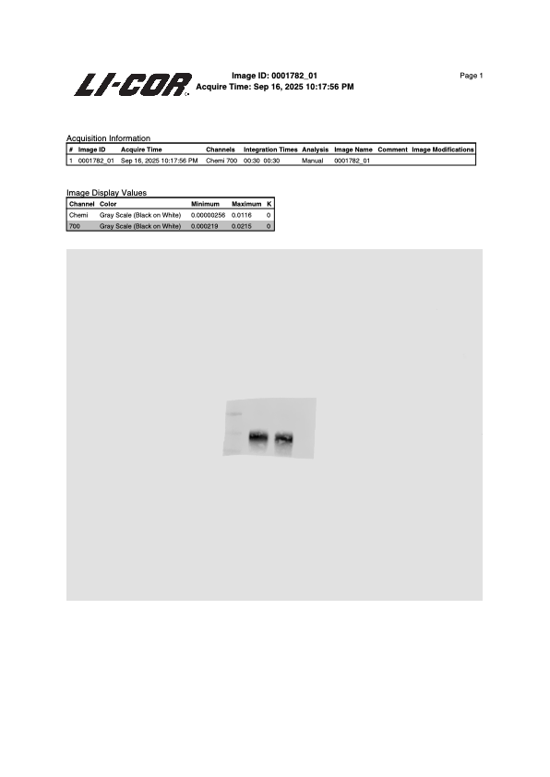
GAPDH Blotting,
Samples: DtxR (NT-MI2)

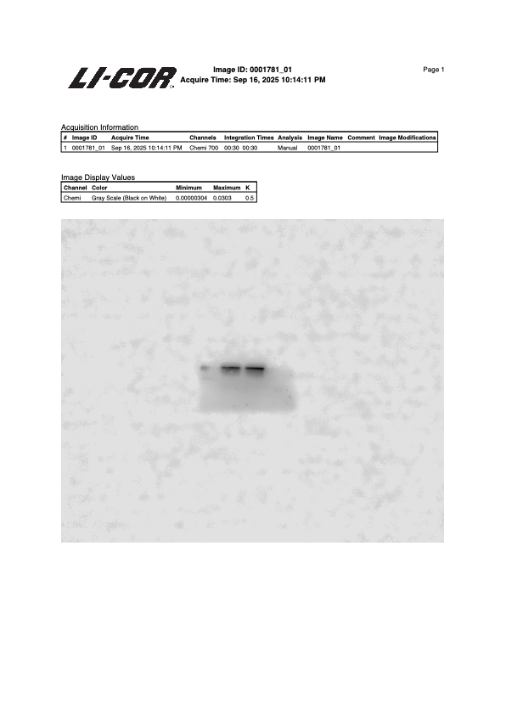
ABCB1 Blotting,
Samples: DtxR (NT-MEN1^{KO})

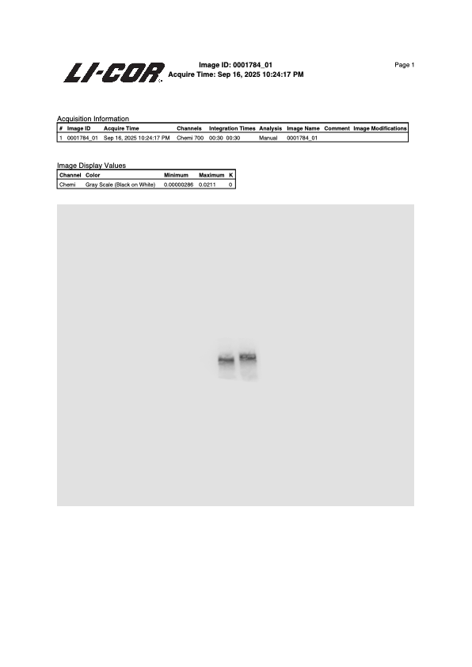
MEN1 Blotting,
Samples: DtxR (NT-MEN1^{KO})

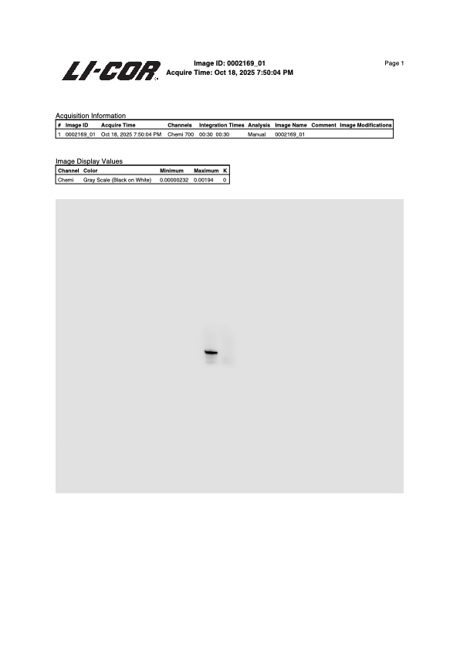

GAPDH Blotting,
Samples: DtxR (NT-MEN1^{KO})

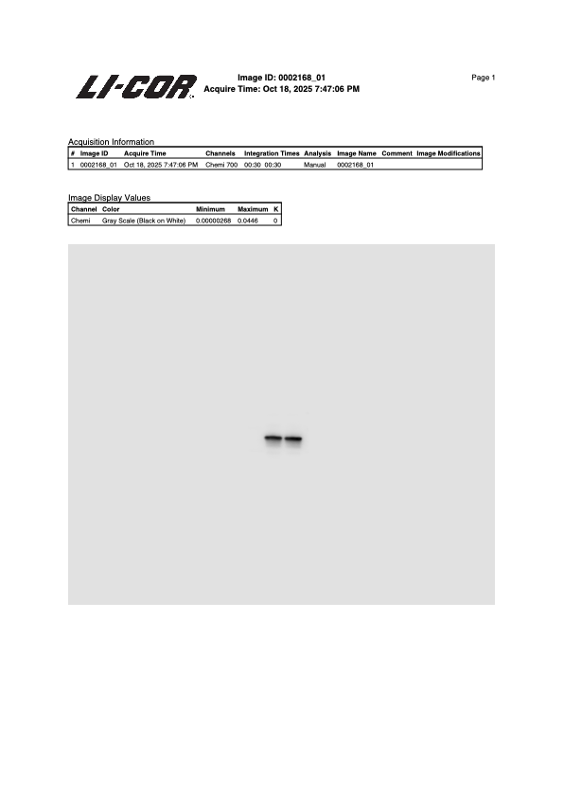

Figure S6A:

Menin Blotting
Samples: Du145P-EmptyVector / Du145P-MEN1^{3xFLAG} / Du145DtxR-EmptyVector / Du145DtxR-MEN1^{3xFLAG}

FLAG Blotting
Samples: Du145P-EmptyVector / Du145P-MEN1^{3xFLAG} / Du145DtxR-EmptyVector / Du145DtxR-MEN1^{3xFLAG}

GAPDH Blotting
Samples: Du145P-EmptyVector / Du145P-MEN1^{3xFLAG} / Du145DtxR-EmptyVector / Du145DtxR-MEN1^{3xFLAG}

Figure S8A:
Cyclin E1 Blotting
Samples: DuDtxR-NT/ DuDtxR-MEN1KO (Main figure)

P-Cyclin B1 Blotting
Samples: DuDtxR-NT/ DuDtxR-MEN1KO (Main figure)

Cyclin B1 Blotting
Samples: DuDtxR-NT/ DuDtxR-MEN1KO (Main figure)

Cyclin D1 Blotting
Samples: DuDtxR-NT/ DuDtxR-MEN1KO (Main figure)

MEN1 Blotting
Samples: DuDtxR-NT/ DuDtxR-MEN1KO (Main figure)

GAPDH Blotting
Samples: DuDtxR-NT/ DuDtxR-MEN1KO (Main figure)

Cyclin E1 Blotting
Samples: DuDtxR-NT/ DuDtxR-MEN1KO (Biologic Replicate)

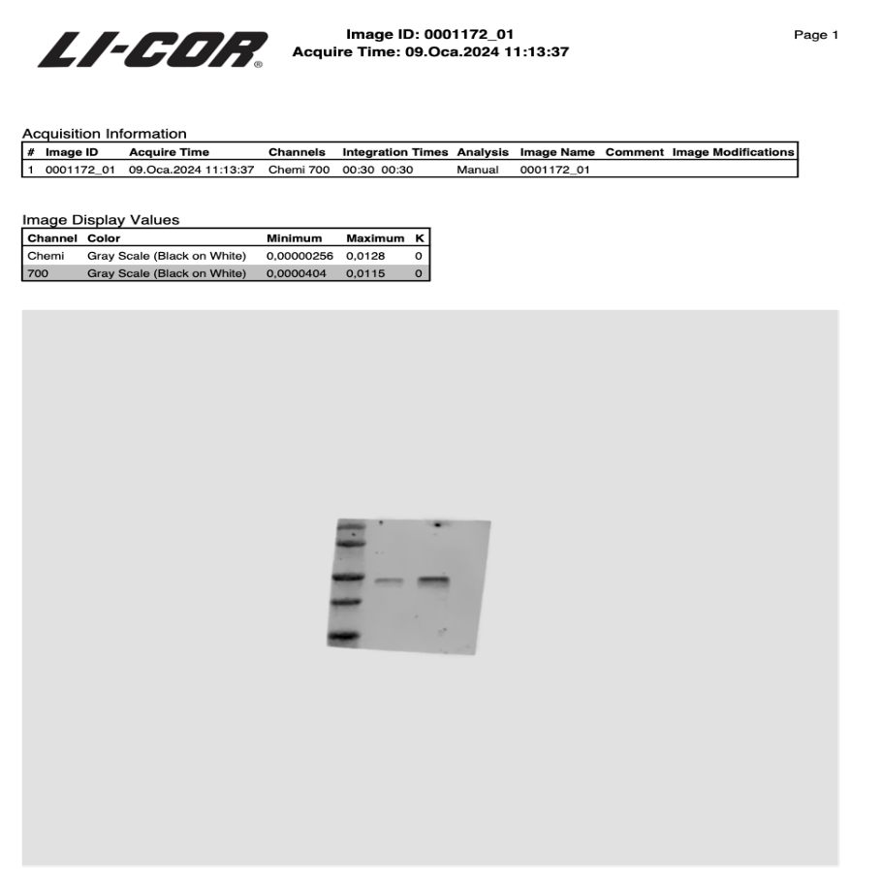

P-Cyclin B1 Blotting
Samples: DuDtxR-NT/ DuDtxR-MEN1KO (Biologic Replicate)

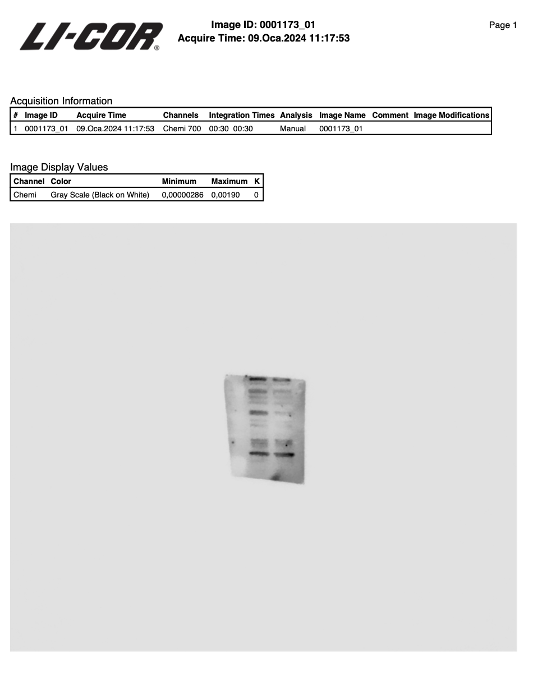

Cyclin B1 Blotting
Samples: DuDtxR-NT/ DuDtxR-MEN1KO (Biologic Replicate)
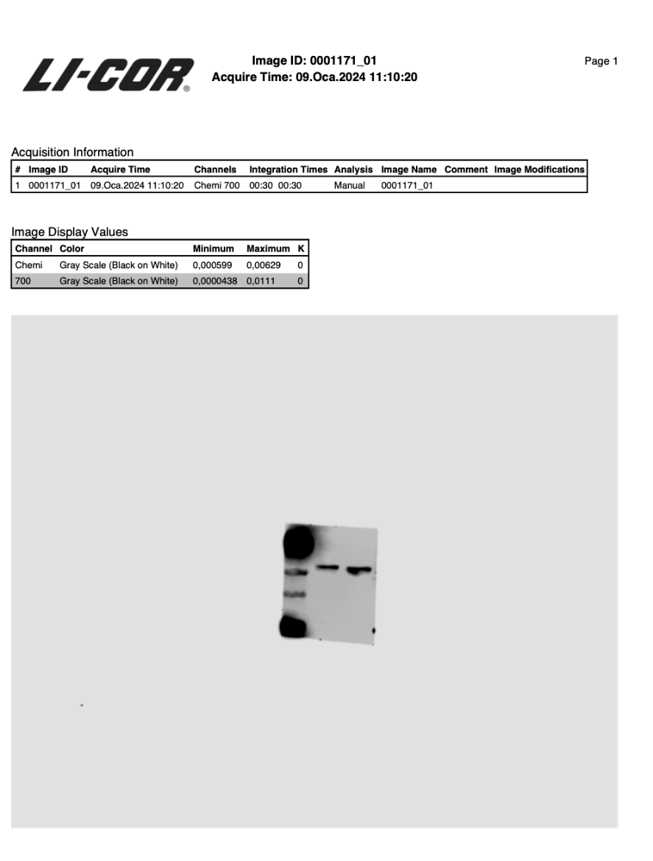

Cyclin D1 Blotting
Samples: DuDtxR-NT/ DuDtxR-MEN1KO (Biologic Replicate)

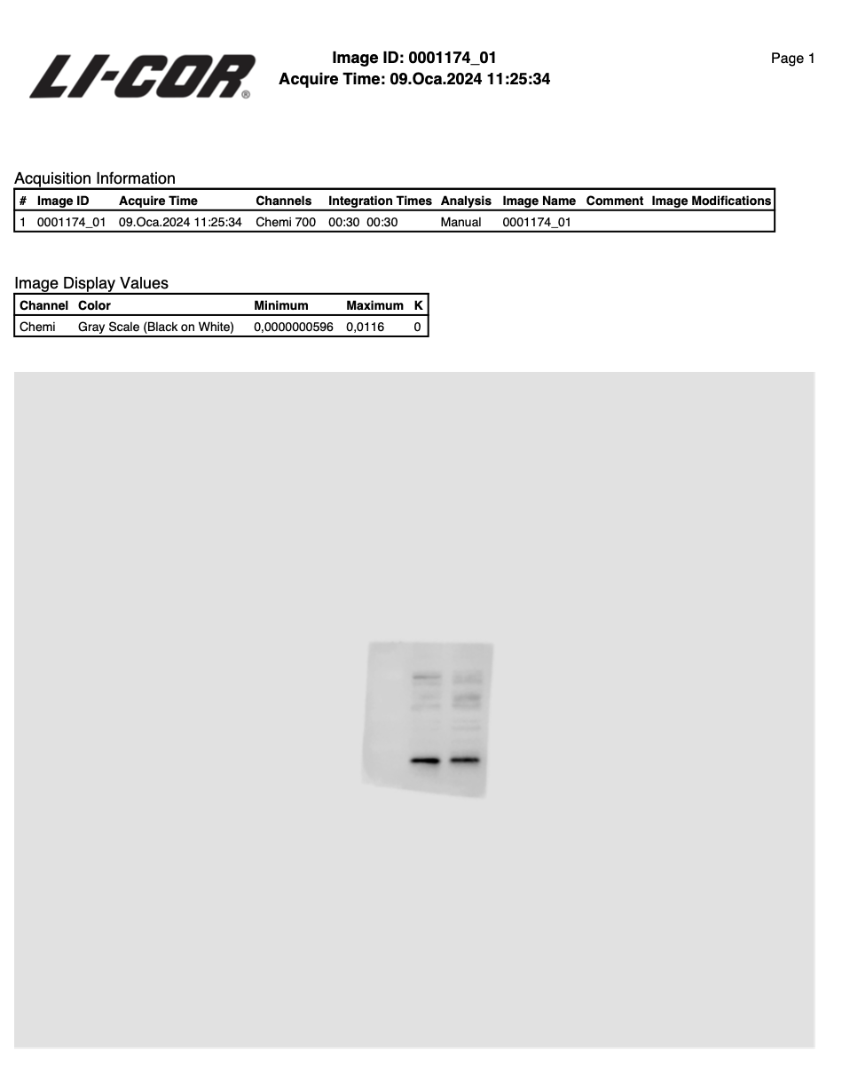

MEN1 Blotting
Samples: DuDtxR-NT/ DuDtxR-MEN1KO (Biologic Replicate)

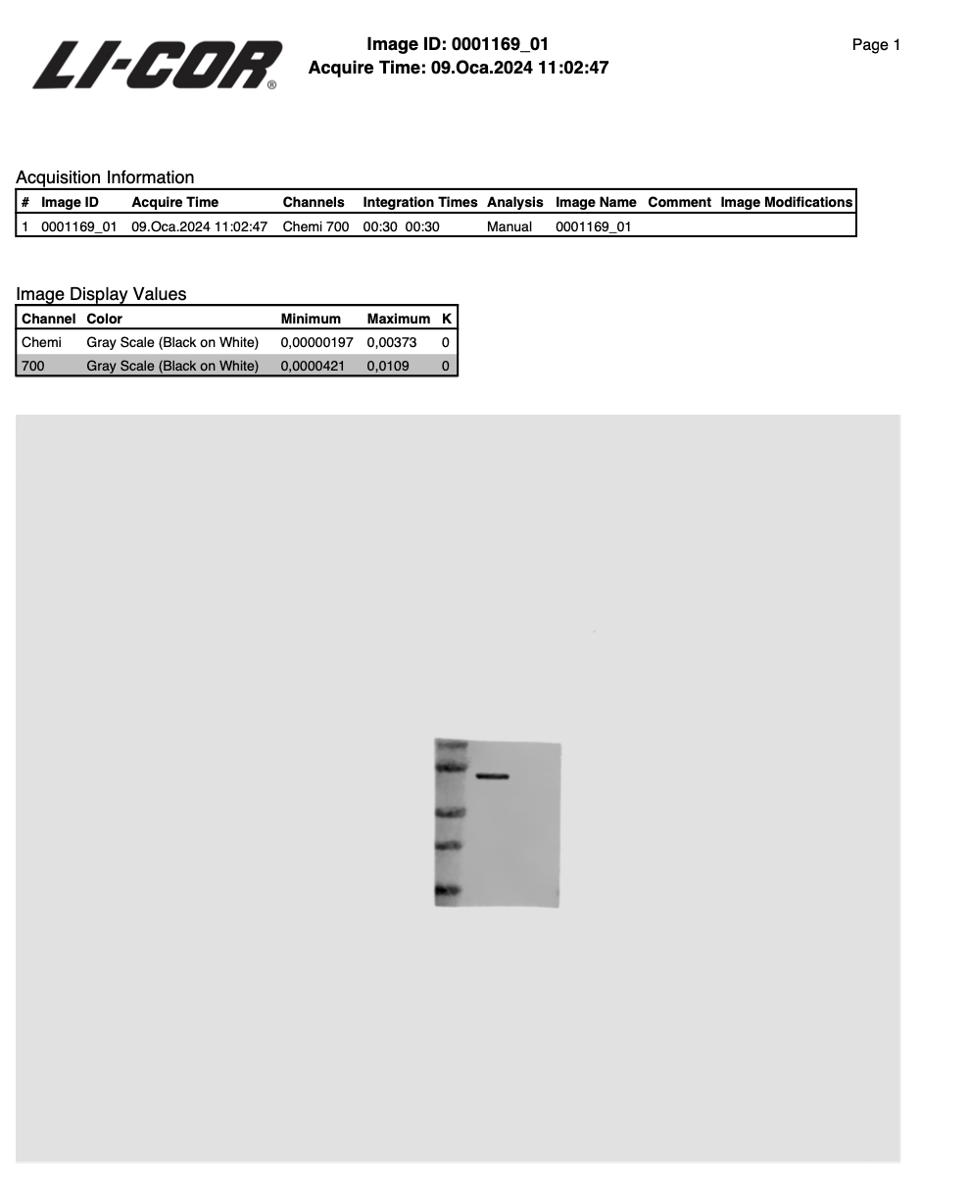

GAPDH Blotting
Samples: DuDtxR-NT/ DuDtxR-MEN1KO (Biologic Replicate)

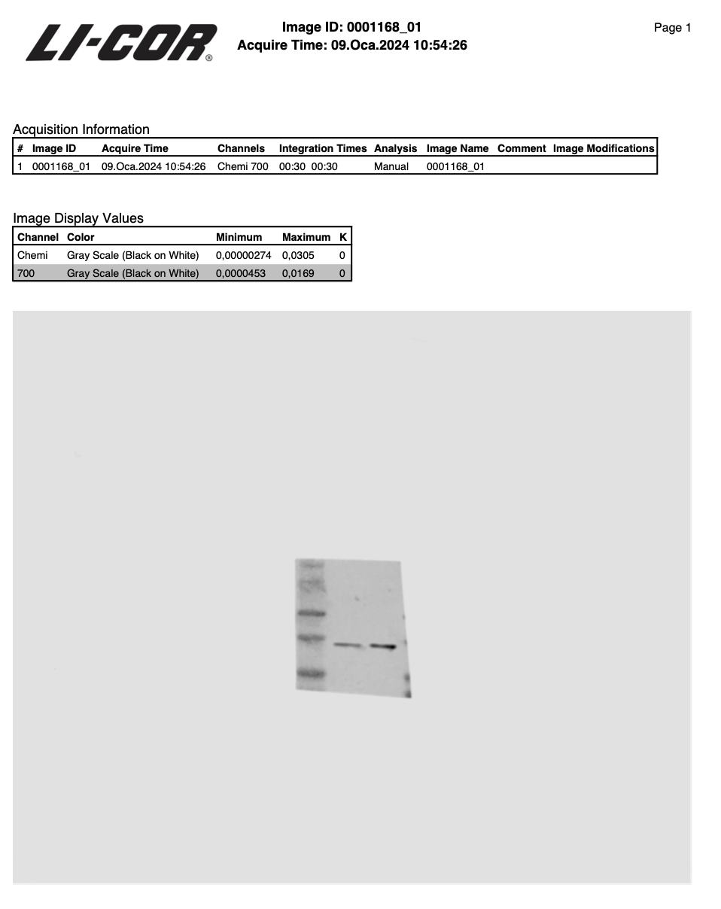

Cyclin E1 Blotting
Samples: DuDtxR-NT/ DuDtxR-MEN1KO (Biologic Replicate)

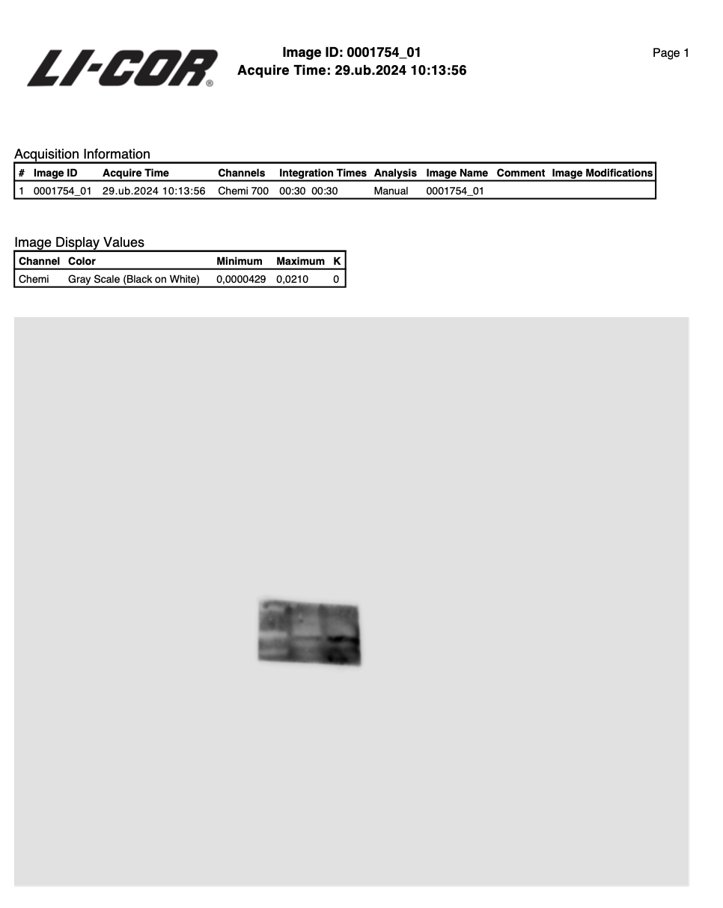

P-Cyclin B1 Blotting
Samples: DuDtxR-NT/ DuDtxR-MEN1KO (Biologic Replicate)

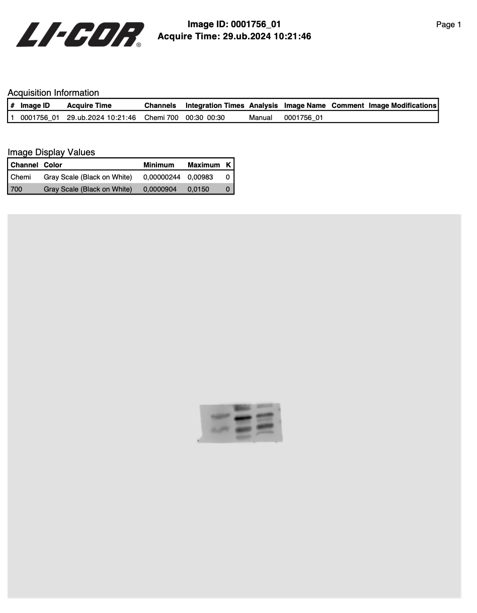

Cyclin B1 Blotting
Samples: DuDtxR-NT/ DuDtxR-MEN1KO (Biologic Replicate)

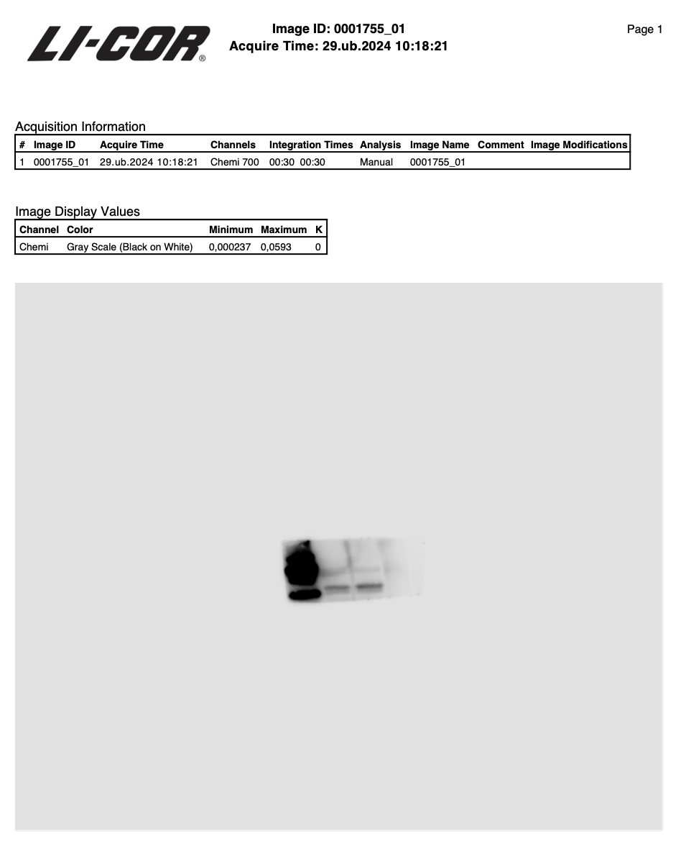

Cyclin D1 Blotting
Samples: DuDtxR-NT/ DuDtxR-MEN1KO (Biologic Replicate)

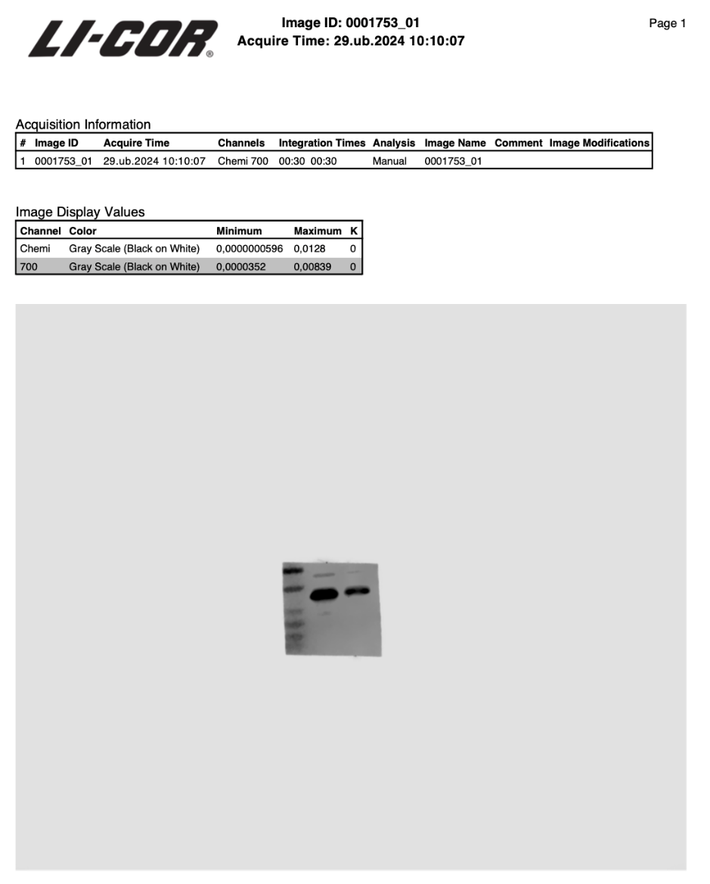

MEN1 Blotting
Samples: DuDtxR-NT/ DuDtxR-MEN1KO (Biologic Replicate

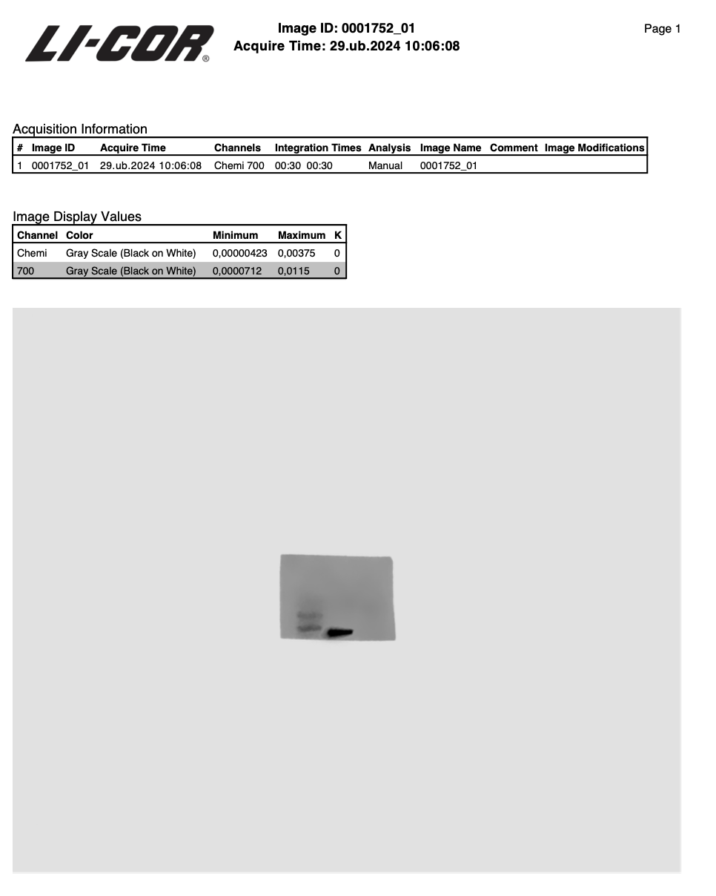

GAPDH Blotting
Samples: DuDtxR-NT/ DuDtxR-MEN1KO (Biologic Replicate)

