ORIGINAL WESTERN-BLOT IMAGES

Figure 1A.-Characterization of 697 parental leukemic cells (697wt) and their DNM-resistant (697R/DNM), CDDP-resistant (697R/CDDP), MTX-resistant (697R/MTX) and P-gp-transfected sublines (697-ABCB1). (A) P-gp (MDR-1, ABCB1) expression in leukemic sublines by Western-blot. GAPDH was used as control protein. Precision Plus Protein Standards were used as Molecular Weight Markers (Bio-Rad)
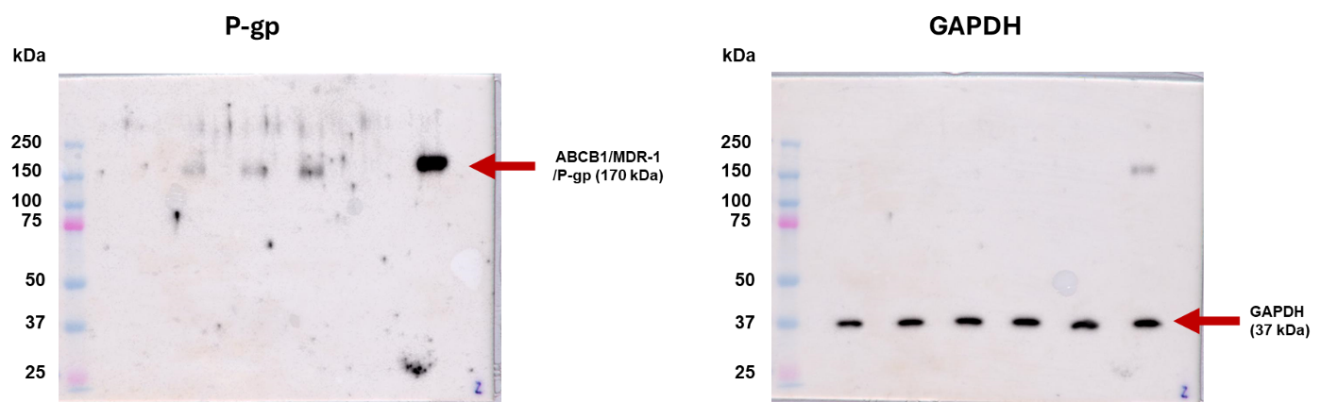

Figure 3A.-Differential activation profile of p38 MAPK on resistant (697R/DNM and 697-ABCB1+) compared with sensitive counterparts (697wt and 697-ABCB1-, respectively) in response to DNM or cold-induced stress. Cells (6 × 10⁵ cells/ml) were incubated at 2–4 °C or in presence of DNM (0.1 mM) for 0.5 to 4 h. Cells were harvested and whole cell lysates were obtained (10-15 μg of each) and subjected to Western blot using the indicated phospho-specific and total protein antibodies to detect activation and total relative expression of the p38 kinase. (A) Representative Western blots (left) and their respective graphs (right) showing p38 MAPK phosphorylation (pp38) and total protein expression (p38) of 697wt, 697R/DNM, 697-ABCB1- and 697-ABCB1+ cells under drug stress (DNM, 0.1 μM).
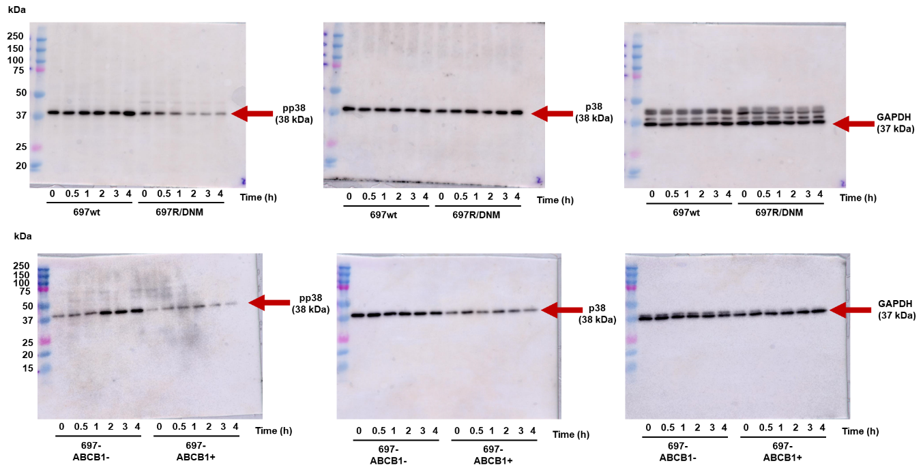

Figure 3B.-Differential activation profile of p38 MAPK on resistant (697R/DNM and 697-ABCB1+) compared with sensitive counterparts (697wt and 697-ABCB1-, respectively) in response to DNM or cold-induced stress. Cells (6 × 10⁵ cells/ml) were incubated at 2–4 °C or in presence of DNM (0.1 mM) for 0.5 to 4 h. Cells were harvested and whole cell lysates were obtained (10-15 μg of each) and subjected to Western blot using the indicated phospho-specific and total protein antibodies to detect activation and total relative expression of the p38 kinase. (B) Representative Western-blots (left) and their respective graphs (right) showing p38 MAPK phosphorylation (pp38) and total protein expression (p38) curves of 697wt, 697R/DNM, 697-ABCB1- and 697-ABCB1+ cells under cold stress.

