Figure S1
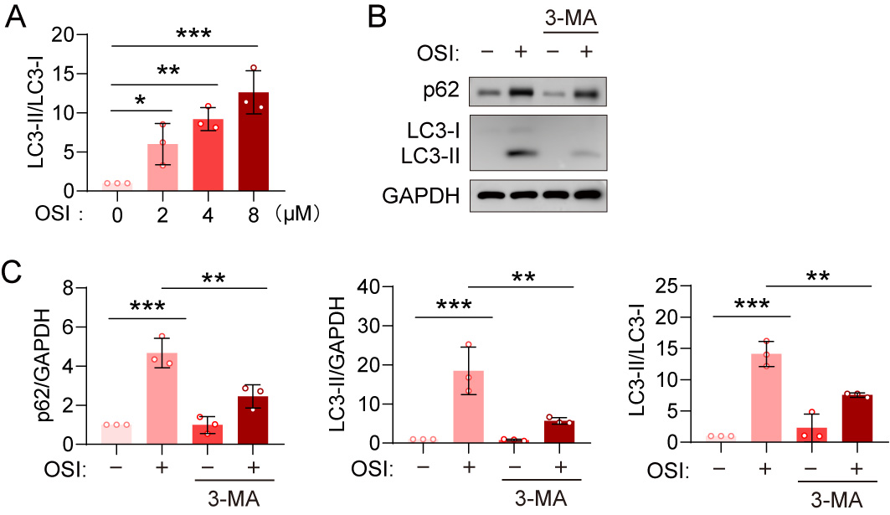
Figure S1 3-MA inhibits osimertinib-induced autophagy.
(A) The ratio of LC3-II:LC3-I in MIHA cells treated with different concentrations of osimertinib for 24 h (n = 3).
(B-C) Immunoblotting analysis of SQSTM1/p62 and LC3-I/II in MIHA cells after treatment with osimertinib for 24 h with or without 5 mM 3-MA (B). GAPDH was used as a loading control. Protein expression levels were quantified (C) (n = 3).

Figure S2
Figure S2 GO analysis of liver tissues and AML12 cells after osimertinib treatment
(A) Volcano plot of genes that are differentially expressed under the treatment with osimertinib in livers (n = 3, fold change >2; P < 0.05)
(B, C) GO analysis of the genes enriched in the liver tissues for control group (B) and osimertinib group (C).
(D) Heatmap analyses of representative lysosome-related and autophagy-related genes that are differentially upregulated in the osimertinib treated mouse livers.
(E) GO analysis of the genes enriched in the AML12 cells for control group.
(F) Venn diagram illustrating the number of co-interacting genes between the predicted targets of SAM and the downregulated and upregulated genes in the osimertinib group.

Figure S3
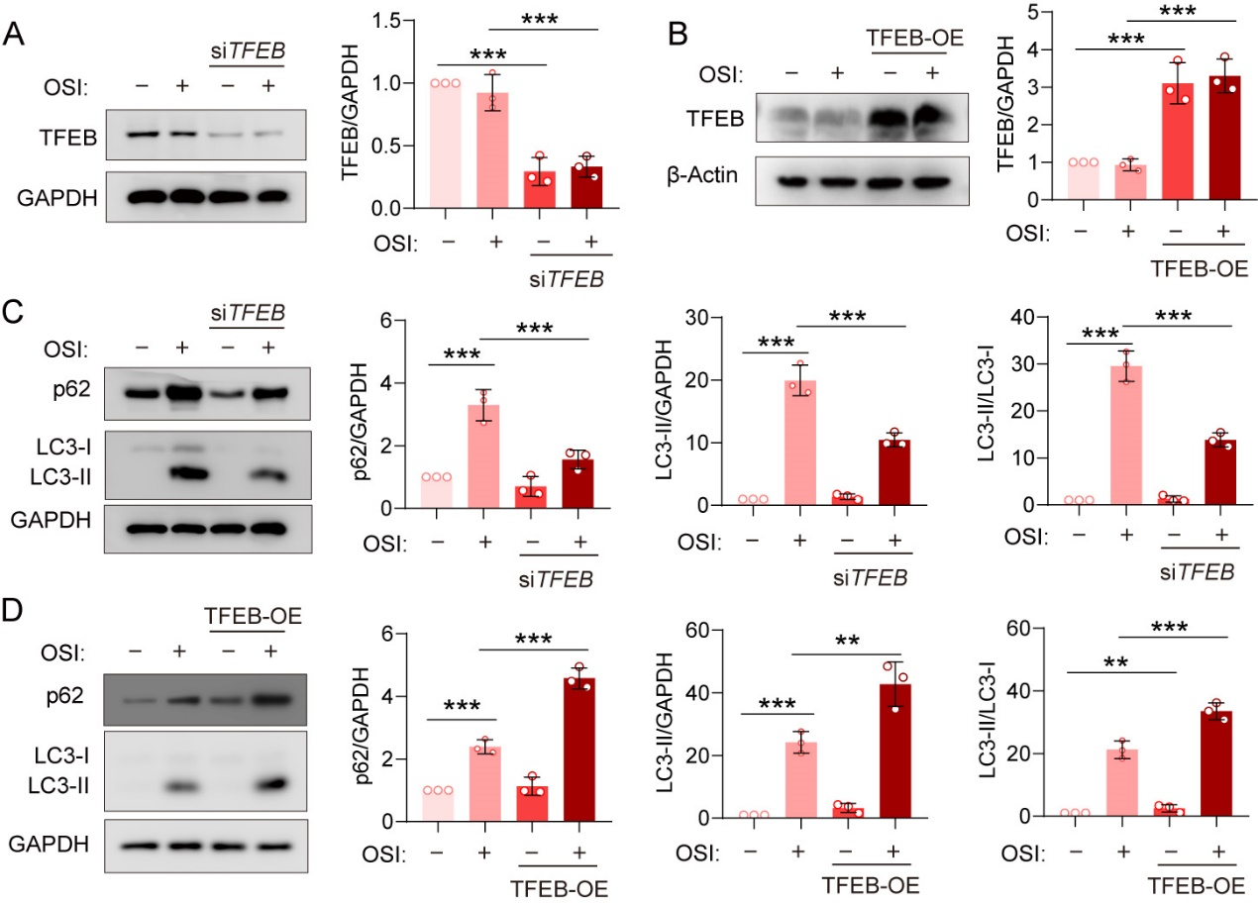
Figure S3 TFEB-mediated osimertinib-induced autophagy.
(A, B) Immunoblotting analysis of TFEB in MIHA cells after treatment with osimertinib for 24 h with or without siTFEB (A) or 3×Flag-TFEB (B) transfection. GAPDH was used as a loading control. Protein expression levels were quantified (n = 3).
(C, D) Immunoblotting analysis of SQSTM1/p62 and LC3-I/II in MIHA cells after treatment with osimertinib for 24 h with or without siTFEB (C) or 3×Flag-TFEB (D) transfection. GAPDH was used as a loading control. Protein expression levels were quantified (n = 3).

