Supplementary Material
RT–ICI therapy induces a distal immunometabolic axis that shapes systemic macrophage polarization and enhances local T cell immunity
Yizhi Ge^{†,1}, Haitao Liu^{†,2}, Jiayi Shen³, Hongming Xu⁴, Yong Feng*,1, Dan Zong^{*,1}, Lijun Wang^{*,1}
1 Department of Radiation Oncology, Jiangsu Cancer Hospital & Jiangsu Institute of Cancer Research & The Affiliated Cancer Hospital of Nanjing Medical University, Nanjing, Jiangsu, 210009, China;
2 School of Life Sciences，Fudan University, Shanghai, 200438, China;
3 The Affiliated Cancer Hospital of Nanjing Medical University, Jiangsu Cancer Hospital, Jiangsu Institute of Cancer Research, Nanjing, China;
4 Department of Oncology, Huai'an 82 Hospital, Huai’an, China.

† These authors contributed equally to this work.

* Corresponding authors:
Lijun Wang, Phone: 86-25-83283560, E-mail: htzlyy@163.com.
Dan Zong, Phone: 86-25-83283560, E-mail: zongdan910@sina. com.
Yong Feng, Phone: 86-25-83283560, yuxindu@njmu.edu.cn.
The mail address: 42 Baiziting Road, Xuanwu District, Nanjing, Jiangsu, 210009, China.
Keywords: Single-Cell; Spatial Transcriptomic; Colon Cancer; Liver Metastasis
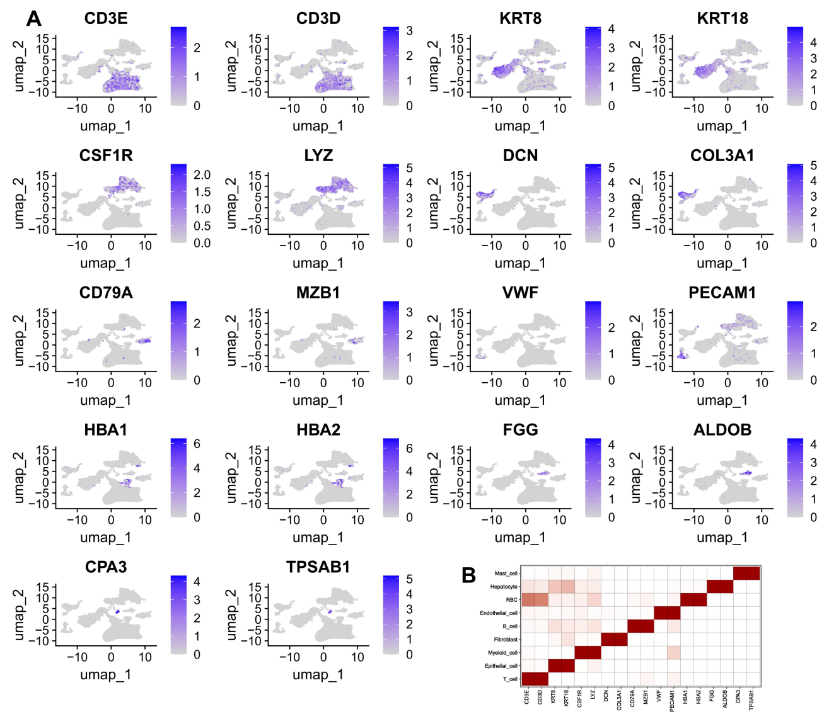
Supplementary Figure 1 | Cell type annotation (A-B) UMAP and heatmap show marker genes for major cell types: T cells (CD3E, CD3D), epithelial cells (KRT8, KRT18), myeloid cells (CSF1R, LYZ), fibroblasts (DCN, COL3A1), B cells (CD79A, MZB1), endothelial cells (VWF, PECAM1), erythrocytes (HBA1, HBA2), mast cells (CPA3, TPSAB1).
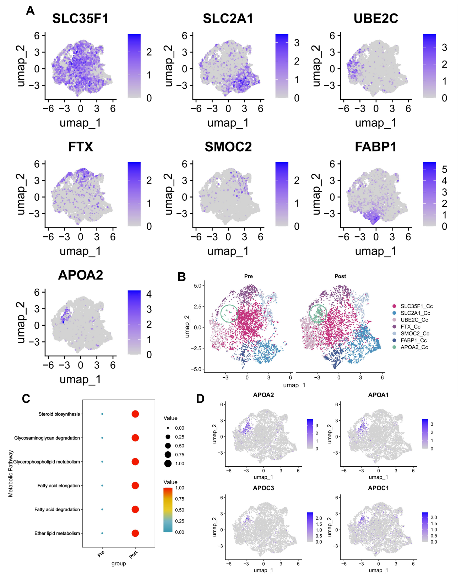
Supplementary Figure 2 | Tumor subpopulation characterization (A) UMAP shows expression of tumor subpopulation markers (SLC35F1, SLC2A1, UBE2C, FTX, SMOC2, FABP1, APOA2). (B) Relative abundance of tumor subpopulations pre- and post-treatment. (C) Dot plot showing enrichment of metabolic pathways before and after treatment. (D) UMAP shows expression of APOA2, APOA1, APOC3, APOC1 in tumor cells.

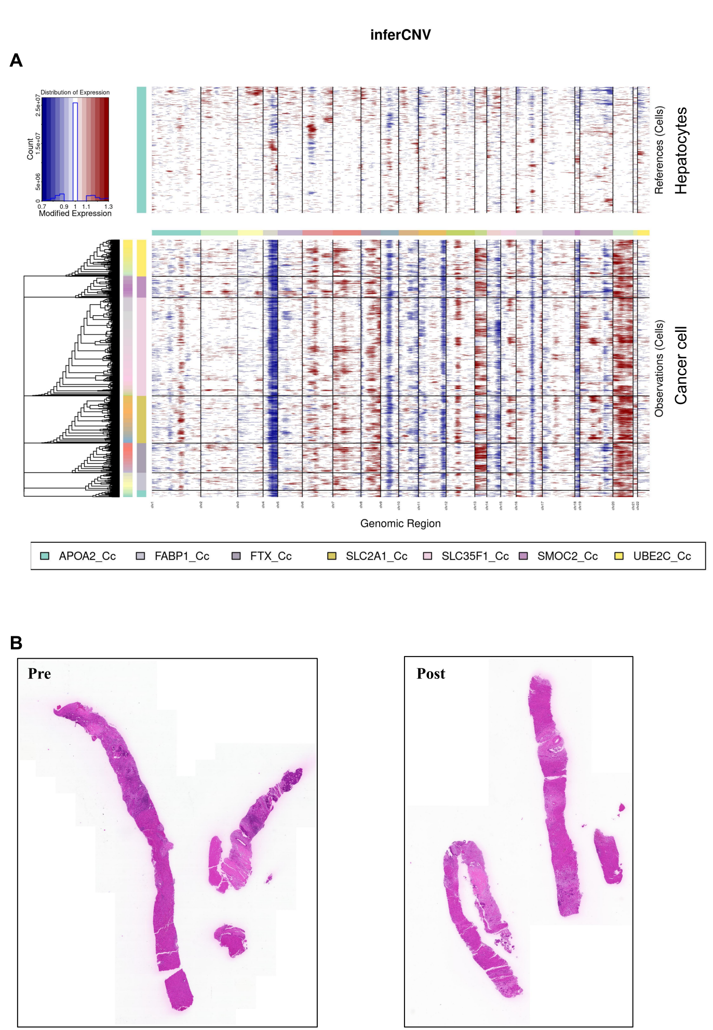

Supplementary Figure 3 | CNV and spatial analysis of tumor cells (A) InferCNV heatmaps compare tumor subpopulations to mast cells, confirming higher CNV in APOA2⁺ cells. (B) Hematoxylin and eosin (H&E) staining of tissue sections used for spatial transcriptomics before and after treatment.

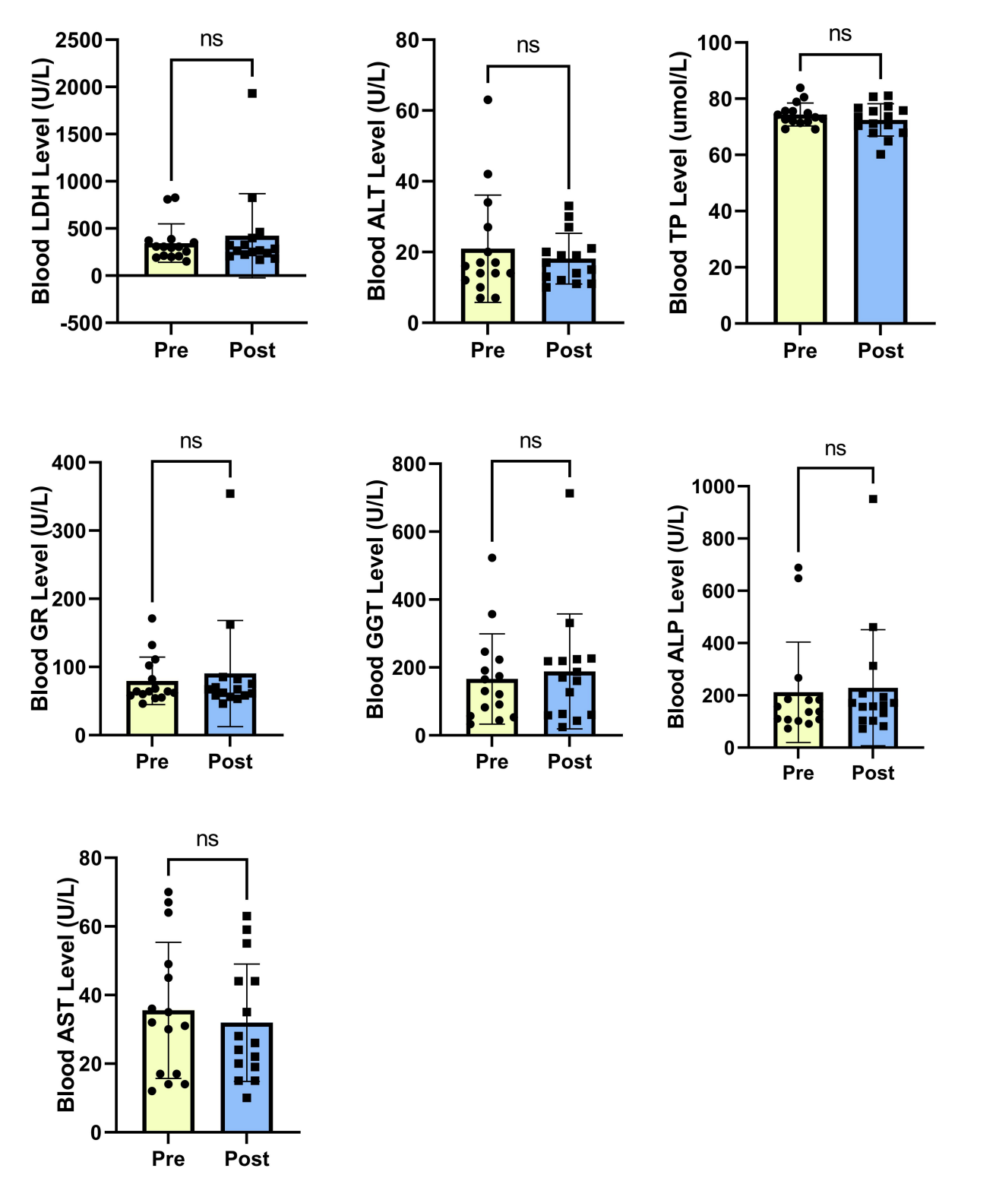
Supplementary Figure 4 | Systemic metabolic profiling. Serum biochemical parameters (including amylase) pre-, on-, and post-treatment support transient HDL elevation and homeostatic feedback.
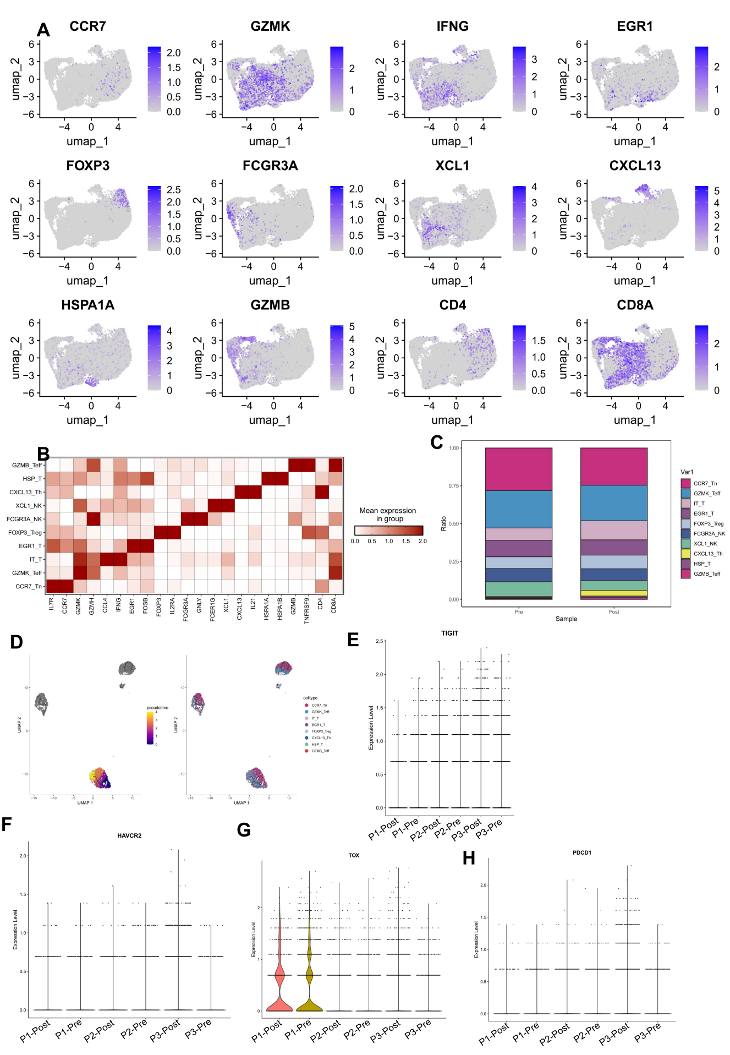Supplementary Figure 5 | T and NK cell characterization (A-B) UMAP and heatmap show expression of T/NK markers: CCR7 (naïve T cells), GZMK/GZMB (effector T cells), FOXP3 (Tregs), FCGR3A/XCL1 (NK cells), CXCL13 (Th cells), EGR1/HSPA1A (activated T cells), CD4/CD8A (T cell subsets). (C) Relative abundance of T/NK subsets confirms IT_T expansion. (D) Pseudotime trajectory analysis shows that pre-treatment T cell subsets fail to form a coherent developmental trajectory. (E-H) Violin plots depict the expression levels of multiple T cell exhaustion genes across patients pre- and post-treatment.

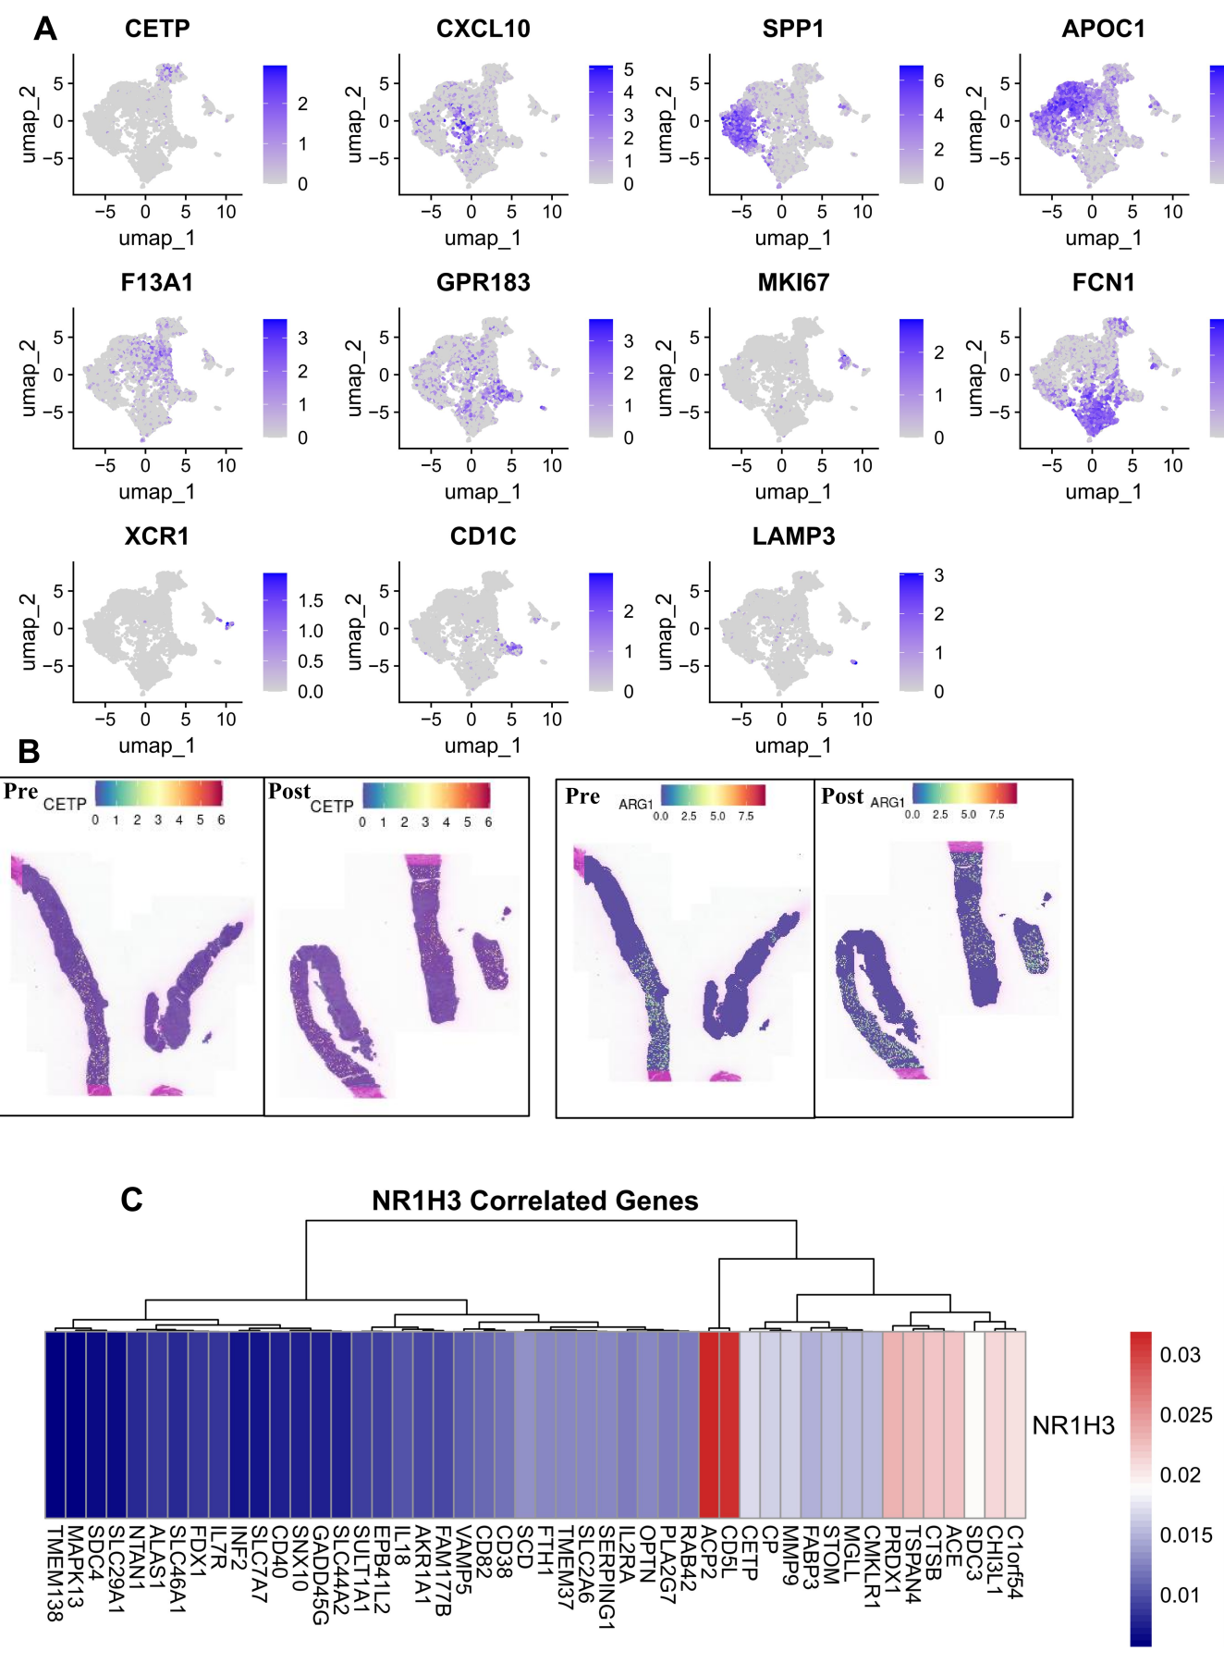Supplementary Figure 6 | Myeloid cell characterization (A) UMAP shows expression of myeloid markers: CETP (CETP⁺ macrophages), CXCL10 (CXCL10⁺ macrophages), SPP1 (SPP1⁺ macrophages), APOC1 (APOC1⁺ macrophages), XCR1 (cDC1), CD1C (cDC2), LAMP3 (cDC3). (B) Spatial expression of CETP and ARG1 (M2 marker) post-treatment. (C) Correlation of NR1H3 (LXRα) with downstream target genes in myeloid cells.
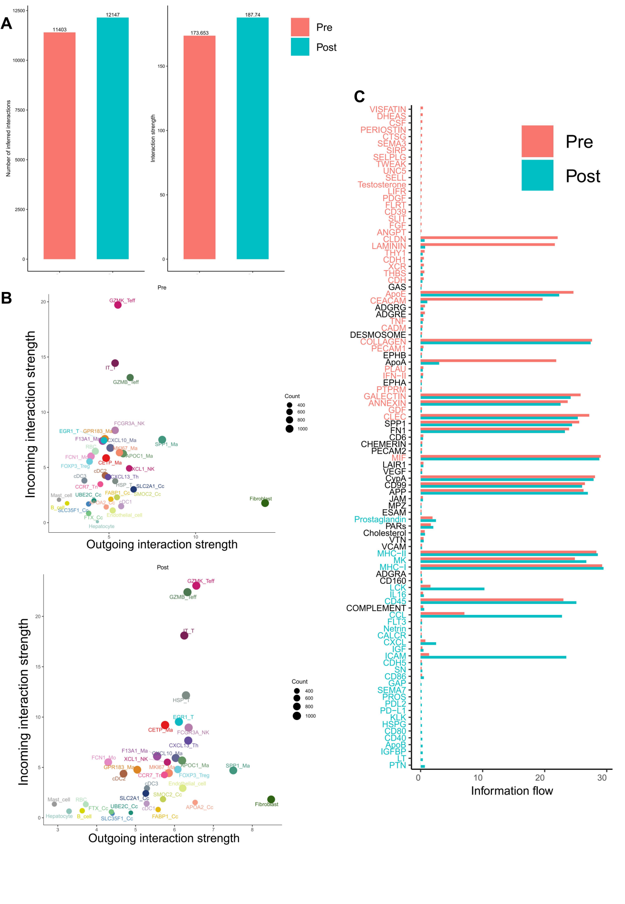Supplementary Figure 7 | Cell-cell communication dynamics (A) Quantification of intercellular interaction strength pre- and post-treatment. (B) Network analysis identifies IT_T and GZMB_Teff as key signaling hubs. (C) Differential interaction strength of CCL and CXCL pathways, with IT_T as major CCL ligand sources.
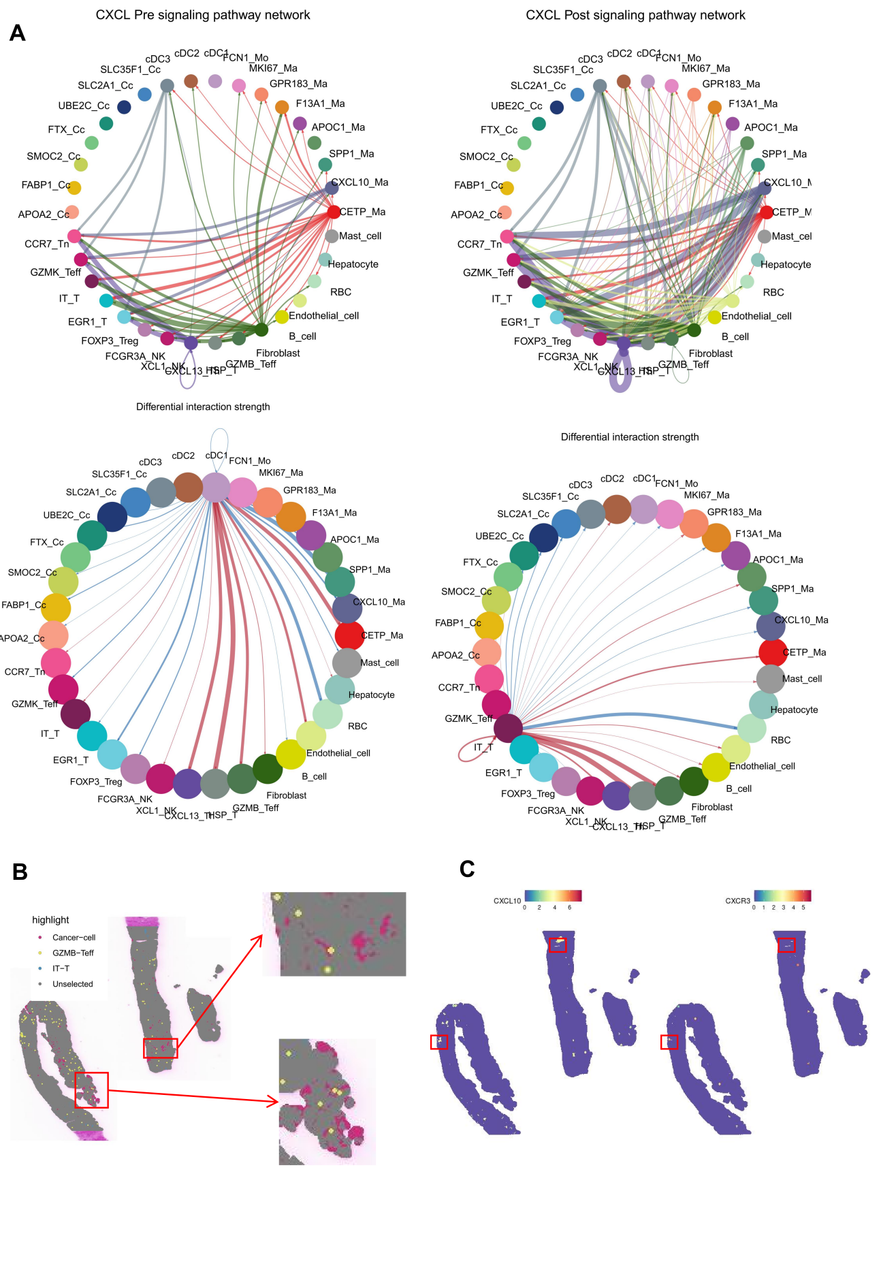Supplementary Figure 8 | Cell-cell communication dynamics (A) Differential interaction strength of CCL and CXCL pathways, with IT_T as major CCL ligand sources. (B-C) Spatial transcriptomics revealed co-localization of GZMB⁺ effector T cells (GZMB_Teff), inflammatory–toxic T cells (IT_T), and tumor cells, as well as co-localization of CXCL10–CXCR3 ligand–receptor pairs.
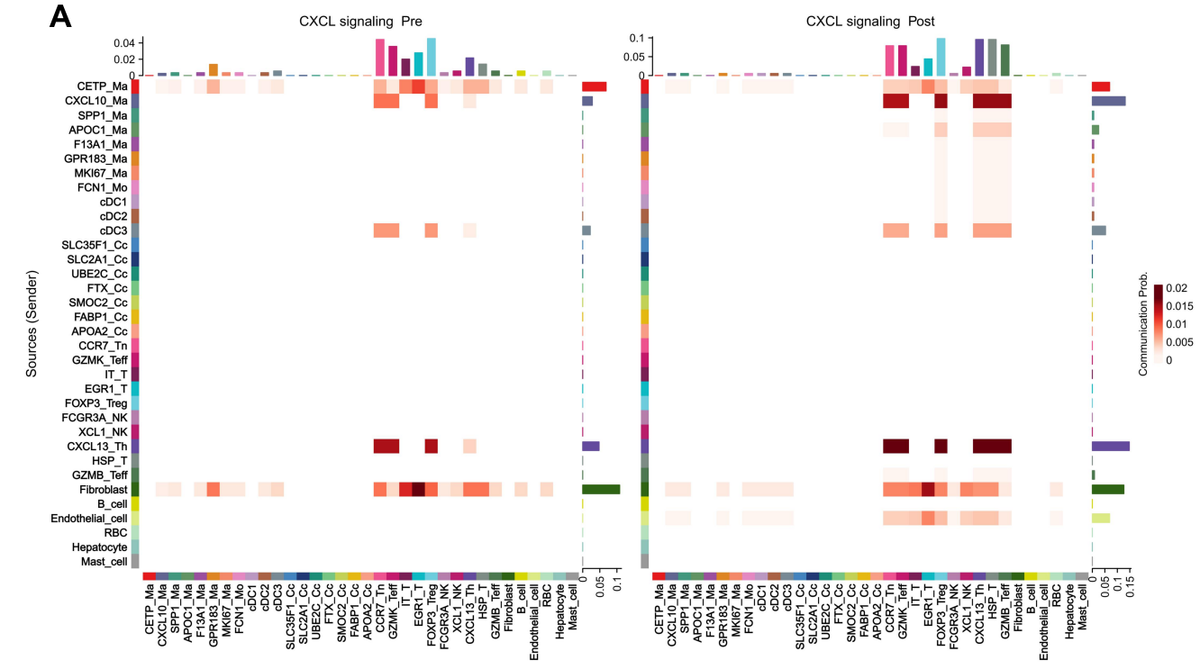Supplementary Figure 9 | Cell-cell communication dynamics (A) Differential interaction strength of CCL and CXCL pathways, with IT_T as major CCL ligand sources.
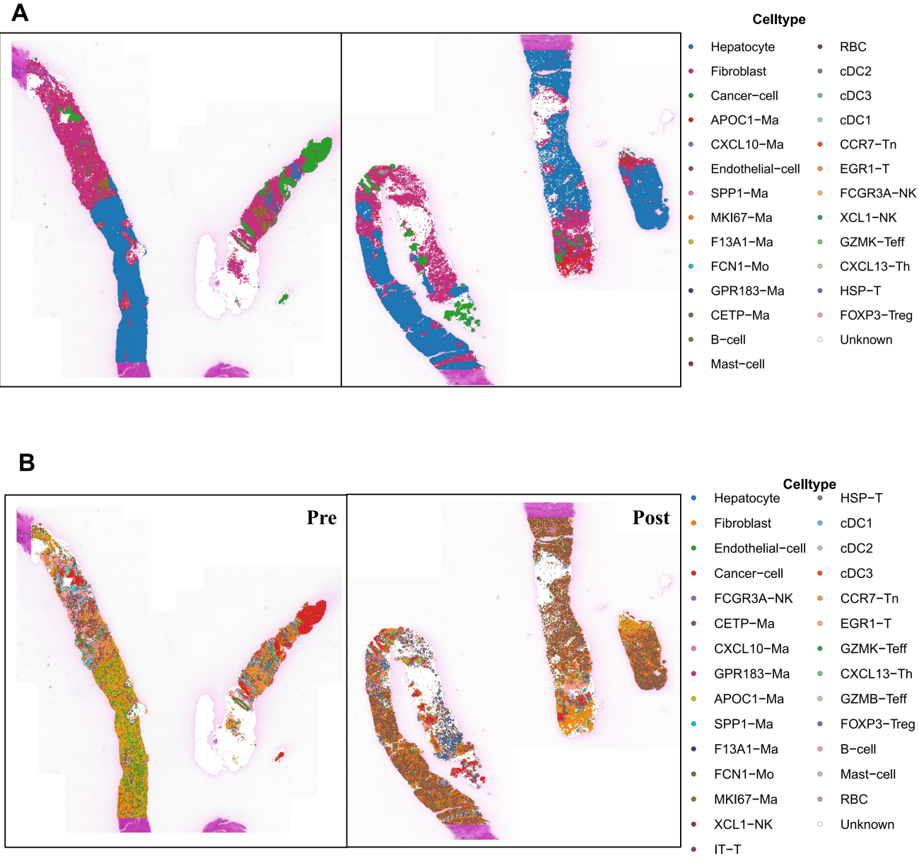Supplementary Figure 10 | Spatial transcriptomics deconvolution (A-B) RCTD-based deconvolution of spatial transcriptomics data from pre- and post-treatment samples identified two distinct types of spot-level cell annotations.
Characteristics | No. of patients
Gender | Male | 13(72.2%)
 | Female | 5(27.8%)
Age Median (Range) |  | 61(42-71) years
Ethnicity | Asian | 18(100%)
Primary Tumor | Colon | 14(77.8%)
 | Rectum | 4(22.2%)
Metastatic Location | Liver | 20
 | Lung | 1
 | bladder | 1
Prior Interventions | Prior Systemic Therapy | 18(100%)
 | Prior Surgery (for primary/metastases) | 14(77.8%)
 | Prior Radiation Therapy (non-study) | 1(5.6%)
Study Treatment | Radiation Therapy Median Dose per Fraction | 8(6–10) Gy per fraction
 | Immune Checkpoint Inhibitor Cycle | 2.2(1-4)
Clinical Outcomes | Partial Response | 1(5.6%)
 | Stable Disease | 4(22.2%)
 | Progressive Disease | 13(72.2%)
Supplementary Table
Patient characteristics

