Supplementary information:
Neddylation relieves cytoskeletal tension to permit primary cilia formation during mouse decidualization
Chen Zhou^{1†}, Yu-Ying He^{†2}, Wen-Xu Yao², Yue Li², Bo Li^{3*}
¹ College of Animal Science and Technology, Henan University of Science and Technology, Luoyang 471023, China.
² Key Laboratory of Animal Genetics, Breeding and Reproduction in the Plateau Mountain Region, College of Animal Science, Guizhou University, Guiyang, 550025, China.
³ Reproductive Sciences Center, Division of Developmental Biology, Cincinnati Children’s Hospital Medical Center, Cincinnati, OH 45229, USA.
† These authors contributed equally to this work.
* Corresponding author. Email: Bo.Li@cchmc.org

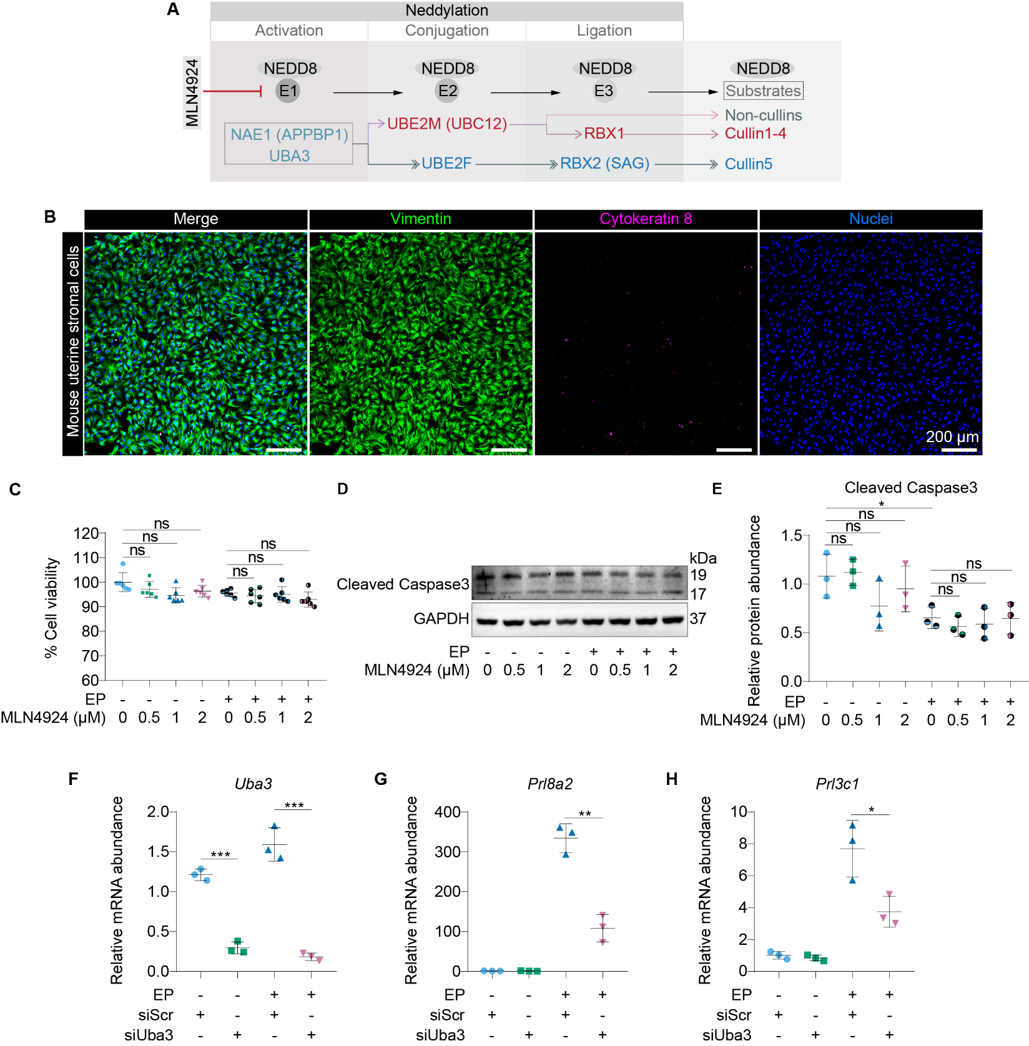
Fig. S1. Validation of cell purity, MLN4924 cytotoxicity, and effect of Uba3 knockdown on decidualization. A Schematic illustration of the neddylation enzymatic cascade. Neddylation involves the sequential transfer of NEDD8 by E1 (NAE1/UBA3), E2, and E3 enzymes to substrates. MLN4924 specifically inhibits the E1 enzyme. B Immunofluorescence staining of isolated mouse uterine stromal cells showing positive staining for the stromal marker Vimentin and negative staining for the epithelial marker Cytokeratin 8. Nuclei were counterstained with DAPI (blue). Scale bars: 200 μm. C Cell viability assessed by MTT assay in stromal cells treated with EP and increasing concentrations of MLN4924 (0-2 μM). D Western blot analysis of Cleaved Caspase-3 and GAPDH in cells treated as indicated. E Quantification of Cleaved Caspase-3 protein levels. F to H Validation via siRNA-mediated knockdown of Uba3. Stromal cells were transfected with scrambled siRNA (siScr) or siRNA targeting Uba3 (siUba3) for 6 hours and treated with EP for 24 hours. qRT-PCR analysis demonstrates the knockdown efficiency of Uba3 F and the significant suppression of the decidual markers Prl8a2 G and Prl3c1 H in Uba3-knockdown cells. Data are presented as mean ± SD. *P < 0.05, **P < 0.01, ***P < 0.001, ns: not significant.
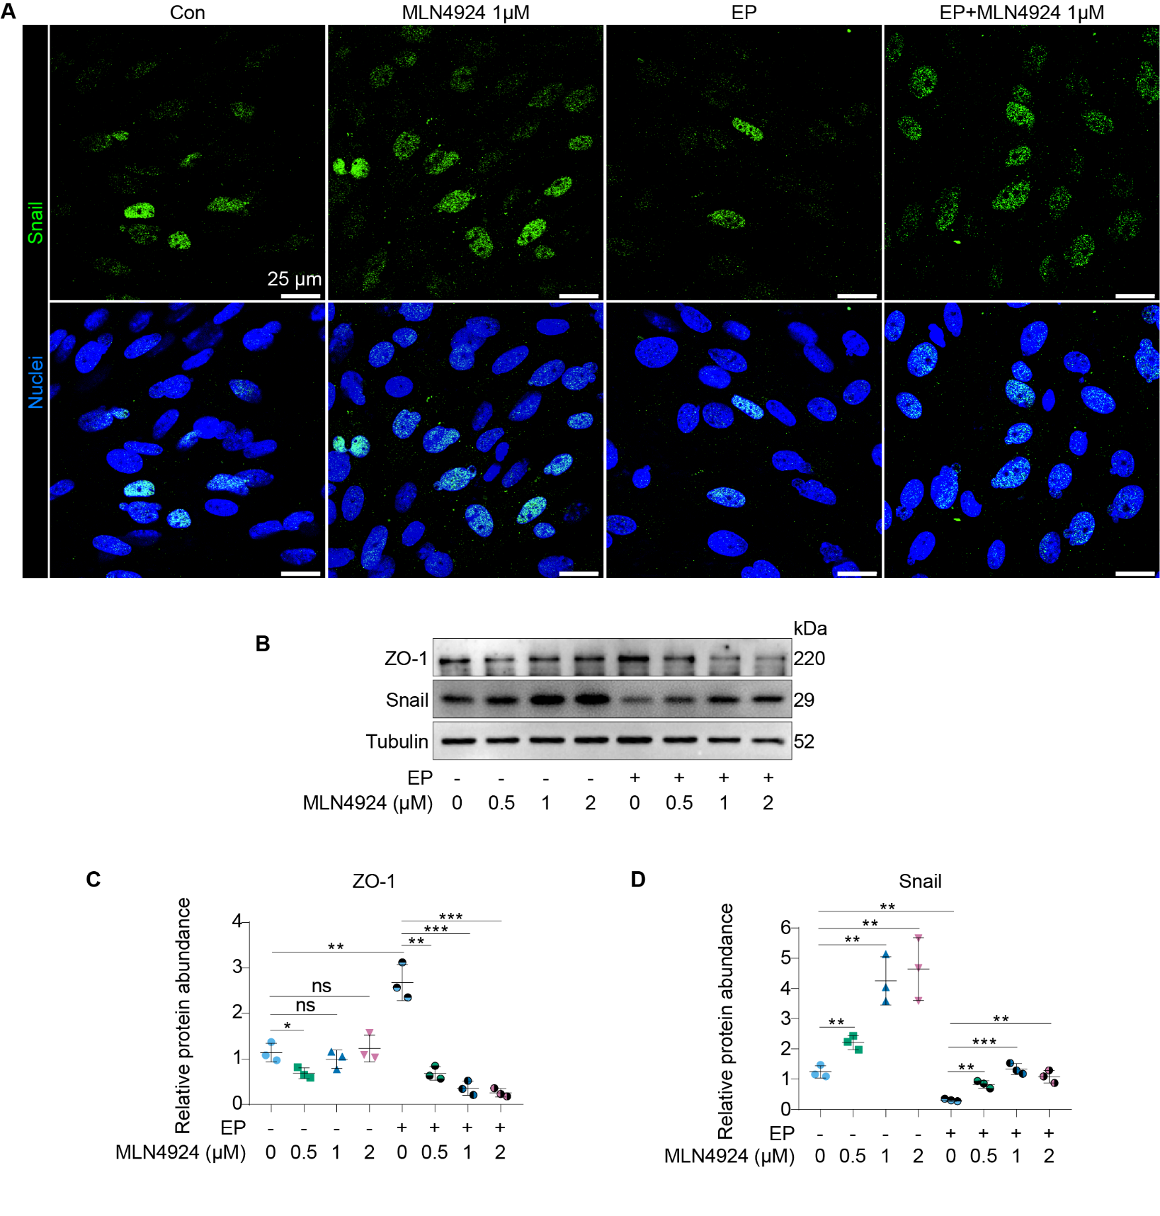
Fig. S2. MLN4924 treatment induces epithelial-to-mesenchymal transition during mouse decidualization. A Immunofluorescence staining of Snail and nuclei (DAPI) in uterine stromal cells under different treatment conditions for 24 hours: control (Con), MLN4924 (1 μM), estrogen plus progesterone (EP), and EP with MLN4924 1 μM. Scale bars, 25 μm. B Western blot analysis of ZO-1 and Snail in uterine stromal cells treated with increasing concentrations of MLN4924 (0-2 μM) for 24 hours in the absence or presence of EP. GAPDH served as a loading control. C and D Quantification of the relative protein abundance of ZO-1 C and Snail D normalized to Tubulin. Data are presented as mean ± SD. *P < 0.05, **P < 0.01, ***P < 0.001, ns: not significant.

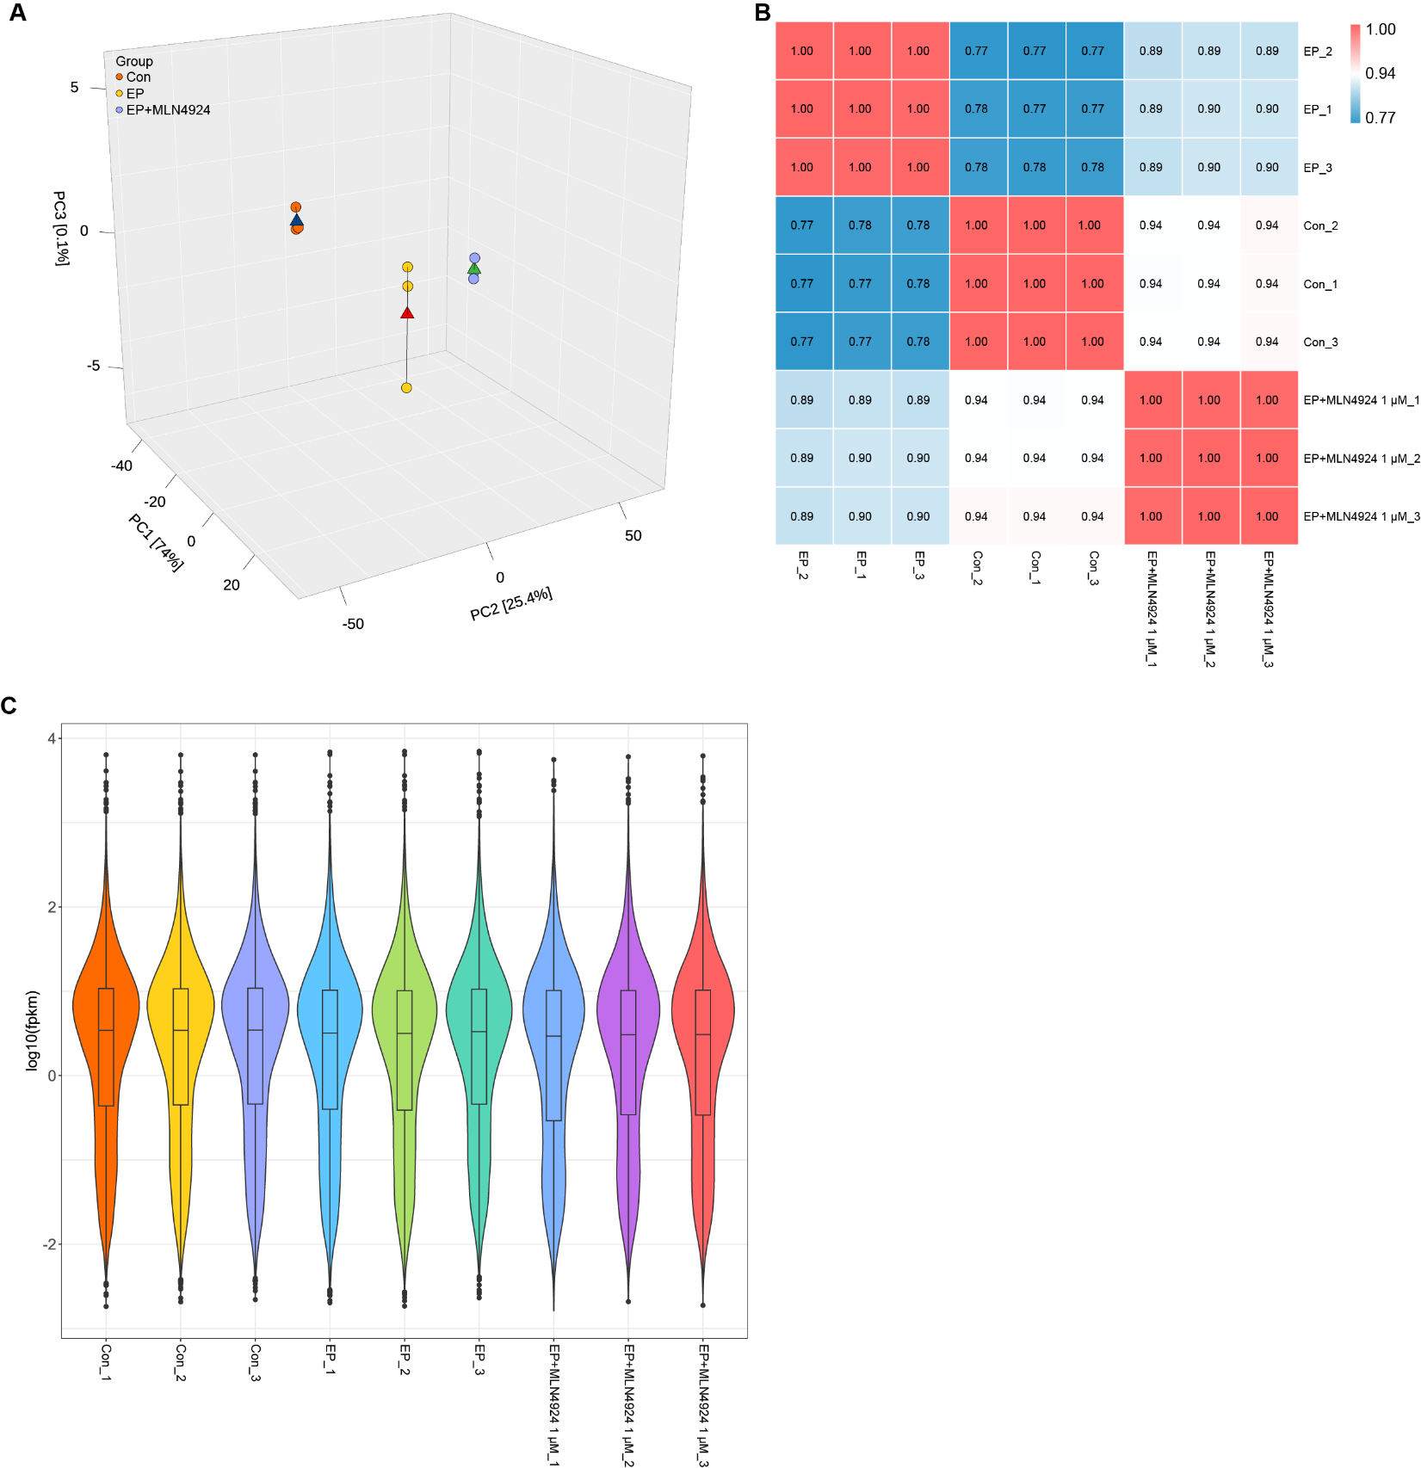
Fig. S3. Global transcriptomic profiling and quality assessment of stromal cells during decidualization with neddylation inhibition. A Three-dimensional principal component analysis (PCA) of RNA-seq data showing distinct clustering of control (Con), estrogen plus progesterone (EP), and EP + MLN4924 1 μM groups. B Sample correlation heatmap with hierarchical clustering, demonstrating strong reproducibility among biological replicates and clear separation of treatment groups. C Violin plots showing the log10-transformed FPKM values of expressed genes in control (Con), estrogen plus progesterone (EP), and EP + MLN4924 1 μM groups.

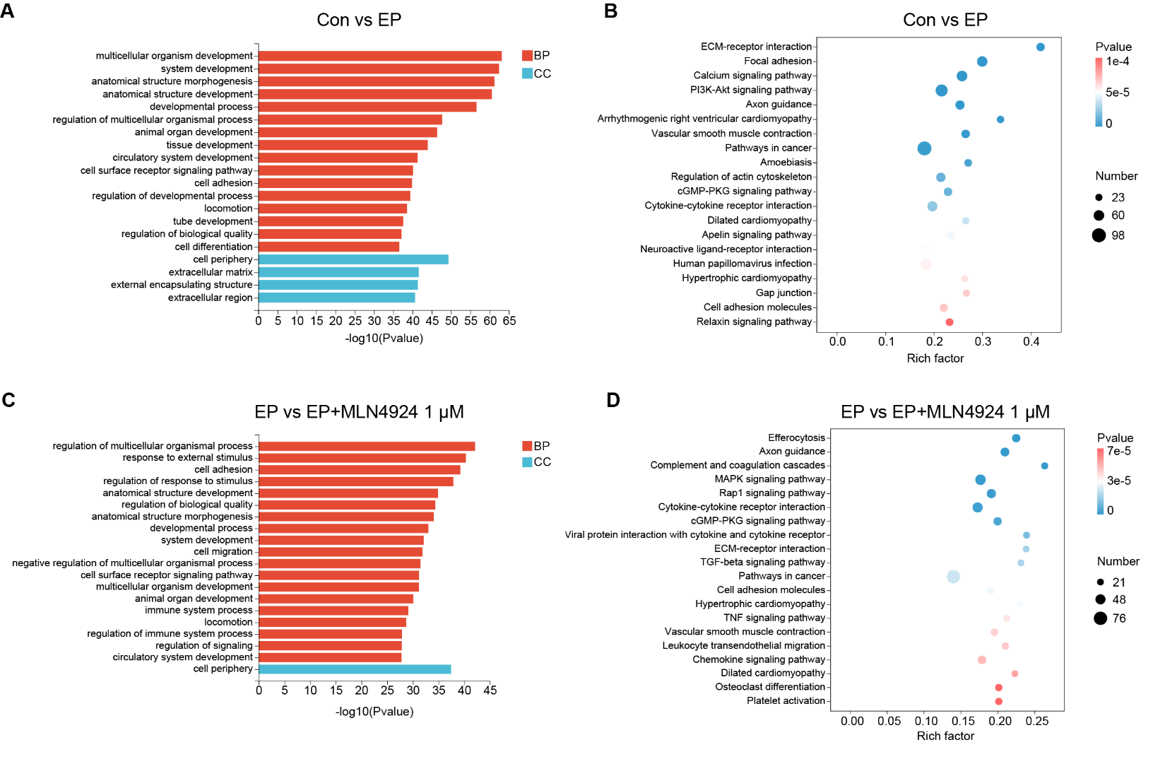
Fig. S4. GO and KEGG enrichment analyses of differentially expressed genes (DEGs) in uterine stromal cells. A Gene Ontology (GO) enrichment analysis of biological process (BP) and cellular component (CC) terms for DEGs between control (Con) and estrogen plus progesterone (EP) groups. B KEGG pathway enrichment analysis of DEGs between Con and EP groups. C GO enrichment analysis of BP and CC terms for DEGs between EP and EP+MLN4924 1 μM groups. D KEGG pathway enrichment analysis of DEGs between EP and EP+MLN4924 1 μM groups. In the dot plots, dot size represents the number of enriched genes, and color indicates statistical significance (adjusted P value).

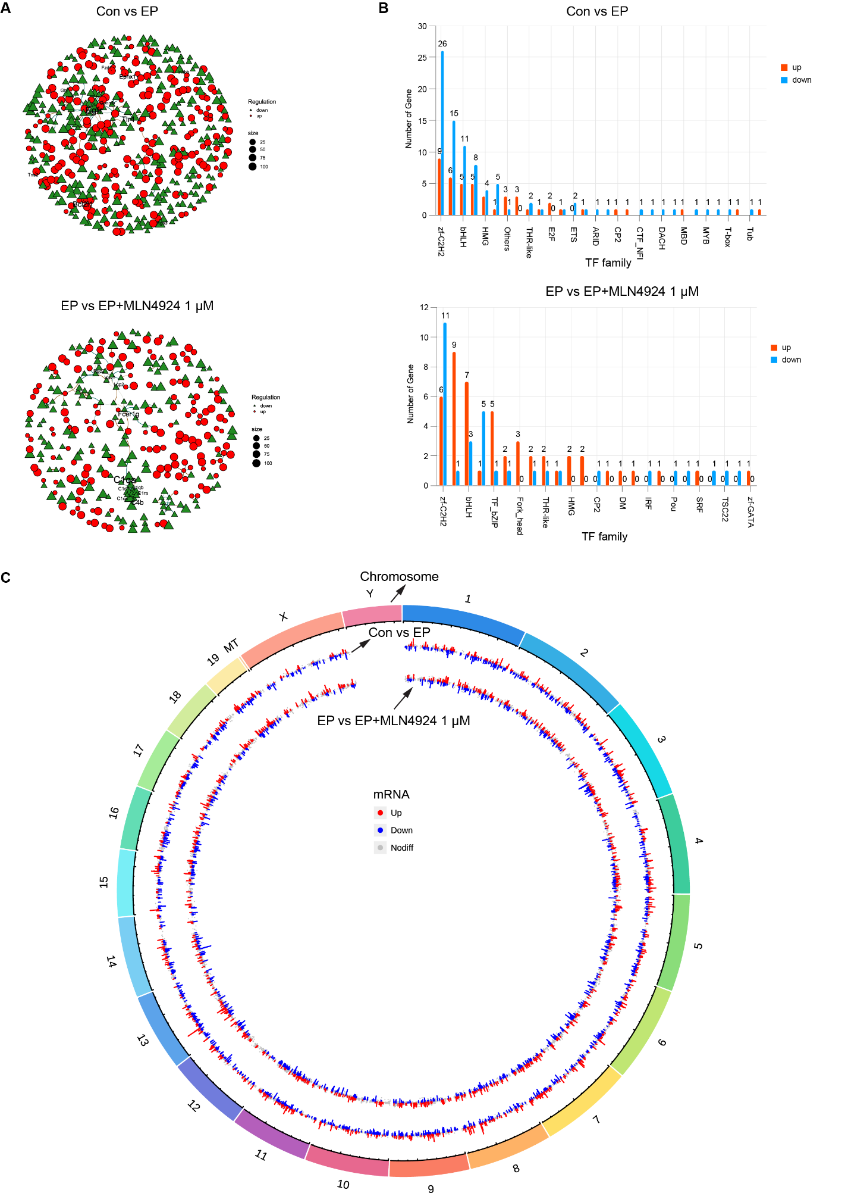
Fig. S5. Protein interaction networks, transcription factor family distribution, and chromosomal localization of DEGs in stromal cells. A Protein–protein interaction (PPI) networks constructed from differentially expressed genes (DEGs) comparing control vs estrogen plus progesterone (Con vs EP) and (EP vs EP+MLN4924 1 μM). Nodes represent DEGs (red circles, upregulated; green triangles, downregulated), and edges represent predicted protein–protein interactions. Node size reflects degree, indicating the number of interactions for each gene. B Bar plots showing the distribution of differentially expressed transcription factor (TF) families in (Con vs EP) and (EP vs EP+MLN4924 1 μM). The x-axis indicates TF families, and the y-axis denotes the number of upregulated (red) or downregulated (blue) TFs within each family. C Circos plot displaying the chromosomal distribution of differentially expressed genes (DEGs) across the mouse genome. The outermost ring represents the chromosomes. From outer to inner rings, the layers correspond to (Con vs EP) and (EP vs EP+MLN4924 1 μM) comparisons, respectively. Red and blue points represent upregulated and downregulated genes, respectively, while grey points indicate non-differentially expressed genes.

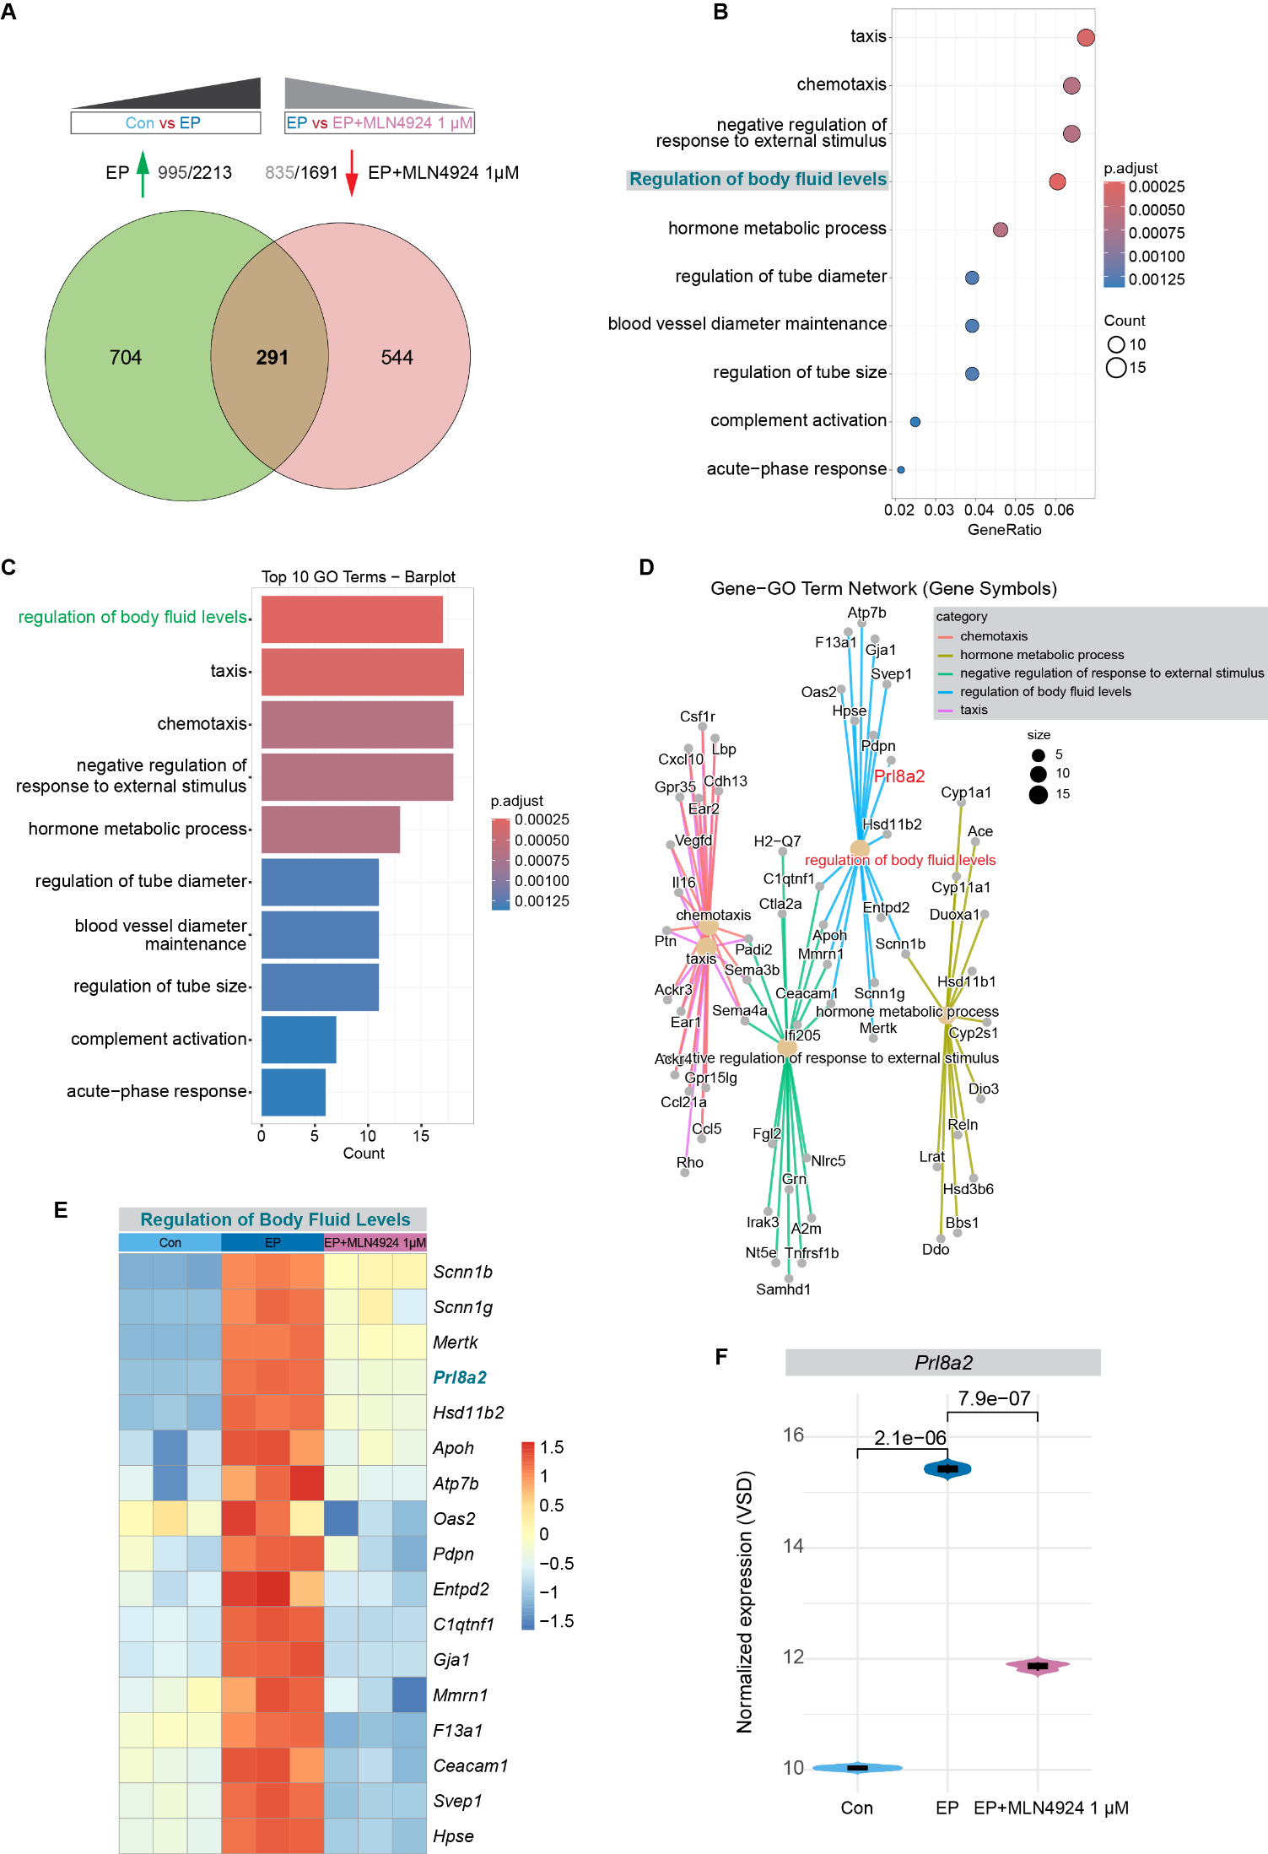
Fig. S6. Functional enrichment analysis of genes upregulated by EP but suppressed by MLN4924. A Venn diagram identifying 291 genes that are significantly upregulated by EP (green) but downregulated by MLN4924 (pink). B Dot plot and C bar plot showing the top 10 enriched Gene Ontology (GO) terms for the 291 overlapping genes. In B, dot size represents the gene count, and color indicates the adjusted P value. D Gene-GO term network visualizing the relationships between genes and enriched biological processes. The connection between Prl8a2 and the term "Regulation of body fluid levels" is highlighted. E Heatmap showing the relative expression of genes belonging to the "Regulation of body fluid levels" pathway across groups. F Violin plot showing the normalized expression (VSD) of the representative gene Prl8a2. P-values between groups are indicated above the brackets.
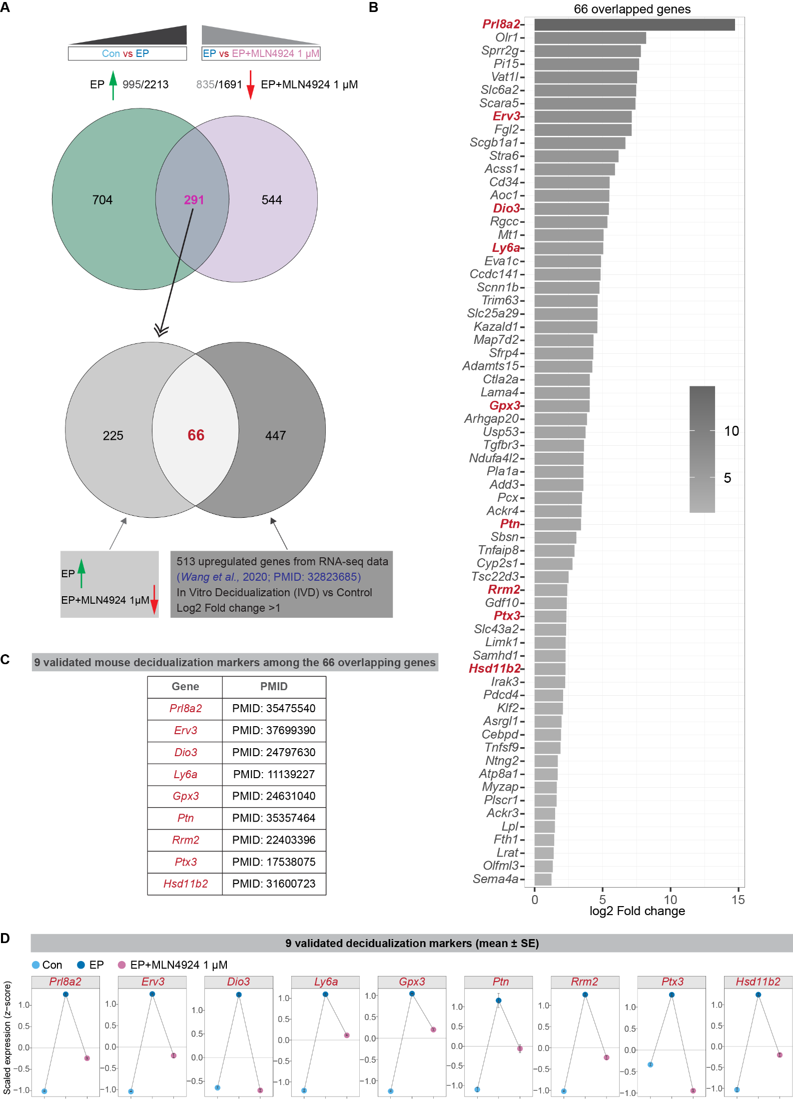
Fig. S7. Identification of neddylation-dependent decidualization markers. A Schematic workflow for identifying neddylation-dependent decidualization markers. The genes upregulated by EP but downregulated by MLN4924 (291 genes) were intersected with a published dataset of mouse in vitro decidualization markers (513 upregulated genes, Wang et al., 2020), yielding 66 overlapping genes. B Bar plot showing the log2 fold change of the 66 overlapping genes. Nine well-characterized decidualization markers are highlighted in red. C List of the 9 validated mouse decidualization markers identified in the intersection, along with the PubMed IDs (PMID) of relevant supporting literature. D Expression profiles (Z-score) of the 9 validated markers across Control (Con), EP, and EP+MLN4924 1μM groups. Data are presented as mean ± SE.
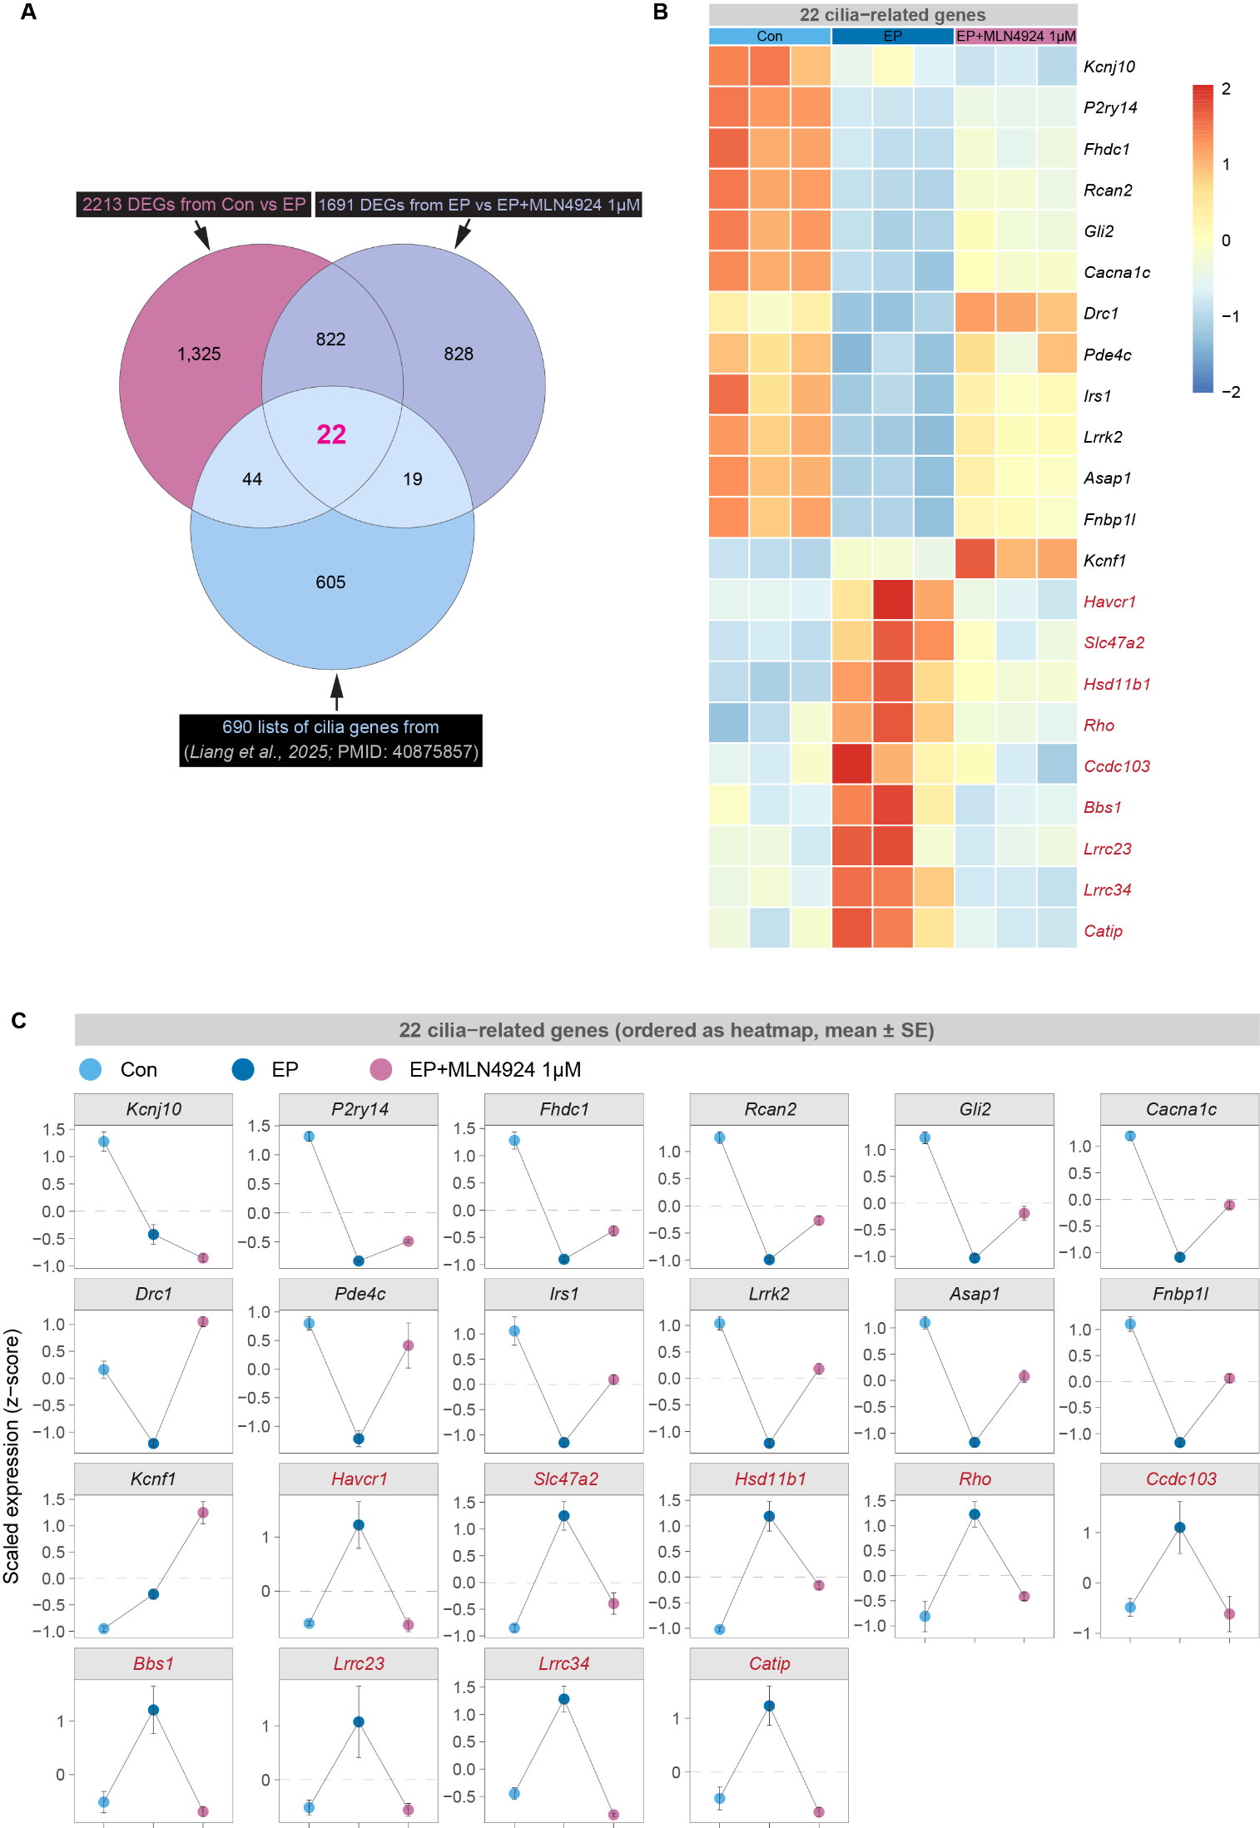
Fig. S8. Identification of neddylation-dependent cilia-related genes. A Venn diagram showing the intersection of DEGs from Con vs EP (2213 genes), EP vs EP+MLN4924 1μM (1691 genes), and a comprehensive reference list of 690 cilia-related genes (Liang et al., 2025). This analysis identified 22 overlapping genes that are dynamically regulated by neddylation during decidualization. B Heatmap visualizing the relative expression levels of the 22 overlapping cilia-related genes across Control (Con), EP, and EP+MLN4924 1 μM groups. Gene names marked in red indicate those upregulated by EP but suppressed by MLN4924. C Detailed expression profiles (Z-score) of the 22 cilia-related genes. Note that key ciliogenesis regulators, such as Bbs1, Ccdc103, and Catip, exhibit induction upon EP treatment but are significantly suppressed by MLN4924. Data are presented as mean ± SE.

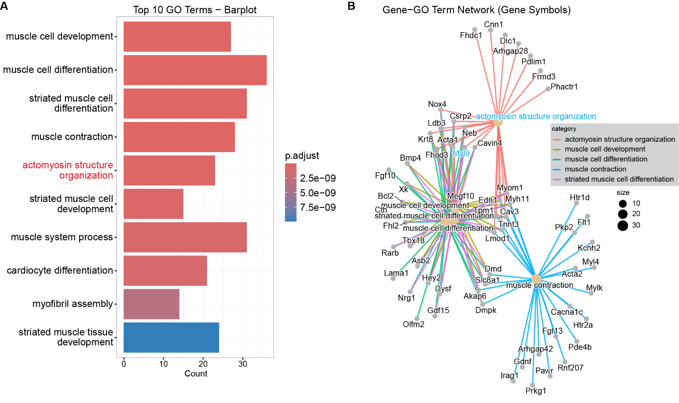
Fig. S9. Functional enrichment analysis of actomyosin-related gene programs. A Bar plot showing the top 10 enriched Gene Ontology (GO) biological process terms for the 440 overlapping genes (downregulated by EP but upregulated by MLN4924). The term ‘actomyosin structure organization’ is highlighted in red. Bar length represents the gene count, and color indicates the adjusted P value. B Gene-GO term network visualizing the relationships between genes and enriched biological processes. The term ‘actomyosin structure organization’ and the key regulator Myl9 are highlighted in blue text to emphasize their connection. Node size represents the number of genes associated with each term.

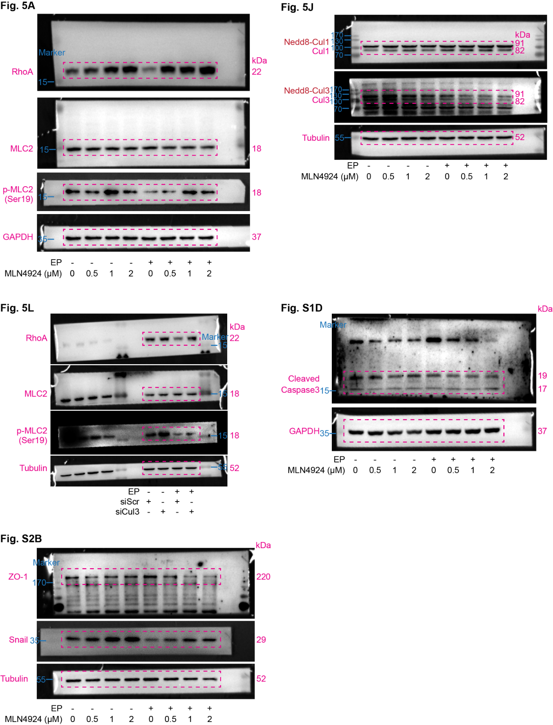
Fig. S10. Uncropped western blot images. This figure presents the full-length, uncropped original membranes for the Western blotting data included in this study. Molecular weight markers (in kDa) are indicated on the sides. The specific bands cropped and displayed in the final figures are outlined in red boxes. The labels above each blot indicate the corresponding figure panels: Fig. 5A, Fig. 5J, Fig. 5L, Fig. S1D, and Fig. S2B.
Table S1. siRNA Sequences.
Genes | Sequences
siCul3-Mus-Sense | 5'-GCACAUGAAGACUAUUGUA-3'
siCul3-Mus- antisense  siUba3-Mus-Sense  siUba3-Mus- antisense | 5'-UACAAUAGUCUUCAUGUGC-3'  5'-GGCGUUACCUACAGACUCA-3'  5'-UGAGUCUGUAGGUAACGCC-3'

Table S2. RT-PCR primer sequences.
Genes | Primers
Prl8a2-Mus-F | 5'-AGCCAGAAATCACTGCCACT-3'
Prl8a2-Mus-R  Prl3c1-Mus-F  Prl3c1-Mus-R | 5'-TGATCCATGCACCCATAAAA-3'  5'-GCCACACGATATGACCGGAA-3'  5'-GGTTTGGCACATCTTGGTGTT-3'
Rpl7-Mus-F | 5'-GCAGATGTACCGCACTGAGATTC-3'
Rpl7-Mus-R | 5'-ACCTTTGGGCTTACTCCATTGATA-3'
Cul3-Mus-F  Cul3-Mus-R  Myl9-Mus-F  Myl9-Mus-R  Hand2-Mus-F  Hand2-Mus-R  Uba3-Mus-F  Uba3-Mus-R | 5'-AGATAGAAGCTGCTATAGTGCG-3'  5'-ACTGGACTTGGTAAGAATCGAG-3'  5'-AGGAGGCCTTCAACATGATTGAT-3'  5'-CTCCTCATCAAAGCAGGCAAAG-3'  5'-ATCAAGAAGACCGACGTGAAAGA-3'  5'-CTCTCCTCTTCTTCACTGCTTGA-3'  5'-TAACGACACTTTCTACCGACAA-3'  5'-AAGTTCCAGAGTGCACTCAATA-3'

Table S3. List of antibodies and reagents used in this study.
Reagent | Application | Dilution | Catalog No. | Manufacturer
Rabbit anti-RhoA | WB | 1:1000 | 10749-1-AP | Proteintech
Rabbit anti-p-MLC2(Ser19) | WB | 1:1000 | 3671s | Cell Signaling Technology
Rabbit anti-MLC2 | WB | 1:1000 | DF7911 | Affinity Biosciences
Rabbit anti-Snail | WB | 1:1000 | 3879T | Cell Signaling Technology
Rabbit anti-ZO-1 | WB | 1:1000 | 61-7300 | Invitrogen
Rabbit anti-Cullin1 (Cul1) | WB | 1:1000 | A2136 | ABclonal
Rabbit anti-Cullin3 (Cul3) | WB | 1:1000 | A16455 | ABclonal
Rabbit anti-Cleaved Caspase-3 | WB | 1:1000 | 9661S | Cell Signaling Technology
Mouse anti-GAPDH | WB | 1:1000 | SC-32233 | Santa Cruz Biotechnology
Rabbit anti-α-Tubulin | WB | 1:1000 | 2144s | Cell Signaling Technology
Rabbit anti-Arl13b | IF | 1:2000 | 17711-1-AP | Proteintech
Mouse anti-γ-tubulin | IF | 1:1000 | T5326 | Sigma-Aldrich
Rabbit anti-Vimentin | IF | 1:200 | 5741T | Cell Signaling Technology
Rat anti-Cytokeratin 8 (TROMA-I) | IF | 1:300 | TROMA-I | DSHB
Rabbit anti-Snail | IF | 1:100 | 3879T | Cell Signaling Technology
Phalloidin-iFluor 488 (F-Actin) | IF | 1:10000 | ab176753 | Abcam

