Mitochondrial preservation through the PKA–DRP1 axis empowers
natural killer cells to resist acidic stress and retain cytotoxicity

Eunchong Maeng¹, Ki seo Ryu¹, A Reum JE², Minwook Lee³, Hail Park¹, Seung Hee Choi*¹, Kyung-Soon Park*¹

¹ Division of life science, Department of Biomedical Science, CHA University, Seongnam-si, Korea (the Republic of)
² Center for Bio-imaging & Translational Research, Korea Basic Science Institute, Cheongju-si, Korea (the Republic of)
³ Department of Life Sciences, College of Natural Science, Hanyang University, Seoul-si, Korea (the Republic of)

* Correspondence to Seung Hee Choi; choicat14@gmail.com and to Professor Kyung-Soon Park; kspark@cha.ac.kr

Supplementary Figures
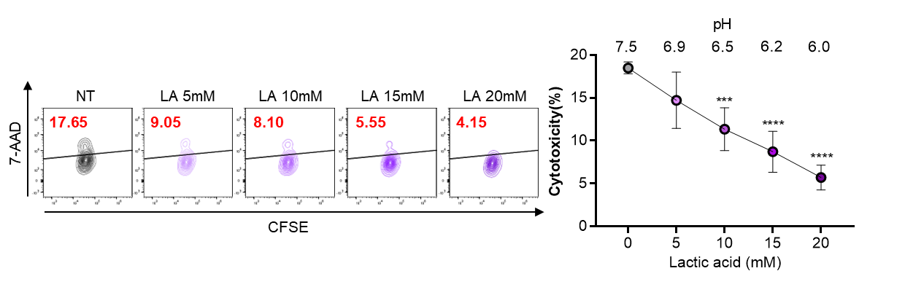
Supplementary Figure 1
Cytotoxicity of C_NK cells against MDA-MB-231 cells was evaluated using CFSE/7-AAD at an E:T ratio of 10:1 upon culture in media at the indicated pH for 4 h. The pH of the culture media was adjusted with LA. Experiments were performed at least in triplicate. Statistical analysis was performed using a one-way ANOVA with Dunnett’s multiple comparisons test. Values represent the mean ± SD. ***p<0.001, ****p<0.0001.
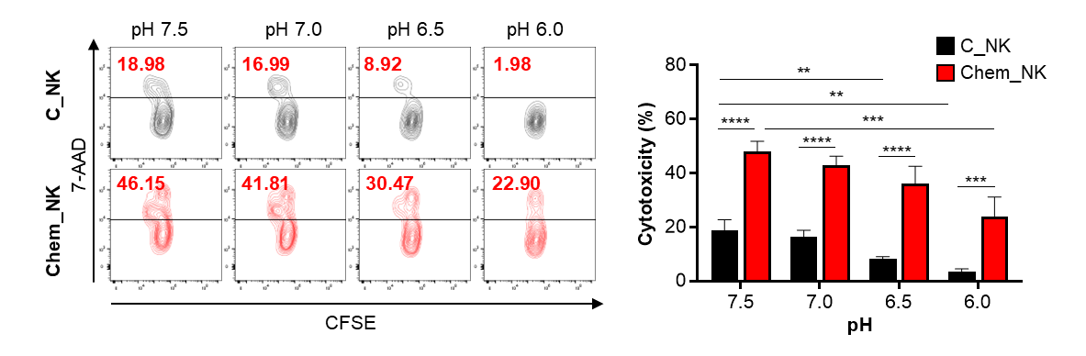
Supplementary Figure 2
Cytotoxicity of C_NK and Chem_NK cells against MDA-MB-231 cells was evaluated using CFSE/7-AAD at an E:T ratio of 10:1 upon culture in media at the indicated pH for 4 h. The pH of the culture media was adjusted with HCl. Experiments were performed at least in triplicate. Statistical analysis was performed using a two-way ANOVA with Tukey's multiple comparisons test. Values represent the mean ± SD. **p<0.01, ***p<0.001, ****p<0.0001.

Supplementary Figure 3
Viability of C_NK and Chem_NK cells cultured at pH 7.5 and pH 6.0 for 1 h. Experiments were performed at least in triplicate. Values represent the mean ± SD.
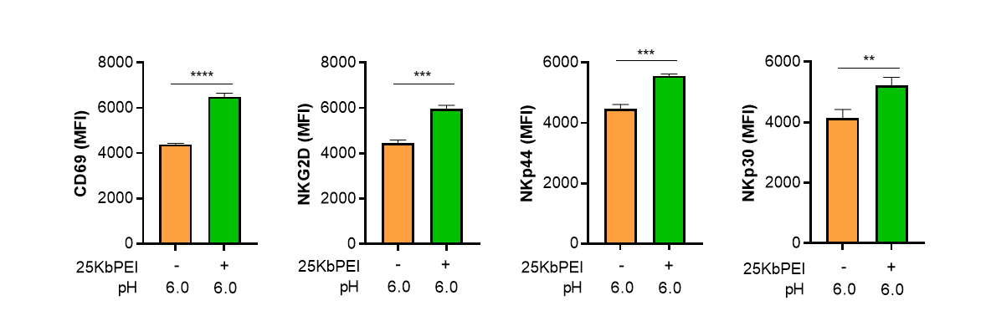
Supplementary Figure 4
Flow cytometry analysis of the major NK activating receptors, quantified as mean fluorescence intensity (MFI), in C_NK and Chem_NK cells at pH 6.0 for 1 h. Experiments were performed at least in triplicate. Statistical analysis was performed using unpaired Student’s t-test. Values represent the mean ± SD. **p<0.01, ***p<0.001, ****p<0.0001.

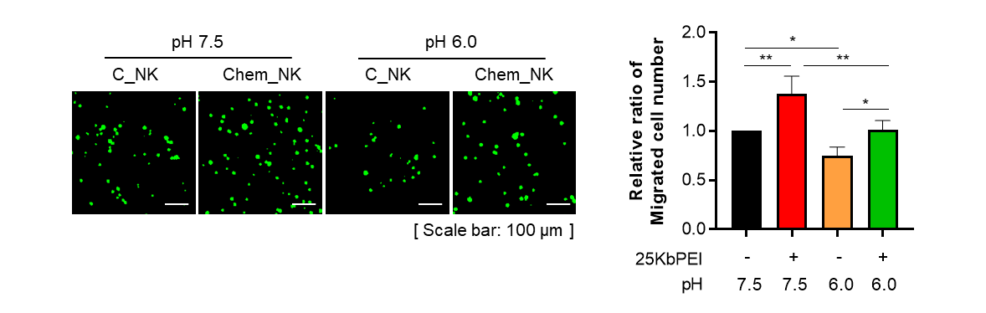
Supplementary Figure 5
Migration assay of C_NK and Chem_NK cells incubated in medium at pH 7.5 and 6.0 for 12 h. Representative fluorescence images (left) and quantification of relative migration ratios (right) are shown. Scale bar, 100 µm. Experiments were performed at least in triplicate. Statistical significance was determined using a two-way ANOVA with Tukey's multiple comparisons test. Values represent the mean ± SD. *p<0.05, **p<0.01.

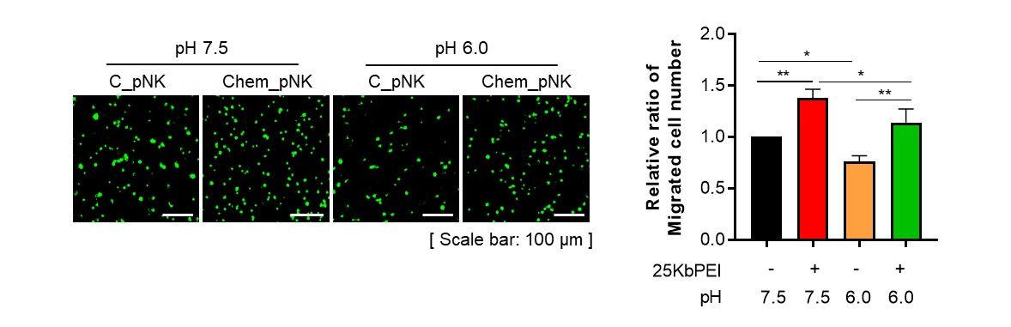
Supplementary Figure 6
Migration assay of control human primary NK (C_pNK) and chemical primed human primary NK (Chem_pNK) cells incubated in medium at pH 7.5 and 6.0 for 12 h. Representative fluorescence images (left) and quantification of relative migration ratios (right) are shown. Scale bar, 100 µm. Experiments were performed at least in triplicate. Statistical significance was determined using a two-way ANOVA with Tukey's multiple comparisons test. Values represent the mean ± SD. *p<0.05, **p<0.01.

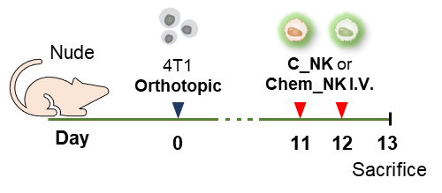
Supplementary Figure 7
Schematic of the 4T1 orthotopic breast cancer mouse model used to evaluate the tumor-infiltrating capacity of adoptively transferred C_NK and Chem_NK cells. On day 0, 2×10⁵ 4T1 cells were implanted into the fourth mammary fat pad. When tumors reached a volume of 300–400 mm³, CFSE-labeled NK cells (1×10⁷ cells per injection) were administered intravenously. Tumors were harvested the day after the final injection.

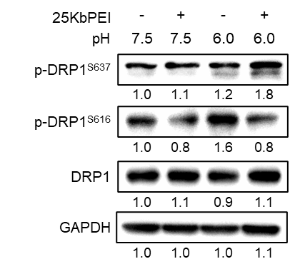
Supplementary Figure 8
Western blot analysis of DRP1 phosphorylation at S637 and S616 in human primary NK cells. NK cells were cultured at pH 7.5 or pH 6.0 for 1 h.

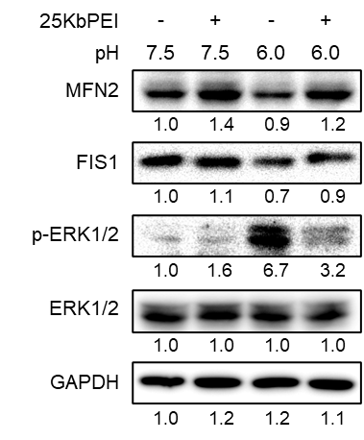
Supplementary Figure 9
Western blot analysis of mitochondrial fusion and fission-related proteins. NK-92MI cells were cultured at pH 7.5 or pH 6.0 for 1 h.

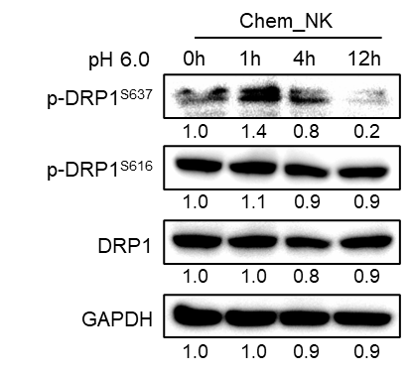
Supplementary Figure 10
Western blot analysis of DRP1 phosphorylation at S637 and S616 in Chem_NK cells after exposure to pH 6.0. Chem_NK cells were cultured at pH 6.0 for the indicated time points.
Supplementary Figure 11
Viability of C_NK cells cultured at pH 7.5 and pH 6.0 for 1 h in the presence or absence of forskolin (50 μM, 30 min pre-treatment). Experiments were performed at least in triplicate. Values represent the mean ± SD.
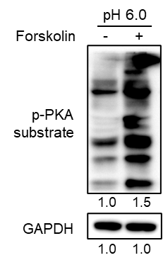
Supplementary Figure 12
Western blot analysis of PKA substrate. NK-92MI cells were cultured at pH 6.0 for 1 h in the presence or absence of forskolin (50 μM, 30 min pre-treatment).

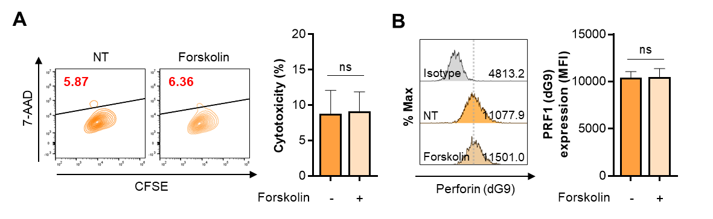
Supplementary Figure 13
A Cytotoxicity of C_NK cells evaluated at pH 6.0 at an E:T ratio of 10:1 for 4 h in the presence or absence of forskolin. B Flow cytometric analysis of intracellular perforin levels (clone dG9) in C_NK cells treated with or without forskolin. Histograms (left) show perforin intensity, and MFI values are quantified (right). NT, non-treated. Statistical analysis was performed using unpaired Student’s t-test. Data represent the mean ± SD from three independent experiments. ns, not significant.

