Supplemental File
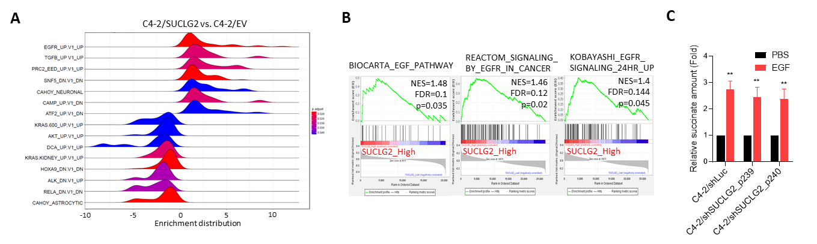
Supplementary Figure and Figure Legends

Supplementary Figure 1. SUCLG2 integrates EGFR signaling and metabolic adaptation in prostate cancer. (A) Ridge plot depicting gene set enrichment analysis (GSEA) of RNA-Seq data from C4-2 prostate cancer cells transduced with a SUCLG2 cDNA vector versus empty vector (EV) control. Enrichment was grouped using the MSigDB C6 oncogenic signatution (c6.all.v7.0.symbols). (B) GSEA plots of TCGA prostate cancer datasets showing that high SUCLG2 expression correlates with enrichment of multiple EGFR signaling-related gene sets. Normalized enrichment score (NES), false discovery rate (FDR), and p-values are indicated. (C) Intracellular succinate levels in the same cells normalized to PBS baseline within each group, demonstrating that SUCLG2 knockdown significantly attenuates but does not completely abolish EGF-induced succinate accumulation.

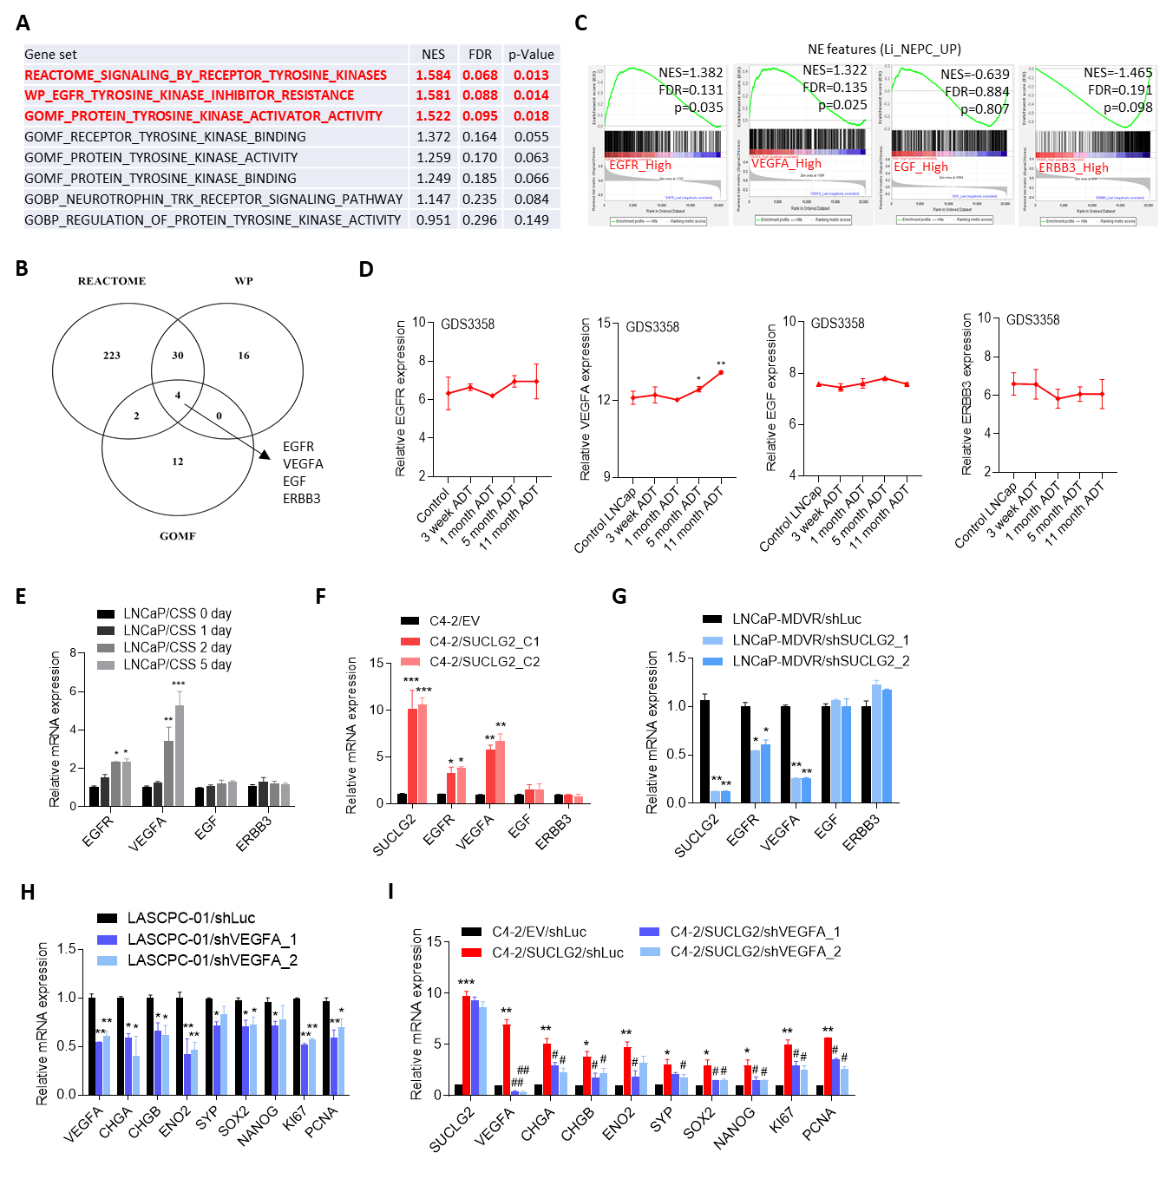

Supplementary Figure 2. SUCLG2 overexpression is associated with EGFR-TKI resistance, potentially through VEGFA upregulation in prostate cancer. (A) Gene set enrichment analysis (GSEA) of TCGA prostate cancer dataset reveals significant enrichment of receptor tyrosine kinase (RTK) signaling and EGFR-tyrosine kinase inhibitors (TKIs) resistance gene signatures in tumors with high SUCLG2 expression. NES: normalized enrichment score; FDR: false discovery rate. (B) Venn diagram of gene sets significantly enriched in three RTK-related gene signatures (REACTOME, Wiki Pathways, and Gene Ontology—Molecular Function). Four overlapping genes (EGFR, VEGFA, EGF, ERBB3) were identified. (C) GSEA of TCGA prostate cancer dataset reveals significant enrichment of NEPC-responsive gene signatures in tumors with high SUCLG2 expression. NES: normalized enrichment score; FDR: false discovery rate. (D) Time-based mRNA expression profiles of EGFR, VEGFA, EGF, and ERBB3 in LNCaP cells under androgen deprivation, as derived from the GDS3358 dataset. (E) Relative mRNA levels of SUCLG2, EGFR, VEGFA, EGF, and ERBB3 in LNCaP cells cultured in charcoal-stripped serum (CSS) medium for 0, 1, 2, and 5 days. (F) qRT-PCR analysis of SUCLG2, EGFR, VEGFA, EGF, and ERBB3 expression in C4-2 cells stably expressing either an empty vector (EV) or SUCLG2 cDNA. (G) qRT-PCR analysis of the same genes in LNCaP-MDVR cells transduced with either control shRNA (shLuc) or SUCLG2-targeting shRNA. (H) qRT-PCR analysis of VEGFA and neuroendocrine (CHGA, CHGB, ENO2, SYP), stem cell (SOX2, NANOG), and proliferation (KI67, PCNA) markers in LASCPC-01 cells with stable VEGFA knockdown (two independent shRNAs) or control shRNA. (I) qRT-PCR analysis of SUCLG2, VEGFA, and neuroendocrine, stem cell, and proliferation markers in C4-2/EV, C4-2/SUCLG2, and C4-2/SUCLG2 with VEGFA knockdown (two independent shRNAs). Data are presented as mean ± SEM from three independent experiments. Statistical analyses (when performed) used one-way ANOVA or Pearson correlation as indicated. *p ≤ 0.05; **p ≤ 0.01; ***p ≤ 0.005.

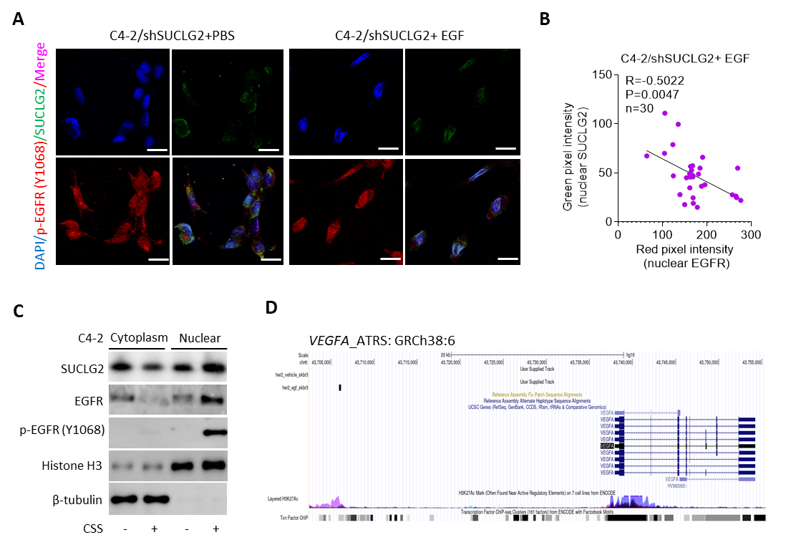
Supplementary Figure 3. Nuclear SUCLG2 and p-EGFR(Y1068) levels are inversely correlated in C4-2/shSUCLG2 cells following EGF stimulation. (A) Representative immunofluorescence images of C4-2 cells expressing SUCLG2-targeting shRNA (shSUCLG2) treated with either PBS or EGF. Cells were stained with DAPI (blue), SUCLG2 (green), and phosphorylated-EGFR (p-EGFR, Y1068, red). Merged images show nuclear localization and expression patterns. Scale bars, 20 μm. (B) Quantitative analysis of nuclear SUCLG2 (green pixel intensity) vs. nuclear EGFR (red pixel intensity) in C4-2/shSUCLG2 cells treated with EGF (Pearson’s R = –0.5022, p = 0.0047, n = 30 cells). (C) Western blot analysis of SUCLG2, EGFR, and p-EGFR (Y1068) in nuclear and cytoplasmic fractions of C4-2 cells cultured for 24 hours in charcoal-stripped serum (CSS)-containing medium. Histone H3 and α-tubulin were used as nuclear and cytoplasmic controls, respectively. (D) ChIP-Seq analysis of nuclear EGFR binding at AT-rich sequences (ATRSs) within the VEGFA gene locus. Tracks shown were obtained from publicly available datasets (GEO: GSM2102443 and GSM2102444) and visualized using the UCSC Genome Browser.

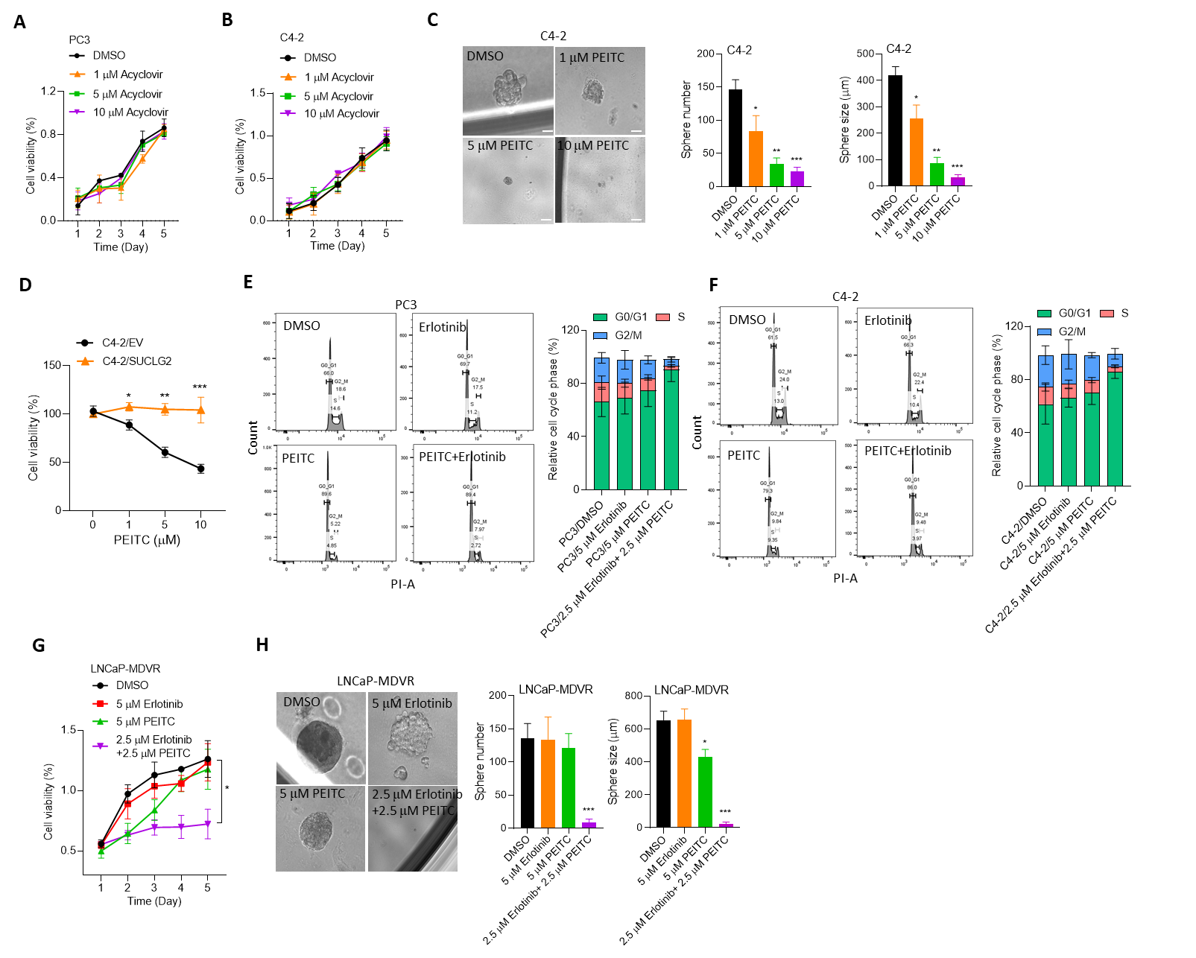
Supplementary Figure 4. PEITC suppresses prostate cancer growth by targeting SUCLG2. (A and B) Cell viability assays in PC3 (A) and C4-2 (B) cells treated with increasing concentrations (0, 1, 5, and 10 μM) of acyclovir for 5 days. * vs. DMSO. (C) Sphere formation assay in C4-2 cells treated with PEITC (0–10 μM) for 1 week. Both sphere number and size were quantified. * vs. DMSO. Scale bar: 100 μm. (D) Cell viability of C4-2/EV and C4-2/SUCLG2-overexpressing cells treated with increasing PEITC concentrations (0–10 μM, 72 h), showing that SUCLG2 overexpression confers partial resistance to PEITC. (E and F) Cell cycle analysis of PC3 (E) and C4-2 (F) cells following 24-hour treatment with DMSO, 5 μM erlotinib, 5 μM PEITC, or the combination of 2.5 μM erlotinib + 2.5 μM PEITC. Cell cycle profiles were determined by flow cytometry; bar plots summarize G0/G1, S, and G2/M phase distribution. * vs. DMSO. (G) Cell viability of enzalutamide-resistant LNCaP-MDVR cells treated for 5 days with DMSO, 5 μM erlotinib, 5 μM PEITC, or a combination of 2.5 μM erlotinib + 2.5 μM PEITC. * vs. DMSO. (H) Representative phase-contrast images and quantification of sphere number and sphere size in LNCaP-MDVR cells under the same treatment conditions; scale bars, 100 μm. All data represent mean ± SEM, n=3. *p<0.05, **p<0.01, ***p<0.001 vs. DMSO control (one-way ANOVA with Tukey's post hoc test; unpaired two-tailed Student's t-test for two-group comparisons).
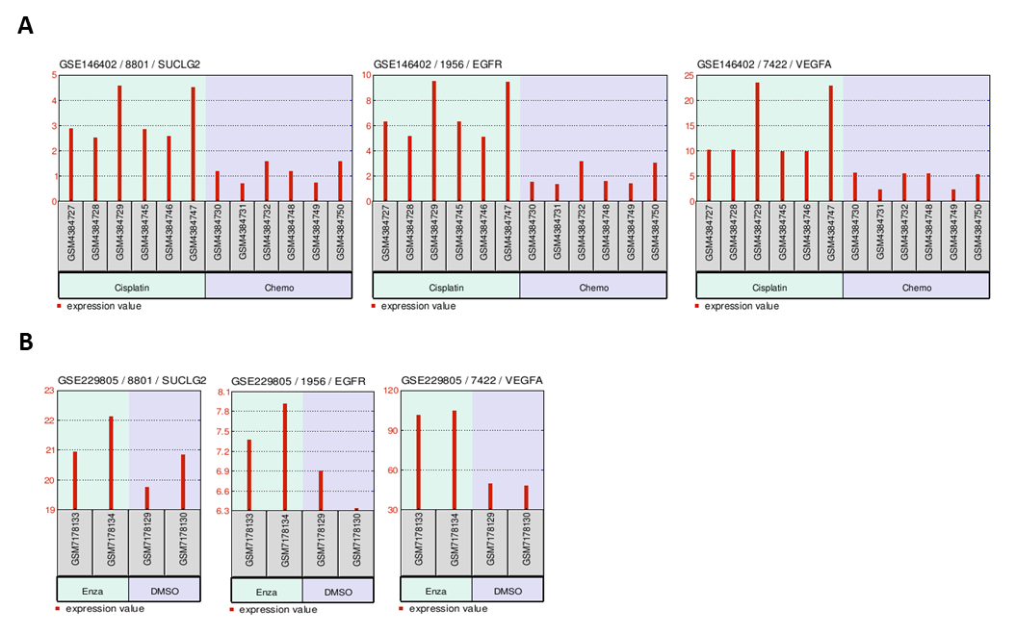
Supplementary Figure 5. Validation of metabolic and signaling gene expression across independent prostate cancer datasets and treatment conditions. (A) Gene expression analysis of SUCLG2, EGFR, and VEGFA in prostate cancer samples from the GSE146402 dataset. Bar graphs display normalized expression values for individual patient samples (GSM prefix identifiers on x-axis) comparing cisplatin-treated (Cisplatin) versus standard chemotherapy control (Chemo) conditions. Each bar represents an individual biological sample. Expression values are shown on the y-axis, with SUCLG2 probe 8801, EGFR probe 1956, and VEGFA probe 7422. Sample IDs are displayed along the x-axis with treatment groups indicated below. (B) Gene expression validation in the GSE229805 dataset comparing enzalutamide (Enza) versus vehicle control (DMSO) treatment conditions. Bar graphs show normalized expression values of the same metabolic and signaling genes (SUCLG2, EGFR, VEGFA) using identical probe sets as panel A. Expression patterns demonstrate treatment-responsive regulation across independent cohorts.

Supplementary Tables
Supplementary Table S1. Primer sequences of the constructs. Primer sequences for full-length SUCLG2, VEGFA variant 1, and VEGFA variant 2 cDNA, as well as wild-type (WT) and mutant (M) AT-rich sequences (ATRS) in the regulatory sequences of human VEGFA, are listed (5’-3’, F: forward, R: reverse).
Promoter reporter | Sequence
pCDH-CMV-SUCLG2-EF1-Puro F | CGTGCCGAGTTTCCTGTTTAAGATG
pCDH-CMV-SUCLG2-EF1-Puro R | CAAAGTAAATCTTTAACATAAAAAAATGCTGATGGCACAC
pCDH-CMV-VEGFA_v1-EF1-Neo F | CCATGAACTTTCTGCTGTCTTGGGTG
pCDH-CMV-VEGFA_v1-EF1-Neo R | GATCTGGTTCCCGAAACCCTGAG
pCDH-CMV-VEGFA_v2-EF1-Neo F | CCATGAACTTTCTGCTGTCTTGGGTG
pCDH-CMV-VEGFA_v2-EF1-Neo R | GATCTGGTTCCCGAAACCCTGAG
pCDH-CMV-VEGFA_v3-EF1-Neo F | CCATGAACTTTCTGCTGTCTTGGGTG
pCDH-CMV-VEGFA_v3-EF1-Neo R | GATCTGGTTCCCGAAACCCTGAG
pCDH-CMV-VEGFA_v5-EF1-Neo F | CCATGAACTTTCTGCTGTCTTGGGTG
pCDH-CMV-VEGFA_v5-EF1-Neo R | GATCTGGTTCCCGAAACCCTGAG
pGreenFire1-VEGFA/ATRS1-WT F | TAATGTACTACATTAATAGAAT
pGreenFire1-VEGFA/ATRS1-WT R | ATGTTACGTGTGGGTTTTTGATA
pGreenFire1- VEGFA/ATRS1-M F | TTGAGAAAATACAAAGGATCCTTGATTAAAAACACTTA
pGreenFire1- VEGFA/ATRS1-M R | GTATTTTCTCAAATGCTTTTTCTGCA
pGreenFire1- VEGFA/ATRS2-WT F | ACCTCATCTAAAATAGAAACAG
pGreenFire1- VEGFA/ATRS2-WT R | AAGTGCTGGGATTACAGGCATGA
pGreenFire1- VEGFA/ATRS2-M F | TAGCATTTATCAACACTATTTGGATCCAATAAATTTATTTATTA
pGreenFire1-VEGFA/ATRS2-M R | TAGTGTTGATAAATGCTATGCAGAC
pGreenFire1- VEGFA/ATRS3-WT F | TCAGCTTTATCTTCCAAATTTCCA
pGreenFire1- VEGFA/ATRS3-WT R | ATAGCGTGAAGAAAGCTTAAAAAT
pGreenFire1- VEGFA/ATRS3-M F | ACCTGTCTCTTATTCTGTTTGGATCCAAAACACTGTTCTGTTTTTGTT
pGreenFire1- VEGFA/ATRS3-M R | CAGAATAAGAGACAGGTCTTAAAA
Supplementary Table S2. Western blotting antibodies. Source and dilution of each antibody used for Western blotting in this study are listed.
Primary antibody | Clonality | Source  (Cat. No.) | Dilution | Secondary antibody | Source | Dilution
SUCLG2 | Monoclonal | Santa cruz: sc-390818 | 1:1000 | 2° Mu | JIR | 1:10000
EGFR | Monoclonal | Cell signaling: #4267 | 1:1000 | 2° Rb | JIR | 1:10000
p-EGFR (Tyr1068) | Monoclonal | Cell signaling: #3777 | 1:1000 | 2° Rb | JIR | 1:10000
p-ERK1/2 | Monoclonal | Cell signaling: #4370 | 1:2000 | 2° Rb | JIR | 1:10000
ERK1/2 | Polyclonal | Proteintech: 16433-1-AP | 1:1000 | 2° Rb | JIR | 1:10000
VEGFA | Monoclonal | Abcam: ab52917 | 1:1000 | 2° Rb | JIR | 1:10000
ENO2 | Polyclonal | Cell signaling: #9536 | 1:1000 | 2° Rb | JIR | 1:10000
SYP | Monoclonal | Abcam: ab8049 | 1:1000 | 2° Mu | JIR | 1:10000
SOX2 | Polyclonal | NOVUS: NB110-37235 | 1:1000 | 2° Rb | JIR | 1:10000
Histone H3 | Polyclonal | Abcam: ab4729 | 1:1000 | 2° Rb | JIR | 1:10000
β-actin | Monoclonal | Sigma-Aldrich: MAB1501 | 1:10000 | 2° Mu | JIR | 1:10000
Lamin B1 | Polyclonal | Abcam: ab65986 | 1:1000 | 2° Rb | JIR | 1:10000
β-tubulin | Monoclonal | Cell signaling: #2128 | 1:2000 | 2° Rb | JIR | 1:10000
Supplementary Table S3. RT-qPCR primer sequences. Sequences of the primers used in real-time qPCR assays in this study are listed 5’-3’. F, forward; R, reverse; m, murine.
Gene | Primer sequence
SUCLG2 F | AGAAACTGATGTCTGACAACGGAGTG
SUCLG2 R | ACCTTTTCCTCTTCCTCCAGCTAAG
VEGFA F | AGGAGTACCCTGATGAGATCGAGTAC
VEGFA R | GTTTGATCCGCATAATCTGCATGGTG
EGFR F | GCTCTGGAGGAAAAGAAAGTTTGCC
EGFR R | CCCAAGGACCACCTCACAGTTATTG
EGF F | AAGTTGTACTGGTGCGATGCCAAG
EGF R | GCATAGCCCAATCTGAGAACCAC
ERBB3 F | GCTATGAGGCGATACTTGGAACGG
ERBB3 R | CCTTAGCTCTGTCTCTTTGAAGATTCTGG
CHGA F | ACTGAAGGAGCTCCAAGAC
CHGA R | TCTGCCTCCTTGGAATCCTC
CHGB F | CTCCGACAGCCAAGTCTCTG
CHGB R | CACTGCTATCTTCCCCTCGC
ENO2 F | TCAGGGACTACCTGTGGTCT
ENO2 R | TTCCACTGCCGCTCAATAC
SYP F | GGCTTTGTGAAGGTGCTGC
SYP R | CACTCTCGGTCTTGTTGGCA
SOX2 F | ACCAGCTCGCAGACCTACAT
SOX2 R | CCTGCTGCGAGTAGGACAT
NANOG F | AAGGTCCCGGTCAAGAAACA
NANOG R | CTTCTGCGTCACACCATTGC
KI67 F | GAAAGAGTGGCAACCTGCCTTC
KI67 R | GCACCAAGTTTTACTACATCTGCCC
PCNA F | CAAGTAATGTCGATAAAGAGGAGGAAGC
PCNA R | GTGTCACCGTTGAAGAGAGTGG
GAPDH F | CCAGTAGAGGCAGGGATGAT
GAPDH R | CTTTCATTGTCTTTTCCGCC
Supplementary Table S4. ChIP antibodies and primer sequences. Source and dilution of each antibody and the sequences (5’-3’) of each primer used for ChIP in this study are listed.
ChIP antibodies
Primary antibody | Species | Clonality | Source | Dilution
SUCLG2 | Mouse | Monoclonal | Santa cruz: sc-390818 | 1:100
p-EGFR (Tyr1068) | Rabbit | Monoclonal | Cell signaling: #3777 | 1:100
Acety-H3 | Rabbit | Monoclonal | Novus (NB300-221) | 1:100
IgG | Rabbit |  | Santa Cruz (sc-2027) | 1:50
ChIP primers
Site | Sequence
VEGFA/ATRS1 F | TAATGTACTACATTAATAGAAT
VEGFA/ATRS1 R | ATGTTACGTGTGGGTTTTTGATA
VEGFA/ATRS2 F | ACCTCATCTAAAATAGAAACAG
VEGFA/ATRS2 R | AAGTGCTGGGATTACAGGCATGA
VEGFA/ATRS3 F | TCAGCTTTATCTTCCAAATTTCCA
VEGFA/ATRS3 R | ATAGCGTGAAGAAAGCTTAAAAAT
Supplementary Table S5: IHC staining antibodies. The source and dilution of each antibody as well as the method of antigen retrieval used for the IHC assays in this study are listed. HRP, horseradish peroxidase-conjugated. cat. no., catalog number.
Primary antibody | Source  (cat. no.) | Dilution | Antigen retrieval | Secondary antibody | Source  (cat. no.)
SUCLG2 | Santa cruz:  sc-390818 | 1:50 | Citrate Buffer | 2° Mu | Vector: #BA-9200-1.5
p-EGFR (Tyr1068) | Cell signaling: #3777 | 1:50 | Citrate Buffer | 2° Rb | NICHIREI BIOSCIENCES: 414341F
VEGFA | Abcam: ab52917 | 1:100 | Citrate Buffer | 2° Rb | Vector: #BA-1000-1.5

