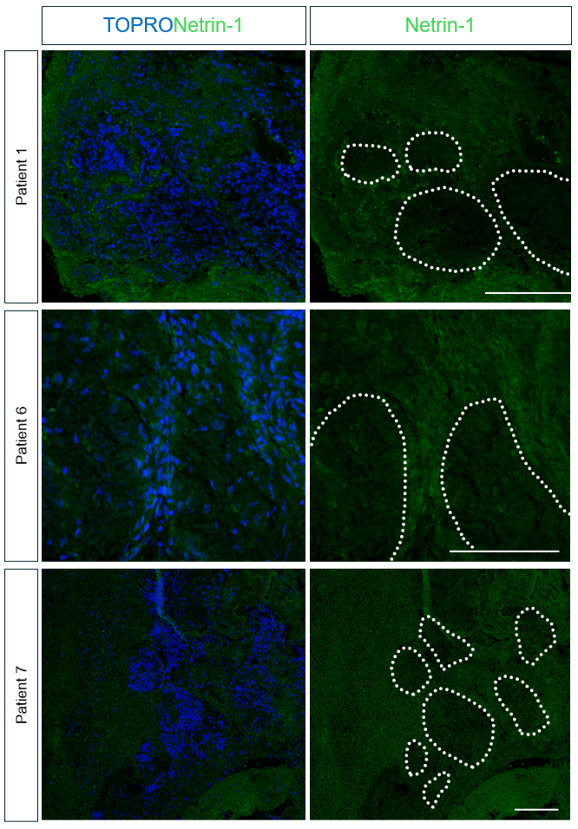
Supplementary Figures

Supplementary Figure S1: Representative images of SHH-MB samples showing Netrin-1 expression pattern. Nodules are highlighted within white dashed lines. Topro was used for nuclear staining. Scale bar: 100 μm.

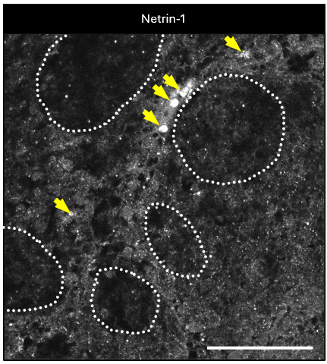

Supplementary Figure S2: Nuclear localization of Netrin-1 in SHH-driven MB. In this representative SHH- driven MB sample, Netrin-1 is observed in both the nucleus and cytoplasm. The yellow arrows indicate nuclear staining. Scale bar: 100 μm.

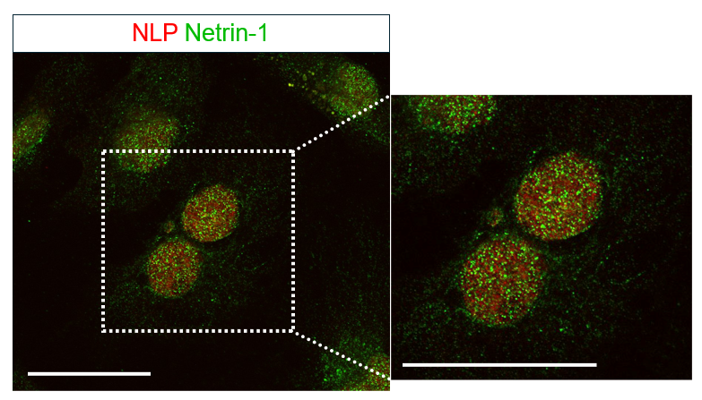

Supplementary Figure S3: Nuclear-cytoplasmic distribution of Netrin-1 in the human DAOY medulloblastoma cell line. Scale Bar: 40µm.

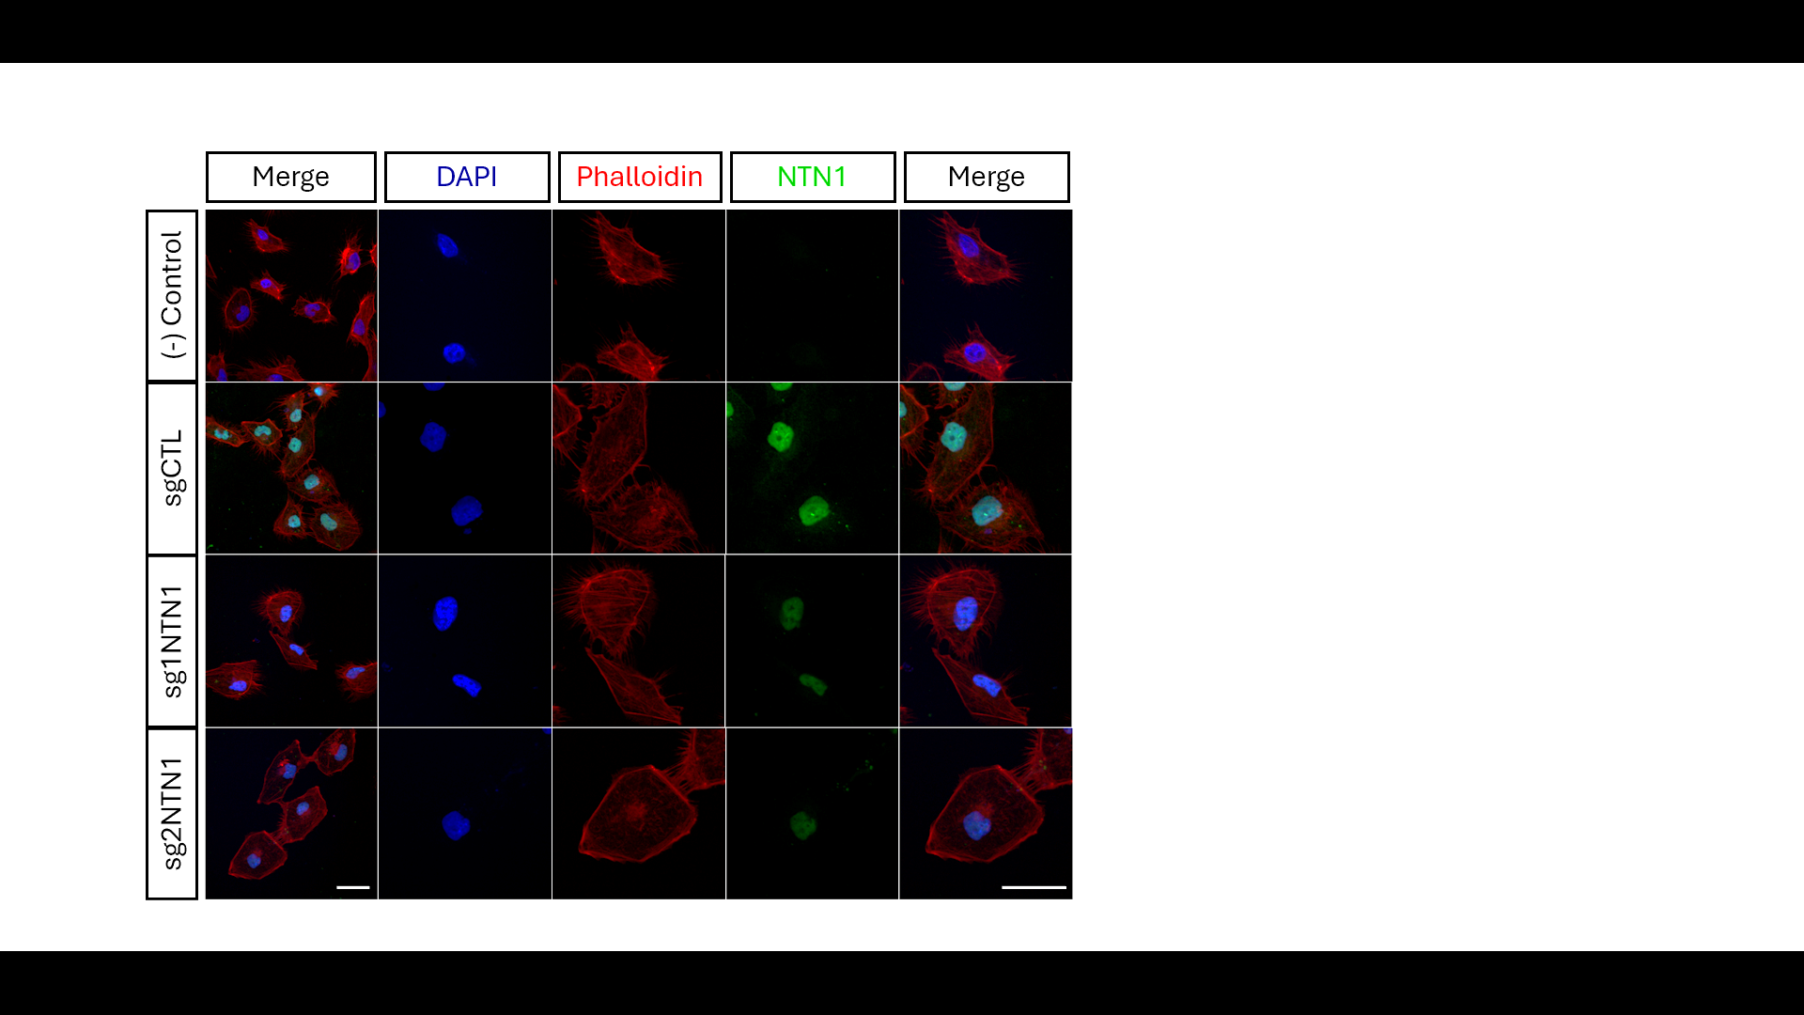
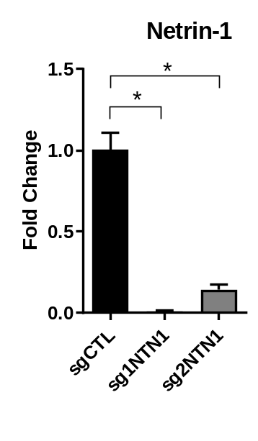
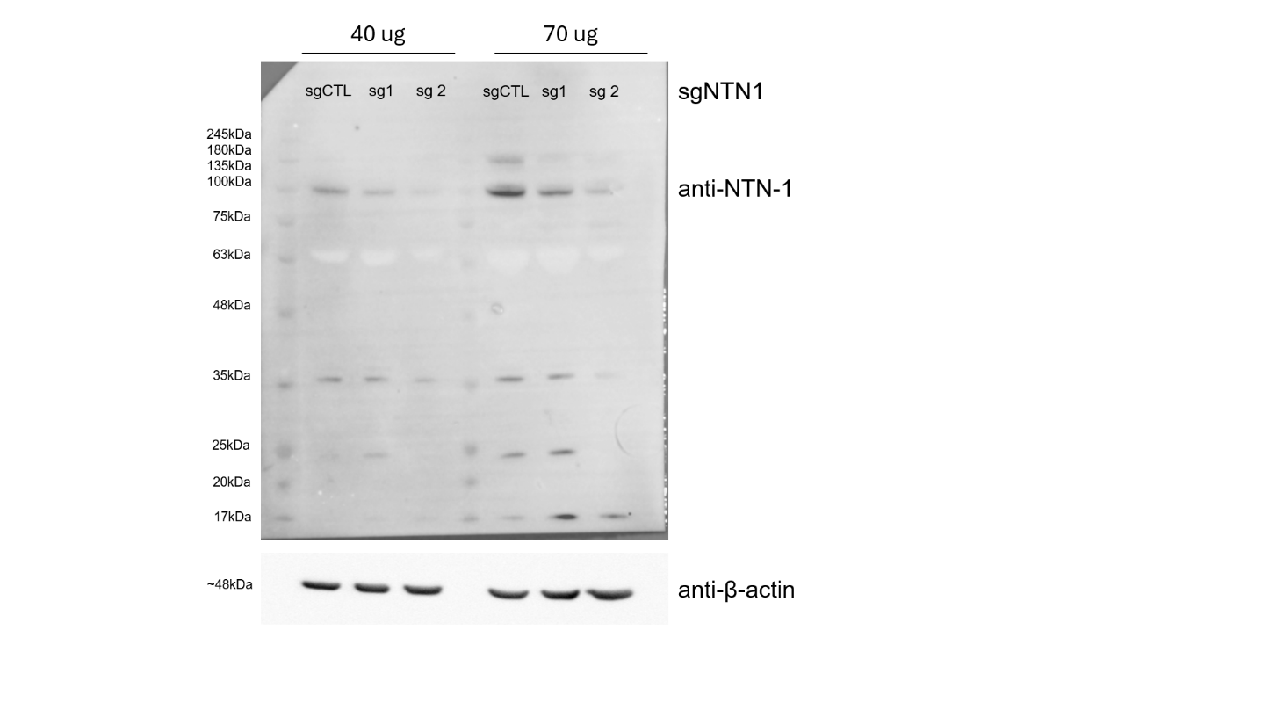
A Netrin-1 B

C

Supplementary Figure S4: Efficient Netrin-1 downregulation in DAOY cells treated with sg1NTN-1 and sg2NTN1. We confirmed the efficient downregulation of Netrin-1 in DAOY sg1NTN1 and sg2NTN cells, through RTqPCR (A), Western blot (B), and immunofluorescence for markers as indicated (C). This analysis shows that, like in some desmoplastic MB patient samples, Netrin-1 in DAOY cells exhibits a predominantly nuclear distribution. Nuclear DAPI staining is shown in blue. Scale Bar: 40µm.

Supplementary Figure S5: Controls for ChIP and luciferase assay experiments. ChIP-PCR of validation using immunoprecipitation of the PTCH1-BS site using antibodies against GLI2 and GLI3, comparing the results to the IgG control (A). Additionally, a positive control for histone H3 precipitation was also performed for PTCH1-GBS (B) and NTN1 GBS1 (C). As a positive control for transcription factor functional activity, a canonical synthetic luciferase reporter based on a tandem of 8x GBS-repeats was utilized. Co-transfection with either GLI1 or the activator isoform GLI3 (GLI3A) confirmed the robust functional activity of the expression constructs used in this (D). Error bars represent SEM; p-values were calculated using the Mann-Whitney test from three independent experiments. In all panels statistics are presented as *P<0,05. **P<0.01.

GNPs
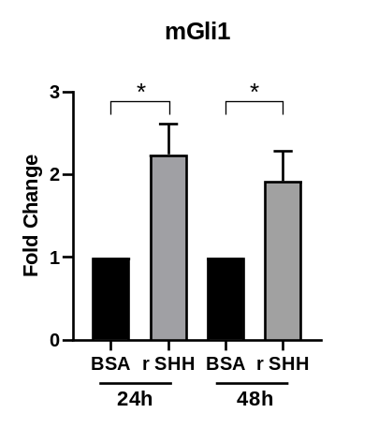
A mGli1 B mNetrin-1
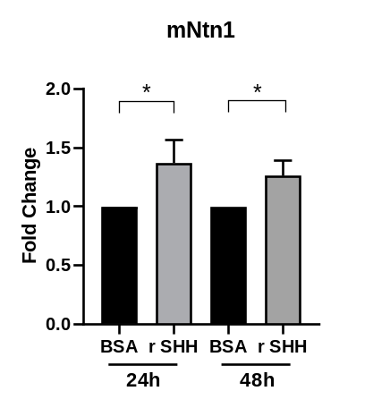

Supplementary Figure S6: NTN1 transcriptional levels respond to the modulation of SHH / GLI signaling in mouse-derived GNPs. The treatment with 50 nM SHH in GNP cells for 24 and 48 hours induces a significant increase in the transcriptional levels of mGli1 (A) and mNetrin-1 (B). Error bars, SEM; p values Mann-Whitney from three independent experiments. *P<0,05.

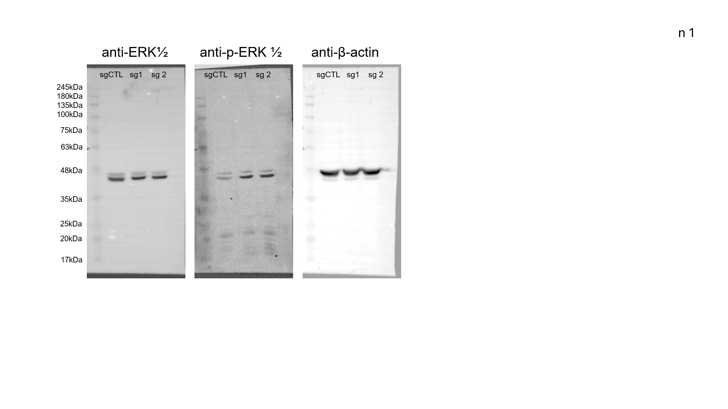
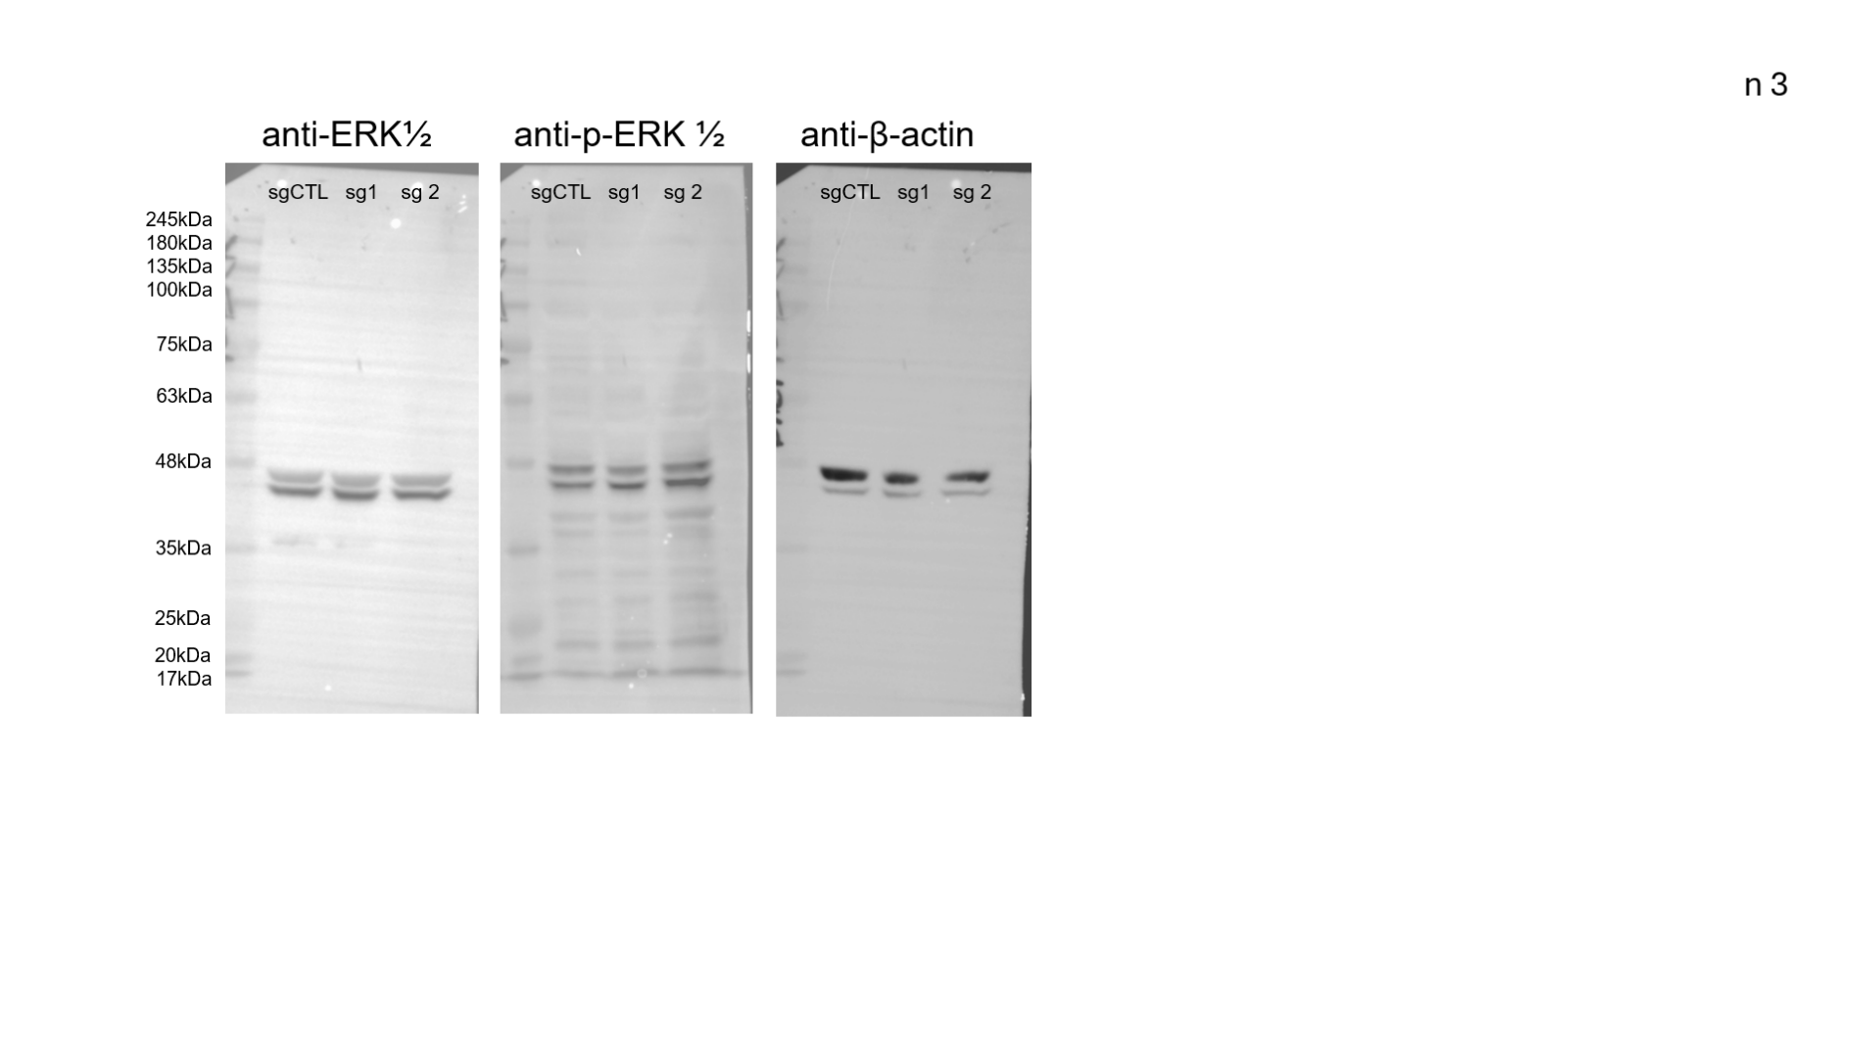
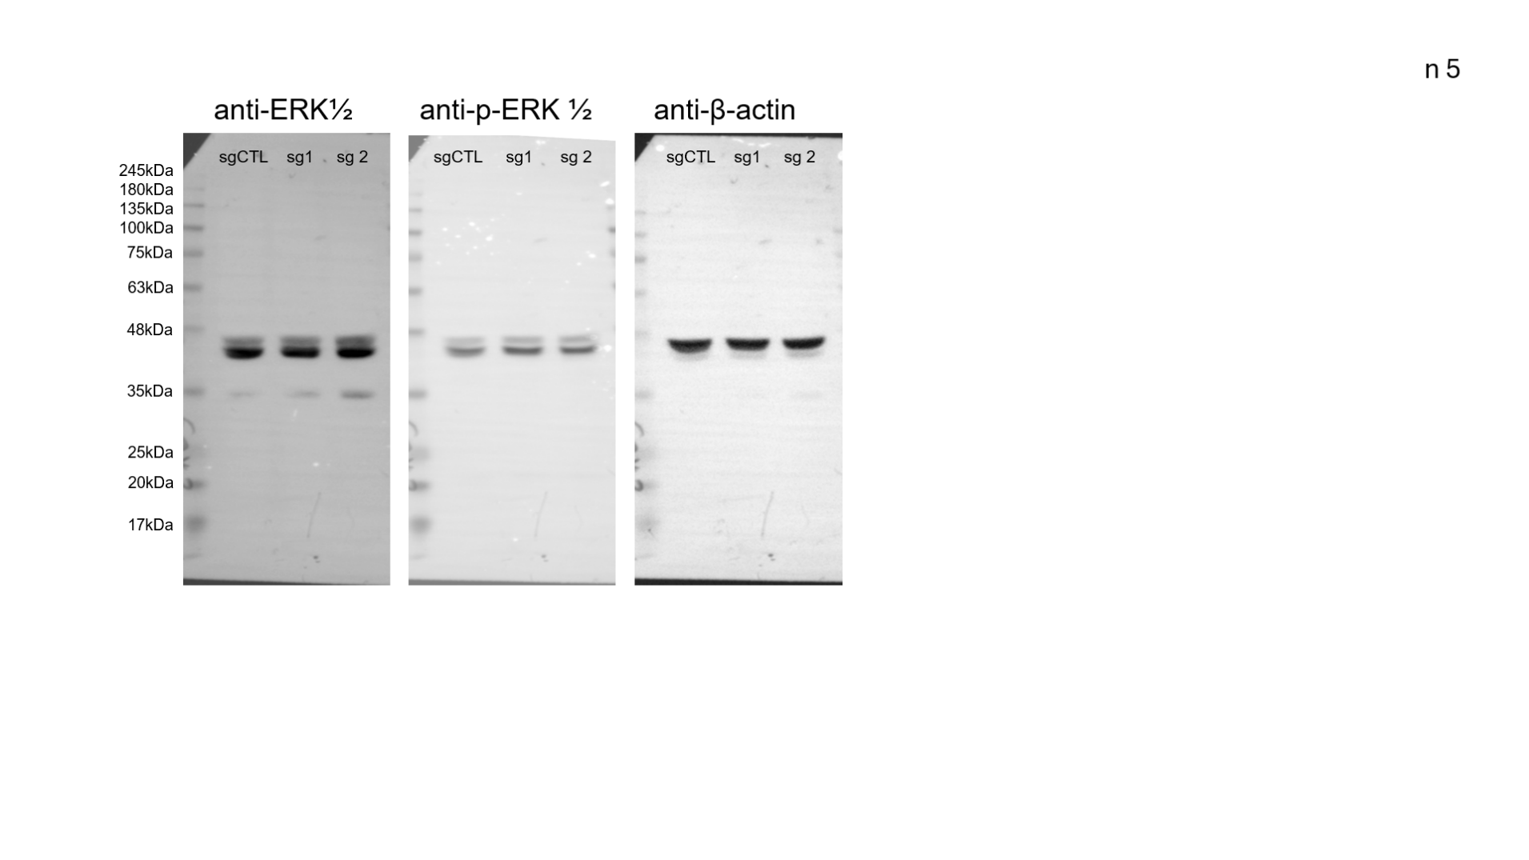

n1

n2

n3

Supplementary Figure S7. Western blot analysis of ERK and p-ERK in DAOY sgCTL, sg1NTN1, and sg2NTN1 cell lines. Three independent replicates of the western blots used for the quantification of ERK and p-ERK shown in Figure 4D are presented.
Supplementary Tables

Supplementary Table 1: Clinical data of SHH-MB patients samples used in this study (Legend; NED: no evidence of disease, DOD: Death of disease PD: Progressing disease).
Patient | Code | Age | Follow-up (months) | Clinical status | Histological subtype | Molecular Subtype (method of detection) | Primary surgery / relapse
1 | E326-01 | 2,2 | 128 | NED | Desmoplastic | SHH (450K + NanoString) | Primary surgery
2 | E845-10 | 40,4 | 32,1 | DOD | Desmoplastic | SHH (450K + NanoString) | Primary surgery
3 | E1179-13 | 25,6 | 40,4 | NED | Desmoplastic | SHH (global GEP) | Primary surgery
4 | E620-06A | 1,4 | 24,1 | NED | Extensively nodular | SHH (global GEP) | Primary surgery
5 | 97-478IC | 30,3 | 44,9 | DOD | Desmoplastic | SHH (450K + NanoString) | Primary surgery
6 | 98-118II | 7,4 | 28,4 | DOD | Desmoplastic | SHH (NanoString) | Relapse
7 | E231-12C | 37,1 | 2,2 | NED | Desmoplastic | SHH (450K) | Primary surgery

Supplementary Table 2: Primers used for SYBR Green Real Time qPCR amplification.
Gene | Forward (5´>3’) | Reverse Forward (5´>3’)
GBS1 | CCTTCTTCCAAGGAGACGGA | GCTCCATTAAGTGCCTCAGTTT
GBS2 | ACCAAAGGATGCTGTCACTGT | ATGATGGTGTCATGGGGCAT
GBS3 | GGGATTCCCAGGGTTTTGCTA | CCAAACTGACGGCAAGACCT
GBS4 | ATGATGATTAACCCTGGAGGAC | TGGAAAAGCAGCACAGTGGA
PTCH1 | GAGGATGCACACACTGGGTT | CTCGCGGAGGGCAGAAATTA

Supplementary Table 3: Taqman qPCR primers
Gene | Forward (5´>3’) | Reverse Forward (5´>3’)
hGLI1 | GGAGAAGCGTGAGCCTGAATC | TGGATGTGCTCGCTGTTGATG
hNTN1 | AAAAGTACTGCAAGAAGGACTATGC | CCCTGCTTATACACGGAG ATG
mGli1 | GGTGCACATGCGCAGACA | TGAGGTTTTCAAGGCGTGAAT
mNtn1 | GCAAGCTGAAGAGATGAACATGA | CTTTGTCGGCCTTCAGGA

Supplementary Table 4: Statistical analysis of NTN1 expression was performed on transcriptomic data including 291 samples of normal cerebellum and 1213 samples of medulloblastoma belonging to the SHH, WNT, Group 3, and Group 4 subgroups.
ANOVA | p-value: 7,39e-206
statistical comparison | Welch p-value | Bonferroni corrected
WNT vs SHH | 0,367 | 1,00
WNT vs Group3 | 1,90e-22 | 2,84e-21
WNT vs Group4 | 5,12e-32 | 7,67e-31
WNT vs Normal | 1,02e-16 | 1,52e-15
SHH vs Group 3 | 1,24e-54 | 1,86e-53
SHH vs Group 4 | 3,33e-119 | 5,00e-118
SHH vs Normal | 3,19e-63 | 4,79e-62
Group 3 vs Group 4 | 3,06e-07 | 4,58e-06
Group 3 vs Normal | 1,58e-06 | 2,37e-05
Group 4 vs Normal | 7,06e-79 | 1,06e-77

Supplementary Table 5: Statistical analysis of GLI1 expression was performed on transcriptomic data including 291 samples of normal cerebellum and 1213 samples of medulloblastoma belonging to the SHH, WNT, Group 3, and Group 4 subgroups.
ANOVA | p-value: 0,00e+00
statistical comparison | Welch p-value | Bonferroni corrected
WNT vs SHH | 3,72e-74 | 5,58e-73
WNT vs Group3 | 0,871 | 1,00
WNT vs Group4 | 0,023 | 0,343
WNT vs Normal | 2,58e-16 | 3,86e-15
SHH vs Group 3 | 2,33e-151 | 3,50e-150
SHH vs Group 4 | 1,42e172 | 2,13e-171
SHH vs Normal | 5,57e-102 | 8,35e-101
Group 3 vs Group 4 | 2,54e-04 | 3,81e-03
Group 3 vs Normal | 5,49e-43 | 8,23e-42
Group 4 vs Normal | 2,18e-97 | 3,28e-96

Supplementary Table 6: Statistical analysis of PTCH1 expression was performed on transcriptomic data including 291 samples of normal cerebellum and 1213 samples of MB belonging to the SHH, WNT, Group 3, and Group 4 subgroups.
ANOVA | p-value: 4,08e-306
statistical comparison | Welch p-value | Bonferroni corrected
WNT vs SHH | 4,33e-66 | 6,49e-65
WNT vs Group3 | 7,03e-25 | 1,05e-23
WNT vs Group4 | 1,02e-16 | 1,53e-15
WNT vs Normal | 9,95e-05 | 1,49e-03
SHH vs Group 3 | 1,35e-139 | 2,02e-138
SHH vs Group 4 | 3,49e-130 | 5,24e-129
SHH vs Normal | 2,98e-73 | 4,47e-72
Group 3 vs Group 4 | 5,36e-07 | 8,04e-06
Group 3 vs Normal | 8,16e-68 | 1,22e-66
Group 4 vs Normal | 5,54e-79 | 8,30e-78

Supplemental Table 7: Qualitative characterization of Netrin-1 expression in internodular and nodular regions of SHH-MB patients’ samples (Legend: + low level, ++ intermediate level, +++ high level of fluorescence signal)
Sample | Histological Subtype | Internodular | Nodular
Patient 1 | Desmoplastic | +++ | +
Patient 2 | Desmoplastic | ++ | +
Patient 3 | Desmoplastic | ++ | +
Patient 4 | Extensively nodular | +++ | +
Patient 5 | Desmoplastic | +++ | +
Patient 6 | Desmoplastic | ++ | ++
Patient 7 | Desmoplastic | ++ | +

Supplemental Table 8: Potential intron 2 GBS. The intron 2 sequence of NTN1 was screened for binding sites using FIMO. The start-stop coordinates are defined relative to the start site of intron 2, based on the Ensembl human genome version GRCh38.
motif_id | motif_alt_id | start | stop | strand | score | p-value | q-value | matched_sequence
GLI1-BS | STGKGTGGBCH | 30609 | 30619 | + | 14.8829 | 3.06e-07 | 0.0405 | CTGGGTGGTCT
GLI1-BS | STGKGTGGBCH | 101052 | 101062 | + | 14.8829 | 3.06e-07 | 0.0405 | CTGGGTGGTCT
GLI1-BS | STGKGTGGBCH | 92587 | 92597 | + | 14.3268 | 7.26e-07 | 0.0572 | CTGGGTGGCCC
GLI1-BS | STGKGTGGBCH | 5746 | 5756 | + | 14.2976 | 8.64e-07 | 0.0572 | CTGGGTGGCCT
GLI2-BS | YWGBGTGTGCGC | 126609 | 126620 | + | 15.2121 | 2.59e-06 | 0.42 | GAGACCACCCTG
GLI2-BS | YWGBGTGTGCGC | 30609 | 30620 | - | 14.1818 | 5.63e-06 | 0.42 | GAGACCACCCAG
GLI2-BS | YWGBGTGTGCGC | 78333 | 78344 | - | 14.0545 | 6.49e-06 | 0.42 | GCCACCACACTG
GLI2-BS | YWGBGTGTGCGC | 83408 | 83419 | + | 14.0545 | 6.49e-06 | 0.42 | GCCACCACACTG
GLI3-BS | CDNBGTGGGTGGBTC | 101048 | 101062 | - | 14.6727 | 4.45e-06 | 0.30 | AGACCACCCAGCCGG
GLI3-BS | CDNBGTGGGTGGBTC | 92583 | 92597 | - | 13.5758 | 9.68e-06 | 0.30 | GGGCCACCCAGCCTG
GLI3-BS | CDNBGTGGGTGGBTC | 14539 | 14553 | - | 13.1939 | 1.25e-05 | 0.30 | AGACCACACAGGGCT
GLI3-BS | CDNBGTGGGTGGBTC | 30605 | 30619 | - | 12.4848 | 1.99e-05 | 0.30 | AGACCACCCAGTCCC

