Fig. S1. Schematic diagram of motifs of various proteins. (a) Schematic diagram of the BRAF^{V600E} mutation. The human BRAF protein contains three conserved domains, with the BRAF^{V600E} mutation located within the CR3 kinase domain. This missense mutation results from a thymine (T)-to-adenine (A) substitution at nucleotide position 1,799, which leads to the replacement of valine by glutamate at codon 600 (exon 15). (b) Protein domain illustration of PTK2B and Fak. Although protein lengths are not exactly the same, PTK2B and Fak share similar protein domains. (c) Drosophila dRaf gain-of-function protein. In dRaf^{GOF} protein, amino acids 2 to 431 of the dRaf that disrupts the autoinhibitory domain are missing, resulting in constitutive kinase activation.

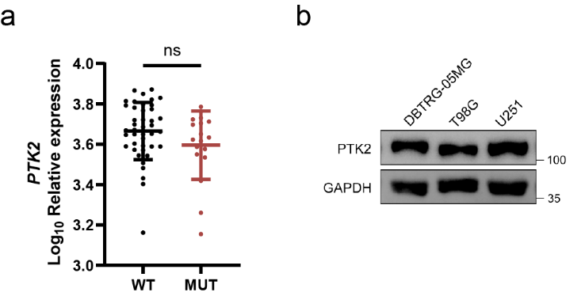
Fig. S2. PTK2 is irrelevant in BRAF^{V600E} gliomas. (a) Comparison of PTK2 mRNA levels between BRAF WT and BRAF V600E mutant pLGG samples in dataset GSE60898. Each point represents expression data from an individual patient. (b) Western blot analysis for three glioma cell lines. PTK2 expression was comparable across all three cell lines DBTRG-05MG, T98G and U251.

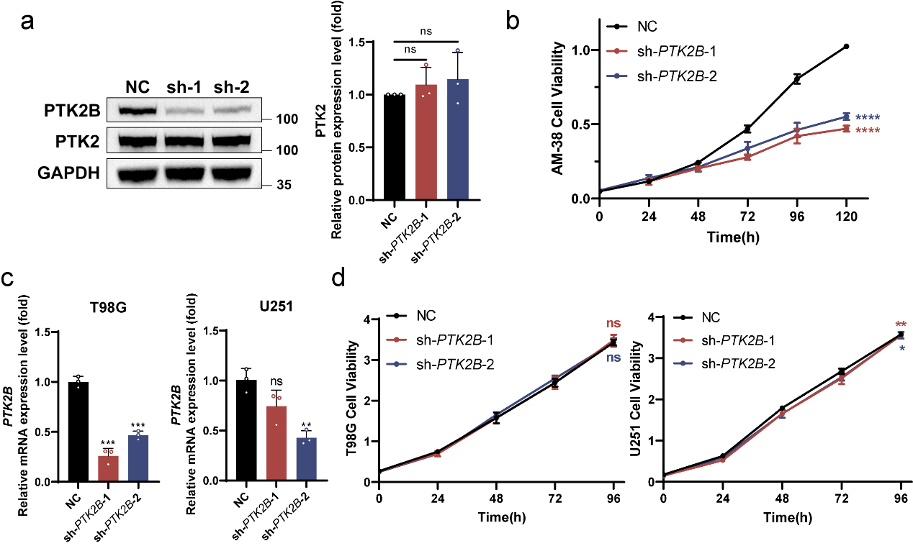
Fig. S3. Knockdown PTK2B, but not PTK2, inhibits tumor proliferation only in BRAF^{V600E} DBTRG-05MG cells. (a) Western blot analysis and the corresponding quantification for DBTRG-05MG cells demonstrated that both shRNAs specifically targeted PTK2B without affecting PTK2 expression (n=3). (b) CCK-8 assay for AM-38 cells after PTK2B knockdown. Knockdown of PTK2B significantly inhibit cell proliferation in this BRAF^{V600E} glioma cell line (n=6). (c) qPCR analysis of PTK2B in T98G and U251 cells. The reduced mRNA levels of PTK2B indicated that two shRNAs could effectively knock down PTK2B in both cell lines (n=3). (d) CCK-8 assays for T98G and U251 cells after PTK2B knockdown. Knockdown of PTK2B did not affect the proliferation levels of BRAF wild-type glioma cell lines T98G and U251 (n=6). * P < 0.05, ** P < 0.01, ***P < 0.001, ****P < 0.0001.

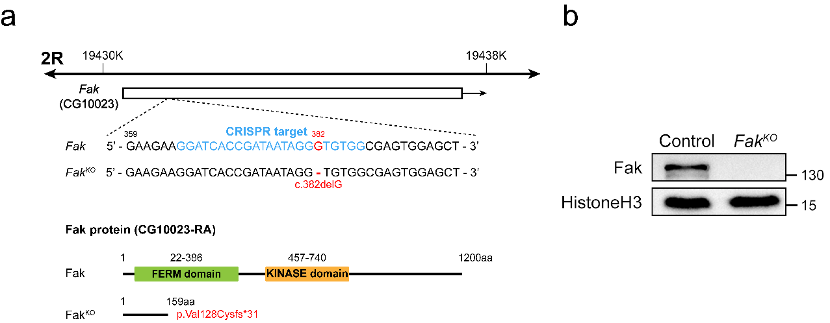
Fig. S4. Schematic diagram and validation of Drosophila Fak mutant. (a) CRISPR-Cas9 was employed to delete the guanine (G) residue at position 382 in the Fak gene. This deletion introduces a frameshift mutation in the coding sequence, resulting in the substitution of valine with cysteine at amino acid position 128 of the 1200-residue Fak protein and a premature termination codon after amino acid 159. (b) Western blot analysis of total protein in Drosophila confirmed knockout of Fak in mutant.

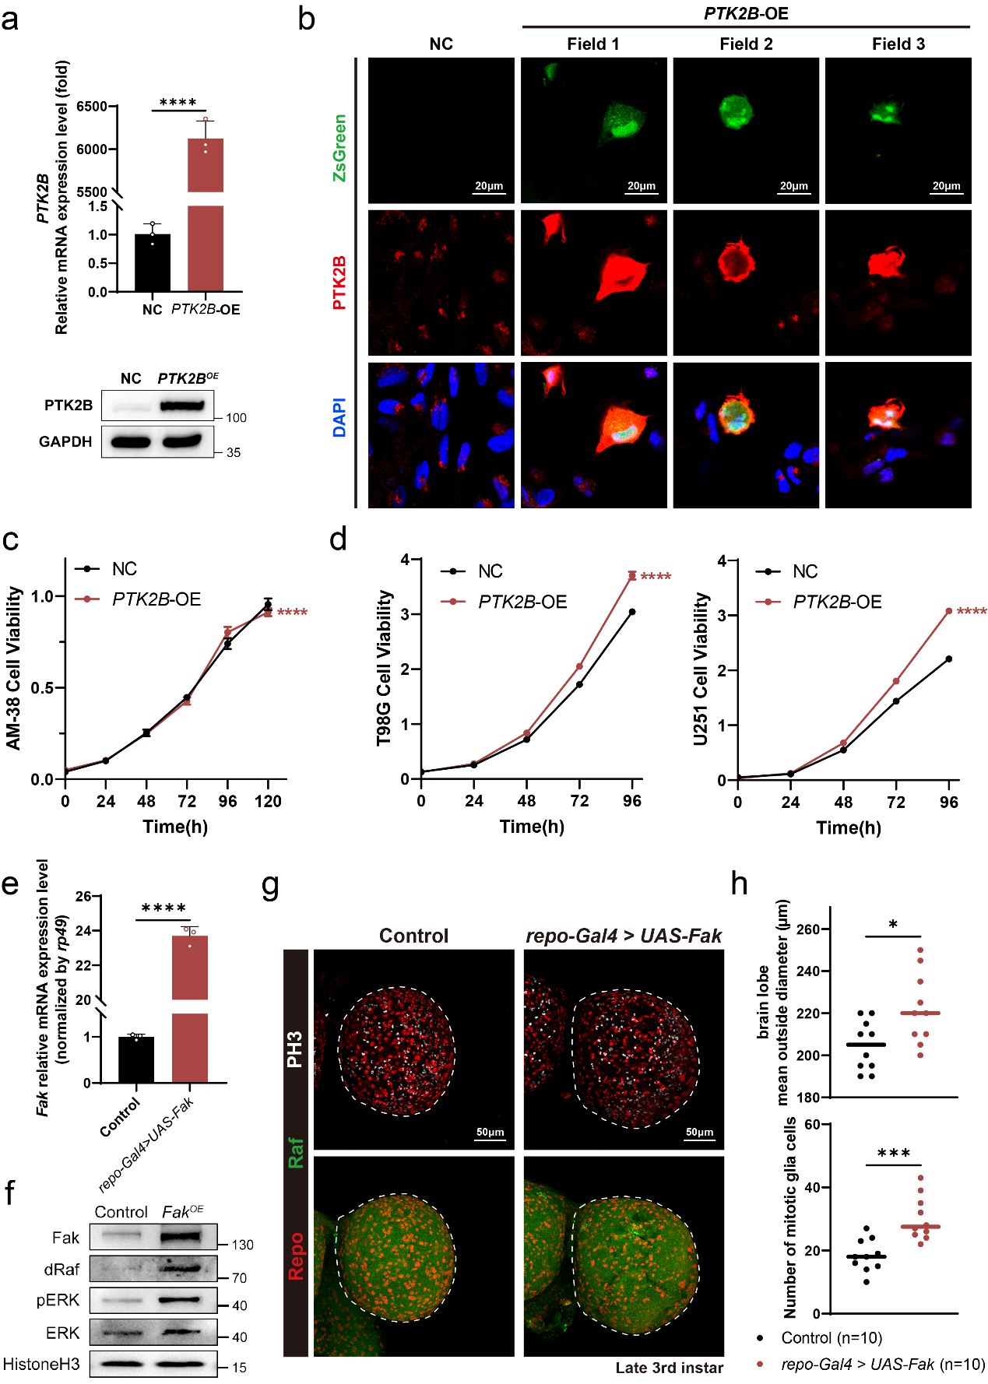
Fig. S5. PTK2B overexpression in BRAF^{V600E} and BRAF wild-type glioma cells and Fak overexpression in wild-type Drosophila. (a) qPCR and Western blot analysis of PTK2B in DBTRG-05MG cells. Exogenous PTK2B overexpression further increases its mRNA and protein levels in DBTRG-05MG cells despite high endogenous expression (n=3). (b) Confocal images of DBTRG-05MG cells transiently transfected with PTK2B overexpression plasmid. Fields 1~3 represent three fields of view in the PTK2B overexpression group. Under identical imaging conditions, ZsGreen-positive cells (green, transfected cells) display saturated PTK2B signals (Red) compared to ZsGreen-negative cells, indicating efficient PTK2B upregulation at the single-cell level. Nuclei are stained with DAPI (blue). Scale bar = 20 μm. (c) CCK-8 assay for AM-38 cells after PTK2B overexpression. PTK2B overexpression did not affect the proliferation levels of this BRAF^{V600E} glioma cell line (n=6). (d) CCK-8 assay for T98G and U251 cells after PTK2B overexpression. PTK2B overexpression notably promoted proliferation of the two cell lines (n=6). (e) qPCR analysis for Fak of Drosophila late 3rd instar larval brains from Control and Fak^{OE} flies. Fak overexpression in a wild-type background substantially upregulated the mRNA levels of Fak (n=3). (f) Western blot analysis for Fak of fly brains in Control and Fak^{OE} groups. Fak overexpression in a wild-type background significantly increased the protein levels of dRaf and pERK. (g) IF staining for Drosophila late 3rd instar larval brains of Control and Fak^{OE} groups. The areas circled by the white dashed line were used for statistics on brain lobe diameter. (red: Repo; green: Raf; white: PH3) Scale bar = 50 μm. (h) Statistics on the diameter of fly brain lobes and number of mitotic glia cells from Fig. S5g. Fak overexpression in a wild‑type background promotes larval brain lobe growth and glial proliferation, indicating its tumor‑promoting function (n=10). * P < 0.05, ***P < 0.001, ****P < 0.0001.

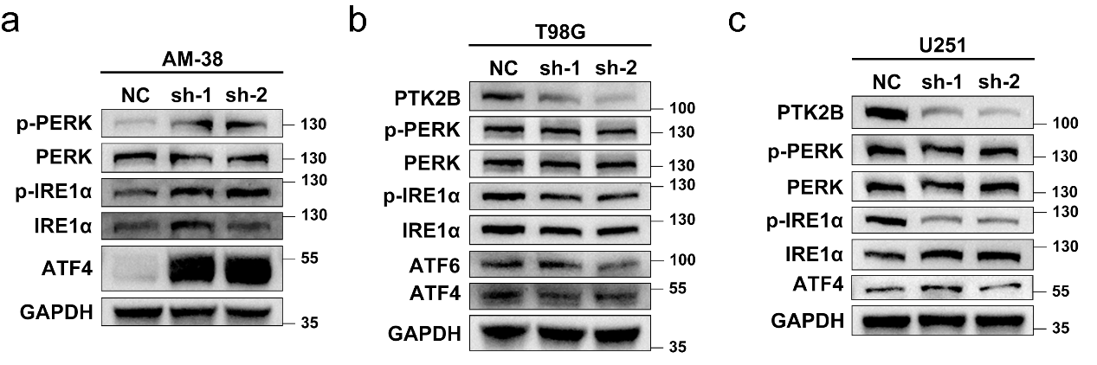
Fig. S6. PTK2B knockdown induces ER stress only in BRAF^{V600E} glioma cells. (a~c) Western blot analysis for ER stress markers of AM-38 (a), T98G (b), and U251 (c) cells with or without PTK2B knockdown. Upon PTK2B knockdown, ER stress markers p-PERK, p-IRE1α and ATF4 were upregulated only in AM‑38 cells (with BRAF^{V600E} mutation), whereas no significant changes were observed in BRAF wild‑type T98G and U251 cells.

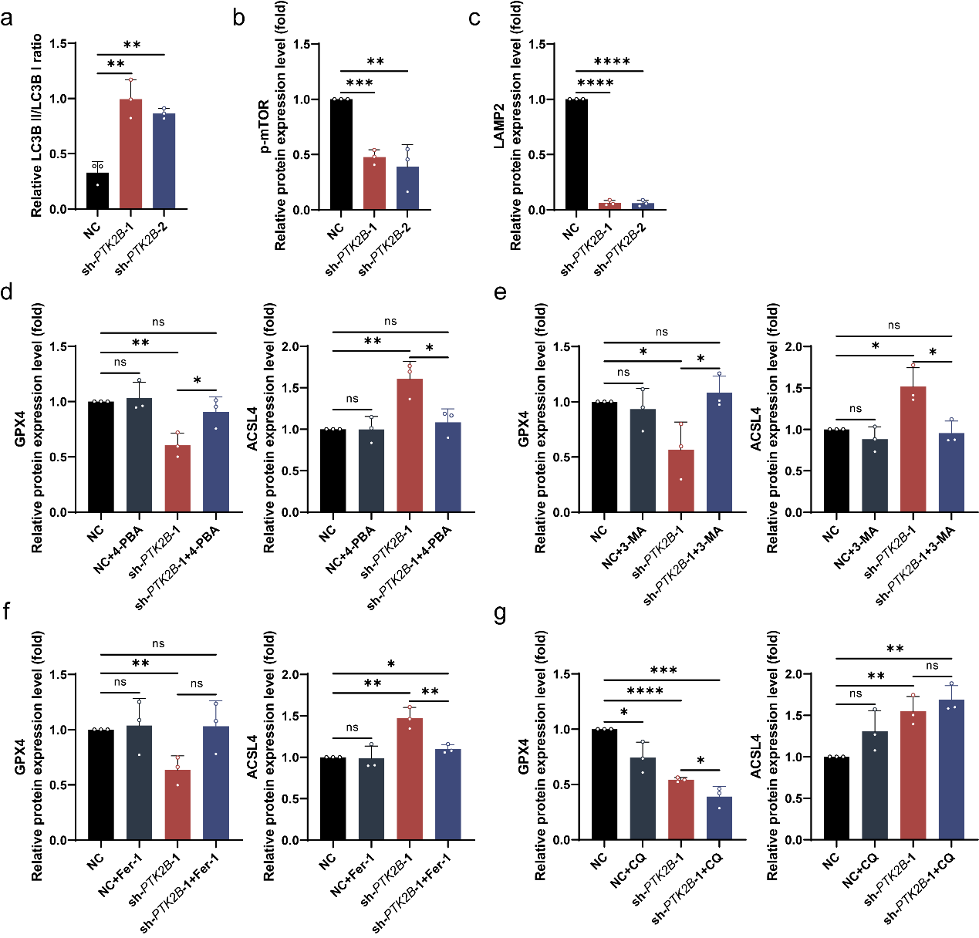
Fig. S7. Densitometric quantification of Western blot analyses for indicated proteins in DBTRG-05MG cells following PTK2B knockdown. (a~c) Quantification of LC3B‑II/I ratio (from Fig. 5b), p‑mTOR levels (from Fig. 5d), and LAMP2 levels (from Fig. 5h), respectively (n=3). (d~g) Quantification of GPX4 and ACSL4 levels from Fig. 7b, 7c, 7d, and 7e, respectively. Each panel in d~g shows the densitometric quantification of both GPX4 and ACSL4 corresponding to the respective Western blot in Fig. 7b~7e (n=3). * P < 0.05, ** P < 0.01, ***P < 0.001, ****P < 0.0001.

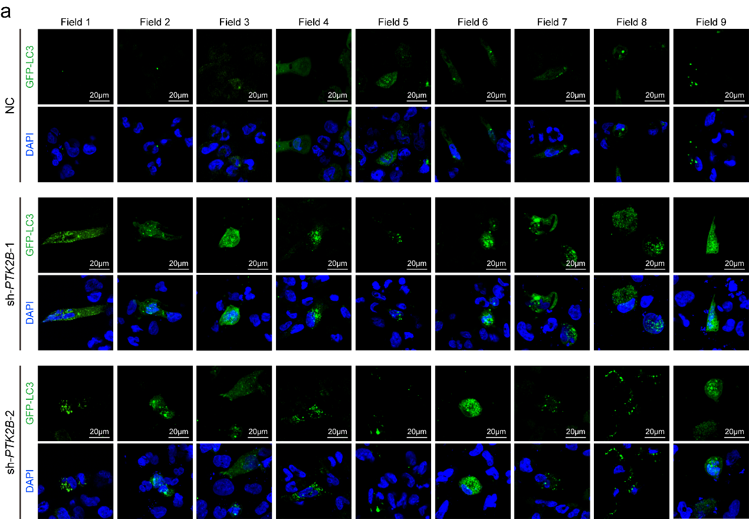
Fig. S8. All nine random fields of view for GFP-LC3 puncta quantification in DBTRG‑05MG cells. (a) For each treatment group (NC, sh‑PTK2B‑1, sh‑PTK2B‑2), nine fields were randomly selected and imaged under confocal microscopy. GFP‑LC3 puncta were counted in every cell within each field, and the average number of puncta per cell was calculated (quantified in Fig. 5c). Green: GFP‑LC3; blue: DAPI. Scale bar = 20 μm.

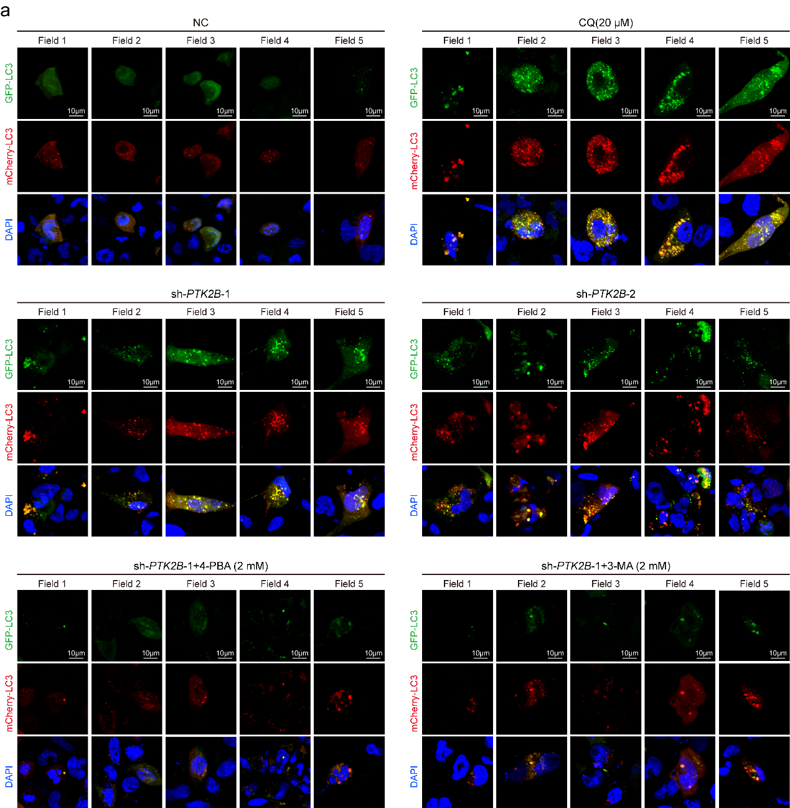
Fig. S9. All five random fields of view for mCherry‑GFP-LC3 puncta quantification in DBTRG‑05MG cells. (a) For each treatment group (NC, CQ, sh‑PTK2B‑1, sh‑PTK2B‑2, sh‑PTK2B‑1+4‑PBA, and sh‑PTK2B‑1+3‑MA), five fields were randomly selected and imaged under confocal microscopy. Orange puncta (mCherry and GFP co‑localized spots) were counted in each cell per field, and the average number of orange puncta per cell was calculated (quantified in Fig. 5i). Green: GFP‑LC3; red: mCherry‑LC3; blue: DAPI. Scale bar = 10 μm.

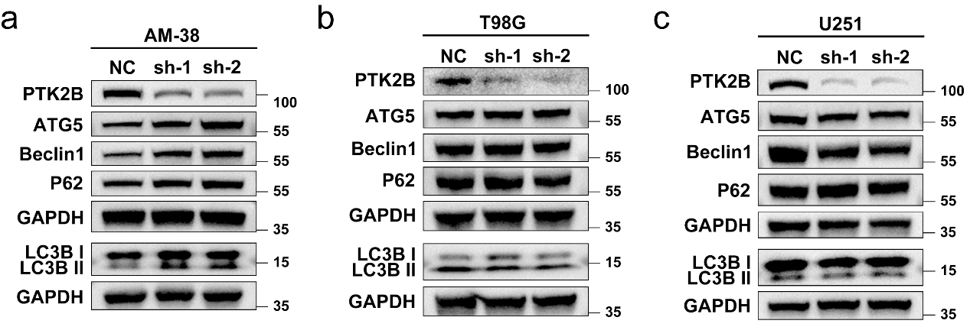
Fig. S10. PTK2B knockdown induces autophagy initiation and autophagic flux disruption only in BRAF^{V600E} glioma cells. (a~c) Western blot analyses for autophagy markers in AM-38 (a), T98G (b), and U251 (c) cells with or without PTK2B knockdown. Upon PTK2B knockdown, autophagy initiation markers ATG5, Beclin1, LC3B II/I and autophagic flux disruption marker P62 were upregulated only in AM‑38 cells (with BRAF^{V600E} mutation), whereas no significant changes were observed in BRAF wild‑type T98G and U251 cells.

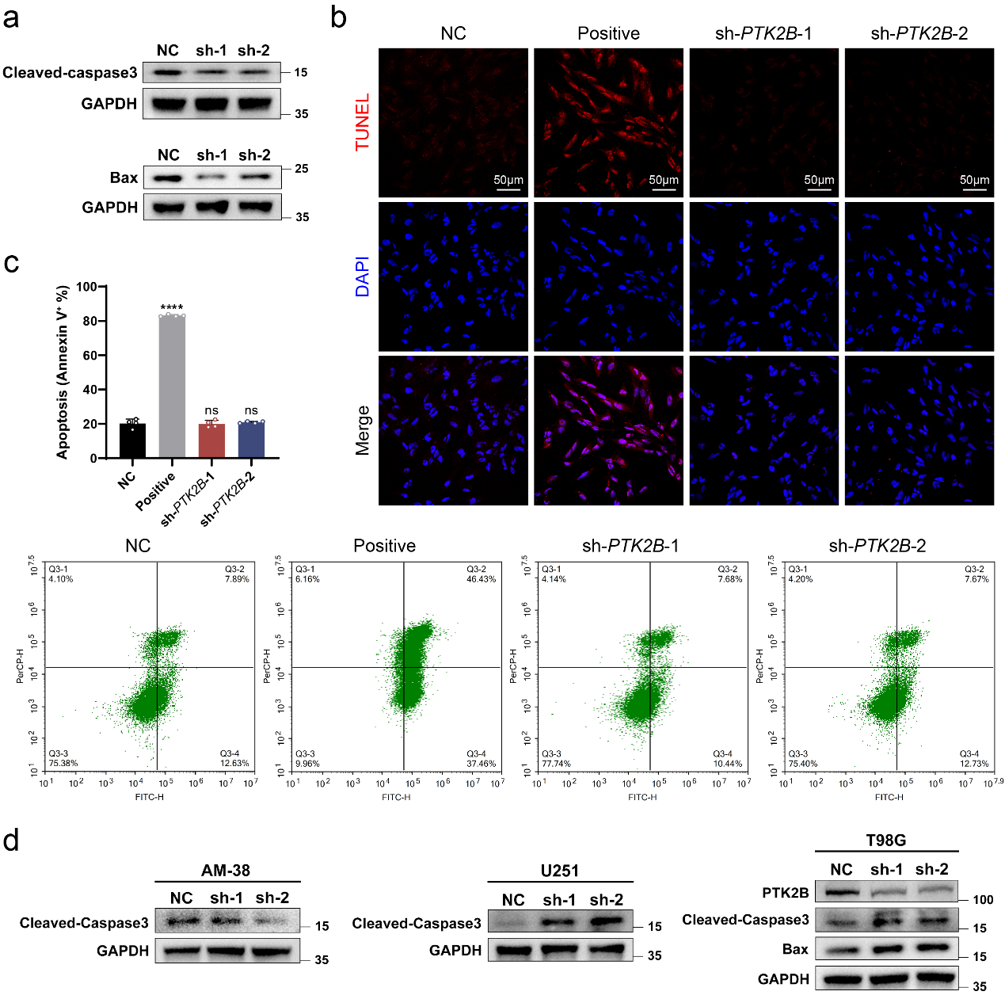
Fig. S11. PTK2B knockdown did not induce apoptosis in BRAF^{V600E} glioma cells. (a) Western blot analyses for Cleaved‑caspase3 and Bax in DBTRG‑05MG cells with or without PTK2B knockdown. The protein levels of Cleaved‑caspase‑3 and Bax were significantly decreased upon PTK2B knockdown. (b) TUNEL fluorescence staining of DBTRG‑05MG cells in the negative control (NC), positive control, and PTK2B knockdown groups. TUNEL: red; DAPI (nuclei): blue. Scale bar = 50 μm. (c) Representative flow cytometry plots of Annexin V‑FITC/PI double staining and quantitative analysis of apoptotic cell percentages in NC, positive control, and PTK2B knockdown groups (n=4). (d) Western blot analyses for Cleaved‑caspase3 and Bax in AM-38, T98G and U251 cells. PTK2B knockdown failed to increase Cleaved caspase‑3 in AM‑38 cells, but upregulated Cleaved caspase‑3 in T98G and U251 cells, and also upregulated Bax in U251 cells. ****P < 0.0001.
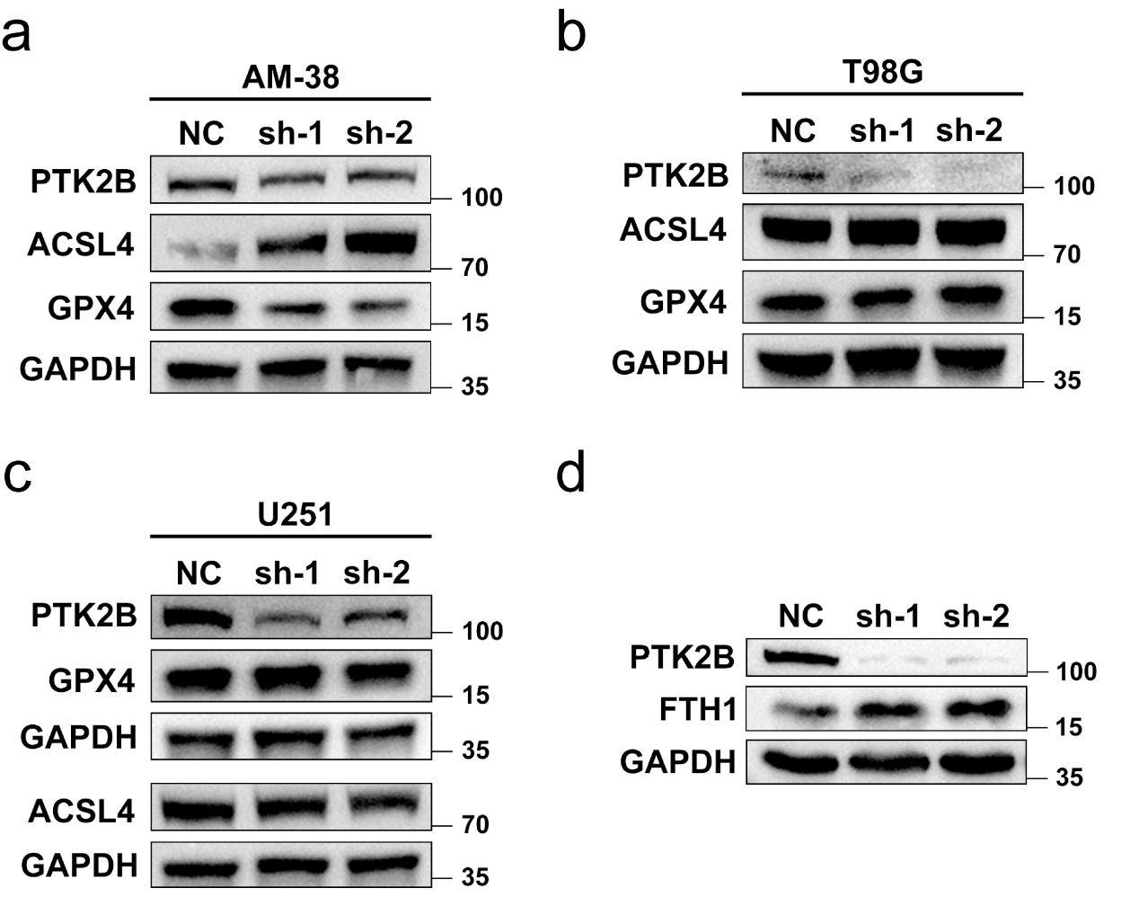
Fig. S12. PTK2B knockdown induces ferroptosis only in BRAF^{V600E} glioma cells. (a~c) Western blot analyses for ferroptosis markers in AM-38 (a), T98G (b), and U251 (c) cells with or without PTK2B knockdown. Upon PTK2B knockdown, GPX4 was downregulated and ACSL4 was upregulated only in AM‑38 cells (with BRAF^{V600E} mutation), whereas no significant changes were observed in BRAF wild‑type T98G and U251 cells. (d) Western blot analysis for DBTRG-05MG cells indicated that FTH1 was upregulated due to PTK2B knockdown, which excluded the possibility of ferroptosis caused by autophagy degradation of ferritin.

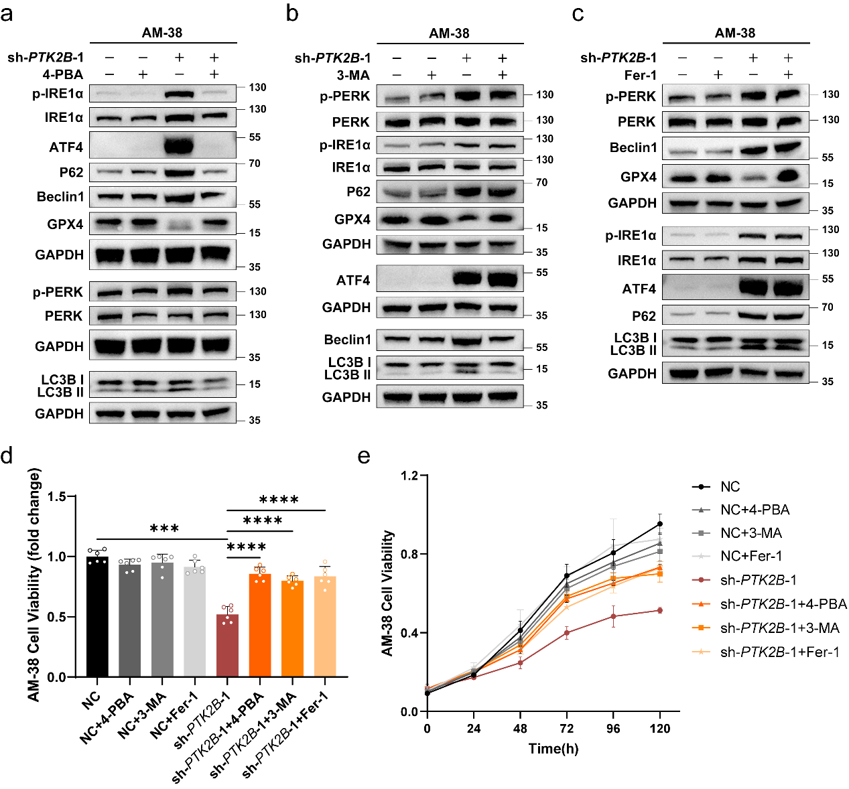
Fig. S13. PTK2B knockdown triggers Ferroptosis through ER stress-induced autophagic flux disruption in AM-38 cells. (a-c) Western blot analyses for ER stress, autophagy and ferroptosis markers of AM-38 cells with 4-PBA (a), 3-MA (b), and Fer-1 (c) treatment. Each GAPDH lane represents an individual membrane; all experiments within the same treatment group employed same batch of protein extracts. PTK2B knockdown induced ER stress, autophagy initiation, autophagic flux disruption, and ferroptosis. 4-PBA reversed all effects; 3-MA reversed autophagy and ferroptosis but not ER stress; Fer-1 only reversed ferroptosis. (d-e) The effects of 4-PBA, 3-MA, and Fer-1 on cell viability (d), and proliferation (e) of AM-38 cells with or without PTK2B knockdown (n=6). PTK2B knockdown decreased viability and proliferation of AM-38 cells, which were substantially rescued by all three inhibitors. ***P < 0.001, ****P < 0.0001.

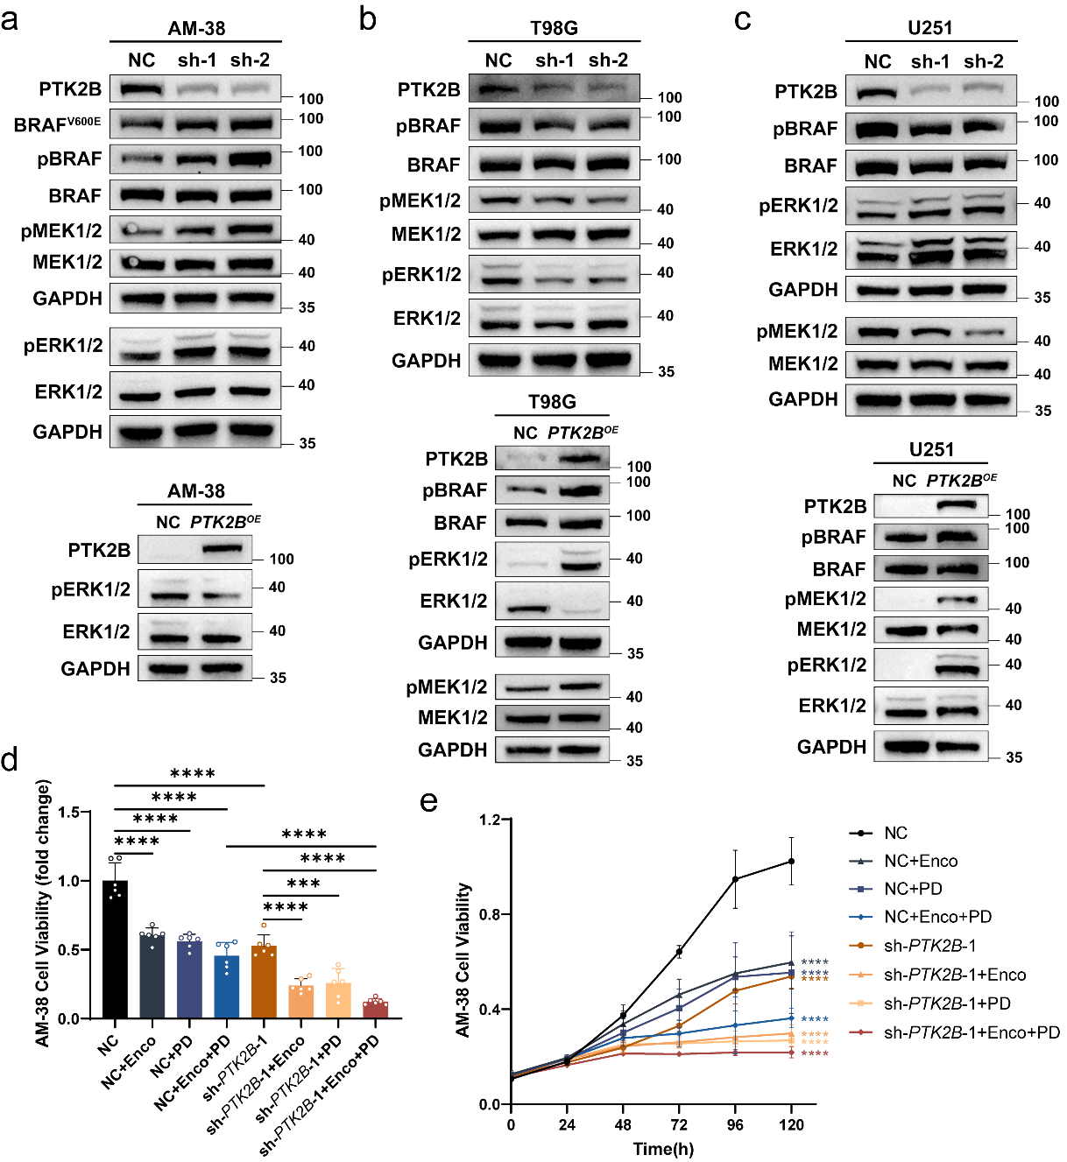
Fig. S14. Negative regulation of MAPK by PTK2B and its synergy with BRAF inhibition are dependent on the BRAF^{V600E} mutation. (a) Western blot analyses of BRAF^{V600E}, pBRAF, pMEK1/2, and pERK1/2 in AM‑38 cells with PTK2B knockdown or overexpression. PTK2B knockdown increased the phosphorylation levels of all three proteins, confirming negative regulation of MAPK by PTK2B in this background. (b~c) Western blot analyses of the same MAPK markers in BRAF wild‑type T98G and U251 cells with PTK2B knockdown or overexpression. PTK2B knockdown decreased pBRAF, pMEK, and pERK levels, and PTK2B overexpression increased these proteins, indicating positive regulation. (d~e) CCK-8 assays were performed to assess the effects of Enco, PD and PTK2B knockdown on cell viability (d), and proliferation (e) in AM-38 cells (n=6). Both single treatments significantly suppressed cell viability and proliferation, and the combination exhibited a stronger inhibitory effect, indicating synergy.

