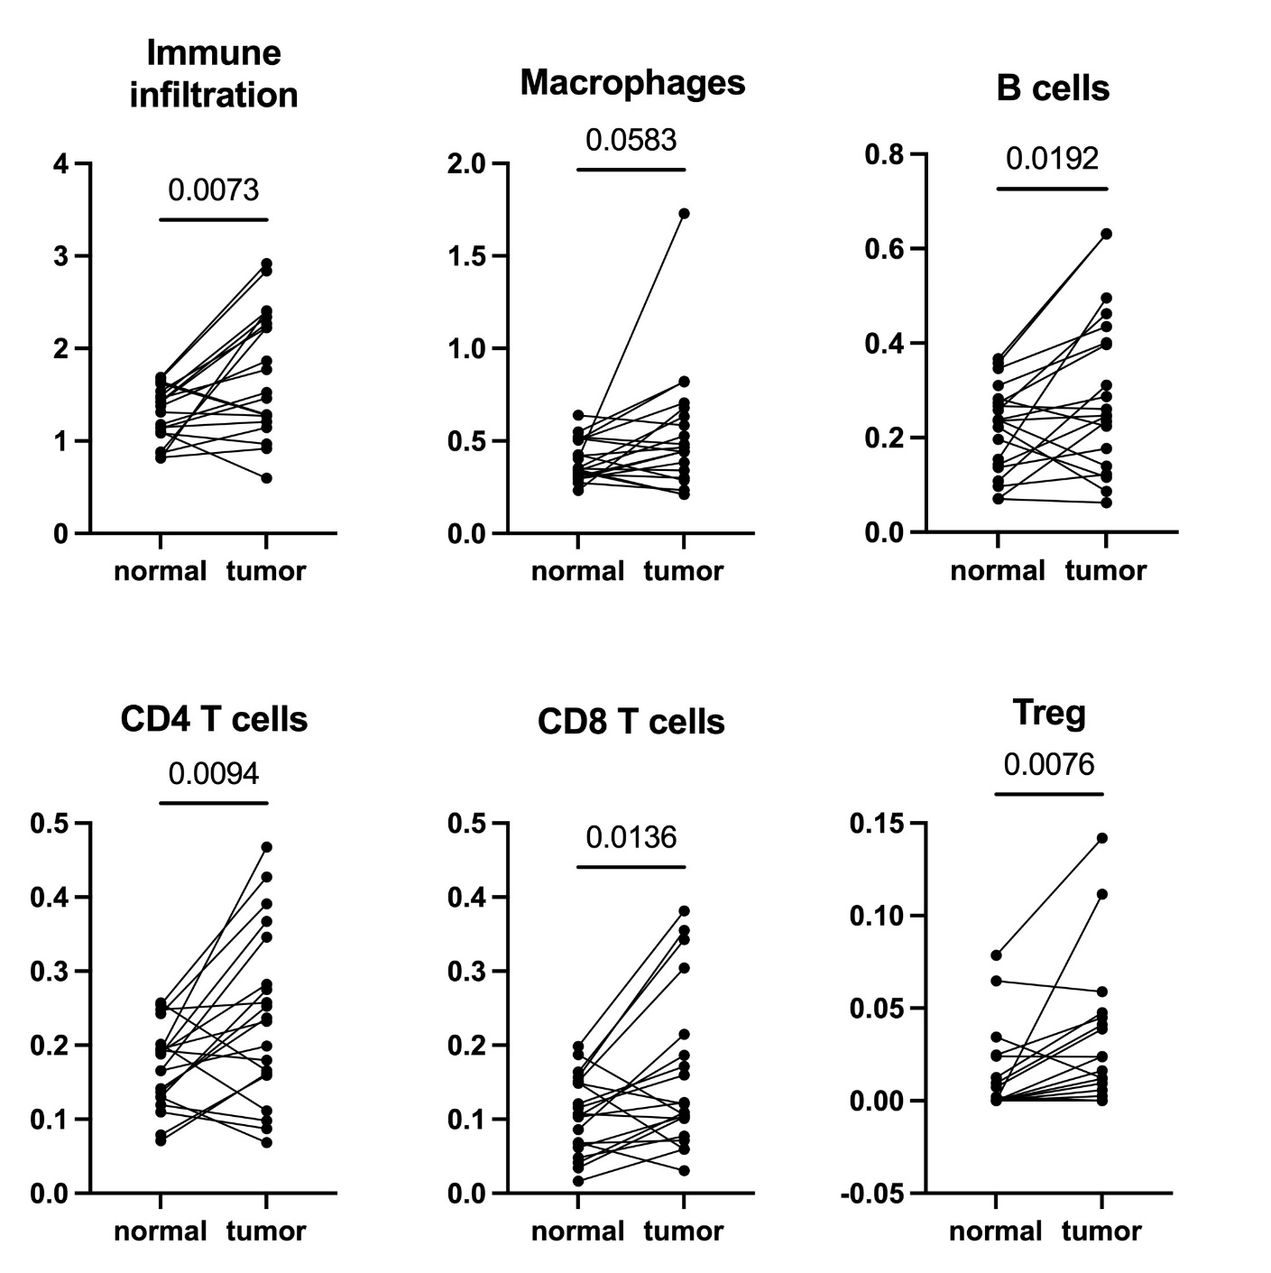

Fig.S3. Paired dot plots on the frequency of deconvoluted immune cell-specific gene expression profiles between paired normal breast and breast carcinoma tissues. Groups were compared using Wilcoxon matched-pairs signed rank test.

