Figure 5D P-CREB1
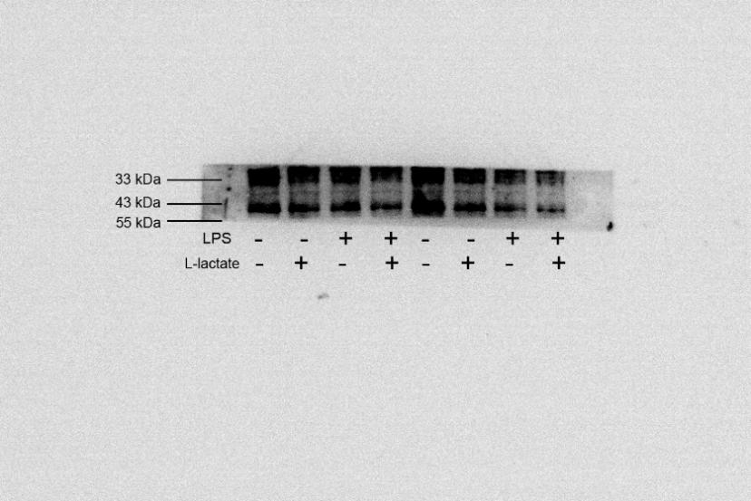

Figure 5D CREB1

Figure 5D β-Actin

Figure 5H VE-Cadherin

Figure 5H p-MLC2
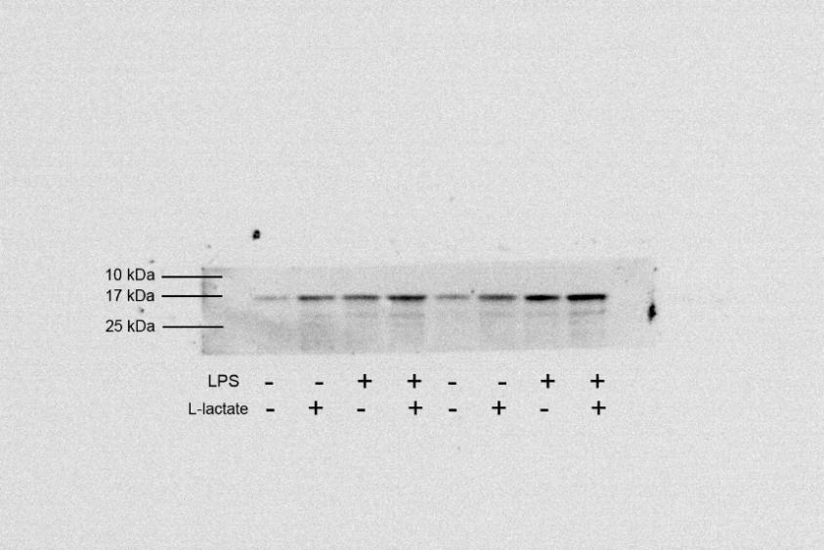

Figure 5H MLC2
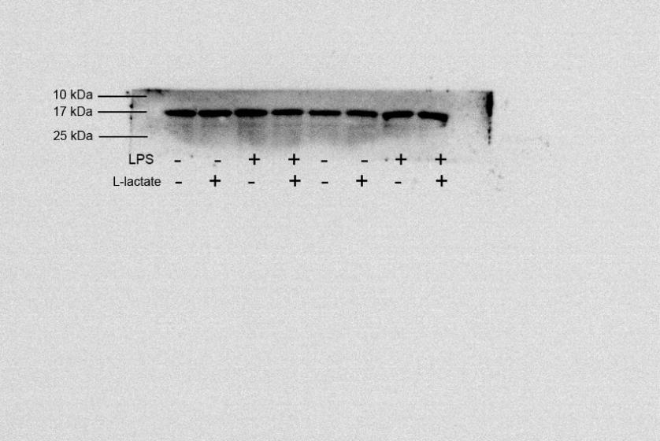

Figure 5D β-Actin

Figure 6B p-CREB1

Figure 6B CREB1

Figure 6B β-Actin
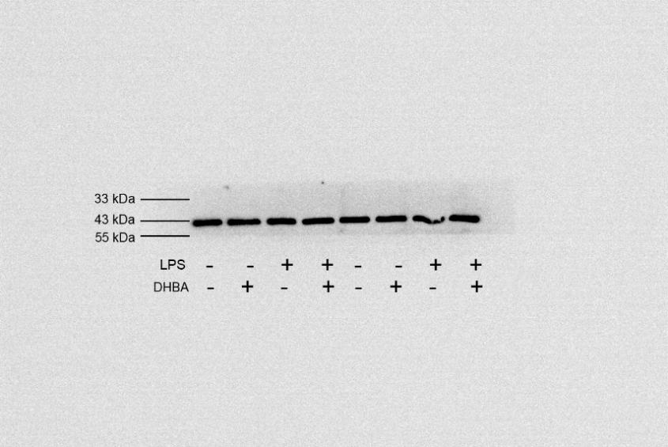

Figure 6D VE-Cadherin

Figure 6DFigure 13 p-MLC2
Figure 6D MLC2

Figure 6D β-Actin
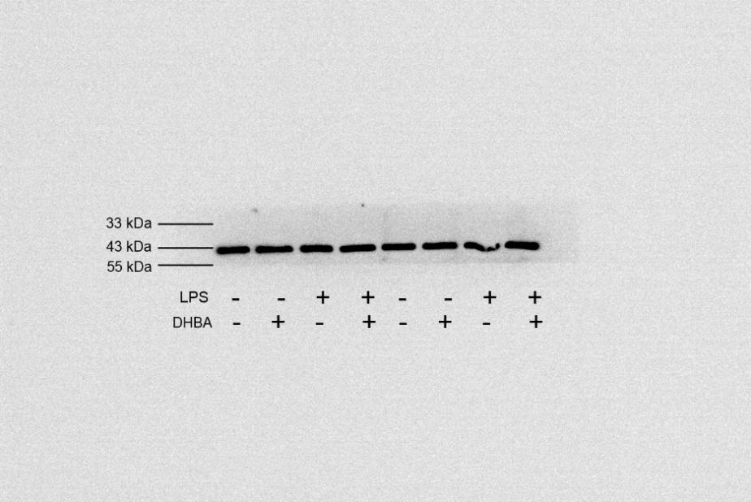

Figure 6F p-CREB1
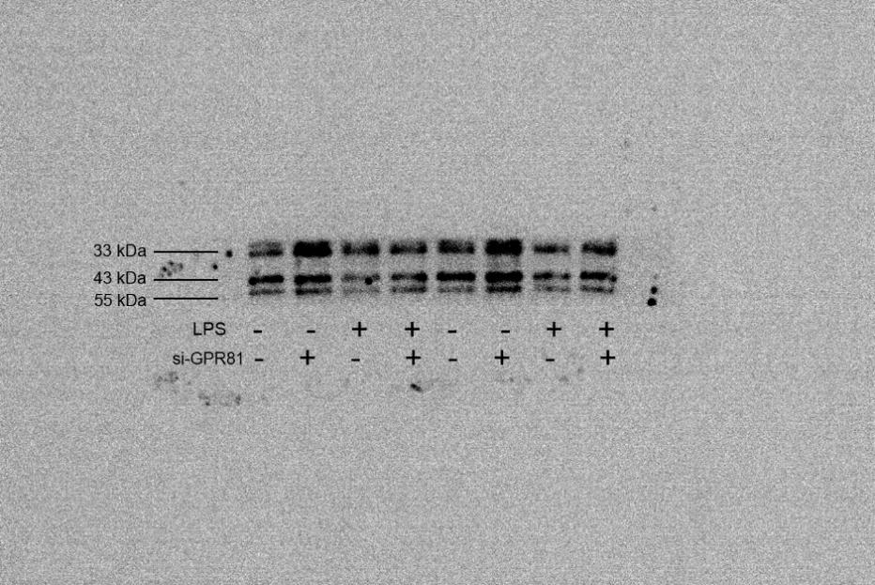
Figure 6F CEB1
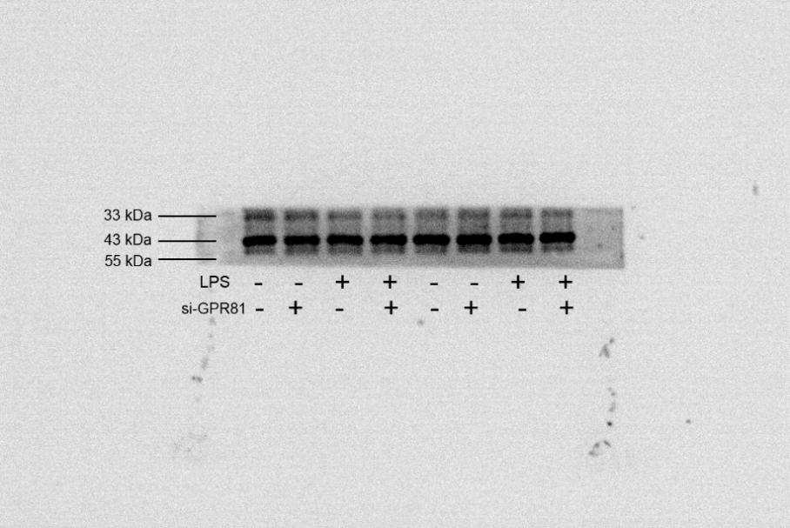

Figure 6F β-Actin

Figure 6H VE-Cadherin
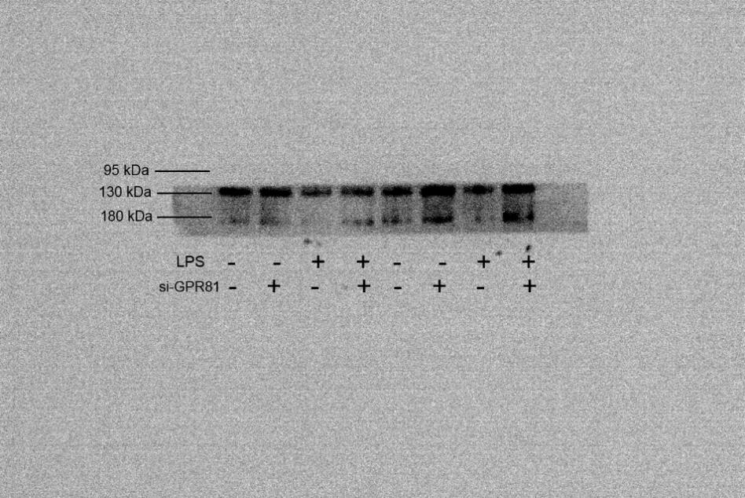
Figure 6H p-MLC2

Figure 6H MLC2

Figure 6F β-Actin
Figure 7B p-CREB1
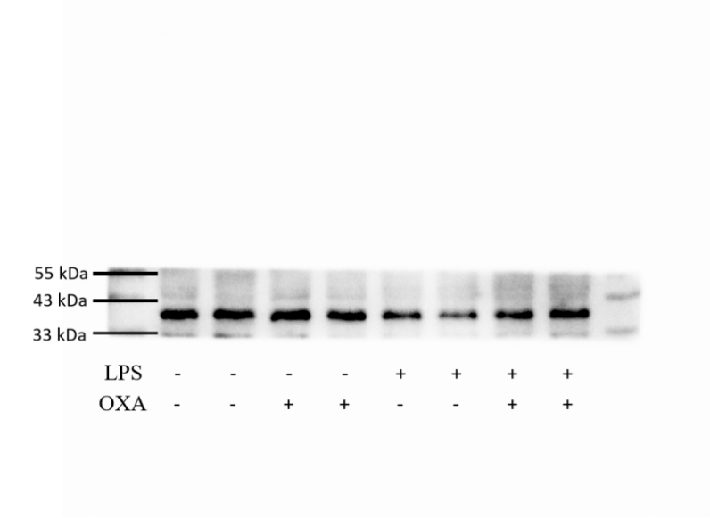

Figure 7B CREB1
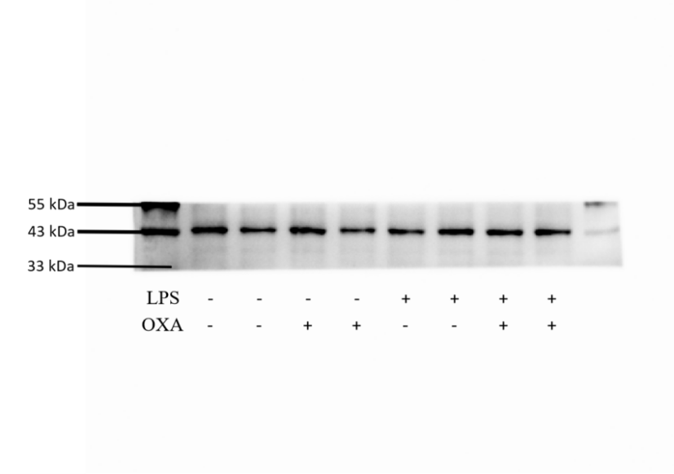

Figure 7B β-Actin
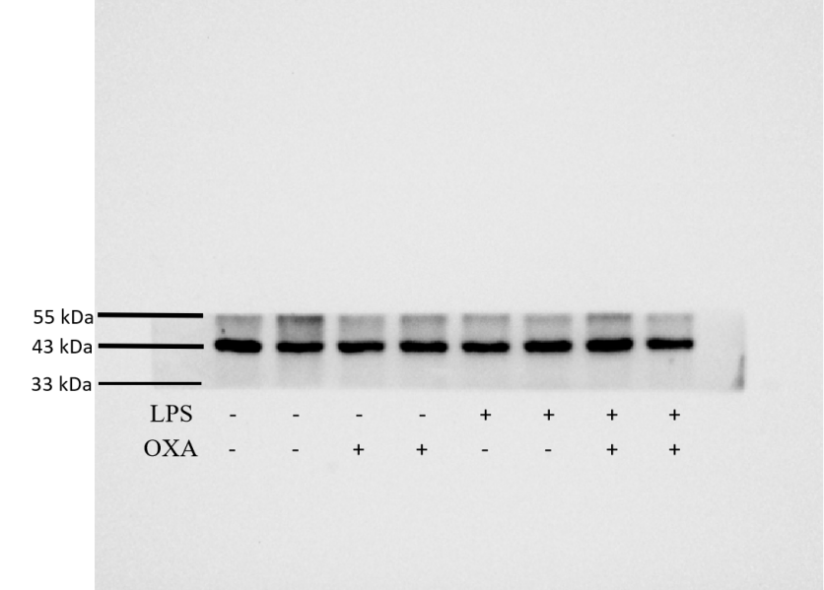
Figure 7D p-MLC2
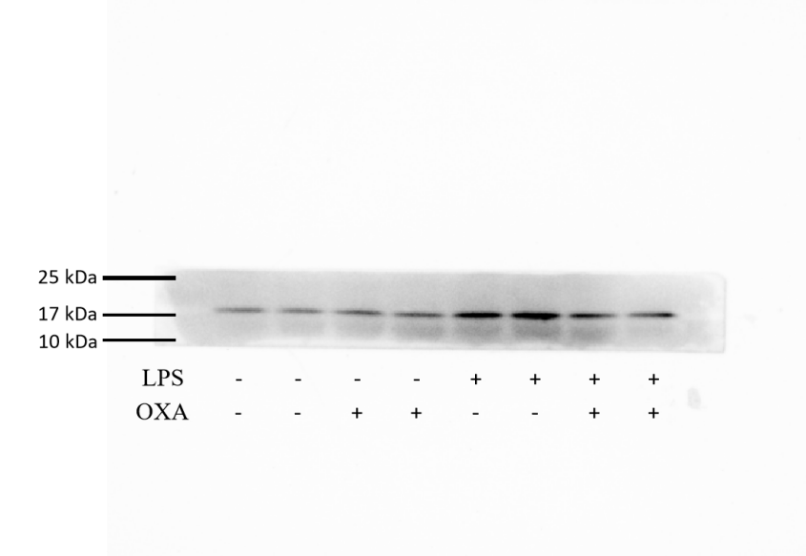

Figure 7D MLC2
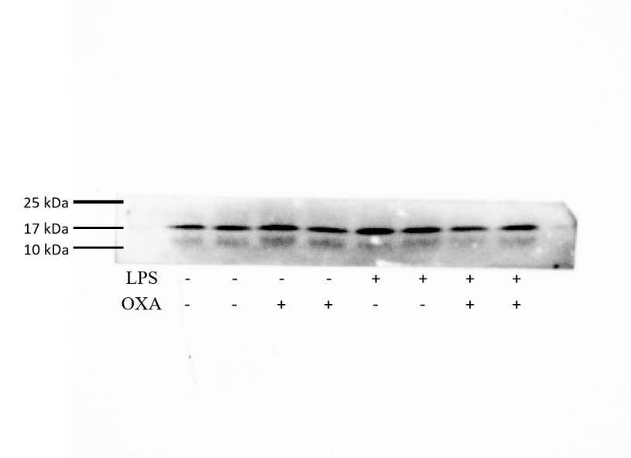

Figure 7D VE-Cadherin
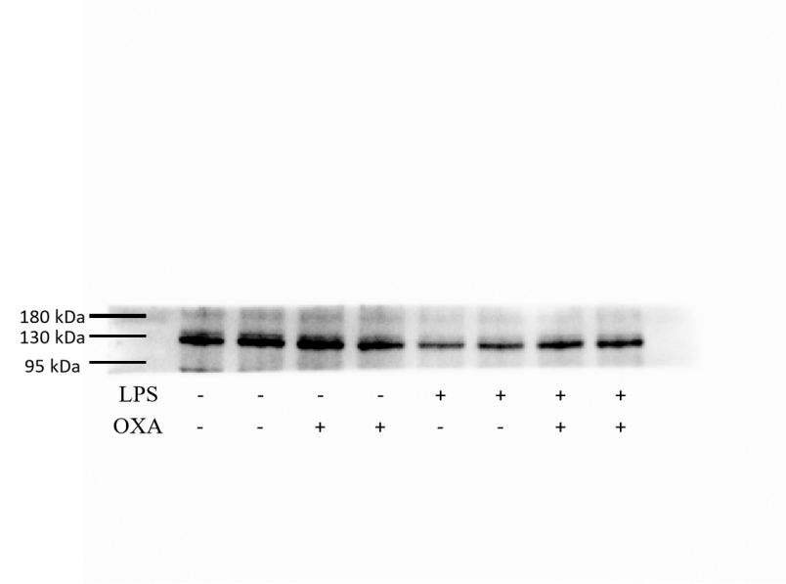
Figure 7D β-Actin
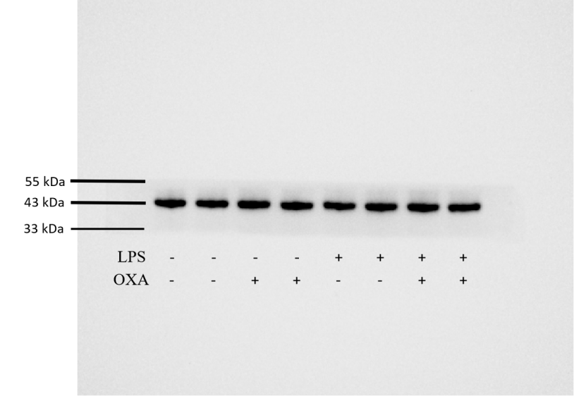

Figure 7F p-CREB1
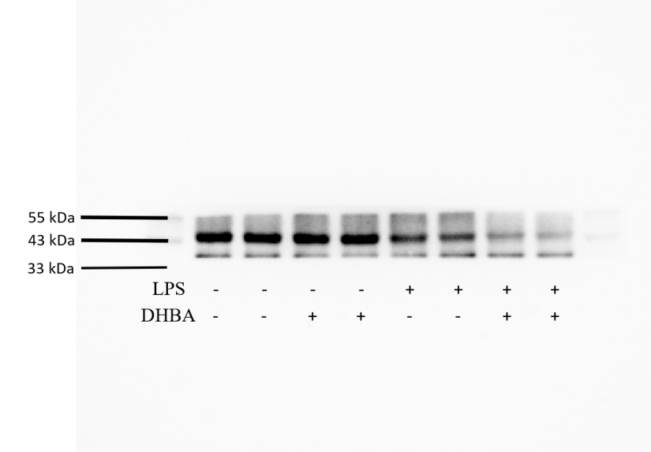

Figure 7F CREB1
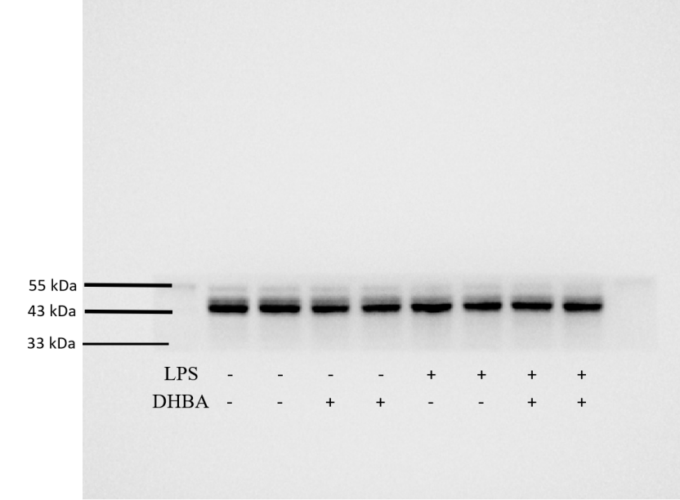
Figure 7F β-Actin
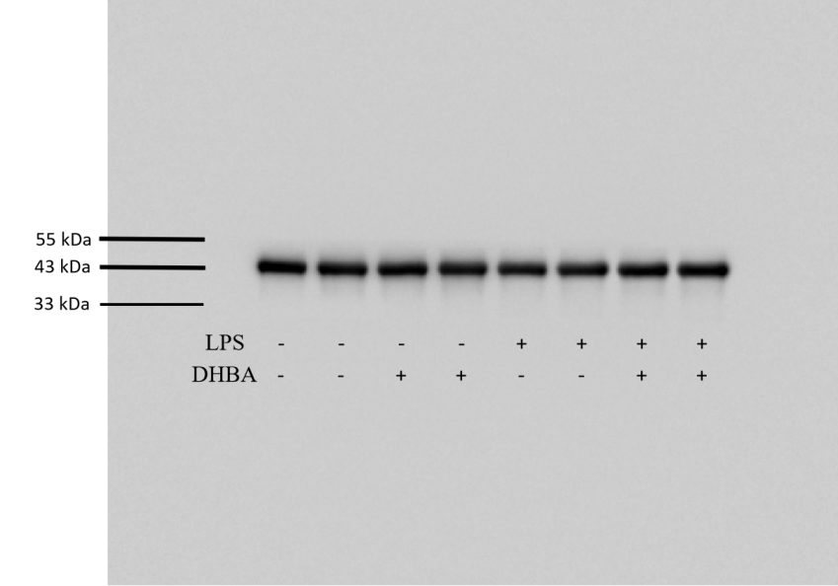

Figure 7H p-MLC2
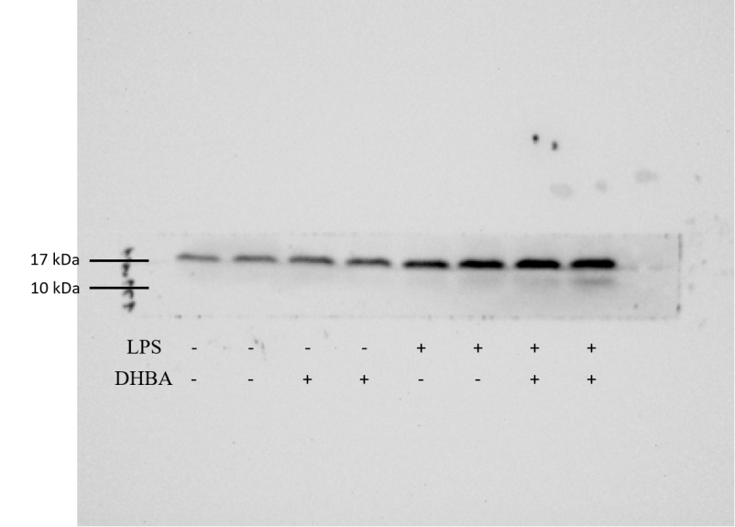

Figure 7H MLC2
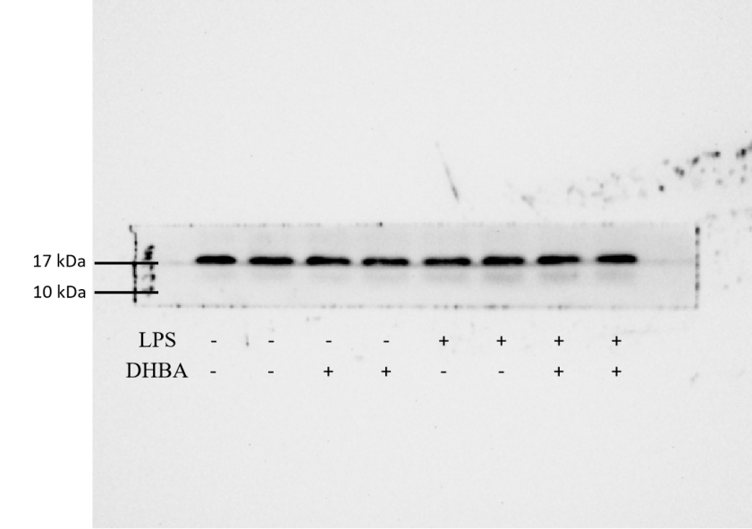
Figure 7H VE-Cadherin
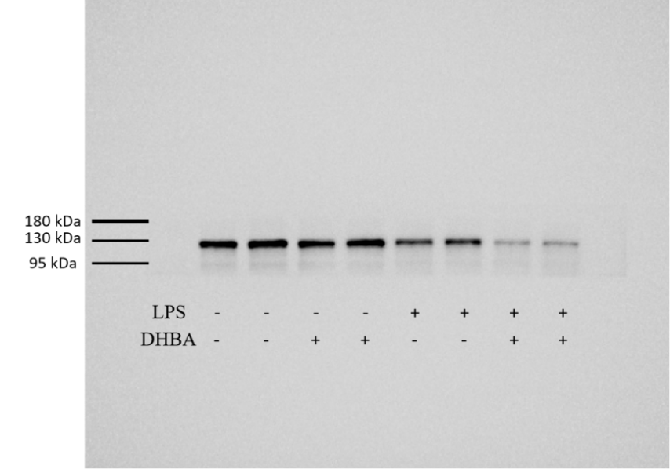

Figure 7H β-Actin
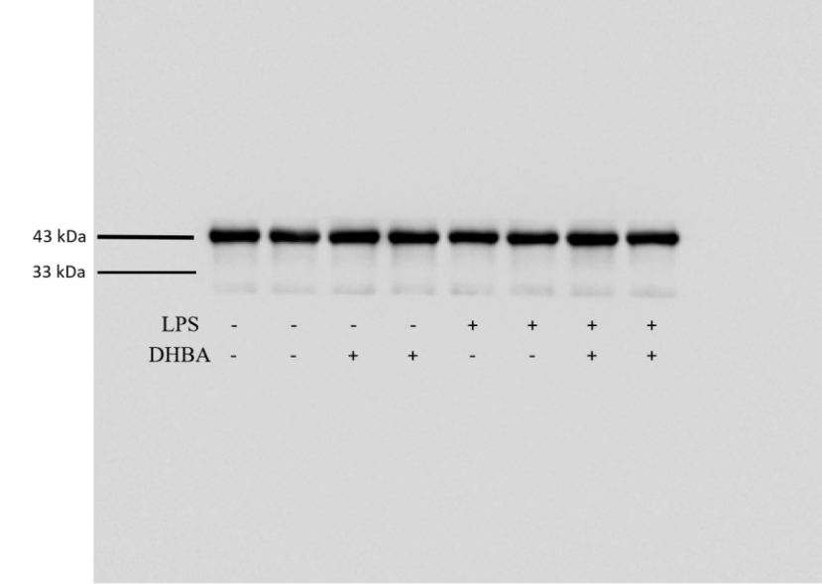

Figure 8B p-CREB1
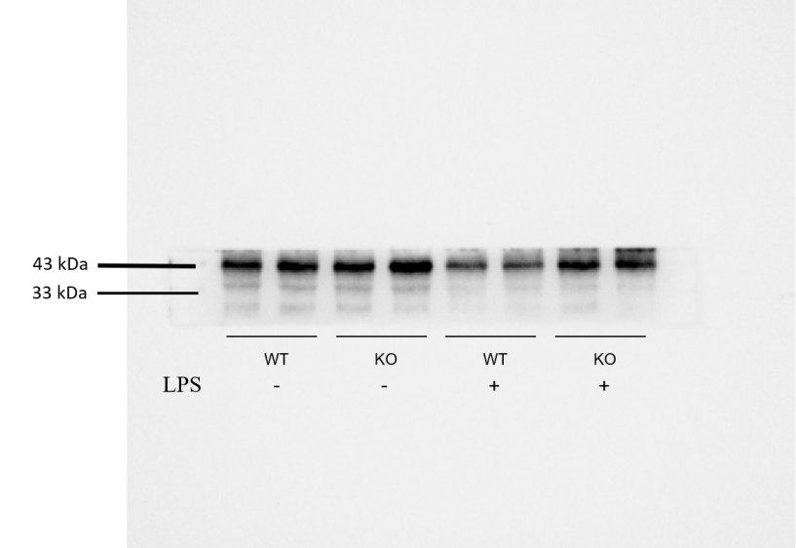
Figure 8B CREB1
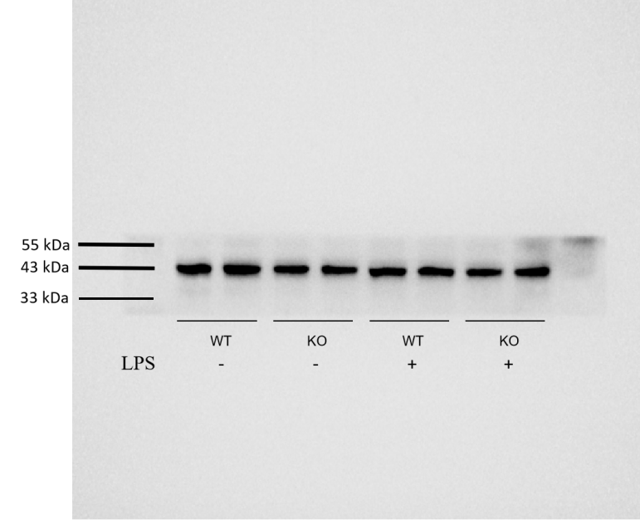

Figure 8B β-Actin
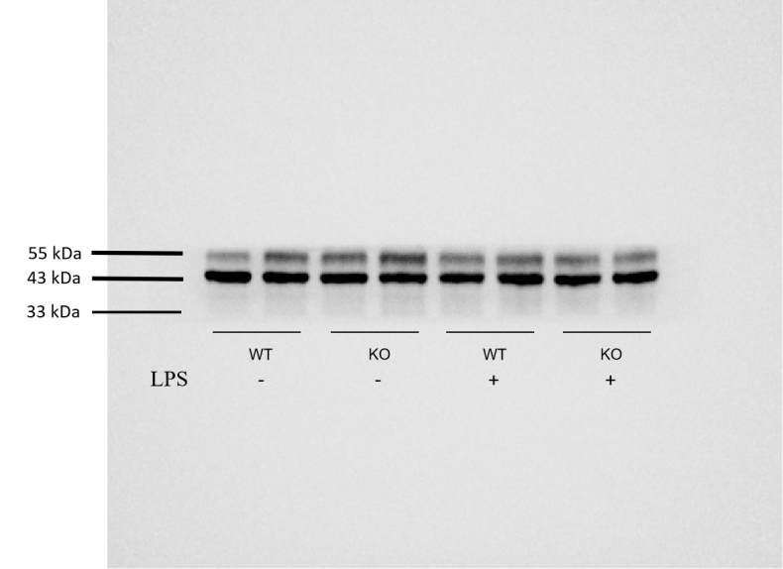

Figure 8D p-MLC2
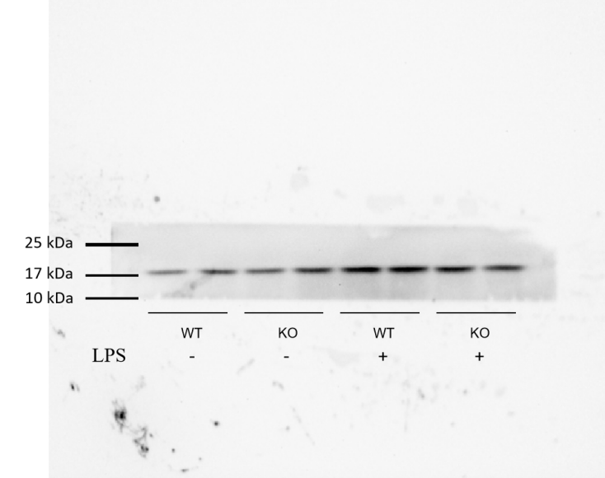
Figure 8D MLC2
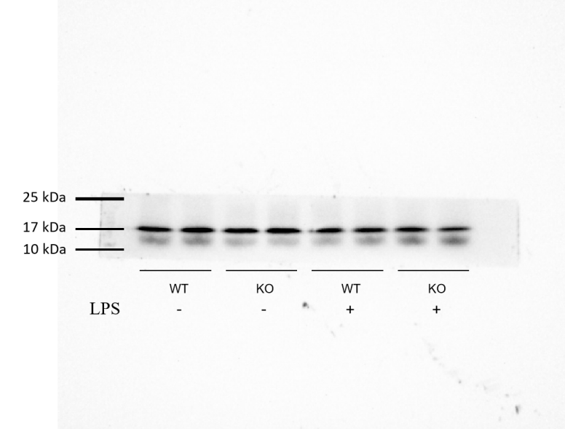

Figure 8D VE-Cadherin
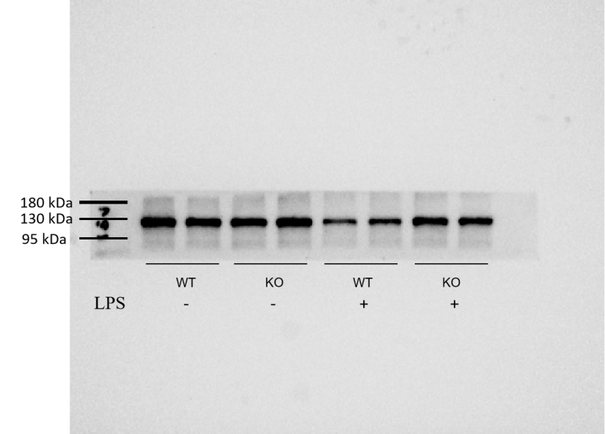

Figure 8D β-Actin
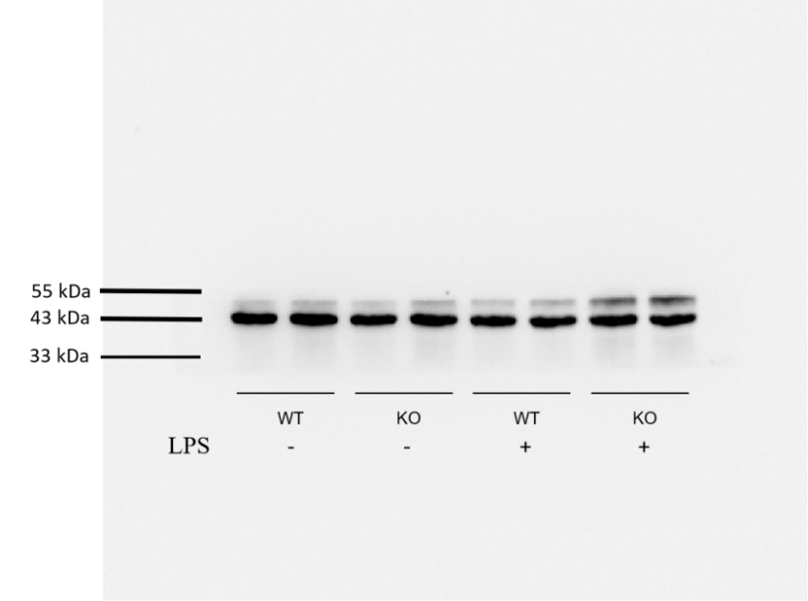
Figure 8F p-CREB1
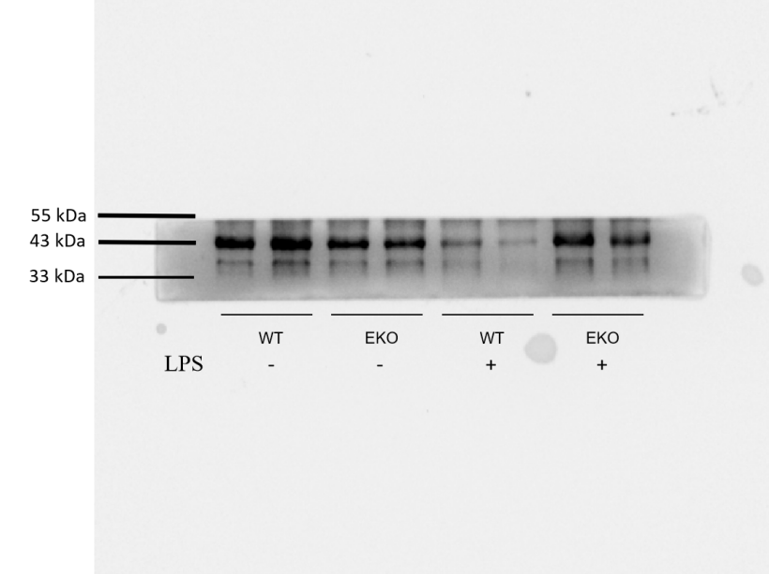

Figure 8F CREB1
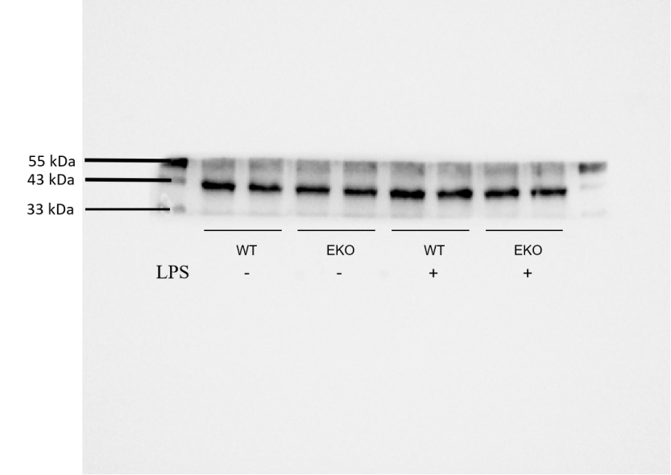

Figure 8F β-Actin
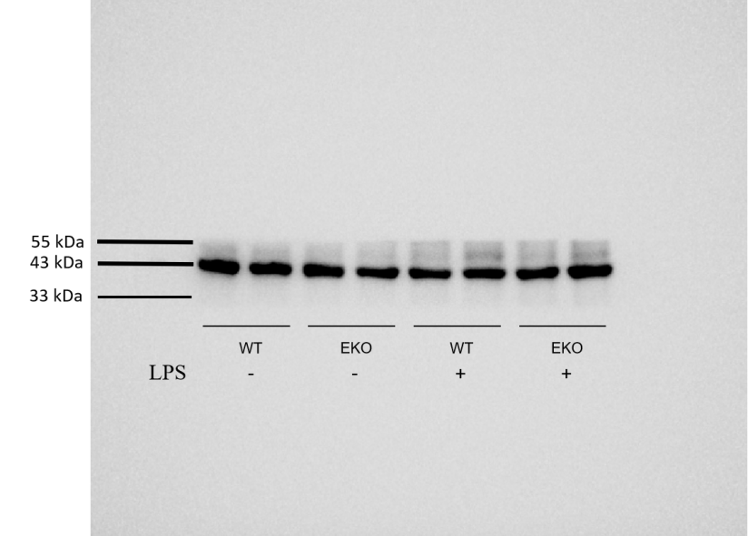
Figure 8H p-MLC2
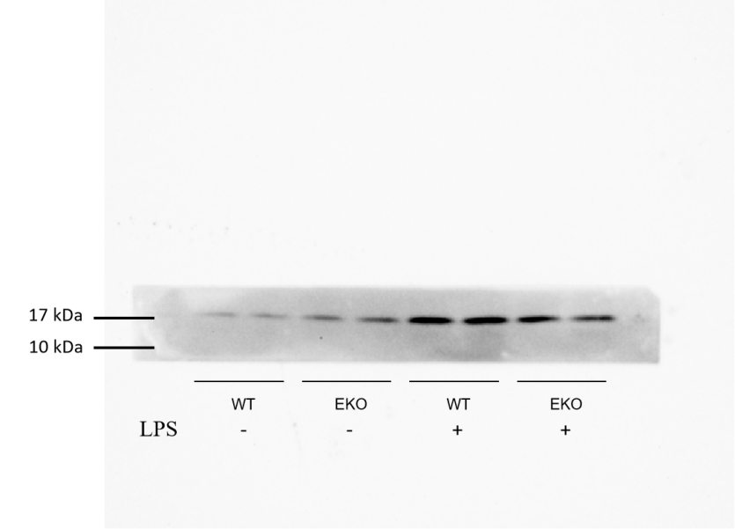

Figure 8H MLC2
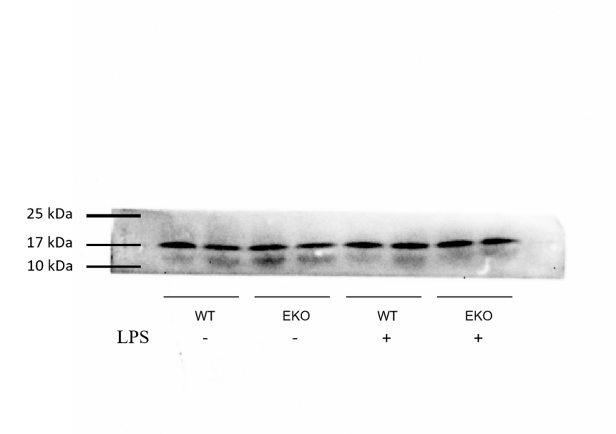

Figure 8H VE-Cadherin
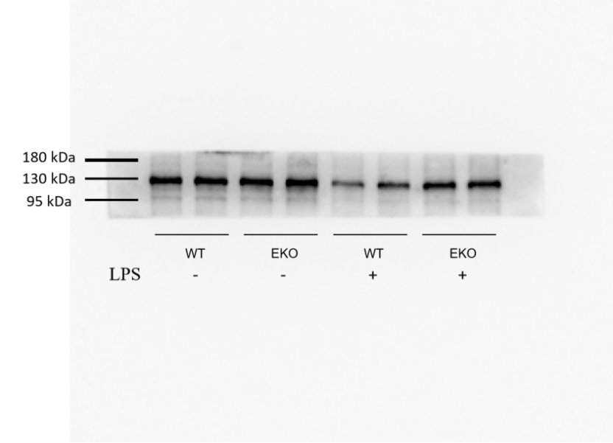
Figure 8H β-Actin
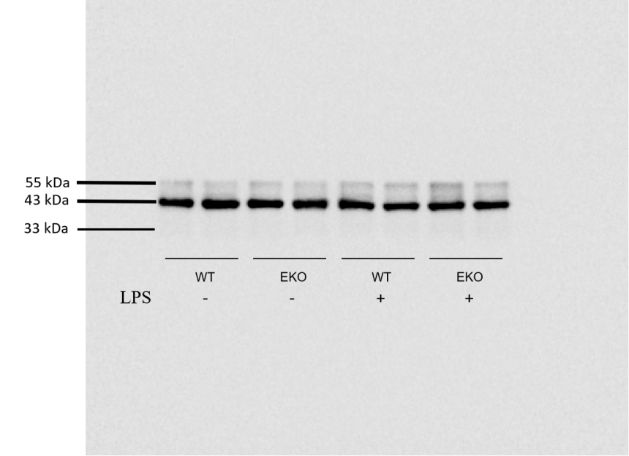

Supplementary Figure 6C p-CREB1
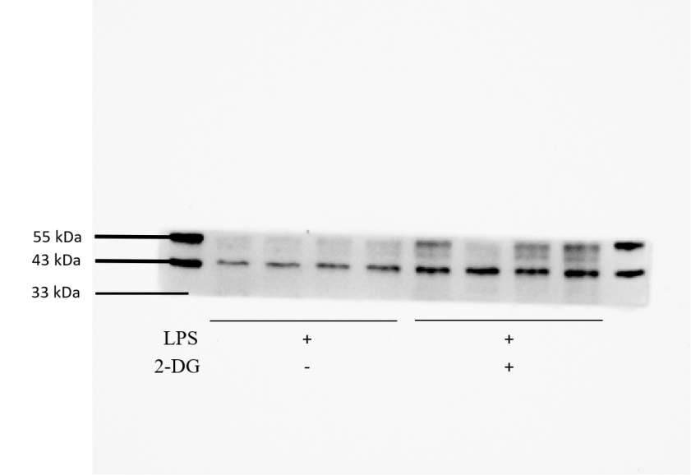
Supplementary Figure 6C CREB1
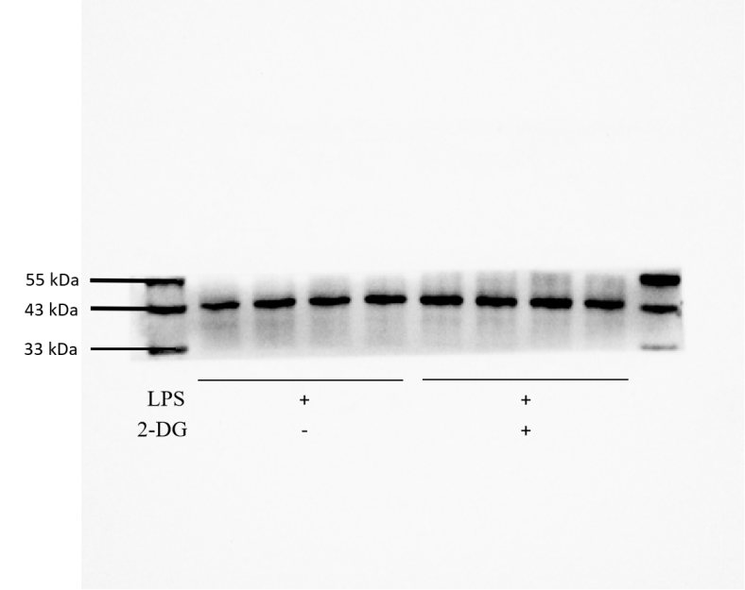

Supplementary Figure 6C β-Actin
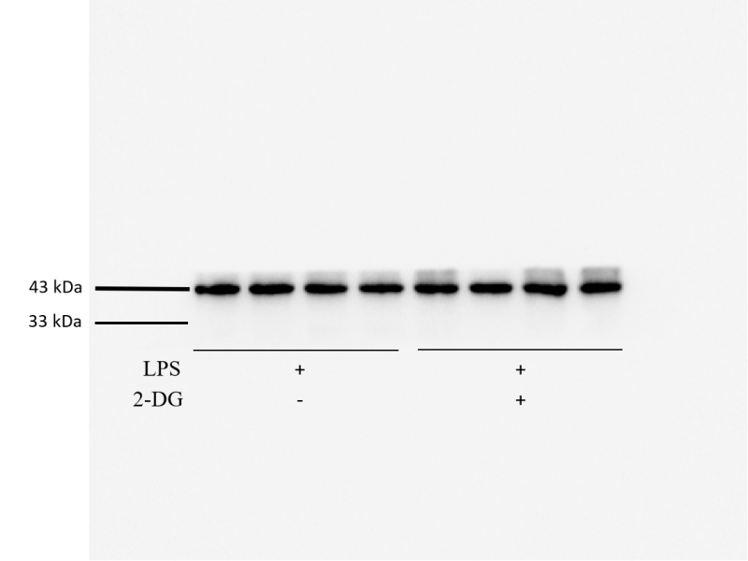
Supplementary Figure 6E p-MLC2
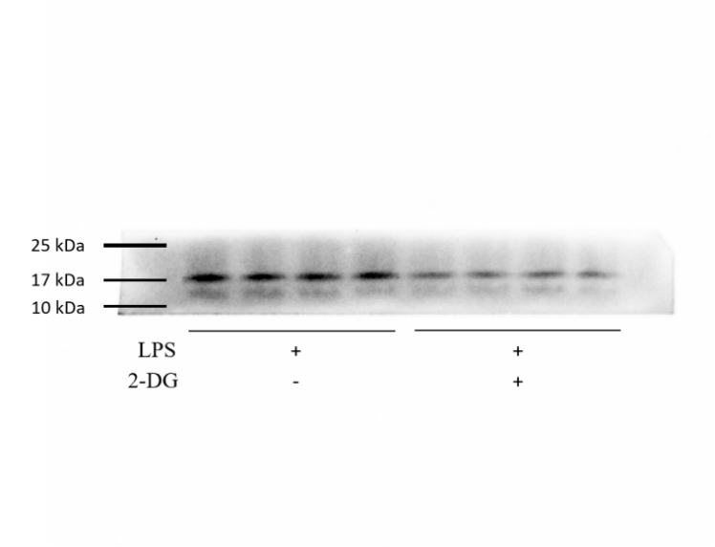

Supplementary Figure 6E MLC2
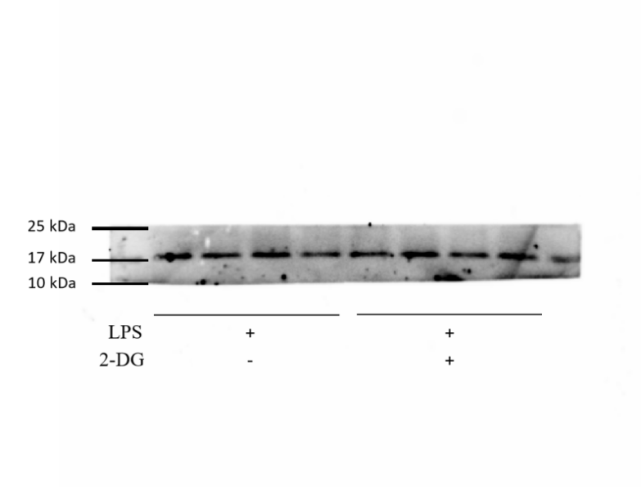

Supplementary Figure 6E VE-Cadherin
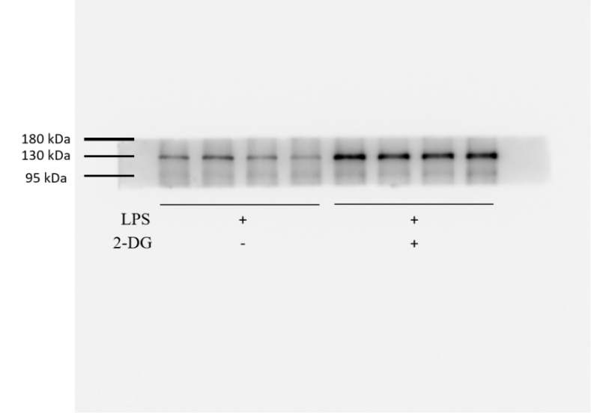

Supplementary Figure 6E β-Actin
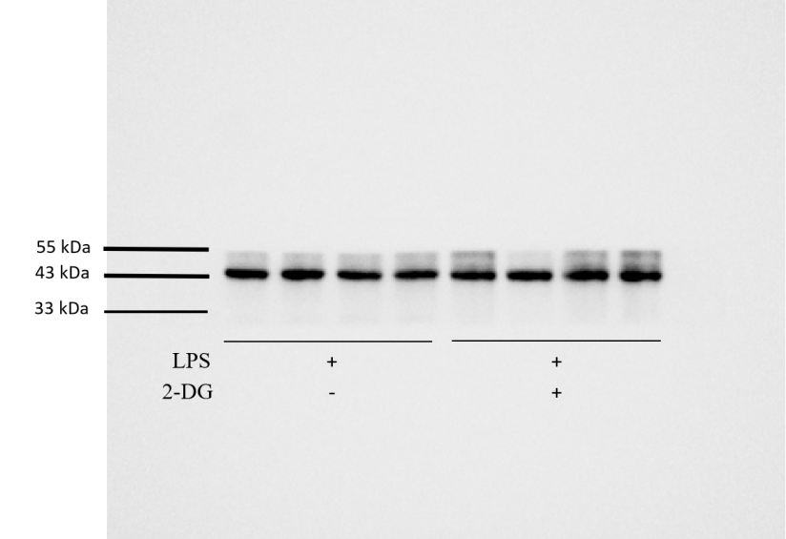

Supplementary Figure 7B p-CREB1
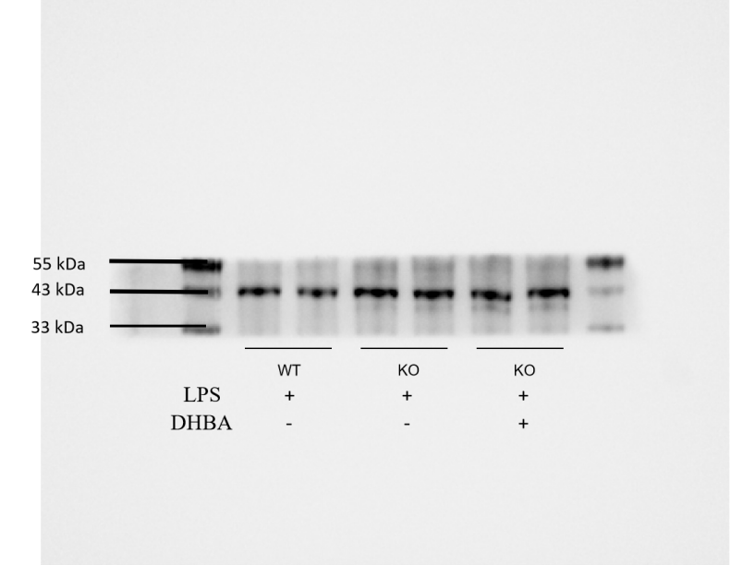
Supplementary Figure 7B CREB1
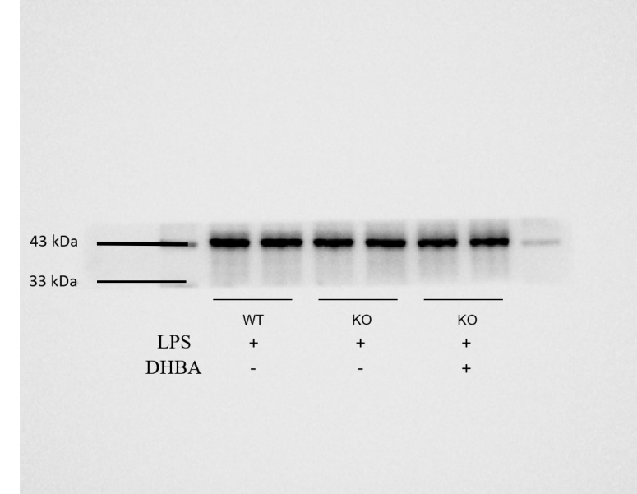

Supplementary Figure 7B β-Actin
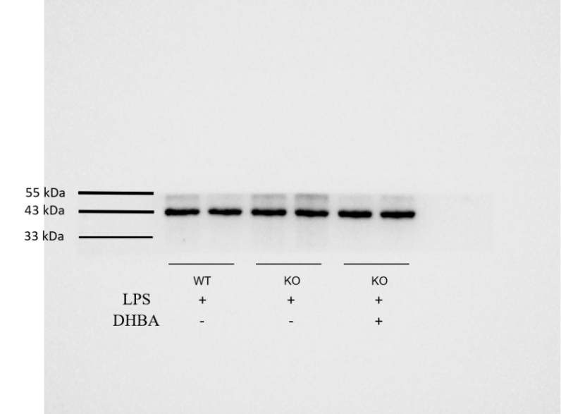

Supplementary Figure 7D p-MLC2
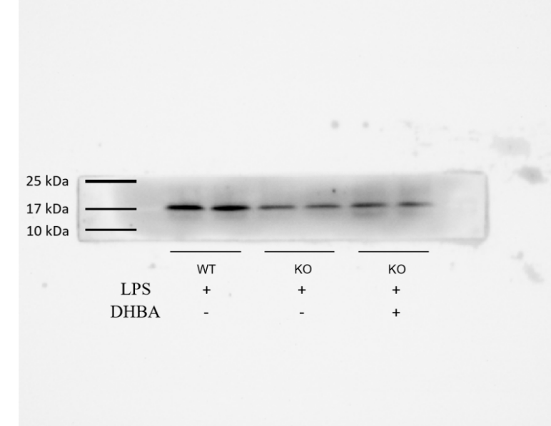

Supplementary Figure 7D MLC2
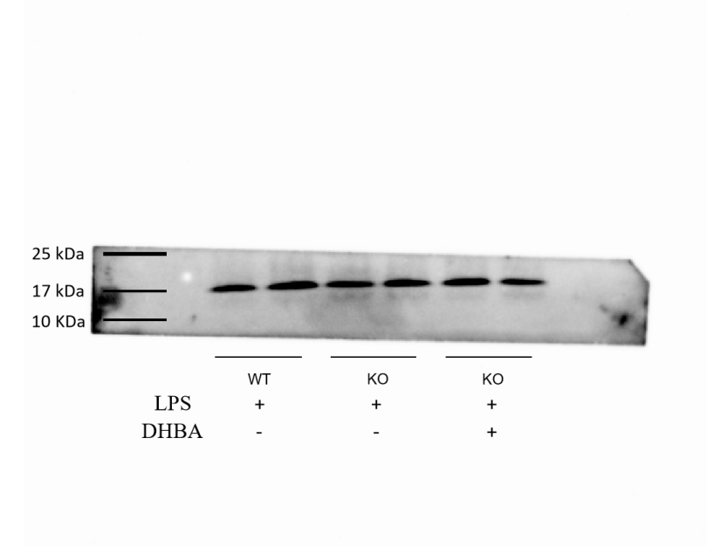

Supplementary Figure 7D VE-Cadherin
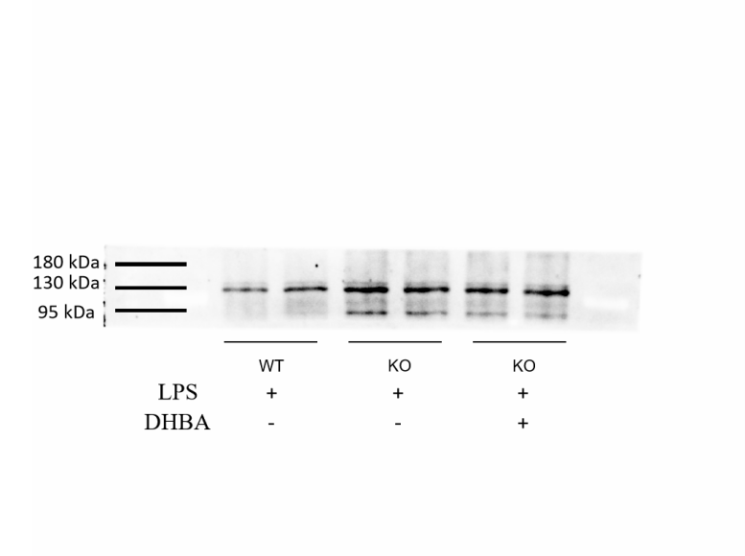
Supplementary Figure 7D β-Actin
