Figure S1. (A) UMAP visualization of dimensionality-reduced and unsupervised clustered cell populations within the tumor microenvironment. Distinct colors represent clusters, with annotated cell types indicated by text labels. The left and right panels represent the PR and SD group, respectively. (B) Bar plots showing the relative percentages of various cell types across samples, with different colors representing distinct cell types. (C) UMAP plot displaying further dimensionality reduction and clustering results for T and NK cells. (D) UMAP plot illustrating the expression density distribution of CD4/CD8/NK-cell markers and cytotoxic genes in the clustered T- and NK-cell populations. (E) Heatmap showing odds ratios (ORs) of NK-cell subtype abundance between radiologic responders and radiologic nonresponders. (F) Heatmap displaying the odds ratios (ORs) of TAM, monocyte, and cDC-cell subtype abundance between the PR and SD groups. (G) Spatial expression of the gene signature scores of cytokine signaling pathways across tissue spots. (H) Quantification of TIGIT+CD56+ NK cells, PDCD1+CD8+ T cells, and CD4+FOXP3+ Tregs per 200 μm × 200 μm field in postoperative tumor samples from radiologic responders (PR, n = 7) and radiologic nonresponders (SD, n = 7) after trastuzumab-based neoadjuvant therapy. (I) Correlation between SPP1 fluorescence intensity and the counts of TIGIT+CD56+ NK cells, PDCD1+CD8+ T cells, and CD4+FOXP3+ Tregs in the analyzed multiplex immunofluorescence fields. For H and I, patient-level mean values were used for statistical analysis. Group comparisons were performed using the Mann-Whitney U test, and correlations were assessed using Spearman correlation analysis.
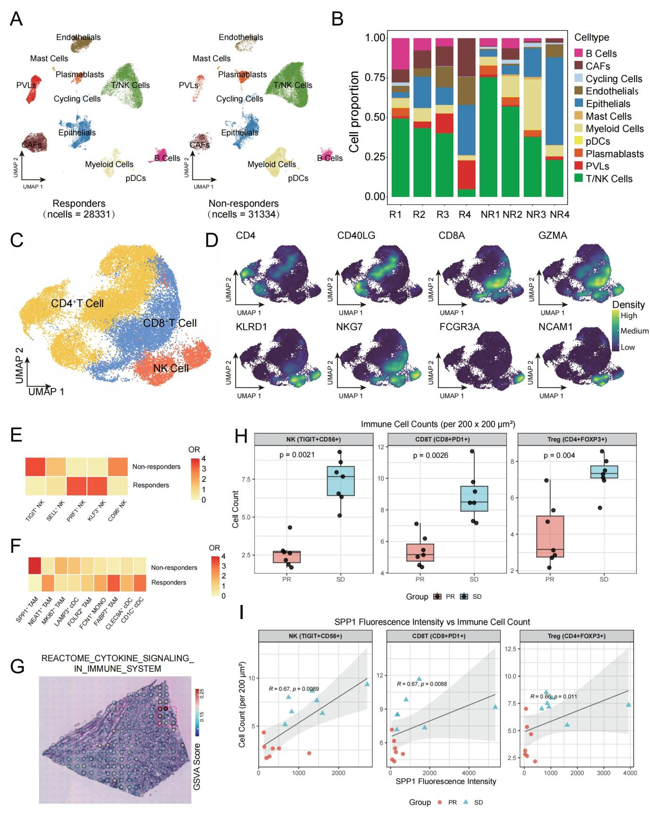

Figure S2. (A) Representative flow cytometry plots showing NK-cell enrichment after isolation from human peripheral blood mononuclear cells. Unstained controls and CD3/CD56-stained samples are shown. The right panel shows the proportion of human CD45+ and CD56+ cells in peripheral blood from humanized NCG mice after immune reconstitution. (B) Flow cytometry plot showing CD45RA and CCR7 expression levels in sorted naive CD8+ T cells. (C) Quantification of TIGIT+CD56+ NK cells per 200 μm × 200 μm field in tumor samples from SPP1EV-THP-1 and SPP1OE-THP-1 groups after trastuzumab treatment. (D) Correlation between SPP1 fluorescence intensity and TIGIT+CD56+ NK-cell counts in tumor samples from the in vivo experiment. Group comparisons were performed using the Mann-Whitney U test, and correlations were assessed using Spearman correlation analysis. (E) UMAP plot displaying the distribution density of the NT5E gene in various myeloid subgroups. (F) UMAP plot displaying the distribution density of the ADORA2A gene across subgroups in NK cells (left), CD4+ T cells (middle), and CD8+ T cells (right).
