SUPPLEMENTARY FIGURES

Supplementary Figures 1. AKAP2 immunoprecipitation for MS analysis. (A) HEK293 cells were transiently transfected for 24h with AKAP2- Flag expressing vector. Lysates were blotted and detected by silver-stained dye. (B) Principal component analysis of mass spectrometry data. Median LC-MS Pearson correlation: R= 0.88+/- 0.07 and R= 0.95+/-0.02 for EV and AKAP2 conditions, respectively.

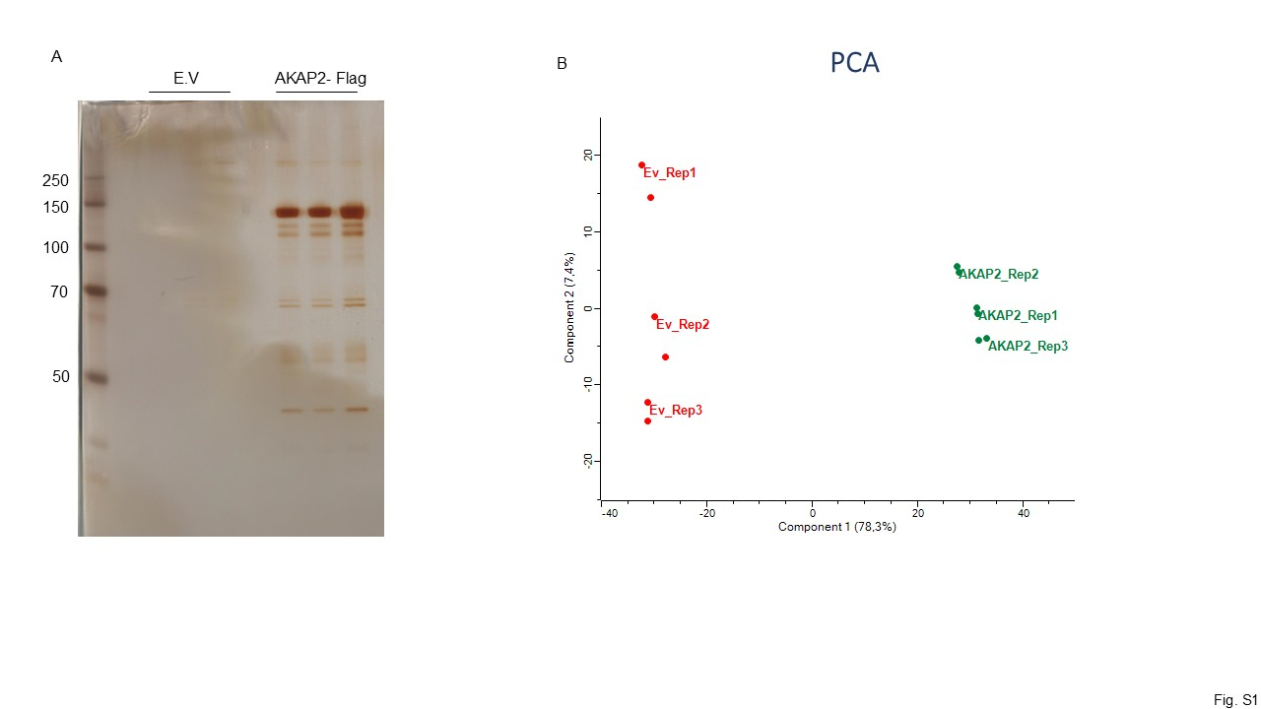

Supplementary Figures 2. AKAP2 localizes at primary cilium. (A) ARPE-19 cells were starved for 36h, fixed and immunostained for AKAP2 (red). Nuclei were stained with DAPI (blue). Scale bar, 5µm and 3µm. (B) ARPE-19 stably expressing AKAP2- GFP were starved for 36h, fixed and immunostained for Acetylated Tubulin (red). Nuclei were stained with DAPI (blue). Scale bar, 5µm.

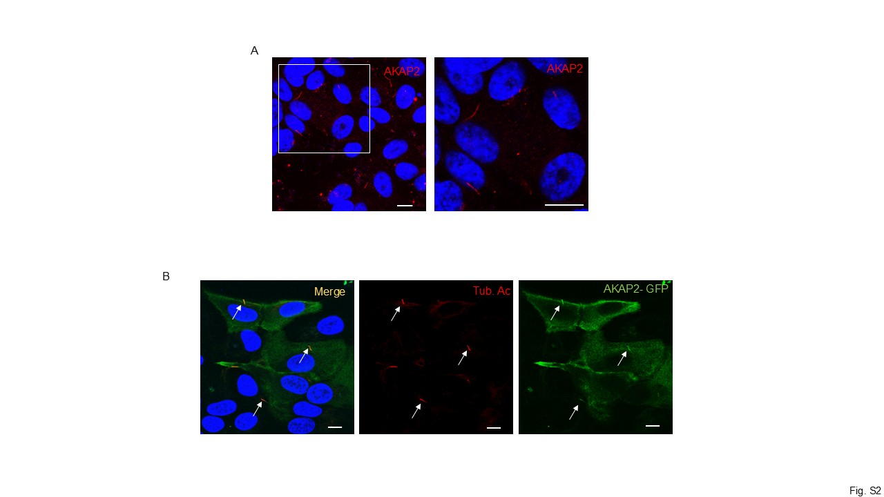

Supplementary Figure 3. AKAP2 KO strategy. (A) Schematic representation of the Cds variant 4 Palm2/ AKAP2 gene. In red the RNA guide (gRNA) used for AKAP2 gene KO strategy.

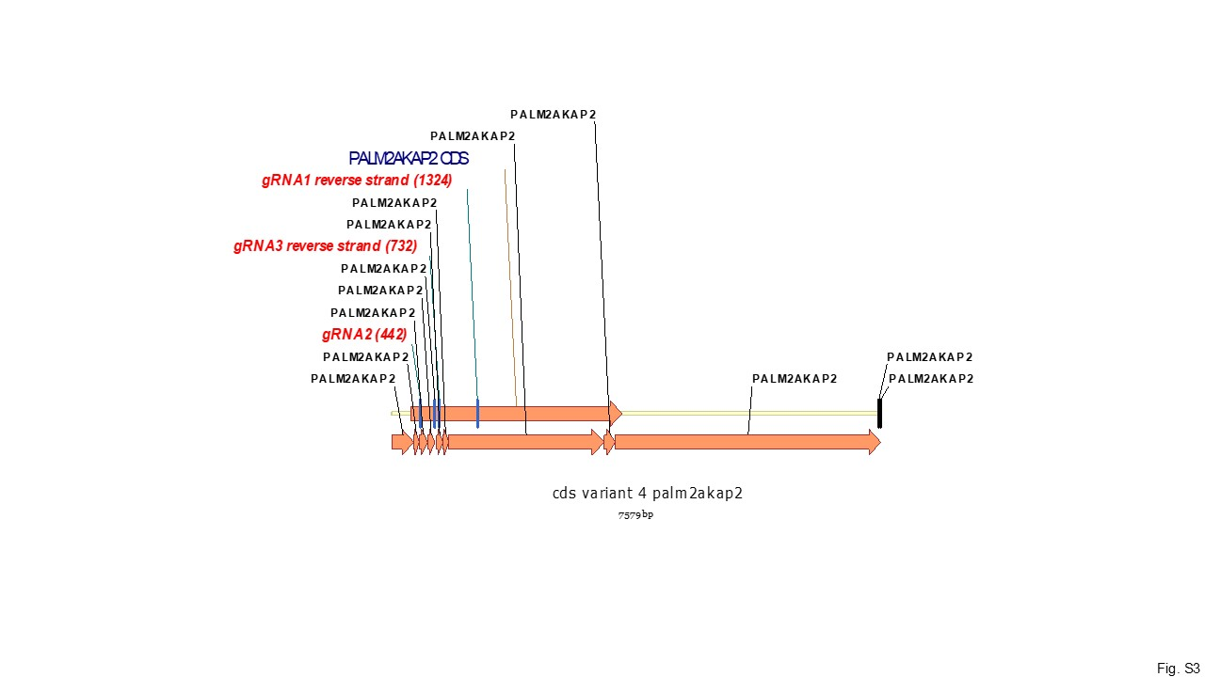

Supplementary Figure 4. AKAP2 is required for ciliary localization of RIIβ subunit. (A) WT and AKAP2 KO cells were starved for 36h, fixed and immunostained for Acetylated Tubulin (red) and PKA- RIIß (green); Scale bar, 3µm. (B) Cumulative data of the experiments shown in (A). Quantitative analysis of three biological independent experiments, mean ± SD is indicated. t test ***P < 0.001.

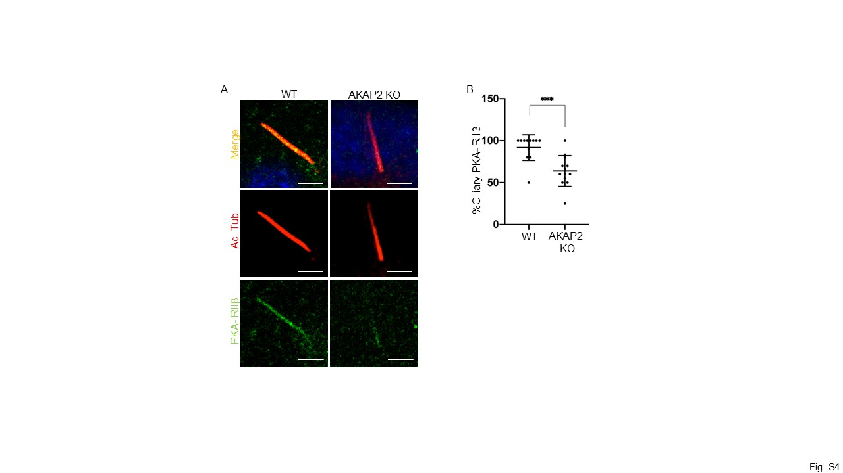

Supplementary Figure 5. AKAP2 regulates PKA regulatory subunits localization at primary cilium. (A) ARPE-19 were transiently transfected with control siRNA (siRNAc) or siRNA targeting AKAP2 (siAKAP2). Cells were starved for 36h, fixed and immunostained for PKA- RI (blu), Arl13b (green) and AKAP2 (red). (B) Cumulative data of three experiments shown in (A). Student’s t test does not show statistical significance. (C) ARPE-19 were transiently transfected with control siRNA or siRNA targeting AKAP2 (siAKAP2). Cells were starved for 36h, fixed and immunostained for PKA- RII (green), acetylated tubulin (blu) and AKAP2 (red). (D) Cumulative data of the experiments shown in (C). Quantitative analysis of three biological independent experiments, mean ± SD is indicated. t test ****P < 0.0001. (E) Western Blot showing the genetic knockdown of AKAP2. Lystes from ARPE-19transiently transfected with control siRNA or siRNA targeting AKAP2 (siAKAP2) were immunoblotted with anti-AKAP2 and anti-β-actin.
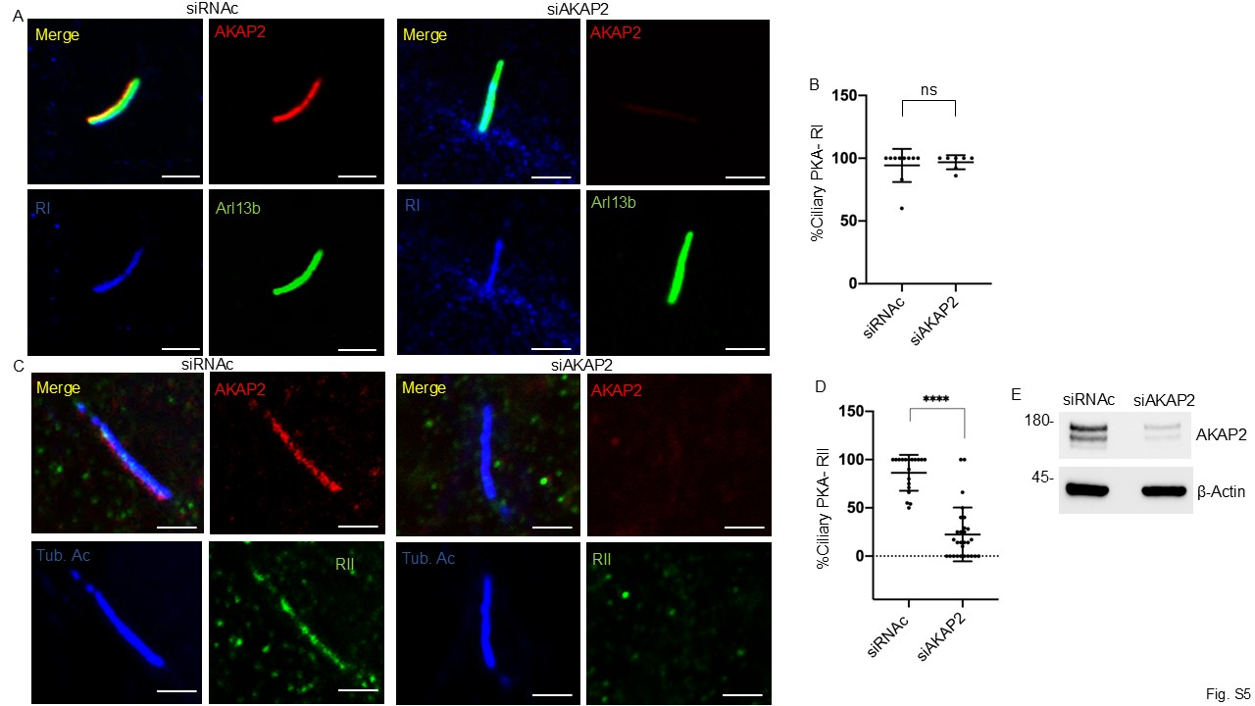

Supplementary Figure 6. AKAP2 did not affect the protein levels and the localization of other ciliary AKAPs. (A) WT and AKAP2 KO cells were starved for 36h, fixed and immunostained for Acetylated Tubulin (green) and AKAP150 (red); Scale bar, 3µm. (B) Lysates from ARPE-19 wild-type and AKAP2KO were immunoblotted with anti-AKAP150, anti- GPR161 and anti-HSP90. (C) Cumulative data of the experiments shown in (B). Quantitative analysis of three independent experiments. A mean value ± SD is indicated. t test P > 0.05.
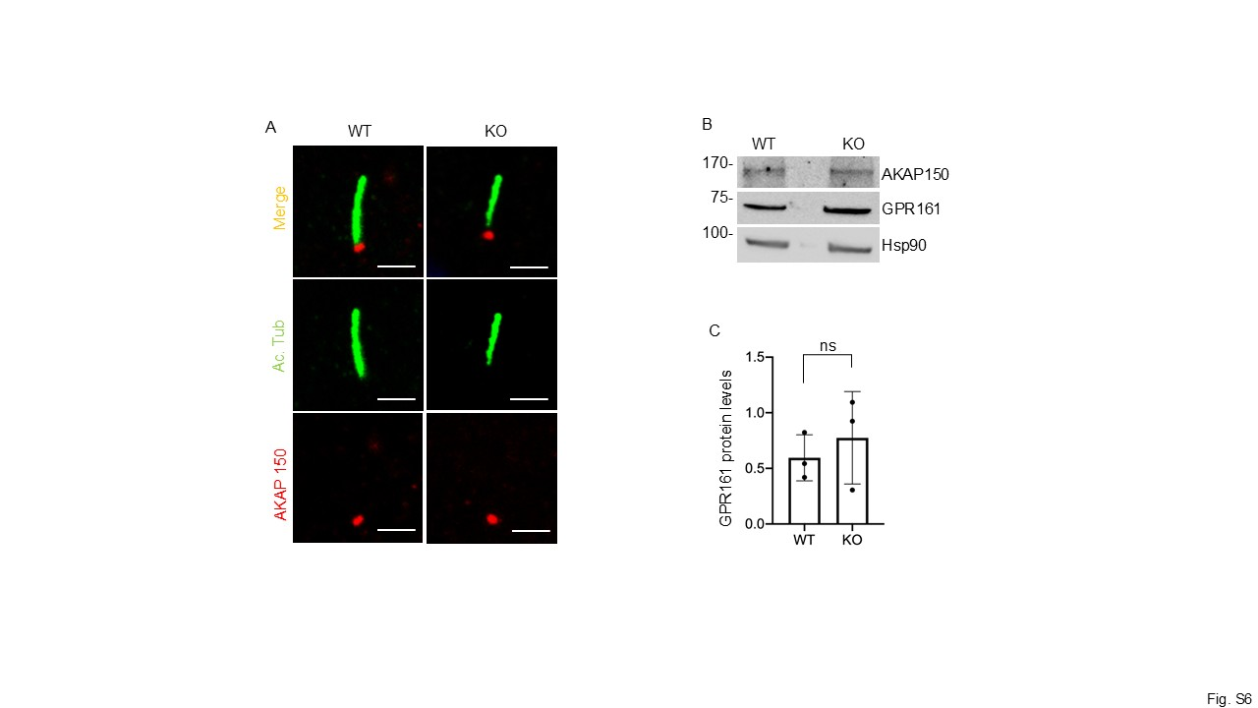

Supplementary Figure 7. Downregulation of AKAP2 affects ciliogenesis and ciliary trafficking. (A) ARPE-19 were transiently transfected with control siRNA or siRNA targeting AKAP2 (siAKAP2). Cells were starved for 36h and left untreated or stimulated with somatostatin (SST) for 3h. Cells were fixed and doubly immunostained for SSTR3 (green) and Acetylated Tubulin (red). Nuclei were stained with DAPI (blue). Scale bar, 5µm. (B) Cumulative data of the experiments shown in (A). Quantitative analysis of three biological independent experiments, mean ± SD is indicated. t test ****P < 0.0001. (C) Percentage of ciliated cells. Cumulative data of the experiments shown in (A and D). (D) ARPE-19 were transiently transfected with control siRNA or siRNA targeting AKAP2 (siAKAP2). Cells were serum-deprived for 36h and left untreated or stimulated with purmorphamine (Pur) for 6h. Cells were fixed and doubly imunostained for GPR161 (green) and Acetylated Tubulin (red). Nuclei were stained with DAPI (blue). Scale bar, 5µm. (E) Cumulative data of the experiments shown in (D). Quantitative analysis of three biological independent experiments, mean ± SD is indicated. t test ****P < 0.0001. (F) Western Blot shows the genetic knockdown of AKAP2. Lystes from ARPE-19transiently transfected with control siRNA or siRNA targeting AKAP2 (siAKAP2) were immunoblotted with anti-AKAP2 and anti-β-actin.
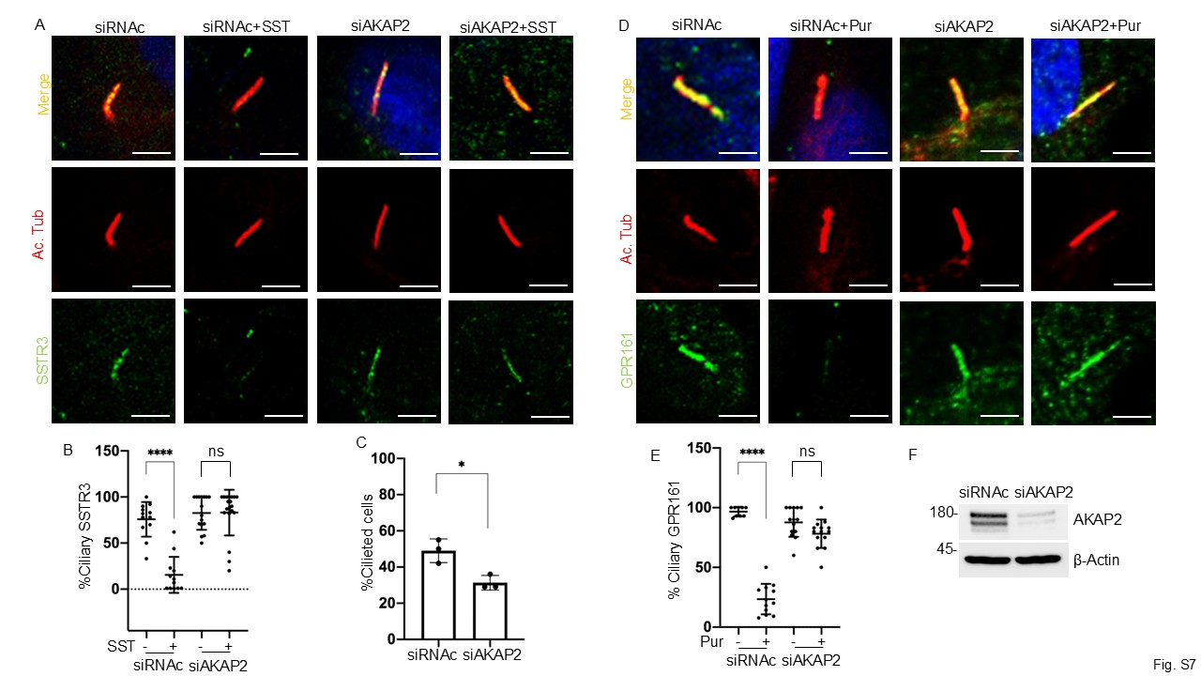

Supplementary Figure 8. Translocation of ciliary GLI2 to the nucleus requires AKAP2 (A) ARPE-19 were transiently transfected with control siRNA or siRNA targeting AKAP2 (siAKAP2). Cells were serum-deprived for 36h and left untreated or stimulated with purmorphamine (Pur) for 6h. Cells were fixed and doubly immunostained for GLI2 (green) and Acetylated Tubulin (red). Nuclei were stained with DAPI (blue). Scale bar, 5µm. (B) Cumulative data of the experiments shown in (A). Fluorescence intensity was measured using Fiji software and expressed in arbitrary units (A.U.). Quantitative analysis of three biological independent experiments, mean ± SD is indicated. t test ****P < 0.01. (C) Western Blot shows the genetic knockdown of AKAP2. Lystes from ARPE-19transiently transfected with control siRNA or siRNA targeting AKAP2 (siAKAP2) were immunoblotted with anti-AKAP2 and anti-β-actin.
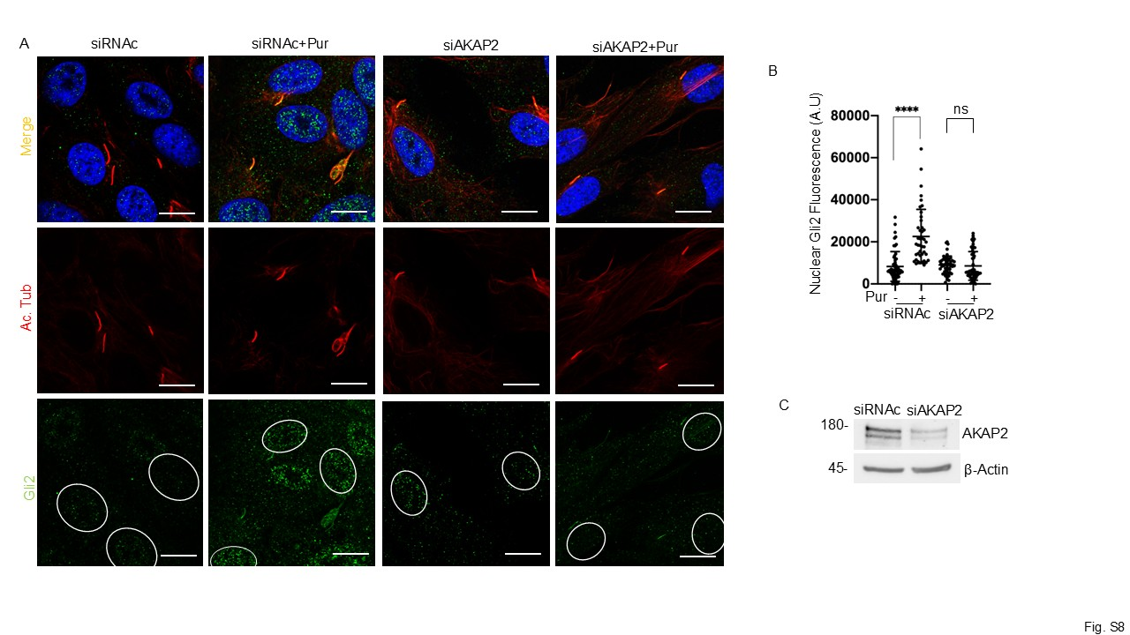

Supplementary Figure 9. Representative images of the primary cilium in medaka fish model. Immunofluorescence analysis of TBC1D31 (magenta) and acetylated α‐tubulin (green) in wild type and Mo Akap2 medaka embryos. Scale bar, 5µm.

