Supplemental material
Supplemental Figure 1. Apoptotic processes were initially induced by the DT insult, but subsided at later time points. (A) Apoptosis-specific GO terms were analyzed during the time course after DT injection and normalized to 0 daDT. (B) Graphs depicting gene expression presented as fold change normalized to 0 daDT, as determined by RNAseq analysis. Points represent average from 3 different samples and p-value is indicated above each point.
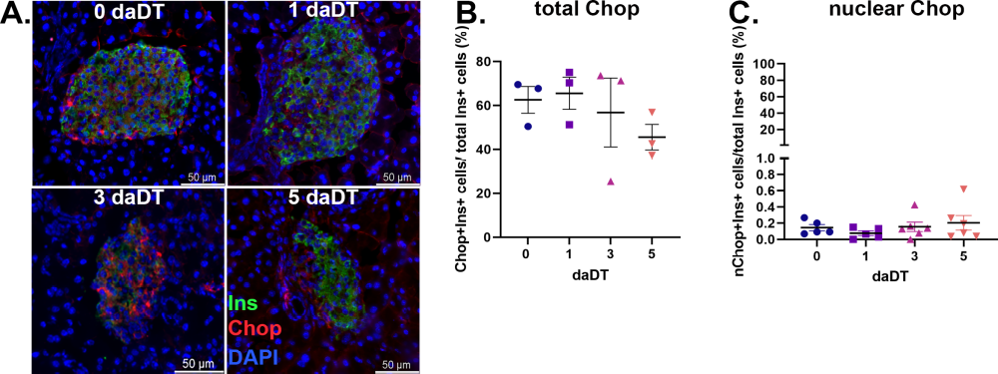
Supplemental Figure 2. Chop expression did not significantly change during the mild ablation. (A) Immunofluorescence images of islet sections stained for Insulin (green), Chop (red) and DAPI (blue), collected at various time points, as indicated. Graphs displaying the percentages of β-cells that present Chop expression (B) and nuclear Chop expression (C), from the total number of β-cells, per islet section, per mouse. Each point represents the mean±SEM per mouse. For (B), n=3/time point, and for (C), n=5 for 0 and 1 daDT, and n=6 for 3 and 5 daDT.
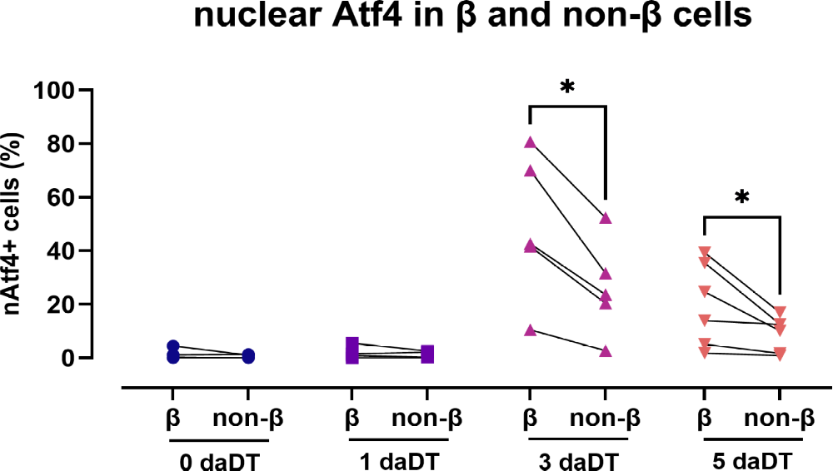
Supplemental Figure 3. Nuclear Atf4 expression in β and non-β-cells. Graph displaying the percentages of nAtf4-positive insulin-positive cells (β-cells) and nAtf4-positive insulin-negative cells (non-β-cells), containing non-β endocrine, exocrine and ductal cells from pancreatic cells during the mild β-cells ablation (images from Figure 5G), per islet section, per mouse. Each point represents the mean±SEM per mouse (n=6 for 0 and 5 daDT, n=5 for 3 daDT, and n=4 for 1 daDT). * p<0.05.

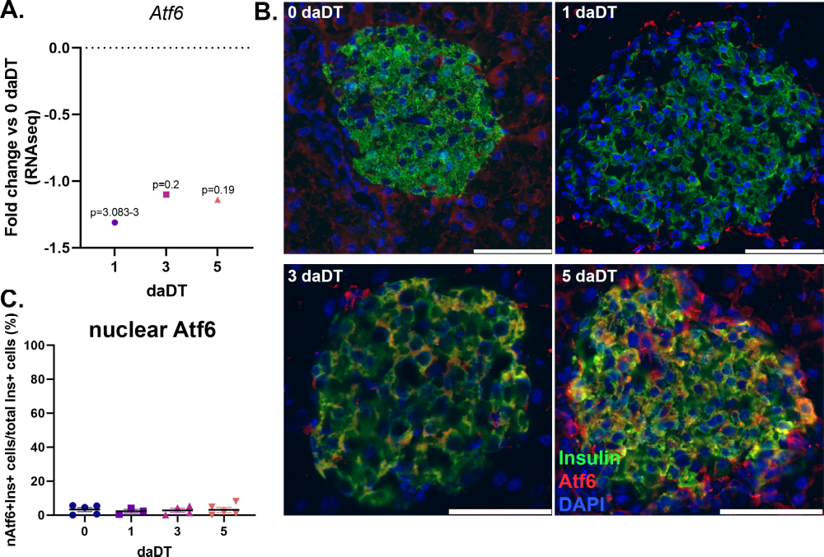
Supplemental figure 4. The Atf6 branch was not significantly modulated in the remaining β-cells during the mild ablation. (A) Evolution of fold change difference for Atf6 mRNA expression during the 5 days time course, as compared to 0 daDT, determined by RNAseq. Each dot represents the average (n=3), and the p-value is shown above. (B) Immunofluorescence images of islet sections stained for insulin (green), Atf6 (red) and DAPI (blue), collected at various time points, as indicated. (C) Quantification of the percentages of double-positive insulin-nAtf6 cells from the total number of insulin-positive cells, per islet section, per mouse. Each point represents the mean±SEM per mouse (n=5 for 0 and 5 daDT, n=3 for 1 daDT, n=4 for 3 daDT).

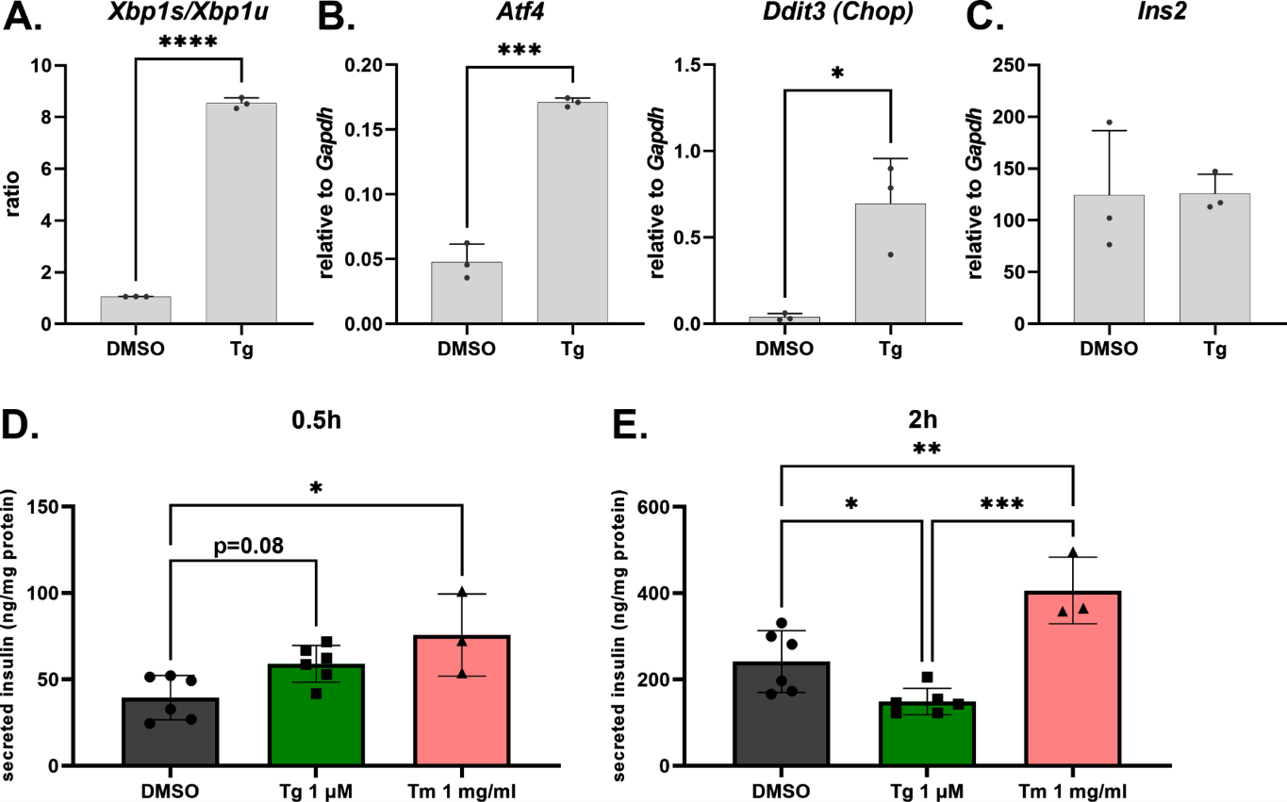
Supplemental figure 5. Temporal dissociation between acute Ca²⁺-dependent insulin secretion and ER stress–mediated suppression following thapsigargin treatment. (A) Graph depicting ratio between spliced Xbp1 and unspliced Xbp1 mRNA levels determined by qRT-PCR analysis in DMSO- and 1 μM thapsigargin- (Tg) exposed Min6 cells after 4 hours of incubation. Relative mRNA expression of UPR targets Atf4 and Ddit3 (Chop) (B) and Ins2 (C) in MIN6 cells treated as in (A), and normalized to Gapdh. Equal numbers of cells were cultured in RPMI culture media supplemented DMSO (vehicle), 1 μM Tg and 1 mg/ml tunicamycin (Tm) for 0.5 and 2 h, respectively. At each time point, media was collected for quantification of secreted insulin that was normalized to the total protein content. Graphical representation of the secreted insulin from the cells treated for 0.5 (D) and 2 hours (E), respectively. Mean ± SD, by one way ANOVA (n=3-6), and *** p<0.0005, **p<0.001, *p<0.05.

