Supplementary figures and figure legends
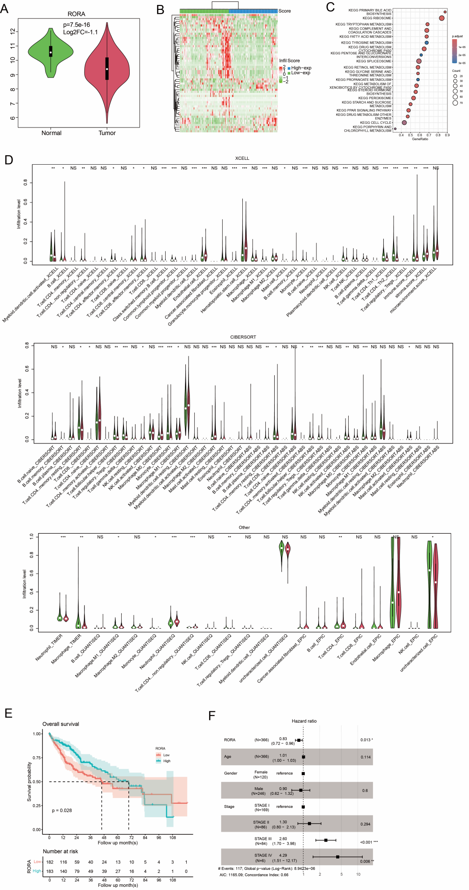
Figure S1. Clinical relevance of RORA in the TCGA liver cancer cohort. (A) RORA mRNA expression in tumor versus normal tissues. (B) Heatmap of differentially expressed genes between high- and low-RORA patient groups. (C) KEGG pathway analysis of DEGs. (D) Correlation of RORA expression with immune cell infiltration scores. (E) Kaplan-Meier analysis of Overall Survival based on RORA expression. (F) Multivariate Cox regression analysis of prognostic factors. *p < 0.05, **p < 0.01, ***p < 0.001.
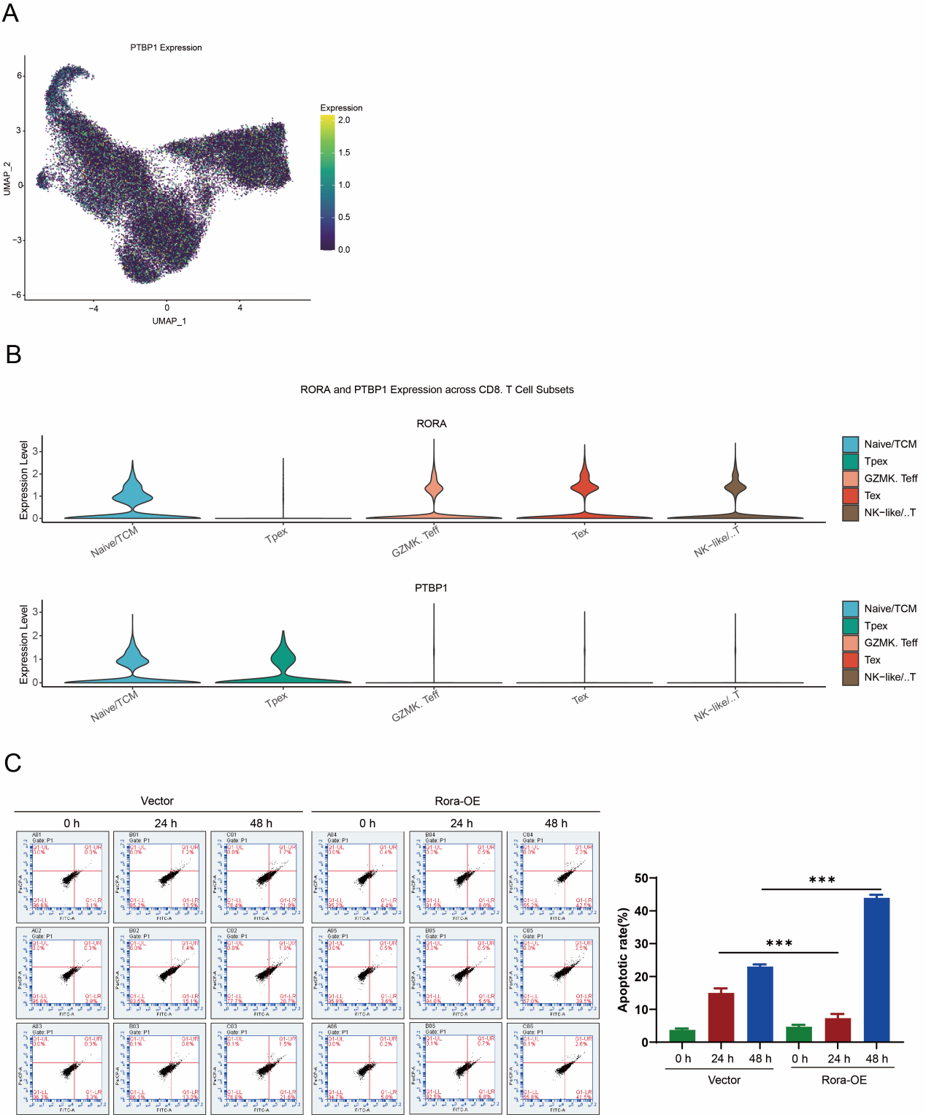
Figure S2. PTBP1 expression across CD8+ T-cell subsets and the effect of sustained RORA overexpression on T-cell survival. (A) Feature plot showing PTBP1 expression in CD8+ T cells from the single-cell RNA-seq dataset. (B) Violin plots illustrating the distribution of RORA and PTBP1 expression across distinct CD8+ T-cell subsets, including Naive/TCM, Tpex, GZMK+ Teff, Tex, and NK-like/γδT cells. (C) Representative Annexin V/PI flow cytometry plots and quantification of apoptosis in primary CD8+ T cells transduced with empty vector or Rora-overexpression constructs and cultured for 0, 24, or 48 h. Rora overexpression reduced apoptosis at the early stage but was associated with increased apoptosis after prolonged culture, consistent with activation-induced cell death following sustained T-cell activation. Data are presented as mean ± SD (n = 3). Statistical significance was determined using one-way ANOVA followed by Tukey’s multiple-comparisons test. ***P < 0.001.
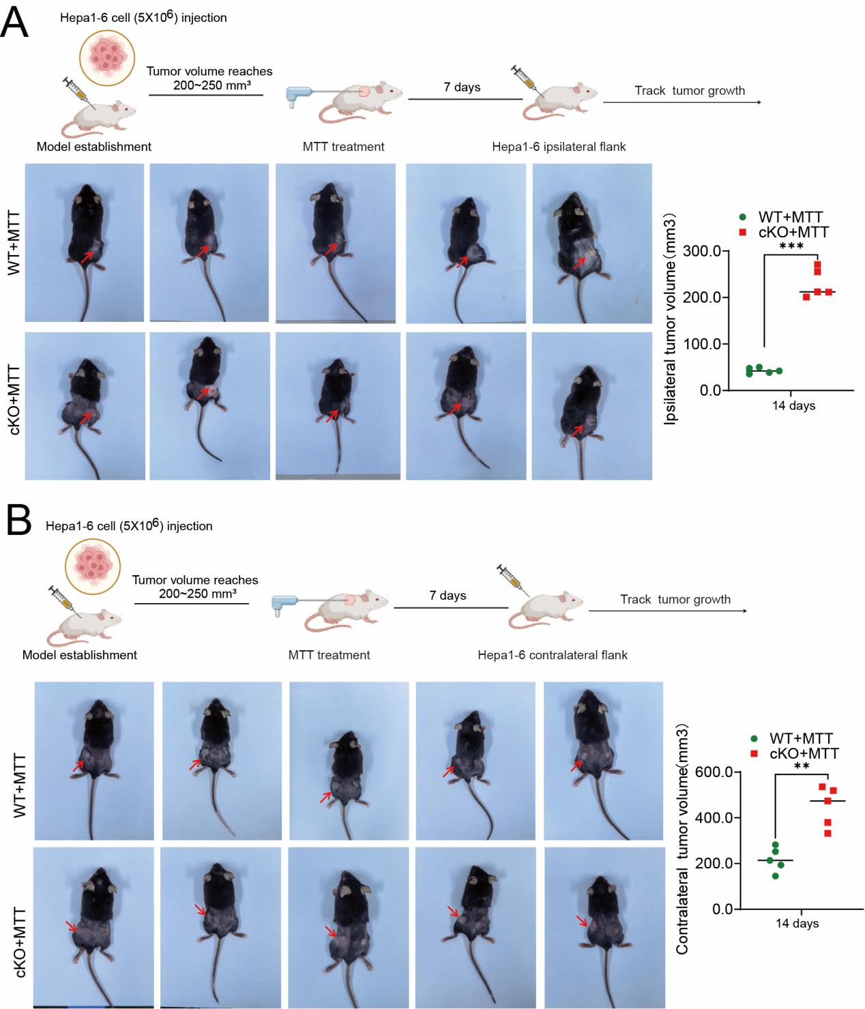
Figure S3. RORA is required for durable local and systemic antitumor protection following MTT treatment. (A) Ipsilateral tumor rechallenge model. Tumor-bearing WT and Cd8a-Cre;Rora^{fl/fl} (cKO) mice were treated with MTT and rechallenged with Hepa1-6 cells at the ipsilateral flank 7 days later. Representative images of secondary tumor growth and quantification of tumor volumes at 14 days after rechallenge are shown (n = 5/group). (B) Contralateral tumor rechallenge model. WT and cKO mice were rechallenged with Hepa1-6 cells at the contralateral flank 7 days after MTT treatment. Representative images of secondary tumor growth and quantification of tumor volumes at 14 days after rechallenge are shown (n = 5/group). Data are presented as mean ± SD. Statistical significance was determined using two-tailed unpaired Student’s t-test. **P < 0.01; ***P < 0.001.

