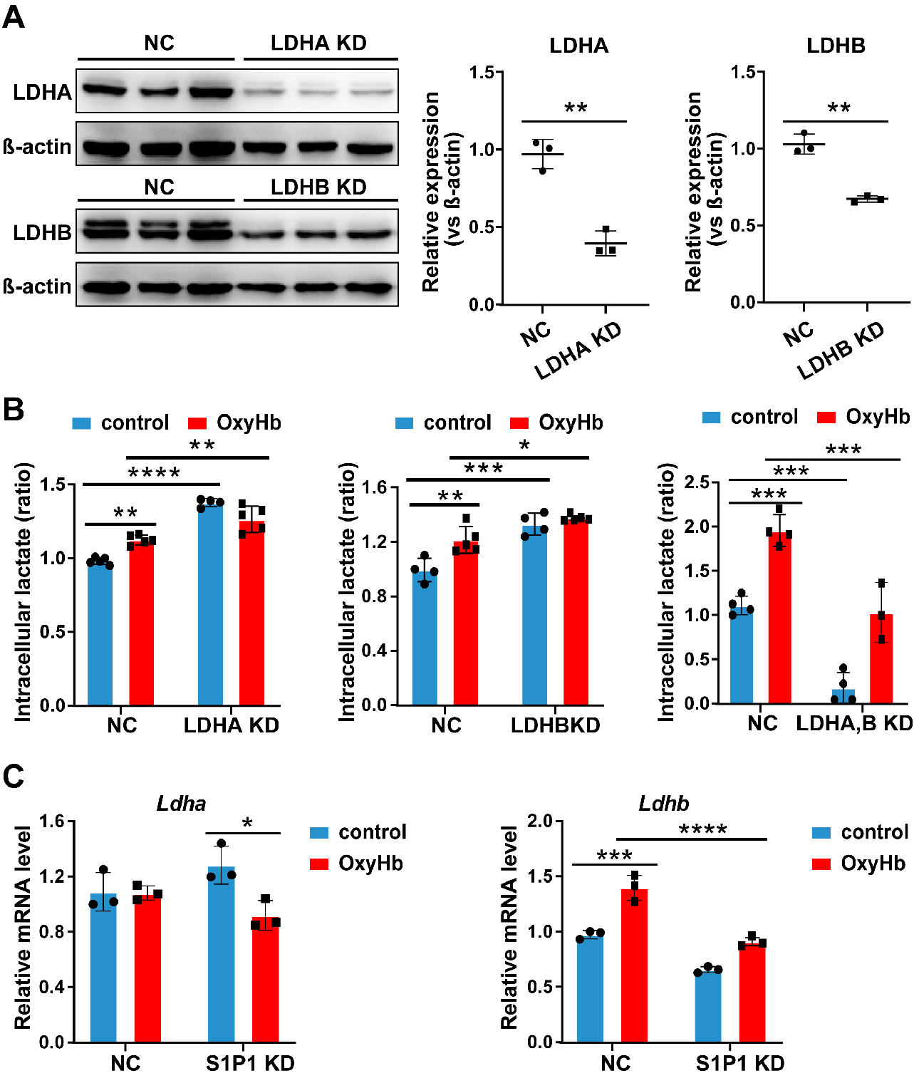
Fig. S1 LDHA, B KD attenuates OxyHb-enhanced astrocytic glycolysis metabolism. A, Measurement of LDHA, LDHB knockdown efficiency by western blotting (n = 3 per group). B, Measurement of lactate production in the NC, LDHA KD, LDHB KD, or LDHA, B KD cells treated with vehicle or OxyHb (n = 4-5 per group). C, Relative mRNA expression of Ldha and Ldhb in the NC or S1P1 KD cells upon OxyHb treatment (n = 3 per group). All values are mean ± SD, unpaired two-tailed Student’s t test was used for A, two-way ANOVA followed by Tukey’s multiple comparison test was applied to B, C. * P < 0.05, ** P < 0.01, *** P < 0.001, **** P < 0.0001.
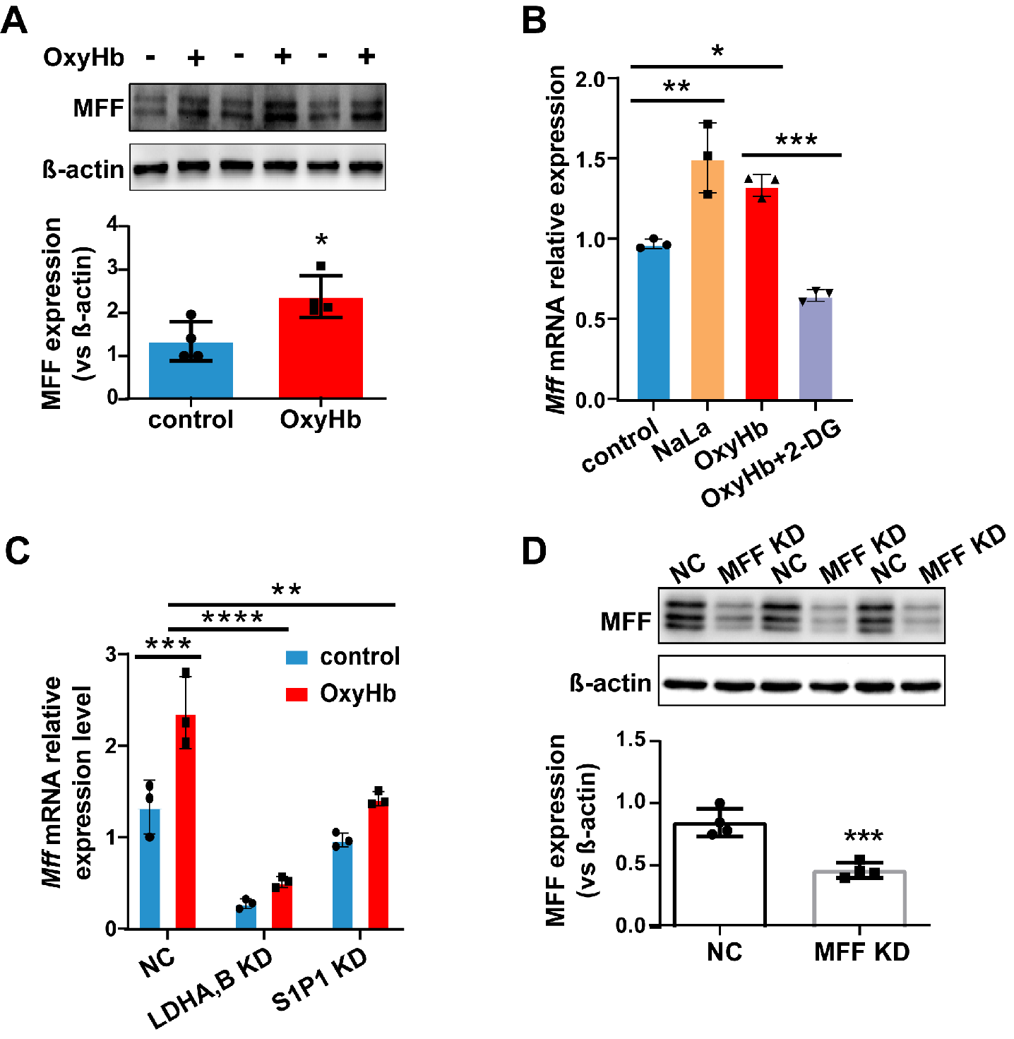
Fig. S2 Lactate levels regulate MFF expression. A, Measurement of MFF expression in astrocytes treated with vehicle or OxyHb by western blotting (n = 4 per group). B, Relative expression level of Mff mRNA in astrocytes treated with vehicle, lactate (100 mM), OxyHb, or OxyHb with 2-DG (10 mM) for 24 h (n = 3 per group). C, Relative expression level of Mff mRNA in the NC, LDHA, B KD, or S1P1 KD cells treated with vehicle or OxyHb (n = 3 per group). D, Measurement of MFF knockdown efficiency by western blotting (n = 4 per group). All values are mean ± SD. Unpaired two-tailed Student’s t test was used for A, D, one-way ANOVA followed by Tukey’s multiple comparison test was used for B, two-way ANOVA followed by Tukey’s multiple comparison test was applied to C. * P < 0.05, ** P < 0.01, *** P < 0.001, **** P < 0.0001.
Supplementary Table 1. Primer sequences for RT-qPCR.
Gene name | Forward | Reverse
Ldha | AACTTGGCGCTCTACTTGCT | TAGCCGCCTGAGGACTTACT
Ldhb | GGATTCACCCCGTGTCTACC | GAGCGACCTCATCGTCCTTC
Mff | CTACTCGTAGGGCTTACCAGCA | GCTCCTTCAATGGCTGCATCTAG
S1p1 | AAATGCCCCAACGGAGACT | CTGATTTGCTGCGGCTAAATTC
Aldh1l1 | GCAGGTACTTCTGGGTTGCT | GGAAGGCACCCAAGGTCAAA
Vim | AGACCAGAGATGGACAGGTGA | TTGCGCTCCTGAAAAACTGC
Gfap | AGAAAGGTTGAATCGCTGGA | CGGCGATAGTCGTTAGCTTC
Mbp | GAGACCCTCACAGCGATCCAAG | GGAGGTGGTGTTCGAGGTGTC
Itgam | TGGCCTATACAAGCTTGGCTTT | AAAGGCCGTTACTGAGGTGG
Snap25 | AGCAAGGCGAACAACTCGAT | AGGCCACAGCATTTGCCTAA
β-actin | CCTAAGGCCAACCGTGAAAA | GAGGCATACAGGGACAGCACA

