Supplementary Figures and Tables
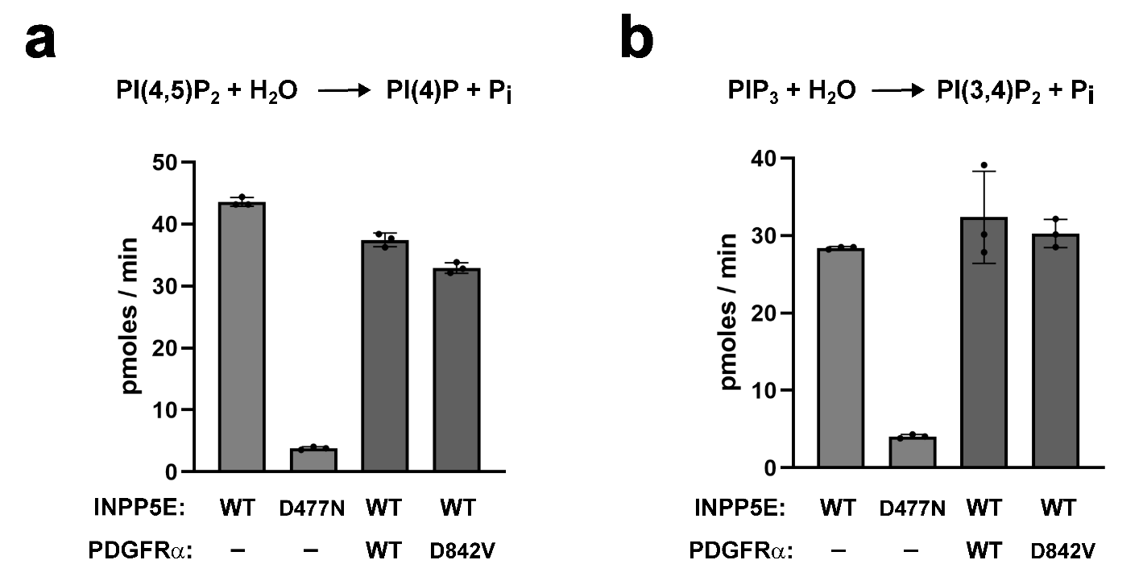
Suppl. Figure S1. PDGFRα-D842V has no effect on INPP5E phosphatase activity. (a) PI(4,5)P₂ phosphatase activity assay was performed on anti-EGFP immunoprecipitates from HEK293T cell lysates cotransfected with EGFP-INPP5E and PDGFRα-Flag (WT or D842V), as indicated. EGFP-INPP5E WT and D477N (catalytically inactive mutant) were used as positive and negative controls, respectively. Data are mean±SD of n=3 technical replicates from a single experiment. (b) Same as in (a) but using PIP₃ as substrate for the phosphatase activity assay. The INPP5E-catalyzed 5-phosphatase reactions are shown above for both substrates.

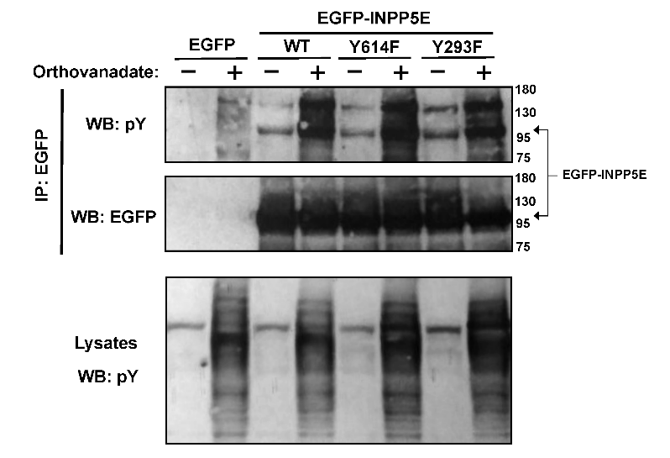
Suppl. Figure S2. Tyrosine phosphatase inhibition increases tyrosine phosphorylation of INPP5E. Lysates from HEK293T cells transiently expressing the indicated EGFP fusion proteins (top) and treated or not with orthovanadate, a tyrosine phosphatase inhibitor, were immunoprecipitated with anti-EGFP beads (IP: EGFP) and analyzed by Western blot (WB) with anti-phosphotyrosine (pY) and anti-EGFP antibodies, as indicated. Molecular weight markers on the right (kDa).
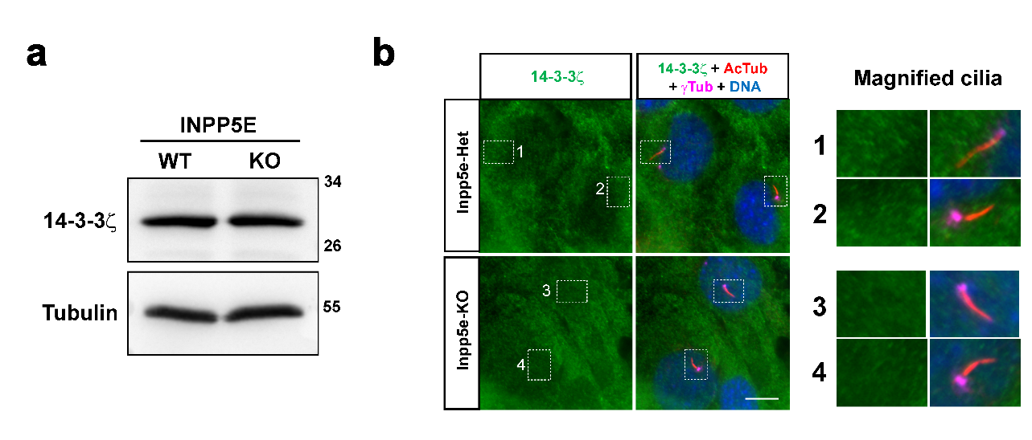Suppl. Figure S3. Protein levels and subcellular localization of 14-3-3ζ in INPP5E-KO cells. (a) Lysates from hTERT-RPE1 INPP5E-WT and KO cells were analyzed by Western blot with 14-3-3ζ and Tubulin antibodies. Molecular weight markers are shown on the right. (b) Inpp5e-KO and heterozygous (Het) mouse embryonic fibroblasts (MEFs) were analyzed by immunofluorescence with antibodies against 14-3-3ζ, acetylated tubulin (AcTub) and gamma-tubulin (γTub), and with DAPI as DNA dye. The boxed cilia on the left are magnified on the right. Scale bar, 10 μm.
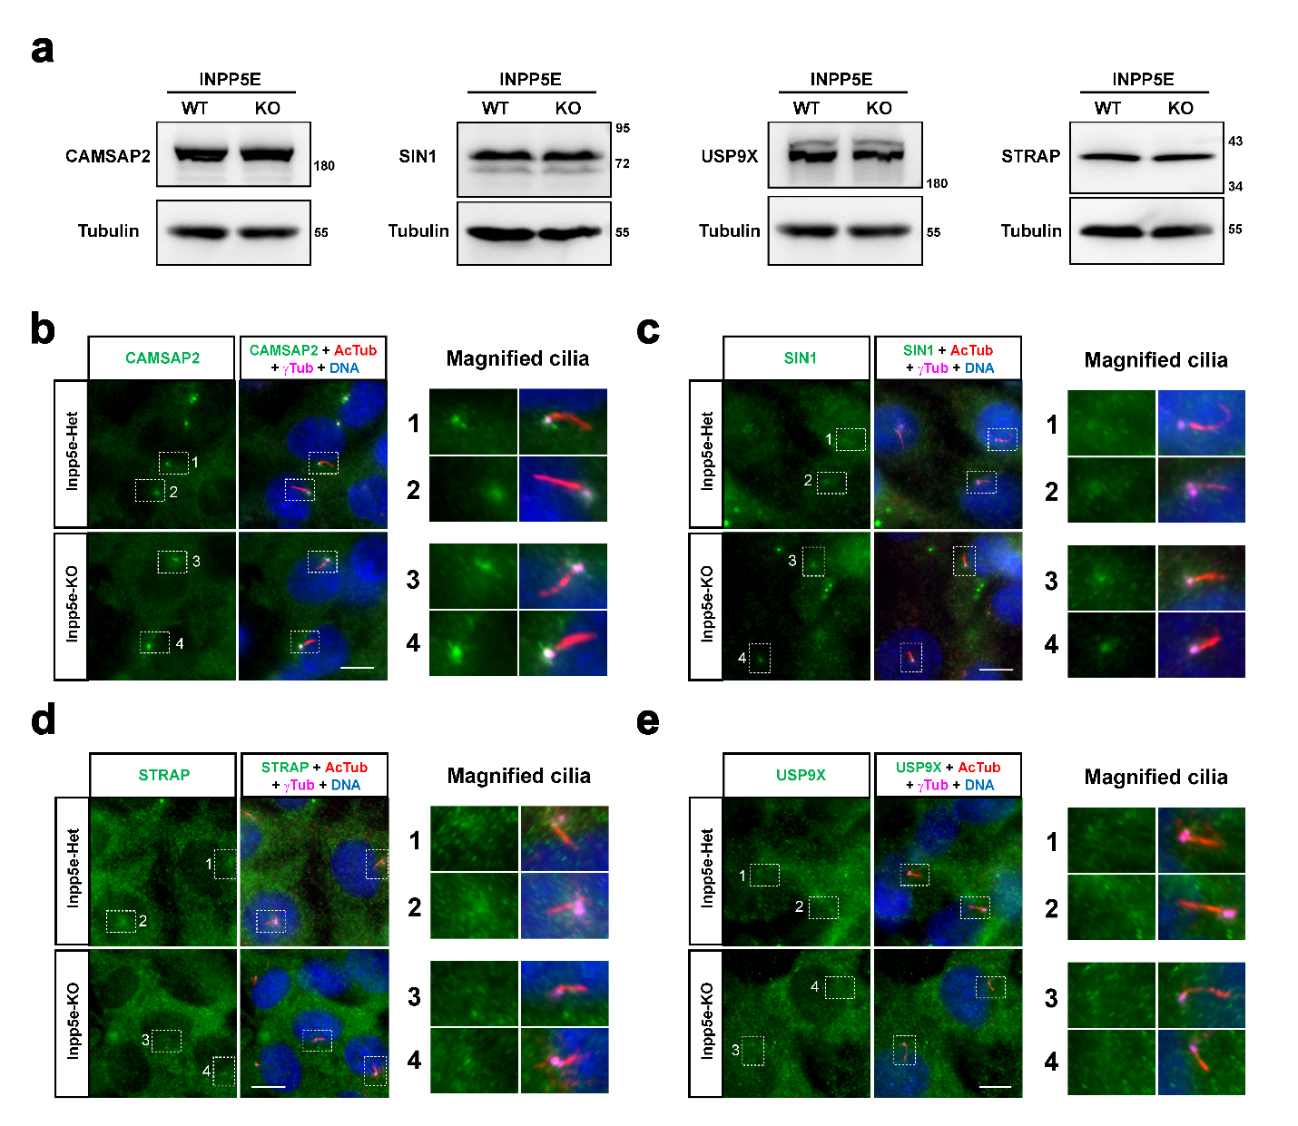
Suppl. Figure S4. Protein levels and subcellular localization of CAMSAP2, SIN1, USP9X and STRAP in INPP5E-KO cells. (a) Lysates from hTERT-RPE1 INPP5E-WT and KO cells were analyzed by Western blot with the indicated antibodies. Molecular weight markers shown on the right. (b-e) Inpp5e-KO and Het MEFs were analyzed by immunofluorescence with DAPI and the indicated antibodies. Boxed cilia on the left are magnified on the right. Scale bars, 10 μm.

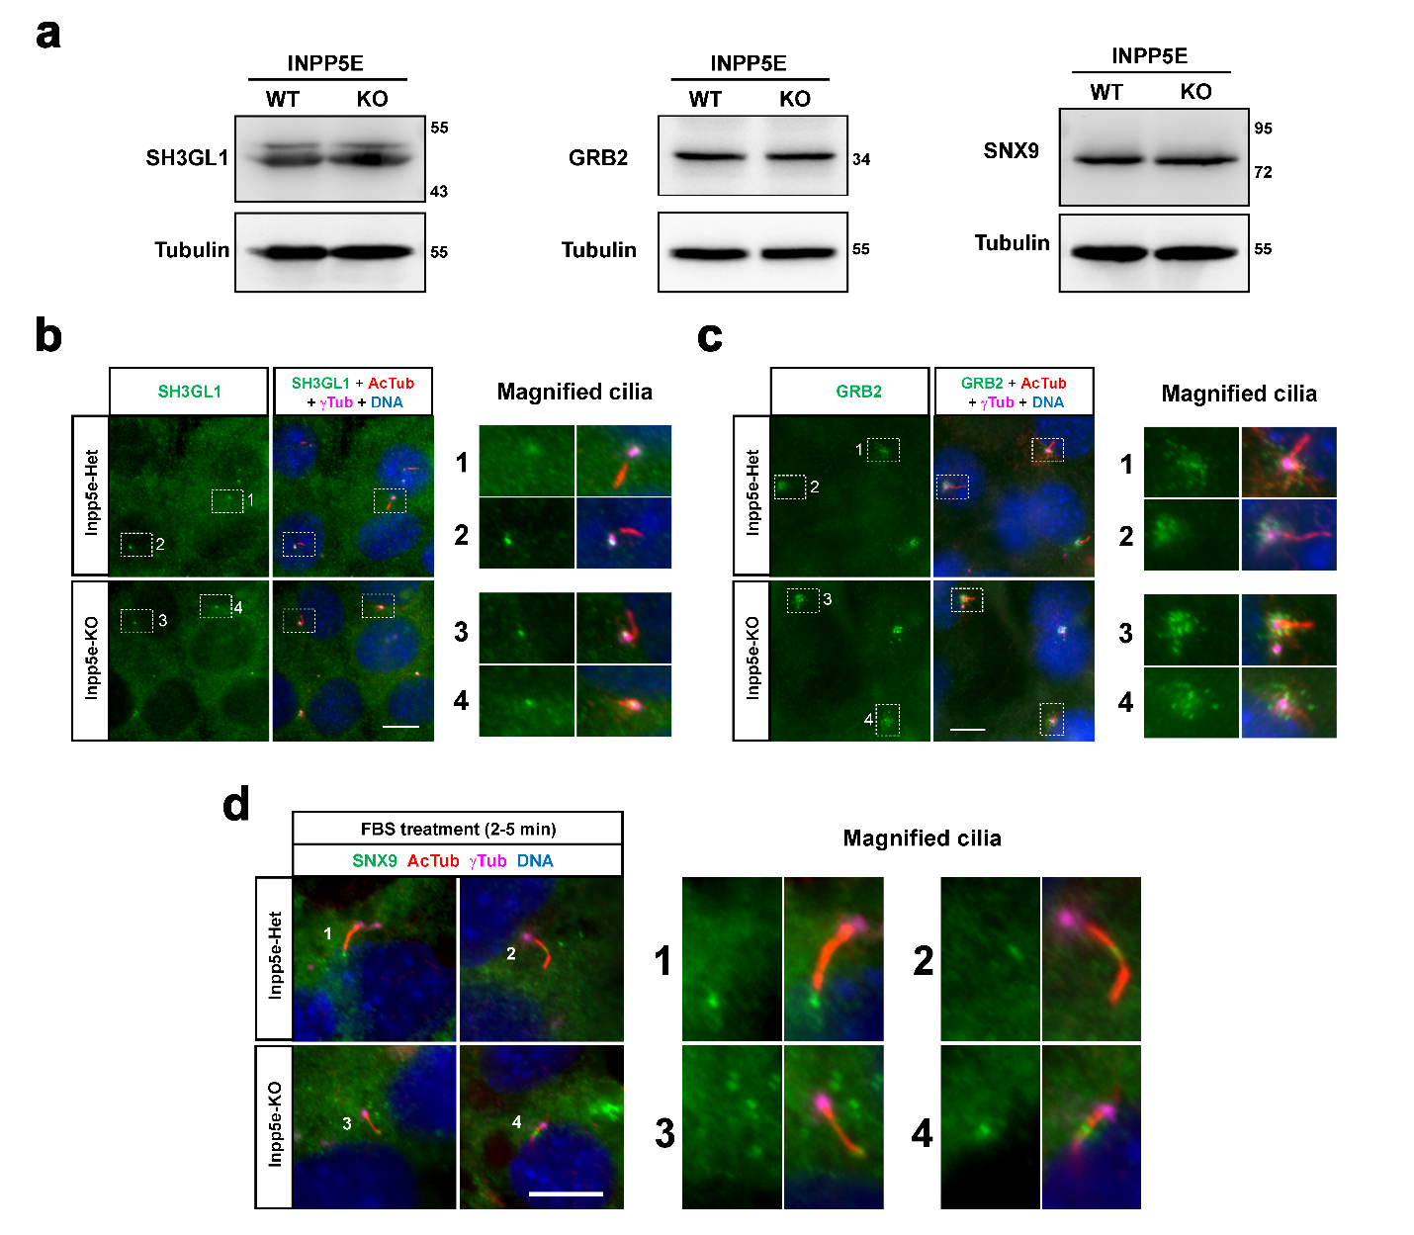
Suppl. Figure S5. Protein levels and subcellular localization of SH3GL1, GRB2 and SNX9 in INPP5E-KO cells. (a) Lysates from hTERT-RPE1 INPP5E-WT and KO cells were analyzed by Western blot with the indicated antibodies. Molecular weight markers on the right. (b-d) Inpp5e-KO and Het MEFs were analyzed by immunofluorescence with DAPI and the indicated antibodies. Cells in (d) were stimulated for 2-5 min with 15% FBS to induce SNX9 ciliary accumulation (Phua et al 2017). Boxed cilia on the left are magnified on the right. Scale bars, 10 μm.
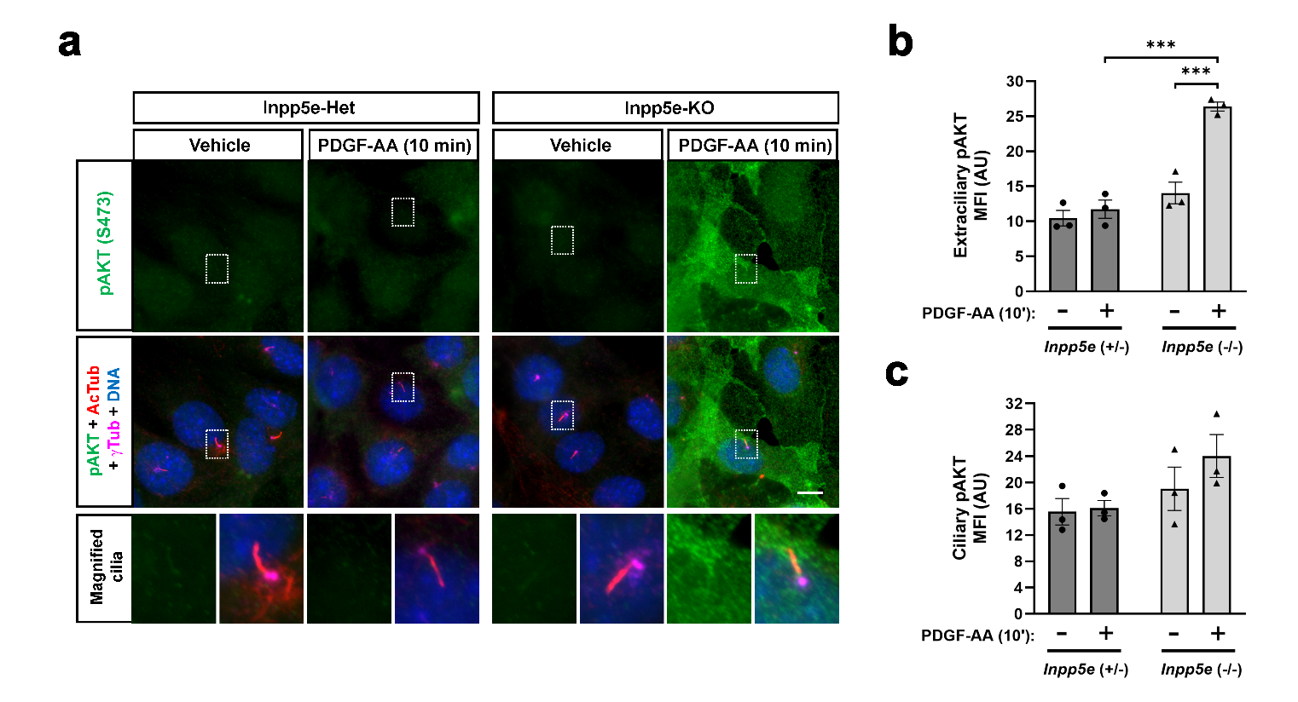
Suppl. Figure S6. Immunofluorescence of phospho-AKT in Inpp5e-KO MEFs. (a) Inpp5e^{+/‒} (Het) and Inpp5e‒/‒ (KO) MEFs were stimulated with vehicle or PDGF-AA and cells analyzed by immunofluorescence as indicated. (b-c) Mean fluorescence intensity (MFI) of extraciliary (b) and ciliary (c) p-AKT (S473) staining was quantified from n=3 independent experiments like the one in (a). Data in all quantitations are mean±SEM, analyzed by two-way ANOVA followed by Tukey tests (p<0.001***). AU: arbitrary units.
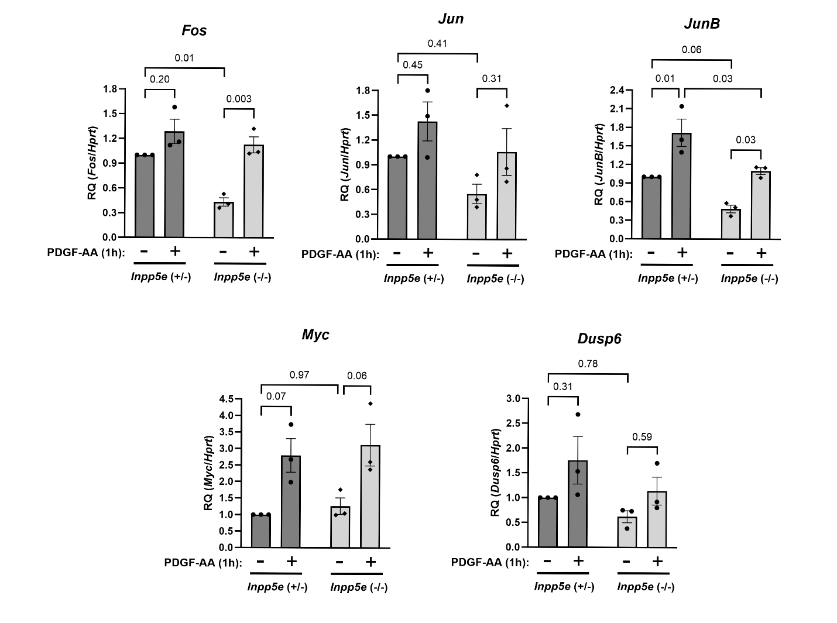
Suppl. Figure S7. PDGF target gene responsiveness in Inpp5e-KO MEFs. Inpp5e-Het (+/-) and Inpp5e-KO (-/-) MEFs were stimulated for 1 hour with 50 ng/ml PDGF-AA and levels of the indicated mRNAs were assessed by RT-qPCR. Relative quantification (RQ) of each mRNA, using Hprt mRNA as housekeeping control, are shown as mean±SEM of n=3 independent experiments. Data were analyzed by two-way ANOVA followed by Tukey tests, whose p-values are displayed.
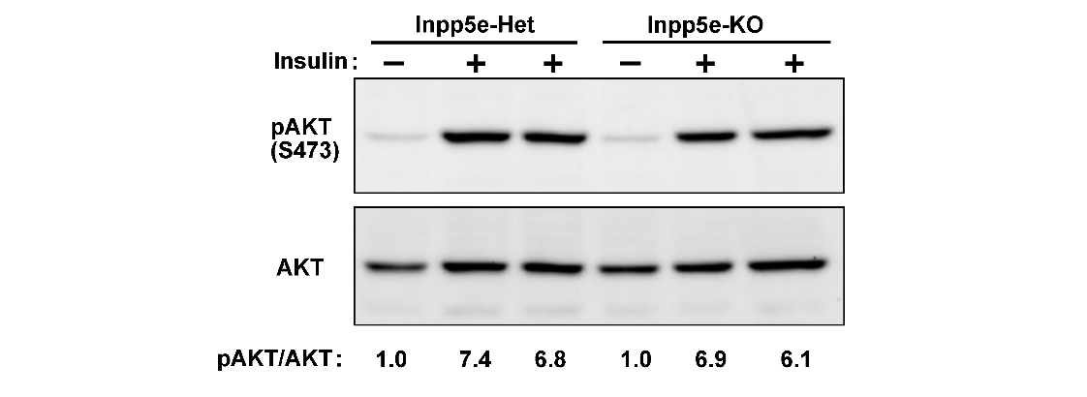
Suppl. Figure S8. INPP5E has no effect on insulin-induced AKT phosphorylation in MEFs. Inpp5e^{+/‒} and Inpp5e‒/‒ MEFs were stimulated with insulin as indicated and AKT phosphorylation at S473 was analyzed by Western blot. The pAKT/AKT ratios for each sample, normalized to untreated heterozygous MEFs, are shown at the bottom.

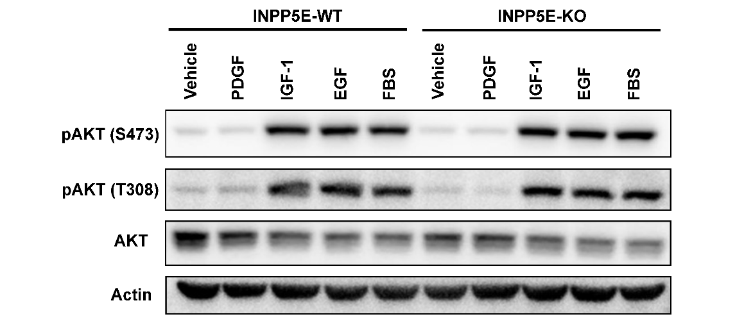

Suppl. Figure S9. INPP5E has no effect on IGF- and EGF-induced AKT phosphorylation in RPE1 cells. INPP5E^{+/+} and INPP5E‒/‒ hTERT-RPE1 cells were stimulated for 10 minutes with the indicated ligands and AKT phosphorylation at S473 and T308 was analyzed by Western blot, using total AKT and actin as controls.

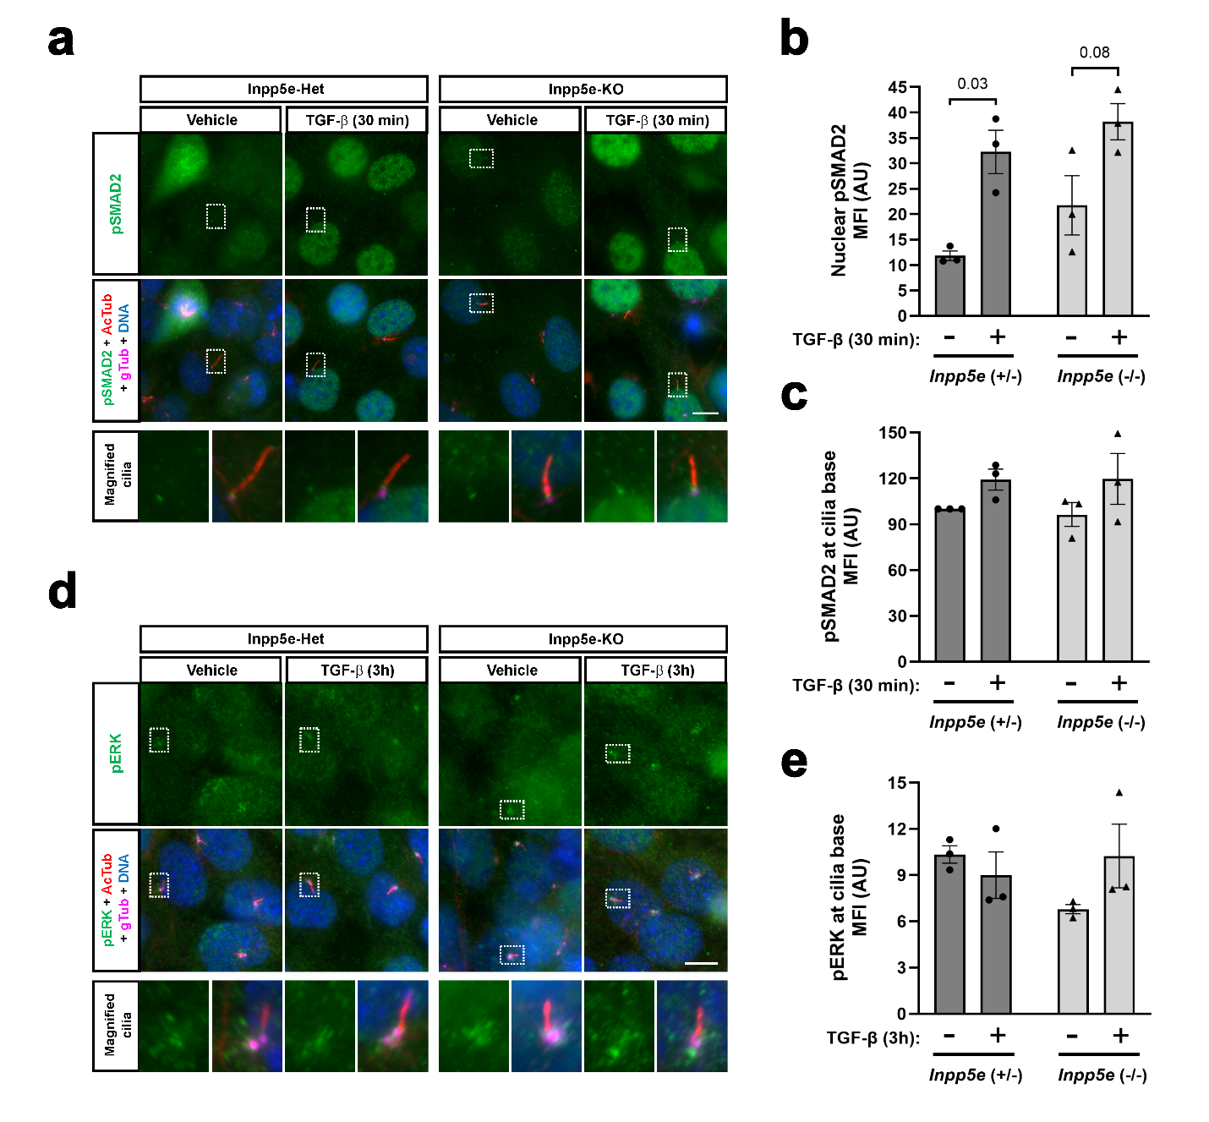
Suppl. Figure S10. Immunofluorescence of pSMAD2 and pERK in TGFβ-treated Inpp5e-KO MEFs. (a) Inpp5e-KO and Inpp5e-Het MEFs were treated with vehicle or TGFβ (30 min) and analyzed by immunofluorescence with DAPI and the indicated antibodies. Boxed cilia are magnified below. Scale bar, 10 μm. (b-c) Mean fluorescence intensity (MFI) of pSMAD2 was quantified at both nuclei (b) and ciliary base (c), from n=3 independent IF experiments such as the one in (a). (d) Inpp5e-KO and Inpp5e-Het MEFs were treated with vehicle or TGFβ (3 hours) and analyzed by immunofluorescence with DAPI and the indicated antibodies. Boxed cilia are magnified below. Scale bar, 10 μm. (e) MFI of pERK at cilia base was quantified from n=3 independent experiments such as the one in (d). Data in all quantitations are mean±SEM, analyzed by two-way ANOVA and Tukey tests. AU: arbitrary units.

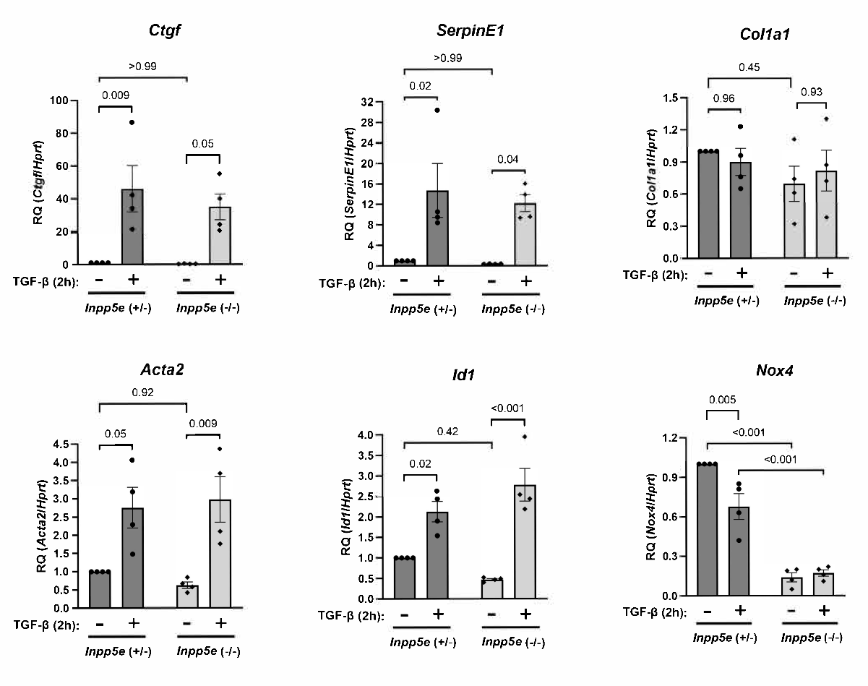
Suppl. Figure S11. TGFβ target gene responsiveness in Inpp5e-KO MEFs. Inpp5e-Het (+/-) and Inpp5e-KO (-/-) MEFs were stimulated for 2 hours with 2 ng/ml TGFβ and levels of the indicated mRNAs were assessed by RT-qPCR. The four mRNAs on the left were induced as expected, unlike the two on the right. Relative quantification (RQ) of each mRNA, using Hprt as housekeeping control, are shown as mean±SEM of n=4 independent experiments. Data were analyzed by two-way ANOVA followed by Tukey tests, whose p-values are displayed.

Suppl. Table S1. List of QPCR primers used in this study.

Mouse gene | Forward primer | Reverse primer
Acta2 | TGC TGA CAG AGG CAC CAC TGA A | CAG TTG TAC GTC CAG AGG CAT AG
Id1 | TTG GTC TGT CGG AGC AAA GCG T | CGT GAG TAG CAG CCG TTC ATG T
Serpine1 | CCT CTT CCA CAA GTC TGA TGG C | GCA GTT CCA CAA CGT CAT ACT CG
Ctgf | TGC GAA GCT GAC CTG GAG GAA A | CCG CAG AAC TTA GCC CTG TAT G
Nox4 | CGG GAT TTG CTA CTG CCT CCA T | GTG ACT CCT CAA ATG GGC TTC C
Col1a1 | CCT CAG GGT ATT GCT GGA CAA C | CAG AAG GAC CTT GTT TGC CAG G
Ccr4 | GAA TTA CGG CAT CGT AGG CAG CTC | GCC TTG ATA CCT TCC TTG GTG CAA GG
Dusp6 | CGT TCT ACC TGG AAG GTG GCT TCA GTA AG | GGT CTC GGT CAA GGT CAG ACT CAA TGT CC
Fos | CGA AGG GAA CGG AAT AAG ATG | GCT GCC AAA ATA AAC TCC AG
Jun | CTC AGG GAA CAG GTG GCA CAG C | CGC AAC CAG TCA AGT TCT CAA G
JunB | CTG CAC CCT CTG GAG GCT CCG | GCT GCG TGC CTC CGG TAC GG
Myc | CCA GCA GCG ACT CTG AAG AAG AGC AAG | AGA CGT GGC ACC TCT TGA GGA CC
Hprt | CTG GTG AAA AGG ACC TCT CGA AG | CCA GTT TCA CTA ATG ACA CAA ACG

