Supplementary materials

UCP1 neddylation regulates white adipocyte browning through NIX-mediated mitophagy

Geon Ho Moon, Min Young Lee, Jooseung Lee, Taerim Oh, Jong-Wan Park,
Hyoung Sook Park, G-One Ahn*, and Yang-Sook Chun*

Supplemental Figures
Figure S1
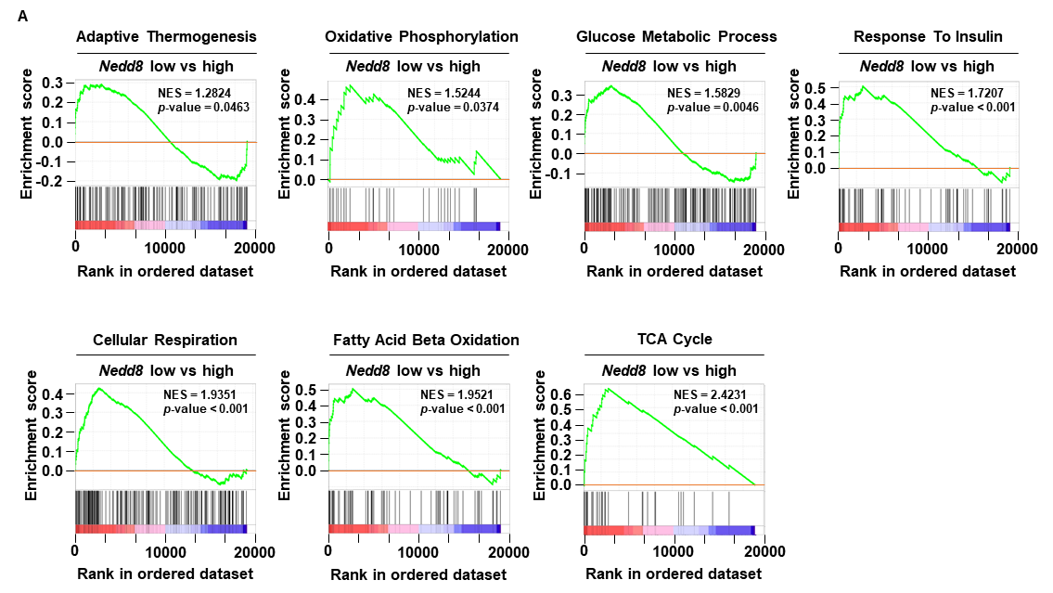
Figure S1. GSEA Comparison of Adipocyte Browning Gene Sets Between Nedd8-Low and Nedd8-High Groups.
A GSEA of adipose tissue transcriptome (GSE214618) for gene sets related to the TCA cycle, Fatty acid beta oxidation, Cellular respiration, Glucose metabolic process, Response to insulin, Oxidative phosphorylation, Adaptive thermogenesis. Samples were divided into Nedd8 low (n = 8) and Nedd8 high (n = 5) groups by k-means clustering.

Figure S2
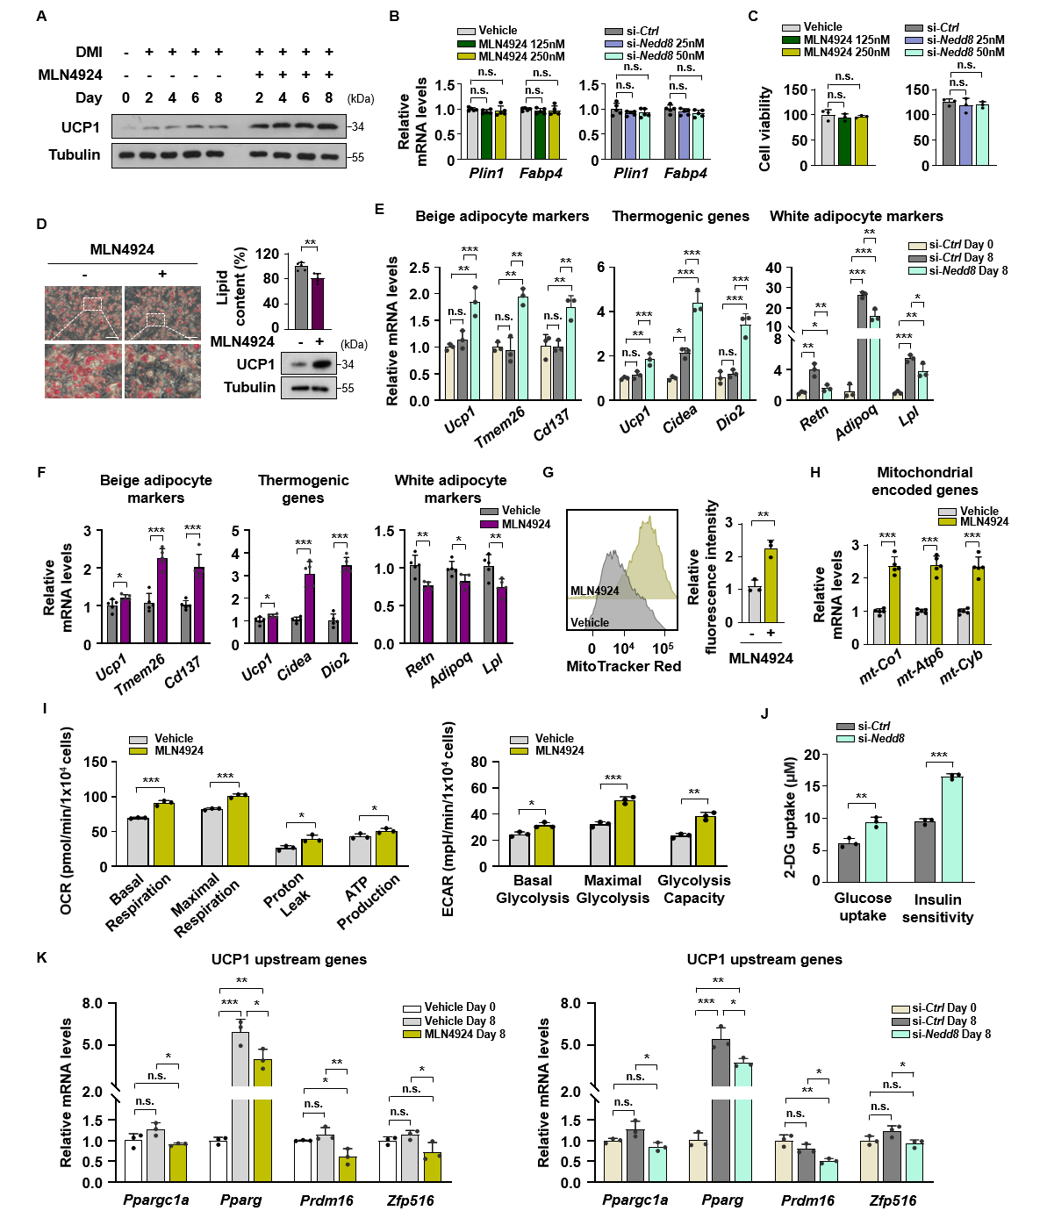
Figure S2. Analyses of browning-associated molecular and metabolic changes by neddylation inhibition.
A 3T3-L1 adipocytes were differentiated for 8 days with vehicle or MLN4924 (250 nM). Immunoblot analysis of UCP1 protein levels in 3T3-L1 adipocytes at the indicated times. B–C 3T3-L1 adipocytes differentiated for 8 days with vehicle or MLN4924 (125 and 250 nM), si-Ctrl, or si-Nedd8 (25 and 50 nM). B RT-qPCR analysis of mature adipocyte marker genes in 3T3-L1 adipocytes (n = 5). C MTT assay in 3T3-L1 adipocytes (n = 5). D Oil Red O staining (left) and immunoblot analysis of UCP1 protein levels (right) in 3T3-L1 adipocytes were differentiated for 8 days and subsequently treated with vehicle or MLN4924 (250 nM) for an additional 4 days (n = 5). Scale bar, 100 μm. E RT-qPCR analysis of beige adipocyte markers, thermogenic genes, and white adipocyte markers in undifferentiated (day 0) 3T3-L1 cells and day 8 differentiated 3T3-L1 adipocytes transfected with si-Ctrl or si-Nedd8 (50 nM). F RT-qPCR analysis of beige adipocyte markers, thermogenic genes, and white adipocyte markers in 3T3-L1 adipocytes were differentiated for 8 days and subsequently treated with vehicle or MLN4924 (250 nM) for an additional 4 days (n = 5). G–I 3T3-L1 adipocytes were differentiated for 8 days with vehicle or MLN4924 (250 nM). G MitoTracker Red staining analyzed by flow cytometry (Texas Red channel). The graph (right) indicates the mean fluorescence intensity. H RT-qPCR analysis of Mitochondrial encoded genes (n = 5). I Basal respiration, maximal respiration, proton leak, and ATP production derived from OCR measurements (left), and basal glycolysis, maximal glycolysis, and glycolytic capacity derived from ECAR measurements (right). J Glucose uptake and insulin sensitivity assays in 3T3-L1 adipocytes were differentiated for 8 days with si-Ctrl or si-Nedd8 (50 nM). K RT-qPCR analysis of UCP1 upstream genes in undifferentiated (day 0) and day 8 differentiated 3T3-L1 adipocytes treated with vehicle or MLN4924 (250 nM) (left), or transfected with si-Ctrl or si-Nedd8 (50 nM) (right). All data are mean ± SEM. Unless otherwise indicated, n = 3 independent experiments. Statistical significance for (D), and (F–J) was determined by two-tailed unpaired Student’s t-test. Statistical significance for (B–C), (E) and (K) was determined by one-way ANOVA followed by Tukey’s HSD post-hoc test. ∗p < 0.05, ∗∗p < 0.01, ∗∗∗p < 0.001, and n.s. > 0.05.

Figure S3
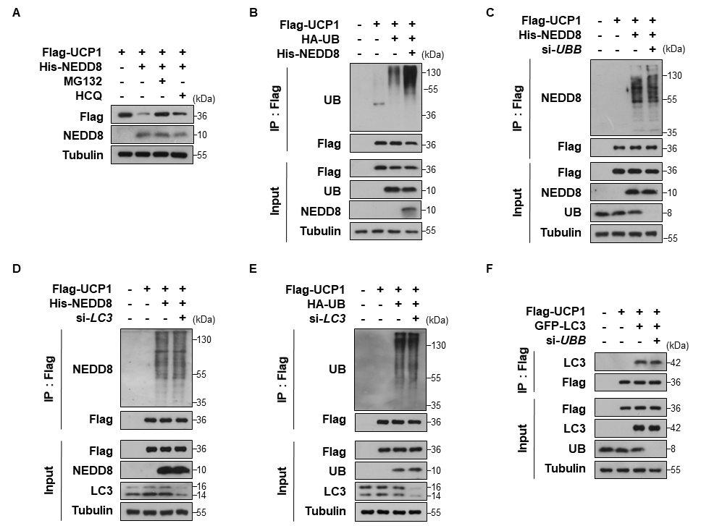
Figure S3. Regulation of ubiquitination and LC3 binding of UCP1 by neddylation through distinct and independent pathways.
A 3T3-L1 adipocytes were differentiated for 2 days with Flag-UCP1 together with pcDNA or His-NEDD8, followed by treatment with MG132 (10 μM) or hydroxychloroquine (HCQ, 20 μM) for 8 h. Flag-UCP1 protein levels were assessed by immunoblotting using an anti-Flag antibody B HEK293T cells co-transfected with Flag-UCP1, HA-UB, and His-NEDD8, were treated with MG132 (10 μM) and HCQ (20 μM) for 8 h. Immunoprecipitation with anti-Flag beads followed by immunoblotting for ubiquitin. C–D HEK293T cells co-transfected with Flag-UCP1 and His-NEDD8 along with either (C) si-UBB or (D) si-LC3, were treated with MG132 (10 μM) and HCQ (20 μM) for 8 h. Immunoprecipitation with anti-Flag beads followed by immunoblotting for NEDD8. E HEK293T cells co-transfected with Flag-UCP1 and HA-UB with si-LC3, were treated with MG132 (10 μM) and HCQ (20 μM) for 8 h. Immunoprecipitation with anti-Flag beads followed by immunoblotting for ubiquitin. F HEK293T cells co-transfected with Flag-UCP1 and GFP-LC3 with si-UBB, were treated with MG132 (10 μM) and HCQ (20 μM) for 8 h. Immunoprecipitation with anti-Flag beads followed by immunoblotting for LC3.

Figure S4
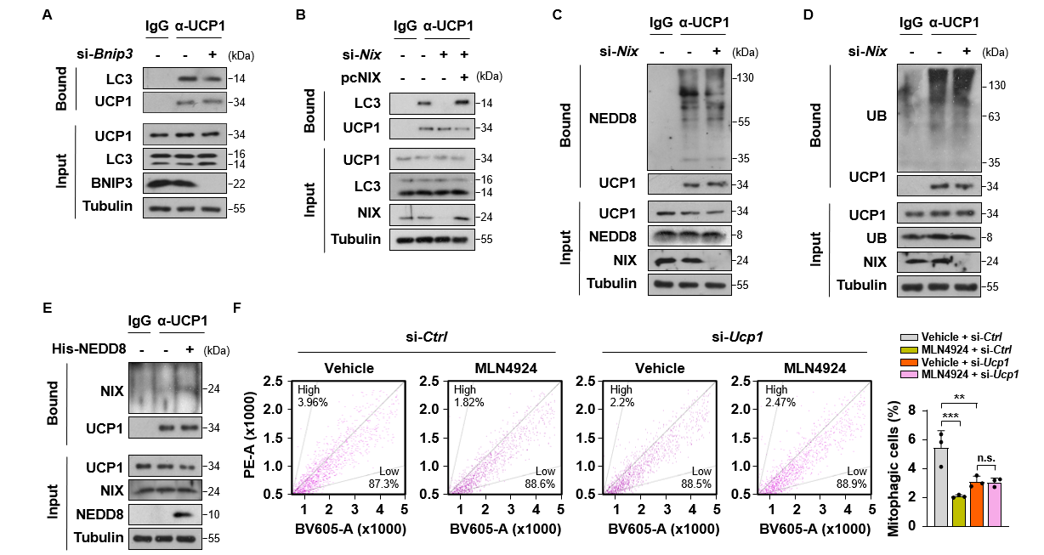
Figure S4. NIX-mediated recruitment of LC3 downstream of UCP1 neddylation.
A Day 8 differentiated 3T3-L1 adipocytes transfected with si-Ctrl or si-Bnip3, were treated with MG132 (10 μM) and HCQ (20 μM) for 8 h. Immunoprecipitation with anti-UCP1 antibody followed by immunoblotting for LC3. B Day 8 differentiated 3T3-L1 adipocytes transfected with si-Ctrl, 3’UTR-targeting si-Nix, or combination of 3’UTR-targeting si-Nix and pcNIX were treated with MG132 (10 μM) and HCQ (20 μM) for 8 h. Immunoprecipitation with anti-UCP1 antibody followed by immunoblotting for LC3. C–D Day 8 differentiated 3T3-L1 adipocytes transfected with si-Ctrl or si-Nix, were treated with MG132 (10 μM) and HCQ (20 μM) for 8 h. Immunoprecipitation with anti-UCP1 antibody followed by immunoblotting for (C) NEDD8 or (D) ubiquitin. E Day 8 differentiated 3T3-L1 adipocytes transfected with His-NEDD8 were treated with MG132 (10 μM) and HCQ (20 μM) for 8 h. Immunoprecipitation with anti-UCP1 antibody followed by immunoblotting for NIX. F 3T3-L1 adipocytes were differentiated for 8 days with si-Ctrl or si-Ucp1 (50 nM) in the presence or absence of MLN4924 (250 nM). mt-Keima analyzed by flow cytometry (PE and BV605 channel). Data are presented as mean ± SEM. n = 3 independent experiments. Statistical significance was determined by one-way ANOVA followed by Tukey’s HSD post-hoc test. ∗∗p < 0.01, ∗∗∗p < 0.001, and n.s. > 0.05.
Figure S5
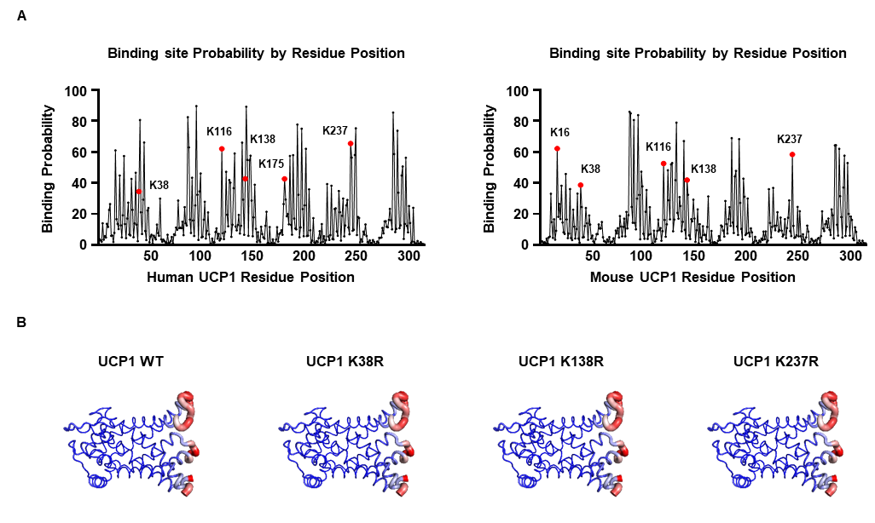
Figure S5. Prediction of UCP1 neddylation sites and structural analysis of lysine-to-arginine mutants.
A Predicted position of modification sites on UCP1 in Homo sapiens (left panel) and Mus musculus (right panel) using AT2Bind (https://neurosnap.ai/service/AF2Bind) algorithms. B Lysine-to-arginine mutants (K38R, K138R, K237R) were generated and their structural integrity was assessed using DynaMut (http://biosig.unimelb.edu.au/dynamut/) simulations.

Figure S6
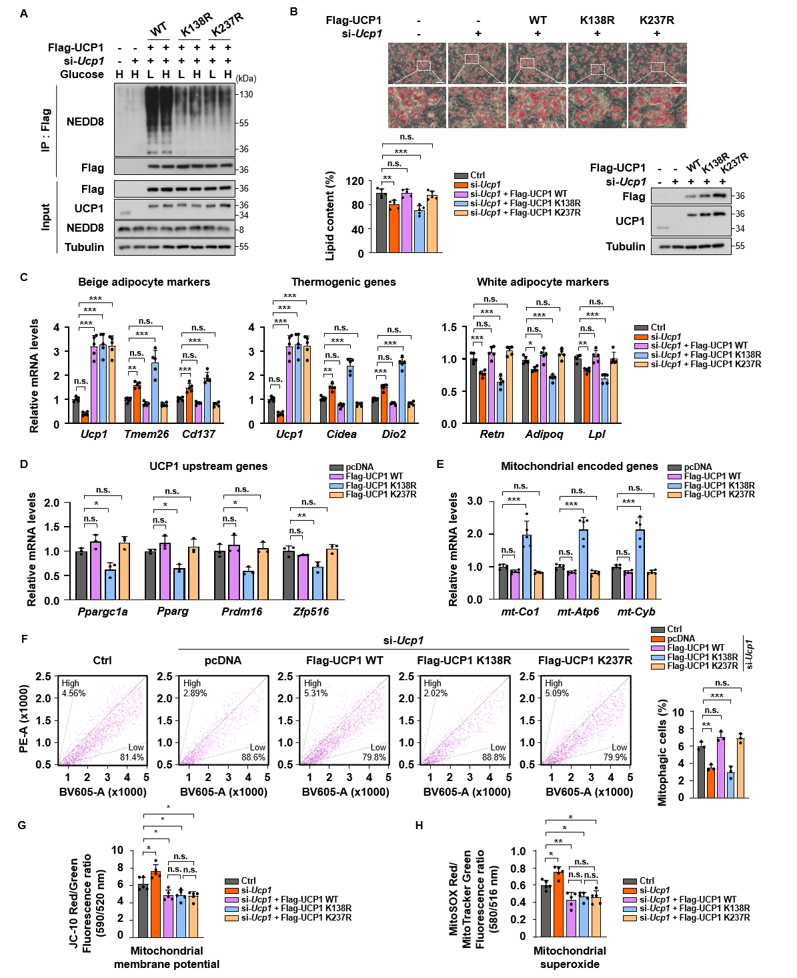
Figure S6 (continue)
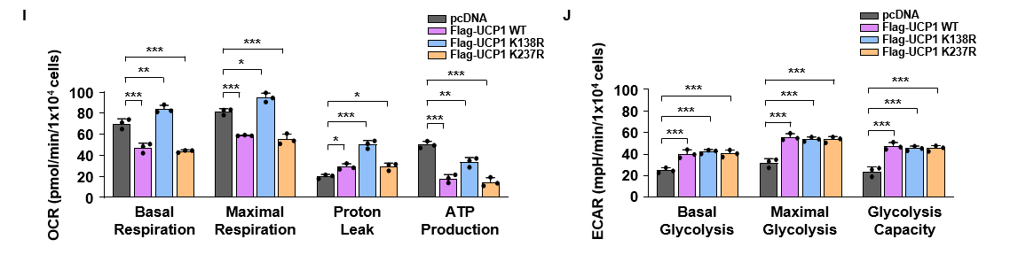
Figure S6. Molecular and metabolic characterization in UCP1 mutant-expressing adipocytes.
A Day 8 differentiated 3T3-L1 adipocytes transfected si-Ucp1 (25 nM), combination of si-Ucp1 (25 nM) and Flag-UCP1 WT, combination of si-Ucp1 (25 nM) and Flag-UCP1 K138R, or combination of si-Ucp1 (25 nM) and Flag-UCP1 K237R. Following transfection, adipocytes were treated with glucose 5.5 mM (Low, L) or 25 mM (High, H) for 24 h. Adipocytes were subsequently treated with MG132 (10 μM) and HCQ (20 μM) for 8 h, followed by immunoprecipitation with anti-Flag beads and immunoblotting for NEDD8. B–C 3T3-L1 adipocytes transfected with si-Ucp1 (25 nM), combination of si-Ucp1 (25 nM) and Flag-UCP1 WT, combination of si-Ucp1 (25 nM) and Flag-UCP1 K138R, or combination of si-Ucp1 (25 nM) and Flag-UCP1 K237R were differentiated for 8 days. B Oil Red O staining (left) and immunoblot analysis of Flag and UCP1 protein levels (right) in (n = 5). Scale bar, 100 μm. C RT-qPCR analysis of beige adipocyte markers, thermogenic genes, and white adipocyte markers (n = 5). D–E 3T3-L1 adipocytes transfected with Flag-UCP1 WT, Flag-UCP1 K138R, or Flag-UCP1 K237R were differentiated for 8 days. D RT-qPCR analysis of UCP1 upstream genes. E RT-qPCR analysis of Mitochondrial encoded genes (n = 5). F–H 3T3-L1 adipocytes transfected with si-Ucp1 (25 nM), combination of si-Ucp1 (25 nM) and Flag-UCP1 WT, combination of si-Ucp1 (25 nM) and Flag-UCP1 K138R, or combination of si-Ucp1 (25 nM) and Flag-UCP1 K237R were differentiated for 8 days. F mt-Keima analyzed by flow cytometry (PE and BV605 channel). G Mitochondrial membrane potential was measured by JC-10 assay. H Mitochondrial superoxide levels were measured by MitoSOX assay, and mitochondrial mass was assessed using MitoTracker Green staining. I–J 3T3-L1 adipocytes transfected with Flag-UCP1 WT, Flag-UCP1 K138R, or Flag-UCP1 K237R were differentiated for 8 days. I Basal respiration, maximal respiration, proton leak, and ATP production derived from OCR measurements. J Basal glycolysis, maximal glycolysis, and glycolytic capacity derived from ECAR measurements. All data are mean ± SEM. Unless otherwise indicated, n = 3 independent experiments. Statistical significance was determined by one-way ANOVA followed by Tukey’s HSD post-hoc test. ∗p < 0.05, ∗∗p < 0.01, ∗∗∗p < 0.001, and n.s. > 0.05.
Figure S7
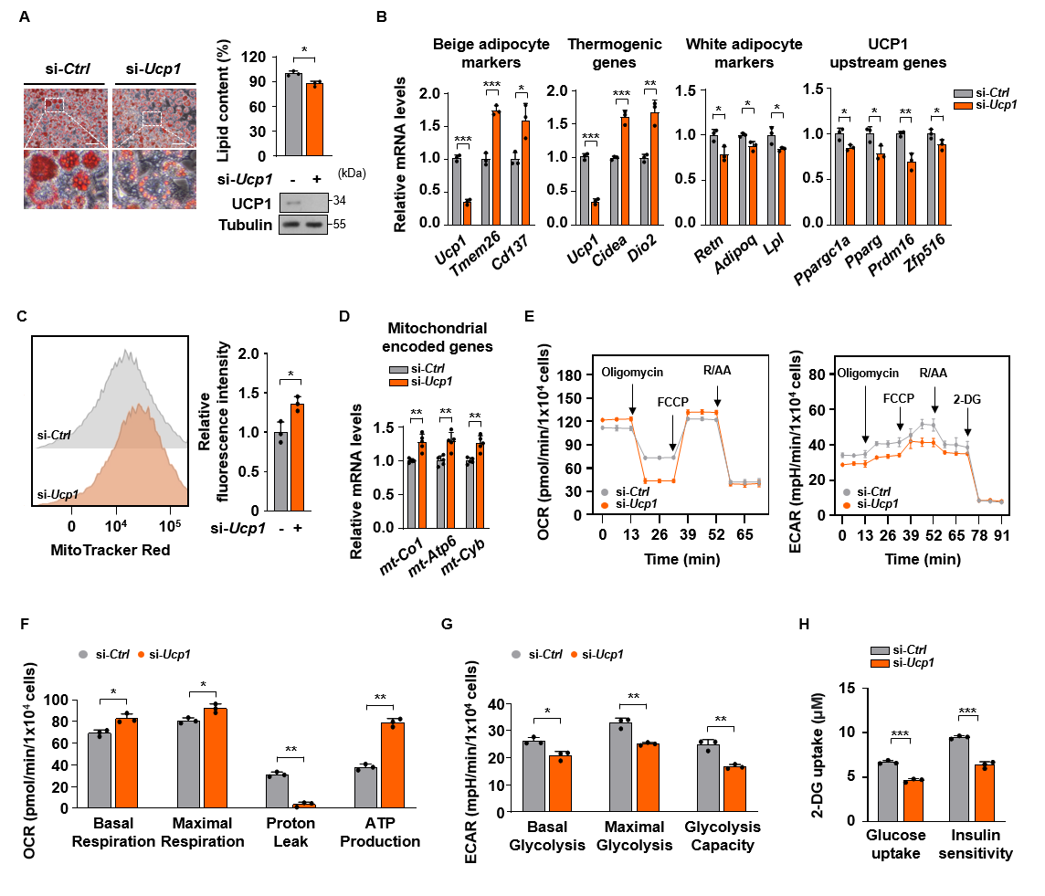
Figure S7. Effects of Ucp1 knockdown on mitochondrial accumulation and glucose metabolism in adipocytes.
A–H 3T3-L1 adipocytes transfected with si-Ctrl or si-Ucp1 (25 nM) were differentiated for 8 days. A Oil Red O staining (left) and immunoblot analysis of UCP1 protein levels (right). Scale bar, 100 μm. B RT-qPCR analysis of beige adipocyte markers, thermogenic genes, white adipocyte markers, and UCP1 upstream genes. C MitoTracker Red staining analyzed by flow cytometry (Texas Red channel). The graph (right) indicates the mean fluorescence intensity. D RT-qPCR analysis of Mitochondrial encoded genes (n = 5). E OCR (left) and ECAR (right) measured by Seahorse XFe96 analyzer. F Basal respiration, maximal respiration, proton leak, and ATP production derived from OCR measurements. G Basal glycolysis, maximal glycolysis, and glycolytic capacity derived from ECAR measurements. H Glucose uptake and insulin sensitivity assays. All data are mean ± SEM. Unless otherwise indicated, n = 3 independent experiments. Statistical significance was determined by two-tailed unpaired Student’s t-test. ∗p < 0.05, ∗∗p < 0.01, ∗∗∗p < 0.001, and n.s. > 0.05.

Figure S8
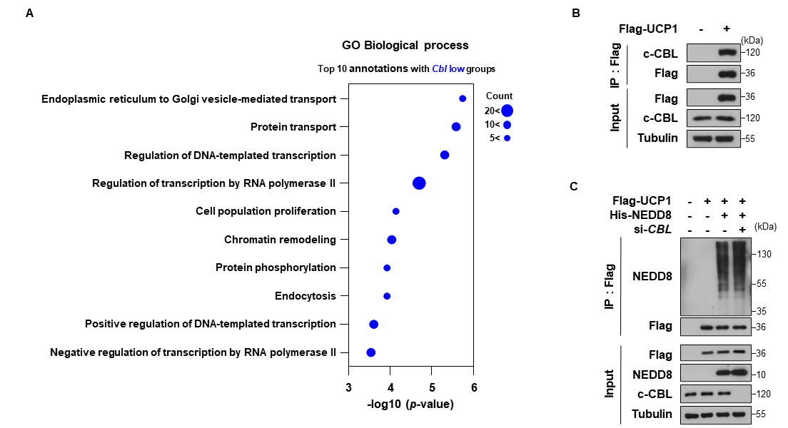
Figure S8. CBL as a non-neddylation E3 ligase for UCP1.
A GO analysis of adipose tissue transcriptome (GSE203414). Samples were grouped into Cbl low (n = 4) and Cbl high (n = 4) by k-means clustering. B HEK293T cells were transfected with Flag-UCP1 were treated with MG132 (10 μM) and HCQ (20 μM) for 8 h. Immunoprecipitation with anti-Flag beads followed by immunoblotting for CBL. C HEK293T cells co-transfected with Flag-UCP1 and si-CBL (25 nM) along with His-NEDD8, were treated with MG132 (10 μM) and HCQ (20 μM) for 8 h. Immunoprecipitation with anti-Flag beads followed by immunoblotting for NEDD8.

Figure S9
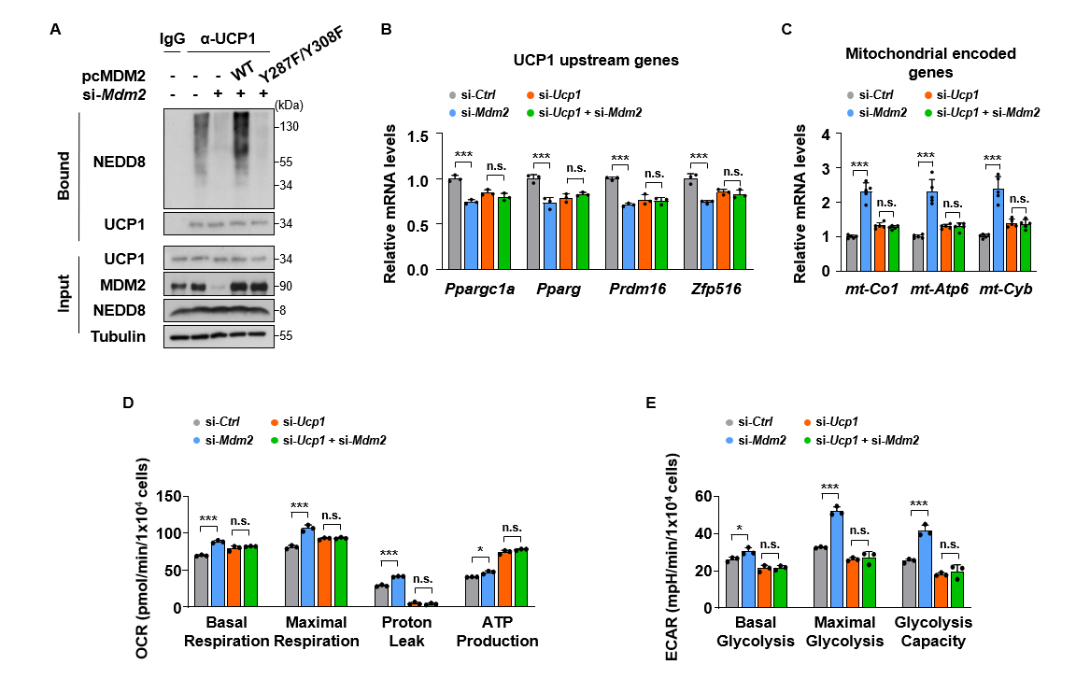
Figure S9. Functional characterization of UCP1-dependent adipocyte browning upon Mdm2 knockdown.
A Day 8 differentiated 3T3-L1 adipocytes transfected 3’UTR-targeting si-Mdm2 (25 nM), combination of 3’UTR-targeting si-Mdm2 (25 nM) and pcMDM2 WT, combination of 3’UTR-targeting si-Mdm2 (25 nM) and pcMDM2 Y287F/Y308F, were treated with MG132 (10 μM) and HCQ (20 μM) for 8 h. Immunoprecipitation with anti-UCP1 antibody followed by immunoblotting for NEDD8. B–E 3T3-L1 adipocytes transfected with si-Ctrl, si-Mdm2 (25 nM), si-Ucp1 (25 nM), or a combination of si-Ucp1 (25 nM) and si-Mdm2 (25 nM) were differentiated for 8 days. B RT-qPCR analysis of UCP1 upstream genes. C RT-qPCR analysis of Mitochondrial encoded genes (n = 5). D Basal respiration, maximal respiration, proton leak, and ATP production derived from OCR measurements. E Basal glycolysis, maximal glycolysis, and glycolytic capacity derived from ECAR measurements. All data are mean ± SEM. Unless otherwise indicated, n = 3 independent experiments. Statistical significance was determined by one-way ANOVA followed by Tukey’s HSD post-hoc test. ∗p < 0.05, ∗∗p < 0.01, ∗∗∗p < 0.001, and n.s. > 0.05.

Figure S10
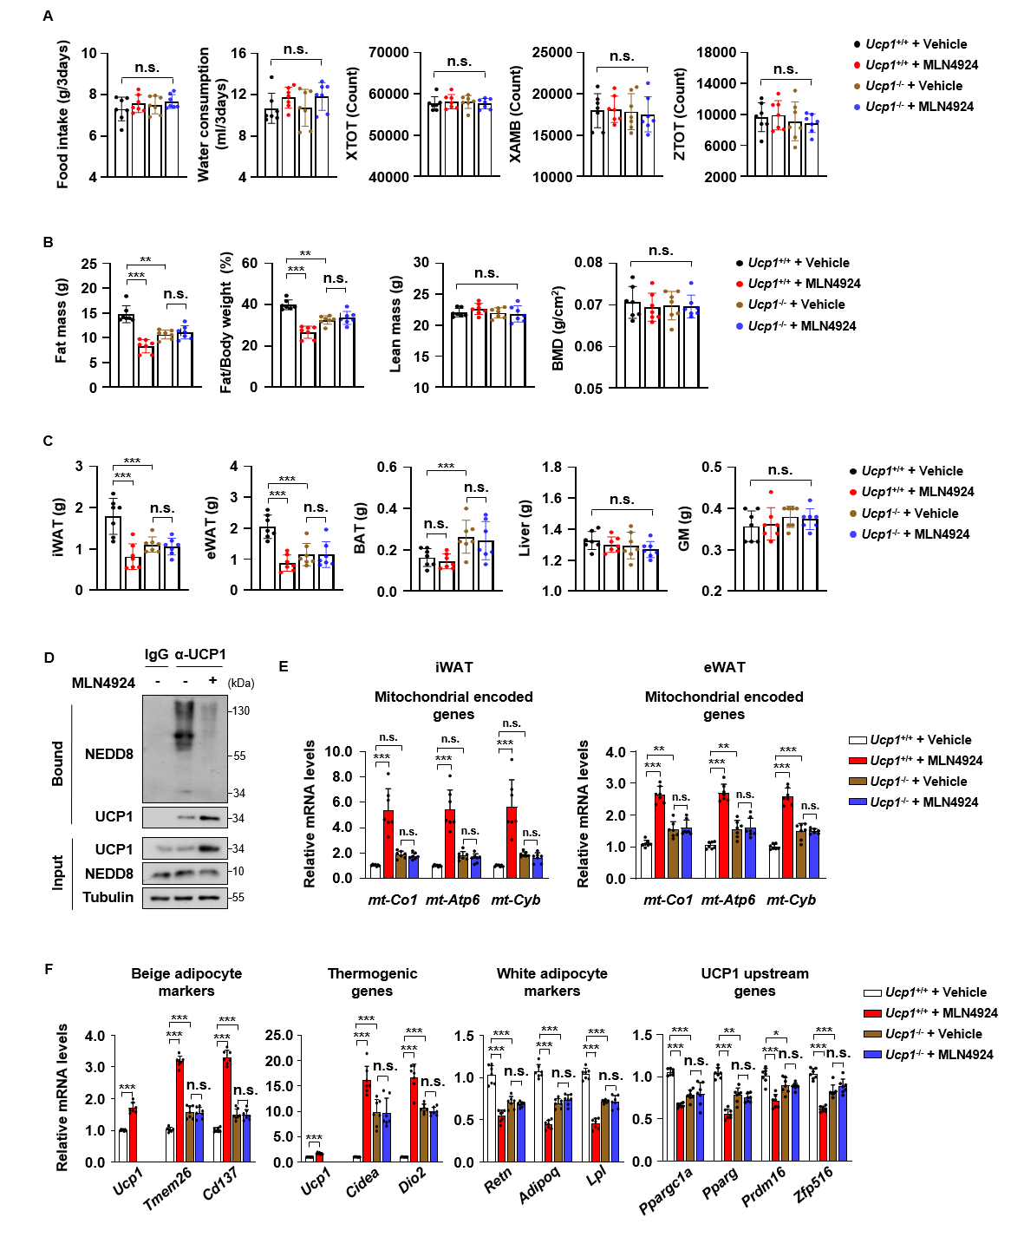
Figure S10. Metabolic and body composition analysis of MLN4924-treated Ucp1^{+/+} and Ucp1^{-/-} mice.
A–F Metabolic and molecular analysis of Ucp1^{+/+} and Ucp1^{-/-} 12-week-old mice following vehicle or MLN4924 treatment (n = 7 per group). A Food intake, water consumption, and activity measured using CLAMS. B Body composition measured by dual-energy X-ray absorptiometry (DXA) C Weights of dissected tissues, including iWAT, eWAT, BAT, liver, and gastrocnemius muscle (GM). D iWAT lysates were subjected to immunoprecipitation with an anti-UCP1 antibody, followed by immunoblotting for NEDD8. E RT-qPCR analysis of Mitochondrial encoded genes in iWAT (left) and eWAT (right). F RT-qPCR analysis of beige adipocyte markers, thermogenic genes, white adipocyte markers, and UCP1 upstream genes in eWAT. All data are mean ± SEM. Statistical significance was determined by one-way ANOVA followed by Tukey’s HSD post-hoc test. ∗p < 0.05, ∗∗p < 0.01, ∗∗∗p < 0.001, and n.s. > 0.05.

Figure S11
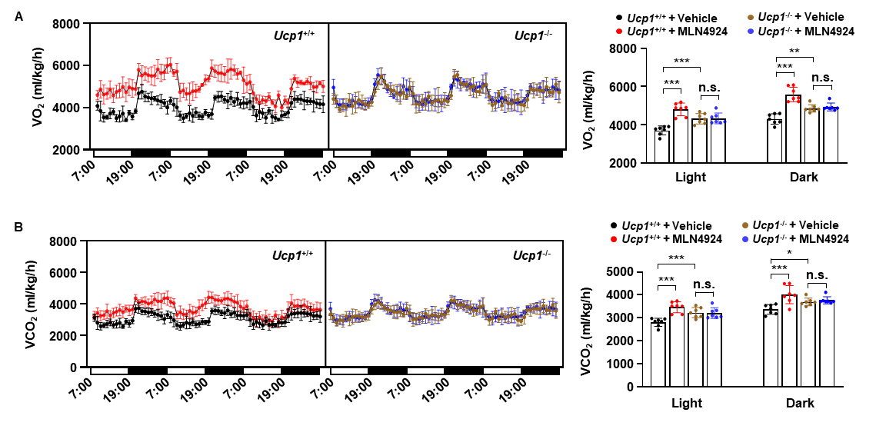
Figure S11. Metabolic analysis of MLN4924-treated Ucp1^{+/+} and Ucp1^{-/-} mice.
A Oxygen consumption (VO₂) (n = 7 per group). Time-course profiles over 3 days (left) and the average values during the light and dark cycles (right). B Carbon dioxide production (VCO₂) (n = 7 per group). Time-course profiles over 3 days (left) and the average values during the light and dark cycles (right). All data are mean ± SEM. Statistical significance was determined by one-way ANOVA followed by Tukey’s HSD post-hoc test. ∗p < 0.05, ∗∗p < 0.01, ∗∗∗p < 0.001, and n.s. > 0.05.

Supplemental Tables
Table S1
 | Genes | Species | Sequences (5’ to 3’)
siRNAs | Ucp1* | Mus musculus | CCAAAACCCUUUACAUCFAUAAACA
siRNAs | Nedd8 | Mus musculus | GGAAGAAGAUGCUAAUUAAAGCGAA
siRNAs | NEDD8 | Homo sapiens | AGCGGUAGGAGCAGCAAUUUAUCCG
siRNAs | Cbl | Mus musculus | GAGAAUCAACUCAGAACGAAAAGCC
siRNAs | CBL | Homo sapiens | GAAGUUACCUAAUAAUCCAAAGATG
siRNAs | Mdm2 | Mus musculus | GCAAUGAUCUACAGAAAUUUAGUGG
siRNAs | Mdm2* | Mus musculus | AAAGACUGAAUCAGAACAUGGAUAA
siRNAs | MDM2 | Homo sapiens | GUAUGUAGACAACCAAUUCAAAUGA
siRNAs | UBB | Homo sapiens | CAAGUUUCAGUAAUAGCU
siRNAs | MAP1LC3A | Homo sapiens | GAGGUAGUUCUGACACUGUCUCAGT
siRNAs | Nix* | Mus musculus | AAACAGAUUGUCCUAUCACAAAGCA
siRNAs | Bnip3 | Mus musculus | AAAAGAACAAGUAAGUGAUAUUAAA
siRNAs | Control |  | UUGAGCAAUUCACGUUCAUTT
Table S1. Nucleotide sequences of siRNAs used in experiments.
*The siRNA sequence targets the 3′ untranslated region (3′ UTR) of the target gene.

Table S2
Genes | Species | Forward Primers (5’ to 3’) | Reverse Primers (5’ to 3’)
Ucp1 | Mus musculus | GTGAACCCGACAACTTCCGAA | TGAAACTCCGGCTGAGAAGAT
Tmem26 | Mus musculus | TGGTCCTGGATACAGTGCTCAC | GGTGCATTTCAAGAAGCCACAGG
Cd137 | Mus musculus | CCAAGTACCTTCTCCAGCATAGG | GCGTTGTGGGTAGAGGAGCAAA
Retn | Mus musculus | CGCTTCCTGATGTCGGTC | ATGCCCACTTCGCCATCC
Adipoq | Mus musculus | ATGACGGCAGCACTGGCA | CGGCCTTGTCCTTCTTGA
Lpl | Mus musculus | GCACTTTCCAGCCAGGATGC | GGCCTGGTTGTGTTGCTTGC
Cidea | Mus musculus | TGACATTCATGGGATTGCAGA | GGCCAGTTGTGATGACTAAGA
Dio2 | Mus musculus | GGTGGTCAACTTTGGTTCAGCC | AAGTCAGCCACCGAGGAGAACT
Pparg | Mus musculus | AGTGGAGACCGCCCAGGCTT | CAGTTCCAGGGCCTGCAGCA
Prdm16 | Mus musculus | CAGCACGGTGAAGCCATTC | GCGTGCATCCGCTTGTG
Zfp516 | Mus musculus | AGCGCTTGGATATCCTCAGTA | GAGGGGCCCTGCTGGCACAGT
Ppargc1a | Mus musculus | GAGAATGAGGCAAACTTGCTAGCG | TGCATGGTTCTGAGTGCTAAGACC
Plin1 | Mus musculus | TGCTGGATGGAGACCTC | ACCGGCTCCATGCTCCA
FABP4 | Mus musculus | CATGGCCAAGCCCAACAT | CGCCCAGTTTGAAGGAAATC
mt-Co1 | Mus musculus | ATTCGAGCAGAATTAGGTCA | CTCCGATTATTAGTGGGACA
mt-Atp6 | Mus musculus | ACGAAAATCTATTTGCCTCA | TGGTGTGTGGATTAGCATTA
mt-Cyb | Mus musculus | TTTTATCTGCATCTGAGTTTAATCCTGT | CCACTTCATCTTACCATTTATTATCGC
Rn18s | Mus musculus | TTCGTATTGAGCCGCTAGA | CTTTCGCTCTGGTCCGTCTT
Table S2. Nucleotide sequences of primers used in experiments.

Table S3
Name |  | Sequences (5’ to 3’)
Ucp1 K38 | Forward | GCTGGACACTGCCCGCGTCCGCCTTCAG
Ucp1 K38 | Reverse | CTGAAGGCGGACGCGGGCAGTGTCCAGC
Ucp1 K138 | Forward | TACAGAGGTCGTGCGCGTCAGAATGCAAGC
Ucp1 K138 | Reverse | GCTTGCATTCTGACGCGCACGACCTCTGTA
Ucp1 K237 | Forward | CCAGTGGATGTGGTACGCACAAGATTCATCAAC
Ucp1 K237 | Reverse | GTTGATGAATCTTGTGCGTACCACATCCACTGG
Table S3. Nucleotide sequences of site-directed mutagenesis primers used in experiments.

Table S4
Antibodies | Source | Catalog #
Mouse monoclonal anti-UCP1 (4E5) | Santa Cruz Biotechnology | Cat# sc-29341
Rabbit polyclonal anti-NEDD8 | Cell Signaling Technology | Cat# 2745S
Rabit polyclonal anti-SUMO1 (FL-101) | Santa Cruz Biotechnology | Cat# sc-9060
Mouse monoclonal anti-Ubiquitin (P4D1) | Santa Cruz Biotechnology | Cat# sc-8017
Mouse monoclonal anti-Cytocrome C | Santa Cruz Biotechnology | Cat# sc-13156
Goat polyclonal anti-BNIP3 | Santa Cruz Biotechnology | Cat# sc-1715
Rabit polyclonal anti-BNIP3L/NIX | Abcam | Cat# ab8399
Rabbit polyclonal anti-FLAG | Sigma-Aldrich | Cat# F7425
Rabbit monoclonal anti-Myc-tag (71D10) | Cell Signaling Technology | Cat# 2278S
Rabbit polyclonal anti-LC3 | Sigma-Aldrich | Cat# L8918
Mouse monoclonal anti-MDM2 (SMP14) | Santa Cruz Biotechnology | Cat# sc-965
Mouse monoclonal anti-Cbl (A-9) | Santa Cruz Biotechnology | Cat# sc-1651
Rabbit polyclonal anti-β-Tubulin | Cell Signaling Technology | Cat# 2146S
Table S4. List of antibodies used in experiments.

