Supplementary materials for

Retinoic acid maintains the primordial follicle reserve by inhibiting PI3K/Akt signaling

Xiaodan Zhang^{1 #}, Nana Zheng ^{1,6,7 #}, Yu Zhao¹, Wenbo Zhang¹, Yashuang Weng¹, Yan Du¹, Jinling Wang¹, Mengjie Weng¹, Huan Lin¹, Yuntong Liu¹, Ziyun Han¹, Sitian Liu¹, Xiaolong Yu¹, Jie Yan^{2,3,4,5}*, Meijia Zhang¹*

¹The Innovation Center of Ministry of Education for Development and Diseases, School of Medicine, South China University of Technology, Guangzhou 510006, China.

²State Key Laboratory of Female Fertility Promotion, Center for Reproductive Medicine, Department of Obstetrics and Gynecology, Peking University Third Hospital, Beijing 100191, China.

³National Clinical Research Center for Obstetrics and Gynecology, Peking University Third Hospital, Beijing 100191, China.

⁴Key Laboratory of Assisted Reproduction, Peking University, Ministry of Education, Beijing 100191, China.

⁵Beijing Key Laboratory of Reproductive Endocrinology and Assisted Reproductive Technology, Beijing 100191, China.

⁶Institute of Neuropsychiatry, The Affiliated Brain Hospital, Guangzhou Medical University, Guangzhou 510006, China.

⁷Center for Sleep and Circadian Medicine, The Affiliated Brain Hospital, Guangzhou Medical University, Guangzhou 510006, China.

*Correspondence to:
Jie Yan, E-mail: yanjiebjmu@bjmu.edu.cn;
Meijia Zhang, E-mail: zhangmeijia@scut.edu.cn

# contributed equally
Supplementary figures and figure legends

Fig. S1. Effect of RA on cell proliferation and PTEN signaling in cultured mouse ovaries. Mouse ovaries at 3 dpp were cultured in the medium (control) or medium with RA + Talarozole (Tala), DEAB, AGN, 10 µM bpV, or bpV + RA + Talarozole for 0.5 days (C, F), 1 day (A, B) or 4 days (D, E). (A, B) Immunofluorescence staining (A) and positive-signal quantification (B) in the control and drug-treated groups. Magnified views of boxed areas are shown in Fig. 2I. (C) Immunofluorescence staining of p-AKT in the control and RA + Talarozole groups. Oocyte cytoplasm was stained with DDX4 (red); nuclei were counterstained with DAPI (blue). (D, E) Comparison of ovarian morphology (D) and follicle number (E) in the ovaries of bpV and bpV + RA + Talarozole groups. The image is a representative picture from the largest section of the ovary. (F) Pten mRNA levels in the control and drug-treated groups. The relative mRNA levels in the control group were normalized to 1. Scale bars: 50 μm. For each experiment, representative images are shown from at least three (n ≥ 3) biological replicates. *p < 0.05, **p < 0.01, and ***p < 0.001.

Fig. S2. Transcriptomic alterations in oocytes and granulosa cells upon Rarα deletion. Oocytes and granulosa cells were collected from 16 dpp WT and Rarα-KO mice for RNA-seq. (A) Volcano plot of differentially expressed genes (DEGs) in Rarα-KO oocytes compared to WT oocytes. (B) Gene set enrichment analysis (GSEA) of downregulated and upregulated pathways in Rarα-KO oocytes and granulosa cells. (C) Volcano plot of DEGs in Rarα-KO granulosa cells compared to WT granulosa cells. (D) Venn diagram illustrating the overlap of upregulated and downregulated DEGs between oocytes (OO) and granulosa cells (GC) in Rarα-KO mice versus WT mice.

Fig. S3. Single-cell clustering analysis of ovarian cells from WT and Rarα/γ double-knockout mice at 16 dpp. (A) Expression of ovarian cell marker genes across nine identified cell clusters. (B) Top 5 highly expressed genes in each cell cluster. (C) Heatmaps depicting GDF signaling-mediated cell-cell interaction strength in WT and Rarα/γ-dKO ovarian cell clusters. Color intensity reflects interaction strength; x-axis denotes receptor cell clusters, and y-axis denotes ligand cell clusters. (D) Volcano plot of DEGs in Rarα/γ-dKO oocyte cluster compared to WT. Genes associated with oocyte development are highlighted. (E) Relative expression levels of oocyte development genes Ooep and Gdf9 in oocyte cluster from WT and Rarα/γ-dKO mice. (F) GSEA of RA response in WT and Rarα/γ-dKO oocyte cluster. (G, H) GO analysis of downregulated (G) and upregulated (H) genes in Rarα/γ-dKO oocyte cluster compared to WT.

Fig. S4. Pathway alterations in oocyte subpopulations upon Rarα/γ deletion at 16 dpp. (A, B) Reactome analysis of WT primary follicle oocytes (A), primordial follicle oocytes and apoptotic oocytes (B). (C) GSEA of downregulated and upregulated pathways in primordial, primary, and apoptotic oocytes of Rarα/γ-dKO mice compared to those of WT mice. (D, E) GO analysis of downregulated and upregulated DEGs in primary follicle oocytes (D) and apoptotic oocytes (E) of Rarα/γ-dKO mice compared to those of WT mice.

Fig. S5. Effects of oral RA administration on estrous cyclicity and development in mice. Prepubertal mice (3 weeks old) were treated orally with or without RA continuously until designated time points. (A) Ovarian morphology in control and RA-treated (100, 500, or 1000 ng/mL) groups. The image is a representative picture from the largest section of the ovary. Magnified views of boxed areas are shown in Fig. 6J. (B) Age of vaginal opening and first estrus (puberty markers) in control and 500 ng/mL RA-treated mice. (C) Estrous cycle length evaluated by vaginal smears in control and 500 ng/mL RA-treated mice. (D) Ovarian morphology in control and 500 ng/mL RA-treated groups at 11, 15, and 19 weeks of age. The image is a representative picture from the largest section of the ovary. Amplified views of boxed areas are shown in Fig. 6N. (E) Body weight comparison in control and 500 ng/mL RA-treated groups at 7, 11, 15, 19, and 23 weeks of age. Nuclei were stained with hematoxylin. Scale bars: 100 μm. For each experiment, representative images are shown from at least three (n ≥ 3) biological replicates.

Fig. S6. Primer specificity analysis by melting curves for qPCR. Melting-curve analysis was performed after qPCR amplification of each target gene in 3 dpp mouse ovaries (A) and human ovarian cortex samples (B).

Fig. S7. Standard curves and amplification efficiency of primers used for qPCR. Standard curves were constructed from five‑point serial dilutions of cDNA from 3 dpp mouse ovaries (A) and from human ovarian cortex (B). Ct values were plotted against the Log₁₀ of the dilution factor. For each primer pair, the regression equation, amplification efficiency (E), and R² value are indicated.

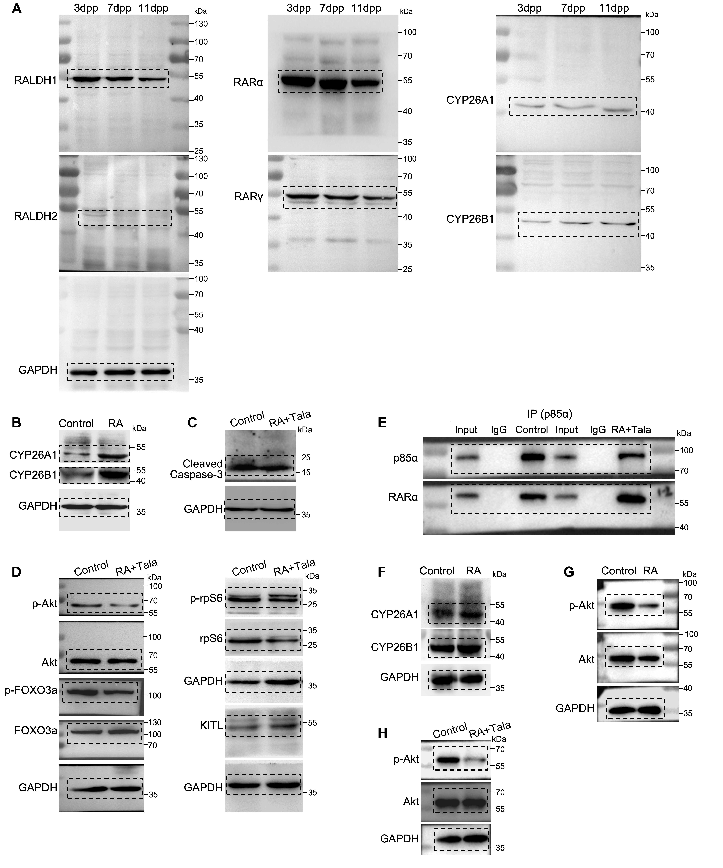Fig. S8. Uncropped scans of the Western blot results in Figs. 1, 2, 6 and 7. (A-H) The blots within the black dashed line boxes correspond to those used in Fig. 1C (A), 2E (B), 2F (C), 2K (D), 2P (E), 6E (F), 6F (G) and 7H (H).

Table S1. Primers for genotyping
Genotyping | Forward primer  (5’-3’) | Reverse primer  (5’-3’) | Annealing Temp (°C) | Product Size  (bp)
Rarα-KO | TAGTATGCAACCAGGCTCCTG | GAGACAAACACACTAGACAGGCAC | 55°C | WT: 271 bp  Target: 319 bp
Rarα-WT | ATCTGGAATTGAAGCTGAGTCCTG | CATAGTGGTAGCCGGATGATTTG | 55°C | WT: 347 bp
Rarγ ^{flox} | AGCAGTTCAGGAATGAAGACAGGC | CCGCAGATGTAGAGGCAAATGG | 55°C | WT: 354 bp  Targeted: 455 bp
Gdf9-Cre | AAGAACCTGATGGACATGTTCAG | CTGATTCTGGCAATTTCGG | 52°C | Targeted: 450 bp

Table S2. Primers for qPCR (mouse)
Genes | Forward primer  (5’-3’) | Reverse primer  (5’-3’) | Annealing Temp (°C) | Product Size  (bp)
Raldh1 | ATACTTGTCGGATTTAGGAGGCT | GGGCCTATCTTCCAAATGAACA | 60°C | 192
Raldh2 | CAGAGAGTGGGAGAGTGTTCC | CACACAGAACCAAGAGAGAAGG | 60°C | 136
Raldh3 | GGGTCACACTGGAGCTAGGA | CTGGCCTCTTCTTGGCGAA | 60°C | 201
Rarα | TTCTTTCCCCCTATGCTGGGT | GGGAGGGCTGGGTACTATCTC | 60°C | 150
Rarβ | GCAGTGCGTGGACACATGA | GGTAGAAGCTGCAAACTGACT | 60°C | 201
Rarγ | TGCCTGGTTTTACAGGGCTC | TCCGAGAATGTCATAGTGTCCT | 60°C | 127
Rxrα | CACACCCACATTGGGCTTC | GAGGCCATATTTCCTGAGGGA | 60°C | 144
Rxrβ | CCTACTCGTGTCGTGATAACAAA | CTCAACGCCTTGGTCACTCT | 60°C | 248
Rxrγ | CATCTACACCTGTCGGGATAACA | CATGTCTTCGTGGCTACTACTG | 60°C | 190
Cyp26a1 | ACAAGACGCATCTGTTTGGG | TGCATAATCACCTTCTTTCGCTG | 60°C | 190
Cyp26b1 | TCATCGGAGAGACTGGTCACT | GGTGCTCACTAGCTGGTGTTC | 60°C | 173
Cyp26c1 | GCTACGGGACAGTGTTTAAGAC | GCGCCAAGTAGTGTGTGTGA | 60°C | 163
Gdf9 | TCTTAGTAGCCTTAGCTCTCAGG | TGTCAGTCCCATCTACAGGCA | 60°C | 116
Zp3 | CCTCAGGACTAACCGTGTGGA | CCATCAGGCGAAGAGAGAAAG | 60°C | 149
Pten | TGGATTCGACTTAGACTTGACCT | GCGGTGTCATAATGTCTCTCAG | 60°C | 180
Rpl19 | CTGAAGGTCAAAGGGAATGTGTTC | TGGTCAGCCAGGAGCTTCTTG | 60°C | 101

Table S3. Primers for qPCR (human)
Genes | Forward primer  (5’-3’) | Reverse primer  (5’-3’) | Annealing Temp (°C) | Product Size  (bp)
RALDH1 | GCACGCCAGACTTACCTGTC | CCTCCTCAGTTGCAGGATTAAAG | 60°C | 129
RALDH2 | TTGCAGGGCGTCATCAAAAC | ACACTCCAATGGGTTCATGTC | 60°C | 121
RALDH3 | TGAATGGCACGAATCCAAGAG | CACGTCGGGCTTATCTCCT | 60°C | 100
RARα | AAGCCCGAGTGCTCTGAGA | TTCGTAGTGTATTTGCCCAGC | 60°C | 122
RARβ | CCCCAGAACAAGACACCATGA | TTTTGTCGGTTCCTCAAGGTC | 60°C | 209
RARγ | TGTCACCGCGACAAAAACTGT | CGAGGGGAAAGTCTCCTGA | 60°C | 234
RXRα | GGACTGCCTGATTGACAAGC | TTCAGCCCCATGTTTGCCTC | 60°C | 246
RXRβ | TTGCCGGGACAACAAAGACT | CCCTGGTCACTCTTCTGTTCC | 60°C | 234
RXRγ | CCGGATCTCTGGTTAAACACATC | GTCCTTCCTTATCGTCCTCTTGA | 60°C | 119
CYP26A1 | GAATGCTACGTGCCGGTGAT | CATGGCGATTCGGAACATGAG | 60°C | 123
CYP26B1 | GGCAACGTGTTCAAGACGC | TGCTCGCCCATGAGGATCT | 60°C | 89
CYP26C1 | CACACTGCTAGGTGCGGTC | TGGAGGCGTCGTAGACTGAG | 60°C | 173
ACTB | TGCCCATCTACGAGGGGTAT | CTTAATGTCACGCACGATTTCC | 60°C | 152
RPS24 | AAGACCACACCGGATGTCATC | TGCCAAAGCCAGTTGTCTTG | 60°C | 76

Table S4. Antibodies for immunodetection
Antibody | Catalog Code | Company | Host | Clonality | Validated Species | Tested Applications | IF_dilution | WB_dilution
RALDH1 | Ab52492 | Abcam | Rabbit | Monoclonal | Mouse, Human | Flow Cyt (Intra), IHC-P, ICC/IF, IP, WB | 1:200 | 1:1000
RALDH2 | sc22591 | Santa Cruz | Goat | Polyclonal | Mouse, Rat, Human | WB, IP, IF, IHC(P), ELISA | 1:200 | 1:1000
RARα | GTX  54703 | GeneTex | Rabbit | Polyclonal | Mouse, Rat, Human | WB,  ICC/IF,  IHC-P | 1:200 | 1:1000
RARα | ab28767 | Abcam | Goat | Polyclonal | Human | WB |  | 1:1000
RARγ | LS-B10760 | LifeSpan BioSciences | Rabbit | Polyclonal | Mouse,  Human | IHC, IHC-P, WB | 1:200 | 1:1000
CYP26A1 | ab151968 | Abcam | Rabbit | Polyclonal | Mouse, Human | WB, IHC-P | 1:200 | 1:1000
CYP26B1 | 21555-1-AP | Proteintech | Rabbit | Polyclonal | Mouse, Rat, Human | WB, IHC, IF/ICC, IP, ELISA | 1:200 | 1:1000
GAPDH | 2118 | Cell Signaling Technology | Rabbit | Monoclonal | Human, Mouse, Rat, Monkey, Bovine, Pig | WB, IHC, IF, Flow Cyt |  | 1:1000
DDX4 | Ab27591 | Abcam | Mouse | Monoclonal | Mouse, Human, Pig, Marmoset | IHC-P, ICC/IF, WB, IHC-Fr | 1:200
Cleaved  Caspase-3 | 9664 | Cell Signaling Technology | Rabbit | Monoclonal | Human, Mouse, Rat, Monkey | WB, IP, IHC, IF, Flow Cyt | 1:200 | 1:1000
PCNA | 2586 | Cell Signaling Technology | Mouse | Monoclonal | Human, Mouse, Rat, Monkey, Bovine, Pig | WB, IP, IHC, IF, Flow Cyt | 1:200
BrdU | ab1893 | Abcam | Sheep | Polyclonal | Human, Mouse | ELISA, IHC-P, IHC-Fr | 1:200
AKT | 4691 | Cell Signaling Technology | Rabbit | Monoclonal | Human, Mouse, Rat, Monkey, melanogaster | WB, IP, IHC, IF, Flow Cyt |  | 1:1000
p-AKT | 4060 | Cell Signaling Technology | Rabbit | Monoclonal | Human, Mouse, Rat, Hamster, Monkey, D. melanogaster, Zebrafish, Bovine | WB, IP, IHC, IF, Flow Cyt | 1:200 | 1:1000
FOXO3a | 12829 | Cell Signaling Technology | Rabbit | Monoclonal | Human, Mouse, Rat, Monkey | WB, IP, IHC, IF, Flow Cyt | 1:200 | 1:1000
p-FOXO3a | ab26649 | Abcam | Rabbit | Polyclonal | Human | ELISA, WB, IHC-P |  | 1:1000
RPS6 | ab40820 | Abcam | Rabbit | Polyclonal | Human | IHC-P, WB, ICC/IF |  | 1:1000
p-RPS6 | ab215214 | Abcam | Rabbit | Monoclonal | Mouse, Rat, Human | Flow Cyt (Intra), IHC-P, ICC/IF, Dot, WB, IP |  | 1:1000
KITL | ab64677 | Abcam | Rabbit | Polyclonal | Human, Mouse, African green monkey | ICC/IF, IHC-P, WB |  | 1:1000
p85α | 4257 | Cell Signaling Technology | Rabbit | Monoclonal | Mouse, Rat, Human | WB, IP | 1:200 | 1:1000;  IP 1:50
PFKL | ab181064 | Abcam | Rabbit | Monoclonal | Mouse, Rat, Human | Flow Cyt (Intra), ICC/IF, WB | 1:200
Alexa Fluor 488 donkey anti-mouse IgG | A-21202 | Thermo Fisher Scientific | Donkey | Polyclonal | Mouse | IHC, ICC/IF | 1:300
Alexa Fluor 488 donkey anti-rabbit IgG | A-21206 | Thermo Fisher Scientific | Donkey | Polyclonal | Rabbit | IHC (P), IHC (F), ICC/IF, Flow | 1:300
Alexa Fluor 488 donkey anti-goat IgG | A-11055 | Thermo Fisher Scientific | Donkey | Polyclonal | Goat | IHC (P), IHC (F), ICC/IF, Flow | 1:300
Alexa Fluor 555 donkey anti-mouse IgG | A-31570 | Thermo Fisher Scientific | Donkey | Polyclonal | Mouse | IHC, ICC/IF | 1:300
Alexa Fluor 555 donkey anti-rabbit IgG | A-31572 | Thermo Fisher Scientific | Donkey | Polyclonal | Rabbit | IHC, ICC/IF, Flow | 1:300
Alexa Fluor 555 donkey anti-goat IgG | A-21432 | Thermo Fisher Scientific | Donkey | Polyclonal | Goat | IHC, ICC/IF | 1:300
Dot: Dot blot
ELISA: Enzyme-Linked Immunosorbent Assay
Flow Cyt: Flow Cytometry
ICC: Immunocytochemistry
IF: Immunofluorescence
IHC: Immunohistochemistry
IHC-Fr: Immunohistochemistry (Frozen sections)
IHC-P: Immunohistochemistry (Formalin/PFA-fixed paraffin-embedded sections)
IP: Immunoprecipitation
WB: Western Blotting

