Sarad et al. “Endothelial senescence impairs efferocytosis and alters macrophage responses: insights into APP–CD74 signaling”
Supplementary figures

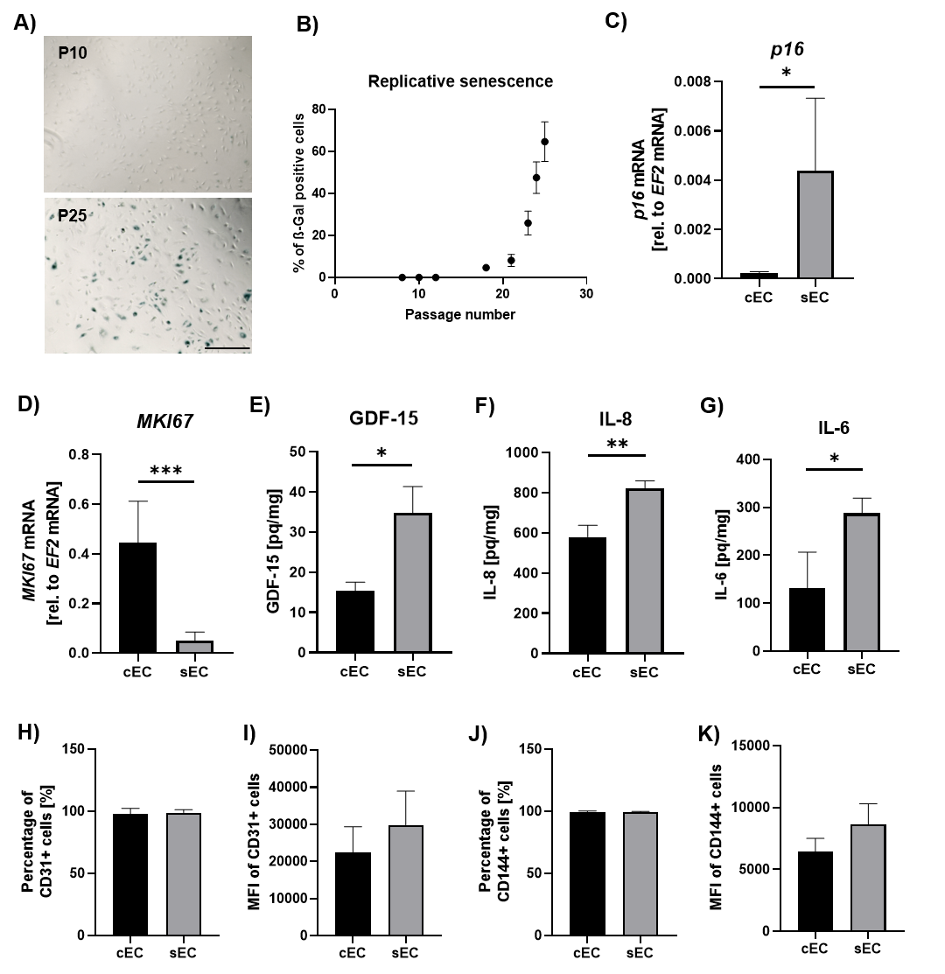
Fig. S1. Characterization of replicative senescence in human umbilical vein endothelial cells (HUVECs). A) Representative images (×200 magnification) and B) quantification of SA-β-Gal staining in HUVEC cells at different passages (P – passage number). Relative mRNA levels of p16 (C) and MKI67 (D) and secretion of GDF-15 (E), IL-8 (F) and IL-6 (G) by cEC and sEC. Percentage (H) and median fluorescence intensity (I) of CD31⁺ cells. Percentage (J) and median fluorescence intensity (K) of CD144⁺ cells. Results are presented as mean ± SD from 3-4 independent experiments (*p<0.05, ** p<0.01, *** p<0.001, **** p<0.0001). Scale bar: 200 µm.

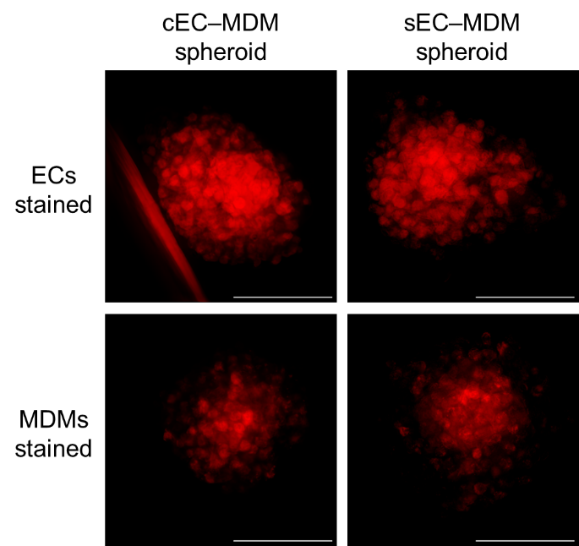
Fig. S2. Co-culture of control (cEC) or senescent (sEC) HUVECs with MDMs in 3D spheroids. One cell type was stained with CellTracker™ Red CMTPX dye prior the spheroid formation. Representative fluorescent microscopy pictures of spheroids at 72 hours of culture. Scale bar: 500 μm.

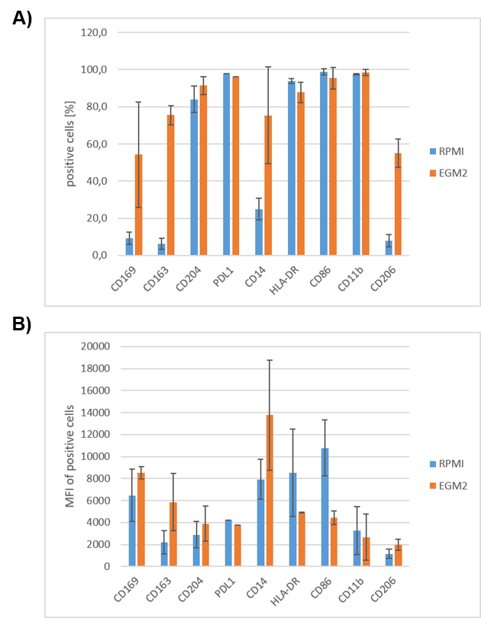
Fig. S3. Flow cytometric analysis of M1/M2 macrophage markers in MDMs grown as 2D monolayers in the presence of EGM-2. Percentage (A) and median fluorescence intensity (B) of positive cells. RPMI – control MDMs cultured in macrophage RPMI complete medium for 72 hours, EGM-2 – MDMs cultured in EGM-2 medium for 72 hours. Data represent mean ± SD from two independent donors.

