Sarad et al. “Endothelial senescence impairs efferocytosis and alters macrophage responses: insights into APP–CD74 signaling”

Full-length, uncropped Western blot images corresponding to Figure 8C. Lanes 1–6 correspond to the samples presented in Figure 8C. Lanes 7–9 contain unrelated samples from the same gel and are not included in the analysis.
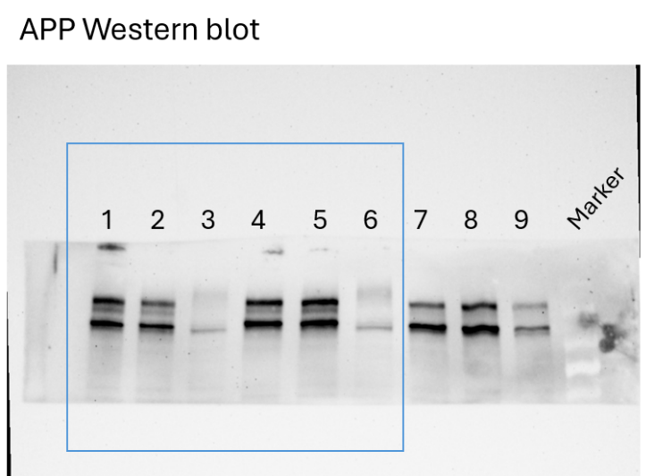
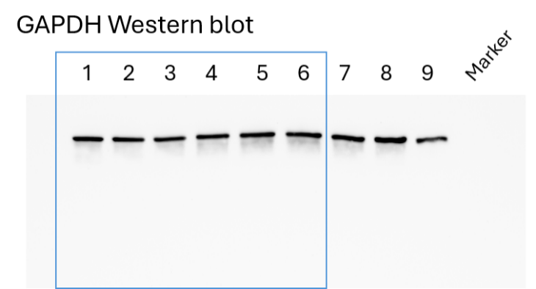
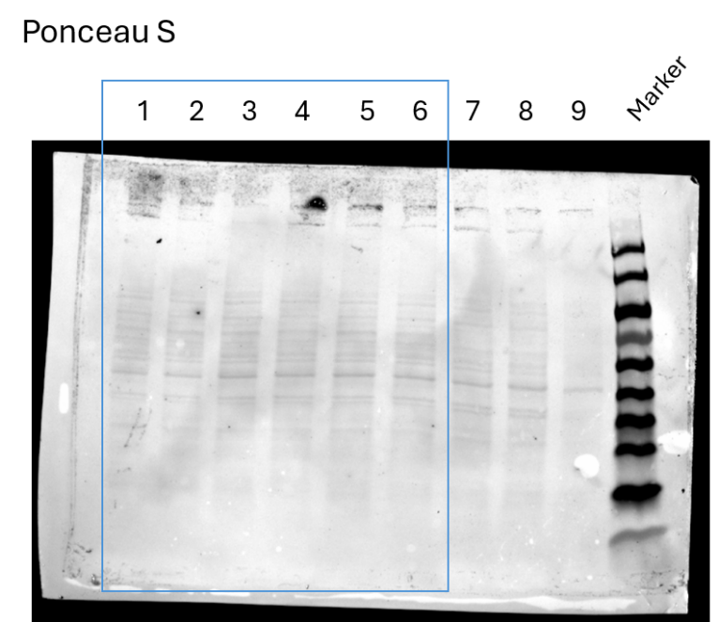

Full-length, uncropped Western blot images corresponding to Figure 8E. Lanes 1–6 correspond to the samples presented in Figure 8E. Lanes 7–8 contain unrelated samples from the same gel and are not included in the analysis.
