Supplementary Materials and Methods
Cell lines
Human EAC47 cell line was isolated from human esophageal mucosa obtained from tumor-adjacent tissue from a patient undergoing surgery at the University of Miami Miller School of Medicine. OE33, OE19, SKGT-2, FLO-1 and EAC47 cell lines were maintained in RPMI 1640 (Corning, Corning, NY, USA) supplemented with 10% fetal bovine serum (Lonza, Basel, Switzerland), 100 units/mL penicillin (GeminiBio, West Sacramento, CA, USA), 100 µg/mL streptomycin (GeminiBio) and 2 mM glutamine (Corning). HCT-116, MDA-MB-231, HEK293T and HEK293 STF cells were cultured in Dulbecco's Modified Eagle Medium (DMEM, Corning) supplemented with 10% fetal bovine serum, 100 units/mL penicillin, 100 µg/mL streptomycin, and 2 mM glutamine. Het1A cells were cultured in BEBM medium (Lonza) supplemented with all the components from the Lonza BEGMTM Growth Media BulletKitTM (CC-3170) except GA-1000. Het1a cells were cultured in the plates pre-coated with a mixture of 0.01 mg/mL fibronectin, 0.03 mg/mL bovine collagen type I, and 0.01 mg/mL bovine serum albumin dissolved in culture medium. The number of passages of the cell lines used in this study did not exceed 25. All cell lines were maintained at 37°C in 5% CO2 and monitored monthly for mycoplasma contamination using the EZ-PCR™ Mycoplasma Detection Kit (Sartorius, Bohemia, NY, USA). OE33 cell line was established from the adenocarcinoma of the lower esophagus (Barrett's metaplasia) of a 73-year-old female patient. OE19 cell was established in 1993 from an adenocarcinoma of gastric cardia/esophageal gastric junction of a 72-year-old male patient. SK-GT-2 cell line was established from a primary adenocarcinoma of the gastric fundus from a 72-year-old Hispanic male. FLO-1 was established from a primary distal esophageal adenocarcinoma in a 68-year-old Caucasian male in 1991. HCT-116 cell line was isolated from the colon of an adult male with colon cancer. Het-1A is an epithelial cell line that was isolated in 1986 from the esophagus of a 29-year-old, male donor. HEK-293 cell lines were isolated from the kidney of a human embryo. MDA-MB-231 cell line was isolated from the mammary gland of a 40-year-old white female with adenocarcinoma.
Generation of OE33 cell line with doxycycline-inducible shRNA
pLKO plasmids containing short hairpin RNA (shRNA) against CK1αLS (5-GAGGAAAAGAAGCATGACT-3 for shRNA-S3 and 5-GAAGCATGACTGTTAGTAC-3 for shRNA-S4, using the hairpin loop sequence TTCAAGAGA) or with a non-targeting sequence (shCTR) were constructed and purchased from GenScript Biotech (Piscataway, NJ, USA). Two different sequences targeting the L insert of CK1αLS were used. Lentivirus was packaged using psPAX2 (Addgene, Watertown, MA, USA) packaging vector and pMD2.G (Addgene) envelope plasmid in HEK293T cells. Transfection and viral infection were performed as described below. For induction of gene knockdown, the cells were treated with 2 µg/ml doxycycline (Sigma-Aldrich, St. Louis, MO, USA) for 96 h. The sequences used for shCTR and shRNA against CK1αLS are listed in Supplemental Table.
Cell transfections and viral infections
Cell transfections were used to introduce siRNA transiently, TCF/LEF luciferase reporter vector (BPS Bioscience, San Diego, CA, USA) and plasmids encoding four CK1α splice transcript variants into cancer or HEK293T cells. The specific siRNAs targeting human CK1αLS and a scrambled negative control siRNA were constructed/purchased from Dharmacon, Lafayette, CO, USA. Two different sequences targeting the L insert of nuclear CK1α were used and are listed in Supplemental Table. PCDNA3.1 plasmids encoding HA-tagged LS, L, S and NI splice transcript variants were custom-made by Genewiz, South Plainfield, NJ, USA. An empty pcDNA3.1 plasmid was used as a negative control. A Lipofectamine™ 3000 Transfection Reagent (L3000001) was purchased from Thermo Fisher, Waltham, MA, USA. The day before transfection, cells were seeded in the cell culture plates containing complete RPMI or DMEM medium and incubated for 24 h. The following day, transfection was performed using Lipofectamine™ according to the manufacturer's instructions. The cells were collected 24-96 h after transfection for analysis.
HEK293T cells were used for the packaging of lentiviruses to generate stable cell lines. HEK293T (3x10⁶ cells) transfection in 6-well plate was performed as described above using 10 µg pLKO.1 vector containing shRNA against CK1αLS or a scrambled sequence (negative control), 4 µg psPAX2 packaging vector (Addgene), and 2 µg pMD2.G envelope (Addgene). Virus was collected 48 h after transfection and centrifuged at 1,500 x g for 10 min before storage. For OE33 cell infection, 1000 cells were seeded into 10-cm plate and 500 µL of virus-containing medium supplemented with 4 µg/mL polybrene (Sigma-Aldrich) were added overnight. Infected cells were selected with 2.0 µg/mL puromycin (Thermo Fisher) and picked using sterile cloning discs (Thomas Scientific, Chadds Ford Township, PA, USA).
Nuclear lysate preparation
Cells were collected from the plates, and the cell pellet was resuspended in 2 package cell volume of buffer A (10 mM HEPES (pH 7.5, Sigma-Aldrich), 1.5 mM MgCl₂ (Fisher Chemicals, Pittsburgh, PA, USA), 10 mM KCl (EMD Millipore, Burlington, MA, USA), 300 mM sucrose (Sigma-Aldrich), 0.5% NP-40 (Amresco, Solon, OH, USA) with inhibitors. The inhibitor cocktail included 0.5 mM PMSF (Sigma-Aldrich), 1 mM Na₃VO₄ (Sigma-Aldrich), 0.5 mM DTT (Sigma-Aldrich), 1 µg/mL leupeptin (Sigma-Aldrich), 25 mM β-glycerophosphate (Sigma-Aldrich), 10 mM NaF (Alfa Aesar, Ward Hill, MA, USA). The cells were kept on ice for 10 min to isolate the nuclei. Then, the cells were briefly vortexed and centrifuged at 2600 x g for 30 sec at 4°C. The supernatant was removed and the cell pellet was resuspended in 2/3 package cell volume of buffer B (20 mM HEPES (pH 7.5), 1.5 mM MgCl₂, 420 mM NaCl (Invitrogen, Waltham, MA, USA), 0.2 mM EDTA (Invitrogen), 2.5% glycerol (VWR, Radnor, PA) with inhibitors as described above. The cells were incubated on ice for 5 min and then centrifuged at 10,400 x g for 5 min at 4°C. The supernatant (nuclear lysate) was diluted isovolumetrically with buffer D (20 mM HEPES (pH 7.5), 100 mM KCl, 0.2 mM EDTA, 8% glycerol) with inhibitors and used in further experiments.
Nuclear/cytoplasmic fractionation
Nuclear and cytoplasmic fractions were prepared using the same fractionation protocol described above for nuclear lysate preparation used in TCF-DNA affinity pull-down assays. Briefly, cells were lysed in buffer A to release the cytoplasmic fraction, which was collected following centrifugation. The remaining nuclear pellet was subsequently extracted with buffer B and diluted with buffer D as described above.
Western blotting
Cell lysates were diluted with 2X Laemmli sample buffer (Bio-rad) and incubated at 95°C for 5 min. Pre-cast 4-20% gels (Bio-rad) were used for SDS-PAGE. 20 μg of proteins were loaded per lane. Proteins were transferred onto nitrocellulose membranes (Bio-rad) using the Trans-Blot Turbo Transfer System (Bio-rad) following manufacturer’s instructions. Membranes were blocked in 5% milk (VWR) or 5% BSA (CST) and incubated with appropriate antibodies overnight at 4°C followed by incubation with an anti-mouse or anti-rabbit secondary antibody conjugated with horseradish peroxidase at RT for 1 h. For detection, enhanced chemiluminescence reaction using PierceTM ECL Western blotting substrate (Thermo Fisher) was performed according to the manufacturer’s specifications. The list of antibodies can be found in Supplemental Table.
Reverse transcription-quantitative polymerase chain reaction (RT-qPCR) analysis
Total RNA was isolated using the RNeasy Plus Mini Kit (Qiagen, Hilden, Germany) and cDNA was synthesized using the High-Capacity cDNA Reverse Transcription Kit (Applied Biosystems, Waltham, MA, USA) following the manufacturer's directions. RT-qPCR analysis was performed using the TaqMan™ Universal Master Mix II (no UNG) and TaqMan™ Gene Expression Assays (Thermo Fisher) according to manufacturer’s instructions. Gene expression was normalized to either HPRT1, TBP, or GAPDH housekeeping gene.
Cell sphere formation
Cancer cells were seeded into 6-well plates (0.01x10⁶ cells/well) and cultured in DMEM/F12 medium (Corning) supplemented with 1 µg/mL epidermal growth factor (Sigma-Aldrich), 1 µg/mL fibroblast growth factor (Sigma-Aldrich), and B27 supplement (Invitrogen) at 37°C and 5%CO₂ for 7 days. Sphere numbers were calculated using a Gelcount imager (Oxford Optronix, Oxford, UK).
MTT cell viability assay
Cell viability following L-insert-specific CK1α knockdown was assessed using the MTT assay. OE33 and HCT-116 cells were seeded in 96-well plates and subjected to L-insert-specific CK1α knockdown or the corresponding control condition. Cell viability was assessed 96 h after knockdown induction/transfection, corresponding to the time point used for the molecular analyses. MTT reagent was added to each well to a final concentration of 0.5 mg/mL, and cells were incubated for 4 h at 37°C. The culture medium was then removed, and the resulting formazan crystals were dissolved in DMSO. Absorbance was measured using a microplate reader, and cell viability was expressed relative to the corresponding control condition, which was set to 100%.
FACS and flow cytometric analysis
Aldehyde Dehydrogenase (ALDH) and CSC markers: cell lines and single cells derived from tumors or spheres were stained using either the ALDEFLUOR kit (StemCell Tech, Vancouver, Canada) or specific monoclonal APC anti-human CD44 (BD Biosciences, Franklin Lakes, NJ, USA) and PE CD24 antibodies (BD) following the manufacturer’s instructions and were analyzed by flow cytometry. Single cells were obtained from tumors using a gentleMACS dissociator and tumor dissociation kit (Miltenyl Biotec, Bergisch Gladbach, Germany).
Apoptosis analysis: flow cytometry-Annexin V analysis in ALDH⁺ OE33 secondary tumor spheres after the treatment with 50, 100 and 200 nM SSTC3 was performed using the annexin V-PI (propidium iodide) kit (Invitrogen) according to the manufacturer’s instructions.
Cell cycle checkpoints analysis: single cells derived from OE33 ALDH+ secondary tumor spheres were incubated with cold 50%HBSS/50%HI (BD). Then, ice-cold 70% ethanol was added while continuously vortexing (low setting) the cells. After fixation, 1 mg/mL RNase A (Thermo Fisher) and 1 µg/mL propidium iodide (Thermo Fisher) were added prior to the flow cytometry analysis.
Tumor cell gating strategies for sorting and analysis
ALDH cell analysis and sorting were performed on a five-laser Beckman Coulter MoFlo Astrios EQ cell sorter using 25 psi and a 100 µm nozzle. Debris, aggregates, and dead cells were excluded through hierarchical gating: FSC-H versus SSC-H to remove debris, SSC-H versus SSC-W to exclude aggregates, and FSC-H versus PI to eliminate PI-positive dead cells.
DEAB-treated Aldefluor-stained cells were used to define gates for ALDH-positive and ALDH-negative populations, while unstained cells were used to set gates for CD44-positive and CD44-negative cells.
Cells were sorted at 10,000 cells per second. A sorted-cell aliquot was re-stained with PI and reanalyzed to assess purity and viability.
CD44 analysis was performed on a Beckman Coulter CytoFLEX S. Debris, aggregates, and dead cells were excluded by hierarchical gating: FSC-A versus SSC-A to remove debris, SSC-H versus SSC-W to exclude aggregates, and FSC-A versus fixable viability dye violet to eliminate viability dye-positive dead cells. Unstained cells were used to define gates for CD44-positive and CD44-negative cells.
Colony formation and cell viability assays
OE33 cells were sorted using the ALDEFLUOR kit (StemCell Tech) to obtain ALDH+ and ALDH- populations. HCT-116 and Colo320DM cells were sorted by CD44 expression (CD44+ and CD44−) using a specific monoclonal anti-CD44 antibody (BD) as described above. Sorted and parental populations were seeded into 6-well plates (500 cells/well) and treated with different concentrations of SSTC3 (0.1, 0.3, 1.0 µM for esophageal and 0.03, 0.1, 0.3 µM for colorectal cells). The cells were cultured for 6–8 days, and formed colonies were fixed with ice-cold methanol for 6 min followed by 0.01% crystal violet staining for 8 min.
Cells were measured using the Cell Titer-Glo and cell viability assays (Promega) following the manufacturer’s instructions.
Immunohistochemistry
ALDH1A, β-catenin and ki67 stains were performed using anti-ALDH1A (Abcam, Cambridge, UK), anti-β-catenin (Abcam) and anti-ki67 (Leica biosystems, Nussloch, Germany). ALDH1A and β-catenin scoring: negative (0), weak (1þ), moderate (2þ), strong (3þ). Ki67 scoring: Count the percentage of positive cells in one 40 field with the highest positive.
In vivo mouse studies
EAC47 PDXs
The EAC47 (esophageal adenocarcinoma) tumors were implanted subcutaneously and grown in nude mice to approximately 200 mm³ before starting SSTC3 treatment. Both oral (p.o.) and intraperitoneal (i.p.) routes of administration were used. Mice were divided into 4 groups (CTR p.o., SSTC3 p.o., CTR i.p., SSTC3 i.p.) and treated with SSTC3 or vehicle daily. (SSTC3 p.o. treatment was administered at 50 mg/kg for 44 days while i.p. treatment was given at 10 mg/kg for 25 days. Tumor measurements were taken every 3-5 days with a digital caliper. On day 7, two tumors from CTR p.o. and SSTC3 p.o. groups were collected for the TCF DNA pull-down and FACS analyses, to investigate the components of the CK1α/β-catenin/TCF transcriptional complex and ALDH1 cell-surface CSC marker levels. On day 7, two tumors (vehicle and SSTC3) were examined by IHC to determine the protein levels of the WNT markers (ALDH1A and β-catenin) as well as Ki67, a marker of cell proliferation.
L met CRC #1 PDXs
The CRC #1 (colorectal) tumors were implanted subcutaneously and grown in nude mice to approximately 200 mm³ before starting SSTC3 treatment. Mice were divided into 2 groups (CTR p.o., SSTC3 p.o.) and treated with SSTC3 at 50 mg/kg or vehicle daily for 14 days. Tumor measurements were taken every 2-3 days with a digital caliper. On day 7, two tumors from CTR p.o. and SSTC3 p.o. groups were collected for the FACS analysis to evaluate the percentage of CD44-expressing cells.
Colo320DM Cell Xenografts
Colo320DM cells (~2x10⁶) were implanted subcutaneously in nude mice. Mice were divided into 3 groups (vehicle, SSTC3 10 mg/kg, and SSTC3 50 mg/kg). Once the tumors reached 200 mm³, mice were treated with SSTC3 or vehicle daily via oral gavage for 27 days. Tumor measurements were taken every 3 days with a digital caliper. One day after the treatment started, single tumor cells prepared using the Miltenyi Biotec kit (#130-095-929) were evaluated by FACS for the expression of the CSC marker CD44 in vehicle-treated and SSTC3 (50 mg/kg)-treated tumors. On day 26, the treatment was stopped and ~2x10⁶ single cells were transplanted into new mice to evaluate tumor initiation ability after the treatment. Mice were monitored for tumor growth until the tumors reached 2000 mm³ (no treatment was administered). Single cells were obtained from tumors following the manufacturer’s instructions (MACS, Tumor Dissociation kit, 130-095-929).
To evaluate the effect of SSTC3 on tumor initiation, Colo320DM cells were implanted subcutaneously into immunodeficient mice and oral treatment began on day 3 and was discontinued on day 32. Mice were randomized into 4 groups: vehicle and three concentrations of SSTC3: 3, 10, and 50 mg/kg. After treatment termination on day 32, mice were monitored for survival (defined as tumor growth reaching 2000 mm³). The survival curve was constructed using GraphPad Prism software (Version 8.4.3).
Cloning of N-terminal HA-tagged human CK1α WT and K46A/K46R mutants
Double-stranded DNA fragments encoding the human CSNK1A1 (CK1α) transcript ENST00000515768.6 were synthesized by Azenta. Three constructs were generated: CK1α WT, CK1α K46A, and CK1α K46R. The K46A and K46R mutants were generated by substituting lysine 46 with alanine or arginine, respectively.
The synthesized DNA fragments contained an N-terminal HA tag and were cloned into the pCDH-EF1-MCS-IRES-RFP lentiviral expression vector (System Biosciences, Cat. No. CD531A-2). In-Fusion cloning was used to insert the WT and mutant CK1α fragments at the BamHI cloning site.
The resulting plasmids, designated pCDH-EF1-HA-CK1α-WT-IRES-RFP, pCDH-EF1-HA-CK1α-K46A-IRES-RFP, and pCDH-EF1-HA-CK1α-K46R-IRES-RFP, were verified by sequencing to confirm the CK1α coding sequence, the respective K46 substitutions, and the integrity of the HA-tagged expression cassette.
Immunofluorescence and confocal microscopy
HEK293 cells were seeded into Lab-Tek chambered #1.0 borosilicate cover glass 2-chamber slides (Thermo Fisher Scientific, Cat. No. 155380) and maintained in DMEM supplemented with 10% FBS. Cells were transiently transfected with the indicated HA-tagged CK1α constructs using Lipofectamine 3000 Transfection Reagent (Thermo Fisher Scientific, Cat. No. L3000001) according to the manufacturer’s instructions. Cells were seeded 24 h before transfection and processed for immunofluorescence 48 h after transfection.
Prior to fixation, cells were washed with 100 µL FACS buffer (3% FBS in PBS). Cells were fixed with 250 µL of 4% paraformaldehyde for 15 min at room temperature and washed with 250 µL FACS buffer. Cells were then permeabilized with 250 µL of 0.15% Triton X-100 in PBS for 2 min at room temperature. After removal of the permeabilization buffer, samples were blocked with 250 µL blocking buffer (1% FBS in 0.03% Triton X-100/PBS) for 30 min at room temperature.
Cells were incubated with Alexa Fluor 594-conjugated anti-HA antibody (Invitrogen, Cat. No. A21288; 1:200 in blocking buffer) for 2 h at room temperature protected from light. Following washing with blocking buffer, nuclei were stained with DAPI (5 µM; Abcam, Cat. No. ab228549) for approximately 5 min at room temperature. Samples were washed and mounted using VectaMount Express Mounting Medium (Vector Laboratories, Cat. No. H-5700-60), coverslipped, and allowed to cure overnight. Images were acquired using a Zeiss LSM 980 confocal microscope equipped with Airyscan 2, with identical acquisition parameters maintained across experimental conditions.
Image analysis and quantification
Nuclear mean fluorescence intensity (MFI) was quantified from confocal images using a semi-automated image-analysis pipeline. Cell and nuclear boundaries were segmented from multichannel TIFF images using Cellpose, and the resulting segmentation masks were converted to regions of interest (ROIs) in Fiji/ImageJ. HA fluorescence intensity was measured within the nuclear ROI of each cell. Background fluorescence, determined from an empty-field region of each image, was subtracted from the corresponding nuclear fluorescence measurements to obtain background-corrected nuclear MFI values.
Statistical analysis of immunofluorescence data
A minimum of 50 cells per group were quantified. Statistical analyses were performed in Python using the SciPy library. Differences among the four experimental groups were initially evaluated by one-way ANOVA. Pairwise comparisons were subsequently performed using two-tailed Welch’s t-tests, with Bonferroni correction for six multiple comparisons. A Bonferroni-adjusted p value <0.001 was considered statistically significant. Data are displayed as violin plots with overlaid boxplots indicating the median and interquartile range, together with individual data points.
Key resources
REAGENT or RESOURCE | SOURCE | IDENTIFIER
Antibodies
Rabbit monoclonal anti-CK1 | Abcam | ab108296
Rabbit monoclonal anti-TCF4/TCF7 | CST | C48H11
Rabbit monoclonal anti-HA tag | CST | C29F4
Rabbit monoclonal anti-b-catenin | Abcam | ab6302
Rabbit monoclonal anti-ALDH1A | Abcam | ab52492
Mouse monoclonal anti-ki67 | Leica biosystem | PA0118
Mouse APC anti-human CD44 | BD Pharmingen | 559942
Mouse PE anti- human CD24 | BD Pharmingen | 555428
Active β-catenin | CST | 8814
β-catenin (pS45) | CST | 9564S
L-insert |  | The antibody was custom-made by Genemed Synthesis, Inc. using the following peptide: CLESPVGKRKRSMTVSTSQDPSFSGLNQ.
IgG | CST
Bacterial and virus strains
Biological samples
Patient-derived xenografts (PDX) EAC47 | University of Miami  Biopsy-derived | N/A
PDX L met CRC#1 | University of Miami  Biopsy-derived | N/A
PDX Colo320DM | University of Miami  Biopsy-derived | N/A
Chemicals, peptides, and recombinant proteins
RPMI 1640 medium | Corning | 10-040-CV
DMEM medium | Corning | 10-013-CV
DMEM/F-12 medium | Corning | 10-090-CV
BEGM Growth Media BulletKitTM | LONZA | CC3171
Fetal bovine serum | LONZA | CC3170
Penicillin/Streptomycin | Gemini Bio | 900-108
Glutamine | Corning | 30-002-Cl
PBS | Corning | 21-040-CM
Epidermal growth factor | Sigma | E5036
Fibroblast growth factor | Sigma | F0291
B27 supplement | Invitrogen | 17504-044
Polybrene | Sigma | TR-1003-G
Puromycin | ThermoFisher | AAJ672368EQ
Doxycycline | Sigma | D5207-1G
Lipofectamine™ 3000 Transfection Reagent | ThermoFisher | L3000001
Milk powder | VWR | M203-104
BSA | CST | 9998S
TaqMan™ Universal Master Mix II (no UNG) | Thermo Fisher | 4440040
WNT ligand | R&D | 5036-WN-010
HEPES | Sigma | H0887-100ML
MgCl₂ | Fisher Chemicals | M33-500
KCl | EMD Millipore | 529552-1KG
Sucrose | Sigma | 59378-1KG
NP-40 | Amresco | E109-500ML
PMSF | Sigma | P7626-1G
Na₃VO₄ | Sigma | S6508-10G
DTT | Sigma | S1504-100G
β-glycerophosphate | Sigma | G942-50G
NaF | Alfa Aesar | 11561
NaCl | Invitrogen | AM9759
EDTA | Invitrogen | 15575-038
glycerol | VWR | M152-4L
Streptavidin-agarose beads | Sigma | 20353
2X Laemmli sample buffer | Bio-rad | 1610737
Triton X-100 | Sigma | T9284-500ML
A/G Plus Agarose beads | Santa Cruz | Sc-2003
Protease inhibitor cocktail | Roche | 11836170001
RNase A | Thermo Fisher | EN0531
Propidium iodide | Thermo Fisher | P1304MP
Critical commercial assays
PierceTM ECL Western blotting substrate | Thermo Fisher | 32106
RNeasy Plus Mini Kit | Qiagen | 74136
High-Capacity cDNA Reverse Transcription Kit | Applied Biosystems | 4368814
QIAquick PCR purification kit | Qiagen | 28104
ADELFLUOR kit | STEMCELL technologies | 01700
Pierce BCA protein Assay Kit | Thermo fisher | 23227
Luciferase assay system | Promega | E1960
CellTiter Glo 2,0 | Promega | G7570
Tumor Dissociation kit | MACS | 130-195-929
Pre-cast 4-20% gels | Biorad | 4568093
Transfer membrane, nitrocellulose | Biorad | 1704158
Deposited data
RNA-seq data | This paper | GEO: GSE304372
Experimental models: Cell lines
Human OE33 | ECCC
Human OE19 | ECCC
Huma SKGT-2 | ATCC
Human FLO-1 | Wang et al.
Human HCT-116 | ATCC
Human MDA-MB-231 | ATCC
Human EAC47 | Our lab
Human HEK293 STF | ATCC | CRL-3249
Human HEK293 T | ATCC | CRL-3216
Human Het1a | ATCC | CRL-2692
Experimental models: Organisms/strains
Mouse: Crl:CD1-Foxn1^{nu} | Charles River Labs | Strain code: 086
Oligonucleotides
si/shRNA CK1αLS sequence S3 | This paper | 5′-GAGGAAAAGAAGCATGACT-3′
si/shRNA CK1αLS sequence S4 |  | 5′-GAAGCATGACTGTTAGTAC-3′
TCF binding site sequence |  | agtcattgacaagatcaaagggggtaagatcaaagggggtaagatcaaaggg ttgcaccatgc
Mutant sequence (control for DNA pull-down) |  | agtcattgacaaggccaaagggggtaaggccaaagggggtaaggccaaaggg ttgcaccatgc
Recombinant DNA
psPAX2 plasmid | Addgene | 12260
pMD2.G plasmid | Addgene | 12259
pcDNA3.1 plasmid encoding HA-tagged CK1αLS  NCBI Reference Sequence: NM_001025105.3 | paper | https://www.ncbi.nlm.nih.gov/nuccore/NM_001025105.3
pcDNA3.1 plasmid encoding HA-tagged CK1αL  NCBI Reference Sequence: NM_001892.6 | paper | https://www.ncbi.nlm.nih.gov/nuccore/NM_001892.6
pcDNA3.1 plasmid encoding HA-tagged CK1αS  NCBI Reference Sequence: NM_001271741.2 | paper | https://www.ncbi.nlm.nih.gov/nuccore/NM_001271741.2
pcDNA3.1 plasmid encoding HA-tagged CK1α  NCBI Reference Sequence: NM_001271742.2 | paper | https://www.ncbi.nlm.nih.gov/nuccore/NM_001271742.2
TCF/LEF luciferase reporter vector | BPS Science | 60500

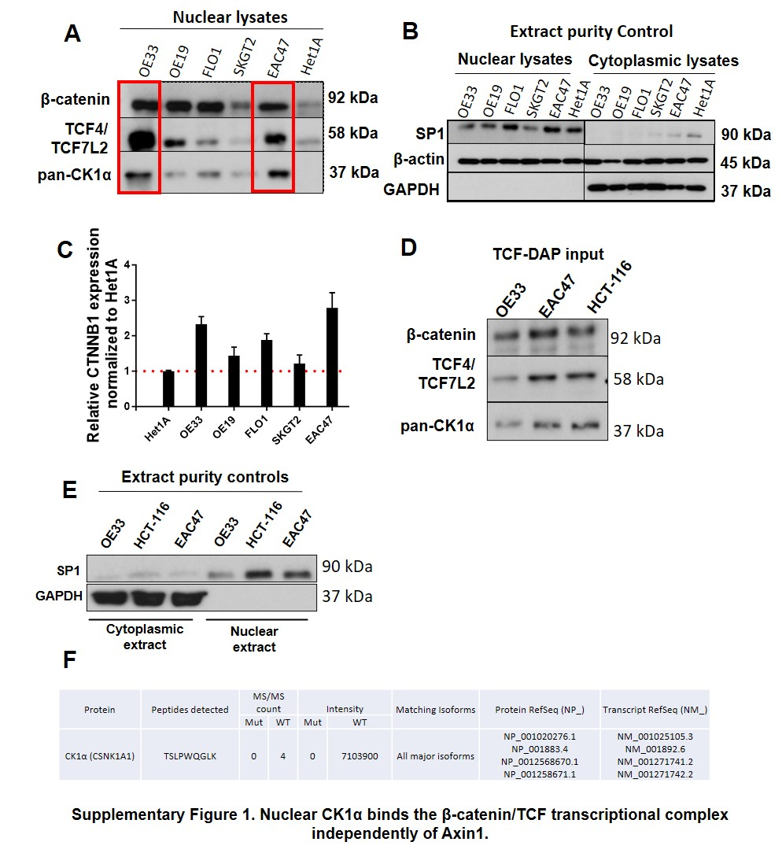
Supplementary Figures

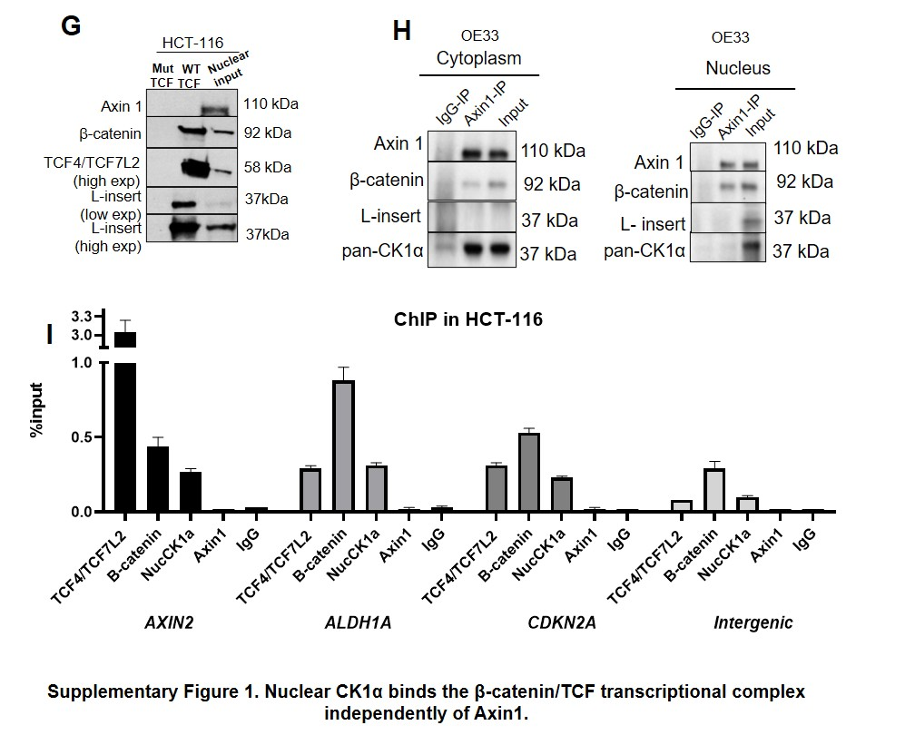

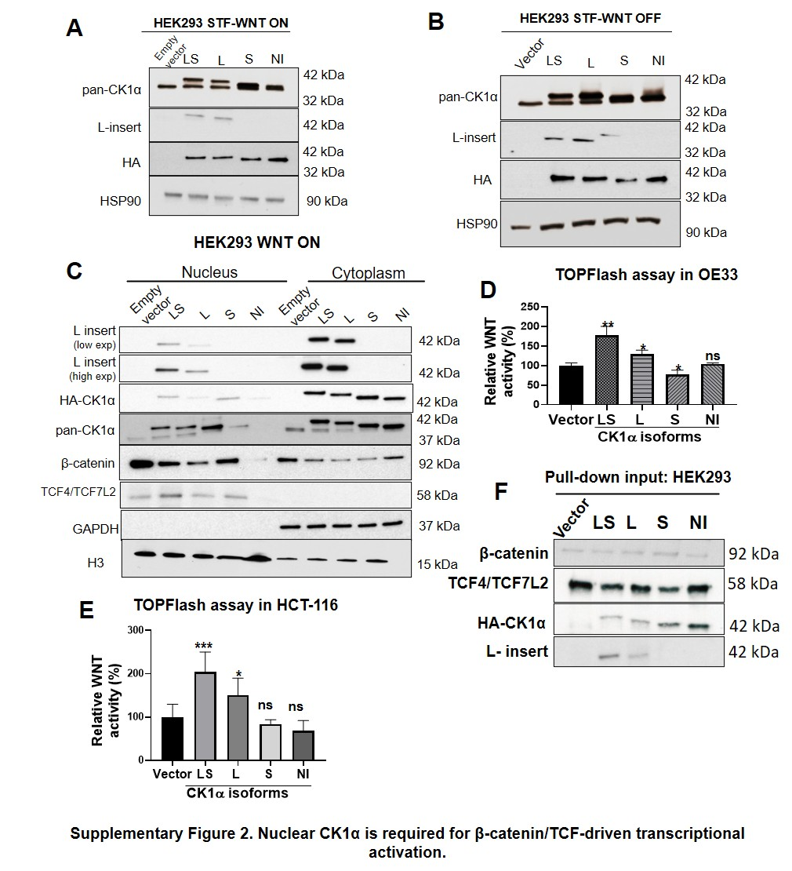

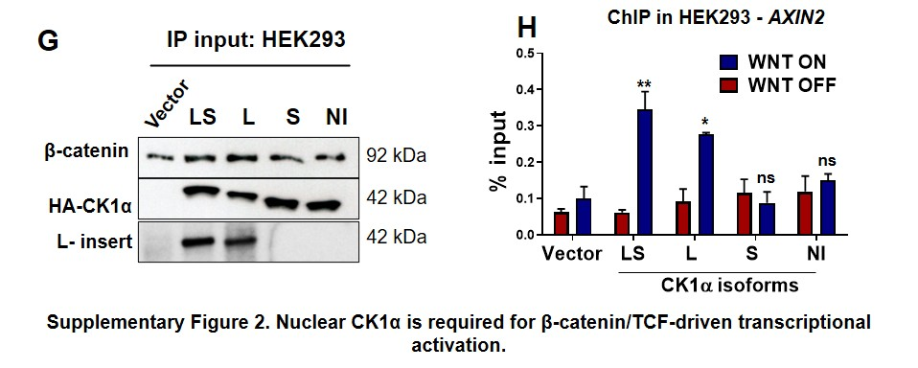

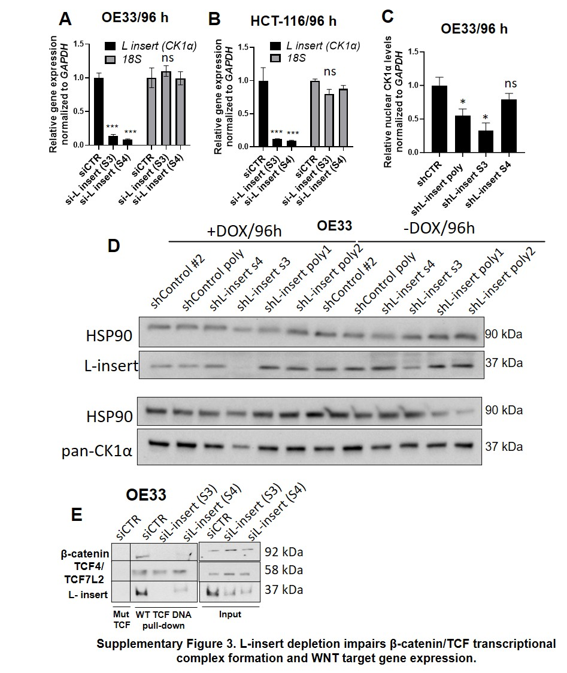

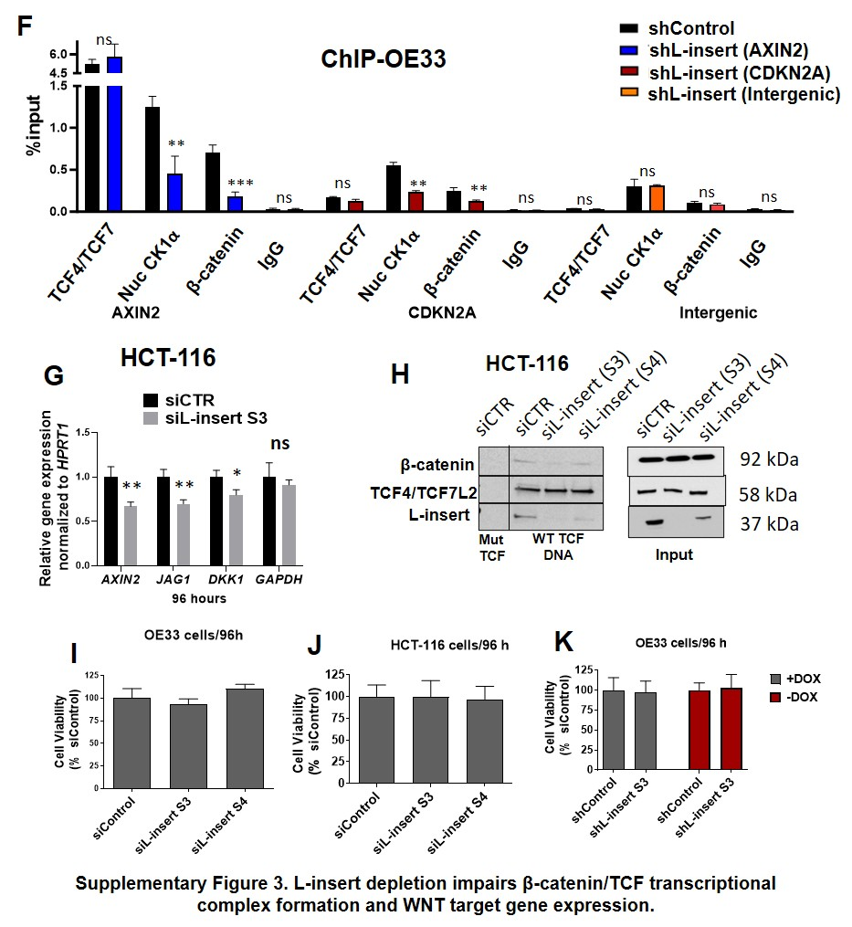

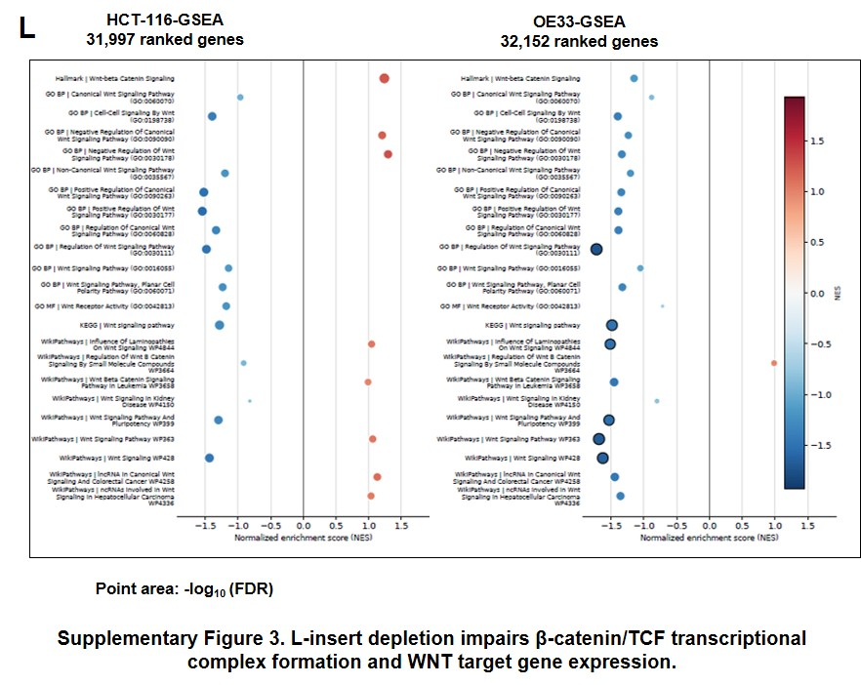

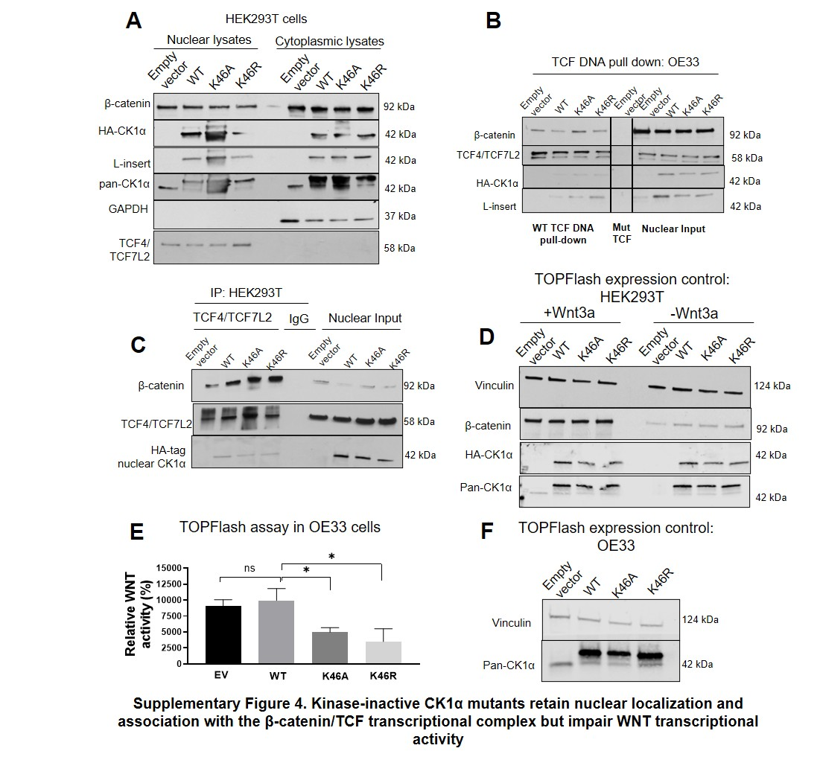

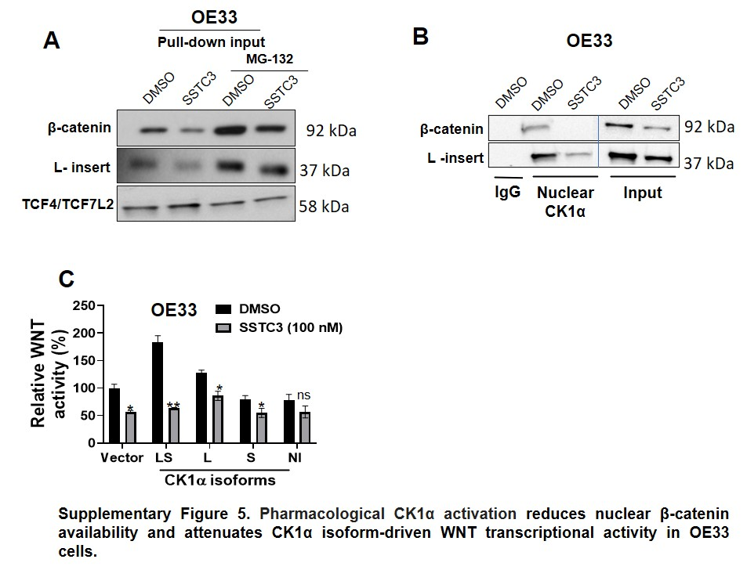

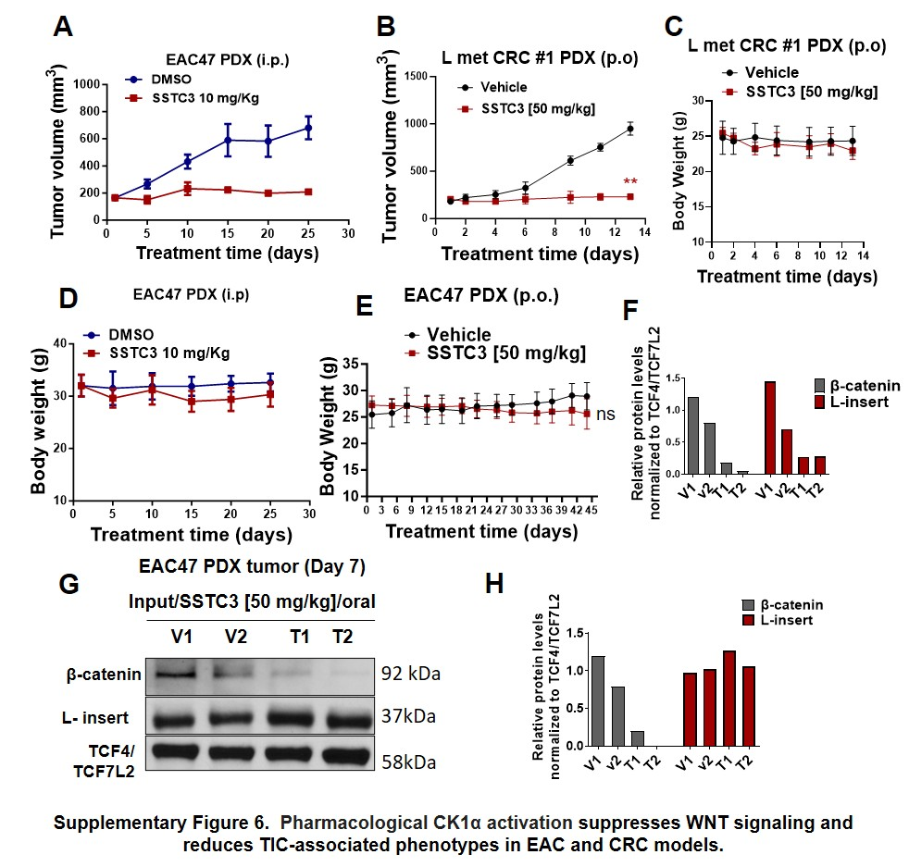

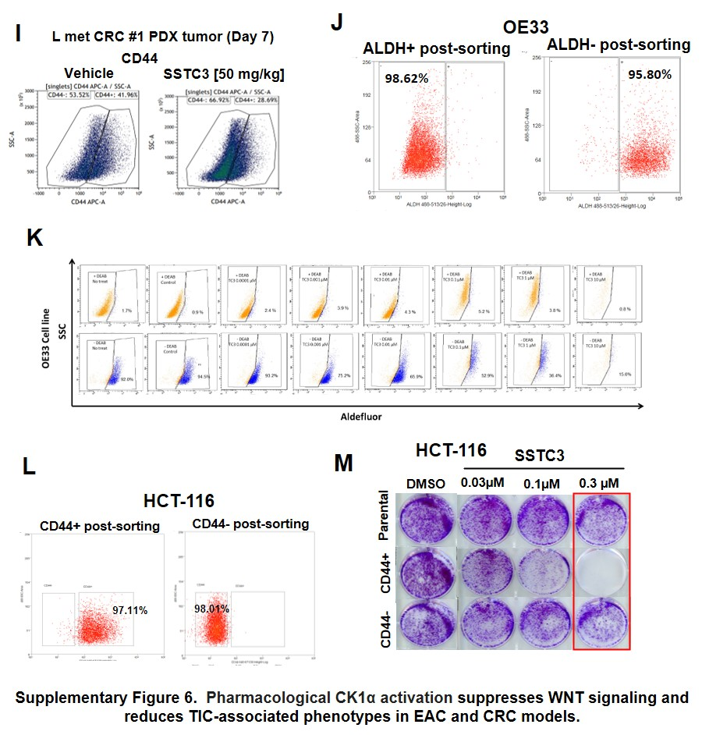

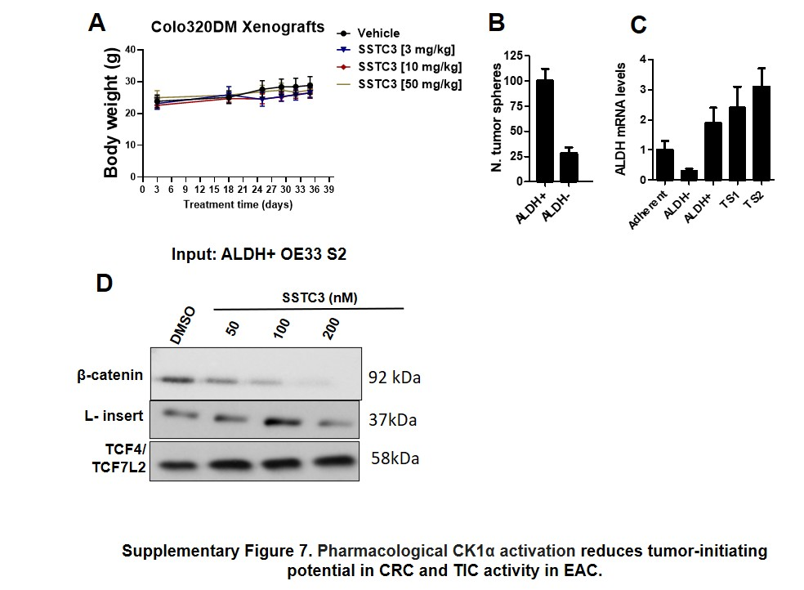

Supplementary legends

Supplementary Figure 1. Nuclear CK1α binds the β-catenin/TCF transcriptional complex independently of Axin1. (A) Immunoblot analysis of CK1α, β-catenin, and TCF4/TCF7L2 in nuclear lysates from the EAC cell lines OE33, OE19, FLO1, SKGT2, and EAC47 and the non-tumorigenic esophageal epithelial cell line Het1A. (B) Immunoblot analysis of nuclear and cytoplasmic fractions from the indicated cell lines using β-actin, GAPDH, and SP1 as fractionation controls. (C) RT-qPCR analysis of CTNNB1 expression in the indicated EAC cell lines. (D) Immunoblot analysis of the nuclear extracts used for the TCF-DNA affinity pull-down shown in Figure 1A. (E) Immunoblot analysis of GAPDH and SP1 in the cytoplasmic and nuclear extracts used in Figure 1A. (F) LC-MS/MS identification of the conserved CK1α peptide TSLPWQGLK recovered by TCF-DNA affinity pull-down from OE33 nuclear extracts and the corresponding CK1α protein and transcript isoforms. (G) TCF-DNA affinity pull-down using WT or mutant TCF-binding oligos and HCT-116 nuclear extracts. Bound proteins were analyzed by immunoblotting for β-catenin, TCF4/TCF7L2, L-insert-containing CK1α, and Axin1. (H) Co-immunoprecipitation using an Axin1 antibody in cytoplasmic and nuclear extracts from OE33 cells, followed by immunoblotting for Axin1, β-catenin, pan-CK1α, and L-insert-containing CK1α. (I) ChIP-qPCR analysis of TCF4/TCF7L2, β-catenin, and L-insert-containing CK1α occupancy at the AXIN2, ALDH1A, and CDKN2A promoters in HCT-116 cells. Data represent mean ± SD (n = 3).

Supplementary Figure 2. Nuclear CK1α is required for β-catenin/TCF-driven transcriptional activation. (A-B) Immunoblot analysis of HA-tagged CK1α isoforms in HEK293 STF cells under WNT ON (A) or WNT OFF (B) conditions, corresponding to the TOPFlash assay shown in Figure 2D. Pan-CK1α, L-insert-containing CK1α, and HSP90 were also analyzed. WNT ON conditions were induced with 200 ng/mL WNT3A ligand. (C) Nuclear and cytoplasmic fractionation of HEK293 cells expressing the indicated HA-tagged CK1α isoforms after stimulation with 200 ng/mL WNT3A ligand, followed by immunoblotting for β-catenin, HA-tagged CK1α, pan-CK1α, L-insert-containing CK1α, and TCF4/TCF7L2. GAPDH and histone H3 were used as cytoplasmic and nuclear fractionation controls, respectively. (D–E) TOPFlash WNT reporter assays in HCT-116 (D) and OE33 (E) cells expressing the indicated CK1α isoforms. (F) Immunoblot analysis of the nuclear extracts used for the TCF-DNA affinity pull-down shown in Figure 2E. (G) Immunoblot analysis of the nuclear extracts used for the HA co-immunoprecipitation shown in Figure 2F. (H) ChIP-qPCR analysis using an HA antibody at the AXIN2 promoter in HEK293 cells expressing the indicated CK1α isoforms under WNT OFF or WNT ON conditions. Data represent mean ± SD (n = 3). ns, not significant; *p < 0.05; **p < 0.01; ***p < 0.001 versus empty vector; t-test.
Supplementary Figure 3. L-insert depletion impairs β-catenin/TCF transcriptional complex formation and WNT target gene expression. (A-B) RT-qPCR analysis of L-insert-containing CK1α transcript levels in OE33 (A) and HCT-116 (B) cells 96 h after transfection with control siRNA or L-insert-specific siRNAs (siL-insert S3 or S4). (C) RT-qPCR analysis of L-insert-containing CK1α transcript levels in OE33 cells after 96 h of doxycycline-induced expression of the indicated control or L-insert-specific shRNAs. (D) Immunoblot analysis of L-insert-containing CK1α and pan-CK1α in OE33 cells under the shRNA conditions described in (C). HSP90 was used as a loading control. (E) TCF-DNA affinity pull-down using WT or mutant TCF-binding oligos and nuclear extracts from OE33 cells transfected with control siRNA or L-insert-specific siRNAs (siL-insert S3 or S4). Bound proteins were analyzed by immunoblotting for β-catenin, L-insert-containing CK1α, and TCF4/TCF7L2. (F) ChIP-qPCR analysis of TCF4/TCF7L2, β-catenin, and L-insert-containing CK1α occupancy at the AXIN2 and CDKN2A promoters in OE33cells expressing control or L-insert-specific shRNA. An intergenic region and IgG were used as negative controls. (G) RT-qPCR analysis of WNT target gene expression in HCT-116 cells transfected with control siRNA or L-insert-specific siRNA. (H) TCF-DNA affinity pull-down using WT or mutant TCF-binding oligos and nuclear extracts from HCT-116 cells transfected with control siRNA or L-insert-specific siRNAs (siL-insert S3 or S4). Bound proteins were analyzed by immunoblotting for β-catenin, L-insert-containing CK1α, and TCF4/TCF7L2. (I-K) MTT cell-viability assays inOE33 and HCT-116 cells after siRNA- or shRNA-mediated depletion of L-insert-containing CK1α isoforms. (L) Gene set enrichment analysis of WNT-related gene sets in HCT-116 and OE33 cells after depletion of L-insert-containing CK1α isoforms. GSEA: Genes were ranked using the DESeq2 Wald statistic; normalized enrichment scores (NES) and false discovery rates (FDR) are shown. (A-C) Data represent mean ± SD (n = 3). ns, not significant; *p < 0.05; **p < 0.01; ***p < 0.001.

Supplementary Figure 4. Kinase-inactive CK1α mutants retain nuclear localization and association with the β-catenin/TCF transcriptional complex but impair WNT transcriptional activity. (A) Nuclear and cytoplasmic fractionation of HEK293T cells expressing empty vector, WT CK1α, K46A, or K46R, followed by immunoblotting for β-catenin, HA-tagged CK1α, L-insert-containing CK1α, and pan-CK1α. Histone H3 and GAPDH were used as nuclear and cytoplasmic fractionation controls, respectively. (B) TCF-DNA affinity pull-down using WT or mutant TCF-binding oligos and nuclear extracts from OE33 cells expressing empty vector, WT CK1α, K46A, or K46R. Bound proteins were analyzed by immunoblotting for β-catenin, HA-tagged CK1α, L-insert-containing CK1α, and TCF4/TCF7L2. (C) Co-immunoprecipitation using a TCF4/TCF7L2 antibody in nuclear extracts from HEK293T cells expressing empty vector, WT CK1α, K46A, or K46R after stimulation with 200 ng/mL WNT3A ligand. Immunoprecipitated proteins were analyzed by immunoblotting for β-catenin, HA-tagged CK1α, and TCF4/TCF7L2. (D) Immunoblot analysis of β-catenin, HA-tagged CK1α, and pan-CK1α in HEK293T cells expressing empty vector, WT CK1α, K46A, or K46R under WNT OFF or WNT ON conditions, corresponding to the TOPFlash assay shown in Figure 3F. Vinculin was used as a loading control. WNT ON conditions were induced with 200 ng/mL WNT3A ligand. (E) TOPFlash WNT reporter assay in OE33 cells expressing empty vector, WT CK1α, K46A, or K46R. (F) Immunoblot analysis of pan-CK1α in OE33 cells used for the TOPFlash assay shown in (E). Vinculin was used as a loading control. Data represent mean ± SD (n = 3). ns, not significant; *p < 0.05.

Supplementary Figure 5. Pharmacological CK1α activation reduces nuclear β-catenin availability and attenuates CK1α isoform-driven WNT transcriptional activity in OE33 cells. (A) Immunoblot analysis of nuclear extracts corresponding to the TCF-DNA affinity pull-down shown in Figure 4C from OE33 cells treated with DMSO, SSTC3, MG-132, or SSTC3 plus MG-132. β-catenin, L-insert-containing CK1α, and TCF4/TCF7L2 were analyzed. (B) Co-immunoprecipitation using an L-insert-specific CK1α antibody in nuclear extracts from OE33 cells treated with DMSO or SSTC3, followed by immunoblotting for associated β-catenin. IgG was used as a negative control. (C) TOPFlash WNT reporter assay in OE33 cells expressing the indicated CK1α isoforms and treated with DMSO or SSTC3. Data represent mean ± SD (n = 3). ns, not significant; *p < 0.05; **p < 0.01.

Supplementary Figure 6. Pharmacological CK1α activation suppresses WNT signaling and reduces TIC-associated phenotypes in EAC and CRC models. (A) Tumor volume measurements of EAC47 PDX tumors treated by daily intraperitoneal injection with DMSO or SSTC3 (10 mg/kg) for 25 days. (B) Tumor volume measurements of L-met CRC #1 PDX tumors treated orally with vehicle or SSTC3 (50 mg/kg) once daily for 14 days. (C) Body-weight measurements of mice from the experiment shown in (B). (D) Body-weight measurements of mice bearing EAC47 PDX tumors treated by intraperitoneal injection with DMSO or SSTC3 (10 mg/kg). (E) Body-weight measurements of mice bearing EAC47 PDX tumors treated orally with vehicle or SSTC3 (50 mg/kg). (F) Densitometric quantification of β-catenin and L-insert-containing CK1α in the TCF-DNA affinity pull-down shown in Figure 5B. Protein levels were normalized to TCF4/TCF7L2. (G) Immunoblot analysis of the nuclear extracts used for the TCF-DNA affinity pull-down shown in Figure 5B. Nuclear extracts were obtained from EAC47 PDX tumors collected after 7 days of oral treatment with vehicle or SSTC3 (50 mg/kg). (H) Densitometric quantification of β-catenin and L-insert-containing CK1α in the nuclear extracts shown in (G). Protein levels were normalized to TCF4/TCF7L2. (I) Flow cytometry analysis of CD44⁺ cells in L-met CRC #1 PDX tumors collected after 7 days of treatment with vehicle or SSTC3 (50 mg/kg). (J) Post-sorting purity analysis of ALDH⁺ and ALDH⁻ OE33 cell populations. (K) Flow cytometry analysis of ALDH⁺ OE33 cells treated with DMSO or increasing concentrations of SSTC3 using the ALDEFLUOR assay. DEAB-treated samples were used as negative controls. (L) Post-sorting purity analysis of CD44⁺ and CD44⁻ HCT-116 cell populations. (M) Colony-formation assay using parental, CD44⁺, and CD44⁻ HCT-116 cells treated with DMSO or SSTC3 (0.03, 0.1, or 0.3 μM).

Supplementary Figure 7. Pharmacological CK1α activation reduces tumor-initiating potential in CRC and TIC activity in EAC. (A) Body-weight measurements of mice bearing Colo320DM xenografts treated orally with vehicle or SSTC3 (3, 10, or 50 mg/kg), corresponding to the experiment shown in Figure 6C. (B) Quantification of tumor spheres generated from sorted ALDH⁺ and ALDH⁻ OE33 cells. (C) RT-qPCR analysis of ALDH1A expression in adherent OE33 cells, sorted ALDH⁻ and ALDH⁺ OE33 cells, and two independently generated OE33 tumor-sphere cultures (TS1 and TS2). (D) Immunoblot analysis of the nuclear extracts used for the TCF-DNA affinity pull-down shown in Figure 6G. Nuclear extracts were obtained from ALDH⁺ OE33 tumor spheres treated with DMSO or SSTC3 (50, 100, or 200 nM) and analyzed for β-catenin, L-insert-containing CK1α, and TCF4/TCF7L2. Data represent mean ± SD (n = 3).

